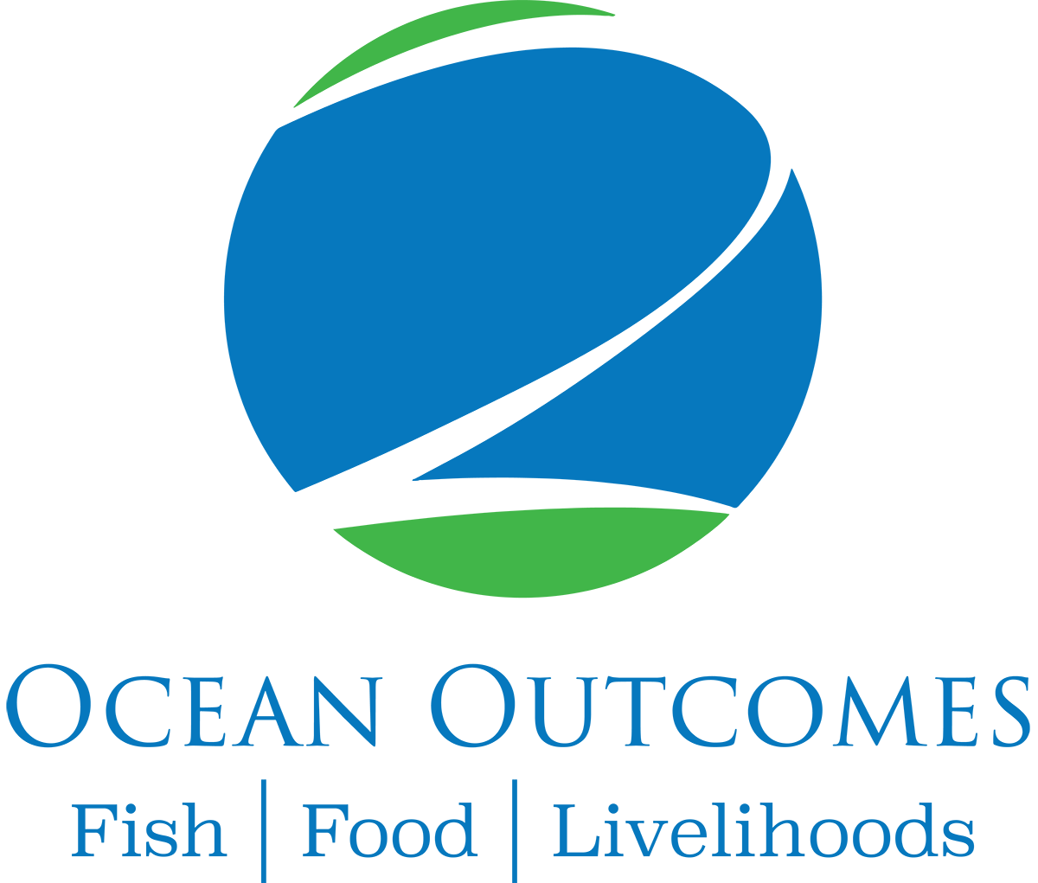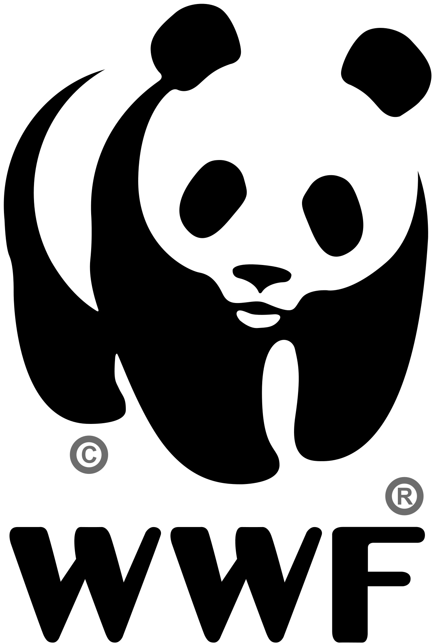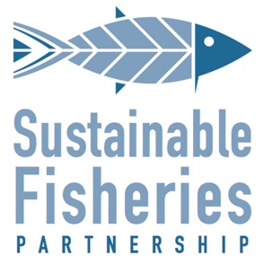

Basic Fishery Improvement Project (FIP) Scoping Document Guidelines

Introduction
The purpose of these guidelines is to help the user create a scoping document for a basic FIP to summarize the results of the rapid assessment and recommend strategies for addressing the fishery’s challenges. Below is an outline of the suggested content to include.

Outline of content:
Basic fishery information overview:
This section should contain basic information that describes the fishery – definition of the target stock(s), fishing method/gear used to target that stock, and any fleets or groups of vessels that could be included in a FIP.

Fishery supply chain analysis:
This analysis will help to identify who else could be involve in the project. The sources of information could be local and national statistics, global data (e.g. FAO), and market reports. As a review of the chain is develop, a stakeholder mapping should allow to invite other participants (e.g. suppliers, exporters, nongovernmental organizations, etc.).

Environmental challenges following the three principles of the MSC standard:
This section should help to identify major sustainability deficiencies in the fishery in the following areas:
- Status of target stocks and harvest strategy
- Ecosystems impacts (impacts on other species, impacts on endangered, threatened and protected species and Impacts on habitats)
- Management (legal framework, fishery objectives and research, monitoring and enforcement)

Improvement Recommendations:
This section should describe the actions that need to happen to improve the deficiencies identified.

Sources of information:
- Sustainability evaluations
- Market and supply chain analyses
- Manager reports
- Peer-reviewed studies
- International body reports (e.g., FAO reports)

