Action #1 Rebuild local salmon stocks
Action Goal: Rebuild wild Kunashir Island pink and chum salmon stocks within five years
PIs 1.1.1, 1.1.2

This year, PCF Yuzhno-Kurilsky Ryibokombinat Co., Ltd. (hereinafter referred to as YKRK) continued work on the adopted Rebuild Local Salmon Stocks Plan for the period 2022-2026. Contracts were signed in April to engage researchers from SakhNIRO and VNIRO to monitor Pink and Chum Salmon spawner escapement in the Kunashir rivers and to collect data for population characterization studies. Table 1 summarizes the activities from the Plan and their status at the time of the FIP visit to Kunashir Island.

Table 1. The list of activities of the YKRK Rebuild Local Salmon Stocks Plan for the period 2022-2026.

Activities | Progress status  as of Oct 01, 2023. | Expected date of report receipt
1. Studying the biology and reproduction of local Pink and Chum Salmon
- Review of modern scientific and literary data on the reproduction of Pink and Chum Salmon on Kunashir Island. | In progress | December 31, 2023
- Conducting the fieldwork by research scientists to collect biostatistical data on Pink and Chum Salmon of Kunashir Island, as well as real-time data on the fish run. | In progress | December 31, 2023
- Analysis of data obtained in the course of field research, including data on Pink and Chum Salmon otoliths. | To be carried out upon the end of the expedition work | January 30, 2024
2. Improving monitoring during the entry of Pink and Chum Salmon spawners to spawning grounds
2.1. Examination of rivers and lakes on Kunashir Island for the spawning escapement with Pink and Chum Salmon spawners. | In progress | December 20, 2023
2.2. Provision of the obtained real-time data to the company's management and external fisheries management structures | In progress | In the evening on the day of the spawning ground examination, or the day after the examination
3. Improving the reproduction of Pink and ChumSalmon in the rivers and lakes of Kunashir Island
3.1. Adoption and implementation of decisions on limiting fishing based on the results of spawning ground examinations | In progress | December 20, 2023

On August 22, based on the extremely low returns of Pink Salmon spawners to the shores of Kunashir, the Anadromous Fish Commission made a decision to establish a passing period from 12 am on Aug 23, 2023 to Sept 10, 2023. However, the situation has not improved. The website of the Sakhalin Region Fisheries Ministry https://fish.sakhalin.gov.ru/?page_id=19462 contains official data from SakhNIRO on the river escapement with Pink Salmon in the Sakhalin Region as of Sept 04, 2023. It also includes data on the examined rivers of Kunashir (Table 2).
Given the extremely low level of Pink Salmon reproduction, proposals are currently being developed to limit the fishing pressure on this species in order to include them in the 2024 Pacific Salmon Fishery Strategy.

Table 2. Escapement of examined spawning rivers of the Sakhalin-Kuril Basin with Pink Salmon spawners as of Sept 04, 2023 according to the data of the Sakhalin branch of FSBSI "VNIRO" ("SakhNIRO").

Watercourse | Spawning Grounds Area m² | Number of spawners, fish | River Escapement, %
Prozrachny Stream | 8,160 | 28 | 0.2
Golovnina River | 840 | 0 | 0.0
Belozerskaya River | 1,440 | 0 | 0.0
Vodopadny Stream | 620 | 8 | 0.6
Vtoroi Dachny Stream | 170 | 0 | 0.0
Asin Stream | 2,750 | 0 | 0.0
Ilyushina River | 21,000 | 680 | 1.6

According to the Association of Fishermen of Sakhalin Region (AFS) https://fish-sakh.ru/vyilov/tihookeanskie-lososi/2023-god/ the catch of Pink Salmon in the Souht Kuril Zone is "zero". It is noteworthy that in the current season Pink Salmon catch on the neighboring island of Iturup was also extremely low and amounted to 1866.64 tons.
The Chum Salmon fishery in the South Kuril zone is increasing. Preliminary data as of Oct 05 (the beginning of the spawning run) suggest that the number of Chum Salmon in 2023 will be higher compared to 2022: as of Oct 05, 2023, the Kunashir Chum Salmon catch was 74.73 tons, while on the same date in 2022, 32.86 tons were caught. Almost the entire amount was caught by the YKRK - 74.3 tons. At that, the main catch falls on fishing parcels No.65-18-06 and No.65-18-08, which are located in the area of Lagunnoye Lake Salmon Hatchery: 63.6 tons were caught here (the catch value as of Oct 05, 2022 was 19.5 tons). Daily dynamics of catches at these sites for the past two years is presented in Figure 1.

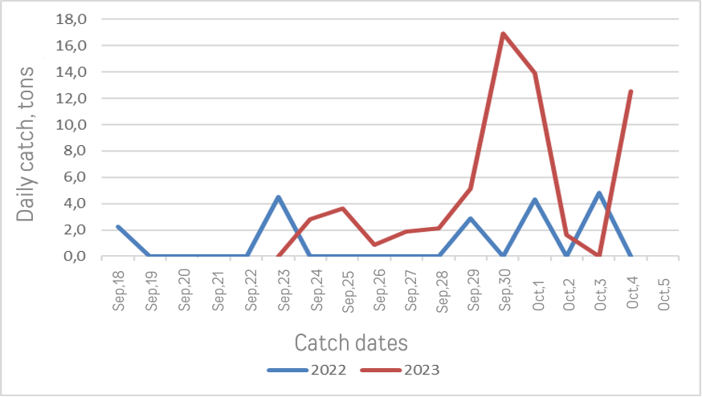
Figure 1. Dynamics of daily catch of Chum Salmon on fishing parcels No.65-18-06 and No.65-18-08 (Pervukhina Bay) as of Oct 05 in 2022 and 2023.

During interviews with various respondents on Kunashir, all respondents noted that in 2023 there was an abnormally hot summer, which led to abnormally high water temperatures for the Sea of Okhotsk and Pacific coastal waters. For this reason, the water content of rivers and lakes was lower, and the facts of blocking of river channels with woody debris and sedimentation in the mouths with alluvial sand and gravel were recorded more often. Some time after the heavy rains, fish passages up rivers were cleared.
Such facts were recorded by the staff of the Kurilsky Nature Reserve and were voiced at the meeting held on October 03. At the same meeting employees of the YKRK explained that the existing legislation does not allow private companies to promptly clear the riverbeds from debris, as they are not the owners of land plots and rivers. The territory, through which the rivers flow, belongs to the Federal Agency for Forestry, respectively, so the rivers are federal property. Therefore, in order to carry out any work, a special permit from the Russian Federal Agency for Fishery is required. As a result of the meeting, the YKRK staff contacted the regional office of this agency (Sakhalin-Kuril Territorial Administration) for clarification of the procedure to be followed in such cases.
Collection of research information for the 2023 season is ongoing. Final data on reproduction of local Pink and Chum Salmon on Kunashir will be presented in the reports of the involved researchers in January 2024.

List of literature and Internet resources:

Rebuild Local Salmon Stocks Plan for the period 2022-2026

Data from SakhNIRO on the escapement of the examined spawning rivers of the Sakhalin-Kuril Basin with Pink Salmon spawners: https://fish.sakhalin.gov.ru/?page_id=19462

Daily in-season information on Pacific Salmon Catch by AFS: https://fish-sakh.ru/vyilov/tihookeanskie-lososi/2023-god/

Lyudmila Fedorova,
Fisheries Eco-Certification Consultant

October 6, 2023

