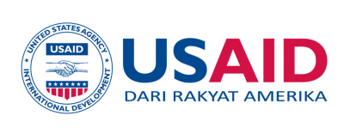
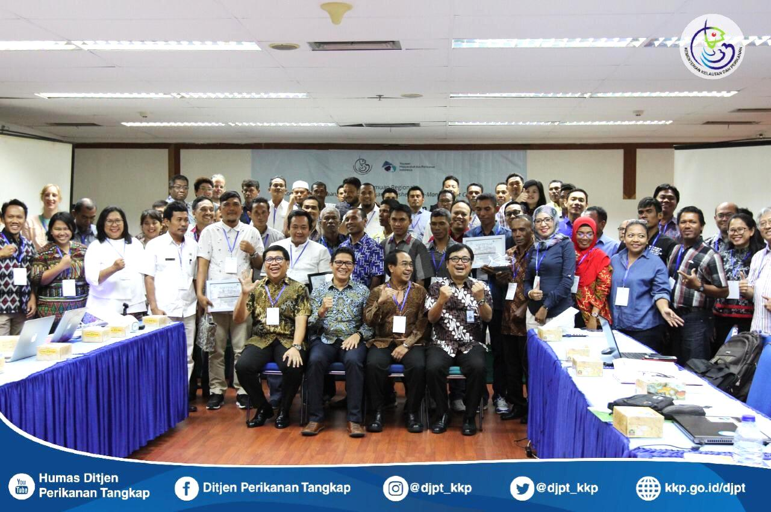

Regional Meeting of Fisheries Co-Management Committee
"Collaborating Towards Sustainable Fisheries"

16 January 2019

Prepared by : Masyarakat dan Perikanan Indonesia-MDPI

DISCLAIMER
This workshop report is made possible by the generous support of the American People through the United States Agency for International Development (USAID) with the close collaboration of the Government of Indonesia (GOI). The contents of this report are the sole responsibility of [ADD HERE, Name of Contractor/ Sub-Contractor] and do not necessarily reflect the views of USAID or the United States Government.

DISCLAIMER
This workshop report is made possible by the generous support of the American People through the United States Agency for International Development (USAID) with the close collaboration of the Government of Indonesia (GOI). The contents of this report are the sole responsibility of [ADD HERE, Name of Contractor/ Sub-Contractor] and do not necessarily reflect the views of USAID or the United States Government.

TABLE OF CONTENTS

INTRODUCTION 03

OBJECTIVE 04

SUMMARY AGENDA 04

DISCUSSION 04

RECOMENDATION 09

DOCUMENTATION 11

ATTACHMENTS 12

INTRODUCTION
Pasal 33 paragraph (3) of the 1945 Constitution of the Republic of Indonesia mandates that the earth, water and wealth contained therein be controlled by the state and used for the greatest prosperity of the people. Furthermore, Law No. 31 of 2004 concerning fisheries as amended by Law No. 45 of 2009 stipulates that fish resources and their environment constitute natural resources in the State Fisheries Management Region of the Republic of Indonesia (WPPNRI) which must be managed in a sustainable manner, in order to achieve maximum benefits for the welfare of the Indonesian people. To realize this policy, good management of fish resources is one of the prerequisites that must be designed and implemented.

Indonesia is rich in marine resources including fish species that have important economic values such as tuna, skipjack and neritic tuna. According to the State of World Fisheries and Aquaculture (SOFIA), Indonesia contributes around 16% of the world production of tuna, skipjack and neritic tuna and about 20% to national fisheries. Considering the important role of tuna, skipjack and neritic tuna fisheries for Indonesia, Decree of the Minister of Marine and Fisheries Number: 107 of 2015 concerning the Management of tuna, skipjack and neritic tuna has been issued. This decree becomes an operational reference in the implementation of tuna, skipjack and neritic tuna management and utilization practices in a sustainable manner, both by the central and regional governments including other stakeholders.

According to Peter Willian (2017), absolute tuna management is based on availability and says:
a. Data not available (No Data) then no management
b. Data is not good (Poor Data), then management has uncertainty.
c. Good data (Good Data), then management can predict (Predictable).

Considering te data is the basis for implementing tuna, skipjack and neritic tuna management practices, the Provincial Marine and Fisheries department together with MDPI initiated the establishment of the Fishery Data Management Committee (DMC) for tuna, skipjack and neritic tuna at the provincial level, namely Maluku, North Maluku, North Sulawesi, South Sulawesi, NTB, and NTT. This committee is a forum for collaboration between tuna, skipjack and neritic tuna fisheries stakeholders to work together to realize tuna, skipjack and neritic tuna resource utilization on an ongoing basis. Given the mutual cooperation between stakeholders is a requirement in the decision-making process of this committee, this committee is actually a joint committee, so that community participation in fisheries management can be further strengthened. This is in line with the provisions of Article 6 paragraph (2) of Law No. 31 of 2004 concerning Fisheries as amended by Law No. 45 of 2009 which stipulates that fisheries management for the benefit of fishing and fish cultivation must consider customary law and / or local wisdom and attention to the participation of the community.

OBJECTIVE
The aims of the Regional Meeting of the Data Management Committee for Fisheries for tuna, skipjack and neritic tuna were to:
- Share information on the achievements and challenges of implementing DMC;
- Ratification of the change of name and concept of the Fisheries Data Management Committee (DMC) into the Fisheries Co-Management Committee (FCMC)
- Improve understanding and sharing information on the benefits of Co-Management

SUMMARY AGENDA

The meeting was held at the Ministry of Maritime Affairs and Fisheries (KKP) office, Mina Bahari II Building, 14th floor, on January 16th, 2019. 108 participants attended (29 women, 79 men) consisting of several representatives of the central government (KKP), Local Government (DKP / District / City Fisheries Service), Ambon LIPI, University (UNHAS) company, fish collectors, fishermen, media / journalists, donors and NGOs. The meeting discussed the developments of the committees in their respective provinces, the importance of collaborative management, the change of the committee's name, which initially was the Fisheries Data Management Committee (DMC) as the Fisheries Co-Management Committee (FCMC). The change in name of this committee was motivated by a committee meeting which not only discussed data, but also issues that developed in the region for fisheries management. During the meeting there was also a plaque and certificate giving session for suppliers and fishermen who contributed in supporting sustainable fisheries in their respective regions. The regional government representatives, companies, suppliers and fishermen came from Maluku, North Maluku, NTT, NTB, South Sulawesi and North Sulawesi.

DISSCUSSION
Introduction from Trian Yunanda (Head of Subdivision of SDI ZEE and Archipelagic Waters PSDI-DJPT)
- Thank you to all participants for their participation in the Regional Meeting of the Fisheries Data Management Committee (DMC)
- One of the achievements of the KKP's collaboration with MDPI is the creation of an MoU between the KKP and MDPI
- The establishment of the Komite Pengelolaan Bersama Perikanan (KPDP) / Fisheries Co-Management Committee (FCMC) was one of the follow-up actions to make the MoU
- This KPDP is a forum for stakeholders to collaborate in the utilization / management of fisheries resources
- One of the objectives of this meeting was to replace the name of the Committee which was originally the Fisheries Data Management Committee (DMC) as the tuna, skipjack and neritic tuna Fisheries Co-Management Committee (FCMC)
- Hopefully in the future with the existence of this Committee, stakeholders can feel the benefits, and can commit to collaborate in Fisheries Management

Introduction from Saut Tampubolon (Executive Director of MDPI)
- Thank you to the Director General of Capture Fisheries (Zulfikar Mochtar) in supporting small fishermen accompanied by MDPI.
- Some of MDPI's achievements were delivered by Saut
- MDPI has succeeded in making technology and developing the technology of traceability of fish such as transformers and trace tales. Products that can be traced are 1383 tons.
- MDPI supports ship registration to obtain 220 BPKPs.
- MDPI conducts the guidance of the Fair Trade (FT) fishermen group, with 39 FT groups, 859 fishermen, with a total premium fund that has been obtained 1.4 billion.
- The Fisheries Data Management Committee (DMC) has been established in 6 Provinces, and routinely conducts diving meetings twice a year.
- There are plans to have the handline tuna fishery enter full assessment this year for yellow fin tuna in Buru Island, Maluku Province

Introduction from Zulfikar Mochtar (Director General of Capture Fisheries, KKP)
- Thank you to MDPI as a facilitator for joint fisheries management in several provinces
- Indonesia is one of the largest tuna producers in the world, which is 16% of the total per year
- 70% of tuna catches in Indonesia, come from small fishermen
- The amount of tuna resources owned by the State, must be managed together.
- The management of tuna is not only handled by Indonesia, but by the world managed by RFMO to ensure tuna management in every country is running well.
- Ecolabel such as Fair Trade and MSC is very necessary for the market, as a guarantee that the product guarantees sustainability

Plaque Submission and certification to champion suppliers and fishermen, for their contribution in supporting sustainable fisheries

National Tuna Management Activities
Utilization of RFMO tuna fisheries (Trian Yunanda)
- Tuna management is not only done nationally, but also internationally. That is RFMO (UNCLOS 1982). Emphasize that the use and conservation of tuna in the ZEE and Archipelagic waters must be carried out through international cooperation (RFMO)
- Indonesia is a member of the IOTC, WCPFC and CCSBT which are obliged to report the data
- Some of the obstacles faced by Indonesia in managing tuna are that the use of tuna in the RFMOs area has not been maximized, tuna catch data is not accurate, installation of FADs for tuna utilization is not in accordance with the rules and 5% observer coverage for vessels that capture the demand has not been fulfilled
- Focus on SDI ZEE and High Seas, namely improvement of data on tuna, (monitoring and reporting), improvement of ship registration system, CPIB and certification process, FAD control and Harvest Strategy implementation in Archipelagic waters

Outlook capture fisheries policies and programs for small fishermen T.A 2019 (Head of program section)
• Priority Activities of DG TA. 2019
- Procurement of 301 fishing vessels (1 carrier carrying 60 GT, 300 fishing vessels <5GT) distributed in 19 Provinces
- Procurement of environmentally friendly fishing equipment (Rawai Rawai Hanyut, Handline (handline eye type three, handline tuna, handline layur), Pancing Tonda, Pole and Line with a volume of 2000 units with tentative distribution in 30 Provinces
- Procurement of 350 engine units (outboard 330 units and 20 units) with tentative distribution in 19 provinces (North Sumatra, Riau Islands, West Sumatra, Jambi, Bengkulu, South Sumatra, DKI Jakarta, West Java, Central Java, East Java, East Kalimantan, North Sulawesi, Central Sulawesi , Southeast Sulawesi, West Sulawesi, Gorontalo, NTB, Malut, Maluku)
- Insurance premium assistance for 150,000 fishermen in 34 provinces for 1 year. Types of death, disability, medical expenses due to fishing activities as well as fishing activities. Determination of BPAN recipients will be held on the 2-3 weeks of June 2019.
- Capital fishing villages from KUB become cooperatives for 2,120 groups, structuring fisherman villages in 40 locations, and capital of capture fisheries in 34 provinces.
- Placement of 300 units of onboard observers, 4000 units of fish storage logbooks, 1 TPI inland waters, and continuation of licensing arrangements in 11 WPP.
- Operationalization of 4 SKPT (Natuna, Sebatik, Merauke and Saumlaki) and development of fisheries port 1 location (PPI Cikadang)
- One of the conditions for obtaining assistance is KUSUKA

Sharing Experience of Achievements and Arrivals in KPDP in each Province.

- Maluku Province (Ahmad Umarela, Head of Capture Fisheries, DKP Maluku Province)
- KPDP in Maluku was stagnant. But the process is starting to run
- The process of updating the committee is underway
- Development of Maluku Province is based on an island group. Maluku has 12 Island Clusters
- Tuna production in Maluku in 2017 - 2018 is 35,974.2 tons. skipjack 127,189.7 tons and neritic tuna 99.991.1 tons
- A total of 211 BPKKPs have been published by DKP Maluku.
- Current problems faced in Prov. Maluku in the framework of fisheries management, namely tuna data has not been recorded properly, fishermen's skills are still low, the limitations of suitable fishing vessels, and the availability of ice factories are still limited

- North Maluku Province (Ibrahim Asnawi, North Maluku Province DKP Capture Fisheries staff
- DMC in North Maluku starts in 2018
- DMC tuna, skipjack and neritic tuna was formed in February 2018, stipulated by decree of the Head of the North Maluku Province Marine and Fisheries Department No. 523/121 / DKP
- There have been three regular meetings held, and in each meeting resulted in a collective action plan for the next six months.
- At present there are three regencies / cities that are members of KPDP: Ternate city, Kab. Halsel and district. Kep. Morotai.
- Some districts will join the KPDP still in the process of development (Halut, Tidore and Sanana)
- At present North Maluku has a database of tuna in I-Fish which is supported by MDPI
- There are 274 vessels in the document registration process, both there are BPKPs, document collection, measurement and small fitting
- Some of KPDP's challenges in implementing it are HR, institution and budget

- North Sulawesi Province (Tienneke Adam, Head of Capture Fisheries, DKPD North Sulawesi Province
- North Sulawesi has DMC since 2017 which was decided by Governor Decree no. 390 concerning the Establishment of the Data Management Committee tuna, skipjack and neritic tuna fisheries in the Prov South Sulawesi
- Some achievements of the committee were carrying out good fish handling training on board and histamine testing, Use of e-CDT equipment, registration of small-scale fishing boats (BPKP) in Manado, Nain Island, Talawaan Bajo, and Kep. Sangihe and tuna, skipjack and neritic tuna data collection
- Some of the things that need to be supported in the committee are strong enthusiasm and awareness by stakeholders, the budget to support activities (APBN, APBD and Donors) and online data systems to facilitate all administrative processes

- NTT Province (Ernes D. Hamel, Head of NTT Province DKP Capture Fisheries)
- MDPI is quite helpful to us in the data sector. Especially data on tuna, skipjack and neritic tuna, and FADs.
- A joint action plan in DMC that has been and will be implemented including;
- Collection of catch data.
- The report is given to the provincial DKP.
- Carry out technical socialization activities
- Socialization of Log Book
- Installation of monitoring vessel (Spot Trace)
- Implement FAD inventory
- Activities of World Fisheries Day.
- Inventory of FADs
- The recapitulation of FADs data according to the coordinates of the data has been 49 units. Because it is in accordance with the OSS policy that the rules for installing FADs have been removed.
- Related to potential, NTT is in 3 WPP (573, 713 and 714). Sustainable potential of 491,700 tons / year.
- Problems faced in the framework of joint management, among others, are based on Law 23 of 2014, ships from 0-5 GT issuance of BPKP are carried out in District / City. But most districts / cities never run it.

- South Sulawesi Province (Febrian Budianto, Head of Subdivision of Regional Fisheries Port II) DKP Prov. Sleatan Sulawesi
- South Sulawesi DMC formed in March 2017, with SK DKP Prov. South Sulawesi 523/51 / SK / TKP / KPDPTCT / IV / 2017 DATED MARCH 24, 2017 with a validity period 2017-2019
- DMC has a database of tuna, skipjack and neritic tuna in I-Fish for support from MDPI
- Several activities in the committee that have been implemented include the prohibition of fishing with destructive fishing campaigns through posters posted at several points, proposing fishermen to take part in the 60-mile BST and SKK training facilitated by PIP Makassar, as well as progress reports

- Development of Fisheries Management Councils - WPP NRI (Dr. Besweni, DJPT KKP)
    - There are 11 WPP based on the legality of fisheries aspects. There is an estimate of potential, and there is a lesson plan that requires a place to manage this fishery. RPP is not prepared by the central government, but is input from all stakeholders in WPP
    - The legal basis for RPP already exists, there needs to be a management institution
    - Every WPP has potential HR. There are academics, government, fishermen, suppliers etc., therefore it is necessary to have a management institution / institution in each WPP.
    - The management team is expected to be able to provide a role in recommending fisheries management programs properly.
    - The WPP Secretariat has several working groups.
    - The WPP Secretariat only communicates data taken by stakeholders in WPP. Discussed in the scientific panel and if there is a problem that arises, a decision is made as an effort to manage fisheries with dangerous stock status. The results of the discussion can then be continued by the WPP secretariat to the central government.

The things that have been done by FMC WPPNRI:
- There is already a legal regulation (Director General Decree for management institutions)
- Have a Director General Decree for the duties of each field in the structure. Note: the position of people in the WPP organizational structure is: Echelon 2
- socialization is complete
- The WPP 11 Secretariat has finished
- WPP's secretariat needs are finished
- Fisheries target and system has been completed

Obstacles:
- Minister's regulation has not been signed
- HR is still an obstacle. Where the costs are also high
- There is a perception that is not the same as the management institution

Things to do in 2019:
- Completing draft regulation for FMC
- Updating HR at the WPPNRI FMC
- Equation of perceptions regarding the operational urgency of the FMC WPP with the scope of the CTF
- Coordination with Dit. Fisheries port (data collection through PIPP). Pusdatin (One data) and optimization of E-Logbook.

Basics in Co-Management for small fishermen and (A. Riza Baroqi, Co-Management Officer, MDPI)
- Co-Management / collaborative management is collaboration between various stakeholders in managing resources for sustainability
- Co-Management is needed because of limited resources, and is used by many parties. So it needs to be managed together well
- Several components in co-management that have important roles, namely the government, academics / researchers, industry, fishermen, NGOs and communities / the general public
- Some challenges in co-management, namely the commitment of all stakeholders has not been strong, there has not been a priority of each agency, budget constraints, and information has not been well channeled to the community
- Co-Management has benefits including good management in maintaining resources, so that resources can be sustainable. In addition, capacity building for stakeholders is due to the large amount of information that is very useful as material for knowledge
- Co-Management with MDPI is implemented in six provinces (Maluku, North Maluku, NTB, NTT, South Sulawesi and North Sulawesi), held twice a year
- The results of the co-management meeting are joint action plans that have been agreed upon, to be jointly followed up in resolving emerging issues in each region

Open discussion: How can Co-Management for Small Fishermen in the Region be Integrated with FMC WPPRI (DKP NTT).
- In this session, Ms. Ibes was not at the location of the activity, because there were other interests. Ms. Ibes is the prime mover of the WPPNRI FMC
- In the future it is planned that the KPDP in the Province can be included in the FMC WPP working group. Therefore, there is still no information regarding this step.

Discussion regarding the agreement of the Committee's concept name: (Saut Tampubolon)
- Along with the development of the issues found, at the DMC meeting it turned out that it was not only talking about data, but also the issues that occurred in the field. Therefore, DMC will be renamed the: Fisheries Co-Management Committee (FCMC)
- In the scope of the Decree, the scope of this KPBP will be focused on tuna, skipjack and neritic tuna fisheries.

RECOMENDATION
- Recommend to the KKP and the regional government so that small-scale fishermen who have succeeded in following the improvement schemes of fisheries management, such as Fair Trade and FIP to receive priority government assistance programs implemented by the government such as fishing facilities and fishermen insurance, including assisting in the process completing the requirements for obtaining such assistance, among others: KUSUKA cards, KUB formation and cooperatives to support sustainable fisheries and encourage other fishermen to participate in improved fisheries management programs or schemes, both those carried out by the government and non-government (NGOs, fisheries company, fishermen's association).
- Request KKP support in completing the completeness of the government aid ship documents that have been submitted to small scale fishermen in (Bitung, Sangihe, Halmahera Selatan and Morotai) so that the assistance of fishing facilities can be immediately used by beneficiary fishermen. The committee will help provide a list of aid vessels that do not yet have vessel documents, namely in the form of names and types of aid vessels, names of groups / cooperatives and locations.
- Open access to fisheries data from the KKP to the regional government (province / district) so that it has good reference data in fisheries management planning in the area.
- Support the data collection and utilization process carried out by the KKP through the integration of data from the joint fisheries management committee for fisheries management needs. Data generated by the joint management committee is also expected to be used in the implementation of Harvest Strategy and / or other fisheries management actions.
- The meeting agreed to change the name of the Fisheries Data Management Committee (DMC) to the Fisheries Co-Management Committee (FCMC).
- The Fisheries Co-Management Committee can be run independently / with a sharing budget system with the central government, local governments, universities, NGOs, industry, associations and other donor institutions.
- Perform updates on each Joint Management Committee Decree in six provinces for the names and concepts agreed upon at the regional committee meeting.
- Through the Fisheries Co-Management Committee it can convey problems at the regional level to be submitted at the central level through the consultative panel of the FMC WPPNRI, given the limited capacity in the committees at the regional level.
- Compilation of the organizational structure of the joint management committee of the fishery will be carried out through small group discussions both directly and intensively
- Increase the participation of committee members in implementing agreed upon action plans.
- Deliver the results of this meeting to the Director General of Capture Fisheries and the KKP Secretary General.

DOCUMENTATIONS

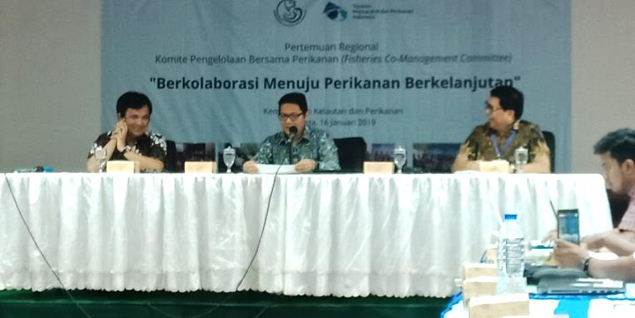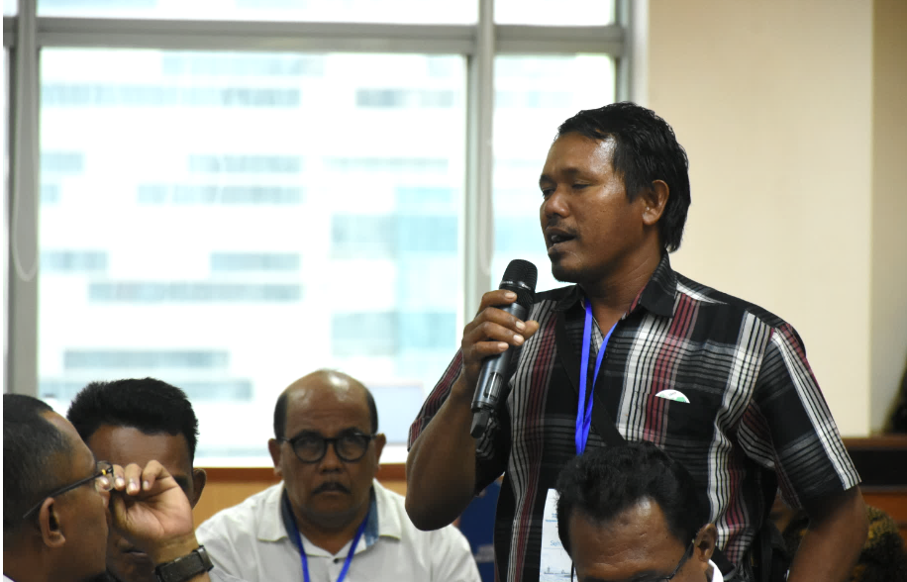

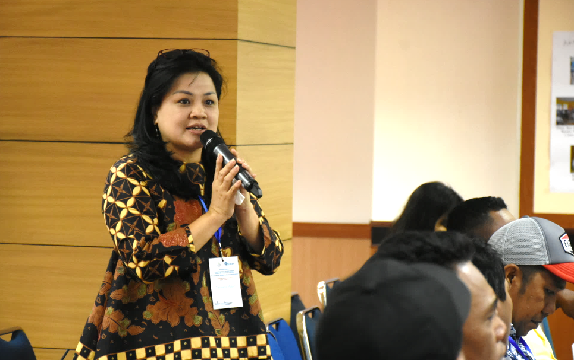

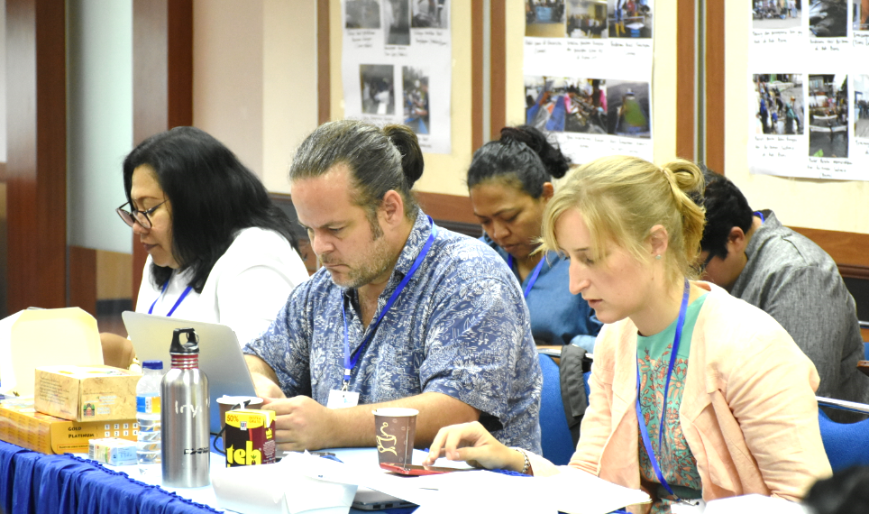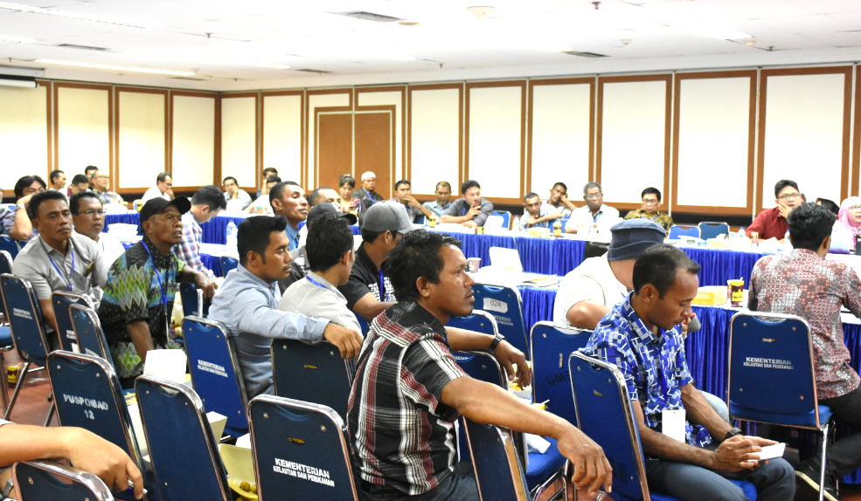
Photos during Regional DMC

ATTACHMENTS
The Schedule of Agenda
Time | Agenda | PIC | Remark
08.00 – 08.30 | Registration Participant | Committee
08.30 – 09.45 | Activity Opening:  - Singing Indonesia Raya  - Do'a  - Introduction to Plt. Director of PSDI - DJPT  - Introduction to MDPI | MC: Mumpuni CP  - Dwi Eni Juliastuti  - Roys Birrul .M.  - Plt. Direktur PSDI –DJPT  - Excecutive Director MDPI
 | - Direction and Opening of Director General of Capture Fisheries, and continued with submission of certificates and souvenirs to 6 (six) champion suppliers | - Director General of Capture Fisheries
 | - Photo Group | - Committee
09.45 – 10.30 | Panel I Presentation and Discussion:  - National Tuna Management Activities | - Kasubdit SDI ZEEI dan Laut Lepas, Dit. PSDI – DJPT | Moderator:  Kepala Pusat Riset Perikanan – BRSDMKP
 | - Outlook for small fisher development policies for FY 2019 | - Sub of Head Program, Setditjen PT – DJPT
10.30 – 10.45 | Coffee Break
10.45 – 11.30 | Panel II Presentation and Discussion:  - Share experiences with achievements & challenges in KPDP in each province. | - Head of Capture Fisheries DKP Prov. Maluku  - Head of Capture Fisheries DKP Prov. North Maluku  - Head of Capture Fisheries DKP Prov. North Sulawesi | Moderator:  Kepala Balai Riset Perikanan Laut, PUSRISKAN – BRSDMKP  Presentation Time:  10 Minutes for each Resource Person  Discussion time: 15 minutes
11.30 – 12.15 | Panel III Presentation and Discussion:  Share experiences with achievements & challenges in KPDP in each province. | - Head of Capture Fisheries DKP Prov. NTB  - Head of Capture Fisheries DKP Prov. NTT  - Head of Capture Fisheries DKP Prov. South Sulawesi | Moderator:  Head of Loka Riset Perikanan Tuna, PUSRISKAN – BRSDMKP  Presentation Time:  10 Minutes for each Resource Person  Discussion time: 15 minutes
12.15 – 13.15 | Break for Praying and Lunch
13.15 – 14.00 | Panel IV Presentation and Discussion:  Overview of joint management  - Basics in co-management for small fishermen | - A. Riza Baroqi,  - Co-Management Officer - MDPI | Moderator:  Hari Christijanto, DJPT KKP  Presentation Time:  10 Minutes per Speaker
 | - Development of Fisheries Management Institutions – WPPNRI | - Kasubdit SDI Inland Sea, Territorial and Archipelago Waters
14.00 – 15.00 | Open discussion:  How can co-management for small fishermen in the region be integrated into the Fisheries Management Institute - WPPNRI | Moderator:  Ernes D. Hamel, Head of Capture Fisheries DKP NTT | Presentation
15.00 – 15.30 | Discussion related to agreement on the name and concept of the Committee | Excecutive Director MDPI | Discussion
15.30 – 16.15 | Reading recommendations for better co-management implementation for small fishermen | Wildan, Manager Fisheries Improvement Team MDPI | Discussion
16.15 | Closing | Directorate General of Capture Fisheries

PARTICIPANTS

- Zulfikar Mochtar (Director General of Capture Fisheries, KKP)
- Trian Yunanda (Dit PSDI, KKP)
- Eko Prianto (Pusriskan)
- Zulkarnaen Fahmi (Loka Riset Perikanan Tuna)
- Yusuf F (DJPT, KKP)
- Sunaryo (DJPT, KKP)
- Lukman Ariadi (DJPT, KKP)
- Ratna D. (Dit PDK, KKP)
- Ariati M. (Dit PDK, KKP)
- Ning Mulyana (Dit PDK, KKP)
- Hary Christijanto (Dit PSDI, KKP)
- Dr. Besweni (DJPT, KKP)
- Cahyani Dwi Setyawati (Dit PSDI, KKP)
- Enang Rucita (Dit PSDI, KKP)
- Mumpuni C. Pratiwi (Dit PSDI, KKP)
- Dwi Eni Juliastuti (DJPT, KKP)
- Roys Birul (DJPT, KKP)
- Neneng (DJPT, KKP)
- Riana Handayani (DJPT, KKP)
- Rizal Rifai (DJPT, KKP)
- Cahyo Priono (DJPT, KKP)
- Joko S. (BHKLN, KKP)
- Oki A. (BHKLN, KKP)
- Ade Fitria Nola (BHKLN, KKP)
- Nasrulloh K. (BHKL, KKP)
- Yosef
- Lukman
- Andi S
- Ahmad Umarella (DKP Prov. Maluku)
- Ibrahim Asnawi (DKP Prov. Maluku Utara)
- Ernes D. Hamel (DKP Prov. NTT)
- Febrian Budianto (DKP Prov. Sulawesi Selatan)
- Tienneke Adam (DKPD Prov. Sulawesi Utara)
- Hamin S. (Dinas Perikanan Kab. Buru)
- Fitriah (Dinas Perikanan Kota Ternate)
- Safri Ishak (Dinas Perikanan Kab. Halmahera Selatan)
- Ernist H. U. (Dinas Perikanan Kab. Kepulauan Sangihe)
- Orson Nawa (Dinas Perikanan Kota Kupang)
- Ruslan W. (Dinas Perikanan kab. Maluku tengah)
- Masita Lohor (Dinas Perikanan Kab. Pulau Morotai)
- Aziz (Dinas Perikanan Kab. Lombok Timur)
- M. Sofyan (Dinas Perikanan Kab. Bone)
- Widhya (LIPI Ambon)
- Prof. Dr. Jamaludin Jompa (UNHAS)
- Sekendri (PT. BOGI)
- Sarah Hutapea (PT. Harta Samudera)
- Phi Bun Tjuan (Muara baru)
- Sarman Hijan (Supplier Maluku Utara)
- La Ode Jaerudin (Supplier Seram Utara
- Roni Ego Artha (Supplier CV. Versace, Lombok)
- Anasrin Hj Hamdjah (Supplier Ternate)
- Saldin Bonelalo (Supplier Buru)
- Yonathan Atimeta (Supplier CV. ASK Kupang)
- H. Andi Syahrul (Supplier Bone)
- Kahar Lastori (Supplier Morotai)
- Muchsin (Supplier Sangihe)
- Asaad Sopamena (Supplier Seram Selatan)
- Sofyan Bagu (Supplier Bacan)
- Bakar (Fisher Lombok)
- Agus Setiawan (Fisher Kupang)
- Danri M. Djae (Fisher Ternate)
- Hayon Buton (Fisher Buru)
- Jumadel Mataga (Fisher Morotai)
- Alwia Kaledupa (Fisher Seram Utara)
- Mansur (Fisher Bone)
- La Tohia (Fisher Seram Selatan)
- Ferdi tamara (Fisher Sangihe)
- Ardani Sanusi (Fisher Bacan)
- Suharlan Arrisa (Fisher P. Bisa)
- Irna Sari (USAID SEA)
- Nandana Godjali (TNC)
- Anka Farita (TNC)
- Saraswati Adiyarini (WWF Id)
- Abdul Muis (AP2HI)
- Agus Abdurahman (SFP)
- Rocky P. (IPNLF)
- Kyana (IPNLF)
- Sven Blankenhorn (PBN)
- Heri (PBN)
- Saut Tampubolon (MDPI)
- Deirdre E. Duggan (MDPI)
- Lanny Djauhary (MDPI)
- Olivia Tanujaya (MDPI)
- Yasmine Simbolon (MDPI)
- Stephani Mangunsong (MDPI)
- Wildan (MDPI)
- Moh. Syifa (MDPI)
- Margaleta (MDPI)
- Santri Dinalhusna (MDPI)
- Putra Satria Timur (MDPI)
- A. Riza Baroqi (MDPI)
- Karel Yerusa (MDPI)
- Prayoga Miftahul Huda (MDPI)
- Amrollah (MDPI)
- Djamal (MDPI)
- Muslim Ambari (Mongabay)
- Desti Kusumo (TV One)
- Tedi Suhendi (TV One)
- Immanuel C. (RRI)
- Victor (Wartaekspres)
- A. Lana (Wartaekspres)
- Nely (Indopost)
- Latif (Kumparan)
- Lukita (Kompas)
- Etha (Bisnis Indonesia)
- Fitri W. (Tribun News)
- Ginting (Sinar Pagi baru)
- Damiana (Investor Daily)

