Survey Results from Monday September 5th, 2022

Scot’s Bay #8

Seven commercial purse seiners conducted the survey on Monday September 5th starting at 8pm which was at high tide. All vessels ran two transects each in the Main Survey Box. There was a plankton tow and replicate conducted and CTD cast by the Lady Janice II. A total of 450 tags were applied during the survey over 2 events across September 5th to 7th from the Sealife II. Samples were obtained for target strength estimation.

Figure 1. Track plot and survey area.

Figure 2. PRC Area Backscattering Coefficient (m2/m2) for each transect and cell using a grid of 1km.

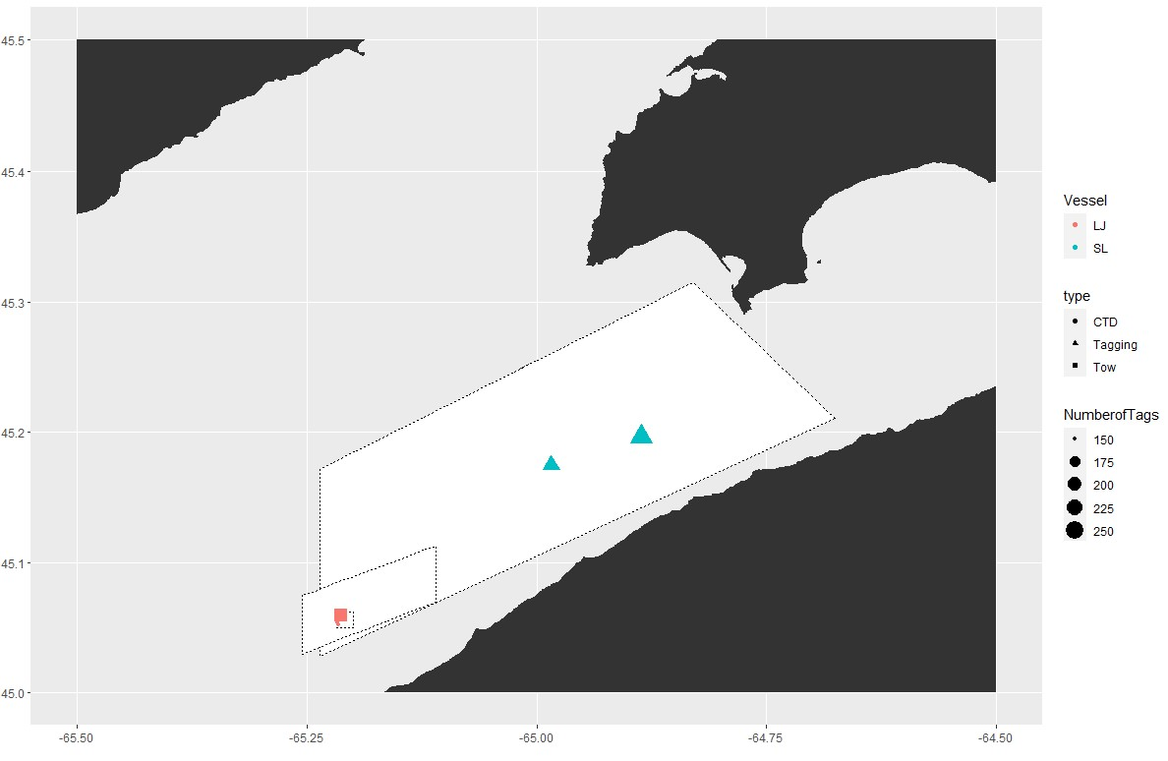

Figure 3. Plankton tow, herring tagging, and CTD cast locations.

Acoustic Equipment

Each vessel was equipped with a Simrad ES38-18/200-18C combi (2-in-1) transducer prior to the survey that contains a 38kHz split beam and 200 kHz single beam transducer. Data was logged to the computer hard-drive for post-processing. All participating boats were calibrated on 38kHz before the survey.

Tide Schedule for Margaretsville NS, Station #315

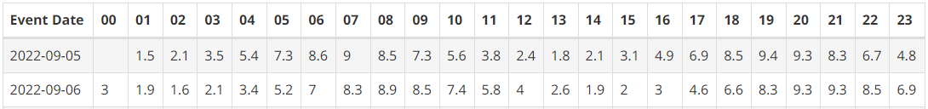

(Source: [www.waterlevels.gc.ca](http://www.waterlevels.gc.ca))

Table 1. Plankton Tow Summary

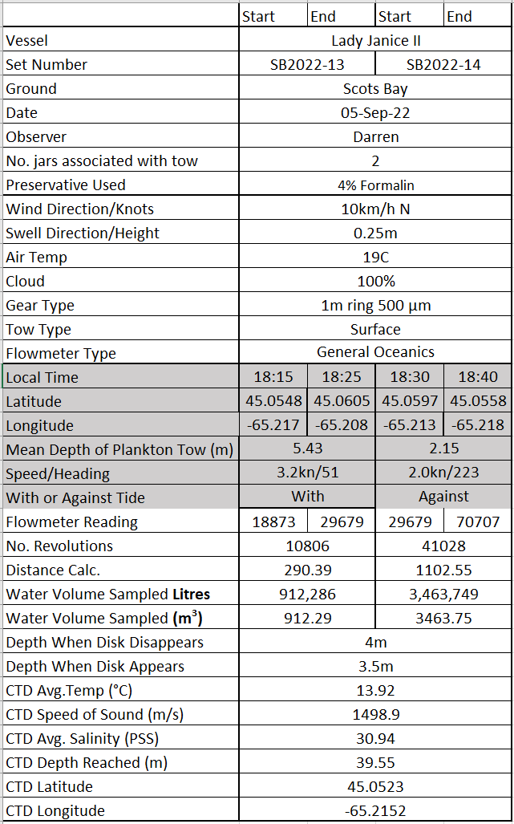

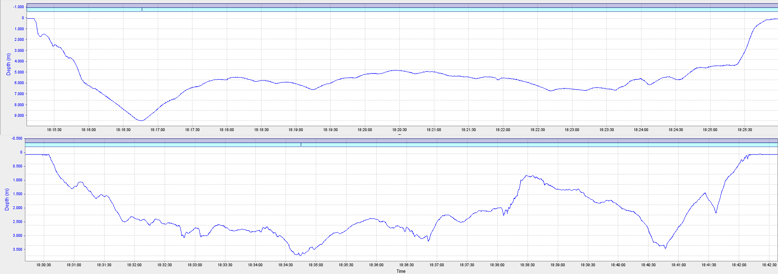

Figure 4. Plankton net depth profiles. The first tow is SB2022-13, which was with the tide and had an average depth of 5.32m. The second tow is SB2022-14, which was against the tide and had an average depth of 2.10m.

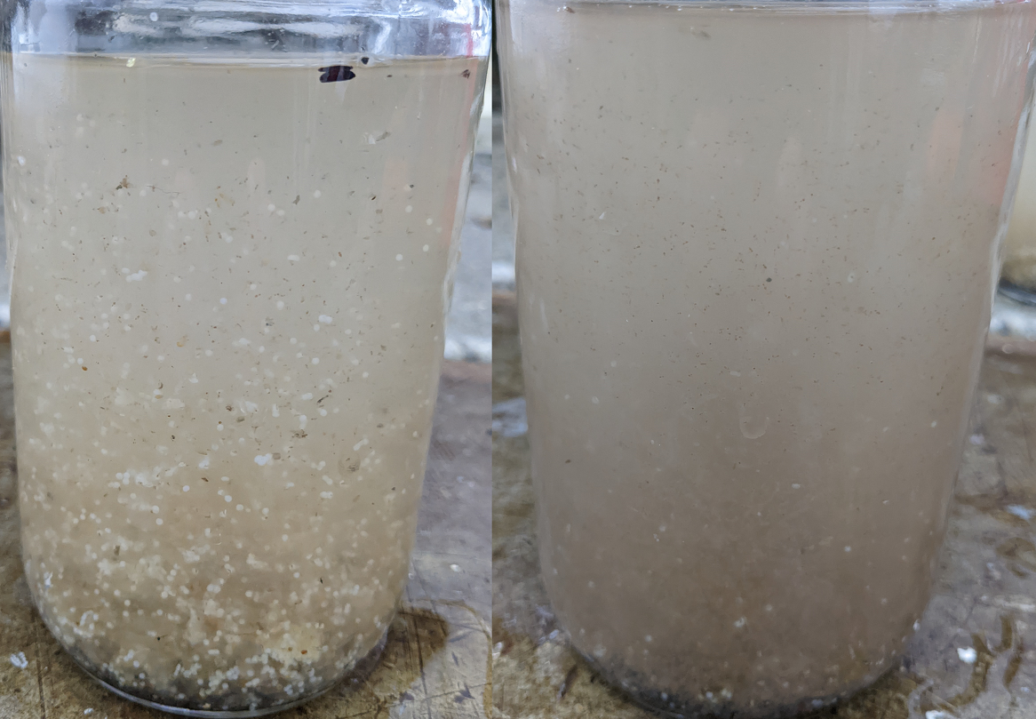

Figure 5. Captured plankton for SB2022-13 and SB2022-14. These tows did not capture much plankton. The white spheres are most likely insect eggs from inside the net being washed into the codend on the first tow. Future tows will ensure that the net is towed first without the codend attached to remove any debris.

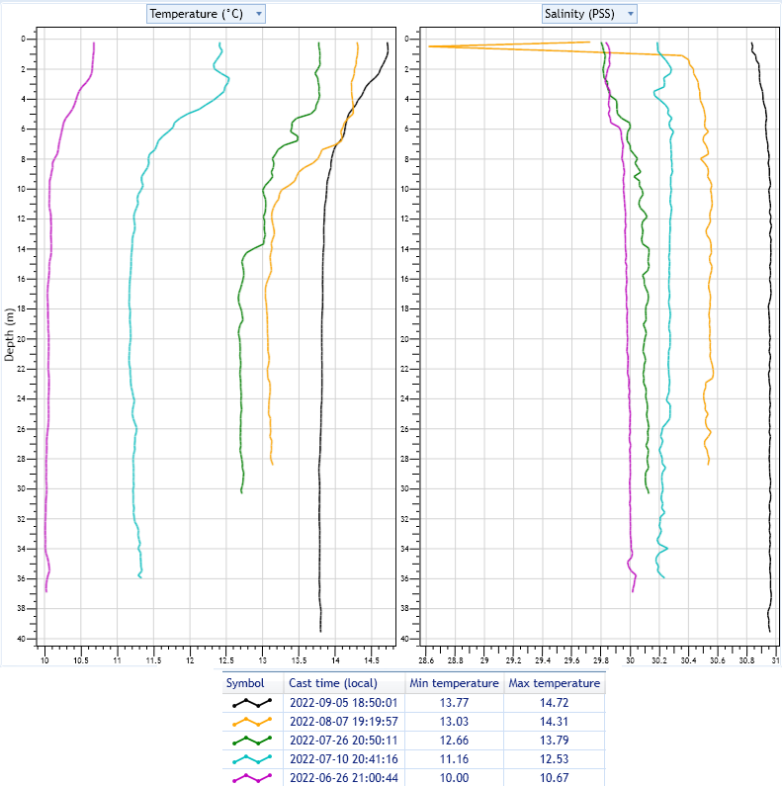

Figure 6. CTD cast summary for all Scots Bay 2022 surveys thus far, excluding the last SB7 survey. Temperature increases at both the surface and deeper in the water column are starting to plateau, with only minor increases being observed. Thermal stratification is still present but also reduced, with a 0.95°C difference between the upper and lower depths of the water column. The water column has increased in salinity by approximately 0.5 PSS.

Results

The results are subject to change as DFO will re-evaluate data editing, area estimation and apply a target strength. Preliminary biomass prediction using standardized parallel transects is **21,908 mt**, and with turnover **21,372 mt**.

Table 2. Transect details.



Table 3. Acoustic survey results - transects are listed from greatest to least backscatter.



Figure 6. Snip from the transect with the greatest backscatter, BP T01 in the middle of the Main Box.

Table 4. Survey summary.



Table 5. Annual comparisons. Surveys with no highlight indicate that they were school surveys.



Appendix A. Vessel Performance

Due to varying vessel performance per transects, speed will no longer be averaged for each vessel. For the first transect, vessels performed well and maintained speeds at or below the recommended 8 knots. The second transect however was a different story. Speeds were much too high, with the Leroy and Barry surpassing a 10 knot average. Vessels area urged to maintain the recommended speed for the entire survey, not just the first transect.

There were no issues with vessels cutting their lines short.

