6 months Progress Report: Eastern Pacific Ocean Swordfish -Longline (Taiwan, Panama, Vanuatu)

Fishery Progress through June 2024

* *The stock appears to be in good shape.* *Swordfish is not overfished and overfishing is not occurring.*

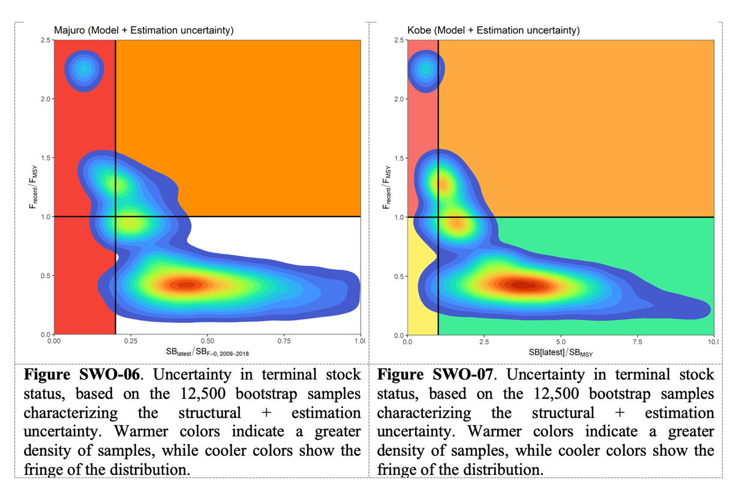

* In February, two FIP meetings were held. The first was to plan improvements and social responsibility steps. The second FIP meeting was about information management with the vessel owners.
  + *Slides from both meetings have been posted to the profile.*
  + *The priority for 2024 is Endangered species outcome & management.*
  + *The FIP is collecting catch information to help estimate risks to endangered species.*
  + *FIP participants agreed on a communications protocol with vessel owners.*
  + *The FIP host assigned Jayden Yen as the liaison with the vessel owners. Jayden will distribute all FIP materials, collect and return all necessary information.*
* In March, appropriate management measures for secondary species were identified, towards meeting 80 on MSC indicator 2.2.2 for secondary species management, currently 60-79.
  + *The measures are: WCPFC CMM 2022-04 Conservation and Management Measure for Sharks, TTC* [*C-23-07 Sharks*](https://www.iattc.org/GetAttachment/6e08563b-454c-4df2-961b-0b9ffef04fcd/C-23-07_Sharks%E2%80%93consolidates-and-replaces-C-05-03,-C-16-04,-and-C-16-05.pdf) *for the Protection and Sustainable Management of Sharks, IATTC C-04-07 Resolution on the Mitigation of Fishing Impacts to Sea Turtles.*
  + *The list is posted to the profile.*
* In April, there was a meeting of the [IATTC, 2ND AD HOC WORKING GROUP ON ELECTRONIC MONITORING](https://www.iattc.org/en-US/Event) (April 23-25) where the co-chairs otabled draft interim minimum standards for electronic monitoring in IATTC fisheries (WGEM-02-01). Their advice is noted by the FIP:
  + *EM equipment should automatically and autonomously collect EM records to generate the required EM data and should be tamper-evident; details in Annex 2.*
* In May, there was a meeting of the [IATTC, 2ND MEETING OF THE PERMANENT WORKING GROUP ON ECOSYSTEM AND BYCATCH](https://www.iattc.org/en-US/Event) The working group published a workplan that is synchronous with the efforts of the FIP, and advised the Commission to consider making its content legally binding. This is noted as a priority in the FIP.
  + *Reference document:* [EB-02-03 - Workplan towards the adoption of best handling and release practices for vulnerable species In IATTC fisheries](https://www.iattc.org/GetAttachment/b8a75f34-bf62-4699-acd4-cb954d9509ed/WGEB-02-03_Workplan-towards-the-adoption-of-best-handling-and-release-practices-for-vulnerable-species-In-IATTC-fisheries.pdf)
* In June, there was a meeting of the [IATTC, 15TH MEETING OF THE SCIENTIFIC ADVISORY COMMITTEE](https://www.iattc.org/en-US/Event) (June 10-14). The IATTC made two management recommendations (SAC-15-13) for swordfish based on the benchmark assessment for south EPO swordfish (SAC-14-15):
  + *1. Continue to monitor the stock (e.g., using stock status indicators and conducting benchmark assessments in 3-5 years).*
  + *2. Adopt interim reference points for the stock taking into consideration those proposed in SAC-14 INF-O*
  + *Details: In the last three years of the compilation (2017 - 2019) the average catch was about 34,000 tons a year. The fleets that are currently the most important are the Spanish longline fleet, which catches about 30% of the total catches in weight, followed by the Chilean gillnet fleet with 22%, and the Ecuadorian longline fleet with 20%. Associated with the increase in catches, there was a clear increase in the indices of abundances, continuing the upward trend since the 2011 assessment.*
* June: IATTC staff made several management recommendations (SAC-15-13) for non-target species that are now noted as priorities in the FIP and added to the list described above.
  + *Seabirds: Revise Resolution C-11-02 to be consistent with the current state of knowledge regarding seabird interactions and mitigation techniques as described in SAC-08-INF-D and Gianuca et al. (2023).*
  + *Sea turtles: Revise Resolution C-19-04 consistent with the simulated efficacy of CMMs assessed in BYC-11-02; Re-evaluate circle hook data; Adopt interim best handling and release practice guidelines available in Annex 1 EB-02-03.*
  + *Sharks: Adopt the shark Best Handling and Release Practices guidelines described in SAC-15-11.* *CPCs should enhance reporting regarding their implementation of Resolution C-23-08.*

Note: This FIP makes progress in parallel to the Eastern Ocean Swordfish FIP due to having the same FIP participants: Fong Hsiang Enterprises and SYMPAC International.