Limited Liability Company PKF
“Yuzhno-Kurilsky Rybokombinat” (South Kuril Fish Factory)

"The current state of the Sakhalin taimen stock on Kunashir Island and its historical data"
Research Report

Prepared by:
S.F. Zolotukhin, Ph.D. in Biology

Khabarovsk - Yuzhno-Kurilsk, 2023

CONTENTS

Introduction……………………………………………………..……………………………...p.3
Chapter 1. Limnological studies in the lakes of Kunashir Island ………………………….p.4
Chapter 2. Ecological requirements for the habitats in adjacent areas of Kunashir Island…………………………………………………………………………………………..p.11
Chapter 3. The history of formation and current state of the Sakhalin taimen habitats on Kunashir Island……………………………………………………………………………….p.17
Chapter 4. Stock groups of the Sakhalin taimen on Kunashir Island…..………………...p.19
Chapter 5. Data on the fisheries impact…………….………………………………………p.22
Chapter 6. Field research …………………………….….......................................................p.26
Chapter 7. Discussion of the field research results ...............................................................p.44
Chapter 8. Legislation of the Russian Federation and Sakhalin taimen on Kunashir Island…………………………………………………………………………………………..p.48
Conclusions and recommendations to YKRK…………….………………………………...p.51
References………………………………………………………………………………….....p. 52

Introduction
The limited liability company PKF “Yuzhno-Kurilsky Rybokombinat” (further – YKRK) harvests marine fish and Pacific salmon with fixed nets in the coastal waters of Kunashir Island. In compliance with the requirements of paragraph No. 8 of the FIP YKRK Work Plan for 2022-2026, it is necessary to find out whether this fishery has any impact on the abundance and reproduction of the Sakhalin taimen – the only salmon species that inhabit Kunashir Island and listed in the Red Book of the Russian Federation and the international IUCN.
The last attempt to describe the taimen of Kunashir Island was made more than 20 years ago. Currently, there are no modern data on the biology and reproduction of this species on Kunashir.
The research goal of the YKRK scientific program is to study the current state of the Sakhalin taimen on Kunashir Island, in compliance with the requirements of paragraph No. 8 of the FIP YKRK Work Plan for 2022-2026.
Objectives of the YKRK Program:
- to carry out expeditions to survey the spawning grounds of taimen in the reservoirs of the Kunashir Island, to collect survey data and record the presence or absence of the Sakhalin taimen reproduction in the Serebryanoe Lake;
- to identify, investigate and describe the modern features of reproduction and life cycle of the Sakhalin taimen on Kunashir Island;
- to find and study historical data, conduct a comparative analysis of expedition results and literature data;
- to identify and assess potential threats to the reproduction of the Sakhalin taimen on Kunashir Island, including the possible impact of the YKRK fishery;
- to describe the legislative aspect and the population status of the Sakhalin taimen on Kunashir Island, as a species included in the “Red Book of the Russian Federation” and the “Red Book of the Sakhalin Region”.
The chapters 1-5 of this report are archival and theoretical in nature. Chapters 6-8 are factual and analytical. This research report also provides with conclusions and recommendations for the YKRK.
The data presented in the report will be used to make decisions as part of a program to improve fisheries on Kunashir Island.
The author expresses gratitude to the managers of the Limited Liability Company PKF “Yuzhno-Kurilsk Rybokombinat” (YKRK) for financing the project to study a rare ancient species of salmon – the Sakhalin taimen, and personally to the head of the coastal fish factory, Vitaly Aleksandrovich Ustenko, who is genuinely interested in and cares a lot about the Kuril Islands.
The author is grateful to the employees of the YKRK, A.A. Avdeeva, S.N. Korostylev, and S.P. Kolomeyts, and the chief fish farmer of the hatchery “Lagunnoe Ozero” of the YKRK Pastukhov Dmitry Aleksandrovich, who greatly contributed to my field work. The author expresses his gratitude to all those who helped in field research and other work on Kunashir Island: the Director of the State Nature Reserve “Kurilsky” Kisleyko A.A., the researcher of the State Nature Reserve “Kurilsky”, Sokov D.A.

Chapter 1
Limnological studies in the lakes of Kunashir Island
As part of the study of new lands for their economic development, Japanese biologists studied the lakes of Kunashir Island in the 1930s. The results of the research in 1934-1935 could not be published since some information was then of a military nature. Mitsugu Takayasu, Kenzo Kondo, Sinichi Ohigashi, Kunio Kuroda published their data 20 years later, in 1955. The purpose of the research was to prove the possibility to develop aquaculture (artificial fish breeding) on Kunashir Island.
As a result of the research conducted in the summer of 1934 and 1935, Japanese biologists obtained the following data:
- Morphology of some lakes, their depths and areas;
- Rivers flowing into and flowing out of the lakes;
- Physical & chemical studies: water and air temperature, water quality indicators;
- Biological research: zoo - and phytoplankton, algae, fish and other animals;
- Based on the research, a conclusion was made about the high productivity of the lakes of Kunashir Island for artificial fish breeding.
Tables 1.1 and 1.2 show a list of the lakes studied by Japanese hydrobiologists in 1934-193, their modern names and some of their characteristics. Unfortunately, Serebryanoe Lake (Furukamappu Numa) was not studied by Japanese scientists. Also, in the Table. 1.1 we provide as a reference the page numbers of the limnological report by Takayasu et al., 1955.
Table 1.1
The lakes of Kunashir Island studied by Japanese scientists
Russian name | Japanese name | Page number of the report by Takayasu et al., 1955
1 Peschanoe Lake | Tofutsu Lake | P.171
2 Veslovsky Lake  (bitter and salty) | Kemurai Lake | P. 186
3 Lagunnoye Lake | Nikishoro Lake | P. 190
4 Valentina's Lake | Onne Lake | P. 199
5 Krugloe Lake | East - Biroku Lake | P. 207
6 Dlinnoe Lake | West - Biroku Lake | P. 211

In 1934-1935 Japanese hydrobiologists found out that the Sakhalin taimen inhabit Lake Onne (Valentina’s) (Takayasu, 1955, p. 205). This species was absent in scientific catches, however, it was included in the list of species in the report, as local residents observed the presence of very large specimens there. There is also a report dated as of 1943 that briefly mentions the presence of the Sakhalin taimen in the Tofutsu River (flows from Peschanoe Lake), and that these fish were caught near the place, where Tofutsu River flows into the Pacific Ocean. Thus, even the earliest studies by Japanese biologists had already mentioned the habitat of the Sakhalin taimen both in the the coast of the Sea of Okhotsk and in the coast of the Pacific Ocean.

Table 1.2
Data on the lakes by Japanese specialists (Takayasu et al., 1855, p. 171)
Lake name | Area, km ² | Height above sea level, m | Max Depth,  M | Length, km | Width, km
1 Peschanoe | 7.14 | 5.0 | 21.0 | 15.35 | 1.62
2 Veslovsky | 1.278 | 0.0 | 3.4 | 7.675 | 1.915
3 Lagoonoye | 3.45 | 10.0 | 24.4 | 13.25 | 2.012
4 Valentina’s | 0.82 | 5.0 | 22.6 | 6.0 | 1.869
5 Krugloe | 3.42 | 5.0 | 4.8 | 7.43 | 1.133
6 Dlinnoe | 1.38 | 0.0 | 2.0 | 10.8 | 2,593

Valentina’s Lake. Temperatures and gas composition at various depths in Valentina’s Lake were investigated by Japanese biologists in July 1936 and 1943. The water temperature in the lake naturally falls from 12.9 ° C at the surface to 4.3 ° C at a depth of 21 m. pH at the surface level was neutral (7,05), but with depth the pH indicator changes to a very weak alkalinity and varies from 6.75 to 6.4. Oxygen levels (cc/L) are highest at the surface, where water is actively mixed with air. At a depth of 15 m, oxygen is already 2 times less than at the surface, and below 16 m, its content was about zero. At a depth of 21 m, oxygen was no longer recorded. The content of oxygen dioxide increased with depth, showing a sharp increase near the bottom, associated with the oxidation of detritus (Fig. 1.1; Table 1.3).
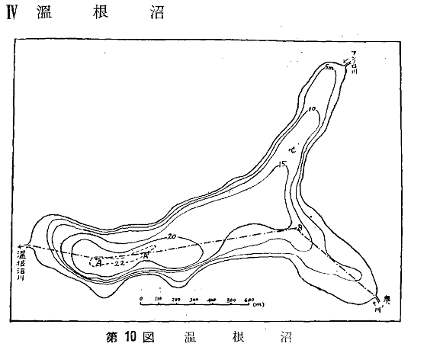
Fig. 1.1. Valentina’s Lake (Onne Lake) and its depth, m (Takayasu et al., 1955, p. 199)

Table 1.3
Water temperature and gas composition at different depths in the Valentina’s Lake in July 1936
Depth, m | 0 | 3 | 6 | 9 | 12 | 15 | 16 | 17 | 18 | 19 | 20 | 21
T º C | 12.9 | 12.3 | 11.4 | 10.2 | 10.0 | 4.9 | 3.9 | 3.6 | 4.0 | 4.0 | 4.2 | 4.3
pH | 7.05 | 6.7 | 6.5 | 6.5 | 6.6 | 6.35 | 6.45 | 6.4 | 6.45 | 6.65 | 6.7 | 6.75
CO2, mg / l | 2.52 | 2.16 | 3.12 | 3.32 | 3.56 | 5.08 | - | 11.2 | 11.9 | 21.1 | 22.1 | 60.6
O ₂ , ss / l | 6.98 | 7.01 | 6.92 | 7.04 | 7.02 | 3.01 | - | 0.07 | 0.39 | - | - | 0

According to the Japanese data, the list of fish in the Valentina’s Lake consisted of only 4 species: Dolly Varden trout, chum salmon, pink salmon, Sakhalin taimen. It is noteworthy how short the list is, as well as the absence of white-spotted char, which is numerous in all lakes.
As far as zooplankton is concerned, five species of crustaceans were registered in the Valentina’s Lake: two species of Rotatoria, two species of Copepoda, and one species of Cladocera.
The phytoplankton of the lake was represented by 23 species.
Peschanoe Lake. The data for the Peschanoe Lake (Fig. 1.2, 1.3: Table 1.4) are given only for comparison with the Valentina’s Lake, since in terms of area it is the largest on the Kunashir Island and is similar to the Serebryanoe lake. However, its study was not within the scope of the present work.
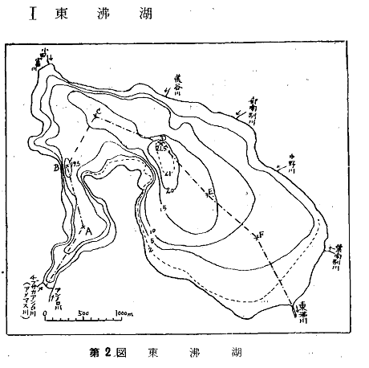
Fig. 1.2. The Peschanoe Lake (Tofutsu Lake) and its depth, m (Takayasu et al., 1955, p. 171)

Table 1.4
Water temperature and gas composition at different depths in the Peschanoe lake in August 1935
Depth, m | 0 | 1 | 2 | 4 | 6 | 8 | 10 | 12 | 14 | 16 | 18 | 20
T ^{about} C | 18.9 | 18.6 | 18.0 | 17.9 | 17.9 | 17.8 | 17.1 | 17.7 | 17.7 | 17.6 | 17.6 | 17.5
pH | 8.85 | 8.8 | 8.25 | 7.7 | 7.4 | 7.35 | 7.2 | 7.1 | 7.05 | 7.05 | 7.0 | 7.0
CO2, mg / l | 0 | - | 0.5 | 0.9 | 1.3 | 1.64 | 2.56 | 2.5 | 2.86 | 3.1 | 3.1 | 3.14
O ₂ , ss / l | 6.75 | - | 6.3 | 5.98 | 5.68 | 5.46 | 4.47 | 4.31 | 4.14 | 4.07 | 4.0 | 3.74

According to the Japanese data, the list of fish in the Peschanoe Lake consisted of 11 species: Dolly Varden trout, white-spotted char, Chum salmon, Masu salmon (cherry salmon), Pink salmon, Sakhalin taimen, smelt Osmerus olidus, big-scaled redfin Tribolodon hakonensis, three-spined stickleback, nine-spined stickleback, floating goby Chaenogobius. However, the information on the Sakhalin taimen was dated as of 1943, when only one specimen of this species was found in the mouth of the Peschanoe Lake. That is, in the 1930s-1940s, according to the Japanese, the Sakhalin taimen was observed rarely in single specimens on Kunashir Island, and annually.
Macrobenthos is represented by shrimp Leander pawcidens, cockscomb pearl mussel Cristaria plicata, and the Japanese mitten Crab Eriocheir japonica.
As far as zooplankton is concerned, 13 species of crustaceans from the families Rotatoria, Copepoda, Cladocera were registered.
The phytoplankton of the lake was represented by 20 different species.
It is necessary to note the meticulous approach taken by the Japanese biologists to carry out hydrochemical studies. These data provide a good chance to get some hints to analyze the distribution of hydrobionts, for example, the food supply for the Sakhalin taimen, in the water area of the lakes. Below are pictures that reflect the situation in the lakes during the warmest time, when the water is warmed up to the maximum. It can be seen that the Peschanoe Lake warms down to the bottom, in contrast to the Valentina’s Lake, where at depths of more than 12 m the water temperature no longer reaches 5.0 º C. The difference of the oxygen content in the Peschanoe lake at the bottom and at the surface is almost twice, while in the Valentina’s Lake at a depth of more than 15 m, there is almost no oxygen. In the Valentina’s Lake at a depth of more than 16 m, there is a very high content of CO ₂: from 11 to 60 mg / l.
It can be concluded that on the Kuril Islands and Hokkaido Island, the abundant populations of the Sakhalin taimen and their reproduction historically formed in large freshwater lakes of lagoonal origin. Hokkaido has the following lagoons: Sarufutsu, Koetoi, Bekanbeushi; Iturup: Slavnoe Lake; Kunashir: Valentina’s and Serebryanoe lakes.

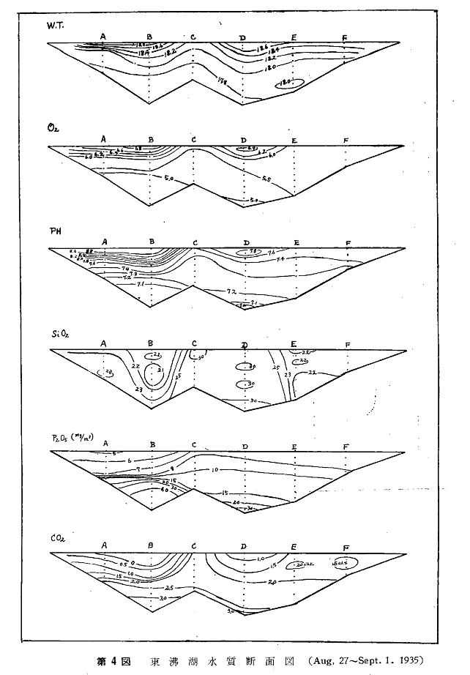
Fig. 1.3. Indicators: WT water temperature (^{о} С), О ₂ oxygen content (cc cm/l), pH, SiO ₂ , P ₂ O ₅ , CO ₂ ( mg / l ) in the Peschanoe Lake on August 27 – September 1, 1935

Below are also some modern data on the lakes of Kunashir Island provided by Russian specialists (Table 1.5).
Table 1.5
Data of Russian biologists on the lakes and rivers of Kunashir Island (Pichugin, Sidorov, 2005)
Name | Type | Water temperature, º C , maximum | Depth, m | Bottom
Peschanoe Lake | Lagoon | 16-17 | 0.5-22.0 (12.0) | In the middle part there is gray silt mixed with sand. In the coastal areas there are rocky-sandy or sandy soils.
Serebryanoe Lake | Lagoon | 18-19 | 0.5-1.7 (1.0) | Brown silts with a significant admixture of semi-decomposed plant debris
Serebryanka River | Semi-mountainous and flat | 18 | 0.5-2.0 | Stony silty bottom
Tyatina River | Mountainous and semi-mountainous | 7.0-9.0 | - | Rocky and pebbly with boulders protruding from the water. In the middle and lower reaches there are rocky and pebble spits.
Lake in the caldera of Golovin volcano | Volcanic | - | - | It is connected to the sea by a stream with waterfalls that are insurmountable for fish. There are no fish in the lake, but there are invertebrates.

However, it is necessary to mention that the Serebryanoe Lake is not of lagoonal origin, but of subsiding origin, that is, it presents simply a geomorphological depression (Makhinov, 2006). The profile of the bottom of Serebryanoe Lake is of a box type with the same depth over the entire area. Valentina’s Lake is also of lagoonal origin.
Water surface temperatures in the rivers and lakes of Kunashir generally coincide with the air temperature. Ice formation on rivers and lakes begins in late December – early January. As a rule, the rivers on Kunashir Island freeze only near the mouth for up to several tens or hundreds of meters if they flow through low-lying plains. The ice cover is smooth and continuous, the ice is crystalline. Ice breakup begins in the first ten days of April. The rivers are completely cleared of ice in the third ten days of April. There is no spring ice drift as the ice melts on the spot. A high degree of forest cover (about 60–85%) is an important factor that stabilizes heat exchange processes and reduces water consumption. Spruce, fir, birch, poplar, and alder grow in river basins; Kuril bamboo is common on the slopes of the hills.
Based on the materials of limnological studies of Japanese and Russian biologists, several conclusions can be drawn regarding the Sakhalin taimen on Kunashir Island. In the warmest time, in July-August, hydrochemical conditions at depths of more than 10 m in some lakes of Kunashir Island, for example, in the Valentina’s Lake (Onne lake), due to stratification, become unfavorable for the Sakhalin taimen. The water in other lakes is bitter and salty and is not suitable for habitation or as a winter habitat for the Sakhalin taimen. It is unfortunate that the data on the Serebryanoe Lake (Furukamappu Numa) are not available in the Japanese publication. Japanese hydrochemical data can be used as an argument in favor of the assertion that some lakes, even those where Sakhalin taimen have been observed, can serve only as a transit spot, rather than a feeding ground. Other lakes, including the Serebryanoe Lake, are shallow and highly productive. Here, water is heated and mixed together with the entire water column, without stratification. Such shallow lakes have quite favorable hydrochemical conditions for the Sakhalin taimen.
Modern archive data from fisheries (the regional department for fisheries and the conservation of aquatic biological resources of the Federal State Budgetary Institution “Glavrybvod”) and environmental organizations (the Kurilsky State Nature Reserve) have scarce data on the Sakhalin taimen on Kunashir Island.
Oral data from specialists of the Kurilsky Nature Reserve about watercourses where Sakhalin taimen was observed on Kunashir Island are as follows:
On Kunashir Island, the Sakhalin taimen was observed sporadically and not annually:
Mikhailovskoe Lake with a channel
Tyatina River
Peschanoe Lake
Lagoonnoe Lake
It was observed in large numbers and annually; spawning was observed
Serebryanoe Lake and the Triangular stream flowing into it;
The Serebryanka River and streams flowing into it: Luchevaya; Malaya, Vtoraya
Valentina’s Lake and the Polynova stream that flows into it;

On Iturup Island, the Sakhalin taimen was observed sporadically and not annually:
Sopochnoye Lake
Blagodatnoe Lake
Lebedinoe Lake
Kuibyshevskoe Lake
The Sakhalin taimen was observed in large numbers and annually; spawning was observed
Dobroe Lake

Chapter 2
Ecological requirements for the habitats in adjacent areas of Kunashir Island
The habitat area of the Sakhalin taimen is relatively small, it includes the basins of the northern part of the Sea of Japan and the southern part of the Sea of Okhotsk. Sakhalin taimen is a narrow-range species with a naturally small population. Over a long period of evolution, the species range has not expanded beyond the boundaries of the Sea of Japan due to the peculiarities of its biology: taimen prefers to migrate from the fresh water no further than estuaries and the estuarine coast. Oceanic (high) salinity waters are a significant barrier for it. The Sakhalin taimen do not migrate far into the sea, like the Pacific salmon. Its movements between fresh and salt water are similar to those of the chars – Dolly Varden and white-spotted char. As a rule, in the sea it stays directly off the coast. Large specimens stay longer in brackish or freshwater lagoon lakes as long as these lagoons are more closely connected to the sea.
A necessary condition for the Sakhalin taimen to inhabit the rivers is the presence of sections of multiple sub-streams in the channel with a slight slope, and on the coast – large bays or lakes of estuary origin, as on Kunashir Island, for example. Brackish-water lakes and tributaries of desalinated sea bays are favorable as marine feeding grounds for this species. Consequently, the Sakhalin taimen will avoid “pink salmon” rivers: with a straight channel, with a significant slope, flowing directly into the sea. It is also absent in large freshwater systems, such as the Amur, which liman (estuary) and the mouth are located hundreds of kilometers away from the potential feeding grounds of taimen.

Spawning on Hokkaido Island and in the coastal rivers of the Sea of Japan.
The author of this research report has taken part in a few fields works to study spawning grounds of the Sakhalin taimen in the coastal rivers of the Sea of Japan: mainland coast, Sakhalin Island, Hokkaido Island. In the rivers Samarga, Koppi, Tumnin, the Sakhalin taimen juveniles under the age of one year were found exclusively in the lower reaches, 40-60 km upstream of the confluence with the sea. The choice of the spawning site differs from Siberian taimen, which spawns in the upper tributaries of the river. However, according to the type of water supply, the spawning ground of the Sakhalin taimen is no different from the Siberian one: the same place of infiltration of the riverbed water into the understream. Spawning takes place in April-May, when there is still ice left in the channel (Fig. 2.1). The water temperature during the spawning period is about 5-8 º C. In the rivers of Hokkaido Island, the lower course of the rivers very often represents a channel with slabs lined along the banks. Spawning occurs in the upper reaches of the rivers in tributaries of the 1st and 2nd order. The spawning nest is located in the lower part of the reach in front of a rift or pit. Immediately after spawning, taimen migrate to the lower reaches of rivers or to feed in the sea.
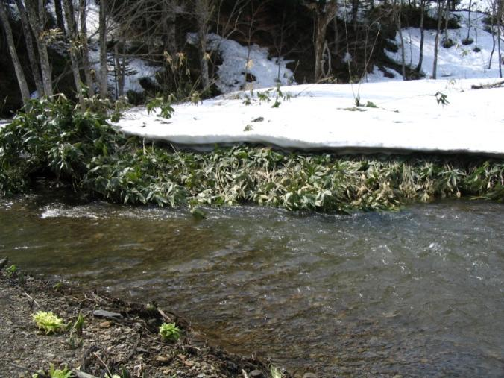
Fig. 2.1. Spawning site of the Sakhalin taimen. Sarufutsu River, Hokkaido Island, early May 2009. Photo taken by the author

On Hokkaido Island the harvest of post-spawning taimen is widespread, and in early May it traditionally attracts many amateur fishermen to the mouths of the rivers. Sakhalin taimen roe is incubated for about a month in conditions of increasing water temperature. Sakhalin taimen larvae do not migrate along the upper reaches of the rivers, but immediately find themselves in the area of a channel with multiple sub-streams, abundant with channels, bays and outlets of cold under-stream waters and a wide variety of food objects. Having quickly overtaken the growth of juveniles of eastern redfin, sculpins and smelts, juveniles of the Sakhalin taimen receive a diverse food spectrum. It should be noted that young taimen spend their first summer in the shallow waters feeding on benthos and terrestrial insects drifting in the water. The older of the juveniles choose areas with very weak currents in small channels, under sunken trees, in backwaters or oxbow lakes, where they lead a predatory lifestyle, adopting the behavioral strategy of an “ambush predator.” The distribution of immature taimen in rivers coincides with the boundaries of the habitat of Dolly Varden, white-spotted trout and redfin – their main food items. Juveniles of the Sakhalin taimen annually expands the range of their migrations along the river.
There is no information about the water supply of the spawning nest of the Sakhalin taimen (Leman, 2003). Spawning does not occur every year. A year before spawning some mature specimens are likely to spend more time in the estuary or in the estuary space of the native river abundant in food supply.
Ecological forms of migration of the Sakhalin taimen in the sea are not characteristic of all specimens, but depend on their physiological state in rivers of various lengths. It is known that the largest rivers of its range are 200-350 km long, and it is in these kinds of rivers that specimens more often demonstrate a river lifestyle, and only a small proportion of fish migrate to the sea. This fact was observed as a result of the standard analysis of the ratio of calcium and strontium (Ca - Sr) in otoliths. Specimens inhabiting small rivers, especially if they flow into lagoons or brackish lakes, often feed in the sea. In the short Sarufutsu River (about 40 km) in the north of Hokkaido, all taimen turned out to be anadromous. In similar tributaries of the Ainskaya lagoon (the western coast of Sakhalin Island), all taimen also turned out to be anadromous. Among those caught in the coastal area at the mouth of the river Tumnin (360 km), the otoliths of two taimen had only traces of strontium, since they had recently entered sea water, and the third otolith had already entered the sea more than once. All studied taimen from the river Koppi (218 km) turned out to be purely river fish!
The most famous example of a residential group of the Sakhalin taimen in Hokkaido is the basin of the rivers Ishikari on Hokkaido Island. Its tributary, the Sorachi, is dammed to form a long and narrow Kanayama Reservoir. Several tributaries flow into the reservoir, the basins of which retain good natural conditions. Taimen is still spawning in the tributaries of Kanayama Lake, where it has been spawning historically. Even after the creation of a reservoir, taimen do not spawn in the tributaries, where spawning of taimen has never been observed. Taimen spend winter in the Kanayama Reservoir, and in the spring, they run along the river Sorachi (1st order tributary) and its tributaries (2nd order tributaries Koyanozawa, Shiisorapuchi) to spawn there (Fukushima, 2001; Edo, Kawamula, Higashi, 2000). The presence of the dam in Sorachi river makes it impossible for this stock group to migrate to the river Ishikari or to the sea. Anadromous groups of taimen exist in other tributaries of Ishikari, but in terms of the number of specimens they are much smaller than in Sorachi river.
These data confirm that the species has 3 ecological forms throughout its range:
- Anadromous, which run into the sea to feed, but does not go far from the mouths of the rivers.
- River, spending the entire life cycle in large rivers or in reservoirs cut off by dams.
- Lagoon, migrating in the river, but not further than the brackish waters of the estuary.

Seeing that on Kunashir Island the rivers are small in extent, but yet the Sakhalin taimen were caught there, as well as in the mouths of the rivers flowing into the sea, it can be assumed that this area is inhabited by the anadromous form of the Sakhalin taimen. There are possibly two other ecological forms, but it requires further studies.
Homing. Japanese and American experts studied the spawning of taimen in the Sarufutsu and Karibetsu rivers in the north of the Hokkaido Island in order to create a strategy for the protection and homing of its local populations (Zimmerman et al, 2012). Both rivers flow from relatively undisturbed, gently sloping hills 300-400 m high, densely overgrown with coniferous and deciduous trees, with bamboo plant dominating the forest. That is, the living conditions of taimen there are very similar to those of Kunashir Island. The scientists installed five receiving antennas in the river Sarufutsu that record the run of taimen with PIT (passive information tag) along the riverbed. In the upper reaches of the river Karibetsu (a spawning tributary of the Sarufutsu River) 5 more receivers with antennas were installed. PIT tags were attached to fish that had previously been measured (body length, weight, age and sex). Over several years of monitoring, it turned out that all Sakhalin taimen in the Sarufutsu river system is anadromous (Rand and Fukushima, 2014; Fukushima and Rand, 2021). The Karibetsu river hosts a group of 335-425 spawning Sakhalin taimen each spring, which is approximately one third of the total spawning group of the species in the Sarufutsu river system. The age of first migration to the sea varies widely from 2 years to >10 years. Anadromous specimens, however, migrate no further than estuaries or a few kilometers from river mouths. The reproduction rates and the success of the homing are critical in defining the life-long reproductive strategy of salmon that spawn multiple times in a lifetime. Using the Sakhalin taimen as an example, the scientists concluded that salmon offspring survive better in the habitat areas favorable for incubation and growth of juveniles, thereby maximizing the reproductive success of their parents and maintaining population-specific adaptation to this place. Consecutively spawning Sakhalin taimen and other salmon, such as char and salmon, in contrast to the Pacific salmon (genus Oncorhynchus) that spawn only once, can maximize their reproductive success over a long evolutionary time. The Hokkaido example has shown that the average frequency of successive return of mature Sakhalin taimen to their former spawning grounds (homing) was 69.5%, which is the highest ever recorded for multiple spawning salmonids. Consistent return rates were highest for the largest Sakhalin taimen parents.
Thus, the data on the biology and high level of homing of the Sakhalin taimen confirm that this species are focused on limited migratory activity, using the same sections of rivers for reproduction, which defines the species as a K-strategist. In the conditions of Kunashir Island, these characteristics of the Sakhalin taimen will manifest at least in the fact that the list of watercourses and lakes visited by this species is limited; and we can say with confidence that if the Sakhalin taimen has never been recorded in certain basins, that means they have no conditions either for feeding or for reproduction. And vice versa, if the Sakhalin taimen were observed in certain basins, that means you can find its feeding grounds and (or) spawning tributaries here.
According to the experts (Sokov, 2000), the Sakhalin taimen in the Serebryanoe Lake does not differ in biological indicators from taimen in Sakhalin or Hokkaido Islands. With age, its migration area expands, and the following life strategies and behavior are observed:
At age 0+ it is non-migratory benthophage inhabiting the areas near the spawning streams;
At the age of 1+ it is a benthophage inhabiting spawning streams;
At the age of 2+ to 4+ it is a benthophage leaving the spawning streams and migrating to the Serebryanka River and Serebryanoe Lake;
At the age of 5+, it is still a benthophage (main food is amphipods), but in spring it is a predator (stickleback, smelt), migrating in the Serebryanoe Lake, Serebryanka River and in its seaside estuary;
At the age of 7+ - 8+, this species reaches maturity and the fish leave fresh water to migrate to seawater. Before spawning, it goes to feed in sea waters and returns to the river Serebryanka after the ice melts at a temperature of 4 º C;
Mature specimens are active migrants (especially in spring) within the population range. During the marine feeding period, they are observed in coastal areas up to 50 km from the mouth of the river Serebryanka, during the river feeding period – in the river Serebryanka and in the Serebryanoe Lake, during the spawning period – in the streams Luchevaya, Triugolny, Malaya, Vtoraya.
The count of taimen in the Sarufutsu River. The main task was quite simple – to count the Sakhalin taimen spawners in the main tributary of the Sarufutsu River basin. High-tech equipment was used – an acoustic sonar that emits and absorbs 128 narrow sound beams. This sonar allows to get a high-quality picture thanks to sound alone. One of the advantages of this device is the ability to obtain images in murky water and at night. The sonar software allows to process the data in just 2 hours. The taimen runs ascends the fish gates and swims through the sonar beam. So, this is how taimen is registered, and then it runs a couple of kilometers further to the spawning ground. Taimen spend about a week in the spawning streams, and after spawning, at the end of May and June, they descend to the lower reaches of the river and the estuary. In the first year of counts (2013), 335 taimen spawners were counted, which was three times more than our estimated number. In 2014, the sonar has already counted 399 specimens! During the spawning migration period on April 29, an unprecedented run of 148 specimens was recorded within just 8 hours! This tributary accounts for about 1/3 of the total spawning area in the Sarufutsu River Basin (the last natural habitat of this endangered species in Japan), so the total spawning stock of this river, according to our estimates, is about 1000-1200 specimens.
Taimen abundance. This study indicates that the taimen population in this tributary is quite numerous and healthy. Based on a survey of spawning mounds last year, we came to the conclusion that most of the suitable spawning grounds in the tributary are used by taimen. The Sarufutsu River is likely to have the largest population of taimen in all Japan – the situation in the other few “taimen” rivers in Hokkaido Island is desperate.
Critical factors of the Sakhalin taimen life cycle (the case of rivers on Hokkaido Island)
Forestry. There are two types of forest management in the Sarufutsu River basin: public (national lands) and private (owned by the Oji company). In recent years, there has been no deforestation on the lands owned by the Oji company. However, with state lands it is a completely different story: I was shown a fairly large area where timber was harvested. We also saw a logging road crossing the river. Only last year, stricter rules were established in the buffer zones on the territory of Japan's national lands, which now extend to 30 meters along water bodies inhabited by fish. The discovered road and timber harvesting site were violations of the new rules, which our Japanese colleagues reported to the relevant authorities for monitoring and further action. Logging activities have also been observed in the Kamisarufutsu River (at the source of the Sarufutsu River). This section was cut down last year which previously used to be a wetland and floodplain that was used to collect and store timber from the higher sections of the forest.
There is no commercial logging on Kunashir Island.
Excessive water temperature. In 2013, the taimen run was divided into a few periods as a result of a sharp cold snap in early May, which resulted in a slowdown of taimen run. In 2014, the run was divided again, but this time due to a sharp melting of snow, which led to a significant increase in water levels at the end of April. In 2014, the spawning run began and ended earlier than in 2013.
The local resident Mitsuru Kawahara from the organization “Sarufutsu Ito no Kai” (friends of the Sarufutsu taimen), a conservationist, has found a total of about 40 dead fish in the Sarufutsu River system since early August (Figure 2.2). There was a smell of rot in the river, and the bones of these large fish, after being eaten by animals, were scattered around. He also found live specimens, but clarified: “Some of the fish were weak and got into the eyes only because they floated to the surface”.
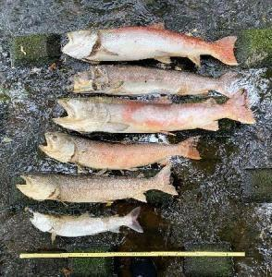
Fig. 2.2. Dead Sakhalin taimen in the Sarufutsu River

Many dead Sakhalin taimen were found in the rivers in the Soya region of northern Hokkaido in the summer of 2021. According to the experts, it is very possible that the oxygen deficiency occurred due to a record-breaking increase in water temperatures due to a heat and drought caused by a lack of rain. Local conservation groups are also urging against fishing until river levels return to the normal.

Chapter 3
The history of formation and current state of Sakhalin taimen habitats on Kunashir Island
The evolutionary age of the Sakhalin taimen is about 40 million years. There is no doubt that, considering the last 20 thousand years, we can be sure that the Sakhalin taimen has inhabited the area within the boundaries of its modern range. During the last glacial maximum about 18 thousand years ago, in and around Japan, glaciation was less developed than in other areas; the shapes of land bridges and river basins were influenced by sea level regressions and transgressions. During glacial maximum, sea levels were lower, and land bridges connected the Kuril Islands, Japan and South Korea. At the most recent minimum, sea level was approximately 125 m lower than present. At low levels, the Seas of Japan and Okhotsk were shallow and most likely closed. All this created unique conditions favorable for masu salmon and char – Dolly Varden and white-spotted char and, of course, for Sakhalin taimen (Augerot et al, 2005).
The global warming on the planet at the end of the Pleistocene epoch (15-12 thousand years ago) resulted in the melting of glaciers and permafrost. This led to a catastrophic rise in the level of the World Ocean, which reached its peak about seven thousand years ago. For five thousand years, the ice shield of Eurasia has melted, and the water in the oceans has risen by more than hundred meters. In the so-called boreal period of the Holocene, six and a half thousand years ago, the ocean level was three meters higher than today. The death and reduction in the number of large animals against dramatic climate swings and landscapes alteration led to a series of ecological crises that followed one after another for several thousand years. For example, in the East and Northeast Asia, this has led to the formation and expansion of Tsushima, Shimonoseki, La Perouse, Izmena and First Kuril straits. The Kuril Ridge islands got separated from Kamchatka and Hokkaido and split among themselves. About eight thousand years ago, that is, in the sixth millennium BC, a strait appeared between Sakhalin and the mainland. Sakhalin again became an island, that it used to be long before the Ice Age. About six thousand years ago, a gradual decrease in the level of the World Ocean began, as a result of which the modern landforms were formed (History ..., 2018; Augerot, 2005).
Over the entire multimillennial history, the Kuril Islands were part of a huge land bridge connecting Asia and America. Regressions and transgressions of sea level periodically flooded or dried out island territories. Based on the geological history, the ichthyofauna of the southern Kuril Islands was formed under the influence of the ichthyofauna of the Hokkaido Island. The South Kuril Island ichthyofauna represents a remnant of the species biodiversity that previously existed in ancient adjacent territories (Sidorov, Pichugin, 2005).
Most of the lakes of Kunashir Island are of lagoon origin. It is in lakes of this type, usually shallow and warm, that taimen are most often found. These are the remains of the former sea bays or straits (Korsunskaya, 1958). They were separated from the sea gradually; for a long time, their level and water composition were influenced by tidal currents. At a later stage, the flow of water into the sea was carried out through a narrow channel or river, and the lakes were gradually desalinated by the river waters flowing into them (Klyuchareva, 1967). The island has lakes of the following types: caldera, crater, lava-dammed, lagoon. Six lakes are located on the territory of the Kurilsky nature reserve. The largest of the lakes in the island is Peschanoe Lake. Kunashir lakes are characterized by a high abundance and biomass of freshwater shrimp and large mollusks, both bivalves and gastropods. The maximum water temperature in shallow lakes (Lagunnoe, etc.) in July-August can reach 18-20 ^{o C.} The Tyatina River is the largest and longest river on Kunashir Island. It flows down from the slopes of the Tyatya volcano, feeding from its glaciers, and therefore is one of the coldest on Kunashir Island. The maximum water temperature in this river in August is 14-15 º C, and the minimum in February is 1.8 º C (Sidorov, Pichugin, 2005).
Under these conditions, the tributaries of lagoon lakes, streams and rivers, turned out to be the most stable and weakly changed systems over thousands of years. They became areas of reproduction for char, the Pacific salmon and the Sakhalin taimen. Other systems of insular water basins underwent severe changes: the feeding grounds in lagoon lakes either disappeared into the sea water or dried up. Undoubtedly, under such conditions, for thousands of years the Sakhalin taimen groups were disappearing and then reappearing again as a result of straying from the nearest areas: southern Sakhalin and northern Hokkaido.
On Kunashir and Iturup Islands, some anadromous species demonstrate the ability and tendency to form races, ecological forms, and stock groups that are not found in the larger rivers of Sakhalin Island and the mainland. L.K. Sidorov and M.Yu. Pichugin note that “…significant reproductive variation: timing of spawning and spawning migrations of anadromous sticklebacks of the genus Gasterosteus, together with morphological differences in distinct populations in different lakes; the formation of residential and lake forms from anadromous forms of redfin of the genus Tribolodon, – leads to the conclusion that these species on Kunashir and Iturup Islands have increased homing, like that of salmon (Sidorov, Pichugin, 2005). The presence of a lacustrine ecological form and the autumn-winter form of “monaco” chum salmon, the presence of residential forms of white-spotted char, Dolly Varden trout and sockeye salmon are indicative of the adaptation and the favorable influence of local conditions on evolutionary processes in the formation of local stock groups of anadromous salmon in small lake basins on Kunashir and Iturup Islands. There is no doubt that the Sakhalin taimen did not stand aside from these processes, and its stock groups over the past millennia have been adapted to the local conditions in the lakes, to the limited spaces of their habitat.
Modern landscapes in the places of the Sakhalin taimen reproduction are sections of the riverbed with multiple sub-streams in the low-gradient uplands, overgrown with spruce forest, birch forest and alder. Unlike the mainland forests, there are no large areas of burnt areas affected by wildfires – due to the presence of the evergreen bamboo saza (Sasa kurilensis). There are groups of trees damaged by spruce bark beetle. The bark beetle eats the bast of living trees, which lead to the trees drying out. The mouths of streams are located in meadow lowlands several kilometers wide. Juveniles of masu salmon, white-spotted char and taimen prefer the multi-channel bed of short streams. These places also represent the reproduction zone of the Sakhalin taimen: its spawning grounds are located in the coniferous forest zone, in the meanders of spawning streams, the length of which is 5-10 km. Spawning stream Triangular – the lowest in the Serebryanoe Lake. There are no spawning grounds above the Triangular stream. Two more streams are located below the Serebryanoe Lake and flow into the river Serebryanka.
Intact landscapes are dominant around the Serebryanoe Lake. The water in the tributaries of the lake is clean and drinkable. The Serebryanoe Lake is a feeding reservoir for the Sakhalin taimen. It is shallow, warms up well in summer (up to 20 ° C), and in winter the water temperature does not fall below 2⁰ C. The lake is rich in food objects for Sakhalin taimen of different ages: gammarus, freshwater shrimp, gobies, sticklebacks, redfins.

Chapter 4
Stock groups of the Sakhalin taimen on Kunashir Island
At the beginning of the 21st century, geneticists proposed a short and very clear definition: “A population is a collection of specimens whose ancestors lived in similar conditions for a long time and reproduced within a community” (Zhivotovsky, 2016, p. 324). Based on the long experience of genetic studies, a two-stage approach has now been proposed to study the population structure of a species, based on the integrated use of ecological, geographical and genetic data: first, eco-geographic units are distinguished relevant to the environmental components and types of life strategies, and only then these identified eco-geographic units are tested genetically (Zhivotovsky, 2016, p. 323). Emphasizing the high efficiency of this approach, Zhivotovsky notes that “despite the impressive achievements in genetics, the role of field biological, biocenotic and geographical and other studies on the formation of species population does not decrease, but increases” (Zhivotovsky, 2016, p. 331; Zhivotovsky, 2017). Thus, with all that in mind, we should look at the situation with the population structure of the Sakhalin taimen on the Kunashir Island.
It is known that the real reasons for the long-term stability of the Sakhalin taimen population, as well as other salmon species, probably lie not only in the large area of the spawning ground. According to the principle of gradual environmental change introduced by G.M.F. Knapsack – the more smoothly the environmental conditions in the biotope change, and the longer it remains unchanged, the richer and the more balanced and stable the biocenosis is (Reimers, 1990, p. 403). The Kuril Islands, however, are not an area with smooth changes or invariable environmental conditions. This is a place with a limited area, changing as a result of regressions and transgressions of the ocean, as well as under the influence of volcanic activity. The life strategy of the species, inhabiting a limited area of lagoon lakes and short rivers, is a minimal migratory activity. Despite the fact that the Sakhalin taimen is an anadromous species, it does not go far into the sea from the river mouth.

Competition with other species and its factors
In the limited habitat spaces, water temperature plays a very significant factor. Let's consider the relationship between the Sakhalin taimen during the feeding period in lagoon lakes and the two most numerous species of salmon: white-spotted char and Dolly Varden trout. L.K. Sidorov and M.Yu. Pichugin noted that “... the main factor determining the species composition and the ratio of salmon species in terms of the number of specimens is the maximum summer water temperature in the reservoir. Dolly Varden outnumbers at 12-13 º C, and white-spotted char predominates 14-16 º C”. During the summer (for example, Lake Peschanoe, Kunashir Island), the ecological niche of the Sakhalin taimen is occupied by white-spotted char in these cool lakes. The Sakhalin taimen inhabits those water systems, which include large shallow lakes, where the temperature in summer reaches 18-20 º C. Immature taimen juveniles at the age of 3+-5+ years stay in these lakes. L.K. Sidorov and M.Yu.Pichugin believe that “... the warm lakes of the islands of Kunashir and Iturup thus reduce competition among salmon, and this ensures the survival of the relic Sakhalin taimen”.
Some researchers support the theory that the taimen's tendency to inhabit relatively warm lake waters casts doubt on the existence of permanent populations of the species in the rather cold lakes such as Slavnoe Lake or in the Tyatin River, in the basin of which there are no lakes at all, and the number of river Dolly Dolly trout is quite high. According to D.V. Sokov (2000), stable populations of the Sakhalin taimen exist only in the Serebryanoe and Valentina’s lakes. At the same time, in a colder and not polluted Valetina’s Lake, the number of taimen is less than in the more polluted Serebryanoe lake. It is assumed that the population of the Sakhalin taimen in the cold Valentina’s Lake is regulated by competitive relations with the Siberian taimen. The Serebryanoe Lake in the summer-autumn time is not available to white-spotted char due to the high temperature of the water. Such conclusions about a small number of stock groupings of the “one watercourse – one population” type are unfounded, and there is no reason to rely on them. After all, with environmental changes, the ratios of species and the strength of competition between them will change as well. Only geneticists may have arguments about the stability of the Sakhalin taimen stock groups living on Kunashir Island.
To find legally indisputable evidence for the existence of the Sakhalin taimen populations on Kunashir Island, it is necessary to allocate their stock units. The main requirement for each of the stock units is the population independence from other stock units of this species (Zhivotovsky, Smirnov, 2018).
L.A. Zhivotovsky and B.P. Smirnov (2018) point out that for a legally significant allocation of salmon stock units in Sakhalin, it is necessary to carry out their detailed certification, i.e., collect hydrological and biological data on all spawning rivers and all populations, both hatchery and wild. The objects of certification should be both commercial salmon species and rare and endangered species. In addition to the data on the abundance, catch, escapement level in the spawning grounds, density of juveniles in the coastal area, etc., each population must be described by size and weight characteristics, fertility and fatness indicators, etc., as well as its genetic passport based on DNA markers. Unfortunately, no one has done this for the Sakhalin taimen. The only information about the possible existence of groups of Sakhalin taimen on Kunashir Island we know from the conversations with amateur fishermen and from scientific publications, which have historical rather than biological significance.
Data from genetic studies
Researchers usually experience lack of materials on rare species, especially from remote places. Fortunately, geneticists L.A. Zhivotovsky and A.A. Yurchenko and biologist D.V. Sokov managed to collect samples of the Sakhalin taimen on the islands of Kunashir and Iturup. The results of sample analysis were compared with similar materials from the rivers in Hokkaido, the coasts of the Sea of Okhotsk and the Sea of Japan of Sakhalin Island, and the rivers of the mainland coast of the Sea of Japan.
According to the results of L.A. Zhivotovsky et al., the degree of genetic differences (Fst) of the Sakhalin taimen in Valentina’s Lake (Kunashir), Sarufutsu (Hokkaido), and Aniva Bay (southern Sakhalin) rivers are about 0.11, which is a relatively high value. However, this value is smaller than Fst between the populations of Kunashir and Iturup (0.23 - 0.31): this difference is large.
“The study has shown that the genetic structure of the Sakhalin taimen is formed by highly differentiated local populations in distinct water bodies with possible micro-geographical differentiation in the distinct spawning streams and tributaries of rivers and lakes. Despite the high level of differentiation between populations, they are grouped in individual geographic ecoregions (northeastern Sakhalin, the Poronai River basin, Iturup Island, northwestern Sakhalin, the mainland part of the species range) and are possibly related by migrations within them. The hypothesis of long-term isolation of zoogeographic groups of populations is not supported by phylogeographic data”. (Yurchenko, 2015, P. 119)
As for the Kunashir Island, the researchers note that “...unfortunately, it is difficult to say with confidence about the populations of Hokkaido and Kunashir – there are only two data samples, which tend towards the heterogeneous group of southern Sakhalin, given their geographical proximity (Yurchenko, 2015, p. 84).
Thus, the authors of genetic studies admit that the stock groupings of Kunashir Island (their population is still unknown), as the closest to Hokkaido, are part of a single population within the boundaries of southern Sakhalin and northern Hokkaido. Taimen of Iturup Island, according to geneticists, belong to a different stock group.
What was the mechanism that governs such an unusual life cycle in the K-strategist of the Sakhalin taimen? Undoubtedly, by different spawners – the founders of stock groups. A.A. Yurchenko believes that the population & genetic structure of the Sakhalin taimen is hierarchically organized with high values of genetic differentiation within populations. The divergence of stock groups (observed by the frequencies of DNA nuclear markers) is caused by the low number of spawners and the limited migrations between groups, which is determined by the natural and geographical conditions of habitat, rather than by long-term isolation in glacial refugia or in modern habitats.
One can not but notice the difference in the terminology used by the authors of genetic studies of the Sakhalin taimen in the Kuril Islands: groups, groupings, local populations, population groups, and even populations. For this reason, in what follows, we will roughly assume that the Kunashir Island is inhabited by stock groups of the Sakhalin taimen from the once common ancient population of Kunashir, Hokkaido and southern Sakhalin islands.
To clarify the situation, it is necessary to:
- To collect samples of genetic material (fragments of pectoral fins from juvenile Sakhalin taimen from spawning tributaries of Serebryanoe Lake and Valentina’s Lake).

Chapter 5
Data on the fisheries impact
Fisheries in the Kuril Island were likely to be poorly regulated until the 21st century. Back in 2005, ichthyologists at Moscow State University noted that “... even the existing scientific developments have not been introduced into the daily practice of fisheries and fish farming: the number of spawners and the escapement level in the spawning grounds are not estimated even in control reservoirs, fishing is carried out carelessly, “leaving too much on chance” and the harvested fish that did not get into the refrigerator goes to waste or is just thrown away. The poaching is very common, targeted only on salmon roe. This is perhaps the only way for the unemployed population and border guards to earn money. The economic and social development of the islands, apparently, is not included in the immediate plans of the state” (Sidorov, Pichugin, 2005).
It should be noted that everything said by the ichthyologists of Moscow State University in 2005 did not apply to the Sakhalin taimen. On the Kunashir Island the situation has been changed a lot since 2005, and the impact of commercial fishing on the Sakhalin taimen has not been observed at all. However, 20 years ago, amateur fishing of white-spotted char with gill nets in the lakes of Kunashir Island has made a negative impact on the catch of taimen, and is now considered as a bad example.
Commercial fishing on Kunashir Island
The UKRK enterprise harvests fish stocks on Kunashir Island. Its fishing grounds are located throughout the island (Figure 5.1). This fishery uses fixed nets. The main fishing targets are pink salmon and chum salmon. In 2017-2022 total catch of pink salmon on the Pacific side of the Kunashir Island was up to 9.04 tons, chum salmon up to 331.04 tons; on the Sea of Okhotsk side – pink salmon up to 144.4 tons, chum salmon up to 1410.4 tons. Their fishing is carried out in the summer, when the migratory activity of the Sakhalin taimen is reduced. Bycatch of taimen by the fixed seine is rare.
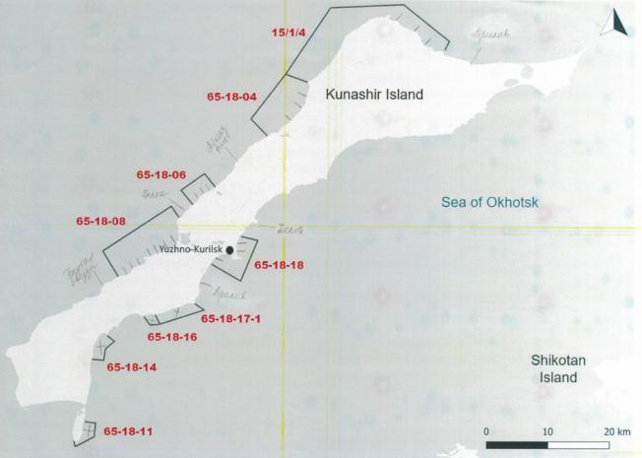
Fig 5.1. Scheme of fishing parcels of YKRK on Kunashir Island (Pacific salmon fishing).

The by-catch in the sea seines by YKRK was studied by VNIRO specialists in 2022. In total, during the observation period in 2022, representatives of 9 families, 10 genus, 12 species were present in by-catch. River fishing parcel RPU 65-18-08, located on the Okhotsk sea side of the Kunashir Island in Pervukhin Bay was characterized by a bycatch diverse in fish species. At RPU 65-18-18, in Golovnin Bay, where the river Serebryanaya flows into, only one species was observed in the by-catch – starry flounder.
The list of fish in the by-catch by marine fixed nets consisted of marine species. The only anadromous fish in the list is the white-spotted char:
Fish species in by-catch in the chum salmon fishery (Tochilina, 2022, pp. 9-10)
Salmonids Salmonidae Cuvier, 1816 Loaches Salvelinus
White-spotted char, S. leucomaenis (Pallas, 1814)
Stichaeidae Gell, 1864 Askoldia Ascoldia, Ascoldia variegata knipowitschi (Soldatov, 1927)
Skates Rajidae, scates Bathyraja
Alaska skate Bathyraja parmifera (Bean, 1881)
Bottom skate Bathyraja bergi (Dolganov, 1985)
Greenlings Hexagrammidae Pleurogrammus Pleurogrammus
The Okhotsk Atka mackerel P. azonus (Jordan & Metz, 1913)
Coryphaenidae, common dolphin-fish Coryphaena C. hippurus (Linnaeus, 1758)
Mackerels Scomdridae, Tuna Thunnus, The Atlantic bluefin tuna Thunnus thynnus (Linnaeus, 1758)
Flatfish Pleuronectidae, Winter flounders Pseudopleuronectes
Cresthead flounder P. schrenki (Schmidt, 1904)
Yellow-striped flounder P. herrensteini (Jordan & Snyder, 1901)
River flounders Platichthys
Starry flounder P.stellatus (Pallas, 1787)
The sculpins Cottidae Kerchaks, or sea sculpins Myoxocephalus
Steller's sculpin, M. stelleri (Tilesius, 1811)
Pufferfish Tetraodontidae, Fugu puffer Takifugu
Purple puffer T. porphyreus (Temminsk & Schlegel

Commercial fishing on the Hokkaido Island
According to the Japanese research data, the by-catch of the Sakhalin taimen in the commercial fishing by gears installed on the coast of the Hokkaido Island, was not observed.

Recreational and sport fishing
Hokkaido
Taimen count results in the Sarufutsu River (Hokkaido Island) has shown that 1000-1200 adult taimen inhabit this river, and annually, about 1200 amateur fishermen catch fish there, and at least one taimen is caught by one amateur fisherman. Usually almost all captured taimen are released into the river more or less intact. It is likewise that numerous immature specimens of taimen are also caught, and the Japanese are well aware that even a few unscrupulous fishermen can cause irreversible damage to the entire population! Fishermen pump lots of money into the local economy. The introduction of new regulations on sport and recreational fishing depends entirely on the local authorities, which play a key role in the environmental legislation. The Japanese, recognizing the value of taimen as the oldest salmon species, pay special attention to the creation of basic rules (or at least voluntary principles) for catching taimen in order to protect it from overfishing as a result of recreational activities.
In all habitats of the Sakhalin taimen in Russia and Japan, both legal catch-and-release fishing (on Hokkaido and in the rivers of the Tatar Strait of the Khabarovsk Territory) and poaching (IUU fishing) are unusually well developed. The reason is that the Sakhalin taimen is a large ‘trophy’ fish for all fishermen. The main task of the “Red Book species” stock management is to prevent any catch of Sakhalin taimen, and instead of bans, to turn the thriving IUU fishing of Sakhalin taimen into legal sport fishing under the “catch and release” system.
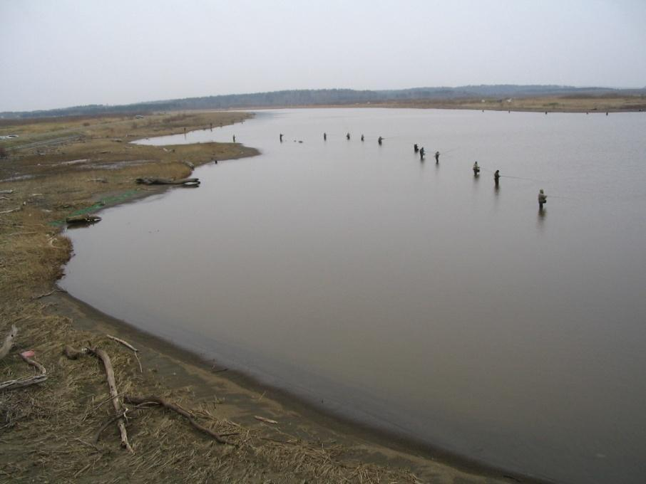
Fig. 5.2. Fishing of post-spawning Sakhalin taimen by spinning. The mouth of the river Sarufutsu, Hokkaido Island. May 4, 2007. Photo by the author
Amateur fishing throughout the range of the Sakhalin taimen causes significant damage to its populations. Catching post-spawning taimen on Hokkaido Island is widespread and attracts many fishermen to the mouths of Hokkaido rivers in May, using the catch-and-release system (see Figure 5.2). But ... in 57% of the river basins, where Hokkaido taimen used to be observed earlier, it has almost disappeared (Edo, 2001).
Kunashir Island
There is no documents and publications on the current state of amateur and sport fishing of taimen.

Chapter 6
Field research
Research material and methods
The data was collected by sampling Sakhalin taimen in the spawning streams; survey data were obtained during the field research on Kunashir Island in May 2023 from amateur fishermen, local fisheries specialists, employees of the Kurilsky State Nature Reserve, professional fishermen of the YKRK.
Names of the rivers and lakes are given as they are indicated in the Fishery Passports by the South-Kuril District Department for Fisheries and Conservation of Aquatic Biological Resources of the Federal State Budgetary Institution “Glavrybvod”.
A map-scheme of the study area is shown in Fig. 6.1:
Fig. 6.1. Map-scheme of the surveyed watercourses, the habitats for the Sakhalin taimen on Kunashir Island in 2023

Taimen sampling in the spawning streams was carried out every 30-50 m by a net, in all biotopes: a stretch, a pit, a riffle, a coastal slope. The fish were observed mostly in the coastal slopes of the riverbed.
In the Malaya (Pionerskaya) stream, the area from the river mouth to the point 44 º 03 12.7 N – 145 º 48 40.4 E along the riverbed was examined;
In the Triangular Creek, a section from the river mouth 44 º 03 28.8 N - 145 º 49 39.7 E to the point 44 º 03 43.9 N - 145 º 49 46.3 E along the riverbed was examined;
In the Bezymyanny Creek, a section from the river mouth 44 º 03 28.6 N - 145 º 49 29.5 E to the point 44 º 03 27.8 N - 145 º 49 24.1 E along the riverbed was examined;
In the Malaya Vtoraya Creek, the section from the river mouth 44 º 03 29.3 N - 145 º 50 36.6 E to the point 44 º 03 32.0 N - 145 º 50 40.4 E along the riverbed was examined;
In the Luchevoy Creek, the section from the river mouth 44 º 03 18.1 N - 145 º 51 15.6 E to the point 44 º 03 48.8 N - 145 º 51 14.6 E along the riverbed was examined.
In two sections:
- “The mouth of the Triangular Spring – the source of the river Serebryanka”
- “The river mouth of the Triangular Creek – mouth of the Malaya (Pionerskaya) Creek” by an electronic thermometer with a 2.0 m cable, water temperatures and depth were constantly measured while the boat was moving.

Geographical coordinates were obtained by GPS receiver Garmin 60 in WGS 84 system. An electronic device with a 2.0 m YSI cable Model 30 (Ohio, USA) and accuracy up to 0.1 ° C was used to measure water temperature and salinity.
A net made of 3 mm seine net with a 150 cm bag was used to capture juvenile fish. Such a net is similar in shape to the standard Kinalev ichthyological net but with an improved filtration coefficient due to the use of 3 mm seine net instead of a finer-mesh in the Kinalev net. The average sampling area was calculated during the trial sampling in the streams - tributaries of Lake Serebryanoe. It was 2.0 square meters.
The data of all sampling, including empty ones, were used to calculate the density of taimen specimens in the watercourse.

Field research trip to Kunashir Island on May 10 -17, 2023
Collection of the available data on the Sakhalin taimen of Kunashir Island from the local experts
Visit to the State Nature Reserve “Kurilsky” on May 11, 2023, Participants: Kisleiko A.A., director, Linnik E.V., researcher, Sokov D.A., researcher, Avdeeva A.A., employee of the YKRK, Korostylev S.N., and the author.
The presence of the Sakhalin taimen in the watercourses of Kunashir Island was discussed. Kisleiko A.A. reported that the Serebryanoe Lake is not within the boundaries of the Kurilsky Nature Reserve. However, there is some available data on it. Taimen is observed annually in the catches by amateur fishermen. In the tributaries of the Serebryanoe Lake Sakhalin taimen spawns 0.5 - 1.5 km above the mouth. D.A. Sokov reported that the basin of the Serebryanoe Lake has only 3 spawning tributaries: the Vtoraya Malaya, Triangular, Luchevaya streams. Valentina’s lake has only one spawning tributary: the Polynov stream. D.V. Sokov also reported that single specimens of taimen were caught by amateur fishermen in the Peschanoe, Lagunnoye, Mikhailovskoye lakes and in the river Tyatina. However, these sporadic catches over many years are really rare. Also, taimen are not observed in these watercourses in winter, in contrast to Serebryanoe and Valentina’s lakes, that are inhabited by taimen.
The archive of the Kurilsky Nature Reserve has two publications that mention the Sakhalin taimen on the Kuril Islands:
Pichugin M.Yu., Sidorov L.K., Lukyanov T.V. Study of the freshwater ichthyofauna of the southern Kuril Islands. – Research report. - VNIRO. - 2000-2001. 30 p.
Sokov D.V. Sakhalin taimen Hucho perryi (Brevoort) Regional studies journal. T 5.- 2000.- P. 333-335
Only the publication by D.V. Sokov has data on the biology and distribution of the Sakhalin taimen on Kunashir Island.

We made a trip to the Lake Lagunnoe on May 11, 2023 in order to obtain data on the possible competition between hatchery chum salmon juveniles and Sakhalin taimen juveniles, as well as on the dynamics of water temperature in this shallow lake, similar to the Serebryanoe Lake. Here, at the mouth of the Pervukhina River, there is a YKRK hatchery, where chum salmon eggs are incubated and hatchery juveniles are grown in the cages. The chief fish breeder of the hatchery is Pastukhov D.A. who controls the process of eggs incubation and monitors the conditions for the growth of artificial juvenile chum salmon. However, it turned out that the water temperature was measured only during a short period of feeding of juvenile chum salmon in cages from May 21 to June 10. As for the competition between juveniles of hatchery chum salmon and juveniles of taimen, it was reported that such a problem does not exists at all on Kunashir Island since there is no any salmon hatcheries in the basin of the Serebryanoe Lake.

We also met with Ustenko Vitaly Aleksandrovich, head of the YKRK onshore fish plant. We discussed the possibility of visiting Valentina’s Lake, but in May the pass is closed so it was impossible to get there.
On May 12, 2023, we visited the South-Kuril Department for fisheries and conservation of aquatic biological resources of the Federal State Budgetary Institution “Glavrybvod”. We examined a few fishery passports of watercourses on Kunashir Island, which may contain information about the distribution and spawning grounds of the Sakhalin taimen. The head of the department, Bakshi Natalya Mikhailovna, and the ichthyologist of the department, Golubyatnikova Lyubov Mikhailovna, showed that the fishery passport of the Valentina’s Lake (1992) mentions that Sakhalin taimen is rare there. The passport of Polynova Creek (2002) indicates that Sakhalin taimen were not recorded there. The passports of Lake Serebryanoe (2021) and the Serebryanka River (2014) indicate that Sakhalin taimen are rarely observed here. There is no information about the Sakhalin taimen in the passports of the tributaries of Lake Serebryanoe. The number of Sakhalin taimen or its juveniles in the watercourses of Kunashir Island has never been estimated.
On May 13, we were getting ready for a trip to the spawning tributaries of Lake Serebryanoe.
Taimen sampling data
The studies were carried out on May 14 and May 16, 2023 by the author, employees of the Kurilsky State Nature Reserve: Dmitry Vladimirovich Sokov and Alexander Alexandrovich Kisleiko and Sergey Nikolaevich Korostylev, an employee of the YKRK. All parts were surveyed: a stretch, a rift, a pit. We also took photos of landscapes and sections of the channel (Fig. 6.2-6.7). The fish species in each sampling were identified, and the number of specimens was counted and entered in the field diary (Tables 6.1-6.5).

Table 6.1
Sampling composition in the Malaya Vtoraya Creek (Serebryanka River) on May 14, 2023
№  Catch | Fish name | Quantity | Sampling area,  sq m | Age,  years | AC body length, cm | Sampling spot,  Taimen juveniles
1 | Masu salmon | 1 | 2 | 0 | 5
2 | Masu salmon | 1 | 2 | 0 | 5
3 | Masu salmon | 1 | 2 | 0 | 5
4 |  | 0 | 2
5 | Masu salmon | 2 | 2 | 0 | 5
6 |  | 0 | 2
7 |  | 0 | 2
8 |  | 0 | 2
9 | Big-scaled redfin | 1 | 2 |  | 6
10 | Masu salmon | 1 | 2 | 1 | 10
 | White-spotted char | 1 |  | 2 | 12
 | Asian goby | 1 |  |  | 7
11 |  | 0 | 2
12 | Masu salmon | 1 | 2 | 0 | 5
 | Pacific Lamprey. Juv | 1 |  |  | 12
13 | Masu salmon | 1 | 2 | 2 | 15
 | Malma | 1 |  | 1 | 10
 | White-spotted char | 3 |  | 1 | 8
 | Taimen | 1 |  | 1 | 6
14 |  | 0 | 2
15 | Masu salmon | 3 | 2 | 0 | 5
16 | Taimen | 1 | 2 | 1 | 6
17 | White-spotted char | 2 | 2 | 1 | 8
18 |  | 0 | 2
19 | Mitten crab | 1 | 2
20 | White-spotted char | 1 | 2 | 1 | 10
21 |  | 0 | 2

The average value of the Sakhalin taimen density in the spawning watercourse of Malaya Vtoraya: the total survey area = 41.0 sq. m., the total number of captured juvenile Sakhalin taimen = 2 specimens.
2 specimens / 41 sq m = 0.048 specimens / sq. m.

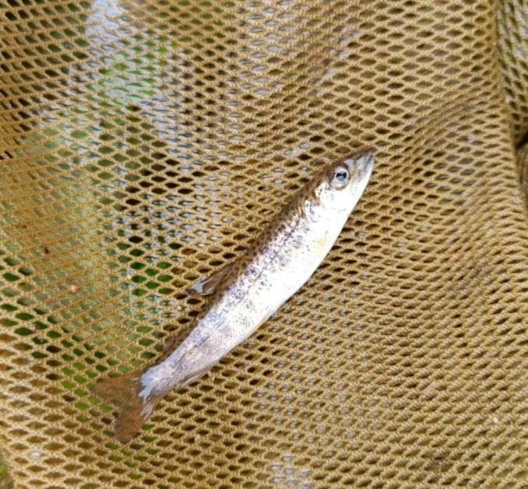
Fig. 6.2. Juveniles of Sakhalin taimen from sampling in the Vtoraya Malaya Creek. May 14, 2023 Photo by the author
Table 6.2
Sampling composition in the Luchevaya Creek (Serebryanoe Lake) on May 16, 2023
№  Catch | Fish name | Quantity | Sampling area,  sq m | Age,  years | AC body length, cm | Sampling spot,  Taimen juveniles
1 | Floating goby | 2 | 2 |  | 5
 | Shrimps | 3
2 | Floating | 1 | 2 |  | 5
3 | Pink salmon | 1 | 2 | 0 | 4
4 | Masu salmon | 1 | 2 | 0 | 5
5 | Masu slamon | 1 | 2 | 0 | 5
6 | Asian goby | 1 | 2 |  | 5
7 | Asian goby | 3 | 2 |  | 7-10
 | Asian goby | 1 |  |  | 5
8 |  | 0
9 |  | 0
10 | Masu salmon | 2 | 2 | 0 | 5
11 | White-spotted char | 3 | 2 | 1-2 | 8-12
 | Masu salmon | 1 |  | 1 | 9
 | Asian goby | 1 |  |  | 10
 | Taimen | 1 |  | 1 | 7 | 44 03 19.9 N - 145 51 15.7 E T = 9.9
12 | Masu salmon | 1 | 2 | 0 | 5
13 | Malma | 1 | 2 | 1 | 10
 | Asian goby | 1 |  |  | 6
14 | Masu salmon | 1 | 2 | 1 | 8
 | White-spotted char | 2 |  | 1 | 8
 | Asian goby | 1 |  |  | 6
15 | Asian goby | 1 | 2 |  | 6
16 | White-spotted char | 1 | 2 | 2 | 15
17 | White-spotted char | 6 | 2 | 1-2 | 8-12
 | Asian goby | 1 |  |  | 6
18 | White-spotted char | 2 | 2 | 1 | 8
 | Masu salmon | 2 |  | 1-2 | 8-15
19 | Asian goby | 1 | 2 |  | 8
20 | Masu salmon | 2 | 2 | 1-2 | 8-15
 | White-spotted char | 2 |  | 1-2 | 8-10
 | Sakhalin sculpin |  |  |  | 12
21 | White-spotted char | 1 | 2 | 2 | 12
 | Masu salmon | 1 |  | 0 | 5
22 | Masu salmon | 3 | 2 | 0 | 5
23 |  | 0 | 2
24 | White-spotted char | 2 | 2 | 1 | 8
 | Sakhalin sculpin | 1 | 2 |  | 25
25 |  | 0
26 | White-spotted char | 1 |  | 3 | 30
27 | Masu salmon | 1 | 2 | 1 | 8
 | Asian goby | 1 |  |  | 8
28 | White-spotted char | 1 | 2 | 1 | 8
29 | Sakhalin sculpin | 1 | 2 |  | 20
30 | Masu salmon | 1 | 2 | 1 | 10
 | White-spotted char | 1 |  | 1 | 12
31 | Masu salmon | 1 | 2 | 1 | 8
32 | White-spotted char | 1 | 2 | 1 | 8
33 | Masu salmon | 1 | 2 | 0 | 5
 | White-spotted char | 1 |  | 1 | 10
34 | Masu salmon | 1 | 2 | 0 | 5
35 | White-spotted char | 1 | 2 | 1 | 8
36 | White-spotted char | 3 | 2 | 1 | 8
 | Masu salmon | 4 | 2 | 1 | 8-10
37 | Pink salmon | 1 | 2 | 0 | 4
38 | Asian goby | 1 | 2 |  | 8
 | Taimen | 1 |  | 1 | 6 | no coordinates
39 | White-spotted char | 1 | 2 | 2 | 14
40 | Mitten crab | 1 | 2
41 | Mitten crab | 1 | 2
42 | Masu salmon | 2 | 2 | 0 | 5 | Beginning of the coniferous forest zone
43 | Masu salmon | 2 | 2 | 0-1 | 5-8
44 | White-spotted char | 1 | 2 | 2 | 15 | Beginning of the multi-thread channel zone
45 | Asian goby | 2 | 2 |  | 10-12
46 | White-spotted char | 1 | 2 | 1 | 6
47 | White-spotted char | 1 | 2 | 2 | 15
 | Masu salmon | 2 |  | 1 | 8
48 | White-spotted char | 1 | 2 | 1 | 8
49 | Asian goby | 1 | 2 |  | 8
50 | White-spotted char | 1 | 2 | 2 | 15

The average value of the Sakhalin taimen density in the spawning watercourse of Luchevaya: total survey area = 100.0 sq. m., total number of captured specimens of juvenile Sakhalin taimen = 2 specimens.
2 specimens / 100 sq m = 0.02 specimens / sq. m.
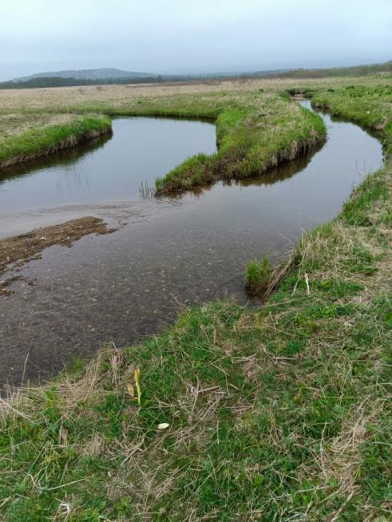
Fig. 6.3. The place of the confluence of the stream Luchevaya (right) into the river Serebryanka (left). May 16, 2023 Photo by the author
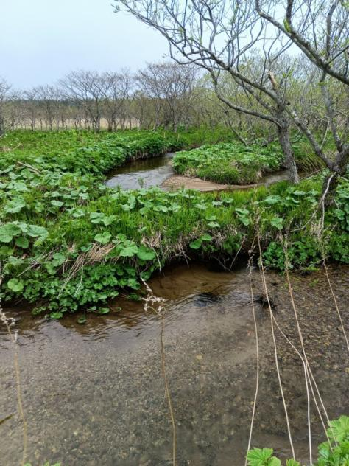
Fig. 6.4. Meanders in the channel of the Luchevaya Creek where Sakhalin taimen juveniles at the age of 1 year were captured. May 16, 2023 Photo by the author

Table 6.3
Sampling composition in the Malaya (Pionerskaya) Creek (Serebryanoe Lake basin) on May 14, 2023
№ fishing | Name | Quantity, specimens | Sampling  area, sq m | Age, years | AC body length, cm
1 | 9-spine stickleback | 2 | 3 |  | 4-6
2 | 9-spine stickleback | 2 | 3 |  | 4-6
3 | 9-spine stickleback | 1 | 3 |  | 4-6
 | White-spotted char | 1 |  | 2 | 10
 | Big-scaled redfin | 1 |  |  | 6
4 | White-spotted char | 2 | 3 | 1-2 | 6-12
5 | Malma | 2 | 3 | 1 | 8
 | White-spotted char | 1 |  | 3 | 20
6 | White-spotted char | 4 | 45 | 2 | 15
 | Masu salmon | 1 |  | 2 | 15

The average value of the Sakhalin taimen density in the Malaya spawning watercourse: the total survey area = 60.0 sq. m., the total number of captured specimens of juvenile Sakhalin taimen = 0 specimens.
0 specimens / 60 sq m = 0.0 specimens / sq. m.

Table 6.4
Sampling composition in the Triangular Creek (Serebryanoe Lake) on May 14, 2023
No. catch | Name | Quantity, specimens | Sampling area, sq m | Age, years | AC body length, cm | Sampling spot,  Taimen juveniles
1 | 9-spine Stickleback | 1 | 2 |  | 5
 | White-spotted char | 2 |  | 1-2 | 8-12
 | Malma | 1 |  | 1 | 8
 | Masu salmon | 1 |  | 2 | 10
2 | 9-spine Stickleback | 1 | 2 |  | 5
3 | 9-spine Stickleback | 1 | 2 |  | 5
 | Shrimp | 1 |  |  | 6
4 | Malma | 1 | 2 | 1 | 8
5 | Masu salmon smolt | 1 | 2 | 1 | 10
6 | White-spotted char | 12 | 20 | 1-2 | 8-12
7 | White-spotted char | 2 | 5 | 1-2 | 8-15
 | Masu salmon | 1 |  | 0 | 5
8 strait in the japanese fishing plot | White-spotted char | 8 | 10 | 1-2 | 8-12 | 44 03 39.1 N - 145 49 45.0 E
 | Taimen | 2 |  | 1 | 8-10 | T in the strait 10.3 T in the stream 8.3
9 strait in the japanese fishing plot | White-spotted char | 5 | 8 | 1-2 | 8-12
10 | White-spotted char | 2 | 2 | 1-2 | 8-12
eleven | White-spotted char | 4 | 2 | 1 | 8
12 | White-spotted char | 1 | 2 | 1 | 8
13 | White-spotted char | 1 | 2 | 1 | 10
 |  |  | 61
Shrimp 5-15 specimens in each sample,
a lot of gammarus

The average value of the Sakhalin taimen density in the spawning watercourse Triangular: total survey area = 61.0 sq. m., total number of captured specimens of juvenile Sakhalin taimen = 2 specimens.
2 specimens / 61 sq m = 0.032 specimens / sq. m.

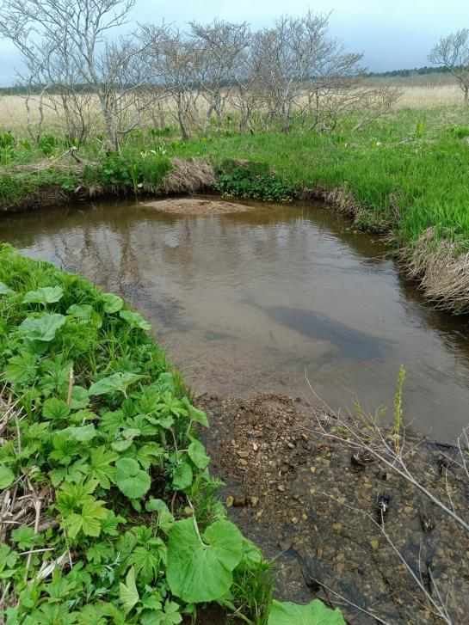
Fig. 6.5. Natural spawning ground of chum salmon in the basin of the Triangular Creek. It was used by the Japanese as a reservoir for incubation of hatchery chum salmon. May 14, 2023 Photo by the author
Table 6.5
Sampling composition in Bezymyanny Creek (Serebryanoe Lake) on May 14, 2023
№ fishing | Name | Quantity, specimens | Sampling area, sq m | Age, years | AC body length, cm
1 | Pond smelt | 2 | 2 |  | 7
 | Shrimp | 20
2 | Big-scaled redfin | 1 | 2 |  | 6
 | Shrimp | 15
3 | White-spotted char | 1 | 2 | 1 | 6
4 | White-spotted char | 2 | 2 | 1 | 6
 | Shrimp | 50 |  |  | 6
5 | White-spotted char | 1 | 2 | 1 | 6
 | Shrimp | 10 |  |  | 6
6 | White-spotted char | 1 | 2 | 1 | 6
 | Shrimp 5 |  |  |  | 6

The average value of the Sakhalin taimen density in the Malaya spawning watercourse: the total survey area = 12.0 sq. m., the total number of captured specimens of juvenile Sakhalin taimen = 0 specimens.
0 specimens / 12 sq m = 0.0 specimens / sq. m.
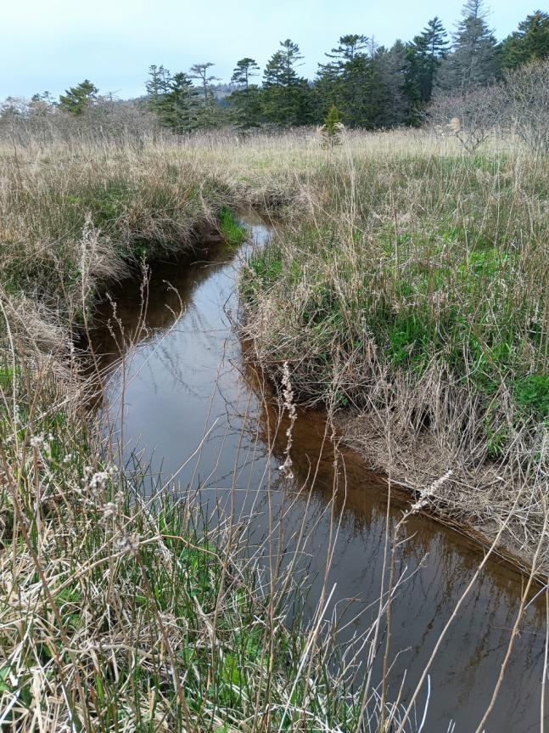
Fig. 6.6. A section of the channel of the Bezymyanny Creek in the basin of the Serebryanoe Lake. May 14, 2023 Photo by the author
1-year-old juveniles of Sakhalin taimen were discovered in the streams known as spawning tributaries of the Serebryanoe Lake. No spawning taimen or spawning mounds were registered. However, the spawning streams were not explored up to the source of the stream, since the task was not to conduct a survey of the streams, but to prove the reproduction of the Sakhalin taimen in Kunashir.
During the examination of three watercourses, known as spawning streams in the Serebryanoe Lake basin, the following data on the average density of Sakhalin taimen juveniles were obtained:
0.02+0.032+0.048 / 3 = 0.033 specimens/ sq.m. with a minimum of 0.02 and a maximum of 0.048.

The Serebryanoe Lake
Together with the with the employees of the State Nature Reserve “Kurilsky” we made a trip to the Serebryanoe Lake: Sokov Dmitry Vladimirovich and Kisleyko Alexander Alexandrovich and an employee of the YKRK, Korostylev Sergey Nikolaevich.
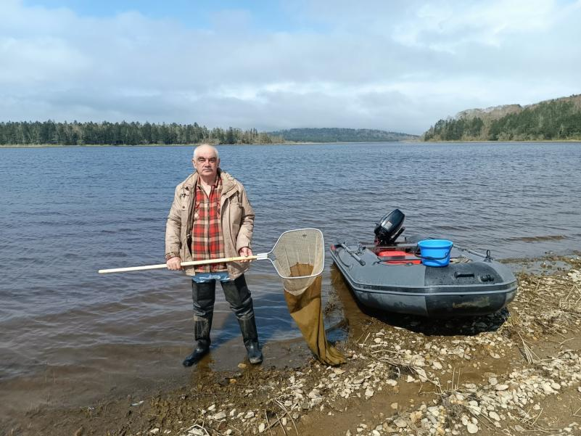
Fig. 6.7. The author of the research report at the Serebryanoe Lake

The depth of the lake near the coast is 0.5 m, the maximum depth is 1.7 m. The main area of the lake is 1 m deep. The length of the lake is 2.5 km, the width is 0.8 km. In summer, the lake is overgrown with aquatic vegetation, which dies off in autumn and contributes to the accumulation of organic residues at the bottom. At the bottom there are brown silts up to 0.4 m thick with a significant admixture of semi-decomposed plant residues. Fine gravel from sedimentary rocks was observed at the bottom. There are spawning grounds of chum salmon located in the lake. The measurements readings were constant throughout the studied area of the lake (the northern longitudinal half of the lake area) from the source of the Serebryanka River to the mouth of the Malaya (Pionerskaya) stream. The water temperature ranged from 13.7 to 14.2 degrees C, the salinity of the water was 0.1 ppt, which means fresh water. All this indicates that the shallow Serebryanoe Lake warms up and is supplied with oxygen equally over its entire area. Stratification of water masses does not exist here. In such cases, hydrobionts do not concentrate in local places (depth, temperature, etc.), but are dispersed evenly over its entire area.

Field trips along the Pacific coast of Kunashir Island
The participants of the field trips along the Pacific coast of Kunashir Island: the author and employee of the YKRK, Sergey Nikolaevich Korostylev. The goal of these research trips was to obtain information about the coastal fishing of YKRK in the sea feeding ground of the Sakhalin taimen, in order to clarify the possible impact of commercial fishing on the abundance of the Sakhalin taimen. The coast line of about 50 km as well as three stationary marine traps (Japanese small set seine) were surveyed.
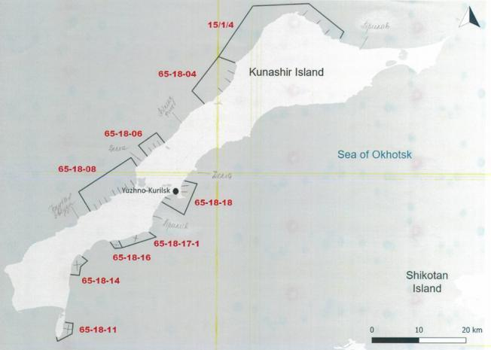
Fig. 6.8. Scheme of fishing parcels of YKRK used in the Pacific salmon fishery

In the area to the north of the mouth of the Sernovodka River, on the fishing parcel No. 65-18-15, the seines of YKRK were examined at the coordinates 43 54 21.5 N - 145 38 36.5 E with two traps and a wing length of 500 m. The traps were located every 250 m length of the seine wing. In the area south of the mouth of the Sernovodka River, a seine was examined at the coordinates 43 53 42.8 N – 145 37 52.6 E with one trap and a wing length of 250 m (Fig. 6.9-6.10).
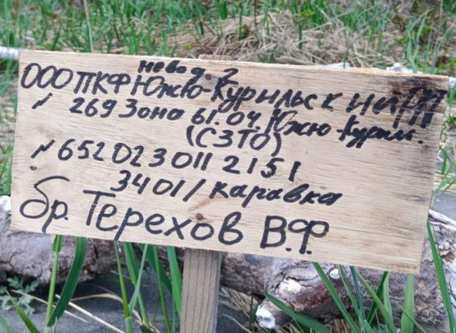
Fig. 6.9. Signpost of the YKRK seine. South of the Sernovodka River mouth, May 2023. Photo by the author

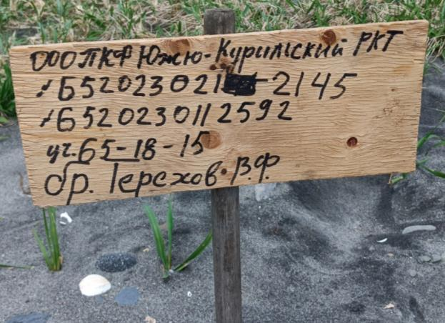
Fig. 6.10. Signpost of the YKRK seine. North of the Sernovodka River mouth, May 2023. Photo by the author

YKRK fishermen, who have been working in this area for more than 10 years, told us that taimen are observed in by-catch in single quantities (1-3 specimens no larger than 1 m), but not in every fishing season. The taimen is released into the sea when the seine is assorted.
The catch in seine nets is assorted directly on the barge. Then the barge goes to Yuzhno-Kurilsk and is unloaded at the YKRK pier under the supervision of border guards and fish protection officers, who issue a discharge report indicating the species composition of the catch and its volume (Fig. 6.11-6.13).
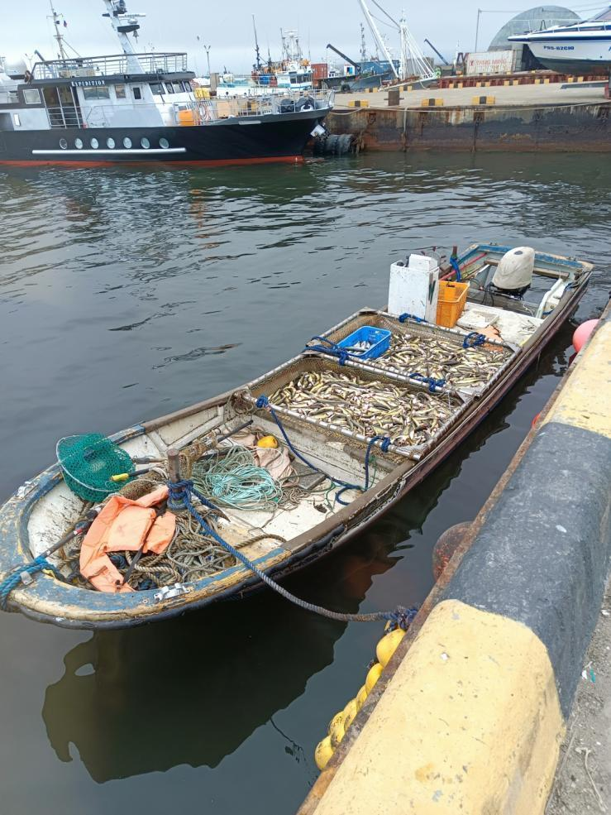
Fig. 6.11. Barge with fish, arrived at the YKRK pier from the Sernovodka River mouth. May 15, 2023. Photo by the author
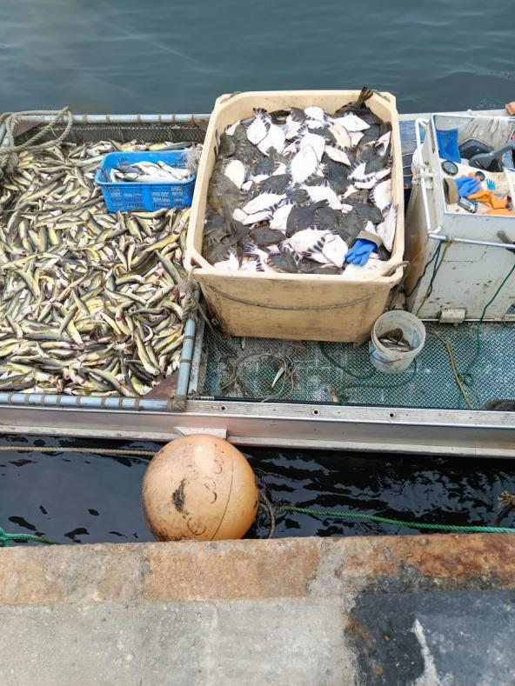
Fig. 6.12. The fish in the barge have already been assorted in the sea. The barge arrives at the berth of YKRK. May 15, 2023. Photo by the author
We joined the unloading of the catch to the YKRK berth. The catch composition in May (the period of the most active feeding migrations of the Sakhalin taimen in the sea coast) does not differ in the variety of species:
Saffron cod 90%;
Flounder of 3-4 species, the main part of which is starry flounder - 5%;
White-spotted char 4%;
Asian smelt 1%.
Other species, such as gobies, were represented by single specimens. The foreman of the YKRK fishermen, who has been working here for more than 10 years, and the representative of the border service confirmed the words of the fishermen that the Sakhalin taimen is observed only sporadically, and not every year. Fishermen release this fish into the sea when emptying and sorting out the fish from the seine trap.
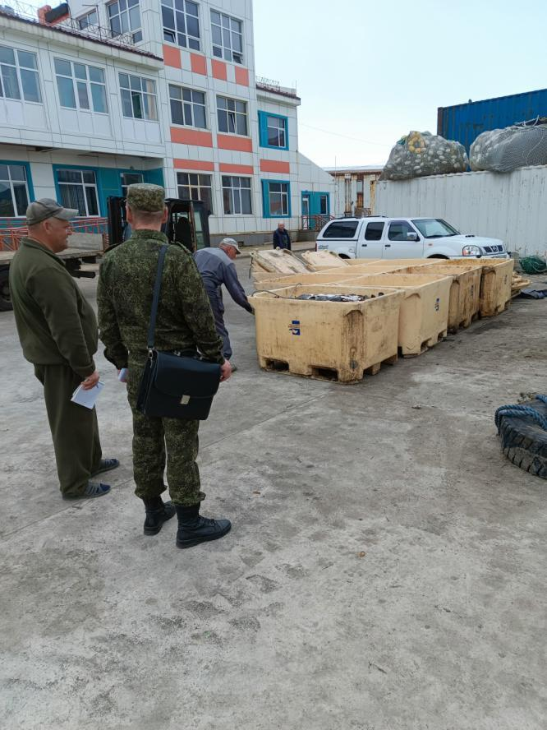
Fig. 6.13. Representatives of YKRK and Fish Protection specialists are always present during the catch discharging. YKRK pier, May 15, 2023. Photo by the author

There are plenty of seines and fishing parcels used during the Pacific salmon fishing season (see Fig. 6.8), however, in summer, the rate of migratory activity of Sakhalin taimen decreases sharply, and this species is rarely found in the sea. For this reason, during the salmon fishing season, the Sakhalin taimen, according to the experts from YKRK, is not observed in sea seines.
Thus, there is no information or estimates of the number of Sakhalin taimen died annually in commercial fishing.
Recreational fishing
On the sea coast and in the river Serebryanka we encountered local people who provided some valuable information on the amateur fishing. According to the locals, the Sakhalin taimen is common in the Serebryanka River and Serebryanoe Lake, although much rarer than, for example, masu salmon or white-spotted char. The catch of the Sakhalin taimen per year is estimated by experts to be up to 10 specimens by each amateur fisherman, and the total catch of Sakhalin taimen by amateur fishermen is about 200 fish. According to local experts, there are not so many amateur fishermen on Kunashir Island. Out of a population of 8,000 people, the number of amateur fishermen in Yuzhno-Kurilsk is no more than 20 people. They enjoy ice fishing and catching white-spotted char using spinning rods, and the Sakhalin taimen is just a bycatch. Some fishermen release the Sakhalin taimen, but some keep them for food. The reason for such a small number of amateur fishermen is the abundance of sea fish: flounder, Saffron cod, cod, halibut, Asian smelt. Sea fishing is preferred here. There is not a single fishing gear & tackle store in Kunashir Island – this is very unusual for the Russian Far East.
About 10 years ago white-spotted char had been harvested with gill nets in the Serebryanoe Lake and on the sea coast, but now it has almost disappeared. During gillnet fishing, the largest number of Sakhalin taimen were observed in gill nets 30-50 m long, installed directly off the coast. The along-shore nature of taimen's migrations to the sea is probably explained by the fact that the species does not tolerate water with oceanic salinity, but prefers fresh and estuarine areas of water in the coastal region.
The use of gillnets in the Serebryanka River is currently observed as an illegal fishing with a five-meter-long net only during the spawning run of pink salmon. In theory, the Sakhalin taimen in the Serebryanka River can get into such nets. Taking into account the fact that some amateur fishermen release the captured taimen, it can be assumed that about 150 specimens of the Sakhalin taimen, which belong to the population group of the Serebryanoe Lake, still die annually from amateur fishing.

Illegal fishing
Illegal fishing on Kunashir Island exists, but it is not targeted at the Sakhalin taimen. The reasons are quite simple: the lack of a market, the lack of food shortage, the availability of other fish species, mainly marine, the natural small population of taimen. Thus, illegal fishing does exist in the Kunashir Island but there is no illegal fishing of the Sakhalin taimen. Much of the taimen caught here is the by-catch by legal fisheries targeting at white-spotted char, for example. To release or keep the fish is a matter of personal convictions and conscience of every fisherman.
Chapter 7
Discussion of the field research results
Serebryanoe Lake is not a lagoon-type reservoir. However, almost all lakes on Kunashir Island are of lagoonal origin. According to geomorphological and geological indicators, Serebryanoe Lake – a depression – a local deflection. Shallow depth guarantees good heating and mixing of waters, the absence of their stratigraphy. This is a very productive reservoir with a good food base for Sakhalin taimen.
Reproduction of taimen. The analysis of data collected in various fisheries and environmental institutions has shown that on the Pacific side of Kunashir Island the Sakhalin taimen reproduce only in the basin of the Serebryanoe Lake. There are only 3 spawning tributaries in its basin: the Vtoraya Malaya and Luchevaya Creek (Serebryanka River) and the Triangular Creek (Serebryanoe Lake). But no one has any data on the number of taimen. It is clear that the total number of specimens in the group of the Serebryanoe Lake is small, since the total area of taimen spawning grounds is small (Fig. 7.1). However, if we refer to the relative values, such as the density of juveniles (ind./m ²) in the channel of spawning rivers, then the efficiency of reproduction of the Sakhalin taimen can be compared with similar and already known data from different areas of the species range. Our field studies determined that the average density of the Sakhalin taimen yearlings in the spawning streams of the Serebryanoe Lake amounted to 0.02-0.48 specimens per 1 m ² of the fishing ground. The average density was 0.033 ind./m ². We compared the average densities in the streams of the Serebryanoe Lake with similar data available in the literature (Zolotukhin, Semenchenko, 2008) (Fig. 7.2).
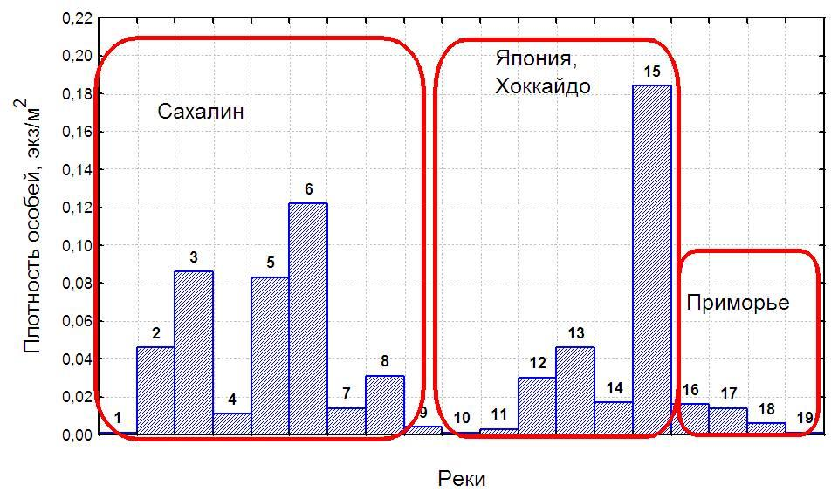
Fig. 7.2. Comparison of the average density of juvenile Sakhalin taimen in catches in three regions. Numbers indicate rivers and streams:
- Sakhalin: 1– river Evay, 2 – river Nabil’, 3– river Pilenga, 4 – river Northern Khandasa, 5 – river Orlovka, 6 – river Elnaya, 7 – river Lesnaya, 8 – river Vawai, 9 – river Shlyuzovka
- Japan, Hokkaido: 10 – Karibetsu Mainstream, 11 – Minaminosawa Creek, 12 – Yukinosawa Creek, 13 – Jyuissenzawa Creek, 14 – Santenzawa Creek, 15 – Higurezawa Creek (Fukushima Mishio, unpublished data, September, 2000)
- Primorye: 16 – river Koppi, 17 – stream Topty, 18 - river Samarga , 19 - river Kievka

If we consider the highest recorded density of the Sakhalin taimen juveniles as 0.185 ind./m ² (Higurezawa stream, Hokkaido), then the average density of 0.033 in the tributaries of the Serebryanoe Lake will be about 18% of the highest. And it can be argued that, in terms of the average density of juveniles, the Serebryanoe Lake is lower than the watercourses of Sakhalin and Hokkaido, but higher than the mainland coast of the Sea of Japan with such rivers as Koppi, Samarga, Kievka (see Fig. 7.2). This is a very good indicator of the reproduction efficiency for the Sakhalin taimen of Kunashir Island.
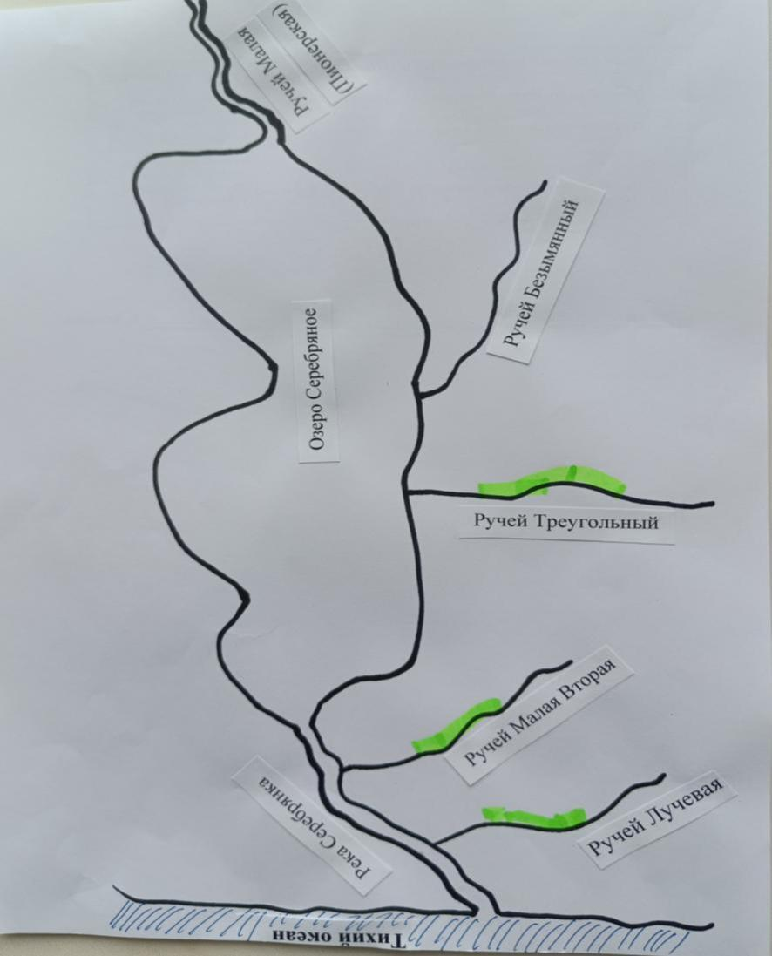
Fig. 7.2. Scheme of the spawning grounds of the Sakhalin taimen in the basin of the Serebryanoe Lake.

Taimen population. The number of Sakhalin taimen or its juveniles in the watercourses of Kunashir Island has never been estimated.
Taimen catch by amateur fishermen. The catch of the Sakhalin taimen per year is estimated by experts to be up to 10 specimens by each amateur fisherman, and the total catch of the Sakhalin taimen by amateur fishermen is 200 fish. According to local experts, there are not so many amateur fishermen on Kunashir Island. Out of a population of 8,000 people, the number of amateur fishermen in Yuzhno-Kurilsk is no more than 20 people. They enjoy ice fishing and catching white-spotted char using spinning rods, and Sakhalin taimen is just a bycatch. Some fishermen release the Sakhalin taimen, but some keep them for food. The reason for such a small number of amateur fishermen is the abundance of sea fish: flounder, Saffron cod, cod, halibut, Asian smelt. Sea fishing is preferred here. The total number of Sakhalin taimen caught annually can be estimated as 150 specimens.
Taimen catch by commercial fishing gears. There is no information or estimates of the number of Sakhalin taimen killed annually by commercial fishing gears. There is information about the by-catch of single specimens of Sakhalin taimen by sea seines – 1-3 specimens per year.
The fish in YKRK sea seines are sorted out in the sea. Sakhalin taimen is well known to the fishermen, and they immediately release this fish alive. At the UKRK pier, the administration of the YKRK together with the team of fishermen and the border agents receive and inspect the catch. It is accompanied with the issuance of “delivery-acceptance act”, which indicates the weight of each species in this catch.
It is noteworthy to mention the statement of local experts that when 10 years ago, pink salmon was harvested with 30-50 m gill nets in the coastal area of the Kunashir Island, most often the Sakhalin taimen got inside the net near the shore, but not into the net traps installed 250-500 m from the shore. From the behavioral perspective this is true for the Sakhalin taimen. Sakhalin taimen does not tolerate oceanic salinity and migrates within the limits of fresh water distribution (Fig. 7.3).
Mixing of river and sea water at river mouths is a dynamic process. As the channel widens and depth increases, the river flow breaks away from the bottom and flows over the denser seawater. Moving away from the river, fresh water gradually mixes with sea water. The nature of this process depends on dynamic factors, primarily of marine origin. In particular, the distance range of fresh water depends on the river flow and the season of the year. Fresh waters run further and mix with sea waters during the spring flood (Smagin, 2017).
In the mixing zone, stable stratification and a two-layer structure are usually observed, the upper part of which was occupied by warmer river waters. Below there was a temperature jump cline (thermocline), where the temperature dropped. Its lower boundary was subject to fluctuations caused by influence of the seawater. Deeper, a thermally homogeneous layer is usually observed, and salty waters occupy the entire water column down to the bottom. The location of the thermocline can often coincide with the location of the halocline (Smagin, 2017).
This kind of thermohaline structure is typical of water mixing zones in the mouth of rivers. That is, the surface layer was fresh, below there was a well-defined halocline several tens of centimeters thick. Here, the salinity of the water increased. Further to the bottom there is a layer of sea water (Smagin, 2017). Consequently, the physical properties of salty and fresh waters determine the facts of short estuarine migrations of the Sakhalin taimen.
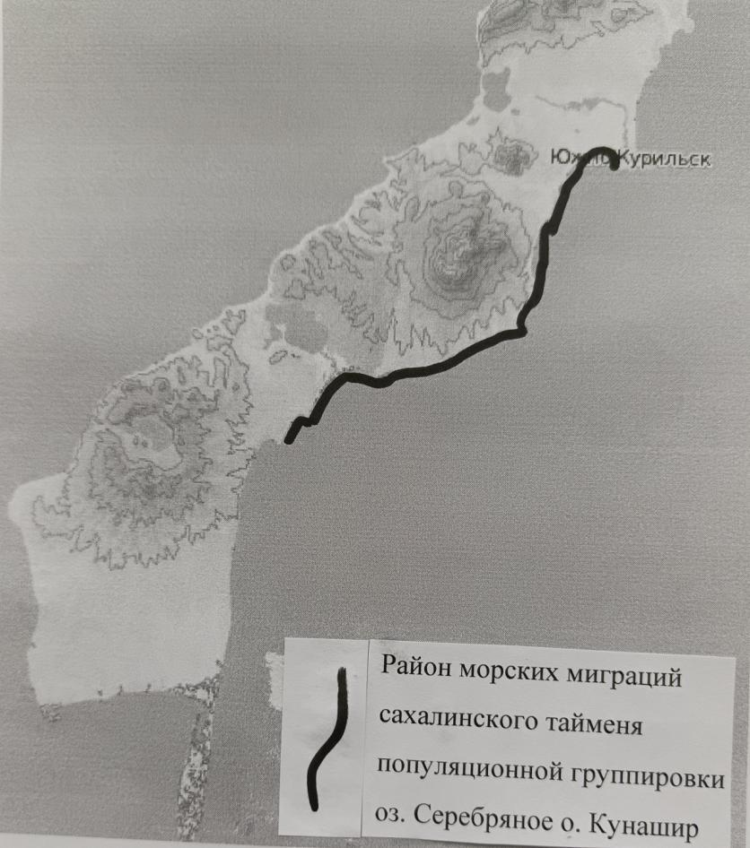
Fig. 7.3. Sea migrations of the Sakhalin taimen along the coast of the Pacific Ocean and Kunashir Island

Illegal fishing. The illegal fishing targeted at Sakhalin taimen on Kunashir Island does not exist. The only case is when the amateur fishermen illegally lay their hands on the by-catch. Random catch of taimen with fixed nets is 1-3 specimens annually. Illegal fishing by amateur fishermen in the Serebryanoe Lake is about 150 specimens annually.
Competitive relations between taimen and chum salmon juveniles. The chief fish farmer of the hatchery “Lagoonoye Lake” of YKRK, Pastukhov Dmitry Aleksandrovich noted that the hatchery had been built since 2012. Over the past 11 years, Sakhalin taimen presence in the Lagoonoye Lake was not observed. To the question: “Is there any influence of hatchery chum salmon on juvenile taimen on Kunashir Island? he answered very clearly “no”. The reason is the lack of salmon hatchery in the basin of the Serebryanoe Lake, and the absence of taimen in the Lagoon Lake.
The status of the Sakhalin taimen population. It is known that island populations of Sakhalin taimen are more susceptible to extinction due to local catastrophic phenomena: volcanic activity, overheating of water, etc. It is highly probable that in the last millennium the Sakhalin taimen went through the repeated cycle of extinction and restoration by straying. With the absence of more detailed data from geneticists, it is prudent to consider that the Kunashir Island is inhabited by population groups of Sakhalin taimen from a common ancient population group, which included the rivers of southern Sakhalin, the rivers of Hokkaido, and rivers of Kunashir islands.

Chapter 8.
Legislation of the Russian Federation and Sakhalin taimen on Kunashir Island
The status of the Sakhalin taimen on Kunashir Island
The current status of this species reflects its state from the biological (numbers, etc.), economic (fishery object or protected species) and legal aspects. If it is a fishery object, then there should be an allowable catch for this species. If this is a specially protected species at the level of the Russian Federation, then it is listed in the Red Book of the Russian Federation. For example, in the new edition of the Red Book of the Russian Federation, the “List ...” was approved by the Ministry of Natural Resources of the Russian Federation on March 24, 2020 by Order No. 162. Specially protected species are presented in 3 categories:
- Rarity status
- Endangered status
- Category of priority of environmental measures

The small stock is the natural state of a large predator in the trophic pyramid of a river basin. The population of Sakhalin taimen in Sakhalin Island were the first to be included in the Red Book of the Russian Federation in the 3^{d} category with the status of “local endemic species of the Far East with a declining population, in need of protection” (Red Book of the Sakhalin Region, 2000). The number of taimen on the Kuril Islands has also decreased sharply in recent years. The population of the Sakhalin taimen is also listed in the Red Book of the Russian Federation in the 2nd category, an even higher protection status (Red Book of the Russian Federation, 2001). In the Red Book of the Primorsky Territory, this species has the second category with the status “declining in numbers: taxa and populations with steadily declining numbers, which can rapidly fall into the category of endangered (Red Book of Primorsky Krai, 2002).
In the Red Book of the Ministry of Environmental Protection of Japan (1999 edition) and in the Red Book of Hokkaido (2001), Sakhalin taimen are classified as endangered species.
In 2006 the Sakhalin taimen was included in the IUCN Red List of the International Union for Conservation of Nature (IUCN) based on an expert assessment carried out by the IUCN Salmonid Species Group in the Critically Category Endangered (A 4 abcd) – “in critical condition” (Rand, 2006).
In the 2020 edition of the Red Book of the Russian Federation, the Sakhalin taimen retained its former status of a specially protected species: populations of only the Primorsky Territory and the Sakhalin Region are included in its lists:
“Sakhalin taimen - Parahucho perryi (populations of Primorsky Krai and Sakhalin Region)
Rarity status category: 1 - Endangered;
Endangered status category: E – Endangered;
Category of the priority of the environmental measures: I - priority. Taking immediate measures and actions is required, including the development and implementation of a conservation strategy and / or a program for the restoration (reintroduction) of the animal world and action plans” (Red Book of the Russian Federation, 2020).
YKRK carries out commercial fishing with fixed nets in the coastal area of Kunashir Island. The anadromous type of Sakhalin taimen migrates to the sea and can be captured by marine fishing gear. During our field trip to Kunashir in May, we visited locations where the sea seines are installed (the period of the most active migrations of taimen in the coastal area) and studied their catches (see the chapter Field studies). The following conclusions were drawn: that in May the Sakhalin taimen can be found in commercial seines in the coastal area only in single quantities (1-3 specimens per year), and in other months its migratory activity is weak and during the salmon fishing season it is not observed in seines at all.
As far as Kunashir Island situation is concerned, there is no reason to assert that the YKRK causes damage to local groups of taimen, since the total amount of catch (1-3 specimens per year) is much less than the value of natural mortality of the Sakhalin taimen. The criminal liability for illegal catch of aquatic biological resources is envisioned in the Article 256 of the Criminal Code of the Russian Federation (hereinafter – the Criminal Code of the Russian Federation). The subject of the crime is aquatic biological resources, including valuable, especially valuable, rare and endangered ones. Federal Law N 150-FZ “On Amendments to Certain Legislative Acts of the Russian Federation” (Federal Law dated 07/02/2013 N 150-FZ) introduced Article 258.1, which establishes liability for the illegal catch, maintenance, storage, transportation, shipment and sale of especially valuable aquatic biological resources belonging to species listed in the Red Book of the Russian Federation and (or) protected by international agreements of the Russian Federation.
YKRK fishermen are well aware that taimen is a protected fish. In the absence of a market and the presence of a large number of less rare and more accessible biological resources (marine fish species, for example), local fishermen are not focused on harvesting Sakhalin taimen.
Among all the freshwater fish that inhabit Kunashir Island, only the Sakhalin taimen is listed in the Red Book of the Russian Federation and IUCN. However, the same streams are inhabited by other small species, for example, from the Gobiidae family: Gymnogobius, Chaenogobius, Acantogobius, Luciogobius, Tridentiger, which number is even less than that of the taimen and some species from the Gobiidae family do not have a systematic status. Several species could also be included in the lists of the Red Book of the Russian Federation. But no one protects these species even from the obvious pollution of their environment and the disappearance of their habitats (Fig. 8.1).

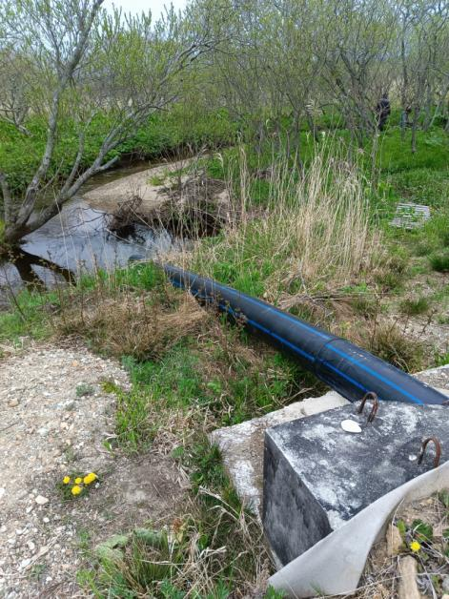
Fig. 8.1. Sewer line drain in the Luchevaya stream (basin of the Serebryanka river). May 15, 2023

Conclusions and Recommendations to YKRK
The Pacific side of Kunashir is inhabited by stock groups of the Sakhalin taimen from the common ancient population group, which included the rivers of southern Sakhalin, the rivers of Hokkaido Island, and the rivers of Kunashir Island. That means that if some catastrophic events lead to the death of the entire group of taimen, for example, in the Serebryanoe Lake, there are two options for their restoration:
- The artificial way: reintroduction of specimens from the reservoirs of southern Sakhalin and Hokkaido;
- The natural way: waiting for new spawners from the straying group.
The accidental catch of taimen using fixed seines by YKRK is only 1-3 specimens annually. Illegal fishing by amateur fishermen in the Serebryanoe Lake kills about 150 specimens annually. The damage to the Sakhalin taimen from the fishing activities of YKRK is at a much lower level than its natural mortality.
The fishermen of YKRK are familiar with the Sakhalin taimen and know that it is a protected species. YKRK fishermen release this fish if it gets captured into sea fishing gear.
The Sakhalin taimen migrates in the sea in the layer of fresh water near the coast, so its migrations are not extended and are not far from the coast, probably not more than 100 m. A distance of 250 m from the shore to the trap net is quite sufficient to exclude this species from entering the traps.
If YKRK is interested in monitoring – obtaining annual (or every 3-5 years) data on the number of Sakhalin taimen in the Serebryanoe Lake, as an indicator of the stock trend, it is possible to organize assessments of juvenile density, similar to the survey conducted in 2023. This will show the proportion of juvenile taimen among juveniles of other fish in the spawning streams in the Serebryanoe Lake. The assessment will take about 7-10 days in August and requires 1-2 specialists.
Our field research has determined that the efficiency level of the Sakhalin taimen natural reproduction is relatively high and amounts to 0.033 specimens/m² within a small area of spawning grounds in only three tributaries of the Serebryanoe Lake. The Serebryanoe Lake, despite the fact that this is the only reproduction place of the Sakhalin taimen along the entire Pacific coast of Kunashir Island, is not part of the Kurilsky State Nature Reserve. Fisheries and environmental organizations have no interest in this reservoir. The Fishery Protection Agency protects the spawning of pink salmon and chum salmon here, but is not aimed at protecting taimen: they claim it is protected by another department.

References

Smagin R.E. Interaction of sea and river waters in a tidal estuary. - Dissertation. - 2017. - St. Petersburg - 121 p .
History of the Kuril Archipelago: discovery, development and views (Yu-Sakhalinsk, November 30, 2018). - 2018. - Collection of research reports. - Yu-Sakhalinsk , SakhSU . - 60 p.
Zolotukhin S. F., Semenchenko A. Yu. Growth and distribution of Sakhalin taimen Hucho perryi ( Brev oort ) in river basins // Readings in memory of Vladimir Yakovlevich Levanidov. 2008. Vol . 4. pp. 317–338.
Sidorov L.K., Pichugin M.Yu. Composition of the ichthyofauna and features of the biology of fish in the southern Kuril Islands in connection with abiotic conditions and the origin of reservoirs // Proceedings of VNIRO. - 2005. - T. 144. - P. 151-175.
Klyuchareva O.A. Ichthyofauna of lagoon lakes of Kunashir Island (Kuril Islands) // Zoological Journal.- 1967.- Vol . XLVI.- Issue . 3.- S. 384-392.
Korsunskaya G.V. Kuril island arc M:. - State publishing house of geographical literature. - 1958. - 224 p .
Zhivotovsky L.A. Population structure of the species: eco-geographical units and genetic differentiation of populations // Biol. seas. 2016.- V. 42, No. 5. S. 323–333. – 2017. Two branches of studies of the population structure of the species – ecological and genetic: history, problems, solutions // Genetics. T. 53, No. 11. S. 1244–1253.

Zhivotovsky L.A., Lapshina A.E., Mikheev P.B. Divergence of seasonal races of Oncorhynchus keta Wabaum , 1792 of the Amur and Poronai rivers: ecology, genetics, morphology // Biol. seas. 2017.- V. 17, No. 4. S. 284–292.

Zhivotovsky L.A., Smirnov B.P. Strategy for the reproduction of Pacific salmon in the Sakhalin region. // Fishing issues. 2018.- V. 19. No. 3. S. 285-299.

Makhinov A.N. Contemporary relief formation under conditions of alluvial accumulation. Vladivostok: Dalnauka, 2006.- 232 p.

Reimers N.F. Nature management: dictionary-reference book. M.: Thought, 1990. - 637 p.

Yurchenko A. A. Genetic structure of Sakhalin taimen Parachucho populations perryi Brevoort and issues of environmental genetics of the species. - 2015.- M: Dissertation. - 168 p.
Leman V.N. Ecological and species specificity of the spawning grounds of the Pacific salmon Oncorhynchus in Kamchatka // Readings in memory of V.Ya. Levanidov. -Issue.2.- Vladivostok: Dalnauka .- 2003.- S. 12-34.

Makhinov A.N. Contemporary relief formation under conditions of alluvial accumulation / Vladivostok. - Dalnauka . - 2006. - 232 p.

Sokov D.V. Sakhalin taimen Hucho perryi ( Brevoort ) of Kunashir Island. // Local history bulletin. 2000.- V. 5. S. 333-336.
Tochilina T.G. Assessment of by-catch of "non-target" fish species in the
salmon fishery on the island. Kunashir. Collection and analysis of biostatistical information on the fishery of pink salmon and chum salmon on the island. Kunashir. - Research Report. - VNIRO Archive. - 2022. - 38 p .
Mitsugu Takayasu , Kenzo Kondo , Sinichi Ohigashi , Kunio Kuroda , Limnological studies in the lakes of Kunashir Island 1955.- No. 10,- P. 169-216僻 札場試験報告No. 10 ( on Japanese language ).
Michio Fukushima &Peter S. Rand High rates of consecutive spawning and precise homing in Sakhalin taimen ( Parahucho perryi ) Environ Biol Fish .- 2021.- 104:41–52 https://doi.org/10.1007/s10641-021-01052-4.
Rand PS (2006) Hucho perryi : The IUCN Red List of Threatened Species 2006: e.T61333A12462795 [online]. https://www. iucnredlist . org/species/61333 /12462795.
Rand Peter, Fukushima Michio (2014) Estimating the size of the spawning population and evaluating environmental controls on migration for a critically endangered Asian salmonid , Sakhalin taimen . Global Ecology and Conservation 2:214–225. https://doi.org/10.1016/j.gecco.2014.09.007
Fukushima Michio (2001) Salmonid habitat–geomorphology relationships in low-gradient streams. Ecology 82(5):1238–1246. https://doi.org/10.2307/2679985
Augerot X., Foley DW, Steinback C. Atlas of Pacific Salmon. The first map-based status assessment of Salmon in the North Pacific. — Berkeley; Los Angeles; L.: Univ. Calif. Press, 2005. - 150 rubles .
Zimmerman CE Migration of Sakhalin taimen ( Parahucho perryi ): Evidence of freshwater resident life history types / CE Zimmerman, PS Rand, M. Fukushima, SF Zolotukhin // Environ. biol . Fishes - 2012. - V. 93 - No. 2 - 223–232 p.

