Survey Results from October 18th, 2021

German Bank #5

The survey occurred on Monday October 18th, 2021. There were 9 participating vessels, with each tasked with surveying two lines in the German Bank box and one line in the Seal Island box each. The survey started at 19:00. There was a plankton tow and replicate collected by the Lady Melissa, but no CTD cast due to rough conditions. Fishing occurred after the survey and completion of 3 lines by each vessel. There were samples obtained and 650 tags applied across 5 events by the Lady Melissa and Lady Janice on October 18th, 20th, 21st and 25th. The standard target strength value for 38 kHz was applied to the results.

Average speed was either below the recommended maximum of 8 knots or within 0.1 knots for all vessels except the Tasha Marie and Sealife which exceeded the recommended average speed by greater than 0.1 knots. Most vessels recorded within 1 km of their lines except for the Leroy and Barry and Lady Janice. The Leroy and Barry missed a small portion of T01, and a more significant section at the end of their Seal Island line, T03. The Lady Janice missed a small portion at the beginning of T01.

Figure 1. Track plot and survey area.

Figure 2. PRC Area Backscattering Coefficient (m2/m2) for each transect and cell using a grid of 1km.

Figure 3. Plankton tow and tagging locations.

Table 1. Plankton Tow Summary

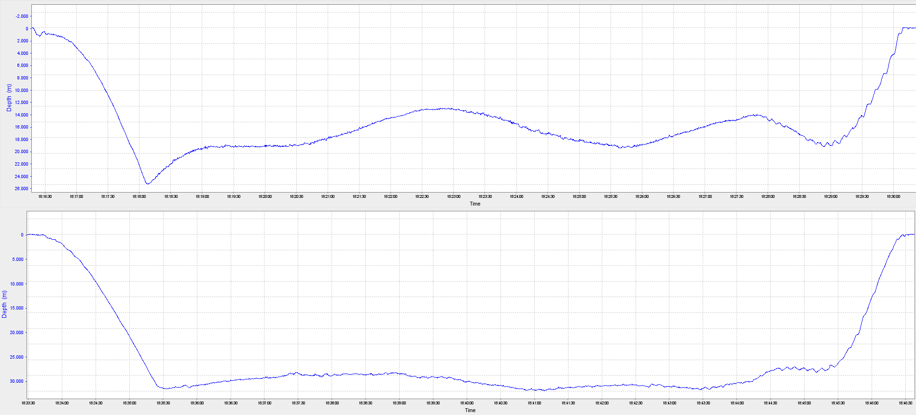

Figure 4. Plankton net depth profile for GB2021-09 and -10 which had an average depth of 15m and 25.7m, respectively.

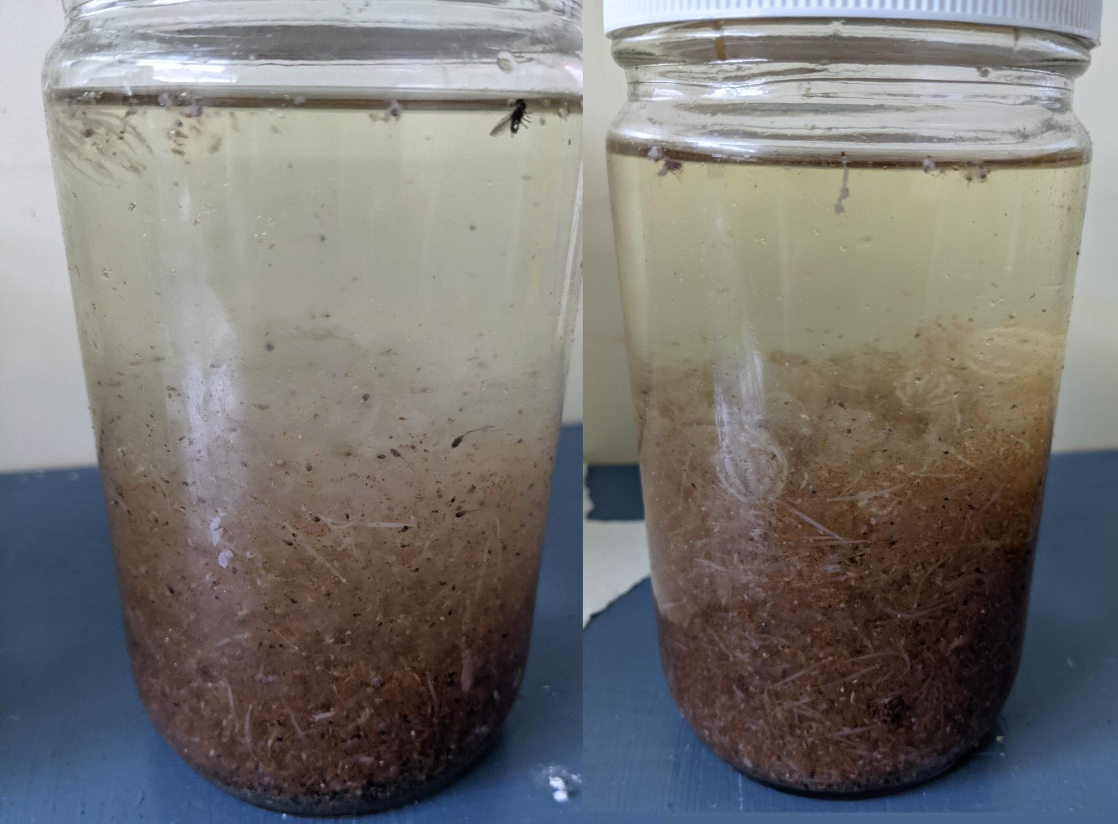

Figure 5. The plankton samples obtained; GB2021-09 and GB2021-10. Comb jellies, copepods and arrow worms can be observed visually.

Acoustic Equipment

Each vessel was equipped with a Simrad ES38-18/200-18C combi (2-in-1) transducer prior to the survey that contains a 38kHz split beam as well as a 200 kHz single beam transducer. Data was logged to the computer hard-drive for post-processing. The Fundy Monarch, Canada 100, Brunswick Provider, Lady Melissa, Lady Janice and Sealife II were calibrated prior to the survey. The remaining participating vessel data is uncalibrated which adds increased uncertainty to the biomass results. The difference is not expected to be major in terms of overall biomass estimate as the default settings applied by Echoview are similar to the calibrated values.

Tide Schedule for Yarmouth NS, Station #365

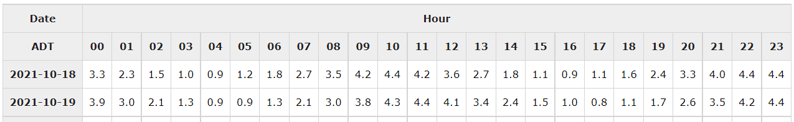

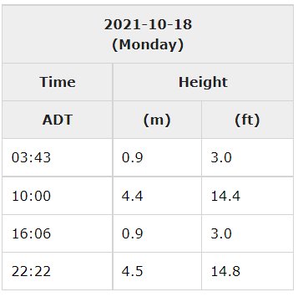

(Source: [www.waterlevels.gc.ca](http://www.waterlevels.gc.ca))

Results

The results are subject to change pending further calibrations and editing review. Preliminary biomass prediction for German Bank using standardized parallel transects, is **3,113** **mt** and with turnover applied is **0** **mt.** For Seal Island, the result is **1,176 mt**.

Table 2. Transect details.



Table 3. Acoustic survey results - transects are listed from greatest to least backscatter.



Figure 6. Echogram of the transect with the greatest backscatter LM_T01 located in the German Bank Survey Box.

Table 4. Survey summary.



Table 5. Annual comparisons. The ad hoc surveys that replaced structured surveys are in white.

