ACTIVITY REPORT

Period : 27 – 29 September 2022
Venue : Kotabaru
Participant(s) : Local fishermen, outreach officer, UNLAM, PT. Sekar Laut
Agenda :
- Agenda : ETP socialization and discussion
Date : 27 September 2022
Venue : Desa Sekapung
Participant(s) : Local fishermen, outreach officer, UNLAM, PT. Sekar Laut, village head of desa Sekapung
Activity :
- Best practice sharing and live discussion related FIP and ETP species on fishing ground
- Understanding about ETP law and regulation
- Understanding that all aspect contributing on obedience of regulations
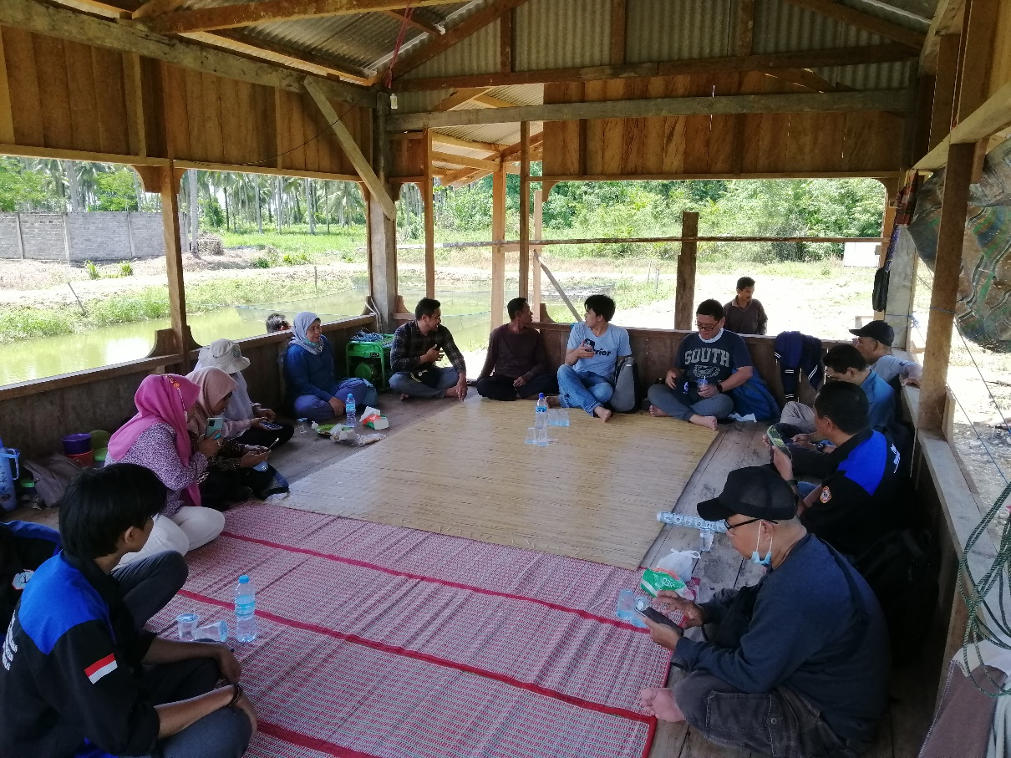

Picutre 1. ETP Socialization

- Agenda : Elogbook verification, socialization and discussion related (ETP & Grievance mechanism), installation tracking device
Date : 28 September 2022
Venue : PPI Kotabaru, Desa Tj. Batu
Participant(s) : Head of PPI Kotabaru and staff, outreach officer, UNLAM, PT. Sekar Laut, Local fishermen
Activity :
- Open discuss related elogbook activation for small fisheries
- Understanding about ETP law and regulation
- Understanding that all aspect contributing on obedience of regulations
- Sharing and live discussion related to the grievance of the fishermen and how to submit
- Sharing and live discussion related used of tracking devices and the CCTV camera
- Handover the tracking devices to fishermen
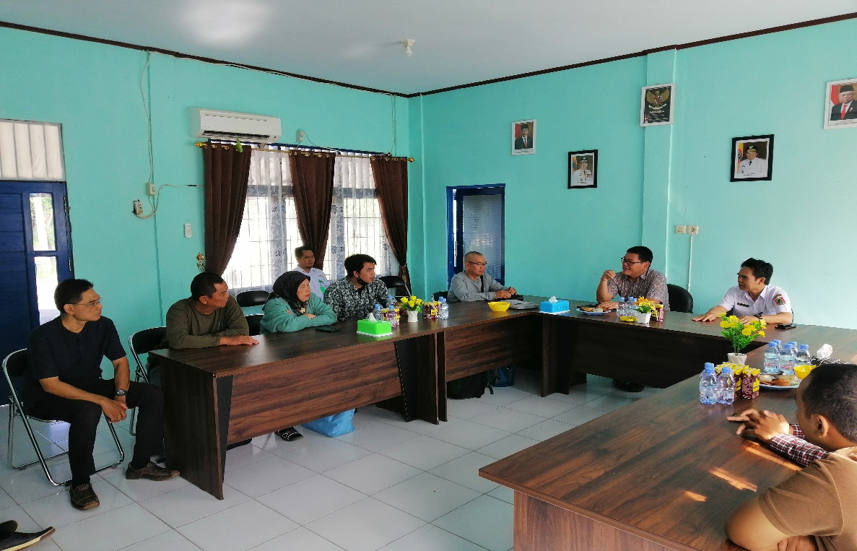

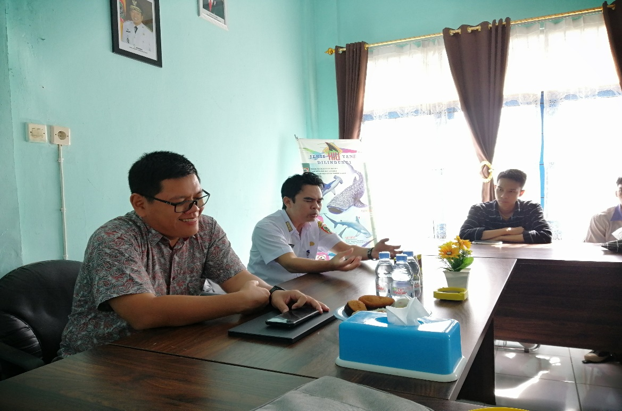

Picture 2. Live discussion on the elogbook activation for small fisheries on PPI Kotabaru

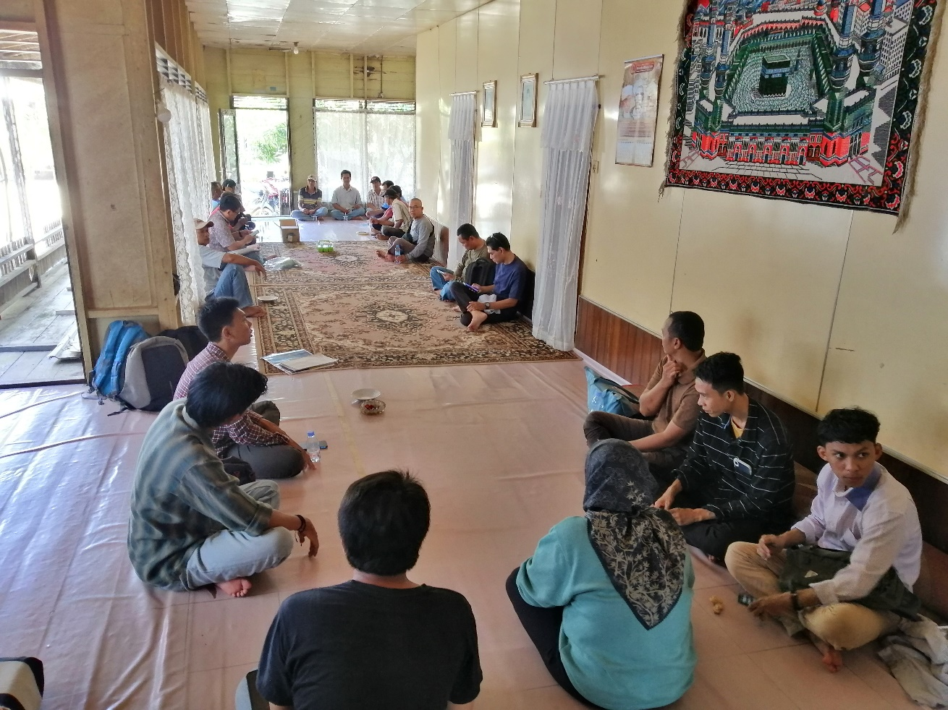

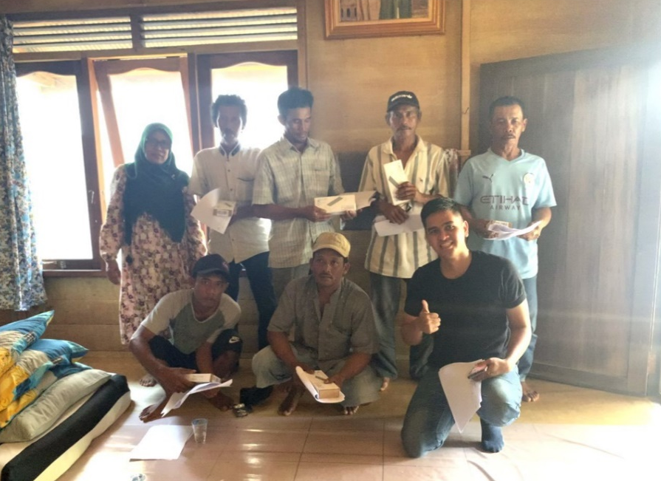
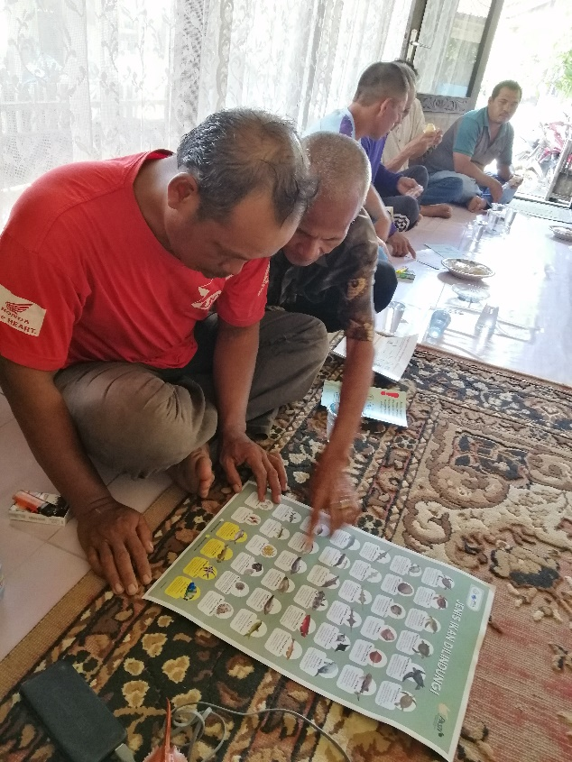

Picture 3. Socialization ETP & Grievance mechanism, tracking devices installation

- Agenda : Installation tracking device
Date : 29 September 2022
Venue : Desa Sungai Pasir & Salino
Participant(s) : Outreach officer, Local fishermen, UNLAM, PT. Sekar Laut
Activity :
- Additional installation tracking devices and review CCTV footages
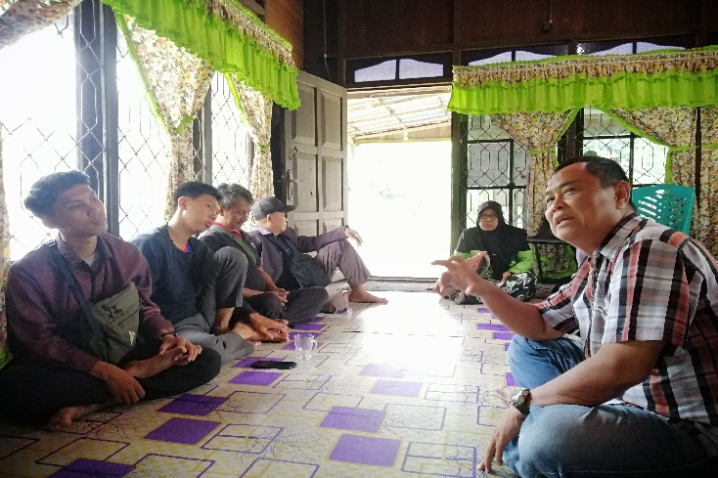
- Handover the tracking devices to fishermen
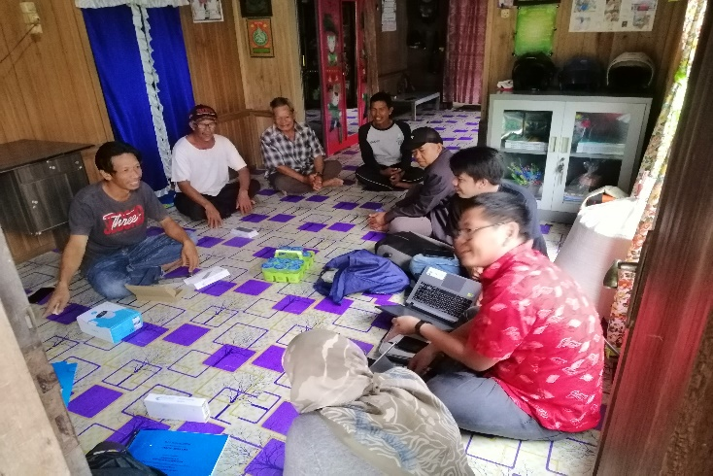
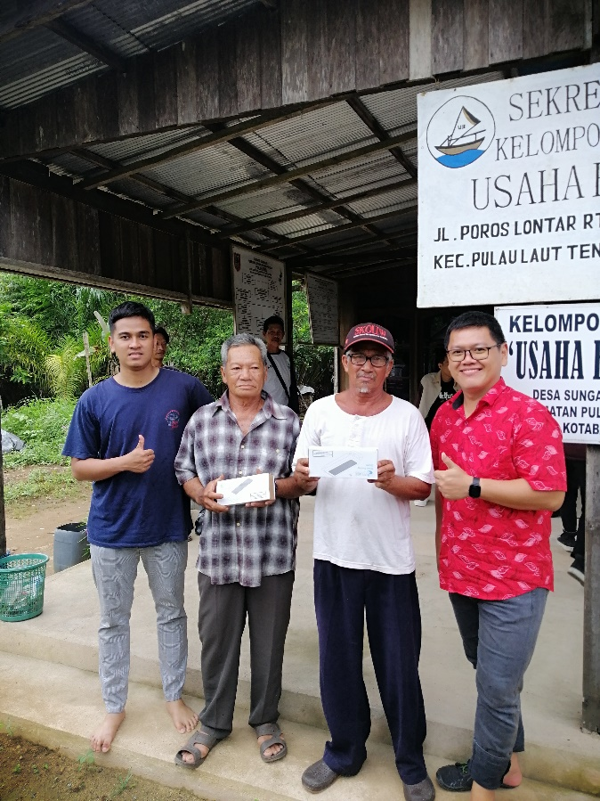

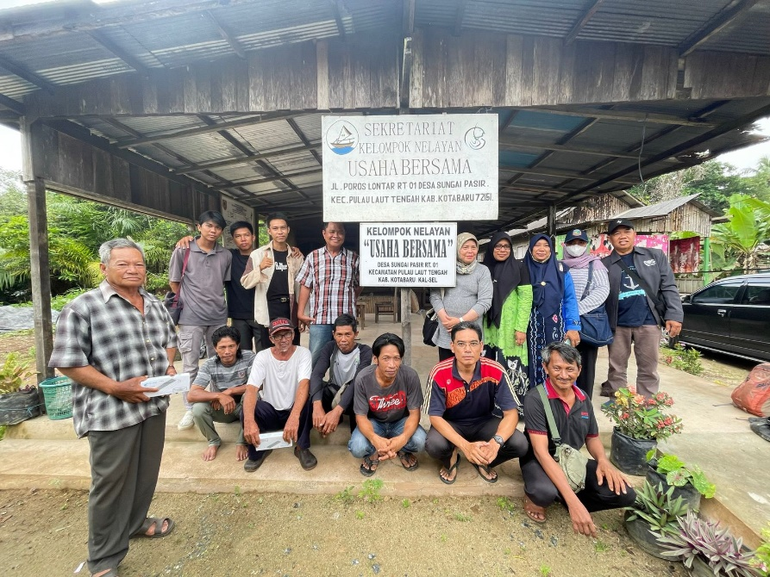

Picture 4. Review the CCTV footages and handover tracking devices at desa Sungai Pasir
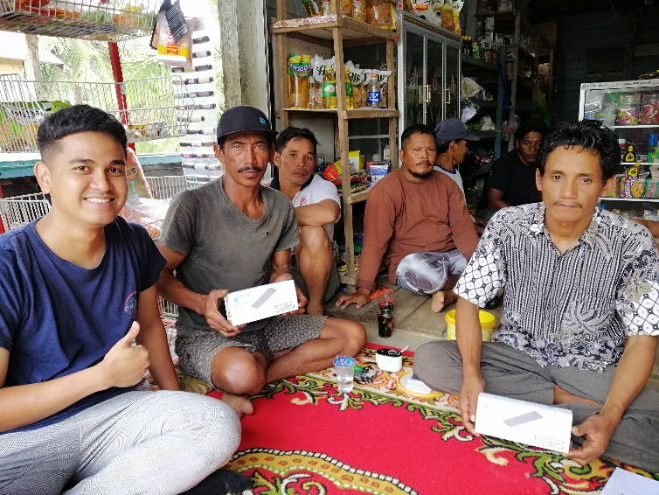
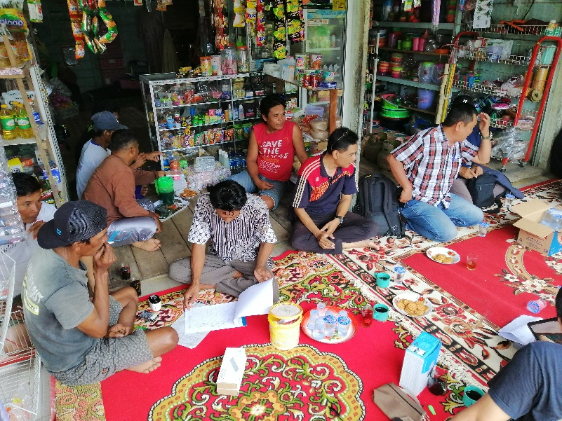

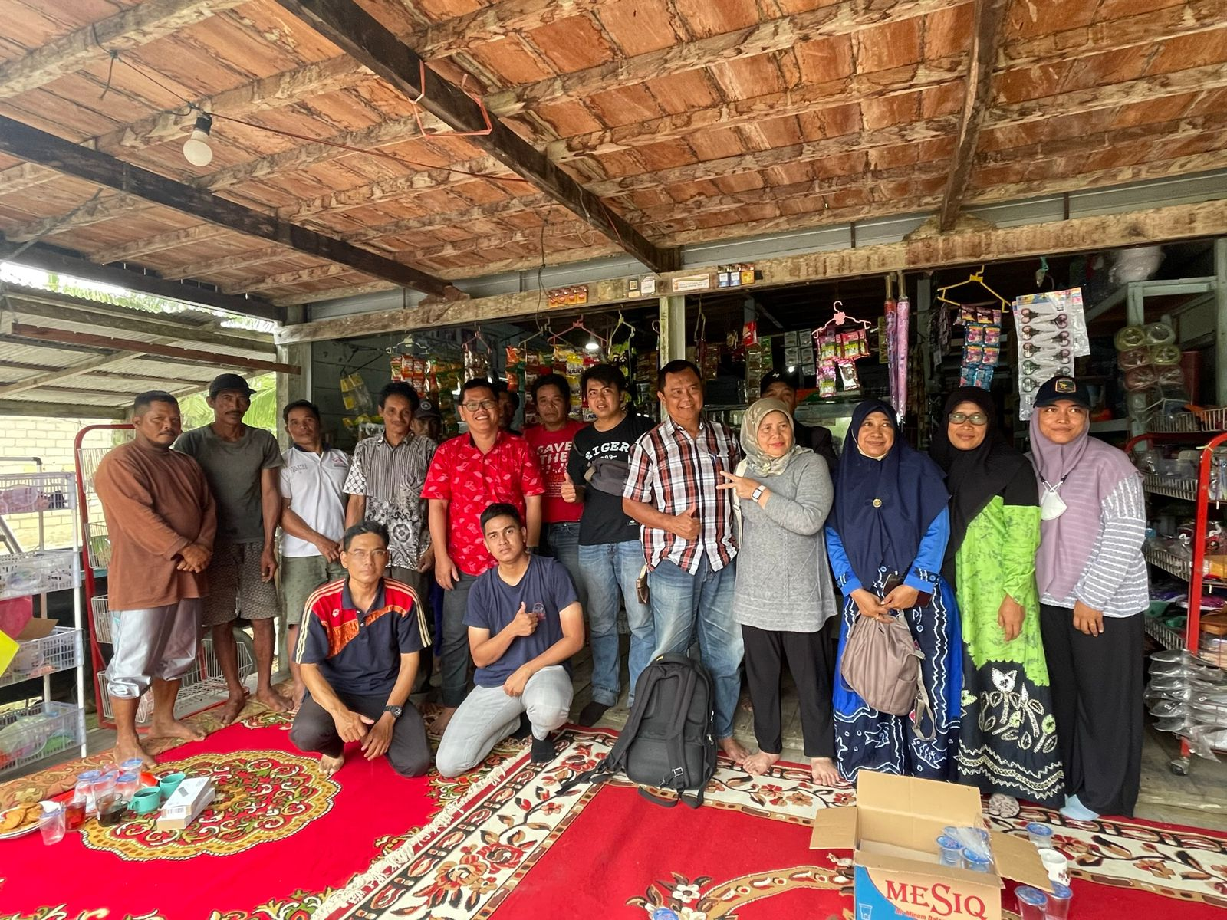

Picture 5. Review the CCTV footages, tracking devices data, and handover additional tracking devices at desa Salino

