ANNUAL Progress Report: Indian Ocean Swordfish -Longline FIP
- The priorities are making progress on (1) the status of the marine animals impacted by the fishery and on (2) management measures for endangered, threatened and protected species impacted by longline fishing for swordfish in the Indian Ocean.
- To this end, the FIP supports the conservation and management measures approved for the convention area of the Indian Ocean Tuna Commission.
- The following fishery progress was made in 2024:
Major Fishery Progress in 2024:
1. Progress on the status of marine animals impacted by the fishery
- Swordfish in the Indian Ocean is not overfished neither does it appear to be undergoing overfishing at this time (IOTC–2024–WPB22–R[E], page 40).
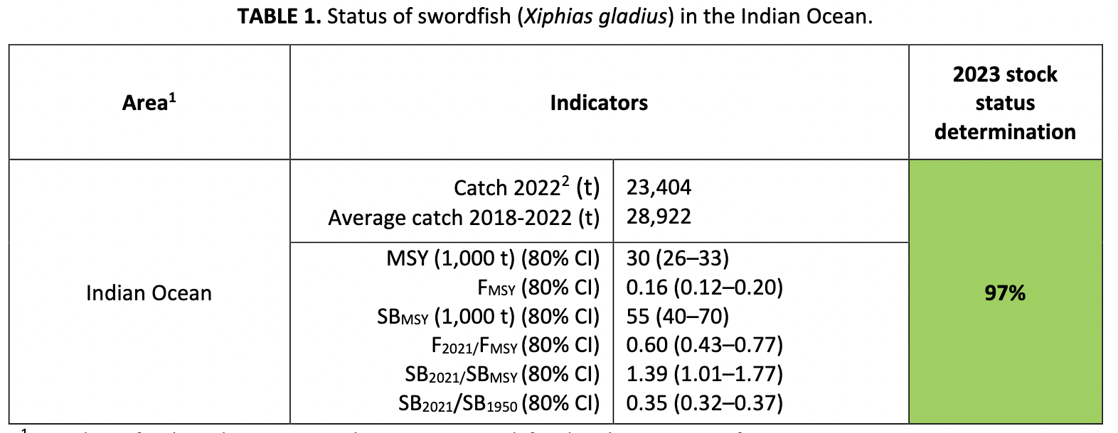
- The Indian Ocean Tuna Commission manages the swordfish fishery through its Working Party on Billfish, which held its 22nd session in the Seychelles, 4-7 September 2024. The Working Party reported on the status of marine animals caught regularly in billfish fisheries in its meeting document, IOTC-2024-WPB22-R[E], including
  - Swordfish (Xiphias gladius) – Not overfished/Overfishing not occurring
  - Black marlin ( Istiompax indica) – Overfishing is occurring
  - Blue marlin (Makaira nigricans) – Overfished
  - Striped marlin (Kajikia audax) – Overfished
  - Indo-Pacific sailfish (Istiophorus platypterus) – Not overfished/Overfishing not occurring
- These findings are timely and reveal that while swordfish is in good shape, three of five major billfish species are not in good shape. As billfishes, these animals occupy a similar niche in the ecosystem and are often captured together by both longline and purse seine fisheries in the Indian Ocean. Additionally, the 2020, 2021 and 2022 swordfish catches exceeded the catch limit prescribed in Resolution 18/05 (25,000 t), although the excess mortality is attributed to coastal gillnet fisheries, and noting that swordfish, marlins and sailfish are caught routinely in tuna fisheries as well.
- These results show that swordfish fishing is contributing to overfishing on marlins. This is needed information to complete a FIP action. In 2024, the FIP addressed the Marine Stewardship Council Fisheries Standard indicator 2.3.1 for the ecosystem outcome in order to, per the FIP workplan:
  - “Give consideration to the ecosystem role of the target species and the wider ecosystem impacts (both direct and indirect) in the setting of fishing opportunities. (2.5.1, MSC 2016:266)”.
- To complete this FIP action, the FIP aligns with the management recommendations set out by the Working Group on Billfishes at their 22nd meeting, as well as pertinent recommendations for this fishery made at the 20th Working Party on Ecosystems and Bycatch Data Preparatory Meeting (WPEB20(DP)) (April 22, 2024).
- In addition to recommendations for shark handling and release, the Working Party report contains catch and effort data for seven shark species and the most recent stock assessment showing mako shark (IOTC-2018-WPEB14-37) is subject to overfishing but not overfished.
- Based then on the best available science, the major targets in the FIP are better status and management for striped marlin, blue marlin, sailfish, mako shark, as priorities, as well as sea birds and sea turtles feeding on baited hooks.

2. Progress on management measures for endangered, threatened and protected species

- Notably for the FIP actions, among the prioritized recommendations made by the 22nd Working Party on Billfishes this year was a pressing need to improve catch-and-effort data (CPUE) for swordfish, marlins and sailfish from priority fleets (IOTC-2024-WPB22-R[E], page 61). Taiwan was identified as one of the priority fleets, and a portion of the vessels participating in the FIP are flagged to Taiwan. Collecting mitigation details was also prioritized.
- Notably for the FIP actions, among the pertinent recommendations made for this fishery by the 20th Working Party on Ecosystems and Bycatch Data Preparatory Meeting (WPEB20(DP)) (April 22) were: Fisheries bycatch of Sharks: Options for Mitigation , IOTC-2024-WPEB20(DP)-INF07, and switching to nylon from wire leaders in longline fisheries, see Effects of leader material on catches of shallow pelagic longline fisheries in the southwest Indian Ocean , IOTC-2024-WPEB20(DP)-INF09.
- These recommendations were taken up into the FIP workplan as priorities for the participating vessels.
- The FIP contributed in 2024 by avoiding incidental catches with gear modifications, reporting incidental catches when they occur, and continuing to improve techniques for safe handling and release.
- Participating vessel owners were engaged in safe handling and release, data collection for incidental catches, and reducing plastics disposal at sea.
- In November 2024, the vessel owners and captains also received instructions to (1) Mark the longline gear and dispose of spent gear back at port, not at sea, (2) Safely de-hook sea birds and avoid sea turtles with circle hooks and finfish bait, and (3) Avoid sharks by using nylon instead of wire leaders. For Taiwanese vessels only, an additional instruction was provided to record incidental catches for blue marlin, black marlin, and striped marlin.

The FIP completed a new social risk assessment in October 2024. The report was posted on the project profile and its results were incorporated into the social workplan that has been posted. This risk assessment departs significantly from the former version, which was previously required. Instead, the new risk assessment conforms to the requirements of human rights due diligence for participating vessels, as it has been defined by the UN Human Rights Council and put into practical guidelines by the Organisation for Cooperation and Economic Development. This new assessment conforms to the UN Guiding Principles on Business and Human Rights 2011 and in the OECD Due Diligence Guidance for Responsible Business Conduct 2018.

Note: This FIP makes progress in parallel to the Indian Ocean Swordfish FIP due to having the same buyer participants: Fong Hsiang Enterprises and SYMPAC International.

