Action 3 – Characterize Fishing Grounds
Task 2. Conduct workshop to solicit cooperative use of mapping tools by fishers

Workshops to encourage the collective use of mapping tools by fishermen have been conducted multiple times. These workshops are not delivered in formal events but are integrated into fishing trips where enumerators join fishermen on the main vessel. Besides introducing the mapping tools and explaining their functions, fishermen are actively involved in the installation of the devices on the vessel. Additionally, fishermen are invited to discuss their catch locations using maps brought by enumerators. These discussions take place during octopus fishing trips aboard the 'KMN. Cahaya Andira 04' to precisely understand the on-site conditions. Both the captain of the vessel and the fishermen participate in these discussions, not only to determine the exact points of catch but also to explore the conditions of the waters at each location. This approach is effective as it allows for easy visualization of the vessel's position and the fishing areas. The role and participation of fishermen can be seen in the images.

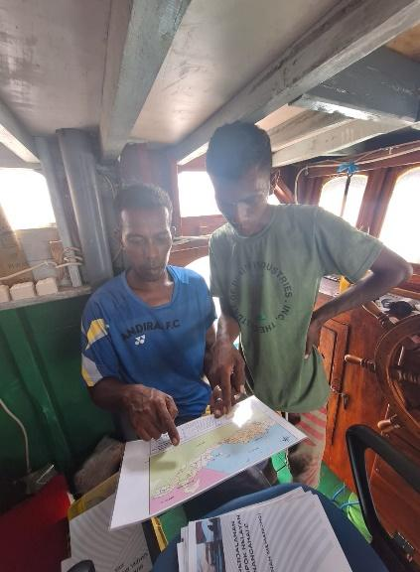 | 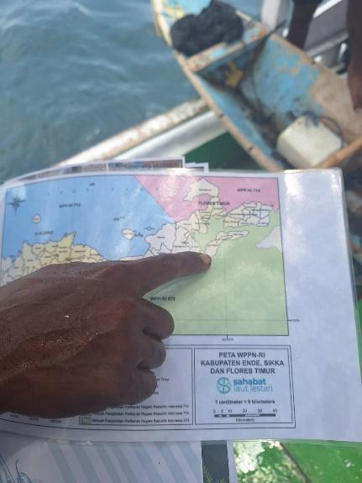 | 