Project UK Fisheries Improvement

**Task 6. Secondary species status for monkfish fishery, beam trawl, demersal trawl and tangle / trammel net**

Author(s): Ana Ribeiro Santos

Issue Date: 23/06/2018 (17/01/2019)

Cefas Document Control

|  |  |
| --- | --- |
| Submitted to: | Chloe North, PUKFI, facilitated by the MSC |
| Date submitted: | 06/07/2018 |
| Project Manager: | Anna Sypniewska-Huk |
| Report compiled by: | Ana Ribeiro Santos |
| Quality control by: | Tom Catchpole |
| Approved by and date: | 18/01/2019 |
| Version: | V3.0 |

|  |  |  |  |
| --- | --- | --- | --- |
| Version Control History | | | |
| Version | Author | Date | Comment |
| V1.0 | Ana Ribeiro Santos | 22/06/2018 | Report compilation |
| V1.0 | Thomas Catchpole | 28/06/2018 | QA |
| V2.0 | Ana Ribeiro Santos | 06/07/2018 | Add the out-of-scope species |
| V3.0 | Ana Ribeiro Santos | 17/10/2019 | Re-do the analysis for the netters to include only netters >=220mm |
| V3.0 | Thomas Catchpole | 18/01/2019 | QA |

Executive Summary

In 2017, Cefas was commissioned to contribute to the Seafish Project UK Fisheries Improvements PUKFI project. The project is facilitated by the MSC and aims to work towards an environmentally sustainable future for UK fisheries. It will do this through determining the environmental performance of key commercial fisheries, demonstrate how sustainability can be enhanced through Fishery Improvement Projects (FIPs) and ultimately achieve MSC certification where possible. Several fisheries were selected due to their importance for the UK market. One of which is the Western and Channel Monkfish beam trawl, demersal trawl, tangle/trammel and gillnets (>=220 mm) fisheries, in ICES areas VIIb-k, VIII a,b,d.

The objective of the study was to identify the main secondary species in the UK monkfish fishery in the Celtic Sea and assess the risk this fishery imposes on these species. The PSA and risk analysis indicate the species that are most at risk from fishing pressure, including their recoverability from removal through fishing.

According to the PSA scores, most of the secondary species have medium risk (between 2 and 3) for all the three gears types. The species with highest of PSA scores (Medium risk) were the skates and rays species – cuckoo ray, blonde ray and undulate ray caught by gill netters.

A review of management measures was carried out and possible alternative measures were discussed for the secondary species identified with the highest risks.

Table of Contents

1 Introduction 5

1.1 Aims and scope of work 5

1.2 Background of fishery 5

2 Material and methods 7

2.1 Data sources 7

2.2 Units of Assessment 7

2.2.1 Landings 8

2.2.2 Discards estimates 8

2.2.3 Out of scope species 9

2.3 Catch profile 9

2.4 Productivity and susceptibility Analysis - PSA 10

2.4.1 Productivity 10

2.4.2 Susceptibility 11

2.4.3 Information sources 13

3 Results 13

3.1 Catch profile 13

3.1.1 Out of scope species catches 13

3.2 Productivity scoring 18

3.3 Susceptibility score 20

3.4 PSA Risk Assessment 24

4 Review of management measures 27

5 Data limitations for bycatch and rare species 29

6 Conclusions 30

7 References 31

Tables

Table 1 Unit of Assessments 7

Table 2 Number of trips sampled for each gear type, between 2014 and 2017, in ICES areas VIIb-k. 8

Table 3. Life history attributes for productivity assessment and cut off scores for risk levels. 10

Table 4. Vulnerability attributes for scoring risk levels to the fisheries. 12

Table 5. Estimated number of porpoises by-catch by the UK gillnet fisheries in 2017, by metier, assuming no pingers were used and assuming all over 12m vessels used pingers, in all areas (adapted from Northridge *et al*., 2018). 14

Table 6. Estimated number (Low 95% CI – Upper 95% CI) of Common dolphin and Common seal by-catch by the UK gillnet fisheries, in 2017, by metier, all areas (adapted from Northridge *et al*., 2018). 14

Table 7. Catch profile – Mean annual Landings and discards, between 2015 and 2017 (Data sources: Official landings database and Cefas Observer programme for discards estimates). 15

Table 8. Productivity score for each Secondary species identified for the monkfish species, demersal trawl, beam trawl and netters. 18

Table 9. Susceptibility score for secondary species from tangle/trammel and gill nets (>=220mm). 20

Table 10. Susceptibility score for secondary species from demersal trawls, targeting monkfish. 22

Table 11. Susceptibility score for secondary species from beam trawls. 23

Table 12. Productivity and susceptibility scores and final PSA score for the monkfish fisheries main secondary species. 25

Figures

Figure 1. Maps with the stock area for monkfish ICES Divisions 7.b-k and 8.a,b,d (Source: Lambert et al, 2018). 5

Figure 2. Number of trips of netters, otter (OTB) and beam trawls (TBB), targeting monkfish in ICES area VII, between 2014 and 2017 (Data source: UK Official landings). 6

Figure 3. Overall risk of netters to secondary species. 26

Figure 4. Overall risk of demersal trawls to secondary species. 26

Figure 5. Overall risk of beam trawls to secondary species. 27

# 

# Introduction

In 2017, Cefas was commissioned to contribute to the Seafish Project UK Fisheries Improvements (PUKFI[1]) project. This initiative is a multi-stakeholder engagement process working towards achieving an environmentally sustainable future for UK fisheries by engaging with six fisheries selected for their importance to the UK market (in particular UK supermarket chains). The project is facilitated by the MSC and aims to work towards an environmentally sustainable future for UK fisheries. It will do this through determining the environmental performance of key commercial fisheries, demonstrate how sustainability can be enhanced through Fishery Improvement Projects (FIPs) and ultimately achieve MSC certification where possible. Several fisheries were selected due to their importance for the UK market. One of which is the Western and Channel Monkfish beam trawl, demersal trawl, tangle/trammel and gillnets fisheries, in ICES areas VIIb-k, VIII a,b,d.

## Aims and scope of work

Under the MSC certification process Principle 1 covers the sustainability and management of the target stocks, while Principle 2 requires that fishing activity must be managed carefully so that other species and other habitats within the ecosystem remain healthy. Other species are defined as primary; secondary; and endangered, threatened or protected (ETP) species. Primary species are species where management tools and measures are in place, intended to achieve stock management objectives reflected in either limit or target reference points, while secondary species are those lacking such management tools and are not classified as ETP.

Due to the limited data for secondary species it is not possible to perform an assessment using the default methods, therefore a Productivity Susceptibility Analysis (PSA) is used to assesses how likely a main secondary species are likely to recover when depleted.

A species is defined as ‘main’ where it represents ≥5% by weight of the total catch or ≥2% by weight of the total catch for species with intrinsically low resilience.

The main aims and the scope of this study are to:

1. Identify the main secondary species for demersal trawls, beam trawls, tangle/trammel and gillnets (>=220mm) fisheries targeting monkfish in in the Celtic Sea, using English landings and discards data;
2. Undertake a Productivity-Susceptibility Analysis (PSA) for all main secondary species, by gear type.
3. Undertake PSA for the out-of-scope species for netters fisheries.

## Background of fishery

Two species of monkfish can be encountered in UK waters; thewhite-bellied anglerfish *Lophius piscatorius* and black-bellied anglerfish *L. budegassa.* They are caught together in the same fisheries, and their landings are reported under the same species code. Overall, catches are usually about 80% *L. piscatorius* and 20% *L. budegassa*. The species are assessed by ICES, separately and both species are considered to be category 3 stocks (i.e *stocks for which survey-based assessments indicate trends: Includes stocks for which survey or other indices are available that provide reliable indications of trends in stock metrics, such as total mortality, recruitment, and biomass*). For category 3 stocks the available knowledge is insufficient to apply the ICES MSY approach and the advice rule is therefore based on the precautionary approach. The management of the two-anglerfish species is under a combined TAC, and because of this, there is a risk of overexploitation of one of the two species. Figure 1 shows the stock area for monkfish stock ICES Divisions 7.b-k and 8.a, b, d.

The TAC for anglerfish in ICES area 7 for 2018 was 33,516t, with all being allocated to EU, and UK receiving 18% of the quota (6,027t).

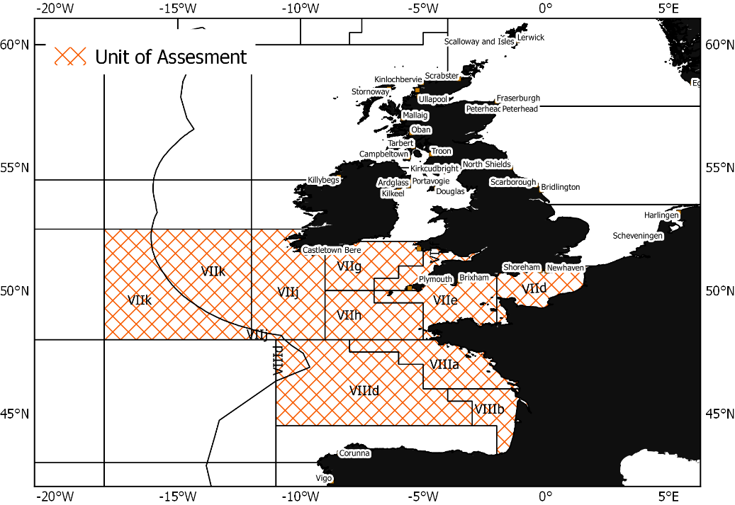

Figure 1. Maps with the stock area for monkfish ICES Divisions 7.b-k and 8.a,b,d (Source: Lambert et al, 2018).

The main gears targeting monkfish are the beam and demersal trawls and gill netters. Figure shows the number of trips per rectangle, by gear, for the trips by UK vessels that were identified to be targeting monkfish (>=5% of the total landings was anglerfish). The gillnet (netters >220mm) trips are widely spread in area VII, while the otter trawls have a more confined fishing area, closer to the shore, with most of the trips west of Lyme Bay, in ICES rectangles 29E5, 28E5 and 29E6. Beam trawls fish across the whole ICES VII.

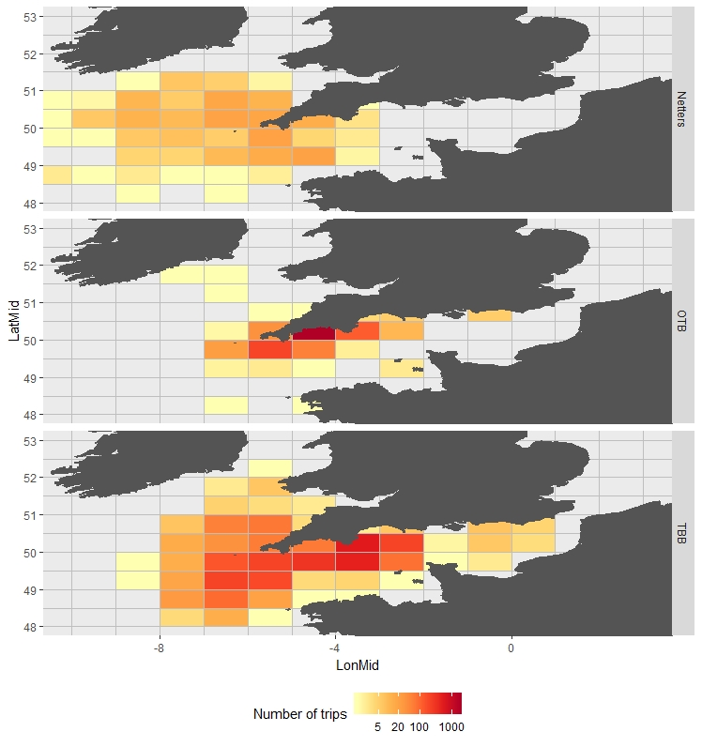

Figure 2. Number of trips of netters (>=220mm), otter (OTB) and beam trawls (TBB), targeting monkfish in ICES area VII, between 2014 and 2017 (Data source: UK Official landings).

# Material and methods

## Data sources

A catch profile was developed using the official landings database (MMO landings database) and discards data collected by Cefas Observer programme, between 2014 and 2017, on beam trawls, otter trawls (demersal trawls) and gillnets/trammel nets (>=220mm), in ICES areas VII b-k and VIIIa,b,d.

## Units of Assessment

The Unit of Assessment (UoA), based upon the stocks, area, people involved and class of boats, for this updated pre-assessment is defined in Table 1.

Table 1 Unit of Assessments

|  |  |
| --- | --- |
| Target Stock: | White anglerfish (*Lophius piscatorius*) and black-bellied anglerfish (*L. bodegassa*) in divisions 7.b–k, 8a–b, and 8d (southern Celtic Seas, Bay of Biscay) |
| Fishing Method / gear type: | UoA 1: Trammel nets and entangling / gillnets (>220 mm mesh size) - Netters  UoA 2: Demersal Trawl - OTB  UoA 3: Beam Trawl – TBB |
| Fishing Fleet | UK Registered vessels |
| Area: | UK & EU waters: ICES Area 7.b–k, 8a–b, and 8d (southern Celtic Seas, Bay of Biscay) |

Given the open scope of the UoA (i.e. all UK registered vessels) no other eligible fisheries are likely; for the purpose of this work, UoA 1 is called ‘Netters’.

### Landings

Landings from a list of vessels from all relevant UK producers’ organisations: South West Fish Producer Organisation (SWFPO), Cornish Fish Producer Organisation (CFPO) and Interfish were used to develop the catch profile. To select trips where monkfish species are targeted, logbook data were analysed for the specified vessels/area/gear combinations. The proportion of the landings of monkfish in the total landings of the trip was calculated. Only the trips where monkfish contributed 5% or more to the total landings were selected for the PSA analysis. The average annual landings per species and gear type (OTB, TBB and Netters), between 2014 and 2017, was calculated.

### Discards estimates

The current Cefas off-shore sampling scheme was set up in 2001, with some changes made throughout the years to take into account the regional and technical. in which the main objective is to collect data on discards and biological data for the main commercial species (Detail of the sampling design in Appendix 2).

The Cefas observer sampled trips (Table 2) targeting monkfish (white anglerfish and black-bellied anglerfish) were selected. This was defined as where the combined catch weight of these two species constituted 5% or more of the total landings for the trip.

For each trip, numbers-at-length were raised to the haul, based on an estimated proportion of the total catch volume sampled, then to the trip, based on the proportion of sampled hauls and fished hauls. The length-based data was converted to biomass, using length-weight relationships for each species collected during various scientific trawl surveys (Cefas, unpubl. data).

The discards were estimated using the same methodology used for the provision of the English discards to ICES stock assessment working groups (Description in Appendix 2). Discard trip-raised estimates summed for sampled vessels, by year and gear type (OTB, TBB and Netters >=220), were raised to total fleet using a ratio between the reported total landing trips and the number of trips sampled. The average discards between 2014 and 2017, for each gear type was calculated.

Table 2 Number of trips sampled for each gear type, between 2014 and 2017, in ICES areas VIIb-k.

|  |  |  |  |
| --- | --- | --- | --- |
|  | Netters (>=220mm) | Otter trawls (OTB) | Beam trawls (TBB) |
| Number of trips sampled | 28 | 48 | 76 |
| Number of landing trips | 1079 | 21201 | 662 |
| Number of landing trips targeting monkfish | 760 | 8446 | 5348 |
| Proportion of trips sampled per year | 3% | 0.5% | 1.4% |

### Out of scope species

Cefas Observer programme did not record catches of any out of scope species (e.g. marine mammals, seabirds and reptiles), for the entangling/trammel nets fishery, between 2014-2017. Therefore, other sources of quantitative information for marine mammals’ catches were obtained from the Sea Mammal Research Unit (SMRU) yearly reports to the European Commission (Northridge *et al*. 2018). SMRU conducts every year a dedicated protected species bycatch monitoring programme, in collaboration with the Centre for Environment, Fisheries and Aquaculture Science at Lowestoft (Cefas) and the Agri-Food and Biosciences Institute of Northern Ireland (AFBINI). Data provided by Cefas and AFBINI include discard 7 sampling conducted under the Data Collection Framework (DCF), data collected under other specific research efforts, and a limited number of dedicated sea days where protected species bycatch monitoring is the main focus for their observers. SMRU dedicated programme samples midwater/pelagic trawls, gillnets and tangle nets and longline.

It is important to note that the catch estimates data presented at the report are for all UK gillnet fisheries, targeting any commercial species. The most recent data showed that the only marine mammal species recorded were: Common porpoise, Common dolphin and Grey/Common Seal species.

## Catch profile

Landings and discards estimates were combined to produce total catch profile for each UoA (OTB, TBB and Netters). Landings, Discards and proportion of each species in the catch are presented in Table 4.

The latest version of the MSC standard re-categorises those other species caught in the fishery as either Primary (PI 2.1.1-2.1.3) or Secondary (2.2.1 – 2.2.3), regardless of whether it is retained or discarded. The rationale to define a species as **Primary species** within Principle 2 as those where an analytical stock assessment is available, that have management measures and tools in place intended to achieve stock management objectives reflected in either limit or target reference points. If a species is a data limited stock (DLS), management limits or reference points are not in place then the species is classified as a **Secondary species** (unless it is classified as Endangered, Threatened or Protected).

The main secondary species were selected for each UoA, based on the proportion of the total catch (kg), using a 5% of total catch threshold or 2% for less resilient species (generally long lived, low fecund species such as most sharks).

## Productivity and susceptibility Analysis - PSA

The PSA approach is a method of assessment which allows all units within any of the ecological components to be screened for risk. The PSA methodology scores attributes on a three-point scale (i.e., 1 = low, 2 = moderate, 3 = high). It combines information on productivity and exposure to fishing to assess potential risk. Because of the precautionary approach to uncertainty, the list of high-risk species should not be interpreted as all being at high risk from fishing. instead this approach considered to be a screening process to identify species or habitats that require further investigation. Stocks that receive a low productivity score and a high susceptibility score are considered to be the most vulnerable, while stocks with a high productivity score and low susceptibility score are considered to be the least vulnerable.

### Productivity

There are eight different intrinsic parameters that are required for assessing the productivity of species. These are explicitly outlined in Table 2.

Table 3. Life history attributes for productivity assessment and cut off scores for risk levels.

|  |  |  |  |
| --- | --- | --- | --- |
| **Productivity attribute** | **High productivity (Low risk, score =1)** | **Medium productivity (medium risk, score =2)** | **Low productivity (high risk, score =3)** |
| Average age maturity | >5 years | 5-15 years | >15 years |
| Average maximum age (*Lmax*) | <10 years | 10-25 years | >25 years |
| Fecundity | >20,000 eggs per year | 100 – 20,000 eggs per year | <100 eggs per year |
| Average maximum size (not to be used when scoring invertebrates) | <100 cm | 100-300 cm | >300 cm |
| Average size at maturity *Lmat* (not to be used when scoring invertebrates) | <40 cm | 40-200 cm | >200 cm |
| Reproductivity strategy | Broadcast spawner | Demersal egg layer | Live bearer |
| Trophic level | <2.75 | 2.75 – 3.25 | >3.25 |
| Density dependence (to be used only for invertebrates) | Compensatory dynamics at low population size demonstrated or likely | No depensatory or compensatory dynamics demonstrated or likely | Depensatory at low populations sizes (Allee effects) demonstrated or likely |

**Average age maturity (*tmat*):** Age at maturity tends to be positively related with maximum age (*tmax*), as long-lived, lower productivity stocks will have higher ages at maturity relative to short-lived stocks.

**Average Maximum age (*tmax*):** Maximum age is a direct indication of the natural mortality rate (*M)*, where low levels of *M* are negatively correlated with high maximum ages.

**Maximum size (*Lmax*)**: Maximum size is correlated with productivity, with larger species tending to have lower levels of productivity. The scoring definitions were based on the ANOVA applied to the observed fish stocks considered to be representative of U.S. fisheries (Patrick *et al.* 2009). The *Lmax* for a majority of these fish ranges between 60 to 150 cm TL.

**Fecundity**: Fecundity (i.e., the number of eggs produced by a female for a given spawning event or period) varies with size and age of the spawner, so Patrick *et al.* (2009) suggested that fecundity should be measured at the age of first maturity. However, low values of fecundity imply low population productivity, but high values of fecundity do not necessarily imply high population productivity; thus, this attribute may be more useful at the lower fecundity values. In reality, estimates of fecundity are rare, and certainly have not been reported specific to age-at-maturity. Nevertheless, low-fecund species could be easily identified and the attribute scores made to reflect this.

**Average size (*Lmat):*** Length at first maturity is more readily available, or could be inferred, for some species. Equivalent approximate breaks in size maturity were defined for total lengths of 40cm and 100cm.

**Reproductivity strategy**: The breeding strategy of a stock provides an indication of the level of mortality that might be expected for the offspring in the first stages of life.

**Trophic level**: The position of a stock within the larger fish community can be used to infer stock productivity, with lower-trophic-level stocks generally being more productive than higher-trophic-level stocks. The trophic level of a stock can be computed as a function of the trophic levels of the organisms in its diet. For this attribute, stocks with trophic levels higher than 3.5 were categorized as low productivity stocks and stocks with trophic levels less than 2.5 were categorized as high-productivity stocks, with moderate productivity stocks falling between these bounds.

**Density dependence –** This attribute was only considered for the shellfish species. Species with a depensatory dynamic, i.e. an effect where a decrease in the breeding population leads to reduction on production and survival of eggs or offspring, imply low population productivity. On the other hand, a species with compensatory dynamic at low population size indicates that the species population increases eggs production and offspring, which implies high population productivity.

### Susceptibility

The level of fishing pressure that a species can sustain depends on its susceptibility (vulnerability) to capture or damage.

Four attributes were used to score the susceptibility of each secondary species in each UoA, described in Table 3.

Table 4. Vulnerability attributes for scoring risk levels to the fisheries.

|  |  |  |  |
| --- | --- | --- | --- |
| Susceptibility attribute | **Low susceptibility (Low risk, score =1)** | **Medium susceptibility (medium risk, score =2)** | **High susceptibility (high risk, score =3)** |
| Areal overlap | <10% | 10-30% | >30% |
| Encounterability | Low overlap with fishing gear | Medium overlap with fishing gear | High overlap with fishing gear |
| Selectivity of gear type | Individuals < size at maturity rarely caught  Individuals <size at maturity can escape or avoid gear | Individuals < size at maturity regularly caught  Individuals <half size at maturity can escape or avoid gear | Individuals < size at maturity frequently caught  Individuals <half size at maturity are retained by gear |
| Post-capture mortality | Evidence of majority released post-capture and survival (>= 50% survival) | Evidence of some released post-capture and survival (20%- 49% survival) | Retained species or majority dead when released (<=20% survival). |

**Areal overlap-** This attribute pertains to the extent of geographic overlap between the known distribution of a stock and the distribution of the fishery. Greater overlap implies greater susceptibility, as some degree of geographical overlap is necessary for a fishery to impact a stock. The simplest approach is to determine, either qualitatively or quantitatively, the proportion of the spatial distribution of a given fishery that overlaps that of the stock, based on known geographical distributions of both.

**Encounterability -** Similar to geographical overlap, this attribute concerns the position of the stock within the water column (i.e., demersal or pelagic) relative to the fishing gear. Information on the depth at which gear is deployed (e.g., depth range of hooks for a pelagic longline fishery) and the depth preference of the species (e.g. obtained from archival tagging or other sources) can be used to estimate the degree of vertical overlap between fishing gear and a stock.

**Selectivity of gear type** - This attribute regards to the likelihood of the species being captured once being encountered by the fishing gear, where the length of the species should be used to inform on this aspect of the assessment. The information gathered from the analysis of the Cefas observer data in the previous section will be used to supplement the classification process appropriately.

**Post-capture mortality** - Fish survival after capture and release varies by species, region, and gear type or and can be influenced by many technical, environmental and biological factors, and thus can affect the susceptibility of the stock. A variety of scientific sources will be used to score the survivability of species. Some species of fish have been subject to post-capture survival studies. Summary of the existent survival evidence for the secondary species (plaice, skates and rays) for the monkfish fishery in the Celtic Sea in Appendix 1.

### Information sources

The species considered here were those reported to be caught by the UK vessels, using demersal trawls, beam, trawls and gill/trammel nets, in the Celtic Sea. The PSA used the information available in Fishbase (Froese and Pauly 2000; [www.fishbase.org](http://www.fishbase.org)) and ICES reports (ICES WKLIFE, 2017). While use of this information directly from Fishbase is not entirely satisfactory, it is quick and, for most species attributes, should be accurate enough to place them in the correct PSA categories.

One species of crabs and cephalopods were reported in the catches. The information used for the PSA was obtained in various scientific papers detailed in Table 6.

# Results

## Catch profile

In this study, the PSA was carried out for each UoA, only for the species classified as **Secondary species**, under Principle 2. Landings and discards estimates were combined to produce total catch profile for each UoA (OTB, TBB and Netters). Landings, Discards and proportion of each species in the catch are presented in Table 3. The main secondary species for each UoA include:

* **Netters (tangle/trammel and gillnets >220 mm):** turbot (*Psetta maxima*), edible crab (*Cancer* pagurus), cuckoo ray (*Leucoraja naevus*), hake (*Merluccius merluccius*), blonde ray (*Raja brachyura*), undulate ray (*R. undulata*) and spider crab (*Maja squinado*).
* **Otter trawls**: cuttlefish (*Sepia spp.*), lemon sole (*Microstomus kitt*), megrims (*Lepidorhombus spp.*), plaice (*Pleuronectes platessa*)[2], gurnards and lesser spotted dogfish (*Scyliorhinus canicular*).
* **Beam trawls**: megrims, plaice, gurnards, Dover sole (*Solea solea*)[3], whiting-pout (*Trisopterus luscus*) and lesser spotted dogfish.

### Out of scope species catches

SMRU dedicated surveys in 2017, recorded observations of 5 harbour porpoises and 3 common dolphins all in static net fisheries including large mesh nets for anglerfish (monkfish), hake nets and haddock gillnets. CEFAS conducted 72 non-dedicated days on static net vessels, 12 days on hand line vessels and 2 days in midwater trawl fisheries in 2017. No mammal bycatch was reported.

**Common Porpoise**

According with Northridge *et al*. (2018), the catch estimates of porpoises taken in the UK gillnet fisheries in 2017 ranged between 1098 individuals, assuming all vessels over 12m used pingers and 1282 individuals, with no pingers used. The catch estimates for each meatier are across all areas (ICES areas IV, VI, VII and VIII). However, 86% of the catches are estimated to come from ICES area VII (Table 5).

Table 5. Estimated number of porpoises by-catch by the UK gillnet fisheries in 2017, by metier, assuming no pingers were used and assuming all over 12m vessels used pingers, in all areas (adapted from Northridge *et al*., 2018).

|  |  |  |
| --- | --- | --- |
| **Metier** | **Estimated total annual by-catch (Low 95% CI - Upper 95% CI), no pinger** | **Estimated total annual by-catch (Low 95% CI - Upper 95% CI), with pinger** |
| Driftnet demersal | 16 (2 - 58) | 16 (2 - 58) |
| Driftnet pelagic | 34 (4 - 120) | 34 (4 - 131) |
| Gillnets | 118 (51 - 231) | 107 (46 - 229) |
| Gillnets hake | 121 (68 - 199) | 20 (5 - 144) |
| Gillnet light | 358 (146 - 729) | 358 (146 - 746) |
| Gillnet flatfish | 61 (2 - 336) | 60 (2 - 602 |
| Tangle/Trammel | 574 (445 - 728) | 503 (383 - 706) |
| **Total** | **1282** | **1098** |

**Common Dolphin and Common Seal**

Northridge *et al*. (2018) estimated a total by-catch of common dolphin and common seal taken by the UK gillnet fisheries of 258 (CV 0.09, 95% confidence limits 140-737) and 572 animals (CV = 0.07; 95% confidence limits 429-1077), respectively. The estimates are by metier across all ICES areas. However, 87% of the catches are from ICES area VII.

Table 6. Estimated number (Low 95% CI – Upper 95% CI) of Common dolphin and Common seal by-catch by the UK gillnet fisheries, in 2017, by metier, all areas (adapted from Northridge *et al*., 2018).

|  |  |  |
| --- | --- | --- |
| **Metier** | **Common dolphin** | **Common seal** |
| Driftnet demersal | 0 (0 - 21) | 0 (0 - 21) |
| Drift pelagic | 0 (0 - 44) | 0 (0 - 44) |
| Gillnets | 28 (8 - 72) | 21 (4 - 62) |
| Gillnets hake | 45 (24 - 79) | 0 (0 - 14) |
| Gillnet light | 30 (1 - 164) | 0 (0 - 109) |
| Gillnet flatfish | 0 (0 - 140) | 38 (1 - 212) |
| Tangle/Trammel | 155 (108 - 217) | 512 (423 - 615) |

**Seabirds**

Reported seabird bycatches in 2017 amounted to 17 individuals of two species (see Table 7.1) and consisted of 15 guillemots and 2 cormorants. These were all reported from Divisions 7def and were mainly caught in gillnets targeting pollack, haddock, plaice and monkfish (see Table 7.2). However, the current existent data is not sufficient for a robust assessment or to provide a total estimated number (Northridge *et al*., 2018).

Table 7. Catch profile – Mean annual Landings and discards, between 2015 and 2017 (Data sources: Official landings database and Cefas Observer programme for discards estimates).

| Gear type (UoA) | Common Name | Mean annual landings (2014-2017) (kg) | Mean annual Discard estimates (kg) | Discard rate | Total estimated catch (kg) | Percentage | Threshold | Spp definition | Comments |
| --- | --- | --- | --- | --- | --- | --- | --- | --- | --- |
| Netters | Angler fishes | 234,819 | 3,634 | 0.02 | 239,210 | 21% | 5% | targeted spp |  |
| Netters | Turbot | 156,898 | 48 | 0.00 | 156,947 | 11% | 5% | Secondary | Stock not Assessed by ICES in area VII. |
| Netters | Edible crab | 29,007 | 24730 | 0.28 | 53,737 | 8% | 5% | Secondary | Stock not Assessed by ICES in area VII. |
| Netters | European hake | 20422 | 5,074 | 0.02 | 25,497 | 7% | 5% | Primary | Stock Greater NS, Celtic Seas and Norther Bay of Biscay. ICES category 1. MSY approach |
| Netters | Cuckoo ray | 20,873 | 3,235 | 0.08 | 24,108 | 7% | 2% | Secondary | Stock in subareas 1-10, 12 and 14. ICES category 3. Precautionary approach |
| Netters | Blonde ray | 18,876 | 1,810 | 0.02 | 20,687 | 6% | 2% | Secondary | Stocks: 7e; 7a and 7f-g. ICES category 5. Precautionary approach |
| Netters | Undulate ray | - | 31,061 | 1.00 | 31,061 | 7% | 2% | Secondary | Stock not Assessed by ICES in area VII. |
| OTB | Cuttlefish | 500,665 | 4,556 | 0.00 | 505,221 | 22% | 5% | Secondary | Stock not Assessed by ICES in area VII. |
| OTB | Angler fishes | 350,342 | 9,570 | 0.01 | 359,912 | 16% | 5% | targeted spp |  |
| OTB | Lemon sole | 336,229 | 14,041 | 0.02 | 350,270 | 15% | 5% | Secondary | Stock not Assessed by ICES in area VII (only in 7d). |
| OTB | Whiting | 199,680 | 127,311 | 0.24 | 326,991 | 9% | 5% | Primary | Stock 7b-c and 7e-k. Category 1. MSY approach |
| OTB | Haddock | 150,121 | 1,377,091 | 0.68 | 1,527,212 | 7% | 5% | primary | Stocks: 7a and 7b-k. Category 1. MSY approach |
| OTB | Lesser spotted dogfish | - | 1,021,753 | 0.80 | 1,021,753 | 13% | 2% | Secondary | Stock 7.a–c and 7.e–j, Category 3. Precautionary approach |
| TBB | Cuttlefish | 3,130,909 | 38,983 | 0.01 | 3,169,892 | 26% | 5% | Secondary | Stock not Assessed by ICES in area VII. |
| TBB | Angler fishes | 2,782,993 | 267,055 | 0.07 | 3,050,048 | 23% | 5% | Targeted spp |  |
| TBB | Megrims | 998,992 | 142,502 | 0.09 | 1,141,494 | 8% | 5% | Secondary | 2 Species stocks: four-spot megrim - category 5 Precautionary approach. Megrim - category1 MY approach |
| TBB | European plaice | 926,023 | 322,925 | 0.37 | 1,248,947 | 8% | 5% | Secondary | Stocks: 7a, 7e, 7b-c, 7f-g and 7h-k. Only stock 7a and 7e are categroy1 and MSY approach. The rest are category 3-6 - Precautionary approach |
| TBB | Gurnards | 686,167 | 324,760 | 0.59 | 1,010,927 | 6% | 5% | Secondary | Stock not Assessed by ICES in area VII. |
| TBB | Dover Sole | 681,154 | 13,442 | 0.02 | 694,596 | 6% | 5% | Secondary | Stocks: 7a, 7e, 7d, 7b-c, 7f-g and 7h-k. Stocks 7a, 7e, 7d and 7f-g are category1 and MSY. 7b-c and 7h-k are 3 and 6, precautionary approach. |
| TBB | Whiting-pout (Bib) | 571,852 | 431,350 | 0.64 | 1,003,203 | 5% | 5% | Secondary | Stock not Assessed by ICES in area VII. |
| TBB | Lesser Spotted dogfish | - | 1,203,153 | 0.93 | 1,203,153 | 8% | 2% | Secondary | Stock 7.a–c and 7.e–j, Category 3. Precautionary approach |

## Productivity scoring

Table 8. Productivity score for each Secondary species identified for the monkfish species, demersal trawl, beam trawl and netters

| **Species** | **Group** | **Average age at maturity (years)** | **Average max age** | **Fecundity** | **Average max size (cm)** | **Average size at Maturity** | **Reproductive strategy** | **Trophic level** | **Density Dependence** | **Total productivity** | **Source** |
| --- | --- | --- | --- | --- | --- | --- | --- | --- | --- | --- | --- |
| Turbot | Teleost | 2 | 18 | 1,000,000 | 88 | 34.2 | Batch-spawner | 3.96 | NA | 1.43 | Fishbase; Erylmaz and Dalyan, 2015; Heesen *et al,* 2015; WKLIFE, 2017 |
| Lemon sole | Teleost | 3 | 23 | 672,000 | 66 | 27 | Batch-spawner | 3.21 | NA | 1.43 | Fishbase; Heesen et al, 2015; WKLIFE, 2017 |
| Megrims | Teleost | 3 | 16 | 27,000 - 640,000 | 60 | 23 | Batch-spawner | 4.3 | NA | 1.43 | Fishbase; WKLIFE, 2017 |
| European plaice | Teleost | 2.7 | 30 | 700,000 | 91 | 22.9 | Batch-spawner | 3.2 | NA | 1.43 | Fishbase; Heesen et al, 2015; WKLIFE, 2017 |
| Dover sole | Teleost | 3 | 40 | 350,000 | 70 | 27 | Batch-spawner | 3.3 | NA | 1.57 | Fishbase; Heesen et al, 2015 |
| Whiting pout | Teleost | 2 | 5-7 | 200,000 | 41 | 21.6 | Batch-spawner | 3.7 | NA | 1.29 | Fishbase |
| Gurnards | Teleost | 3-4 | 8-21 | 300,000 | 40-50 | 18-26 | Batch-spawner | 3.85 | NA | 1.43 | Fishbase; Heesen et al, 2015 |
| Blonde ray | Elasmobranch | 10 | 15 | 90 | 128 | 92 | Demersal egg layer | 3.76 | NA | 2.29 | Fishbase |
| Cuckoo ray | Elasmobranch | 5 | 12 | 70-150 eggs | 71 | 57 | Demersal egg layer | 3.63 | NA | 2.29 | Fishbase; Heesen et al, 2015 |
| Undulate ray | Elasmobranch | 7.5 males / 9 females | 20 | 88 eggshells/year | 114 | 73 - 83 | Demersal egg layer | 3.5 | NA | 2.29 | Fishbase; Heesen et al, 2015 |
| Lesser spotted dogfish | Elasmobranch | 9 | 12 | 29-62 | 100 | 57 | Demersal egg layer | 3.8 | NA | 2.29 | Fishbase; Shark Trust Guide; Heesen et al, 2015 |
| Edible crab | Crustaceans | NA | NA | 345,000 - 3,000,000 | 25 | 11 | Batch-spawner | No info | 1 | 1.33 |  |
| Cuttlefish | Cephalopod | <1 year | 90 days | 3700 - 8000 | 45 | 13 | Batch-spawner | 3.7 | 1 | 1.17 | Onsoy and Salman, 2005; ICES, 2010; Forese *et al*., 2005. |
| **Out of Scope Species** | | | | | | | | | | | |
| Common porpoise | Marine Mammal | 3-4 | 22-24 | 1 pup/2 years | 173cm | 130-145cm | Live bearer | 4.1 | NA | 2.29 | Lockyer (2003); Learmonth *et al*. (2014); Pauly *et al (*1998) |
| Common dolphin | Marine Mammal | 12 | 25-30 | 1 pup/2 years | 170-170 cm | 195-233cm | Live bearer | 4.2 | NA | 2.57 | Murphy *et* al., (2005); Pauly *et al (*1998) |
| Common seal | Marine Mammal | 3-5 | 30 | 1 pup/2 years | 200-230 cm | 200cm | Live bearer | 4.0 | NA | 2.43 | JNCC (2005); Pauly *et al (*1998) |
| Guillemot | Seabird | 5 | 20 | 1 egg /year | 38–46 cm (length) | no info found | Oviparous | >=4.0 | NA |  | Harry *et* al., (2000); Pauly *et al (*1998) |
| Cormorants | Seabird | 2-4 | 25 | 3-5 eggs/year | 80-100cm (length) | no info found | Oviparous | >=4.0 | NA |  | http://ec.europa.eu/environment/nature/cormorants/home_en.htm;  Pauly *et al (*1998) |

## Susceptibility score

Table 9. Susceptibility score for secondary species from tangle/trammel and gill nets (>=220mm).

| Species | **Tangle/ Trammel and Gill nets (Netters >=220mm)** | | | |  |
| --- | --- | --- | --- | --- | --- |
| Areal coverage | Encounterability | Selectivity | Post-capture mortality | Source |
| Turbot | 10-30% Widely distributed around the British Isles. | Demersal / Continental shelves, 50m | High | Medium (like the other flatfish) | Heesen et al, 2015; |
| Blonde ray | 10-30% Widely distributed on the west British continental shelf | Demersal / Continental shelves, 15-150 (50m) | High | 44% immediate survival - medium | Heesen et al, 2015, Catchpole *et al*., 2017. |
| Cuckoo ray | 10-30% Widely distributed on the west British continental shelf | Demersal / Continental shelves, 30-300m | High | 33% survival - medium | Heesen et al, 2015; Enever *et al*., 2009 |
| Undulata ray | >30% Patchy distribution, mainly in the English Channel | Demersal / Continental shelves, <80m | High | Low mortality | Heesen et al, 2015 |
| Edible crab | <10% Widely distributed | Benthic, 50-90m | High | 46 - 78% immediate survival - Low mortality | Revill, 2012 |
| **Out of scope species** | | | | | |
| Common porpoise | 10-30% Widely distributed around the British Isles. | Demersal when foraging / limited to continental shelves, 50m | Low | High | Defra 2004; JNCC, 2005 |
| Common dolphin | 10-30% Widely distributed around the British Isles, in particular in Celtic Sea, Irish sea and west of Ireland. | Pelagic / Often seen in shallow water | Low | High | Defra, 2004; JNCC, 2005; Saavedra, *et al.* (2014) |
| Common seal | 10-30% Widely distributed around the British Isles. | Demersal when forage on the seabed / Often sighted in rocky shores, shallower coastal waters. | Low | High | JNCC, 2005 |
| Guillemots | >30% Spread on cliffs of British Isles and off-shore. | Upper Waters/ Demersal When foraging in Coastal Areas / | Low | High | Mitchell *et al*., 2004; Pollock *et al*., 2000 |
| Cormorants | >30% Spread on cliffs of British Isles and off-shore. | Upper Waters/ Demersal When foraging in Coastal Areas / | Low | High | Pollock *et al*., 2000; http://jncc.defra.gov.uk/page-2876 |

Table 10. Susceptibility score for secondary species from demersal trawls, targeting monkfish.

|  |  |  |  |  |
| --- | --- | --- | --- | --- |
| Species | Demersal trawlers (OTB) | | | |
| Areal coverage | Encounterability | Selectivity | Post-capture mortality |
| Cuttlefish | <10% Widely distributed | Continental shelves, <80m | High | 16% Survival - Low |
| Lemon sole | 10-30% Widely distributed around the British Isles. | Demersal / Continental shelves, 100- 200m | High | 43% immediate survival - medium |
| Megrim | 10-30% Widely distributed around the British Isles. | Demersal / Continental shelves, <50m | High | Medium (like the other flatfish) |
| European plaice | 10-30% Widely distributed around the British Isles. Highest densities in Sourthern North Sea | Demersal / Continental shelves, 15 - 60m | High | 57% survival - High |
| Gurnards | 10-30% Widely distributed around the British Isles. | Demersal / Continental shelves, 40-200m | High |  |
| Lesser spotted dogfish | 10-30% Widely distributed around the British Isles. | Demersal / Continental shelves, 10-250m | High | 98% survival - High |

Table 11. Susceptibility score for secondary species from beam trawls.

|  |  |  |  |  |
| --- | --- | --- | --- | --- |
| Species | Beam trawls (TBB) | | | |
| Areal coverage | Encounterability | Selectivity | Post-capture mortality |
| Cuttlefish | <10% Widely distributed | Continental shelves, <80m | High | 16% Survival - Low |
| Megrim | 10-30% Widely distributed around the British Isles. | Demersal / Continental shelves, <50m | High | Medium (like the other flatfish) |
| European plaice | 10-30% Widely distributed around the British Isles. Highest densities in Sourthern North Sea | Demersal / Continental shelves, 15 - 60m | High | 31% survival - Medium |
| Gurnards | 10-30% Widely distributed around the British Isles. | Demersal / Continental shelves, 40-200m | High |  |
| Dover sole | 10-30% Widely distributed around the British Isles. Highest densities in Sourthern North Sea | Demersal / Continental shelves, 5-50m | High | 34% - 55% survival - Medium |
| Whiting-pout | 10-30% Widely distributed around the British Isles. | Demersal / Continental shelves, 10-40m | High | Low (like the other gadiformes) |
| Lesser spotted dogfish | 10-30% Widely distributed around the British Isles. | Demersal / Continental shelves, 10-250m | High | 98% High |

## PSA Risk Assessment

The overall PSA scores based on the productivity and susceptibility score are given in Table 5. The arithmetic mean was calculated for the productivity attribute and the geometric mean should be calculated for the susceptibility attribute. These were then plotted on a graph with productivity risk (high to low productivity) for each gear type (Figures 1, 2 and 3). The PSA and risk analysis indicate the species that are most at risk from fishing pressure, including their recoverability from removal through fishing.

According with the PSA scores, most of the secondary species have medium risk (between 2 and 3) for all the three gears types. The species with highest of PSA scores across all gears were the skates and rays species – cuckoo ray, blonde ray and undulate ray. They have lower productivity than the teleosts fish and have high level of spatial and ecological overlap with the fishery. However, there is sufficient evidence that suggests that these species demonstrate a resilience to fishing pressure due to their survivability potential. Lesser spotted dogfish exhibited the lowest risk levels for elasmobranch species. Although it had the same productivity score as the skates and ray species, this species has discard rates of 100% and according with the available evidence has very high survivability (98%).

The species with lowest PSA score which means that are less vulnerable to fishing pressure are the invertebrate species, cuttlefish and edible crab. They have geographically widely spread distribution and are highly productive. Edible crab might be a targeted species for these netters and as crustacean it was considered to have high survivability (Revill, 2012), demonstrating their high resilience to the fishery.

Among the teleost fish, European plaice was considered to be most resilience - based on widely spread geographic distribution, high productivity and evidence of medium survival rates for both gears, beam and otter trawls.

**Out of Scope species**

The PSA analysis indicates the species that are most at risk from fishing pressure, including their recoverability from removal through fishing are the marine mammals and seabirds, presenting a risk above 3, for the netters fisheries. Their high susceptibility and vulnerability to fishing pressures are due to their low productivity and high spatial and ecology overlap with the fishery.

Table 12. Productivity and susceptibility scores and final PSA score for the monkfish fisheries main secondary species.

|  |  |  |  |  |  |  |  |  |
| --- | --- | --- | --- | --- | --- | --- | --- | --- |
| **Gear type** | **Species** | **Total Productivity (average)** | **Total Susceptibility (multiplicative)** | **PSA Score** | **Weighted PSA Score** | **MSC PSA-derived score** | **Risk Category Name** | **MSC scoring guidepost** |
| Netters | Turbot | 1.43 | 1.88 | 2.36 | 2.36 | 89 | Low | ≥80 |
| Netters | Blonde ray | 2.29 | 1.88 | 2.96 | 2.96 | 75 | Med | 60-79 |
| Netters | Cuckoo ray | 2.29 | 1.88 | 2.96 | 2.96 | 75 | Med | 60-79 |
| Netters | Undulate ray | 2.29 | 1.65 | 2.82 | 2.82 | 78 | Med | 60-79 |
| Netters | Edible crab | 1.33 | 1.20 | 1.79 | 2.00 | 96 | Low | ≥80 |
| OTB | Cuttlefish | 1.17 | 1.65 | 2.02 | 2.02 | 95 | Low | ≥80 |
| OTB | Lemon sole | 1.43 | 1.88 | 2.36 | 2.36 | 89 | Low | ≥80 |
| OTB | Megrim | 1.43 | 1.88 | 2.36 | 2.36 | 89 | Low | ≥80 |
| OTB | European plaice | 1.43 | 1.43 | 2.02 | 2.02 | 95 | Low | ≥80 |
| OTB | Gurnards | 1.43 | 2.33 | 2.73 | 2.73 | 81 | Low | ≥80 |
| OTB | Lesser spotted dogfish | 2.29 | 1.43 | 2.69 | 2.69 | 82 | Low | ≥80 |
| TBB | Cuttlefish | 1.17 | 1.65 | 2.02 | 2.02 | 95 | Low | ≥80 |
| TBB | Megrim | 1.43 | 1.88 | 2.36 | 2.36 | 89 | Low | ≥80 |
| TBB | European plaice | 1.43 | 1.88 | 2.36 | 2.36 | 89 | Low | ≥80 |
| TBB | Gurnards | 1.43 | 2.33 | 2.73 | 2.73 | 81 | Low | ≥80 |
| TBB | Dover sole | 1.57 | 1.43 | 2.12 | 2.12 | 94 | Low | ≥80 |
| TBB | Whiting-pout | 1.29 | 2.33 | 2.66 | 2.66 | 82 | Low | ≥80 |
| TBB | Lesser spotted dogfish | 2.29 | 1.43 | 2.69 | 2.69 | 82 | Low | ≥80 |
| **Out of scope species** | | | | | | | | |
| Netters | Common porpoise | 2.29 | 1.33 | 2.55 | 2.55 | 85 | Low | ≥80 |
| Netters | Common dolphin | 2.57 | 1.33 | 2.81 | 2.81 | 79 | Med | 60-79 |
| Netters | Common Seal | 2.43 | 1.33 | 2.68 | 2.68 | 82 | Low | ≥80 |
| Netters | Guillemots | 2.43 | 1.20 | 2.71 | 2.71 | 81 | Low | ≥80 |
| Netters | Cormorants | 2.43 | 1.20 | 2.71 | 2.71 | 81 | Low | ≥80 |

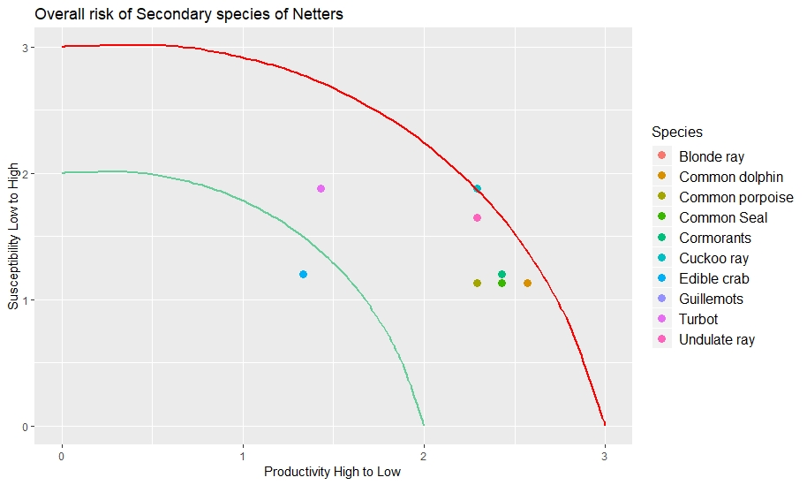

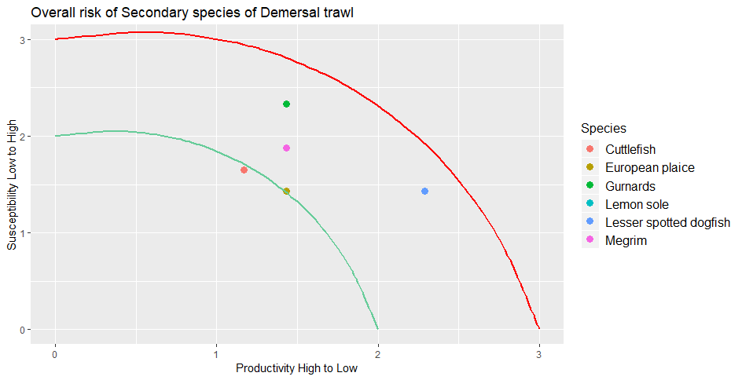Figure 3. Overall risk of netters to secondary species.

Figure 4. Overall risk of demersal trawls to secondary species.

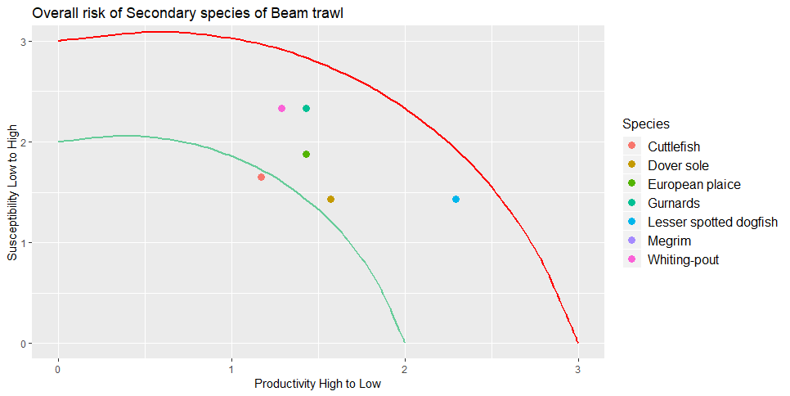

Figure 5. Overall risk of beam trawls to secondary species.

# Review of management measures

There is a range of input (e.g. control of fishing effort, limits on number of vessels and licenses) and output (e.g. set up of TAC or catch quotas) controls and technical measures (including spatial measures) used to regulate fishing mortality in the UoA. In the EU, the main management principles arise from the Common Fisheries Policy (CFP; EC, 2013) and Marine Strategy Framework Directive (MFSD; EC, 2010). The principal objective for the management is to achieve maximum sustainable yield (MSY)for all commercial species by 2020 at the latest, while simultaneously eliminating discards, and to achieve Good Environmental Status (GES) of marine waters by 2020 and to protect the resource base upon which marine-related economic and social activities depend. The CFP aims to fulfil its objectives by defining regional fisheries multi-annual management plans that take account of species and fishery interactions in establishing conservation and technical measures to achieve the targets (Articles 9–10).

As a member of the European Union, UK fisheries have been subject to the EU’s Common Fisheries Policy (CFP) since its inception in 1983. As such, the main management measure for most stocks is annual Total Allowable Catches, where the main approach is to controlling fishing exploitation through annual TACs. In 2014, the reformed EU CFP introduced a phased landing obligation (LO) for all quota species. The principle of the LO is that all catches from quota species have to be landed and all catches will account against their quota. The principle of the new CFP is to incentivise fishers to avoid catching unwanted fish. The policy includes a number of exemptions and flexibility tools. One exemption from the landing obligation is described for “species for which scientific evidence demonstrates high survival rates, taking into account the characteristics of the gear, of the fishing practices and of the ecosystem”. The main strength is it limits total fishing mortality, if enforced, while the main weakness is that it may limit the fishing opportunities for other stocks when quota reached (“choked”). The starting point for these is scientific advice provided by ICES. While TACs are agreed annually, they are increasingly based on multi-annual management plans which allow for a longer-term approach to be taken to the management of these stocks. In some cases, particularly for cod (EC, 2008), these plans also include limits on fishing effort alongside the catch limits. Historically, EU fisheries legislation has also included many technical measures, particularly those related to fishing gear selectivity (Reeves *et al*. 2008).

In this section we describe possible management measures for the species and fisheries that were classified with the medium PSA risk.

**Skates and Rays species (Blonde ray, Cuckoo ray and Undulate ray)**

Three species were identified as main secondary species for the netters targeting monkfish, in ICES areas VII b-k – Blonde ray, Cuckoo ray and Undulate ray. These species showed the highest PSA risk, across all gears and species due to their life history and vulnerability to the fisheries.

Currently, under EU regulation, skates and rays are currently managed under five regional TACs. Each is a general skate and ray TAC including several species. ICES (International Council for the Exploration of the Sea) used to publish generic skates and rays stock assessment scientific advice but increasing scientific knowledge and data reporting at species level has allowed for the provision of advice at a more detailed level, at species level. In 2016, the Commission proposed a change to skate and ray TAC management for 2017, with several new sub-TACs for different species. The proposal used the existing "SRX" quota allocation key, applying the relative stability shares to each sub-TAC. However, feedback from stakeholders and Member States raised concerns that this allocation did not reflect current fishing activity and the distribution of species within the management area, causing significant socio-economic impact on fishermen. Thus, at the December Fisheries Council, the proposal reverted back to the 2016 system of combined skate and ray quota management, but with a joint statement from Member States and the Commission to further explore alternative management options.

In 2017, an STECF Working group reviewed the possible long-term management measures for skates and rays and their pros and cons, including TAC based measures, landing sizes, selectivity and survival exemptions, among others (STECF, 2017). The EWG reports that gear-based technical measures for towed gears such as increased codend mesh sizes and square mesh panels are ineffective in increasing size selectivity for skates and rays because their large, flattened body shape prevents escape once inside fishing gears (Ellis et al., 2016). However, this type of modification can improve the condition of skates and therefore their survival chances, by reducing the volume of catch in the codend (e.g. Enever et al., 2010). Other type of improvements in the selectivity of trawls for skates can be achieved through modifications which utilise the difference in shape and size of skates and behaviour compared with other species in the catch. These can be divided into sorting grids and By-catch Reduction Devices (BRDs), escape panels and separator trawls, and other trawl gear modifications. For static gears and long line fisheries, the options for reducing skate bycatch are limited, but there have been few studies to date. Several possible modifications were given, including restricted lengths of net, limiting soak times, adjusting mesh size, hanging ratio and height of the net and modifying the thickness and colour of netting material for static nets and hook design for long lines.

Among the TAC based approaches reviewed by the group, the TAC by stock was the only one that permits the setting of limits on catches by stock in line with individual stock development and the catch levels recommended by ICES. The current general skate and ray TACs may not offer adequate protection for stocks that require reductions in fishing mortality (F) and conversely, may limit catch opportunities for stocks in good condition. However, there is acknowledge that there are issues with misreporting and misidentification of species that need to be addressed, as well as improvement in the dead discards estimates. The current stock assessments do not include discard estimates on their assessments. Data collected under DCF programmes should be explored to include as much discards information as possible into the assessments

Member countries may request exemptions to the Landing Obligation, based on the discard survival estimates. According with recent studies on discard survival estimates covers a limited number of fleets, areas and species, and because the factors that influence survival are poorly understood extrapolation across species, fisheries and areas is challenging. The survival rates varied across species and gears, with blonde ray captured with netters having an estimated survival rate of 92%, although this was based on a sample size of 5 (See reference in Appendix 1). The proportion of fish alive at the point of discarding does not provide a robust survival estimate because mortality can occur some period after release. However, the health status of the fish when released is often used to predict its chance of survival. Data on the health condition of skates at the point of discarding from a series of projects have been collated to supplement directly observed discard survival estimates (Bird, et al., 2018). Vitality data, describing the health of commercially caught skate and ray species at the point of release back to the sea, were available from 17,259 individual fish from 10 projects. These data show that 99.8%, 97.9% and 95.4% of skates and rays survived fishing capture in longline, otter trawl and netter fisheries, respectively. At-vessel mortality rates, those assessed as dead at the point of release, were low across these gears, with only 2% of rays being reported dead when discarded. Based on this information, survival exemptions for skates and rays species across all gears in the North Western Waters region has been requested for 2019.

Landing size restrictions could be used to protect juveniles with a minimum conservation reference size (MCRS) and/or reproducers with a maximum landing size. This is important for species that have late maturation and slow growth. It could be set by species or by group of species and/or by area. The size measure could be set by length or width and should be harmonised across regions and species. However, it should be noted that this management measure would be in contradiction with the landing obligation if implemented in association with catch limits, except in the case of exemptions for high survival. In case of no exemption, the introduction of a maximum landing size might be problematic (STECF, 2017). Currently some IFCAs (e.g. North West, North Eastern, Southern, Kent and & Essex IFCAs) apply local bylaws for the inshore fisheries, where is not allowed to land any skates and rays under a certain length.

# Data limitations for bycatch and rare species

The data used in this study to provide catch amounts for the secondary species are based on the reported landings by species and estimated discards from Cefas Observer programme. This sampling programme follows the EU Data Collection Framework (DCF), in which the main objective is to collect data on discards and biological data for the main commercial species. Although the Member States are required to record data on incidental bycatch of all birds, mammals and reptiles and protected and rare fish species, the DCF sampling programmes were not designed with that specific purpose in mind, and for this reason it may not be statistically valid to provide estimates of catch for these species based on data collected by these programmes. Due to the random design of the sampling procedure and low coverage of the programme, rare species, such as some species of elasmobranchs may not be effectively sampled. The raising of bycatch/discard data of this type to estimate catches of PETS at fleet level may lead to biased estimates with very low precision. There is a need to develop directed studies to monitoring PETS bycatch and rare species and a need to develop statistically sound sampling programmes with the objective of monitor catches of those species.

Since 2009, countries are required to report skates and rays landings by species. However, is recognised that the reported landings by species have issues with miss reporting and species identification. Is important that species-specific landings/catch data are correct. The fishing industry might provide catch data and biological (e.g. length, sex) for those skates and rays species that are not effectively sampled by the scientific sampling programmes. Bycatch data can also be generated using new technologies, such as EM technology on-board of fishing vessels. These data would inform and improve the stock assessment for these species.

# Conclusions

In summary, the Celtic Sea monkfish poses a medium risk to the skates and rays species (blonde ray, cuckoo and undulate ray) captured with netters (>=220mm). For the other gears, the main secondary species were classified with low risk. Cefas Observer data did not have any recorded for “out-of-scope” species for the period between 2014-2017. Data for these species were requested from Sea Mammal Research Unit (SMRU). The data collected and the estimated catches of common porpoise, common dolphin and seal from SMRU, indicated that around 1,280, 258 and 570 individuals were caught by netters in 2017. While for seabirds, guillemots and cormorants were observed, but due to low numbers and coverage was not possible to provide total catch estimates. However, the SMRU estimations are based on netters covering all mesh sizes. When considering only netters >=220 mm mesh size, these gears are mainly bottom nets and in general they lay on the bottom for catching bottom living species, such as anglerfish, skate and rays and shellfish. Because of the features of these nets, the risk of catching marine mammals and seabirds is relatively low.

There are limitations with the data used from the Observer programme, due to the low to the random design of the sampling procedure and low coverage of the programme, rare species, such as some species of elasmobranchs may not be effectively sampled. The coverage and data collected could be improved with the use of new technologies (e.g REM) and/or fishing industry collected and providing catch data.

# References

Catchpole, T., Serena Wright, Victoria Bendall, Stuart Hetherington, Peter Randall, Elizabeth Ross, Ana Ribeiro Santos, Jim Ellis, Jochen Depestele (ILVO), Suzanna Neville (2017). Ray Discard Survival. Enhancing evidence of the discard survival of ray species. Lowestoft: CEFAS.

Defra. 2004. Caught in the net: by-catch of dolphins and porpoises off the UK coast- Third report of Session 2003-04. House of Commons – Environment, Food and Rural Affairs Committee. 137pp. https://publications.parliament.uk/pa/cm200304/cmselect/cmenvfru/88/88.pdf

Eryilmaz, L. and Dalyan, C. 2015. Age, growth, and reproductive biology of turbot, *Scophthalmus maximus* (Actinopterygii: Pleuronectiformes: Scophthalmidae), from the South-western coasts of Black Sea, Turkey. Acta Ichthyologica et Piscatoria, 45 (2): 181 – 188.

Froese, R., Garthe, S., Piatkowski and Pauly, D. 2005. Trophic signatures of marine organisms in the Mediterranean as compared with other ecosystems. Belgium Journal of Zoology, 135(2): 139 – 143.

M.P. Harris , S. Wanless , P. Rothery , R.L. Swann & D. Jardine (2000). Survival of adult Common Guillemots *Uriaaalge* at three Scottish colonies, Bird Study, 47:1, 1-7, DOI:10.1080/00063650009461154.

Heino, M., Svasand, T., Nordeide, J. T. and Ottera, H. 2012. Seasonal dynamics of growth and mortality suggest contrasting population structure and ecology for cod, pollack, and saithe in a Norwegian fjord/ ICES Journal of Marine Science, 69(4): 537-546.

ICES. 2010. Cephalopod biology and fisheries in Europe. ICES Cooperative Research Report No.303.175p.

JNCC. (2005). Common standards monitoring guidance for Marine Mammals. ISSN 1743-8160. http://jncc.defra.gov.uk/pdf/CSM_marine_mammals.pdf.

Lockyer, C. 2003. Harbour porpoises (*Phocoena phocoena*) in the North Atlantic: Biological parameters. NAMMCO Sci. Publ. 5:71-90.

Meyer, Carl. 2010. *Maja squinado*, the European Spider crab: Biology and Fishery. University of Haway. <http://www2.hawaii.edu/~carlm/spider.html>.

Mitchell, P., Stephen F. Newton, Norman Ratcliffe and Timothy E. Dunn (Eds.). 2004. Seabird Populations of Britain and Ireland: results of the Seabird 2000 census (1998-2002). Published by T and A.D. Poyser, London.

Murphy, S., Collet, A and Rogan, E. 2005. Mating strategy in the male common dolphin (*Delphinus Delphinus*): what gonadal analysis tells us. Journal of Mammalogy, 86(6): 1247-1258.

Onsoy, B. and Salman, A. 2005. Reproductive biology of the common cuttlefish *Sepia officinalis* L. (Sepiida: Cephalopoda) in the Aegean Sea. Turkish Journal of Veterinary Animal Science, 29: 613 – 619.

Patrick, W. S., P. Spencer, O. Ormseth, J. Cope, J. Field, D. Kobayashi, T. Gedamke, E. Cortés, K. Bigelow, W. Overholtz, J. Link, and P. Lawson. 2009. Use of productivity and susceptibility indices to determine stock vulnerability, with example applications to six U.S. fisheries. U.S. Dep. Commer., NOAA Tech. Memo. NMFS-F/SPO-101, 90 p.

Revill, A., Dulvy, N. and Holst, R. 2005. The survival of discarded lesser-spotted dogfish (*Scyliorhinus canicular*) in the Western English Channel beam trawl fishery.

Revill, A. 2012. Survival of discarded fish – A rapid review of studies on discard survival rates. Request from European Commission, DGMARE. http://nsrac.org/wp-content/uploads/2012/08/EU-discard-survival-short-study-version-001.pdf.

Revill, A. S., M. K. Broadhurst and R. B. Millar (2013). "Mortality of adult plaice, *Pleuronectes platessa* and sole, *Solea solea* discarded from English Channel beam trawlers." Fisheries Research **147**: 320-326.

Revill, A., Bloor, I. S. M. and Jackson, E.L. 2015. The survival of discarded *Sepia officinalis* in the English Channel. Fisheries Management and Ecology, 22: 164 – 171.

Scientific, Technical and Economic Committee for Fisheries (STECF) – Long-term management of skates and rays (STECF-17-21). Publications Office of the European Union, Luxembourg, 2017, ISBN 978-92-79-67493-8, doi:10.2760/44133, JRC109366.

Seafish. 2014. Species Guide - Pollack v4. <http://seafish.org/media/Publications/SeafishSpeciesGuide_Pollack_201401.pdf>

Appendix 1:



| ID | Author | Title | Source | Year | Survival Est. | Species | Fishery | Gear | Quality and comment |
| --- | --- | --- | --- | --- | --- | --- | --- | --- | --- |
| 1 | Bendall, V. A., Hetherington, S. J., Ellis, J. R., Smith, S. F., Ives, M. J., Gregson, J. and Riley, A. A. | Spurdog, Porbeagle and Common Skate Bycatch and Discard Reduction | CEFAS Report | 2012 | At-vessel mortality only, based on vitality assessments | common skate complex (Dipturus batis) | Mixed target gill net fishery in ICES Division VIIe-f | GN1 | Health assessment was not the focus of the study; tagging results incomplete |
| 2 | Ellis, J.R., Burt, G.J. and Cox, L.P.N. (2008) | Thames ray tagging and survival. | CEFAS Report | 2008 | At-vessel mortality only, based on vitality assessments | Mixed ray species dominated by thornback ray (Raja clavata) | North Sea trawl, longline and gillnet fisheries | GN1, LL1 | Health assessment was not the focus of the study; tagging results incomplete |
| 3 | Depestele, J., Desender, M. Benoît, H.P., Polet, H., Vincx, M. | Short-term survival of discarded target fish and non-target invertebrate species in the “eurocutter” beam trawl fishery of the southern North Sea. | FISHERIES RESEARCH 154: 82-92. | 2014 | 72% (n=141) | Mixed ray species dominated by thornback ray (Raja clavata) | North Sea Beam trawl | BT2 | Modelled to asymptote; mixed ray species; survival rate likely overestimated |
| 4 | Enever, R.; Catchpole, T. L.; Ellis, J. R.; Grant, A. | The survival of skates (Rajidae) caught by demersal trawlers fishing in UK waters | FISHERIES RESEARCH 97(1–2): 72–76 | 2009 | 55-87% (n=162) | Thornback ray (Raja clavata) | Bristol Channel otter trawl | TR2 | Not monitored to asymptote; survival rate overestimated |
| 4 | Enever, R.; Catchpole, T. L.; Ellis, J. R.; Grant, A. | The survival of skates (Rajidae) caught by demersal trawlers fishing in UK waters | FISHERIES RESEARCH 97(1–2): 72–76 | 2009 | 33% (n=6) | Cuckoo ray (Leucoraja naevus) | Bristol Channel otter trawl | TR2 | Not monitored to asymptote; survival rate overestimated |
| 4 | Enever, R.; Catchpole, T. L.; Ellis, J. R.; Grant, A. | The survival of skates (Rajidae) caught by demersal trawlers fishing in UK waters | FISHERIES RESEARCH 97(1–2): 72–76 | 2009 | 51% (n=39) | Small-eyed ray (Raja microocellata) | Bristol Channel otter trawl | TR2 | Not monitored to asymptote; survival rate overestimated |
| 4 | Enever, R.; Catchpole, T. L.; Ellis, J. R.; Grant, A. | The survival of skates (Rajidae) caught by demersal trawlers fishing in UK waters | FISHERIES RESEARCH 97(1–2): 72–76 | 2009 | 55-67% (n=14) | Blonde ray (Raja brachyura) | Bristol Channel otter trawl | TR2 | Not monitored to asymptote; survival rate overestimated |
| 5 | Kaiser M.J., Spencer, B. E. | Survival of by-catch from a beam trawl | MARINE ECOLOGY PROGRESS SERIES 134: 303-307. | 1995 | 59% (n=32) | Cuckoo ray (Leucoraja naevus) | Irish Sea beam trawl | BT2 | Not monitored to asymptote; no control; survival rate likely overestimated |
| 6 | Ellis, J. R., McCully, S. R., Silva, J. F., Catchpole, T. L., Goldsmith, D., Bendall, V. and Burt, G. | Assessing discard mortality of commercially caught skates (Rajidae) – validation of experimental results. | DEFRA Report MB5202, 142 pp. | 2012 | 0-100% (n=2) | Small-eyed ray (Raja micro-ocellata) | Western Channel beam trawl | BT2 | Not monitored to asymptote; no control; survival rate likely overestimated |
| 6 | Ellis, J. R., McCully, S. R., Silva, J. F., Catchpole, T. L., Goldsmith, D., Bendall, V. and Burt, G. | Assessing discard mortality of commercially caught skates (Rajidae) – validation of experimental results. | DEFRA Report MB5202, 142 pp. | 2012 | 25-74% (n=25) | Blonde ray (Raja brachyura) | Western Channel beam trawl | BT2 | Not monitored to asymptote; no control; survival rate likely overestimated |
| 6 | Ellis, J. R., McCully, S. R., Silva, J. F., Catchpole, T. L., Goldsmith, D., Bendall, V. and Burt, G. | Assessing discard mortality of commercially caught skates (Rajidae) – validation of experimental results. | DEFRA Report MB5202, 142 pp. | 2012 | 40-67% (n=13) | Spotted ray (Raja montagui) | Western Channel beam trawl | BT2 | Not monitored to asymptote; no control; survival rate likely overestimated |
| 6 | Ellis, J. R., McCully, S. R., Silva, J. F., Catchpole, T. L., Goldsmith, D., Bendall, V. and Burt, G. | Assessing discard mortality of commercially caught skates (Rajidae) – validation of experimental results. | DEFRA Report MB5202, 142 pp. | 2012 | 25-83% (n=26) | Cuckoo ray (Leucoraja naevus) | Western Channel beam trawl | BT2 | Not monitored to asymptote; no control; survival rate likely overestimated |
| 7 | Saygu, I., Deval, M. C. | The Post-Release Survival of Two Skate Species Discarded by Bottom Trawl Fisheries in Antalya Bay, Eastern Mediterranean | TURKISH JOURNAL OF FISHERIES AND AQUATIC SCIENCES 14: 947-953 | 2014 | 81% (n=120) | Thornback ray (Raja clavata) | GFCM Geographical subarea 24 otter trawl | TR1 | Not monitored to asymptote; survival rate likely overestimated |
| 7 | Saygu, I., Deval, M. C. | The Post-Release Survival of Two Skate Species Discarded by Bottom Trawl Fisheries in Antalya Bay, Eastern Mediterranean | TURKISH JOURNAL OF FISHERIES AND AQUATIC SCIENCES 14: 947-954 | 2014 | 21% (n=68) | Brown skate (Raja miraletus) | | TR1 | Not monitored to asymptote; survival rate likely overestimated |
| 8 | Enever, R., Revill, A. S., Caslake, R., Grant, A. | Discard mitigation increases skate survival in the Bristol Channel | FISHERIES RESEARCH 102(1–2): 9–15 | 2010 | 55-67% (n=278) | Small-eyed skate (Raja micro-ocellata) | Bristol Channel, otter trawl | TR2 | Not monitored to asymptote; no control; survival rate likely overestimated |
| 9 | Tom Catchpole, Serena Wright, Victoria Bendall, Stuart Hetherington, Peter Randall, Elizabeth Ross, Ana Ribiero Santos, Jim Ellis, Jochen Depestele (ILVO), Suzanna Neville | Ray Discard Survival - Enhancing evidence of the discard survival of ray species | CEFAS Report | 2017 | 41-44% (n=25) | Blonde ray (Raja brachyura) | Western Channel beam trawl | BT2 | Ellis et al (2012) enhanced estimates modelled to assymtote |
| 9 | Tom Catchpole, Serena Wright, Victoria Bendall, Stuart Hetherington, Peter Randall, Elizabeth Ross, Ana Ribiero Santos, Jim Ellis, Jochen Depestele (ILVO), Suzanna Neville | Ray Discard Survival - Enhancing evidence of the discard survival of ray species | CEFAS Report | 2017 | 34-35% (n=26) | Cuckoo ray (Leucoraja naevus) | Western Channel beam trawl | BT2 | Ellis et al (2012) enhanced estimates modelled to assymtote |
| 9 | Tom Catchpole, Serena Wright, Victoria Bendall, Stuart Hetherington, Peter Randall, Elizabeth Ross, Ana Ribiero Santos, Jim Ellis, Jochen Depestele (ILVO), Suzanna Neville | Ray Discard Survival - Enhancing evidence of the discard survival of ray species | CEFAS Report | 2017 | 57-69% (n=162) | Thornback ray (Raja clavata) | Bristol Channel otter trawl | TR2 | Enever et al (2009) enhanced estimates modelled to assymtote |
| 9 | Tom Catchpole, Serena Wright, Victoria Bendall, Stuart Hetherington, Peter Randall, Elizabeth Ross, Ana Ribiero Santos, Jim Ellis, Jochen Depestele (ILVO), Suzanna Neville | Ray Discard Survival - Enhancing evidence of the discard survival of ray species | CEFAS Report | 2017 | 95% (n=15) | Thornback ray (Raja clavata) | North Sea gill netter | GT1 | DST tagging, effect of predation included within estimate |
| 9 | Tom Catchpole, Serena Wright, Victoria Bendall, Stuart Hetherington, Peter Randall, Elizabeth Ross, Ana Ribiero Santos, Jim Ellis, Jochen Depestele (ILVO), Suzanna Neville | Ray Discard Survival - Enhancing evidence of the discard survival of ray species | CEFAS Report | 2017 | 92% (n=5) | Blonde ray (Raja brachyura) | North Sea gill netter | GT1 | DST tagging, effect of predation included within estimate; not representative sorting |
| 10 | Christopher Bird, Victoria Bendall, Jim Ellis, Thomas Catchpole | Health and vitality of discarded skates and rays | CEFAS Report | 2018 | At-vessel mortality only, based on vitality assessments | Nine skate ray species | NS, NWW various | TR2,GT1,GN1,LL1 | Compiled vitality (health) scores from 10 projects |

Appendix 2:

***Offshore sampling scheme: UK-E+W Observer at sea***

The current off-shore sampling scheme was set up in 2001, with some changes made throughout the years to take into account the regional and technical (ie. gear types) specifications. The sampling frame is a virtual frame of all fishing trips of the vessels in the list, which comprises all commercial fishing vessels [registered in England and Wales]. The list of active vessels is updated quarterly to capture the polyvalent and seasonal nature of regional fisheries. list frame of fishing vessels, from which a stratified random selection is made for direct observation by Cefas observers

The list of vessels in the sampling frame is stratified by: Region - 2 strata in the North Sea and Eastern Artic and 3 in the North Atlantic - and predominant fishing method (nets, trawls, lines, beam trawl and scallop dredge). In addition, some region / fishing method strata are further stratified by vessel LOA (<10m; 10m+). In most regions the nets, trawls and lines are combined into single strata but in some regions where gear specific fisheries are more distinct Nets and Trawl are separated. Beam trawl and Scallop dredge vessels are also kept distinct but cover all regions - the North Sea and North East Atlantic to capture the nomadic nature of a lot of these vessels.

Some vessels are excluded from the sampling frame:

1. Vessels less than 7m, excluded for health & safety reasons
2. Vessels considered unsafe to take observers for reasons other than size.
3. Vessels specialising in fishing methods or target species for which a derogation has been granted:
   1. Clam, oyster and cockle dredgers
   2. Some pelagic vessels
   3. Potting vessels
4. Vessels fishing from foreign ports or outside England and Wales. Vessels subject to bilateral agreements to be sampled in another country, or where RCMs consider the metier is effectively sampled by another country.

Teams of regionally based observers work to quarterly targets and use shared drawlists of randomly ordered vessels. Each vessel in turn is approached and non response and refusals are recorded.

Once at sea, for each sampled haul the following information is collected: gear type and mesh size, tow duration, shot and haul position, species catch composition and quantity of the landings and discards in the catch. The sampling scheme is a multistage process in which discards are estimated from a fraction of a haul, and typically >60% of the hauls are sampled during a trip. In each sampled haul all the species are sampled; length measurements are registered for all fish, crustaceans and cephalopods species. When is not possible to sample the whole haul catch, the observer estimates the volume measured relative to the total catch to obtained a raising factor that is used to estimate the total catch of the haul. Due to the randomness nature of the sampling procedure, rare species, such as some species of elasmobranchs may not be representatively sampled. For each trip, numbers-at-length were raised to the haul, based on an estimated proportion of the total catch volume sampled, then to the trip, based on the proportion of sampled hauls and fished hauls. The length based data was converted to biomass, using length-weight relationships for each species collected during various scientific trawl surveys (Cefas, unpubl. data).

Trip-raised estimates summed for sampled vessels in stratum, are then raised to total fleet using a ratio between the reported total fleet landings of stock and reported landings of stock by the sampled vessels. When no landings are reported, used effort (number of trips in stratum) to raise the discard data.

About us

The Centre for Environment, Fisheries and Aquaculture Science is the UK’s leading and most diverse centre for applied marine and freshwater science.

We advise UK government and private sector customers on the environmental impact of their policies, programmes and activities through our scientific evidence and impartial expert advice.

Our environmental monitoring and assessment programmes are fundamental to the sustainable development of marine and freshwater industries.

Through the application of our science and technology, we play a major role in growing the marine and freshwater economy, creating jobs, and safeguarding public health and the health of our seas and aquatic resources

**Head office**

Centre for Environment, Fisheries & Aquaculture Science

Pakefield Road

Lowestoft

Suffolk

NR33 0HT

Tel: +44 (0) 1502 56 2244

Fax: +44 (0) 1502 51 3865

Weymouth office

Barrack Road

The Nothe

Weymouth

DT4 8UB

Tel: +44 (0) 1305 206600

Fax: +44 (0) 1305 206601



Customer focus

We offer a range of multidisciplinary bespoke scientific programmes covering a range of sectors, both public and private. Our broad capability covers shelf sea dynamics, climate effects on the aquatic environment, ecosystems and food security. We are growing our business in overseas markets, with a particular emphasis on Kuwait and the Middle East.

Our customer base and partnerships are broad, spanning Government, public and private sectors, academia, non-governmental organisations (NGOs), at home and internationally.

We work with:

* a wide range of UK Government departments and agencies, including Department for the Environment Food and Rural Affairs (Defra) and Department for Energy and Climate and Change (DECC), Natural Resources Wales, Scotland, Northern Ireland and governments overseas.
* industries across a range of sectors including offshore renewable energy, oil and gas emergency response, marine surveying, fishing and aquaculture.
* other scientists from research councils, universities and EU research programmes.
* NGOs interested in marine and freshwater.
* local communities and voluntary groups, active in protecting the coastal, marine and freshwater environments.

www.cefas.co.uk

1. http://www.seafish.org/industry-support/fishing/project-uk
2. Plaice was considered a secondary species because it covers five plaice stocks: Plaice VIIa, VIIe, VIIb-c, VIIf-g and VIIh-k. From the five stocks, only plaice VIIe and VIIa have analytical assessment and the remaining are considered data limited stocks.
3. Sole was considered a secondary species because it covers four sole stocks: Sole VIIa, VIIe, VIIf-g and VIIh-k. From the four stocks, only sole VIIh-k does not have analytical assessment and is considered a data limited stock. The remaining have full analytical.