Analysis report of electronic-monitoring in
longline fishing vessel

- Objectives
At present, China's distant-water fishing industry has entered a stage of high-quality development, with an overall stable fleet size, steady development of the whole industry chain, continuous strengthening of scientific and technological empowerment, and overall enhancement of compliance capabilities. Due to the compliance requirements of regional fisheries management organisations and the management of the distant-water fisheries industry, professional at-sea observers are required to record and obtain basic biological data on fish, but professional observers require a lot of time for training and have long-standing problems such as insufficient personnel. Therefore, Shanghai Ocean University and Ping Tai Rong Ocean Fishery Group Co.,Ltd. are cooperating to conduct an electronic-monitoring experiment, hoping to use the electronic-monitoring system and AI intelligent analysis as an alternative and supplement to regular observers, solving the problems of long training time and insufficient backup personnel for regular observers.
2. Materials and methods.
2.1 Trial vessel
Low temperature albacore tuna longline fishing vessel
2.2 Equipment information
2.2.1 Camera type
Infrared 50M camera:DS-IPC-B12HV2-IA
Infrared camera :DC-IPC-T12H-IA
2.2.2 Arrangement
In order to accurately record the fishing situation, two HD cameras were installed towards the starting point and the processing platform respectively, the arrangement is shown in Figure 1 and 2.
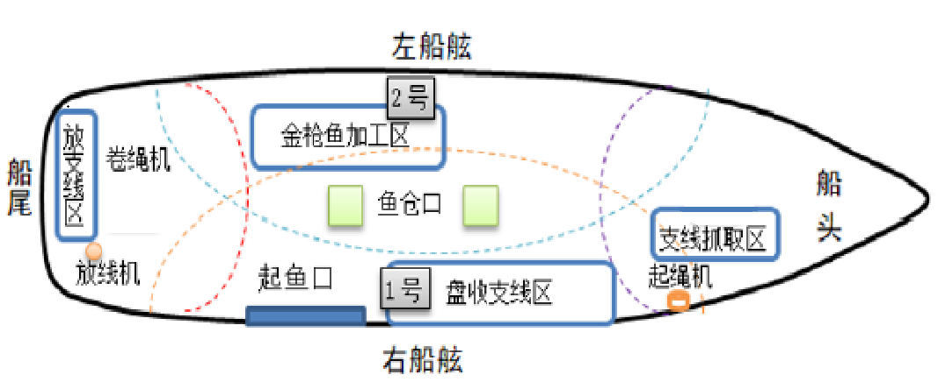

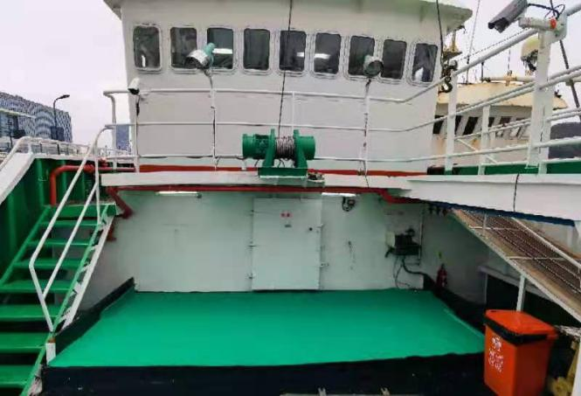

Figure 1、2 Camera Locations
2.3 Technical pathway
The video is recorded through the camera, in two ways: through real-time video transmission and ship-side storage. The ship-side video storage cycle is 6 months, and after the storage capacity reaches the upper limit, the old hard disk is replaced using a pull-out hard disk, and the old hard disk is brought back for analysis through the transport vessel,real-time transmission is currently only used for viewing special situations and temporary storage for emergencies.
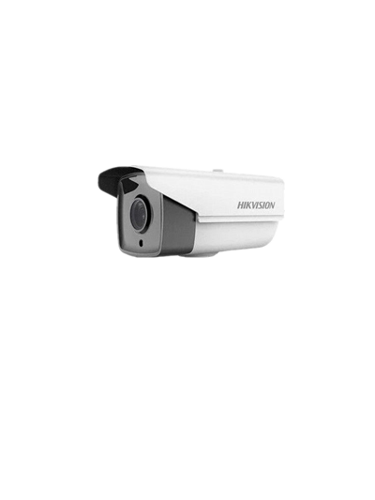
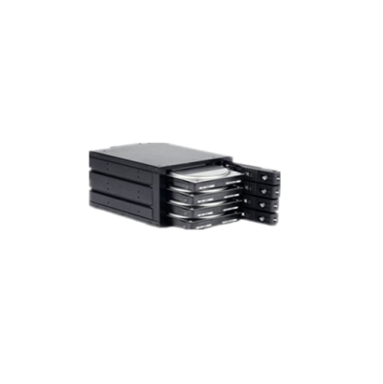
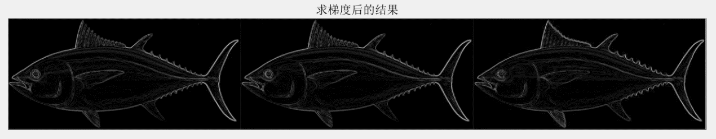
Once the hard drives arrive at the port, Shanghai Ocean University sends students or teachers with observer experience to analyse them and convert the video data into digital information for storage through recording software.
- Camera
- Hard Disk
- Satellite
- Data Center
- Analysis

Figure 3 Technology pathway

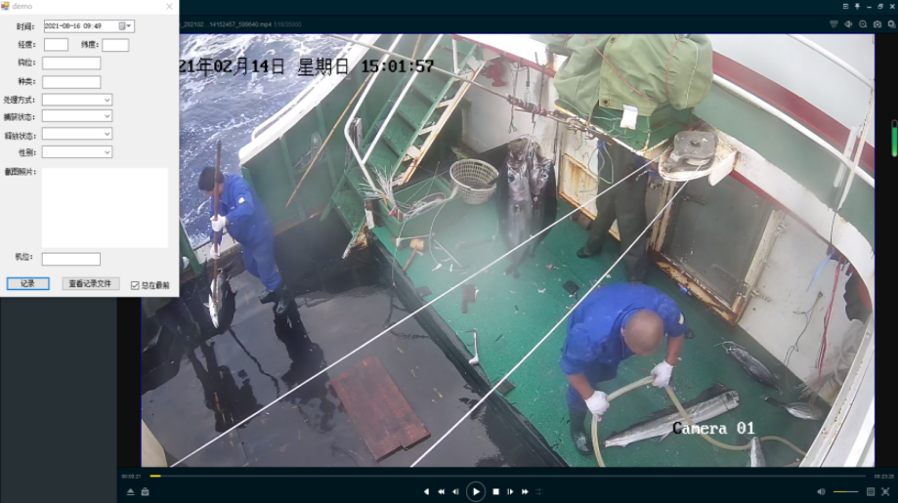
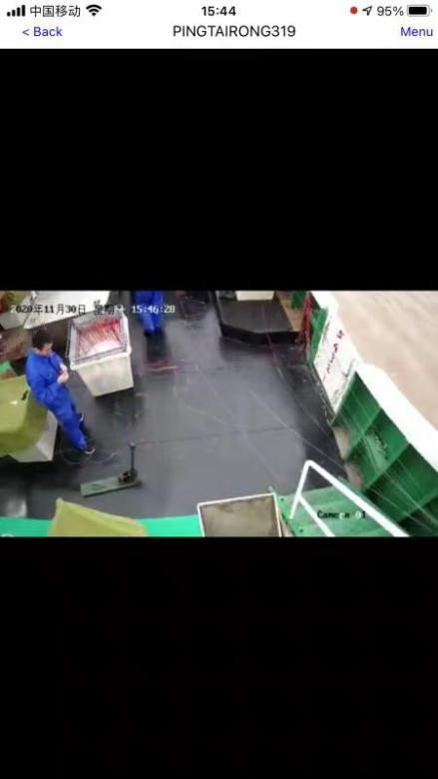

Figure 4.5 Recorded information
3. Test results
The video recordings received for this trial were from 14 February to 30 June, and the time period for video analysis was from 14 February to 24 February, of which no fishing activity was carried out on 23 February and 10 times operations were carried out from 14 to 24 February, with a total video duration of 264 hours and 40 hours spent on data analysis and entry. The fishing vessel operated in a manner and handled its catch in accordance with the specifications during the 14-24 days, and did not reproduce, catch or retain fish species, precious and endangered aquatic wildlife or other marine organisms prohibited by the State of entry or RFMO with jurisdiction.
4. Discussion
Compared to traditional observers, electronic-monitoring can cover 100% of the operating time, work in a safer and more comfortable environment, the data recorded can be viewed repeatedly and the efficiency of the analysis can be constantly improved through technical means. However, there are also disadvantages such as the inability to collect biological data and the fact that the environment in which the photographs are taken can be easily disturbed by many factors (too much light, darkness and seawater obscuration can lead to difficulties in identifying some fish species). Therefore, improving the analysis efficiency, increasing the length and weight data collection, and standardising the video recording environment will be the focus of the next phase of research and experimentation.
Data fields | Observer | EM | Notes
时间（Date、Time） | yes | yes
位置（Location） | yes | yes
钩位（Hook No.） | yes | yes
鱼种（Species） | yes | yes
捕获状态（Condition） | yes | yes
释放状态（Condition releases） | yes | yes
处理类型（Fate） | yes | yes
性别（Sex） | yes | NO | Mahi-mahi can be identified
长度（Length） | yes | NO
重量（Weight） | yes | NO
摄食等级（Ingestion Levels） | yes | NO

Table 3: Comparison

