Improved Ecosystem Monitoring:
A Strategy for the NAFO Yellowtail Flounder Fishery

Executive Summary

Trawlers exploiting the Yellowtail Flounder stock in NAFO-regulated waters could more successfully monitor ecosystem outcomes and avoid endangered, threatened and protected (ETP) species with the combination of electronic monitoring and ETP training for fishery observers. This report’s purpose is to provide recommendations that would facilitate the fishery’s standing as a leader in ecosystem conservation on the Grand Banks and avoid serious or irreversible harms to the ecosystem.

The Southeast Shoal represents the highest overall benthic biomass on the Grand Banks and presents a single nursery area of the entire stock of Yellowtail Flounder. The yellowtail flounder stock is managed by the North Atlantic Fishery Organisation (NAFO), a regional fisheries management organisation, and is commercially exploited by 13 Contracting Parties (CPCs), including the USA. Currently, the fishery is managed without making explicit requests to participating vessels to record interactions with non-commercial and/or potential ETP species (NAFO CEM: Article 48).

This fishery is very well managed and meets the MSC SG80 scores on nearly every PI. In 2021, USA-based fishing companies, Pier Fish Company and Tremont Fisheries LLC – the sole USA-based fishing operators to exploit the stock - engaged the Sustainability Incubator to conduct an MSC pre-assessment of the Yellowtail Flounder fishery to assess its alignment with the MSC’s Fisheries Standard and then develop a “Fishery Improvement Project” (FIP) to address the unaligned areas.

The pre-assessment results suggested that the USA portion of the fishery could pass the MSC standard today possibly with the exception of Performance Indicator 2.5.1 (Ecosystem management performance) due to a lack of monitoring and reporting of bottom structure and tow contents by other CPCs. The priority for the “FIP” is to encourage fishery improvements to protect endangered, threatened and/or protected species endemic to the NAFO 3LNO area and Southeast Shoal.

Table of Contents
Executive Summary 1
Introduction 4
Yellowtail Flounder 4
Yellowtail Flounder Ecosystem 5
Yellowtail Fishery Improvement Project 6
MSC Pre-Assessment 6
FIP Workplan 6
An Overview of NAFO’s ETP Monitoring Policies 7
Electronic Monitoring 7
Overview 7
Trawling: Electronic Monitoring for Primary Species 8
Trawling: Improving ETP Species Monitoring 9
Observer Monitoring 11
Recommendations 11

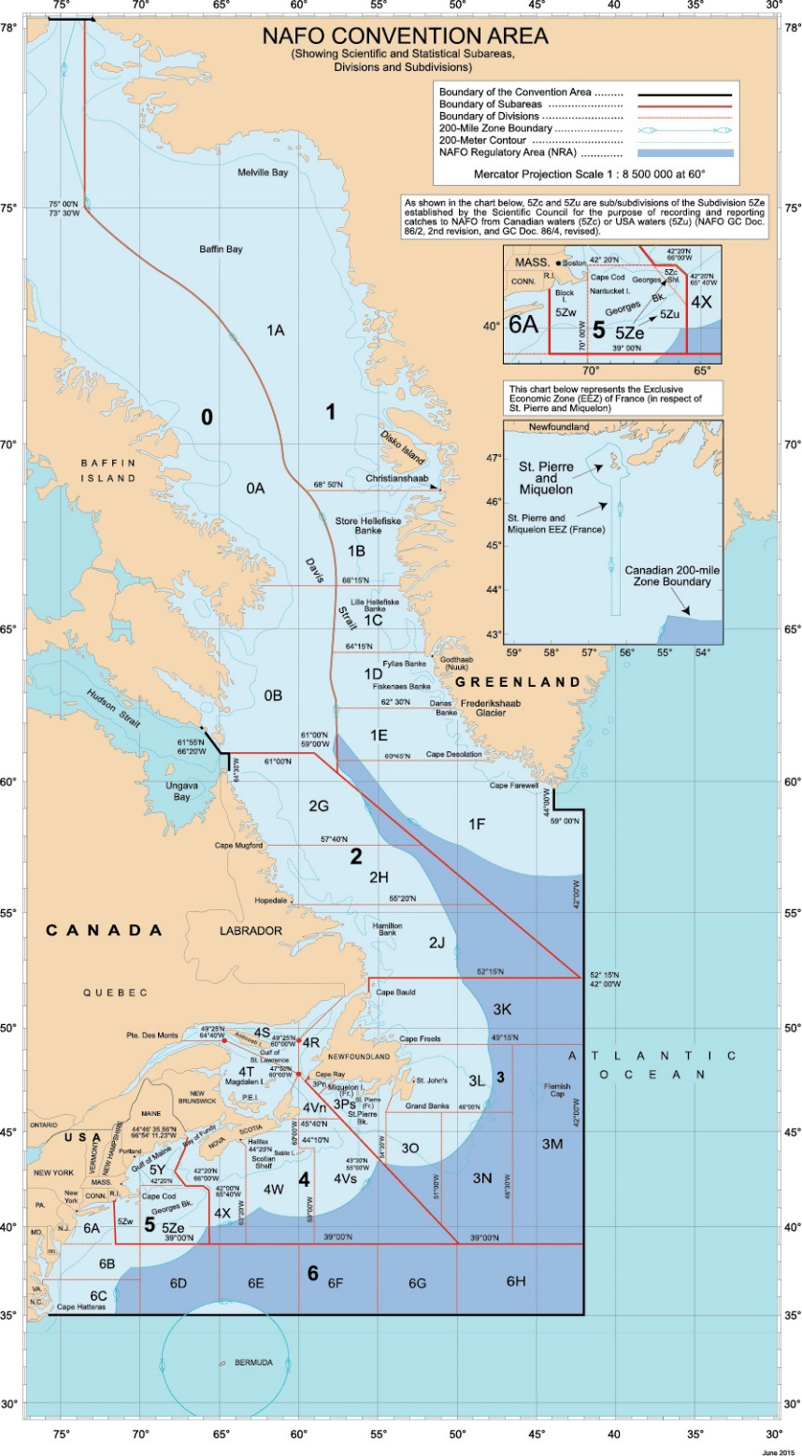
Figure 1 - The Northwest Atlantic Fisheries Organisation (NAFO) is a regional fisheries management organisation with a mandate to management and conserve the fishing grounds in the international waters off the East Coast of North America.

Introduction

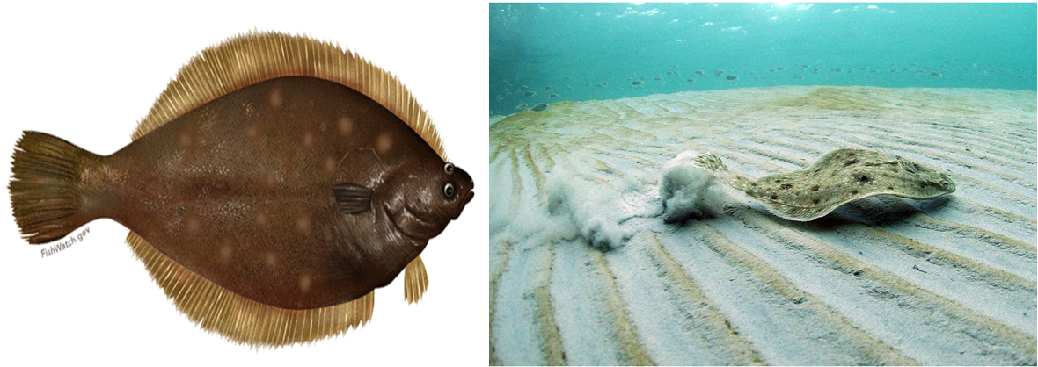
Yellowtail Flounder
Figure 2 - photograph and profile of Yellowtail Flounder

Yellowtail flounder are found along the Atlantic coast of North America from Newfoundland to the Chesapeake Bay.
- They can live up to 17 years, although most don’t live past age 7.
- Almost all females are able to reproduce by the time they reach age 3
- Yellowtail flounder grow faster than most flatfish, growing to between 30 – 55cm
- They spawn during the spring and summer.
- Adults feed on crustaceans and worms.
- Spiny dogfish, skate, and a number of fish such as cod, hakes, flounder, and monkfish prey on yellowtail flounder.

The stock has been under TAC regulation since 1973, when an initial level of 50 000 t was established. With the exception of 1985 and 1986, when the nominal catch was around 30 000 t, catches were in the range of 10 000 to 18 000 t from 1976 to 1993. During the moratorium (1994 - 1997), catches decreased to around 300 - 800 tons per year, as by-catch in other fisheries. Since the fishery re-opened in 1998, catches have increased from 4 400 tons to around 13 000 tonnes, with TAC being set at 17 000 tonnes.

Yellowtail flounder are commonly harvested using trawl nets and, to a lesser extent, gillnets. In 2020, commercial landings of yellowtail flounder totalled just under 500 thousand kilos and were valued at over USD 1.1 million. Areas closures and gear restrictions reduce habitat impacts from trawl nets.

Yellowtail Flounder Ecosystem

The Southeast Shoal - NAFO 3L, 3N and 3O (Figure 1) - is a unique shallow, sandy habitat with the highest overall benthic biomass of the Grand Banks. It presents a single nursery area for the entire stock of Yellowtail flounder. The area is an important spawning ground and nursey also for capelin, American plaice, Atlantic cod, striped wolffish, blue mussels, wedge crabs, and a feeding ground for cetaceans and seabirds (Diz, 2014).

Yellowtail Fishery Improvement Project

MSC Pre-Assessment

MSC Principle 2.5.1 (Ecosystem Outcome) requires that fishing by the vessels in the fishery in scope (per MSC Unit of Assessment (UoA)) do not cause serious or irreversible harm to the key elements of ecosystem structure and function. This ecosystem component considers the ecological community in which the fishery operates. This indicator seeks to determine whether there is an impact from the fishery (either direct or indirect) that is likely to cause serious or irreversible harm to ecosystem structure and function, including trophic relationships, and biodiversity.

In 2021, the Sustainability Incubator conducted an MSC pre-assessment of the USA portion of the NAFO Yellowtail Flounder fishery. Among the findings, “while the USA contribution to impacts in the NAFO 3LNO ecosystem is highly controlled, the same is not occurring by other nations fishing in the area.” The lone vessel operator in the USA fishery, the FV Tremont, is obliged to report the numbers of animals per species in each tow to NOAA which then can direct the vessel to change location to avoid fishing on bottom habitats and structures that are ecologically diverse, based on, for example, the presence of sea pens in the tow.

Although oversight is high for the USA portion of the fishery, and Tremont Fisheries LLC subsequently displays the highest levels of conduct, the fishery itself would not likely be awarded MSC-certification because tow contents appear to go unobserved in the remainder of the fishery operated by other NAFO Member States. It is not possible to conclude that the “fishery is highly unlikely to disrupt key elements underlying ecosystem structure and function to a point where there would be a serious or irreversible harm”. As a result, it would not possibly not meet SG60 for PI 2.5.1.

For a Certification Assessment Body (CAB) to realistically be expected to provide a passing score for the Yellowtail Flounder fishery, enough information must be available around the impact of the fishery on the in-situ ecosystem to establish risks of serious or irreversible harms. A review of materials on NAFO and NAFO CPC sites suggests that this information is not accessible now and availability could improve. It is not clear that the information is collected by other CPCs. Accordingly, the US delegation proposed a rule that would increase the monitoring levels and encourage new methods; however it did not pass. Progress could still occur in numerous ways. The intention of this report is to provide some ideas based on new research into electronic monitoring opportunities.

FIP Workplan

Considering the assessment, Pier Fish Company and Tremont Fisheries LLC engaged The Sustainability Incubator to conduct a Fishery Improvement Project (FIP) to investigate opportunities where the USA fishery and NAFO’s ‘Conservation and Enforcement Measures’ (NAFO CEM) could potentially be improved to increase the likelihood of the Yellowtail Flounder fishery achieving MSC certification.

The central objective of the FIP is to “design ongoing monitoring requirements to ensure changes in ecosystem balance over time are captured and to ensure that any mitigation measures implemented are achieving their objectives.” (2.5.1, MSC 2016:275). The rationale for this objective is to protect ETP species endemic to the NAFO 3LNO area or, the Southeast Shoal.

An Overview of NAFO’s ETP Monitoring Policies

The NAFO CEM - which incorporates all NAFO’s conservation and enforcement measures presently in force, and was most recently revised at the 43rd Annual Meeting in September 2021 – presents very little in the way of objectively monitoring vessels’ interaction with ETP species. Obligations for vessels to record species interactions are only vaguely mandated and there is no policy under Article 28 (Monitoring of Catch) that explicitly requests the vessel to record interactions with non-commercial and/or potential ETP species.

Fishery observers are mandated to observe “the quantity of all catch, by species, including for discards and VMEs indicators as referred to in Annex I.E.VI” (59). This policy, in essence, requires observers to record all catch, but aside from the species listed in Annex I.E.VI, the duty to record any other form of non-commercial and potential ETP species is extremely vague.

In 2019, the USA put forward a proposal to Improve Data Collection of Bycatch of sea turtles, sea birds and marine mammals (COM WP 19-32 Rev.). The proposal would have observers-at-sea perform an additional duty under Article 30.14(a), recording fishing gear interactions with the aforementioned species. The proposal did not attain consensus and was deferred to the mid-term 2021 Standing Committee on International Control (STATIC).

In 2021, the USA again presented the proposal (STACTIC WP 21-51), highlighting the commitment to apply an ecosystem-based approach to fisheries management in the 2017 NAFO Convention. After some revisions to the proposal, NAFO CPCS agreed on the importance of the data collection by NAFO observers, however, requested more time to deliberate on the proposal and that it be deferred to the 2022 STACTIC Intersessional Meeting.

During the 2022 STACTIC Intersessional Meeting, Contracting Parties expressed concern about singling out these categories of species given that they are covered by the FAO 3-Alpha Species Codes (ASFIS) list and are already expected to be reported by masters and observers. Further decisions on the subject were deferred to the 2022 NAFO Annual Meeting.

Electronic Monitoring

As a supportive context emerges, considering that electronic monitoring is advancing, we provide the following overview for NAFO to consider to improve its oversight and management of fishery impacts to the Southern Shoal ecosystem and ETP species.

Overview
Electronic Monitoring (EM) is an integrated system of onboard cameras and sensors that record fishing activity and extract data. It is a powerful tool that can provide the detailed information fishery managers need to solve their data and compliance challenges. EM can also enable more targeted, cost-efficient management strategies (e.g., targeted sanctions, bycatch cap and trade systems) and create opportunities for seafood industry stakeholders to drive improvements in their operations and demonstrate legality and sustainability to the seafood marketplace.

Van Helmond et al. (2020) reviewed the success of EM in 100 trials and 12 fully implemented programs globally. EM in bottom trawling was present in 34% of the trials and 17% of the fully implemented programs (including the US West Coast groundfish bottom trawl). The overall conclusion of the review was that EM is cost-effective as compared to traditional monitoring systems; provides a more representative coverage of a fleet than any observer program; and provides a more enhanced registration of fishing activity and location.

Globally, EM is most frequently used to monitor bottom trawling and longlining (Figure 3), indicating that bottom trawling already enjoys extensive research on the use of the monitoring method.
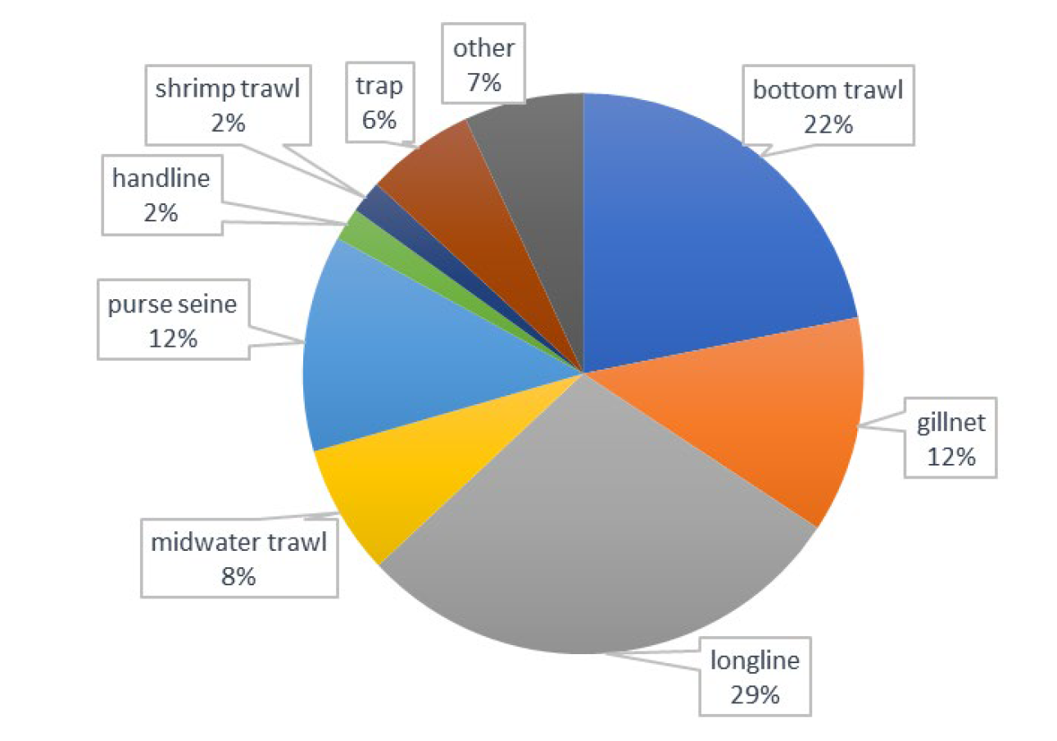
Figure 3 - overview of the use of EM for monitoring different types of fishing gear by %. Source: Van Helmond et al. 2020

Trawling: Electronic Monitoring for Primary Species

Despite the wide use of EM, the use of EM in bottom trawling is not without its shortcomings. Intuitively EM is expected to be more efficient for gears that bring catch on deck one individual at a time, such as hook and line (longline) and gillnetting. In trawling this is not the case with a mixed catch often being brought on deck at once making it difficult and time consuming to identify the contents of the catch.

Several studies analysing the use of EM in bottom trawling reported strategies where a random 10%–20% of the camera footage was validated against (self‐) recorded catch data in logbooks (Course et al., 2011; van Helmond et al., 2015; Kindt‐Larsen et al., 2011; Needle et al., 2015; Ulrich et al., 2015). This ‘audit approach’ is commonly used around the world (van Helmond et al., 2020) and means, that only a small (random) selection is validated with EM information.

Van Helmond et al. (2017) explored the use of EM to record catches of common sole (solea solea) in North Sea bottom trawling. The study found that “video review of the standard catch-processing routines on board bottom trawlers significantly underestimates the number of sole <24 cm present in the catch” and “for sole >24 cm, no significant systematic difference was found between logbook records and video observations”. In the context of Yellowtail Flounder, that grow between 30-55cm, this result suggests suggesting that EM could well be used for recording catches.

However, a key challenge raised by Van Helmond et al. (2017) is the need to maintain EM system on board like, for example, cleaning camera lenses. Technical failure and poor image quality is still a potential risk to the effectiveness of EM. In the US West Coast groundfish bottom trawl fishery, where a fully implemented EM program is in use, the National Marine Fisheries Service (NMFS) requires the EM service provider to be fully responsible for the installation and technical support of EM systems, and the collection and review of EM video data.

Canada’s Department of Fisheries and Oceans requires that all fisheries will report their catches electronically by 2024. In Canada’s Westcoast groundfish bottom trawl fishery, service provider Archipelago provides the electronic monitoring and Vericatch the reporting by digital logbook. Pre-pandemic, a robust system operated with a digital skipper’s logbook, digital observer’s logbook, and a digital ‘way out’ logbook (independent dockside monitoring of catches). With EM on some vessels, the fishery could corroborate what was being caught.

Trawling: Improving ETP Species Monitoring

EM has shown the potential to be accurate at examining fisheries interaction with ETP species, such as whales, turtles, seabirds, and sharks as these animals are often large or distinct from the target fish species. When EM imagery captures these interactions, species identification is possible in most cases. Life status can also be determined when animals are vigorous, especially when brought on deck prior to release. Detection of unusual or unexplained behaviour, that may result from crews wishing to avoid a ETP species being recorded by EM, is also possible (Pierre, 2018). Moreover, EM can even be played at a higher rate (10–12 times faster than real time) (Kindt‐Larsen et al., 2012), thereby reducing monitoring time.

In applying this assessment to the ETP species commonly found in Southeast Shoal, humpback whales, leatherback turtles and loggerhead turtles, as well as 20 species of seabirds could benefit from EM onboard fishing vessels. However, the Southeast Shoal is also a nursery and spawning ground for fish species such as yellowtail flounder, capelin, cod, plaice and striped wolffish. As Van Helmond et al. (2020) find, EM is not ideal for identifying species below a certain size especially in trawl fisheries where everything is dumped on deck at once. The only instance where Van Helmond et al. (2017) found this issue could be mitigated was where crew lined up the small catch in front of the camera. This protocol led the EM systems to return equally good results as the logbook, but was estimated to add 12 hours to the fishing trip.

Machine learning is not yet capable of identifying the ETP species in large pulls, according to Max Vanry of Vericatch. Observers are necessary and human reporting is needed unless, as mentioned, species of concern are passed through a camera range. EM is still a very long way from having a really successful artificial intelligence for diverse trawl catches. Its current strength is facilitating a vessel’s capabilities for monitoring and reporting of ecological impacts via digital logbooks. Specifically, EM on all or some vessels expands the range of observations of fishery interactions with ETP species. It could be used to corroborate and extrapolate observer data.

Please add a couple of paragraphs on expanding observer training to monitor non-target catches better, particularly ETP in the trawl, and juvenile and observer digital logbooks.

Flexibility for Vessel Operators

Operational flexibility is a further advantage of improving the monitoring of non-target catches, but this needs to be demonstrated in practice. In the near future, combinations of electronic monitoring and an expanded observer scope will assist vessel operators to make more efficient decisions about where and how intensely they fish. The need for this is demonstrated in the US West Coast groundfish bottom trawl fishery, where the NMFS has provided vessels with a choice between “maximum” and “optimised” retention. Originally, the authorities recommended “optimized” retention rules as the preferred alternative for bottom trawl trips because “maximized” retention was considered too restrictive. However, some vessel operators expressed a preference for “maximized” retention as it simplified catch handling. As such it was determined that allowing vessel operators to choose the retention rules that best fit the operation of gear and vessel, as well as the characteristics of the target species, would provide operational flexibility. However, without independent observers or EM spotting hotspots for juveniles, a “maximised” approach could overexploit undersized species, whilst an “optimised” approach could reduce objectivity because it requires the complicity of the vessel (Federal Register, 2022). As the following section illustrates, a balance of objectivity and complicity is needed for success in the overall management of the fishery. Finding the right combination to achieve the right balance will require practice by NAFO fishery monitors, fishing vessel operators, fishery observers and EM service providers in service of a common goal to avoid hazards to ecosystem harms.

EM Initiatives by Non-Government Organizations

Research into fishers’ views on the presence of EM on fishing vessels has yielded very different results which seem to depend greatly on the attitude of the implementing agency. In cases where the agency demonstrated respect and cooperation with the vessel operators, EM has proven successful to some degree. In cases where the opposite is true, distrust and non-compliance has led to abandonment of EM trials and programs (Mangi et al., 2013).

The Nature Conservancy (TNC) and California Environmental Associates (CEA), jointly authored the report, ‘Catalysing the Growth of Electronic Monitoring in Fisheries’, in 2020 (a follow up to the 2018 predecessor). The report considers the opportunities, barriers and future considerations for the implementation of EM in fishing. In the context of providing support to regulators, a core recommendation is developing poles of intersectional expertise that could bring together the different threads. Specifically, the report urges that industry representatives be included in such discourses. “As the stakeholder group most immediately impacted by EM, it is important to bring industry to the table to ensure that their views are integrated into the design and iteration process to build their commitment to the program” (51).

For example, in the context of the NAFO Yellowtail Flounder fishery, some interviewees gave conflicting opinions on the best way to display catch-data. One interviewee said they preferred being able to print daily reports, especially if an inspector were to come aboard; whilst another interviewee noted that inspectors preferred reviewing the data on a screen. Clearly there is some disconnect between the different stakeholders involved in the fishery and providing a legitimate space for this to be resolved should be a priority for regulators. Unfortunately however, Interviewees for this report conceded that NAFO adopt an esoteric management approach and were not described as facilitating access to decision-making processes for stakeholders other than government representatives of the Contracting Parties.

The Case for Leadership by NAFO and CPC governmental entities

It is commonly the case in fisheries management that it is government-led initiatives that will likely lead to paradigm shifts. Notable activities that may result in such a shift include the International Council for the Exploration of the Sea (ICES), which convened the first Working Group on Technology Integration for Fishery-Dependent Data (WGTIFD) in 2019. The group includes a mix of regulators, non-governmental organizations (NGOs), service providers, and academics who are tasked with providing advice to the community on electronic tools and applications that support fisheries-dependent data collection. Similarly, in the US, NOAA held two sessions of its third national EM workshop at the end of 2019 and beginning of 2020, which has brought together multiple stakeholders, including fishers or fisher representatives, to discuss electronic monitoring.

An interesting political decision made by the NMFS in the case of the US West Coast bottom trawl fishery, was delaying the implementation of the program by one year for the purpose of building further momentum and buy-in from industry. In other words, the NFMS used its political leverage to draw more stakeholders in the milieu discussing the use of EM in West Coast trawl fisheries, thereby including the number of entities complicit in the design of the program, and reducing the number of actors who might be excluded should the program expand on its original focus.

Observer Monitoring

As indicated by Van Helmond et al. (2017), the use of EM in trawl fishing has to be perfected to the point where the technology itself is capable of accurately identifying each of the different species, target or non-target.

For NAFO there is an inherent interest in finessing its Observer Program regardless of whether it looks to include the use of EM in its conservation management policies. As explored in the section of this report ‘An Overview of NAFO’s ETP Monitoring Policies’, NAFO observer are currently not expected to report upon a wide range of ETP and non-target species commonly found in the North West Atlantic Ocean.

However, should NAFO seek to include EM in it conservation management plans, Observers will be required both to validate and ensure that the results of EM. Observers will be required in the initial phase of introducing the technology to ensure that EM can deliver accurate conservation results. Equally, for the long-term, human observers will be required to validate video recordings.

Recommendations

Given the often complex decision-making processes and competing objectives, the NAFO Secretariat could bring to the fore the subject of EM in NAFO-regulated fisheries, in order to encourage the discussion of ecosystem impacts and how they can be managed efficiently. Appreciating it will possibly take time for an EM program to be rolled out in a NAFO-regulated fishery, this recommendation seeks to initiate the inevitable discussions sooner rather than later.

- NAFO could invite presentations from service providers for EM and digital logbooks in trawl fisheries as well as testimonies from industry users and independent fishery observers.
- NAFO could distribute ecosystem findings for the Convention Area from research institutes with practical summaries for fishing vessel operators.
- NAFO could invite presentations from fishing companies operating in the Convention Area with advanced systems and experience with non-target catch monitoring and reporting, like Tremont Fisheries.
- NAFO should consider revising its Observer Program to mandate observers keep more detailed records of ETP and non-target species. Moreover, should NAFO consider using EM in its conservation policies observers will need to be trained and equipped with the capacity to validate and ensure consistent and accurate results.
- NAFO could host a markets-oriented event or otherwise reach out to seafood companies that drive the trade in NAFO-caught fishery products to learn about and influence their sourcing policies to meet the growing demand for sustainability. By advocating for the development, adoption, and implementation of robust EM programs, fishers, processors, and retailers can help guarantee a consistent supply of sustainable fish for the global market.

Under proposed “maximized” retention requirements, vessels on bottom trawl trips would not sort or discard catch at-sea and would be required to retain all catch until landing, with exceptions for prohibited and protected species. Under “optimized” retention, EM vessel operators would be allowed to discard species that can be differentiated on camera, and retain those species that cannot be easily distinguished in video data. Some groundfish species are difficult to distinguish from each other without close inspection of certain physical features which cannot be easily viewed using video data.

