Bycatch Handling Tools Checklist

Key Traceability

Inspector
Date
Vessel
Skipper

Name | Description | Seen onboard (Y/N) | Notes
De-hooker  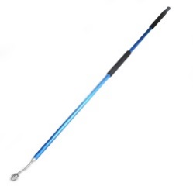 | De-hooker on short pole with female threads (to use on short handle to remove hooks from organisms when being handled on deck, and to use on the long pole to remove non-ingested hooks from animals in the water)
Line Cutter  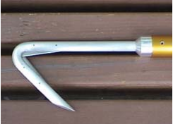 | Line cutter on short pole with female threads
Landing dipnet  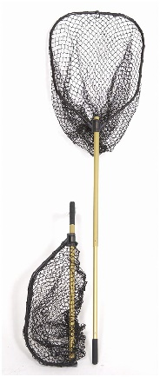 | Landing dipnet on short pole with female threads (to bring caught organisms on deck that require handling to remove gear and/or to resuscitate before release). The net hoop can be made from 9mm stainless steel rod and be at least 73 cm in diameter. The net bag on the ring should be at least 96 cm deep, with mesh no larger than 7.5 X 7.5 cm. The net can be made with heavy-duty purse seine twine commonly available on all tuna purse seiners or from net supply companies.
Sling  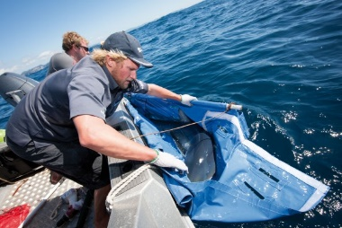 | Sling made with stiff multi-monofilament (to bring small sharks and rays aboard)
Bolt cutters  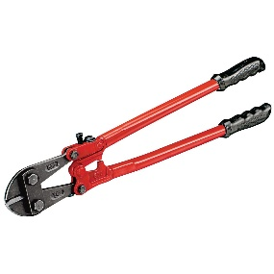 | Bolt cutters strong enough to easily cut off the barb of circle hooks used on the vessel
Automobile tyre or equivalent  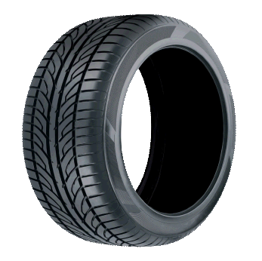 | Automobile tyre (to raise the rear flippers of comatose / sluggish turtle)  Ask crew for alternatives as some use steps on board or blocks of wood.
Block of hard wood or equivalent  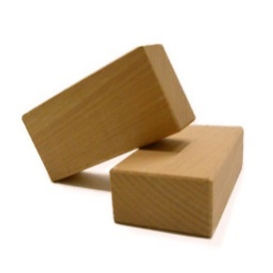 | Block of hard wood 7.5 cm thick, 30 cm long (to place into mouth of a turtle or shark)  Equivalents could include broom handles.
Dark-coloured towels  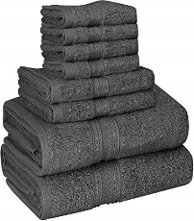 | Dark-coloured towels (wet towels are to be placed on turtles, sharks, birds when they are being handled)
Cleat  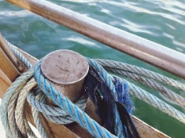 | Cleat installed on deck near fish door at the hauling station (to attach the mainline or branch line when handling a large shark or toothed whale)

