C7488 Project UK Fisheries Improvement - Task 5. Scallop and monkfish ecosystem assessment
Information for Scale Intensity Consequence Analysis (SICA) of performance indicator (PI) 2.5.1

Author(s): Gwladys Lambert, Roi Martinez, Stephen Mangi
Issue Date: 08/06/18

Cefas Document Control
Submitted to: | Chloe North
Date submitted: | 08/06/2018
Project Manager: | Anna Sypniewska-Huk
Report compiled by: | Gwladys Lambert
Quality control by: | Thomas Catchpole
Approved by and date: | Stephen Mangi 08/06/2018
Version: | 1.2

Version Control History
Version | Author | Date | Comment
1.0 | Gwladys Lambert, Roi Martinez | 23/05/18 | First draft
1.1 | Gwladys Lambert, Roi Martinez | 08/06/18 | Addressed QA comments
1.2 | Gwladys Lambert | 11/06/18 | Accepted Mangi’s minor corrections

Executive Summary
We used the MSC SICA guidelines, under Performance Indicator (PI) 2.5.1, to provide information necessary to score the impact of two fishing activities on the part of the ecosystem with which they interact. These are scallop dredging in area 27.7.d and e and monkfish in 27.7b-k and 8a-b, 8.d. Vessel Monitoring System (VMS) maps were compiled to enable scoring of the spatial scale, temporal scale and intensity of the activity.
Existing published literature has documented the effect of towed bottom gears on the seabed and its associated benthic and demersal communities to inform the effect of the activities on the ecosystem sub-components (species richness, functional diversity, community distribution, trophic/size structure). The aim of the present report is not to provide scores on these sub-components, nor the full evidence that would be necessary to score, but rather to discuss the scoring rationale with respect to the two fisheries of interest, giving indications of what might be the most vulnerable subcomponent, and briefly report the discussions held with the industry representatives.
The maps and information collected from the literature were presented to industry representatives at workshops and their feedback is briefly reported here.
Scallop dredging is widespread in the unit of assessment (UoA) but the activity is patchy within this area. There are well defined scallop grounds that have been consistently fished over several years. Considering the VMS data exclusively, the activity of the unit of certification (UoC) covers about 28% of the UoA. This however does not cover the <12m fleet which, from the industry view point, was not expected to significantly increase the overall impact of the fishery. The extent of the activity was only visually assessed during the workshop and the value of 28% was only calculated from VMS data afterwards. An increase of 2% of the footprint (accounting for the <12m vessels) would change the expected score from 3 to 4. Monkfish beam trawling covers a very small part of the UoA (<15%). The authors consider that by including the activity which is not covered by VMS data, the percentage coverage would not exceed 15% (cut-off point on the MSC scoring scale).
Both fisheries operated most days of the year, i.e. ranging from 345 to 355 days of activity per year during the 2012-2016 period.
For both fisheries, the intensity was difficult to score and subject to debate with the industry, due to the apparent lack of agreement between actual score (1-6) and associated wording in the MSC guidelines. For instance, a score of 3 out of 6 may be perceived as relatively high while the definition is “moderate detection of activity at broader spatial scale, or obvious but local detection”, which the industry would have scored as a 2/6, i.e. not middle of the impact scale. It was suggested that the “negligible” score should be set to 0 instead of 1. Under the current scoring guidelines, the limited footprint of the monkfish UoC would point to a score of minor impact (score of 2 – “activity occurs rarely or in few restricted locations and evidence of the activity even at these scales is rare”).
Both types of fishing have been shown to have a significant impact on their local ecosystem, but dredging is often considered to be the most damaging of the two fishing methods assessed here. Defining which of the subcomponents is the most vulnerable is not straight forward as each subcomponent is linked to the others. For towed fishing gears that have a significant impact on the seabed the species composition is linked to the functional group composition.
Functional group composition is known to be affected by dredging. Dredged scallop beds will tend to be dominated by small, short lived, mobile, opportunistic and scavenger species. The beam trawl fishery will also impact the species displaying the least resilient traits. The actual effect will depend on the spatio-temporal scale of the fishing intensity, the state of the original ecosystem and the level of natural disturbance it is already subjected to.
Beam trawls are known to have poor selectivity, as a number of species are caught or indirectly impacted by the contact of the gear with the seabed. Monkfish are also caught alongside other commercially important species as part of a mixed fishery. The Cefas Observer Programme (COP) shows that megrim, cuttlefish, dogfish, plaice and a number of other species are caught alongside monkfish.
Overall, scallops or anglerfish are not thought to be key prey species. In the beam trawl fishery, there may be an indirect consequence of removing a top predator from the local ecosystem. However, stock assessment over the whole UoA does not show signs of decline of the species and therefore the impact might be limited at the larger scale.
Under a data limited approach, which could be questioned here in light of the amount of data available for both fisheries, the score of PI 2.5.1 for both fisheries is likely to be high, due to the relatively small footprint of the fisheries in their respective UoA and because none of the species are tightly linked to a specific habitat and the UoC does not cover all gears and countries that target those given stocks.
Further investigation into the spatial footprint of non-VMS equipped vessels would help better characterise the footprint as well as further research into mapping the species habitat or considering the anglerfish as two separate species.

Table of Contents
1 Introduction 5
1.1 Scallop dredging fishery in area 27.7.d and 27.7.e (English Channel) 5
1.2 Monkfish beam trawl fishery in area 27.7.b-k, 8.a-b and 8.d (southern Celtic Seas, Bay of Biscay) 6
1.3 Scale Intensity Consequence Analysis (SICA) 7
2 Methods 7
2.1 PI 2.5.1 SICA Spatial, temporal and intensity scale 7
2.2 PI 2.5.1 SICA Subcomponents 8
2.3 Maps 9
2.4 Catch composition 11
3 Results 12
3.1 Scallop fishery 12
3.1.1 Spatial scale of activity 14
3.1.2 Temporal scale of activity 14
3.1.3 Intensity of activity 15
3.1.4 Relevant subcomponents 15
3.1.5 Further rationale to inform scoring 16
3.2 Monkfish fishery 16
3.2.1 Spatial scale of activity 19
3.2.2 Temporal scale of activity 19
3.2.3 Intensity of activity 20
3.2.4 Relevant subcomponents 20
3.2.5 Further rationale to inform scoring 22
4 Discussion 23
5 References 26

Figures and Tables
Figure 2-1 MSC SICA scoring tables 9
Figure 2-2 MSC SICA scoring table for the subcomponent 10
Table 2-1 Table of cutoff points for inclusion of tows in the fishing effort calculations 11
Figure 2-3 Map of Unit of Assessment for scallop dredgers 11
Figure 2-4 Maps of Unit of Assessment for Monkfish fishery 12
Figure 3-1 Map of sediment type of the UoA 13
Figure 3-2 Map of swept area ratio of scallop dredging 2012 13
Figure 3-3 Map of swept area ratio of scallop dredging 2013 14
Figure 3-4 Map of swept area ratio of scallop dredging 2014 14
Figure 3-5 Map of swept area ratio of scallop dredging 2015 14
Figure 3-6 Map of swept area ratio of scallop dredging 2016 15
Table 3-1 Number of unique days of fishing for the scallop dredging fishery in the UoA 15
Table 3-2 Table of proportion of the scallop dredging activity by year and quarter 15
Figure 3-7 Map of sediment type of the UoA 17
Figure 3-8 Map of swept area ratio of monkfish beam trawling 2012 18
Figure 3-9 Map of swept area ratio of monkfish beam trawling 2013 18
Figure 3-10 Map of swept area ratio of monkfish beam trawling 2014 18
Figure 3-11 of swept area ratio of monkfish beam trawling 2015 19
Figure 3-12 Map of swept area ratio of monkfish beam trawling 2016 19
Table 3-3 Number of unique days of fishing for the monkfish beam trawl fishery in the UoA 20
Table 3-4 Table of proportion of the monkfish beam trawl activity by year and quarter 20
Figure 3-13 Catch composition of monkfish beam trawl fishery 21
Figure 3-14 Place of monkfish in the Celtic/Biscay ecosystem from 2012 Ecopath model, from Bentorcha et al. 2017 22

Introduction

Scallop dredging fishery in area 27.7.d and 27.7.e (English Channel)
The king scallop (Pecten maximus) is a large filter-feeding bivalve that can grow up to 175mm (shell length) and live up to 20 years. It is found on the continental shelf of NW Europe, common in depths in the range of 5-200m. It prefers gravelly sandy substrates but is found across a range of habitats from muddy sand to coarse gravel or even more cobbly areas. Fisheries are concentrated on mixed grounds of gravelly sandy substrate type which results in a patchy distribution of the scallop fishery along the English Channel (area 27.7).
Scallops from the English Channel are the most valuable commercial species in the UK, with landings of around 35,000 tonnes in 2016. The MMO reports 38,400 tonnes landed in the UK by UK vessels in 2016 for a value of £74.1 million. This is a non-quota stock (or stocks) and is mainly exploited by France and the UK. Management falls mostly under national regulation although the EU sets the minimum landing size and caps the level of effort of ≥15m vessels in areas 27.7.d and 27.7.e. There is also a limit on retained fish by-catch to 5% of the total quantity of bivalve molluscs to prevent scallop dredgers from targeting sole. The UK fishery comprises a fleet of large (≥15m) nomadic vessels and smaller (10-15m) ones often fishing more locally. UK regulations consists of licence conditions, gear restrictions as well as spatial restrictions.
The fisheries targeting scallop consist mostly of scallop dredgers, which are known to be one of the most impactful towed bottom gear types with respect to seabed habitats and associated species. The Scallop Fishing (England) Order 2012 sets the specifications of the dredges that can be used within 12nm of the English coastline, such as weight of dredges, width, number, ring size, teeth length and spacing between teeth. These measures will have a direct effect on the level of impact of the activity on the target species and wider ecosystem. At the target species level however, except for the direct removal of species, mortality is not expected to be significantly affected by discard rates as scallops are generally assumed to have a high survival rate, although indirect mortality causes such as the risk of predation will increase (Jenkins and Brand, 2001). The Endangered, Threatened and Protected (ETP) species analysis conducted in the English Channel in 2017 found that 9 Elasmobranch species were identified to have the highest vulnerability score of the assessment scale to scallop dredging gears, in particular the sandy skate Leucoraja circularis, blonde ray Raja brachyura and thornback skate Raja clavata, which all presented high risk scores.

Monkfish beam trawl fishery in area 27.7.b-k, 8.a-b and 8.d (southern Celtic Seas, Bay of Biscay)
There are two species included in the unit of assessment (UoA), the white anglerfish Lophius piscatorius and the black anglerfish Lophius budegassa. There is no clear evidence of the existence of separate stock units for each species in the UoA. Despite the biology and ecology of both species still being poorly understood, L. piscatorius is expected to grow faster than L. budagessa and live further north. Both are most abundant at depths of 200-800m but also occur in coastal waters. Size patterns observed in surveys suggest migrations with juveniles mostly found offshore, medium-sized fish inshore and larger adults offshore. Therefore, the species may exploit several ecological niches at various stages of their lifecycle. Anglerfish are ambush predators who feed opportunistically, non-selectively on passing prey, which is lured by their specialised illicium. The diet of the small individuals is dominated by invertebrates while larger monkfish prey on fish, e.g. small gadoids, sandeels, flatfish, and, to a lesser extent, on cephalopods.
Anglerfish is caught in mixed fisheries using a range of gear types such as otter trawls, gillnets and beam trawls. The units of assessment for this fishery include (i) bottom otter trawls, (ii) beam trawls and (iii) gillnets (trammel & entangling/gill nets) in the Western Seas and Channel (VII b-k, VIII a/b/d). The fishery is under EU quota management, with a joint quota for both species. The landings are all recorded as one species group as they are difficult to distinguish ashore. They are separated in sampling schemes designed at national level, which provide a splitting index that can be applied to the landings for assessment and management purposes. However, there remains a problem with the smaller, juvenile individuals as well as consistency between sampling schemes. Landings are in the range of 20-40 thousand tonnes per year, i.e. including all countries and metiers of the UoA. France takes most of the landings (60%), followed by Spain (20%), the UK (10%) and Ireland (10%). Minor landings have been recorded for Belgium, Germany and Portugal. About 95% of the UK landings consist of L. piscatorius. Across all countries, ca. 10% of L. piscatorius are caught in beam trawls, against 65% for otter trawls and 20% for gillnets. Discarding in this stock is relatively minor overall (in the order of 5-10%) although there will be large variations between gear types and possibly regions.
Beam trawls can be towed over a range of substrate types, from mud, sand to rocky or even cobbly grounds. Monkfish do not seem to strongly associate with one specific type of sediment. It is mostly found on sandy or muddy bottoms but is also present on shell, gravel and occasionally rocky areas. As with all other bottom towed fishing gears, beam trawls have direct impacts on the seabed that have been documented to be particularly detrimental on certain species and habitats. They are further known to have poor selectivity, which has been a focus of research in recent years. The UK Project 50% for example used gear modification techniques such as benthic panels, large mesh top panels and cod ends to reduce discard rates by about 50%. The pre-assessment report indicates that the primary species caught in the beam trawl monkfish fishery, except for monkfish, are megrim, plaice and sole and the secondary species are cuttlefish and gurnard. The 2018 ETP species analysis conducted in the UoA found that common skate was observed as bycatch in relatively significant amounts. Undulate ray was of concern prior to 2010 but seemed to have improved, i.e. decreased, while other elasmobranchs such as nurse hound, starry smooth hound and blond rays have increased. It reports the ETP species of the beam trawl fishery to be common skate, undulate ray, spurdog and northern gannet.

Scale Intensity Consequence Analysis (SICA)
The MSC SICA, under Performance Indicator (PI) 2.5.1, provides a framework to score the impact of an activity, defined as a Unit of Certification (UoC), over the ecosystem of the whole UoA in situations where data may be limited. The objective of this report is to provide some information towards the SICA scoring of both fisheries described above (see details in methods overview below).
The MSC definition of an ecosystem under PI 2.5.1 refers to communities. It states that “there can be many interpretations of community—from very large-scale, ocean basin species assemblages to the small-scale, such as assemblages of a single taxon or small-scale habitat associations such as infaunal invertebrate communities. Community members include all mobile fauna, vertebrate or invertebrate, but do not include sessile organisms such as coral that are largely structural and therefore classified as habitat.” Impact on habitat and ETP falls under different PIs and are covered elsewhere in the MSC assessment process. Here we aim to provide information on the larger picture.

Methods

PI 2.5.1 SICA Spatial, temporal and intensity scale
We compiled Vessel Monitoring System (VMS) maps to help score the spatial, temporal and intensity scale of each activity under the PI 2.5.1 criteria. The spatial scale is defined as the percentage of the overall range of the stock covered by the greatest spatial extent of the activity of interest. The temporal scale is the number of single days in a year when the activity occurs. The intensity is based on a combination of spatial and temporal scales. See scoring tables below as extracted from the MSC documentation (Figure 2-1).
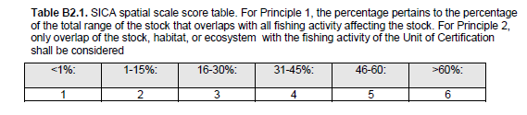
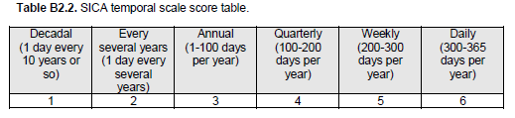
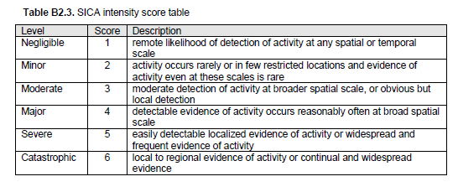
Figure 2-1 MSC SICA scoring tables
The maps, along with further information gathered from the literature and data on the catch composition of the monkfish beam trawl fishery, were presented at two workshops/meetings attended by a few representatives of the fishing industry in Ivybridge and Penzance, on the 16th and 17th April 2018. Here we report on the information presented, with some feedback on the discussions held at the meetings.

PI 2.5.1 SICA Subcomponents
We then further discuss the subcomponent aspect of the SICA analysis (scoring guidelines presented in Figure 2-2). Those subcomponents are species composition, functional group composition, distribution of the community and trophic/size structure. The aim of the present report is not to provide a score for each of those, nor all the available evidence, but rather discuss the rationale behind their scoring with respect to the two fisheries of interest, give indications of what might be seen as the most vulnerable subcomponent, and briefly report the discussions held with the industry representatives.
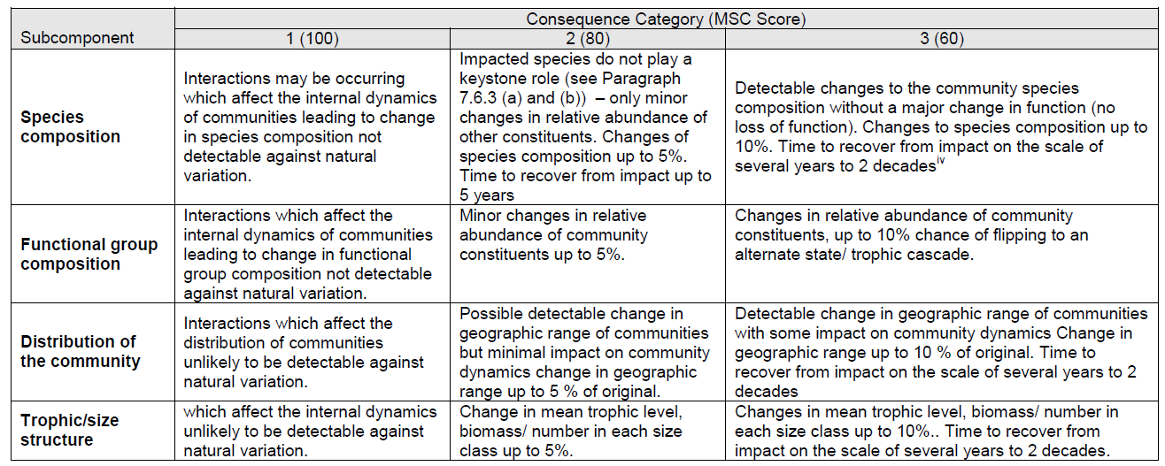
Figure 2-2 MSC SICA scoring table for the subcomponent
A wealth of published literature documenting the effect of towed bottom gears on the seabed and its associated benthic and demersal communities has been building up over the past 20+ years. A series of very recent studies (from 2016 onwards), resulting from projects such as BENTHIS and the ‘Trawling Best Practices Project’, have aimed to draw on the accumulated knowledge and evidence, using tools such as systematic reviews, metadata analyses and modelling approaches, to help better understand the interactions between fishing gears and ecosystems as well as the implications for sustainable management (see e.g. Kaiser and Spencer 1994; Groenewold and Fonds 2000; Kaiser et al. 2000; Jennings et al. 2001; Riemann and Hoffman 2001; Jennings et al. 2002; Heath 2005; Kaiser et al. 2006; Hiddink et al. 2008; Hiddink et al. 2011; van Denderen et al. 2013; Collie et al. 20016; Duplisea et al. 2016; Eigaard et al. 2016; Hiddink et al. 2016; Rijnsdorp et al. 2016; Bolam et al. 2017; Eigaard et al. 2017; Hiddink et al. 2017; Pitcher et al. 2017; Rijnsdorp et al. 2017; Sciberras et al. 2018). Those cover aspects such as direct and indirect impact, recovery rates, interactions substrate type/communities/fishing gear, species and functional changes in composition, changes in size structure, in productivity, depth of disturbance in the sediment, link between fishing and top-down/bottom up control etc. We draw on the studies cited here and references therein to make some general comments on the likelihood of the fisheries of interest to have an impact on each subcomponent.

Maps
Maps were produced to support SICA analysis scoring and used as documents for SICA workshop discussion. Maps of fishing effort were created using VMS data (satellite position and speed of a fishing vessel larger than 12 meters reported every 2 hours) and logbook data (fishing trip dates, fishing gear characteristics and catches reported at ICES rectangle level). VMS data were selected only for fishing vessels belonging to South Western, Interfish and Cornish FPO’s. VMS points indicating fishing activity were selected to be those attached to a speed of 2 to 5 knots both for monkfish and scallops. Those VMS points were combined with the logbooks to filter out the beam trawlers and dredging fishing trips where scallops and monkfish were the targeted species or anticipated in the catch. The selection of trips was straight forward for scallops as scallopers’ landings have to be 95% scallops. For beam trawlers, a minimum composition percentage was calculated for every year (Table 2-1) so that 95% of the monkfish landings would be represented for that year. Selected VMS data were then placed over a grid of 0.05 degrees square cells that covers the respective UoA areas. The SAR (swept area ratio) was calculated as the gear width multiplied by vessel speed and fishing time at each point. The point value was then aggregated per grid cell and divided by the area of the grid cell. The resulting SAR is therefore the number of time the grid cell has been fished over a year.
Table 2-1 Table of cutoff points for inclusion of tows in the fishing effort calculations
Year | Scallops | Monkfish
2012 | 0.95 | 0.06
2013 | 0.95 | 0.07
2014 | 0.95 | 0.09
2015 | 0.95 | 0.07
2016 | 0.95 | 0.07

SICA spatial and temporal fishing impact indicators were supplied by fishery as swept area ratio and number of days fishing per year respectively. Swept area ratio is the proportion of each cell of the grid swept by the fishing gear (Gerritsen et al. 2013), the numbers of days fishing were represented by grid cell as well as total number of days in a year.
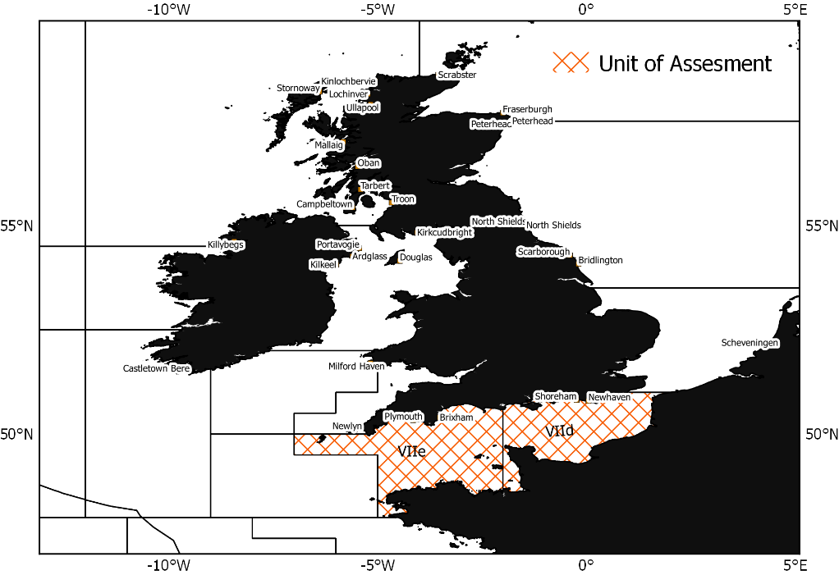
Figure 2-3 Map of Unit of Assessment for scallop dredgers
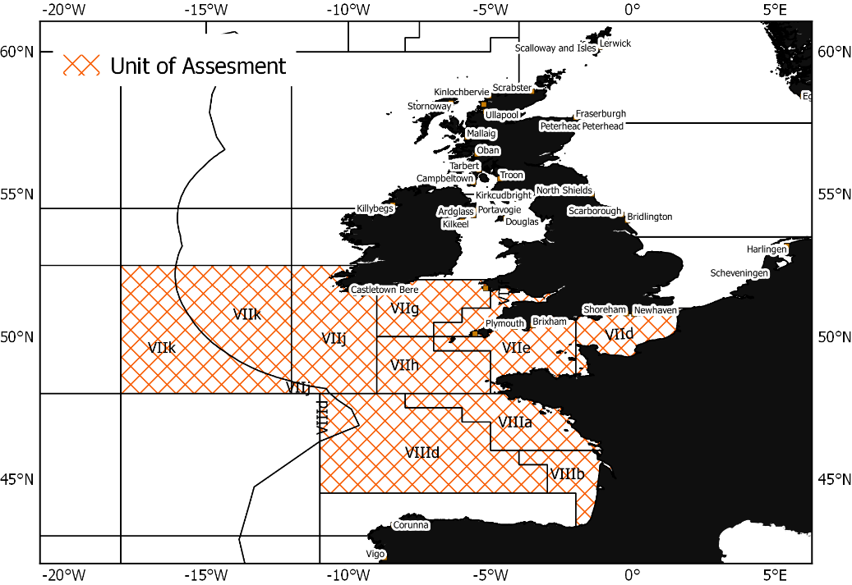
Figure 2-4 Maps of Unit of Assessment for Monkfish fishery

Catch composition
The information used here is presented elsewhere (see report task 6) and concerns only the monkfish fishery. In brief, a catch profile was developed using the data collected by Cefas Observer Programme (COP) between 2014 and 2017, in ICES areas VII b-k and VIIIa,b,d. The sampled trips used for the analyses were the ones considered to target monkfish (white and black-bellied anglerfish). A trip was defined as targeting monkfish when this species constitutes 10% or more of the catch. For each trip, numbers-at-length were raised to the haul, based on an estimated proportion of the total catch volume sampled, then to the trip, based on the proportion of sampled hauls and fished hauls. The length-based data was converted to biomass, using length-weight relationships for each species collected during various scientific trawl surveys.

Results

Scallop fishery
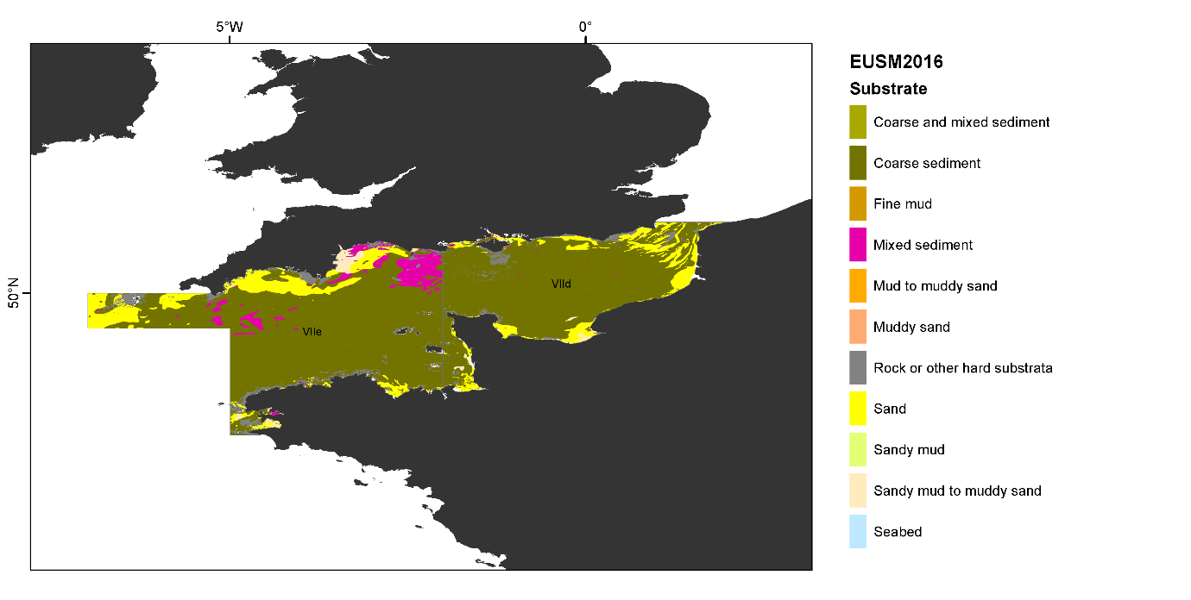
Figure 3-1 Map of sediment type of the UoA

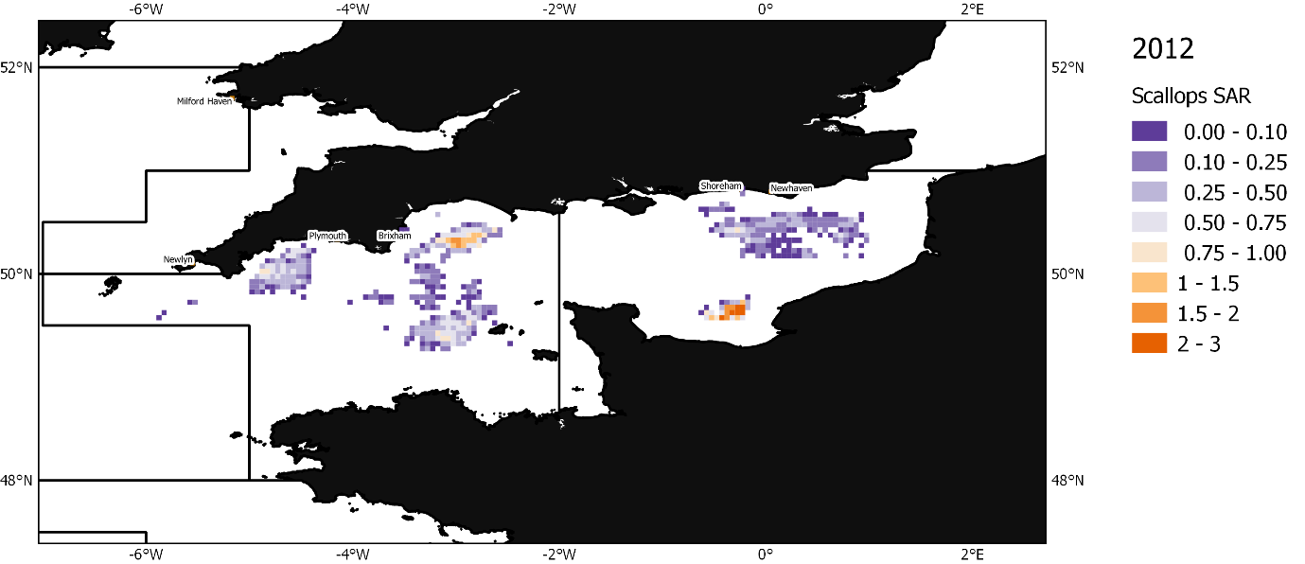
Figure 3-2 Map of swept area ratio of scallop dredging 2012
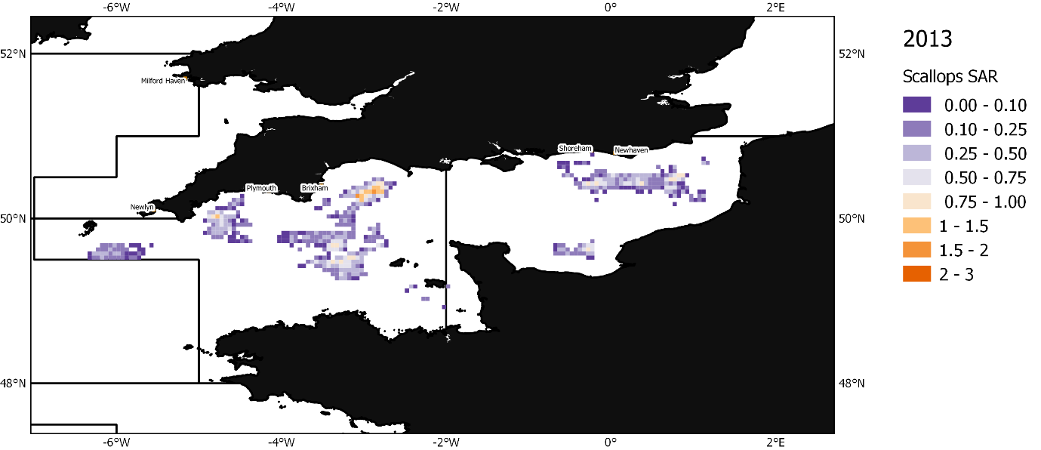
Figure 3-3 Map of swept area ratio of scallop dredging 2013
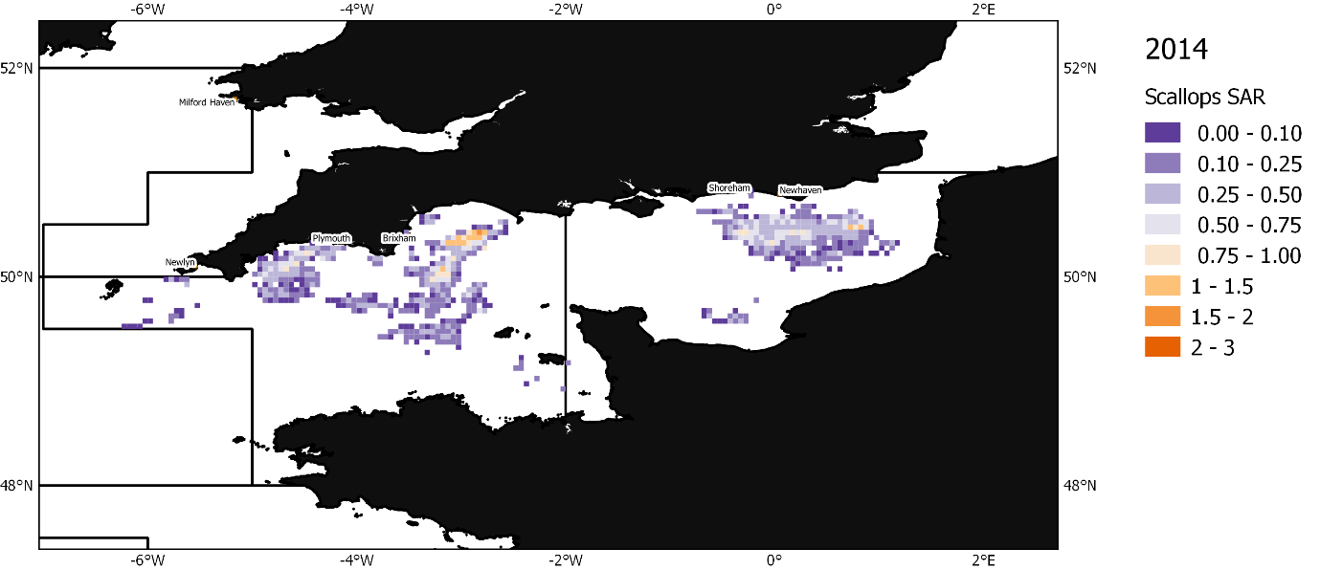
Figure 3-4 Map of swept area ratio of scallop dredging 2014
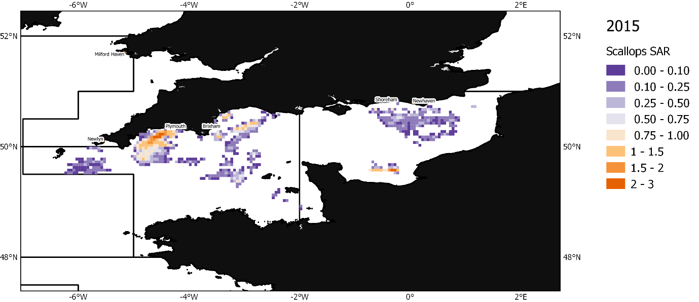
Figure 3-5 Map of swept area ratio of scallop dredging 2015
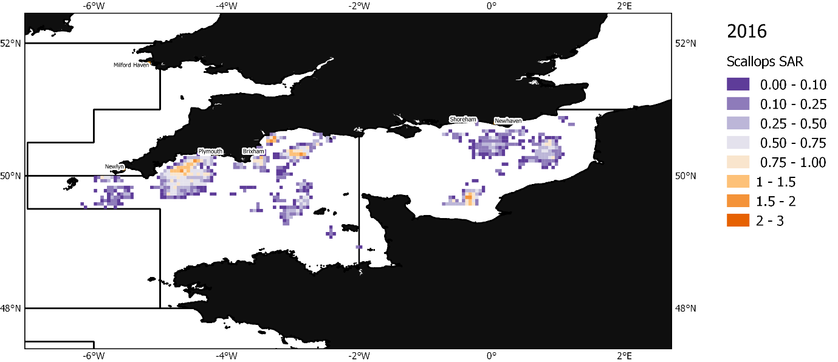
Figure 3-6 Map of swept area ratio of scallop dredging 2016

Spatial scale of activity
The UoA covers ICES areas 27.7.d and 27.7.e, i.e. the English Channel. Scallop dredging is widespread in the UoA but patchy. There are well defined scallop grounds as can be seen with the VMS data and those are consistent over years. Considering exclusively the VMS data, the activity of the UoC cover about 28% of the UoA. VMS data however only include vessels over 12m. IFCAs can provide further information on the smaller vessels fishing inshore. The consensus at the workshop was that including this missing activity would not significantly extend the footprint of the UoC, in light of the criteria set by the MSC (i.e. footprint under 30% of the UoA, corresponding to a score of 3). However, the estimate of 28% was produced based on VMS data after the workshop (only a visual estimate was discussed then) and it is possible that the activity would score 4 in light of the actual estimate of 28% coverage which do not account for an unaccounted part of the activity (<12m vessels).

Temporal scale of activity
There are very few days in the year when no vessel of the UoC is active in the UoA (Table 3-1).
Table 3-1 Number of unique days of fishing for the scallop dredging fishery in the UoA
2012 | 2013 | 2014 | 2015 | 2016
355 | 350 | 347 | 350 | 355

Table 3-2 Table of proportion of the scallop dredging activity by year and quarter
Quarter | 2012 | 2013 | 2014 | 2015 | 2016
1 | 0.25 | 0.19 | 0.2 | 0.11 | 0.16
2 | 0.29 | 0.27 | 0.26 | 0.36 | 0.28
3 | 0.19 | 0.29 | 0.32 | 0.30 | 0.23
4 | 0.27 | 0.24 | 0.22 | 0.22 | 0.32

Intensity of activity
There was a debate at the workshop on how the level of intensity should be scored due to the wording of the MSC scoring table. A score of 3, equating to “moderate”, is described as “moderate detection of activity at broader spatial scale, or obvious but local detection”. While this description best reflected the group’s view in light of the spatial and temporal scales of the activity described above, the industry debated why this should correspond to a score of 3 out of 6 as a score of 2, equating to “minor”, would have been more appropriate. However, “minor” corresponds to an “activity [that] occurs rarely or in few restricted locations and evidence of activity even at these scales is rare”. The evidence suggests that this is not a rare activity but the restricted spatial extent of the UoC generated discussion.

Relevant subcomponents
All information provided below in section 3.1.4 is based on published literature with references which are given in the methods section 2.2.

Species composition
Notwithstanding the effect on habitats (which include sessile organisms), scallop dredging is known to cause one of the greatest disturbance to the seabed of all towed fishing gears due to the depth of penetration of the gear and physical characteristics of the dredges. Dredged scallop beds tend to be composed of species that are resilient to disturbance and attract scavengers. Species composition is thereby linked to functional group composition for towed fishing gears that have a significant impact on the seabed.

Functional group composition
As mentioned in the species composition subcomponent, functional group composition is known to be affected by dredging. Direct and indirect fishing mortality from dredging is one of the highest of all towed fishing gears. Dredged scallop beds will tend to be dominated by small, short lived, mobile and opportunistic and scavenger species. However, the actual effect will depend on the spatio-temporal scale of the fishing intensity, the state of the original ecosystem and the level of natural disturbance it is already subjected to. If the area is naturally disturbed and resilient, then the effect of fishing can be negligible.

Community distribution
The activity is not expected to affect the distribution of the community. Evidence from the literature and the spatial and temporal extent of the UoC suggest that scallops are widespread and live in mixed habitats while the location of fishing grounds (mostly sandy/gravelly) has been relatively stable. There is no suggestion that the fishing activity would interfere with the distribution of the associated community, although this might be an indirect consequence of removing an efficient filter feeder and habitat feature (some species settle on scallop shells) from the ecosystem.

Trophic/size structure
Scallops are filter feeders. The highest level of predation will most likely be on the juveniles. Adult scallops are mostly preyed upon by starfish.

Further rationale to inform scoring
Some technical management measures are in place (such as number of dredges within 6nm) but the effort or the catch is not currently regulated. Therefore, very high levels of effort can occur in places. Dredgers tend to fish an area down to economically unviable levels before moving ground, leaving the area to recover for as long as necessary before coming back. While there are specific scallop grounds, scallop dredgers are a nomadic fleet. However, the industry members participating in the workshop stated that conducting exploratory tows was not common practice and scallop grounds were well established. Since the highest impact from a towed bottom fishing gear is made the first time a new area is fished, this suggests that the impact of scallop dredgers might be limited. However, the resolution of VMS data is low (i.e. one ping every 2 hours, with tows that can be less than 20 minutes long). Therefore, the question of the scale of sensitive habitats remains a limitation since one cannot confidently assess how sensitive habitats may be impacted by first time fishing at this resolution.
The UoA covers the whole English Channel where there is a known environmental and ecological gradient from east to west. It is likely that the UoC will fish across a variety of communities and natural conditions, although they do repeatedly go back to established scallop grounds as stated above. The western part of the English Channel is deeper than the east, most of it below 50m (from ca. 100m to 40m from western to eastern English Channel). 50m roughly corresponds to the depth at which the seabed will not be affected by wave stress. The currents system is mainly tidal and there is a gradient of vertical mixing with stratified waters in the west, deeper waters and weaker currents compared to the east. Western Channel sediments also tend to be coarser. Faunal distribution reflects these differences, with the western English Channel being reported as richer in terms of number of benthic species than the east (Araujo et al. 2005 and references therein).

Monkfish fishery
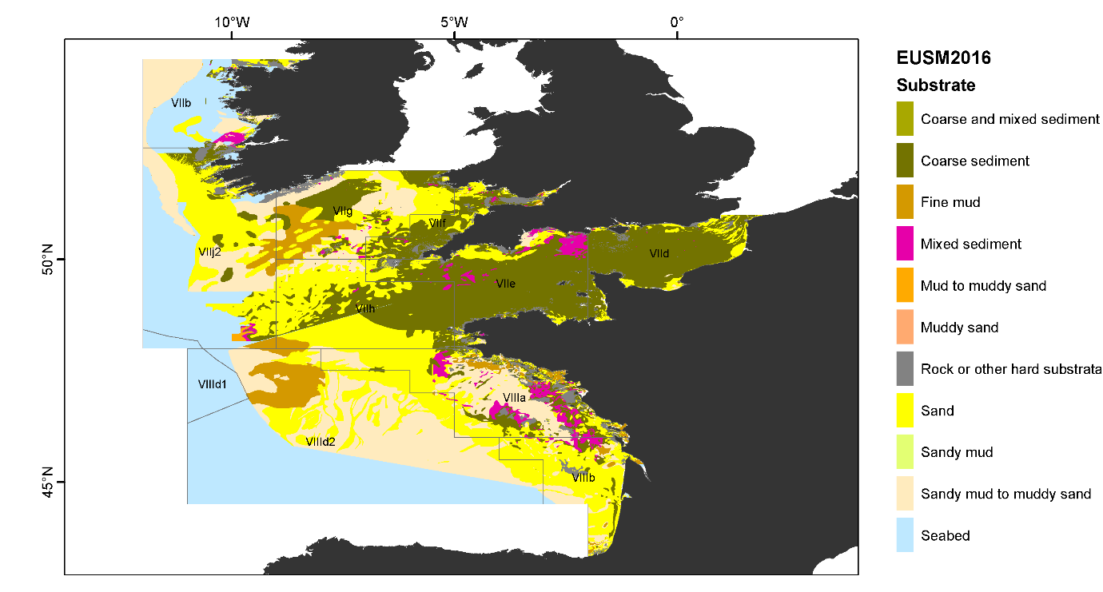
Figure 3-7 Map of sediment type of the UoA
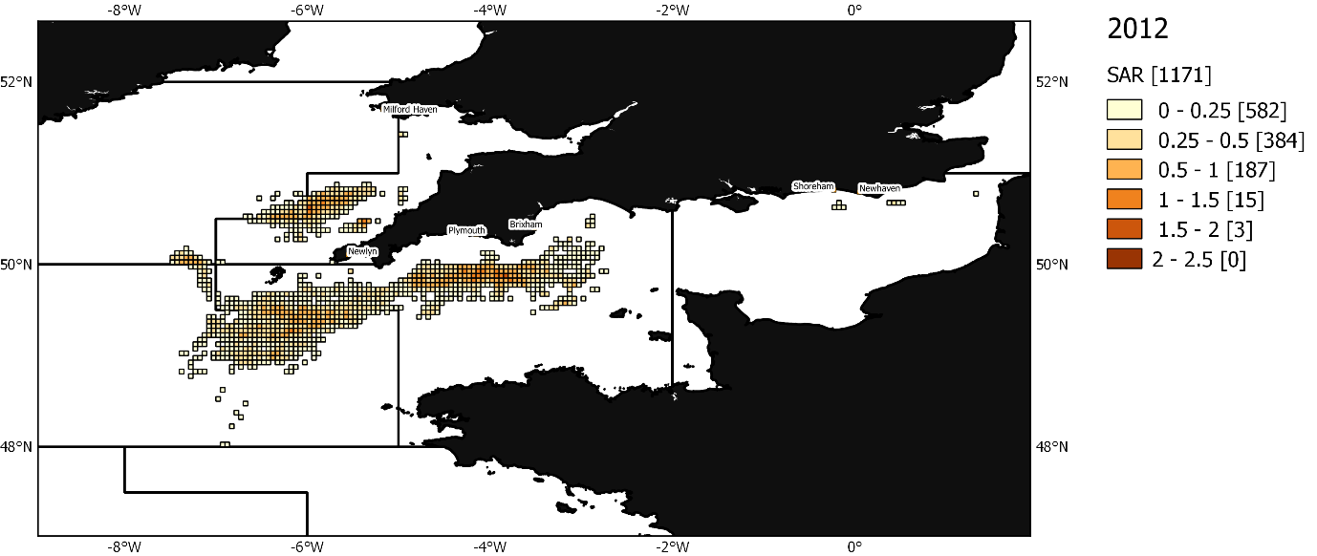
Figure 3-8 Map of swept area ratio of monkfish beam trawling 2012
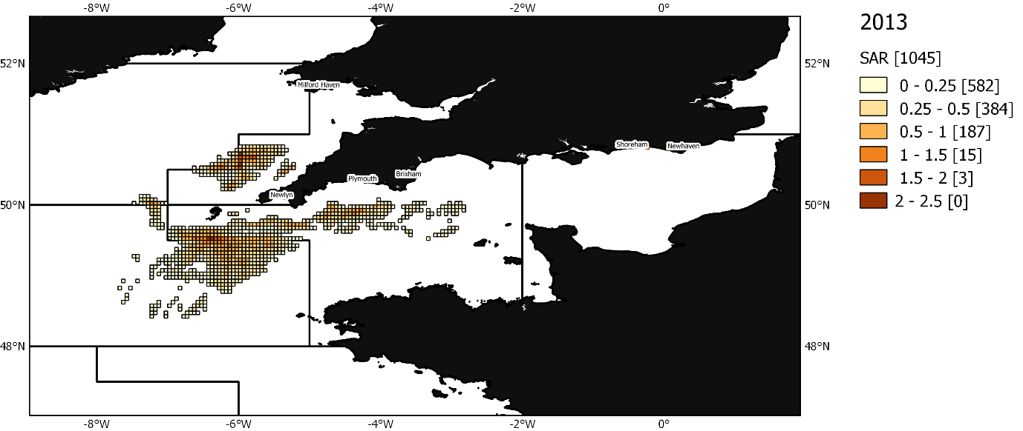
Figure 3-9 Map of swept area ratio of monkfish beam trawling 2013
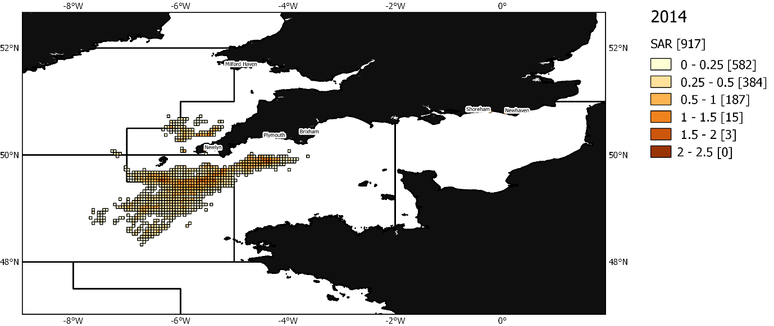
Figure 3-10 Map of swept area ratio of monkfish beam trawling 2014
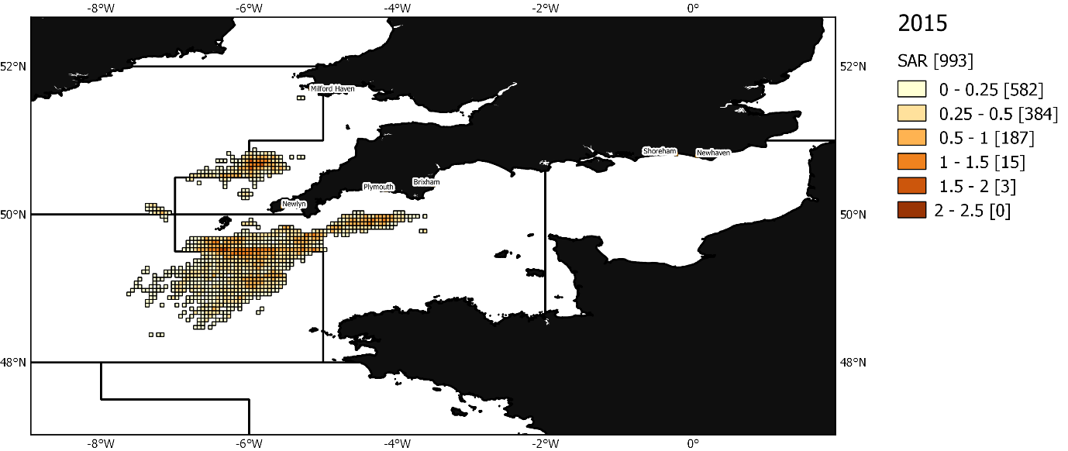
Figure 3-11 of swept area ratio of monkfish beam trawling 2015
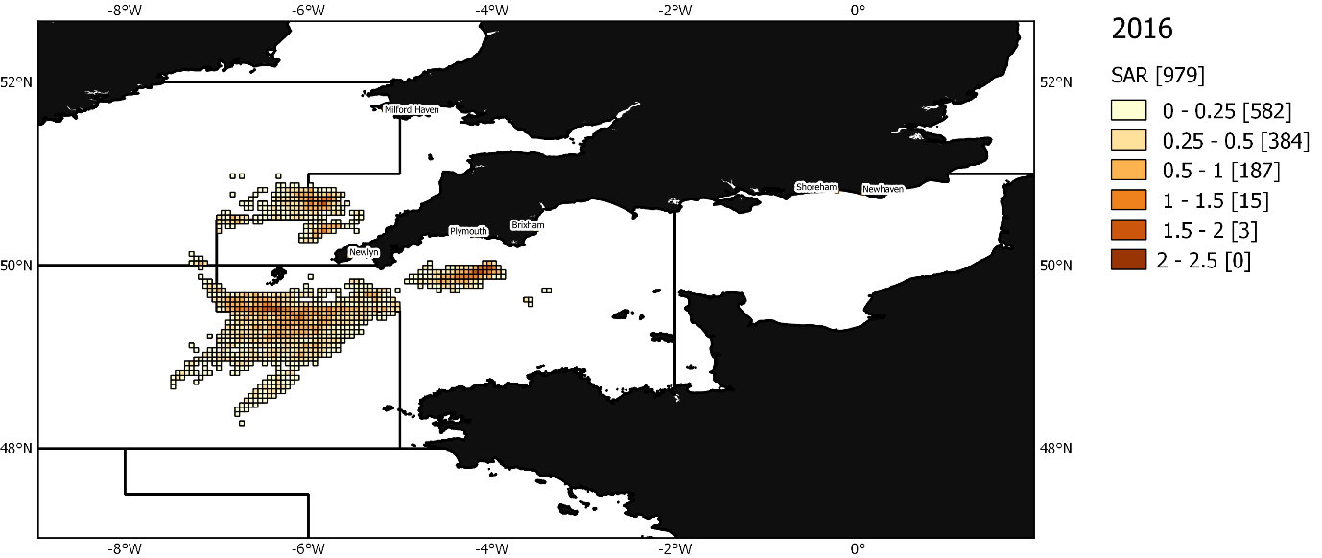
Figure 3-12 Map of swept area ratio of monkfish beam trawling 2016

Spatial scale of activity
The unit of assessment (UoA) covers ICES areas 7d,e,f,g,h,j,k and 8a,b,d, i.e. the English Channel + Celtic Sea + south Irish Sea + Bay of Biscay. Monkfish is widespread in the whole area, and, although some locations have got higher concentrations of the stock(s), there is no known habitat that monkfish will never be found in.
Considering this very large area, the fact that it is difficult to narrow down the habitat of monkfish, and that this assessment is for 2 species (L. budagessa and L. piscatorius), the spatial footprint of the UoC is very minimal (largely <15%, about 6% of the UoA). Beam trawls however can fish over a range of grounds, potentially very rough, as confirmed by fishers during the workshop and therefore are not tied to specific sections of the seabed. Workshop participants also confirmed that monkfish fishers do tend to conduct exploratory tows, as opposed to sticking to very specific locations but the consistency of the extent of the VMS data over years suggest that the activity is contained within the boundaries of the areas shown on the maps. However, since the highest impact from a towed bottom fishing gear is made the first time a new area is fished, exploratory tows will increase the risk of the fishery having a significant negative impact. Furthermore, the resolution of VMS data is low (i.e. one ping every 2 hours). Therefore, the question of the scale of sensitive habitats adds a limitation since one cannot confidently assess how sensitive habitats may be impacted by first time fishing at this resolution.
There is also a part of the fleet that is not covered by VMS data but the industry and IFCAs did not expect that this would affect the rating in view of the very low coverage of the activity compared to the UoA.

Temporal scale of activity
There are very few days in the year when no vessels of the UoC is active in the UoA.
Table 3-3 Number of unique days of fishing for the monkfish beam trawl fishery in the UoA
2012 | 2013 | 2014 | 2015 | 2016
352 | 350 | 345 | 348 | 351

Table 3-4 Table of proportion of the monkfish beam trawl activity by year and quarter
Quarter | 2012 | 2013 | 2014 | 2015 | 2016
1 | 0.3 | 0.23 | 0.19 | 0.24 | 0.22
2 | 0.23 | 0.24 | 0.27 | 0.29 | 0.26
3 | 0.24 | 0.28 | 0.29 | 0.25 | 0.25
4 | 0.23 | 0.25 | 0.25 | 0.22 | 0.27

Intensity of activity
There was a debate at the workshop on how the level of intensity should be scored due to the wording of the MSC score table. A score of 3, equating to “moderate”, is described as “moderate detection of activity at broader spatial scale, or obvious but local detection”. In light of the spatial and temporal scales of the activity described above, this was seen by the group as inappropriate. A score of 2, equating to “minor”, better reflected the relative impact of the fishery on the UoA. “Minor” corresponds to an “activity [that] occurs rarely or in few restricted locations and evidence of activity even at these scales is rare”. While the wording suggests very little impact, the industry agrees that the impact will be locally significant, a score of 3 out of 6 seemed unrepresentative of the limited spatial extent of the UoC (relative to the UoA).

Relevant subcomponents
See literature cited in methods

Species composition
As described earlier beam trawls have a poor selectivity, so a number of species will be caught or indirectly impacted by the contact of the gear with the seabed. Like scallop dredges, the effect might be reflected in the resulting functional composition. Catch composition based on the Cefas observer programme, i.e. including discards, is shown in Figure 3-13.
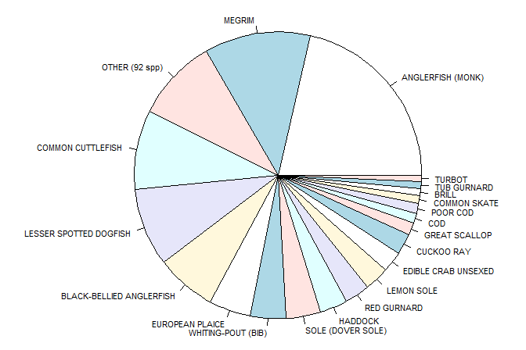
Figure 3-13 Catch composition of monkfish beam trawl fishery

Functional group composition
Most bottom fishing gears have an impact on specific functional groups. Beam trawling is known as one of the most impactful gear types, after scallop dredging, and therefore species that display certain characteristics such as being sessile, large, slow or hard shelled will suffer higher mortality rates than others and take longer to recover.

Community distribution
There is no suggestion that the fishing activity would directly interfere with the distribution of the community as such, although this might be an indirect consequence of removing a top predator from the ecosystem or affecting different species/functional groups disproportionately.

Trophic/size structure
Monkfish are opportunistic feeders and a top predator in this ecosystem (Figure 3-14). There are no reports of predators that specifically target anglerfish in European waters although seals may prey directly on anglerfish. Anglerfish remains were found in one stranded sperm whale in the Netherlands. In Faroese waters juvenile anglerfish remains have been found in the stomachs of large cod (Thangstad et al. 2006). Overall, anglerfish are not thought to be a key prey species for any piscivorous fish, mammal or bird, although they may be taken opportunistically by a range of predators across their lifespan.

While the assessments are limited by the data availability and quality, the total biomass is still expected to be high relative to other species in the Western English Channel (Araujo et al. 2005), i.e. around where most of the monkfish beam trawl fishery occurs. Whether the ecosystem is dominated by bottom-up or top-down pressures will affect the level of impact of the direct removal of the species. Overall, stock assessments suggest that the stock is not showing a decline due to fishing pressure but the assessment is over a large area making it difficult to draw conclusions at the local level. Furthermore, surveys used in the assessment do not cover the Western English Channel.

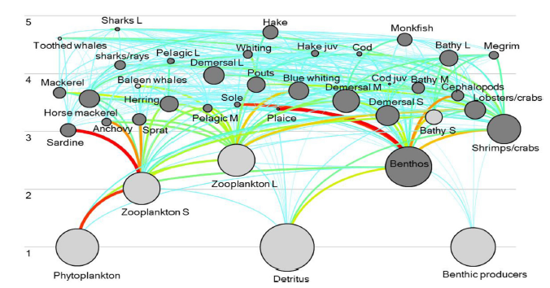
Figure 3-14 Place of monkfish in the Celtic/Biscay ecosystem from 2012 Ecopath model, from Bentorcha et al. 2017

Further rationale to inform scoring
The beam trawl fishery takes place in the western English Channel and eastern Celtic Sea (27.7.e and 27.7.h) which, from the habitat report Task 2, are dominated by sand and coarse sediment, followed by fine mud in 27.7.h and mixed and rocky substrates in 27.7.e. Combining all gear types that catch monkfish, the habitat report shows that 65% of the fishing effort area overlaps with coarse sediments, while there was a 6% overlap in 2016 with OSPAR threatened and protected habitats/species. 0% overlapped with VMEs. As explained in relation to the scallop fishery (section 2.2.5), the western part of the English Channel is deeper than the east, below 50m, the currents system is mainly tidal, and waters are stratified, with deeper waters and weaker currents compared to the east. The seabed is coarser and there are richer benthic communities. As for the eastern Celtic Sea, species richness (number of species) is higher in the Celtic Sea than in the rest of the ecoregion (Celtic Seas) due to the number of warm-favouring Lusitanian species present here. The Celtic Sea groundfish community consists of over a hundred species, but the 25 most abundant of these account for 99 percent of the total estimated biomass (of which monkfish is one).
A number of surveys are used or considered in the monkfish stock assessments that provide information on the stock distribution, abundance, biomass and the population dynamics characteristics. Some of the main ones are the French EVOHE-WIBTS-Q4 survey, covering the largest proportion of the stock distribution, the shelf area in the Celtic Sea and Bay of Biscay, and providing a recruitment index; the Irish Groundfish Survey (IGFS-WIBTS-Q4), covering around Ireland and Northern Ireland; the Spanish Porcupine Groundfish Survey (SPPGFS-WIBTS-Q4), covering the Porcupine Bank, west off Ireland; the Irish Anglerfish and Megrim Survey (IAMS-Q1), covering from northern Ireland, west of Ireland, and to the south of the Celtic Sea. Other surveys such as the English Cefas Q1 Southwest Ecosystem Survey (Q1-SW-ECOS), the Q1 Irish Beam trawl Ecosystem survey (IBES) or the Q3 UK (E&W) beam trawl survey in divisions 7afg may be relevant to provide more information on the local ecosystem where monkfish is caught by the UoC, particularly Q1-SW-ECOS.

Discussion
This report aims at providing some information necessary to score the impact of two fishing activities on the part of the ecosystem with which they interact, i.e. scallop dredging in area 27.7.d and e and monkfish in 27.7b-k and 8a-b, 8.d. following the MSC SICA guidelines, under Performance Indicator (PI) 2.5.1. VMS maps were compiled to enable scoring of the spatial scale, temporal scale and intensity of the activity and existing published literature briefly reviewed to document the effect of towed bottom gears on the seabed and its associated benthic and demersal communities. It includes data, rationale and industry input to inform the MSC scoring process of the two fisheries of interest.
Under the current data limited approach for PI 2.5.1, both fisheries assessed here would likely get a score level of over 80, due to the relatively small footprint of the fisheries in their respective UoA. This is because none of the species are tightly linked to a specific habitat and the UoC do not cover all gears and countries that target those given stocks. Furthermore, the assessment of the monkfish fishery combines two species, making their distribution range even larger in comparison to the UoC, while the UK seems to catch predominantly white anglerfish L. piscatorius at 95%. Following from this, it is evident here that how the UoA is set will drive the outcome of the scoring on the scale of the impact. Considering all this would likely increase the footprint of the UoC.
Further investigation into the spatial and temporal activity of non-VMS equipped vessels would help better characterise the impact of smaller vessels. This information would confirm the anecdotal information shared at the workshop which suggested that the spatial footprint would not pass the threshold of <15% of the UoA. For scallops however, this might make a difference. A better understanding of the fishing speed would also make the VMS-derived fishing maps more accurate but with 20-minute tows and 2hr ping rates, some of the activity will inevitably be missed.
Defining which of the subcomponents is the most vulnerable is not straight forward as each subcomponent is linked to the others. For towed bottom fishing gears, a large part of the literature on their impact focuses on functional differences observed in benthic communities and potential regime shifts, or at least they justify differences in species composition by their resilient/vulnerable traits. Monkfish is a relatively abundant top predator so the impact of the fishery on the local foodweb could be significant. But again, at the scale of the UoA, which corresponds to the assessment unit, there is no specific concern that monkfish is overfished, and the population has appeared relatively stable over years.
Considering that landings are reported, VMS data available for a large part of the fleet, stock assessments exist (only available for monkfish at the time of writing this report) multiple surveys are conducted over the UoAs, and that there is a high volume of recently published research on fishing gear impacts on ecosystems and potential for recovery, one would need to justify why a data limited approach is considered appropriate in either case here. See for example the published standardised dataset for benthic macrofauna and sediments that covers faunal distribution all around the UK (publication: http://rdcu.be/wi6C , tool :https://www.benthosapps.net/ma_tool/).
Overall, the report provides the information available to Cefas to map the fishing activity but misses out on the <12m vessels which, for both fisheries, seemed to form an insignificant part of the UoCs, although they could affect the scoring of the scallop fishery. Further information could be gathered and used as suggested in the previous paragraph to score the impact on the ecosystem components, although clearer guidelines on how changes should be assessed, against what and how would help with this task. A limitation here is the way the scoring is defined, i.e. the relative spatial footprint (of the monkfish fishery at least) would mean that any negative impact, even if highly significant locally, would not affect the overall score of the fishery on their ecosystem impact performance indicator.

References
Araújo, J. N., Mackinson, S., Ellis, J. R., & Hart, P. J. B. (2005). An Ecopath model of the western English Channel ecosystem with an exploration of its dynamic properties. Science Series Technical Reports, 125.
Bentorcha, A., Gascuel, D., & Guénette, S. 2017. Using trophic models to assess the impact of fishing in the Bay of Biscay and the Celtic Sea. Aquatic Living Resources, 30, 7.
Bolam, S. G., Garcia, C., Eggleton, J., Kenny, A. J., Buhl-Mortensen, L., Gonzalez-Mirelis, G., van Kooten, T., et al. 2017. Differences in biological traits composition of benthic assemblages between unimpacted habitats. Marine Environmental Research, 126: 1-13.
Collie, J., Hiddink, J. G., Kooten, T. v., Rijnsdorp, A. D., Kaiser, M. J., Jennings, S., and Hilborn, R. 2016. Indirect effects of bottom fishing on the productivity of marine fish. Fish and Fisheries.
Duplisea DE, Jennings S, Warr KJ, Dinmore TA. 2002. A size-based model of the impacts of bottom trawling on benthic community structure. Can. J. Fish. Aquat Sci. 59, 1785–1795.
Eigaard, O. R., Bastardie, F., Breen, M., Dinesen, G. E., Hintzen, N. T., Laffargue, P., Mortensen, L. O., et al. 2016. Estimating seabed pressure from demersal trawls, seines, and dredges based on gear design and dimensions. ICES Journal of Marine Science, 73: i27-i43.
Eigaard, O. R., Bastardie, F., Hintzen, N. T., Buhl-Mortensen, L., Buhl-Mortensen, P., Catarino, R., Dinesen, G. E., et al. 2017. The footprint of bottom trawling in European waters: distribution, intensity, an seabed integrity. ICES Journal of Marine Science, 74: 847-865.
Gerritsen, H. D., Minto, C., & Lordan, C. 2013. How much of the seabed is impacted by mobile fishing gear? Absolute estimates from Vessel Monitoring System (VMS) point data. ICES Journal of Marine Science, 70(3), 523-531.
Groenewold S, Fonds M. 2000. Effects on benthic scavengers of discards and damaged benthos produced by the beam-trawl fishery in the southern North Sea. ICES J. Mar. Sci. 57, 1395–1406. (doi:10. 1006/jmsc.2000.0914)
Heath MR. 2005. Changes in the structure and function of the North Sea fish foodweb, 1973– 2000, and the impacts of fishing and climate. ICES Journal of Marine Science 62, 847–868.
Hiddink JG, Rijnsdorp AD, Piet G. 2008. Can bottom trawling disturbance increase food production for a commercial fish species? Can. J. Fish. Aquat. Sci. 65, 1393–1401.
Hiddink JG, Johnson AF, Kingham R, Hinz H. 2011. Could our fisheries be more productive? Indirect negative effects of bottom trawl fisheries on fish condition. J. Appl. Ecol. 48, 1441–1449.
Hiddink, J. G., Moranta, J., Balestrini, S., Sciberras, M., Cendrier, M., Bowyer, R., Kaiser, M. J., et al. 2016. Bottom trawling affects fish condition through changes in the ratio of prey availability to density of competitors. Journal of Applied Ecology, 53: 1500-1510.
Hiddink, J. G., Jennings, S., Sciberras, M., Szostek, C. L., Hughes, K. M., Ellis, N., ... & Collie, J. S. 2017. Global analysis of depletion and recovery of seabed biota after bottom trawling disturbance. Proceedings of the National Academy of Sciences, 114(31), 8301-8306.
Jenkins, S. R., & Brand, A. R. (2001). The effect of dredge capture on the escape response of the great scallop, Pecten maximus (L.): implications for the survival of undersized discards. Journal of experimental marine biology and ecology, 266(1), 33-50.
Jennings S, Dinmore TA, Duplisea DE, Warr KJ,Lancaster JE. 2001. Trawling disturbance can modify benthic production processes. J. Anim. Ecol.70, 459–475.
Jennings S, Nicholson MD, Dinmore TA, Lancaster JE. 2002. Effects of chronic trawling disturbance on the production of infaunal communities. Mar. Ecol. Prog. Ser. 243, 251–260.
Kaiser MJ, Spencer BE. 1994. Fish scavenging behaviour in recently trawled areas. Mar. Ecol. Prog. Ser. 112, 41–49.
Kaiser MJ, Ramsay K, Richardson CA, Spence FE,Brand AR. 2000. Chronic fishing disturbance has changed shelf sea benthic community structure. J. Anim. Ecol. 69, 494–503.
Kaiser MJ, Clarke KR, Hinz H, Austen MCV,Somerfield PJ, Karakassis I. 2006. Global analysis of response and recovery of benthic biota to fishing. Mar. Ecol. Prog. Ser. 311, 1–14.
Pitcher, C. R., Ellis, N., Jennings, S., Hiddink, J. G., Mazor, T., Kaiser, M. J., Kangas, M. I., et al. 2017. Estimating the sustainability of towed fishing‐gear impacts on seabed habitats: a simple quantitative risk assessment method applicable to data‐limited fisheries. Methods in Ecology and Evolution, 8: 472-480.
Riemann B, Hoffmann E. 1991. Ecological consequences of dredging and bottom trawling in the Limfjord, Denmark. Mar. Ecol. Prog. Ser. 69, 171–178.
Rijnsdorp, A. D., Bastardie, F., Bolam, S. G., Buhl-Mortensen, L., Eigaard, O. R., Hamon, K. G., Hiddink, J. G., et al. 2016. Towards a framework for the quantitative assessment of trawling impact on the seabed and benthic ecosystem.ICES Journal of Marine Science , 73: i127-i138.
Rijnsdorp, A. D., Eigaard, O. R., Kenny, A., Hiddink, J. G., Hamon, K., Piet, G. J., ... Gregersen, Ó. 2017. Assessing and mitigating of bottom trawling. Final BENTHIS project Report (Benthic Ecosystem Fisheries Impact Study).
Sciberras, M., Hiddink, J. G., Jennings, S., Szostek, C. L., Hughes, K. M., Kneafsey, B., ... & Hilborn, R. 2018. Response of benthic fauna to experimental bottom fishing: A global meta‐analysis. Fish and Fisheries.
Thangstad, T. 2006. Anglerfish (Lophius spp) in Nordic waters. Nordic Council of Ministers.
van Denderen PD, van Kooten T, Rijnsdorp AD. 2013. When does fishing lead to more fish? Community consequences of bottom trawl fisheries in demersal food webs. Proc R Soc B 280: 20131883.

Appendix 1: Maps of monkfish fishery days/year by grid cell
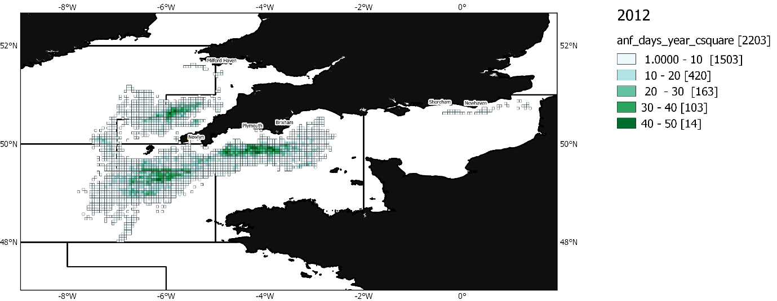
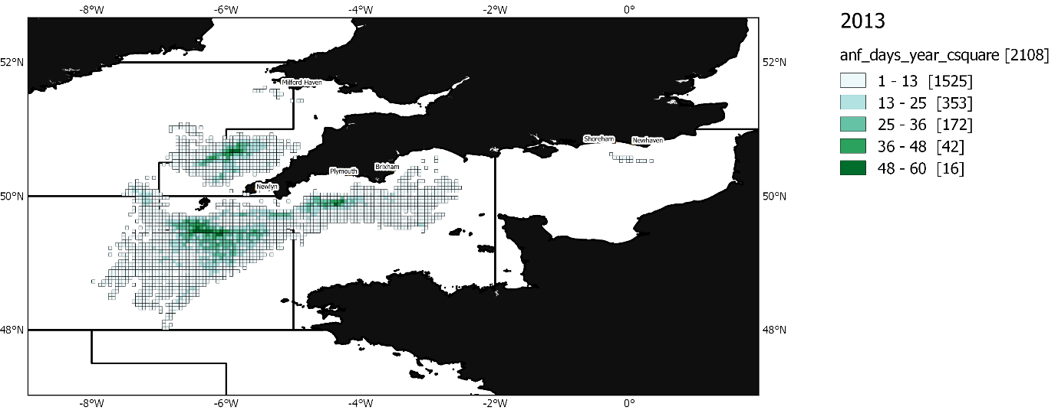
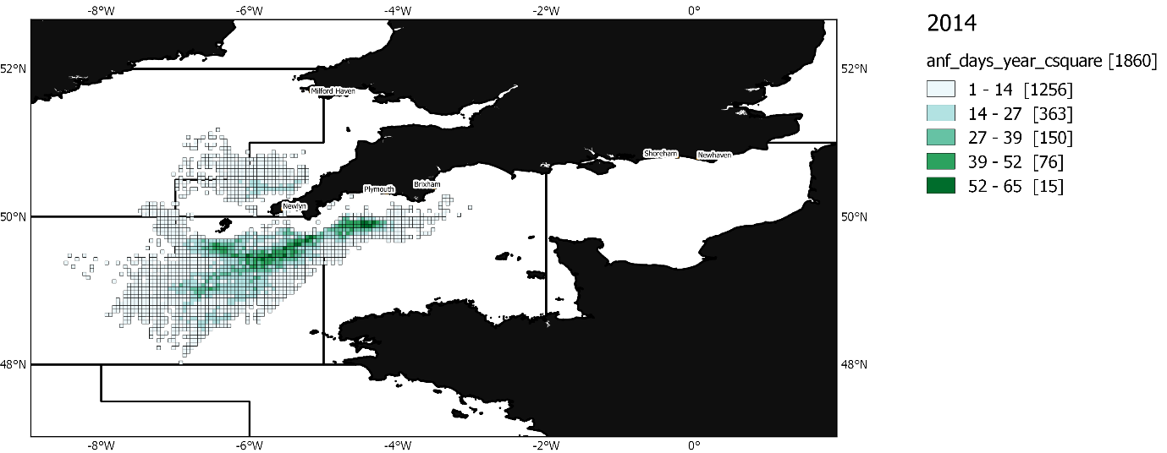
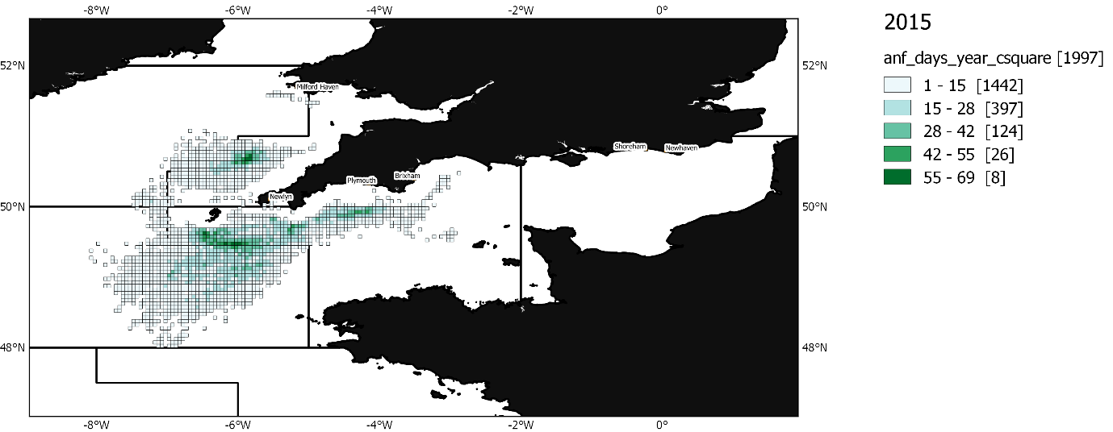
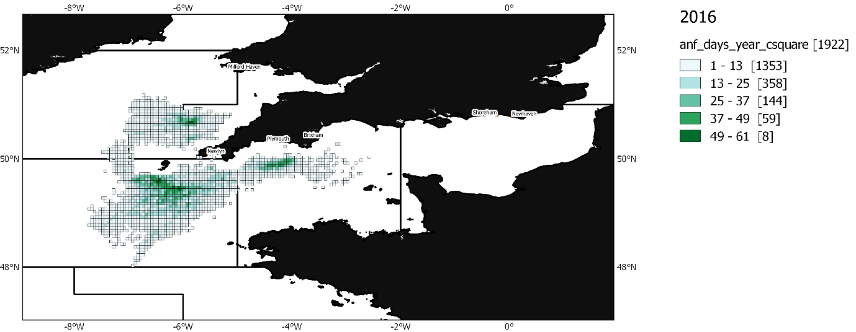

About us
The Centre for Environment, Fisheries and Aquaculture Science is the UK’s leading and most diverse centre for applied marine and freshwater science.

We advise UK government and private sector customers on the environmental impact of their policies, programmes and activities through our scientific evidence and impartial expert advice.

Our environmental monitoring and assessment programmes are fundamental to the sustainable development of marine and freshwater industries.

Through the application of our science and technology, we play a major role in growing the marine and freshwater economy, creating jobs, and safeguarding public health and the health of our seas and aquatic resources

Head office
Centre for Environment, Fisheries & Aquaculture Science
Pakefield Road
Lowestoft
Suffolk
NR33 0HT
Tel: +44 (0) 1502 56 2244
Fax: +44 (0) 1502 51 3865

Weymouth office
Barrack Road
The Nothe
Weymouth
DT4 8UB

Tel: +44 (0) 1305 206600
Fax: +44 (0) 1305 206601

Customer focus
We offer a range of multidisciplinary bespoke scientific programmes covering a range of sectors, both public and private. Our broad capability covers shelf sea dynamics, climate effects on the aquatic environment, ecosystems and food security. We are growing our business in overseas markets, with a particular emphasis on Kuwait and the Middle East.

Our customer base and partnerships are broad, spanning Government, public and private sectors, academia, non-governmental organisations (NGOs), at home and internationally.

We work with:

- a wide range of UK Government departments and agencies, including Department for the Environment Food and Rural Affairs (Defra) and Department for Energy and Climate and Change (DECC), Natural Resources Wales, Scotland, Northern Ireland and governments overseas.
- industries across a range of sectors including offshore renewable energy, oil and gas emergency response, marine surveying, fishing and aquaculture.
- other scientists from research councils, universities and EU research programmes.
- NGOs interested in marine and freshwater.
- local communities and voluntary groups, active in protecting the coastal, marine and freshwater environments.

www.cefas.co.uk

Project UK Fisheries Improvements - ETP report, Holden 2017
Project UK Fisheries Improvements - Task 4, 2018
https://assets.publishing.service.gov.uk/government/uploads/system/uploads/attachment_data/file/647482/UK_Sea_Fisheries_Statistics_2016_Full_report.pdf
ICES. 2017. Report of the Benchmark Workshop on Widely Distributed Stocks (WKWIDE), 4-11 May 2017, Copenhagen, Denmark. ICES CM 2017/ACOM:36. 534 pp.
Project UK Fisheries Improvements - ETP report, Page 2018
Project UK Fisheries Improvements - Task 2, 2018
MSC Assessment ISF Iceland Anglerfish Fishery 2017 https://fisheries.msc.org/en/fisheries/isf-iceland-anglerfish/@@assessments
Stock annex to WKAngler, benchmark workshop for anglerfish stock assessment, February 2018, Copenhagen (unpublished), Hans Gerritsen
Project UK Fisheries Improvements – MSC Pre-assessment http://www.seafish.org/industry-support/fishing/project-uk/project-uk-fisheries-improvements/western-channel-monkfish-multiple-gear-fip
http://www.marlin.ac.uk/species/detail/2123
https://www.benthis.eu/en/benthis.htm
https://trawlingpractices.wordpress.com/
ICES. 2017. Report of the Benchmark Workshop on Widely Distributed Stocks (WKWIDE), 4-11 May 2017, Copenhagen, Denmark. ICES CM 2017/ACOM:36. 534 pp.

