Task 2. Habitat assessment
Plaice, lemon sole

Author(s): Isidora Katara, Roi Martinez
Issue Date: 25/03/2019

Cefas Document Control
Submitted to: | Marine Stewardship Council
Date submitted: | 25/03/2019
Project Manager: | Anna Sypniewska-Huk
Report compiled by: | Isidora Katara and Roi Martinez
Quality control by: | Ewen Bell, Stephen Mangi
Approved by and date: | S Mangi 25/03/2019
Version: | 7

Version Control History
Version | Author | Date | Comment
1.0 | Isidora Katara | 01/03/2018
2.0 | Isidora Katara | 09/05/2018 | Edits from S Mangi
3.0 | Isidora Katara | 10/05/2018 | Edits from Roi Martinez
4.0 | Isidora Katara | 14/05/2018 | Final edits by I Katara
5. | Isidora Katara | 09/01/2019 | Edits from I Katara
6.1 | Isidora Katara | 07/02/2019 | Final report
7 | Roi Martinez | 25/03/2019 | Final report

Executive Summary
This report aims to provide information for the improvement of the sustainability of the North Sea plaice and lemon sole FIP fleet in terms of its impact on habitats. The analyses and results presented refer to the impact of fishing vessels that participate in the North Sea lemon sole and plaice Fisheries Impovement project (FIP). Trips were selected based on gear type used: beam trawl, otter trawls, Danish seines, and pair seines. Other vessels that might target the same species in these areas were not considered.
The fleet effort was derived from vessel monitoring system (VMS) and logbook data. Effort distribution estimates refer to the unit of assessment in terms of area and the gears used by the the vessels that belong to specified producers’ organisations participating in the FIP. Habitat maps were derived from publicly available databases (EUSeaMap, OSPAR, and ICES) and cover Vulnerable Marine Ecosystems (VMEs), threatened and declining ecosystems, and common substrates. The extent of the habitats was clipped to the extent of the unit of assessment (UoA) and covers the North Sea (ICES sub regions 27.4.a, 27.4.b, and 27.4.c).
Two indicators were estimated to quantify the impact of the FIP vessels on different types of habitats. A simple indicator was based on the area overlap between fishing effort and habitats and shows the percentage of a type of habitat that overlaps with fishing effort. This indicator doesn’t account for the intensity of the fishing effort or for the recovery rate of the habitat, two parameters that have proven challenging to estimate. A more complex indicator, Relative Benthic Status (RBS), has therefore been developed to account for the intensity of the fishing effort or for the recovery rate of the habitat. It however, can be uncertain due to the issues relating to some of the parameters necessary for its calculation. Nevertheless, both indicators combined can provide a complete assessment of the impact of the FIP vessel on different habitats.
For the first indicator, effort maps were overlayed on habitat distributions and the overlapping area was calculated. The percentage of the habitat that overlaps with fishing effort was calculated. These values can be used to identify cases where a big proportion of a certain habitat is impacted by the fishery, per gear and how fishing effort is distributed in terms of habitats exploited. This indicator is useful for habitats with low recoverability where even low fishing effort could impact the habitat beyond recovery. The analysis focused mainly on these habitats but we also present calculations of this indicator for commonly encountered habitats.
We also used the rate of change in benthic biomass over time to calculate the Relative Benthic Status (RBS), a quantitative indicator of the risk of depletion for benthic habitats, i.e. the rate of change in abundance of benthic biomass in time due to fishing. RBS has been developed for fisheries impact assessments on habitats and it combines information on (i) the time it takes a habitat to recover after a disturbance and (ii) the magnitude of the disturbance, in this case the magnitude of the impact of the gear and the frequency that the gear is used in an area. RBS is the percentage of the habitat that will be able to recover within a year after the disturbance. RBS was not calculated for vulnerable habitats such as reefs or sea pens because estimates on the recovery of these habitats per fishing gear are not available and these parameters are necessary for the calculation of RBS. This analysis was restricted to commonly encountered habitats.
The fishing effort of the plaice and lemon sole FIP fleet overlaps with >20% (up to 60%) of sea pens, sponges and cup corals (VMEs), and sea-pen and burrowing megafauna communities (OSPAR threatened and declining habitats) in the North Sea. These habitats have low recoverability and based on MSC standards overlap should be lower than 20%. RBS values for plaice and lemon sole FIP vessels are higher than 95%, indicating that the impact of the vessels on commonly encountered habitats is low according to MSC standards.
The report sections 3.4 and 3.5 provides a clear differentiation between VME habitat and VME indicators. The VME habitat conformed by sponges and cup corals species are in deep waters (<200 meters) with no significant FIP fishery action in this sea area. The interaction between the fishery footprint and the sea-pen VME indicator occurs in North Sea shallow water ( >200 meters) , therefore we have referred to the MPA monitoring program to analyse the presence of VME species indicators. Central Fladen is the unique MPA with sea-pens species and related habitats and it is covered by the FIP fleet activity up to 51% of the area with SAR intensities between 0.25 and 1.5 and an average of 0.36. The fishing effort intensity lower than 0.25 were excluded to identify the main locations of significant impacted areas, but if we would include the whole fishing activity, the Central Fladen MPA is covered up to 92% of the total area.
Caveats of this analysis relate to two main sources of uncertainty: (i) VMS and logbooks are not available for all trips and/or all FIP vessels and (ii) recovery and depletion rates are not specific to the fleet and its area of operation. Results could be characterised by an unknown bias that relates to lack of information on the distribution of effort for the proportion of the fisheries with vessel length < 12m, as these vessels are not obliged to report logbooks or use VMS. Errors of fishing set identification are also probable (but not quantifiable) due to the long interval between consecutive VMS pings (2hours) when fishing sets might take less than 2 hours. The RBS calculations involve the use of recovery and depletion rates that are not specific to the area, thus the results could be uncertain.

 | average overlap | maximum overlap | average RBS | minimum RBS
commonly encountered habitats
Coarse sediment | 5.75 | 21.34 | 0.96 | 0.87
Fine mud | 1.42 | 3.46 | 1.00 | 0.99
Mixed sediment | 3.61 | 11.05 | 0.99 | 0.96
Mud to muddy sand | 3.90 | 15.48 | 1.00 | 1.00
Rock or other hard substrata | 2.46 | 9.55 | 1.00 | 0.98
Sand | 5.58 | 17.47 | 0.99 | 0.96
Sandy mud to muddy sand | 8.64 | 22.09 | 0.98 | 0.87
Seabed | 0.00 | 0.02 | 0.99 | 0.95
VMEs
Cup coral | 22.43 | 22.43
deep-sea sponge aggregations | 6.10 | 10.49
Sea-pen | 13.95 | 36.04
Soft coral | 4.77 | 7.53
Sponge | 6.93 | 35.07
Protected and Declining Habitats
Deep-sea sponge aggregations | 1.98 | 6.40
Intertidal mudflats | 0.35 | 0.64
Intertidal Mytilus edulis beds on mixed and sandy sediments | 1.34 | 2.47
Littoral chalk communities | 6.43 | 16.37
Lophelia pertusa reefs | 7.15 | 14.69
Maerl beds | 1.14 | 1.89
Modiolus modiolus horse mussel beds | 3.38 | 8.13
Sabellaria spinulosa reefs | 2.55 | 7.31
Sea-pen and burrowing megafauna communities | 24.62 | 56.93
Zostera beds | 0.53 | 0.85

TABLE Average and maximum values of percent overlap per habitat type. Average and minimum RBS values for commonly encountered habitats.

Table of Contents
1 Background 6
2 Methodology 6
2.1 Effort Distribution 6
2.2 Habitat Distribution 9
2.3 Indicator 1: Habitat – Fisheries Overlap 11
2.4 Indicator 2: Relative Benthic Status 12
3 Results 13
3.1 Data: Effort and Habitat Distribution 13
3.2 Indicator 1: Habitat – Fisheries Overlap 15
3.3 Indicator 2: Relative Benthic Status 16
3.4 Fishing intensity and VME habitat distribution 17
3.5 Fishing intensity distribution and MPAs 19
4 Discussion 23
4.1 Quantifying the impact of the FIP fleet 23
4.2 Caveats 23
4.3 Suggestions for Improvement 24
5 References 25

Tables and Figures
TABLE Average and maximum values of percent overlap per habitat type. Average and minimum RBS values for commonly encountered habitats. iii
Figure 1 Histogram of the overall vessel length for the given list of vessels. The first two bars show vessels 10m-12m and vessels 12m-15m. We should note here that possibly some of the vessels do not target plaice and lemon sole. However, for the vessels < 12m (or 15m before 2012-2013), we cannot know what they are targeting, which is a source of uncertainty. 7
Table 1 Number of unique RSS numbers for which logbook records were available 7
Table 3 cut-off points in terms of species catch ratio per trip for the selection of trips that will account for at least 95% of the annual species catch. Note that for lemon sole any catch > 0 meant that the trip was selected. 8
Table 4 Number of trips analysed per year per fishery. 8
Figure 2 The extent of the habitat layers was clipped to the extent of the area that was indicated by the client as the area of operation of the FIP fleet, namely ICES rectangles 27.4.a, 27.4.b, and 27.4.c. The figure shows the EMODnet broad-scale seabed habitat map clipped at the extent of ICES rectangles 27.4.a, 27.4.b, and 27.4.c. 10
Figure 3 VMEs mapped based on the ICES Vulnerable Marine Ecosystems (VMEs) dataset. 11
Table 5 Values of depletion and recovery for different types of habitats after (Pitcher et al. 2016). 12
Table 6 Values of depletion and recovery for otter and beam trawls after (Hiddink et al. 2017). The median recovery rate reported by the authors was 0.82. 12
Table 7 Calculations of the mismatch between logbook records and VMS data. Logbook records do not perfectly match with VMS data due to errors in VMS data, low temporal resolution of the VMS data and subsequent misidentifications of fishing sets or because vessels below a certain length, which decreases through the years) are not obliged to have VMS. 13
Table 8 Calculations of the mismatch between VMS data (pings) and logbooks. VMS data do not perfectly match with logbook records. 14
Figure 4 Fishing effort distribution of the FIP vessels per gear for 2016. 14
Table 9 Indicator 1: proportion of VMEs overlapping with fishing effort per gear and year. The values presented are > 20%. 15
Table 10 Indicator 1: proportion of threatened and declining habitats, based on OSPAR database, overlapping with fishing effort per gear and year. The values presented are > 20%. 15
Table 11 Indicator 1: proportion of substrate overlapping with fishing effort per gear and year. The values presented are > 20%. 16
Table 12 Average RBS values per year, per substrate and gear. All values are above 80%. 16
Table 13 The lowest RBS value for the plaice and lemon sole FIP. The values presented here are < 90%. All other combinations of gear – substrate are > 90% and are presented in Annexe Table 6. 17
Annex Table 1 Depletion and recovery rates per substrate. The table shows the values used as input for the RBS calculation. 20
Annex Table 2 Depletion and recovery rates per gear. The table shows the values used as input for the RBS calculation. 20
Annex Table 3 Indicator 1: proportion of VMEs overlapping with fishing effort per gear and year. Values > 20% are highlighted. 20
Annex Table 4 Indicator 1: proportion of threatened and declining habitats, based on Ospar database, overlapping with fishing effort per gear and year. Values > 20% are highlighted. 21
Annex Table 5 Indicator 1: proportion of common benthic habitats, indicated as types of substrate, overlapping with fishing effort per gear and year. Values > 20% are highlighted. 23
Annex Table 6 Plaice and lemon sole FIP fishery RBS estimates per habitat, gear and year. All values are above 0.8 (80%). 30

Background
According to MSC assessment criteria, interactions with common and vulnerable marine habitats (VMEs) need to be identified and quantified. To inform improvements for the plaice and lemon sole targeting fishery in the North Sea, we assessed the impact of the vessels that participate in a Fisheries Improvement Project (FIP) on benthic habitats. We overlaid maps of fishing effort to maps of habitats, including vulnerable, protected and priority habitats, and quantified the overlap in terms of area. Because vulnerable, protected and priority habitats have very slow recovery rates, their recovery can take decades. According to the MSC criteria 80% of the distribution should remain intact, or in other words less than 20% of their distribution should be fished. For common habitats we followed an assessment approach proposed by Pitcher et al. (2016) and Szostek et al. (2017) that relates to the distribution and intensity of the fishery and the gears it uses to the ‘sensitivity’ of the habitat i.e. the capacity of the habitat to recover. The assessment approach has been proposed focusing on the needs of MSC assessments.

Methodology

Effort Distribution
Effort distribution was based on VMS and logbook data from vessels that relate to the unit of assessment as this was defined in terms of vessels, gears and area of operation. For plaice and lemon sole, all vessels belonging to the Scottish Fisheries Sustainable Accreditation Group (SFSAG) were used. The list of vessels was provided by MSC. Logbook trip records were selected based on the following criteria:
- The vessel was included in the list of unique Registry of Shipping and Seamen (RSS) number provided by MSC. These included 367 RSS numbers from SFSAG that target plaice and lemon sole in the North Sea and participate in the Fisheries Improvement Project. Not all of these vessels related to the RSS numbers have logbook and VMS data (Table 1) due to reporting obligations requiring only vessels > 15m until 2013; and for vessels > 12m from 2013 onwards (Figure 1) to have these onboard.

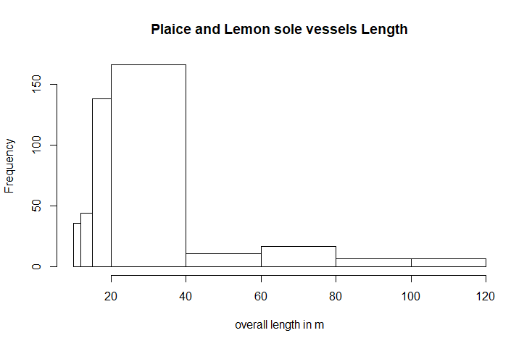
Figure 1 Histogram of the overall vessel length for the given list of vessels. The first two bars show vessels 10m-12m and vessels 12m-15m. We should note here that possibly some of the vessels do not target plaice and lemon sole. However, for the vessels < 12m (or 15m before 2012-2013), we cannot know what they are targeting, which is a source of uncertainty.

Table 1 Number of unique RSS numbers for which logbook records were available
year | Plaice and lemon sole
2012 | 326
2013 | 329
2014 | 336
2015 | 336
2016 | 347

- The fisheries take place in areas (ICES rectangle) indicated by MSC as the unit of assessment. For the North Sea, the ICES divisions indicated were 27.4.a, 27.4.b, and 27.4.c; Logbook trips that record these rectangles as their fishing area were selected.

Table 2 Number of RSS numbers that report fishing in the indicated areas with the indicated gears.
year | Plaice and lemon sole
2012 | 193
2013 | 196
2014 | 202
2015 | 203
2016 | 199

- Trips that report the following fishing gear usage were selected: beam trawls TBB, otter trawls – bottom OTB, pair trawls bottom PTB, otter twin trawls OTT, Danish seines SDN, and pair seines. The code of pair seines was not found in the logbooks database, possibly because their trips are classified under pair trawls PTB due to the similarity between the two gears. Table 2 shows the number of vessels (RSS) in the list that reports fishing in the indicated areas with the above-mentioned gears.

- To select trips where the species in question are targeted, we analysed logbook data for the specified vessels/area/gear combinations. The percentage of the catch of the species (plaice or lemon sole) in the total catch of the trip was calculated. Then we found the percentage of the species in the total trip catch that should be selected so that the trips would account for at least the 95% of the total species catch on a given year. Finally, the trips with species catch proportion equal or greater than the percentage calculated above were selected. Table 3 and 4 shows the species catch proportions used to select trips.

Table 3 cut-off points in terms of species catch ratio per trip for the selection of trips that will account for at least 95% of the annual species catch. Note that for lemon sole any catch > 0 meant that the trip was selected.
Year | Plaice | Lemon sole
2012 | 4% | 0%
2013 | 3% | 0%
2014 | 2% | 0%
2015 | 3% | 0%
2016 | 2% | 0%

Table 4 Number of trips analysed per year per fishery.
year | Plaice and lemon sole
2012 | 1540
2013 | 1652
2014 | 2083
2015 | 2093
2016 | 2704

Selected logbook records were merged with VMS records based on temporal and spatial information and fishing operations were identified based on speed patterns. The effort was estimated based on the duration of fishing operations (hours) and the data were aggregated to a 0.05 x 0.05 decimal degrees (DD) grid. The analysis followed the workflow adopted by ICES for the analysis of VMS and logbook data, and the algorithms developed by (Gerritsen & Lordan 2011, Hintzen et al. 2012). The fishing speed patterns used were derived from experts’ opinion (mainly through interviews with fisheries observers).
Annual maps of the distribution of each fishery for the period 2012-2016 were produced. The data were aggregated per gear.

Habitat Distribution
Habitat data were derived from three sources:
- The EMODnet broad-scale seabed habitat map for Europe 2016 (EUSeaMap 2016) which is a predictive habitat map which covers the seabed of a large area of European waters (www.emodnet-seabedhabitats.eu). Substrate layers were derived from this dataset (Cameron & Askew 2011). This source indicates common habitats.
- The EMODnet OSPAR Threatened and/or Declining Habitats 2015, which is a compilation of OSPAR habitat data for the northeast Atlantic, compiled on behalf of the OSPAR Commission (https://odims.ospar.org/). The list of threatened and/or declining species and habitats in the North-East Atlantic was established by OSPAR as part of its commitment to assess species and habitats that need to be protected. The most comprehensive dataset is in the form of points. For the purposes of this analysis, a buffer of 0.05 DD was built around the points and the resulting areas were dissolved into polygons. The dataset includes Vulnerable Marine Ecosystems (VMEs) but also other protected, declining and priority habitats with high depletion and low recovery rates.
- The ICES Vulnerable Marine Ecosystems (VMEs), (and organisms considered to be indicators of VMEs) across the North Atlantic was derived from the ICES data portal (http://vme.ices.dk/download.aspx). The ICES VME dataset gives the location of VMEs and organisms considered to be indicators of VMEs across the North Atlantic as set up by the Joint ICES/NAFO Working Group on Deep-water Ecology (WGDEC). Criteria used to select habitats and indicators for inclusion in the database were those described in the FAO International Guidelines for the Management of Deep-sea Fisheries in the High Seas (FAO, 2009) (ICES, n.d.). The dataset records both VME habitats that have been verified and VME indicators. This was the only dataset publicly available. All VME indicators for all years were downloaded. The data are provided in the form of lines. Hence, for the purposes of this analysis, a 0.05 DD buffer was built around the lines and dissolved into polygons.

All three datasets were clipped to the extent of the indicated area of operation namely the ICES divisions 27.4.a, 27.4.b, and 27.4.c (Fig 2).

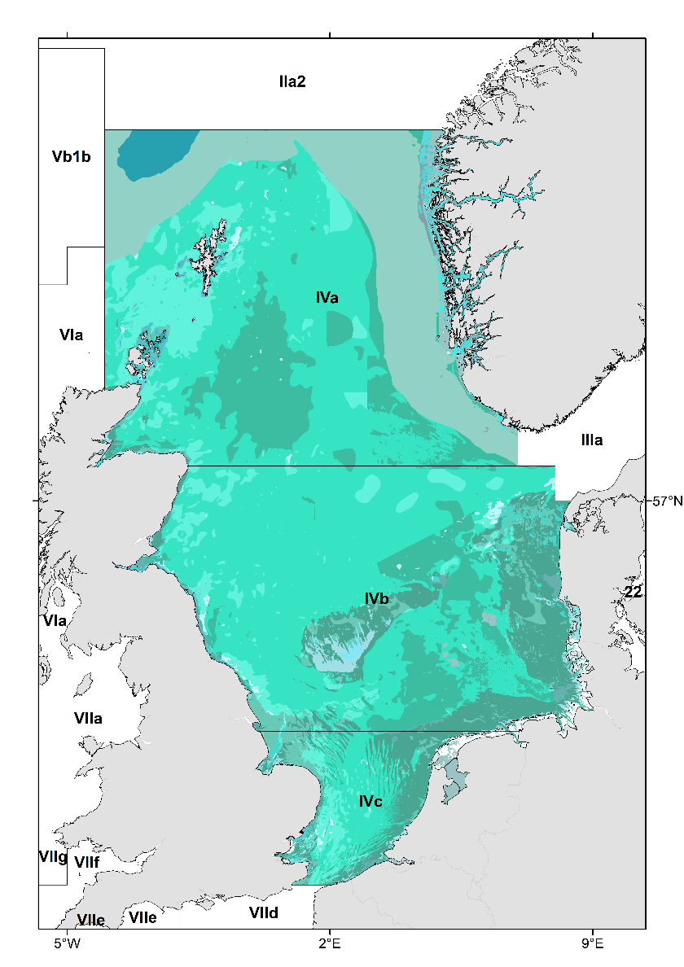
Figure 2 The extent of the habitat layers was clipped to the extent of the area that was indicated by the client as the area of operation of the FIP fleet, namely ICES divisions 27.4.a, 27.4.b, and 27.4.c. The figure shows the EMODnet broad-scale seabed habitat map clipped at the extent of ICES divisions 27.4.a, 27.4.b, and 27.4.c.
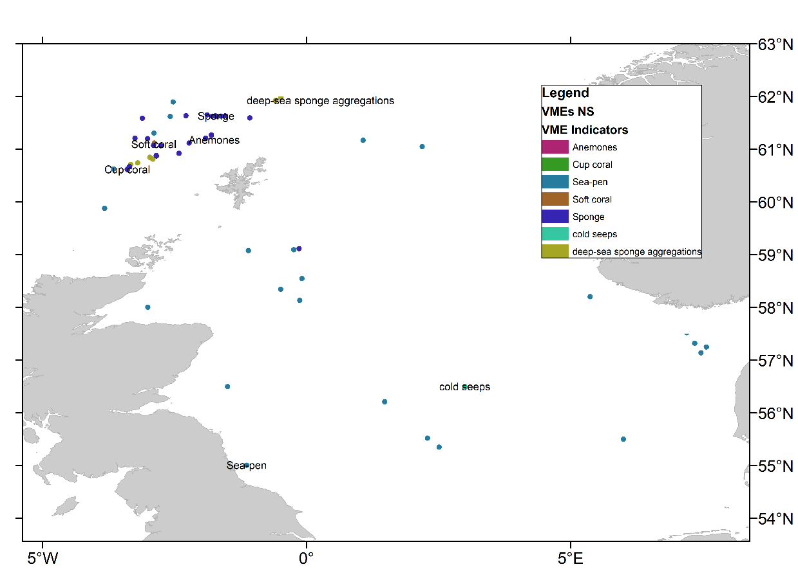
Figure 3 VMEs mapped based on the ICES Vulnerable Marine Ecosystems (VMEs) dataset.

Indicator 1: Habitat – Fisheries Overlap
A GIS algorithm was developed to calculate the overlap between the distribution of the fishery and each of the habitats. The algorithm was applied to pairings of the fishery distribution and each of the habitat layers and involved: (i) intersect between the grid of the distribution of the fishery for a certain year and the polygon of the habitat, and (ii) calculation of the common area (per habitat type or substrate).
The total area of the distribution of each fishery was calculated based on the available VMS data for the FIP fleet, as described in section 2.1. To calculate the area that is occupied by a certain habitat (i) the habitat dataset was clipped based on the areas indicated by the client and related ICES rectangles and (ii) the total area was calculated (per habitat type or substrate in the case of the EUSeaMap 2016 data).
Indicator 1 is the proportion of habitat area that overlaps with fishing effort (P_{h})
P_{h} = O_{fh} / A_{h} (equation 1)
Where O_{fh} is the overlap area between fishing effort and habitat A_{h}.
For those habitats with low recovery rates (> 5 years) and high depletion rates - such as VMEs and threatened habitats as those described in the EMODnet OSPAR Threatened and/or Declining Habitats 2015 and the ICES Vulnerable Marine Ecosystems dataset.

Indicator 2: Relative Benthic Status
To evaluate the impact of the fisheries on common benthic habitats, we used the approach described in Pitcher et al. (2016) and Szostek et al. (2017) and calculated the Relative Benthic Status (RBS), a quantitative indicator of the risk of depletion for benthic habitats, i.e. the rate of change in abundance in time. According to (Pitcher et al. 2016) estimating RBS requires only maps of fishing intensity and habitat type and parameters for impact and recovery rates, which might be taken from meta-analyses. Equation 2 describes this relationship.
$RBS=1-F\frac{R}{D}$ (equation 2),
where F is trawling frequency, d is the depletion rate of biota caused by each trawl pass (expressed as a proportion), and r is the rate of increase of biota interpreted here as the recovery rate.
The swept area was calculated based on the methodology developed by Gerritsen et al. (2013) for VMS data. Depletion of biota (d) and recovery rates ( r) were derived from literature, namely two meta-analyses of experimental studies. Pitcher et al. (2016) provide values of depletion and recovery for different types of habitats (Table 5) and Hiddink et al. (2017) for different types of trawling gears (Table 6).

Table 1 Values of depletion and recovery for different types of habitats after (Pitcher et al. 2016).
Habitat | R (recovery rate) | D (depletion rate)
Mud | 5.5 | 0.27
Muddy Sand | 4.1 | 0.41
Sand | 12.5 | 0.37
Gravel | 2.2 | 0.48

Table 2 Values of depletion and recovery for otter and beam trawls after (Hiddink et al. 2017). The median recovery rate reported by the authors was 0.82.
Gear | R (recovery rate) | D (depletion rate)
Otter trawls (OT) | 1.05 | 0.16
Beam trawls (BT) | 4.49 | 0.25

For the analysis, we used the average values of recovery and depletion for each combination of habitat and gear; e.g. if an otter bottom trawl (d = 0.16) impacts coarse sediments (d = 0.48) then the average d = 0.32 was used for the calculations. EUSeamap habitats have more classes than the ones reported by (Pitcher et al. 2016). We used recovery and depletion values for those habitats that resembled the (Pitcher et al. 2016) habitat classification the best. Annexe Table 1 gives the values of recovery and depletion rates for each common habitat type in the EUSeamap habitats. Similarly, Annexe Table 2 gives the values of recovery and depletion rates for each gear used by the FIP fleet when it targets plaice and lemon sole.
RBS is an indicator of the status of a benthic habitat given the fishing effort of the fleet for a certain period. RBS = 0 indicates total depletion of a habitat due to fishing effort, while an RBS = 100% refers to the un-trawled state of the habitat. As such RBS > 80% can be considered to comply with the MSC criterion 2.4.1.

Results

Data: Effort and Habitat Distribution
A total of 347 RSS numbers related to FIP vessels had logbook records in the period 2012-2016. As already stated, some of the vessels (depending on their length, see methodology) had no logbook records as they are not obliged to carry VMS and use logbooks. The match between logbook records and VMS records i.e. logbook records that could be linked to VMS records - ranged from 92% (2012) to 99.4% (2016). Indicatively, in 2013, from the 149 RSS numbers selected in the logbook data, 141 had related VMS records (94.6%), from the 1652 trips, 1340 could be linked to VMS records (81%) (Table 7). Table 8 shows calculations of the mismatch between VMS data (pings) and logbooks. Figure 3 shows the distribution of the FIP fleet.
Table 3 Calculations of the mismatch between logbook records and VMS data. Logbook records do not perfectly match with VMS data due to errors in VMS data, low temporal resolution of the VMS data and subsequent misidentifications of fishing sets or because vessels below a certain length, which decreases through the years) are not obliged to have VMS.
year | variable | logbooks | Matched | % matching
2012 | RSS numbers | 146 | 135 | 92.5
2012 | trips | 1540 | 1138 | 73.9
2012 | revenue | 152394 | 117958 | 77.4
2012 | catch | 7584699 | 6835297 | 90.1
2013 | RSS numbers | 149 | 141 | 94.6
2013 | trips | 1652 | 1340 | 81.1
2013 | revenue | 127092 | 102325 | 80.5
2013 | catch | 10867469 | 9871156 | 90.8
2014 | RSS numbers | 156 | 151 | 96.8
2014 | trips | 2083 | 1877 | 90.1
2014 | revenue | 94666 | 83143 | 87.8
2014 | catch | 12847902 | 12527642 | 97.5
2015 | RSS numbers | 148 | 147 | 99.3
2015 | trips | 2093 | 2014 | 96.2
2015 | revenue | 119824 | 113065 | 94.4
2015 | catch | 12174335 | 12126055 | 99.6
2016 | RSS numbers | 154 | 153 | 99.4
2016 | trips | 2704 | 2612 | 96.6
2016 | revenue | 329808 | 320051 | 97
2016 | Catch | 17937515 | 17845727 | 99.5

Table 4 Calculations of the mismatch between VMS data (pings) and logbooks. VMS data do not perfectly match with logbook records.
Year |  | number of VMS pings | % of linked pings | % of remaining pings
2012 | Total | 56995
2012 | Not able to link | 155 | 99.73 | 0.27
2013 | Total | 65623
2013 | Not able to link | 195 | 99.7 | 0.3
2014 | Total | 101701
2014 | Not able to link | 272 | 99.73 | 0.27
2015 | Total | 135188
2015 | Not able to link | 572 | 99.58 | 0.42
2016 | Total | 180160
2016 | Not able to link | 554 | 99.69 | 0.31

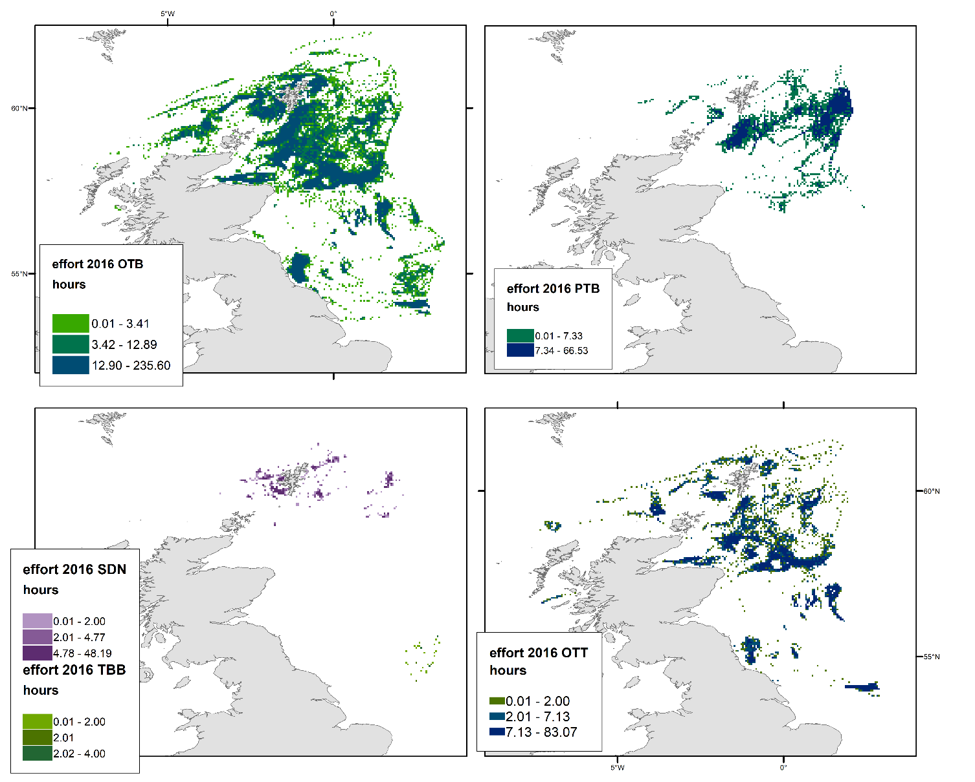
Figure 4 Fishing effort distribution of the FIP vessels per gear for 2016.

Indicator 1: Habitat – Fisheries Overlap
Indicator 1 shows the percentage of habitat area that overlaps with fishing effort per gear. The analysis of the VMEs based on ICES database shows that there is more than 20% overlap of fishing effort and VMEs especially for otter bottom trawls and otter twin trawls with sea pens, sponges, and cup corals (Table 9). It is worth noting that our list includes both deep sea sponge aggregations and sponges since the ICES database defines ‘deep-sea sponge aggregations’ as a habitat type and habitat types have been validated by surveys. ‘Sponge’ on the other hand is a VME indicator for VME habitats that include deep sea sponges but have not been validated by surveys. Similarly, cup coral is a VME indicator according to the Joint ICES/NAFO Working Group on Deep-water Ecology. Given the low recovery rates of these habitats, an overlap over 20% implies that 80% of the habitat will not be able to recover at a decadal scale and thus an 80% MSC score would not be achieved.
The above-mentioned results are confirmed by the analysis of the OSPAR dataset that includes VMEs and other vulnerable habitats with low recovery rates. Otter bottom trawlers (OTB) effort overlaps with more than 45% of the Sea-pen and burrowing megafauna communities found in the area of operation of the FIP vessels. Twin trawlers (OTT) also show high values for indicator 1. Table 10 shows all cases where the percentage of the habitat that overlaps with effort exceeds 20%.
Table 5 Indicator 1: proportion of VMEs overlapping with fishing effort per gear and year. The values presented are > 20%.
VME Indicators | year | gear | Indicator 1: P_{h}
Sea-pen | 2015 | OTB | 36.0446
Sponge | 2015 | OTB | 35.07095
Sea-pen | 2016 | OTB | 34.60347
Sea-pen | 2012 | OTB | 32.26389
Sea-pen | 2013 | OTB | 32.1363
Sea-pen | 2014 | OTB | 28.01682
Cup coral | 2015 | OTB | 22.43261
Sea-pen | 2016 | OTT | 19.6419

Table 6 Indicator 1: proportion of threatened and declining habitats, based on OSPAR database, overlapping with fishing effort per gear and year. The values presented are > 20%.
OSPAR habitat type | year | gear | Indicator 1: P_{h}
Sea-pen and burrowing megafauna communities | 2014 | OTB | 56.93
Sea-pen and burrowing megafauna communities | 2016 | OTB | 54.98
Sea-pen and burrowing megafauna communities | 2015 | OTB | 49.91
Sea-pen and burrowing megafauna communities | 2013 | OTB | 49.08
Sea-pen and burrowing megafauna communities | 2012 | OTB | 47.06
Sea-pen and burrowing megafauna communities | 2014 | OTT | 39.82
Sea-pen and burrowing megafauna communities | 2016 | OTT | 36.95
Sea-pen and burrowing megafauna communities | 2013 | OTT | 28.30
Sea-pen and burrowing megafauna communities | 2015 | OTT | 27.99
Sea-pen and burrowing megafauna communities | 2012 | OTT | 20.83

Indicator 1 was also calculated for common substrates (Table 11). Recovery rate and depletion rate values for common habitats, denoted here by the different substrates are variable (see methodology for specific values) and they are not considered as vulnerable as the habitats found in the ICES VMEs database and the OSPAR database. This indicator does not account for recovery and depletion, so for these habitats RBS was also calculated. P_{h} can be useful along with depletion and recovery rates to find the reason for low RBS values and ways to mitigate impact on habitats.
Table 7 Indicator 1: proportion of substrate overlapping with fishing effort per gear and year. The values presented are > 20%.
Substrate | year | gear | Indicator 1: P_{h}
Sandy mud to muddy sand | 2014 | OTB | 22.09
Sandy mud to muddy sand | 2016 | OTB | 21.94
Coarse sediment | 2016 | OTB | 21.34

All area calculations per habitat, gear and year can be found in the Annexe table 5.

Indicator 2: Relative Benthic Status
Table 12 shows the average RBS values per year or substrate or gear. These values show that the status of common habitats relative to un-trawled habitats is > 80%. Annexe Table 6 shows all RBS values per year, gear and common habitat (substrate). The plaice and lemon sole fishery is characterised by RBS values higher than 87%, which indicates a good status of the habitat given the current fishing effort of the FIP vessels. It should be noted that the real status of the habitat depends on all fleets that use towed gears and that the current analysis accounts only for the FIP vessels.
Table 8 Average RBS values per year, per substrate and gear. All values are above 80%.
year | RBS
2012 | 98
2013 | 97.5
2014 | 96
2015 | 96
2016 | 95
substrate
Coarse sediment | 87
Fine mud | 98
Mixed sediment | 95
Mud to muddy sand | 99
Rock or other hard substrata | 98
Sand | 96
Sandy mud to muddy sand | 87
gear
OTB | 87
OTT | 94
PTB | 94
SDN | 93.8
TBB | 99

Table 9 The lowest RBS value for the plaice and lemon sole FIP. The values presented here are < 90%. All other combinations of gear – substrate are > 90% and are presented in Annexe Table 6.
habitat | gear | RBS | Year
Coarse sediment | OTB | 87 | 2016
Sandy mud to muddy sand | OTB | 87 | 2016
Coarse sediment | OTB | 88.7 | 2014
Coarse sediment | OTB | 89 | 2015

Fishing intensity and VME habitat distribution
The 2009 FAO Guidelines on VME define VME’s as “species groups, communities and habitat forming species that are documented or considered sensitive and potentially vulnerable to deep-sea fisheries (DSFs) in the high-seas, and which may contribute to forming VMEs”. This definition is also referred to in the ICES Vulnerable Marine Ecosystem (VME) Database Factsheet although this database provides locations of VME species indicators in North Sea shallow water areas.
The spatial distribution of 99% of the studied FIP fleet is within a depth range between 40 and 150 meters. Deep-sea waters are generally assumed to be sea areas deeper than 200 meters. This excludes, therefore, any spatial interaction between the FIP footprint based on the above definition of potential vulnerable marine ecosystems. However, these VME species indicators positions are evidence of the presence of important conservation species in North Sea shallow areas that might be captured by the UK MPA conservation program.
We use the VMS fishing vessel locations to derive the fishing effort intensity that directly interacts or surrounds these VME species indicators positions. The scale and intensity of the fishing impact on benthic habitats was calculated using the swept area ratio (SAR). To obtain the SAR indicator, firstly we calculated the swept area per VMS location identified as fishing, by multiplying the gear specific gear width by instant vessel speed and the time interval of each VMS location (each point represents ~2 hours of fishing effort). Next, the geographical fishing footprint extension was divided in equal 0.05 degrees grid cells, hereafter referred as c-squares. Then, the swept area associated to each fishing location within the same c-square grid cell was summed to obtain total swept area in the c-square and dividing it by the c-square area we obtained the swept area ratio (SAR). SAR is the proportion of the c-square estimated to be in contact with mobile bottom fishing gear and it can be as well interpreted as the mean number of times the seabed in the cell was impacted by a bottom fishing gear.
The ICES VME database include observations obtained from bottom trawl surveys that are represented as a discrete position data while camera video transects are included as a set of points characterizing the underwater-camera transect. In order to match the underwater-camera transect locations with the fishing activity data resolution (0.05 degrees c-square), the survey locations within a distance-radius of 0.05 degrees were spatially clustered. The result was the identification of 13 clusters of which 10 represent sea-pens occurrence and 4 of sponge species observations (1 cluster has both sea-pen and sponges observations). Then, we analysed the frequency of fishing intensity associated to each VME cluster, selecting the fishing activity c-squares occurring within 0.025 degrees (~ 2.5nm) from the centre of these VME species clusters.
The result of this analysis indicates that 10 of these VME clusters are directly overlapped and 5 surrounded by the FIP fleet fishing activity. The survey stations showing presence of cup-coral species were excluded as they were further than 0.05 degrees from any source of FIP fishing disturbance and in a deep area (< 400 m) where FIP fishing intensity is residual (the cup-coral stations are relatively close to spatial clusters with id 2 and 12). Figure 5 shows an overview map of the FIP fleet intensity and the location of the VME species indicator spatial clusters. The box plot graph in Figure 6, highlights the VME species clusters associated with a high level of fishing activity and the density graph compares the density of SAR c-squares cells at each VME spatial cluster.

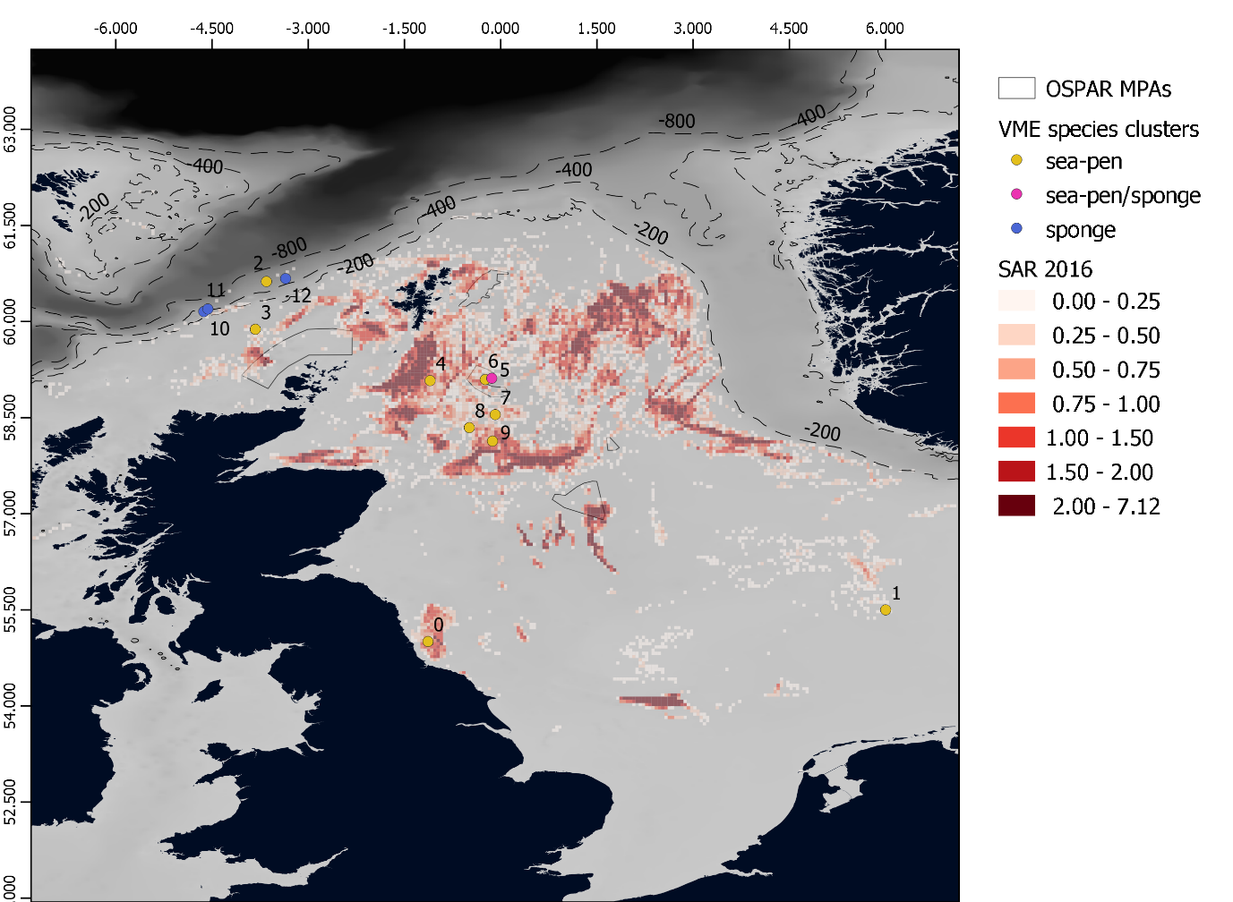

Figure 5 – ICES VME indicator locations and linked fishing SAR c-squares

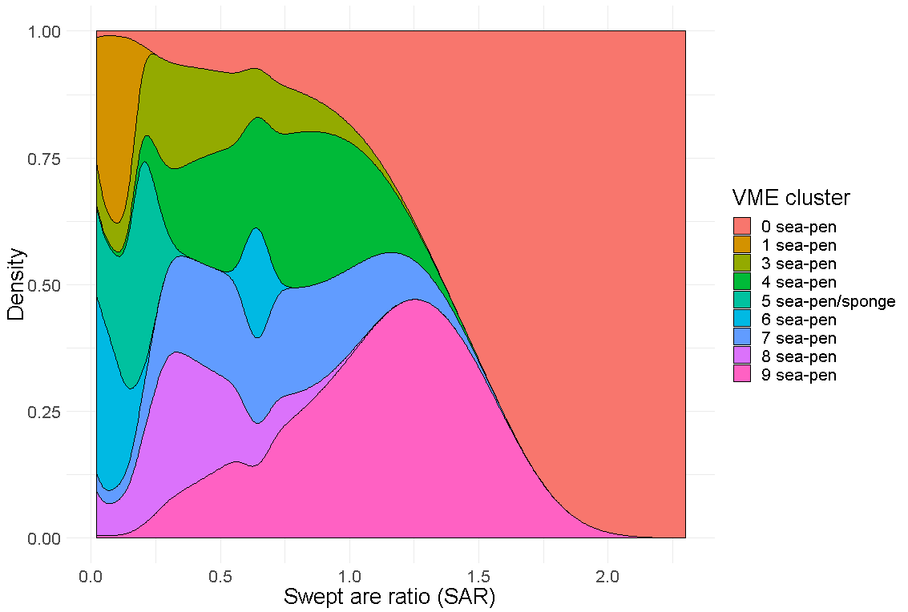
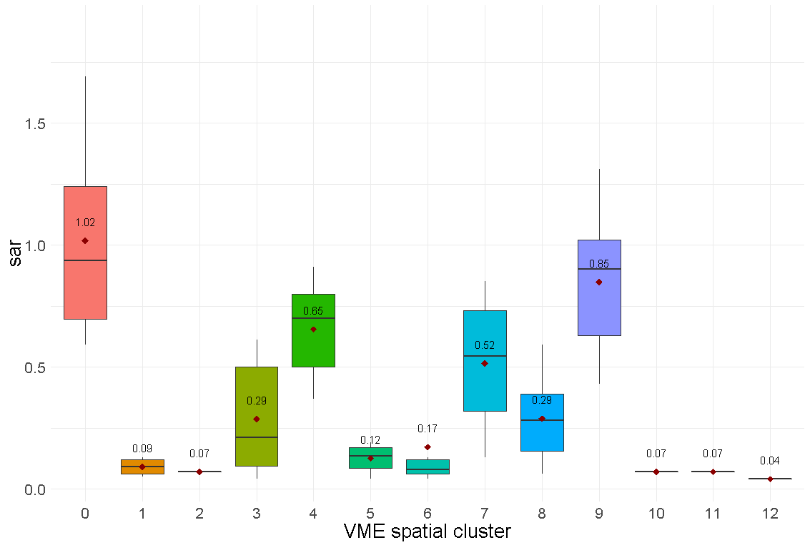

Figure 6: Box plot of the VME spatial cluster and the Swept area ratio related (left). Density graph of the SAR values by each VME spatial cluster (right)

Fishing intensity distribution and MPAs
In relation to the deep-sea sponges’ habitats, these are catalogued as UK BAP Priority Habitat (BAP habitats are now Habitats of Principal Importance/Priority Habitats) and included in the SPAR List of Threatened and/or Declining Species and Habitats (Region V – Wider Atlantic). Figure 7 shows the VME cluster 10, 11 and 12 with sponge community observations in deep-sea areas (< 400 m). In 2016, the FIP fishing activity occurring in ocean areas deeper than 200 meters represent the 1% of the total and the 2% of the averaged FIP fishing activity between 2012 and 2016 (left and right graphs below respectively).
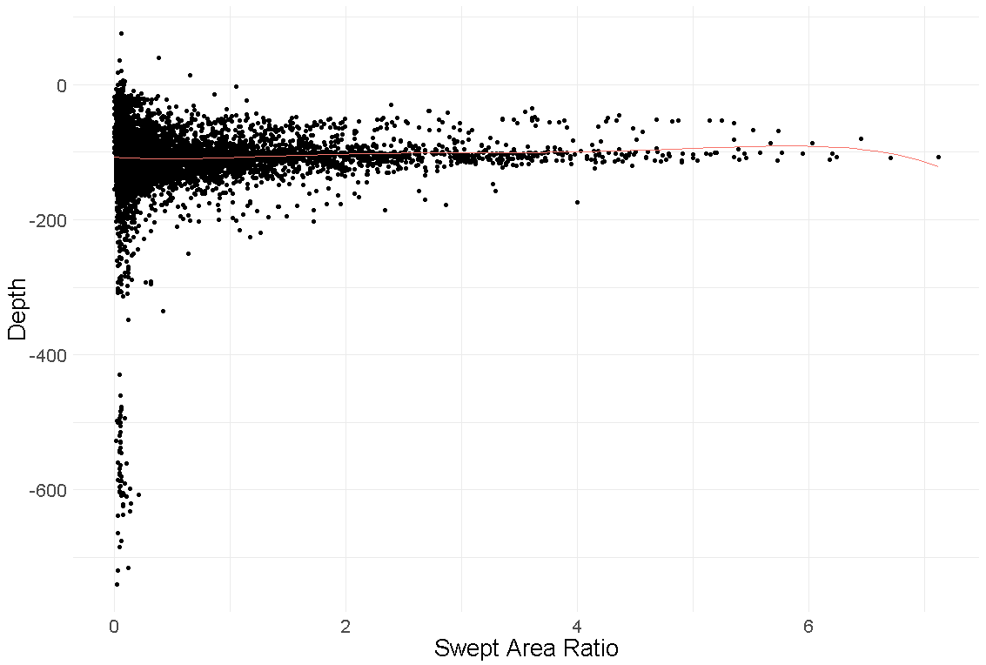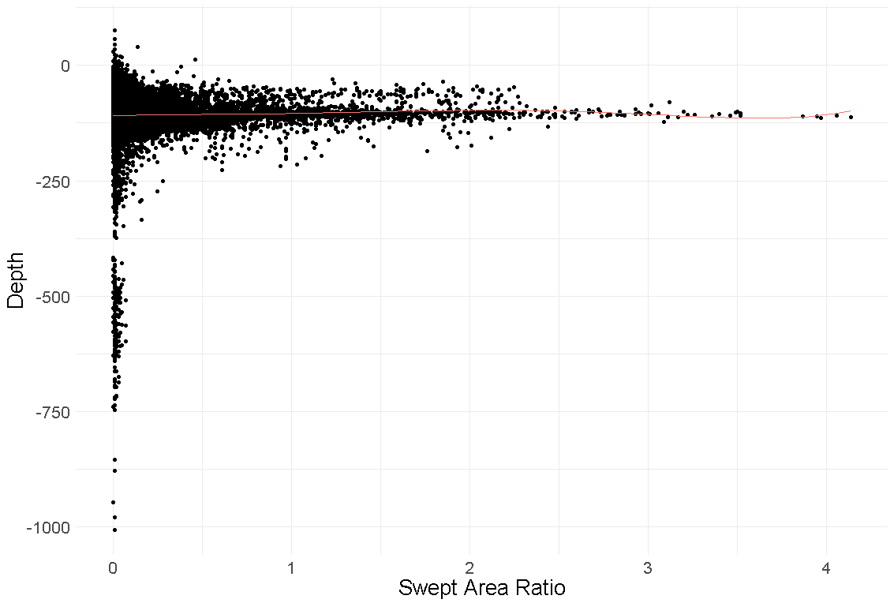
Figure 7 shows the VME cluster 10, 11 and 12 with sponge community observations in deep-sea areas

The conclusion of the sponges VME analysis is that they only occur in the deep-sea areas where the FIP activity is not significant in occurrence and intensity.
In relation to the sea-pen species observations, the previous analysis of the FIP fleet intensity overlapping with the location of VME species indicates that sea-pen are the unique VME species indicator existing in the area where FIP fleet targets plaice and lemon sole. The habitat related to sea-pens occurrence are identified as ‘Sea-pen and burrowing megafauna communities’ and defined as plains of fine mud, at water depths ranging from 15 to 200 metres or more, which are heavily bioturbated by burrowing megafauna. Burrows and mounds may form a prominent feature of the sediment surface with conspicuous populations of sea-pens, typically Virgularia mirabilis and Pennatula phosphorea. The burrowing crustaceans present may include Nephrops norvegicus, Calocaris macandreae or Callianassa subterranea. The main threats to this habitat are activities that physically disturb the seabed, such as demersal fisheries, marine pollution through organic enrichment and increased bottom water temperature due to climate change. In relation to conservation status, this habitat is included in the OSPAR List of Threatened and/or Declining Species and Habitats (Region II – North Sea, Region III – Celtic Sea).
The UK MPA program is responsible for the conservation of marine biodiversity and protection of species and habitats in the geographical area where the FIP footprint is extended and with a significant intensity. Therefore, to provide an estimation of the FIP fishing activity overlapping the protected areas associated, we have performed a spatial overlapping analysis between FIP activity footprint and MPA boundaries.
The left map below presents the distribution of the overall FIP fleet activity extension in yellow and it is overlapping with the different UK MPAs categories. The right figure displays the fishery footprint intensity in 2016 from where we have removed the low intensity (0 to 0.24 SAR) grid cells to highlight the main grounds and significantly benthic impacted areas.
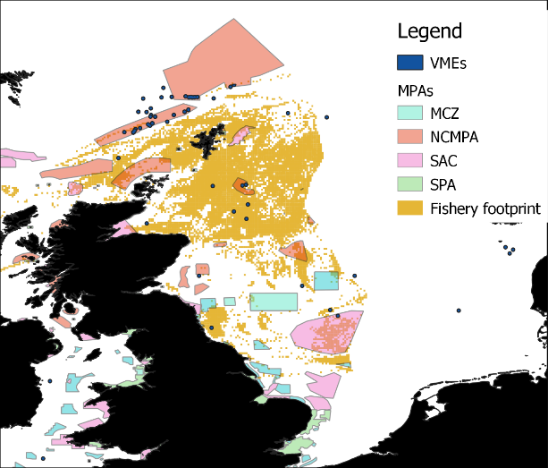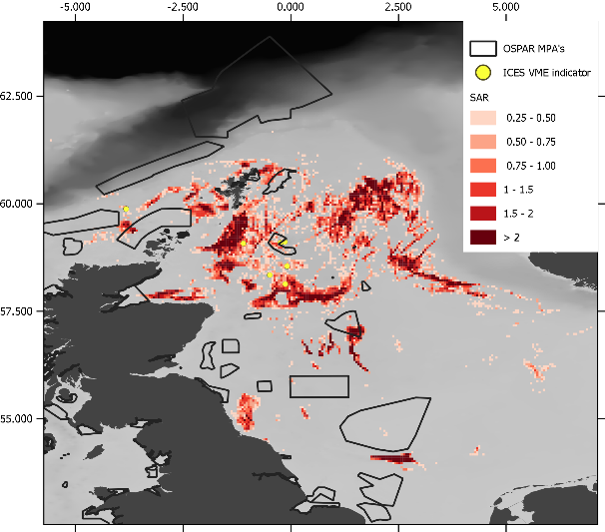

A further spatial overlap analysis was performed between significant fishing intensity (larger than 0.25 SAR) and MPA boundaries to observe in detail fishing intensity distributions by MPA.
The map represents the selected MPA locations and the spatial distribution of associated fishing activity intensity. Table 10 provides the results of this analysis as percentage of the MPA area overlapped by the fishing footprint and the average, minimum and maximum swept area ratio.
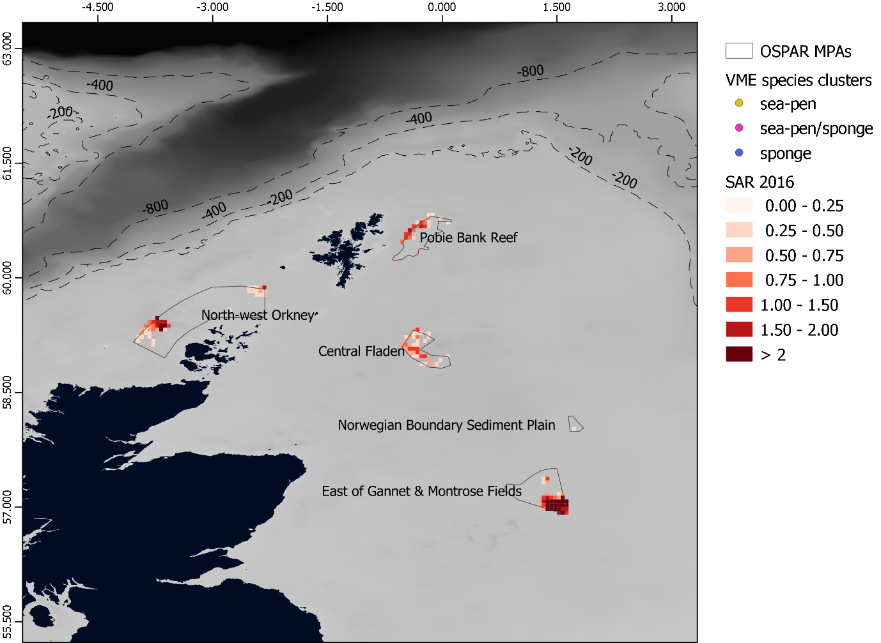
Figure 8 – MPAs boundaries associated to FIP fishing activity and the calculated swept area ratio (SAR) indicator.

Table 10 – Detail of MPA boundaries overlapped by the fishery and intensity SAR statistics.
Site name | Country | Status year | UK Designation | Overlap % | SAR max | SAR min | SAR avg
Pobie Bank Reef | Scotland/UK offshore | 2012 | Special Area of Conservation | 20.44 | 1.63 | 0.01 | 0.41
North-west Orkney | Scotland/UK offshore | 2014 | Nature Conservation MPA | 12.14 | 2.86 | 0.01 | 0.37
East of Gannet & Montrose Fields | UK offshore | 2014 | Nature Conservation MPA | 29 | 5.74 | 0.01 | 1.51
Central Fladen | UK offshore | 2014 | Nature Conservation MPA | 51.62 | 1.49 | 0 | 0.36
Norwegian Boundary Sediment Plain | UK offshore | 2015 | Nature Conservation MPA | 10 | 0.43 | 0.04 | 0.16

The conclusions obtained from Table 10 and the graphs in Figure 9 are that the habitats more likely to be expose to high fishing pressure are in East Gannet and Montrose Fields MPA, with fishing activity existing in 29% of the area and with average SAR of 1.27 and with maximum of 5.74. However, Central Fladen although with a significant less fishing intensity (0.36 SAR), the FIP fishery covers the 52% of the area.
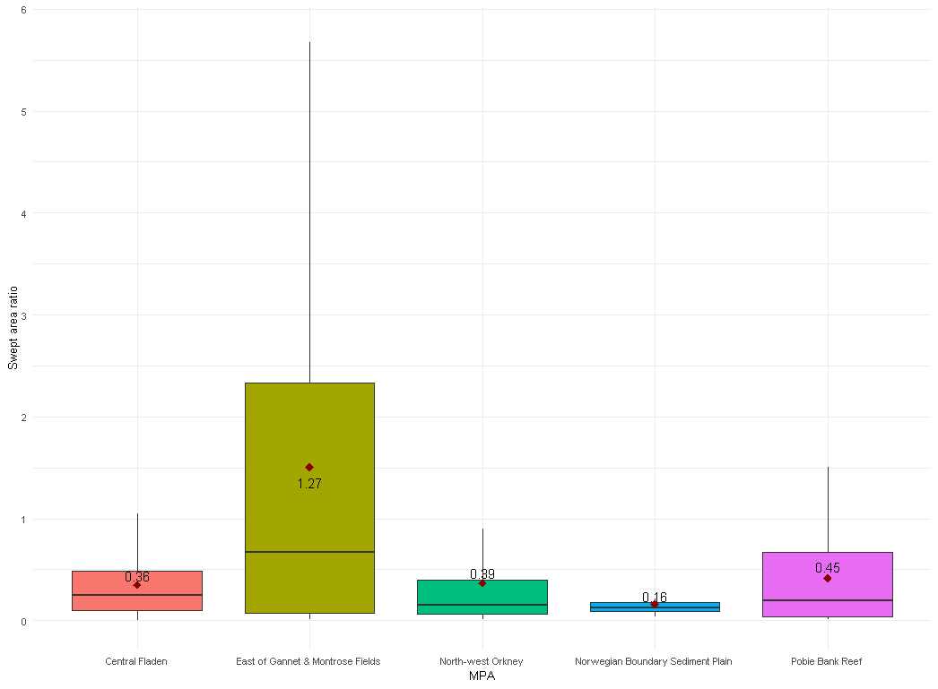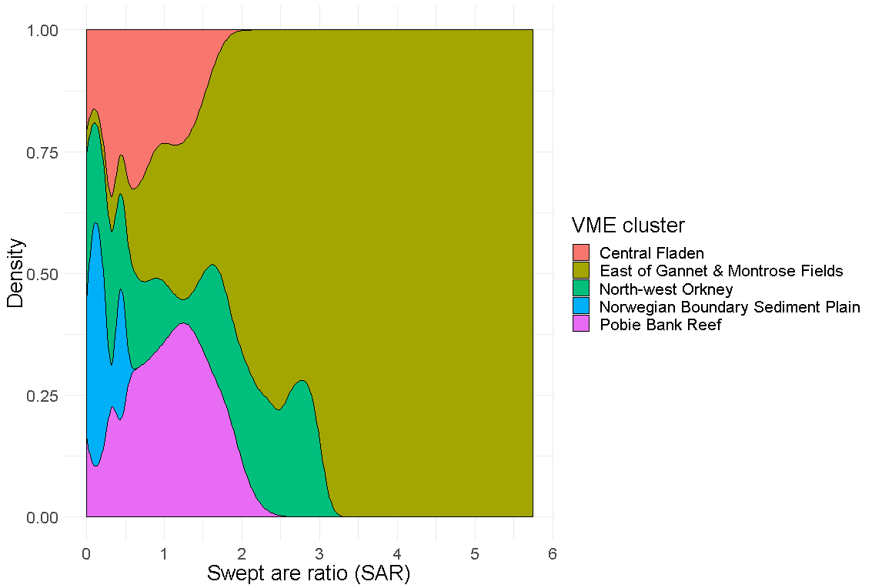
Figure 9 - Box plot of the MPAs and the swept area ratio distribution (left). Density graph of the SAR values by each overlapped MPA (right)

In addition, we have provided a table with the list of protected features and feature types for each MPA linked with FIP fishing activity. This list shows that the only MPA with ‘Sea-pen and burrowing megafauna communities’ habitat as a protected feature objective is Central Fladen MPA. The fishing activity of FIP fleet within Central Fladen MPA boundaries has a value of 0.36 SAR average. Although not showing the highest intensity value in comparison with the other fishing within MPA boundaries, it is most widely extended inside the MPAs boundary, covering up to 51% of the MPA area. Detailed maps with the MPAs and their protected features locations are provided in the Annex. These maps show evidence that besides Central Fladen, the rest of the MPAs related to FIP fishing activity, have potential interactions with some of the locations where protected features were observed.

Table 11 – Protected features and types by MPA overlapped by the fishery
Site name | Features | Feature Type
Pobie Bank Reef | Reefs | Annex I Habitat*
North-west Orkney | Sandeels | Mobile species
North-west Orkney | Sand banks, sand wave fields and sediment wave fields representative of the Fair Isle Strait Marine Process Bedforms Key Geodiversity Area. | Geomorphological feature
East of Gannet & Montrose Fields | Offshore deep sea muds | Habitat
East of Gannet & Montrose Fields | Ocean quahog aggregations (including sands and gravels as their supporting habitat) | Low or limited mobility species
Central Fladen | Burrowed mud (seapens and burrowing megafauna and tall seapen components) | Habitat
Central Fladen | Sub-glacial tunnel valley representative of the Fladen Deeps Key Geodiversity Area | Geomorphological feature
Norwegian Boundary Sediment Plain | Ocean quahog aggregations (including sands and gravels as their supporting habitat) | Low or limited mobility species

Discussion

Quantifying the impact of the FIP fleet
The habitat-fisheries overlap analysis showed that more than 20% of three different types of VMEs species indicators namely sea pens, sponges and cup corals overlapped with fishing effort. The same analysis based on OSPAR data showed that more than 20% of the area occupied by sea-pen and burrowing megafauna communities – in some years more than 50% - overlapped with the fishing activity of the FIP fleet. Littoral chalk communities and Lophelia pertusa reefs show overlap values ~15%. According to OSPAR, a percentage of each habitat type that OSPAR characterises as threatened and declining habitats falls under disturbance categories 5-9, which means that after disturbance, recovery will not take place in less than a decade. Both for VMEs and for OSPAR threatened and declining habitats, an overlap >20% with fishing can jeopardise the recovery of the habitat to 80% of its current state if disturbance from fishing activity ceases.
The sections 3.4 and 3.5 provide a clear differentiation between VME habitat and VME indicators. The VME habitat conformed by sponges and cup corals species are in deep waters with no significant FIP fishery action in the area. The interaction between the fishery footprint and the sea-pen VME indicator occurs in North Sea shallow water ( >200 meters), therefore we have referred to the MPA monitoring program to analyse the presence of VME species indicators. Central Fladen is the unique MPA with sea-pens species and related habitats and it is covered by the FIP fleet activity up to 51% of the area with SAR intensities between 0.25 and 1.5 and an average of 0.36. The fishing effort intensity lower than 0.25 was excluded to identify the main locations of significant impacted areas, but if we would include the whole fishing activity, the Central Fladen MPA is covered up to 92% of the total area.
Given RBS values for plaice and lemon sole fishery are higher than 80% for all substrates and gears. Based on the RBS values for common habitats, and at a gear level, in the absence of fishing, the common habitats could recover to 80% compared to an un-disturbed habitat.

Caveats
Three sources of uncertainty could affect the reliability of the results of the habitat assessment and relate to (i) the fishing effort data, (ii) the habitat distribution data and (iii) the depletion and recovery rates. Vessels below 15m until 2013; and for vessels below 12m from 2013 onwards do not have logbooks or VMS data. As a result, we do not account for the fishing effort of approximately 40 RSS numbers of related vessels and could underestimate the fishing effort and the magnitude of fishing disturbance. There is uncertainty on the distribution of VMEs and other threatened and declining habitats. The data are derived mainly from surveys and only a percentage of the fishery operation area is covered by surveys. Also, because surveys have been conducted after fishing activities had commenced, the un-trawled, ‘unimpacted’ level of the habitat is largely unknown. Finally, depletion and recovery rates come from meta-analyses and are not specific to all the gears used and all the different types of impacted habitats. Both rates greatly affect RBS values.
The analysis presented here focuses on the impact of a part of the fishing effort in the North Sea relating to the North Sea plaice and lemon sole FIP. The values presented refer to the recovery of habitats if the given fleet were the only one operating in the area. We are not assessing the cumulative impact of all fisheries in the area hence the estimated values will underestimate the total disturbance of the benthic ecosystems and overestimate the relative benthic status. For assessment purposes, the cumulative impact of all fisheries in the area should be studied and the contribution of the assessed fishing fleet should be estimated. RBS and SAR are indicators to evaluate the status of the sediments and estimating their value without the knowledge of the total impact of all fisheries on the substrate underestimates impact on habitats.

Suggestions for Improvement
Regarding the quality of information used in this analysis, improved estimates of impact could be achieved if all vessels, including those below the obligatory length of 12m, reported logbooks and carried a location monitoring device. This could be either VMS or AIS (Automatic Identification Systems). The latter could provide better temporal resolution of location data that would further decrease the uncertainty around fishing set identification. Reliable information could come from habitat models that predict the distribution of such features but are not yet available. Knowledge of recovery and depletion values for the specific fisheries and the habitats they disturb could affect the results of the assessment. Experimental studies in the areas of interest could provide more reliable values for these parameters. These actions would provide the necessary evidence to support the MPA sites management program that literally says: ‘the restriction of fishing activity within an MPA will be only applied to the affected area of an MPA, rather than the entire site, if the evidence is available’.
Fishers can be informed of the locations of vulnerable habitats to avoid them and contribute to the improvement of current habitat distribution maps by reporting encountering vulnerable habitats in areas that the current maps do not cover. In a meta-analysis of studies on recovery rates after physical disturbance, Kaiser et al. (2006) noted that in sand habitats beam trawling has a severe initial impact but rapid recovery, while otter trawls have a delayed effect on sand habitats, in terms of both impact and recovery. The patterns are similar in muddy sand habitats. As expected, fishing has severe effects on biogenic habitats that show the longest recovery periods or no recovery; thus, these areas should be avoided.
Fishing effort distribution and possibly magnitude could change after 2017 due to a voluntary closure to protect areas of sea pens in the Fladen Ground area, put in place by SFSAG. However, the redistribution of the fishing effort could affect other areas.

References
Cameron A, Askew N (2011) EUSeaMap - Preparatory Action for development and assessment of a European broad-scale seabed habitat map final report. JNCC
Gerritsen H, Lordan C (2011) Integrating vessel monitoring systems (VMS) data with daily catch data from logbooks to explore the spatial distribution of catch and effort at high resolution. Ices J Mar Sci 68:245–252
Gerritsen HD, Minto C, Lordan C (2013) How much of the seabed is impacted by mobile fishing gear? Absolute estimates from Vessel Monitoring System (VMS) point data. Ices J Mar Sci 70:523–531
Hiddink JG, Jennings S, Sciberras M, Szostek CL, Hughes KM, Ellis N, Rijnsdorp AD, McConnaughey RA, Mazor T, Hilborn R, others (2017) Global analysis of depletion and recovery of seabed biota after bottom trawling disturbance. Proc Natl Acad Sci 114:8301–8306
Hintzen NT, Bastardie F, Beare D, Piet GJ, Ulrich C, Deporte N, Egekvist J, Degel H (2012) VMStools: open-source software for the processing, analysis and visualisation of fisheries logbook and VMS data. Fish Res 115:31–43
ICES, n.d. http://www.ices.dk/marine-data/data-portals/Pages/default.aspx
Kaiser M, Clarke K, Hinz H, Austen M, Somerfield P, Karakassis I (2006) Global analysis of response and recovery of benthic biota to fishing. Mar Ecol Prog Ser 311:1–14
Pitcher C, Ellis N, Jennings S, Hiddink J, Mazor T, Kaiser M, Kangas M, Mcconnaughey R, Parma A, Rijnsdorp A, Suuronen P, S. Collie J, Amoroso R, Hughes K, Hilborn R (2016) Estimating the sustainability of towed fishing-gear impacts on seabed habitats: a simple quantitative risk assessment method applicable to data-limited fisheries.
Szostek C, Hiddink J, Sciberras M, Caveen A, Lart W, Rodmell D, Kaiser M (2017) Tools to estimate fishing gear penetration depth and benthic habitat impacts of fisheries at a regional scale. Bangor University
https://www.gov.uk/government/collections/managing-fisheries-in-marine-protected-areas

Annex
substrate | Depletion rate | Recovery rate
Coarse and mixed sediment | 0.48 | 2.2
Coarse sediment | 0.48 | 2.2
Cymodocea beds | 0.48 | 2.2
Cymodocea nodosa meadows | 0.48 | 2.2
Dead mattes of Posidonia oceanica | 0.48 | 2.2
Fine mud | 0.27 | 5.5
Mixed sediment | 0.41 | 4.1
Mud to muddy sand | 0.27 | 5.5
Muddy Sand | 0.41 | 12.5
Posidonia oceanica meadows | 0.48 | 2.2
Rock or other hard substrata | 0.48 | 2.2
Sand | 0.37 | 12.5
Sandy mud | 0.41 | 4.1
Sandy mud to muddy sand | 0.41 | 4.1
Seabed | 0.41 | 4.1
Unknown | 0.41 | 4.1

Annex Table 1 Depletion and recovery rates per substrate. The table shows the values used as input for the RBS calculation.

gear | Depletion rate | Recovery rate
OTB | 0.16 | 1.05
OTT | 0.25 | 1.05
PTB | 0.16 | 0.82
SDN | 0.16 | 0.82
TBB | 0.25 | 4.49

Annex Table 2 Depletion and recovery rates per gear. The table shows the values used as input for the RBS calculation.

Annex Table 3 Indicator 1: proportion of VMEs overlapping with fishing effort per gear and year. Values > 20% are highlighted.

VME Indicators | year | gear | Indicator 1: P_{h}
Sea-pen | 2015 | OTB | 36.0446
Sponge | 2015 | OTB | 35.07095
Sea-pen | 2016 | OTB | 34.60347
Sea-pen | 2012 | OTB | 32.26389
Sea-pen | 2013 | OTB | 32.1363
Sea-pen | 2014 | OTB | 28.01682
Cup coral | 2015 | OTB | 22.43261
Sea-pen | 2016 | OTT | 19.6419
Sea-pen | 2014 | OTT | 16.03629
Sea-pen | 2015 | OTT | 15.02401
Sea-pen | 2013 | OTT | 14.77008
Sponge | 2013 | OTB | 13.67322
Sea-pen | 2012 | OTT | 11.25742
deep-sea sponge aggregations | 2016 | OTB | 10.4928
Soft coral | 2013 | OTB | 7.532904
Sponge | 2012 | OTB | 6.621606
Soft coral | 2015 | OTB | 6.368373
Sponge | 2016 | OTB | 5.789325
Sea-pen | 2016 | PTB | 3.799723
Sponge | 2014 | OTB | 3.001997
Sea-pen | 2014 | PTB | 2.168873
deep-sea sponge aggregations | 2014 | OTB | 1.701076
Sponge | 2013 | OTT | 1.681637
Sponge | 2012 | OTT | 1.602035
Sea-pen | 2016 | TBB | 1.260633
Sea-pen | 2013 | PTB | 1.226132
Sea-pen | 2012 | TBB | 1.169376
Sponge | 2015 | PTB | 1.133934
Sea-pen | 2015 | PTB | 1.101884
Sponge | 2016 | OTT | 0.678726
Sea-pen | 2012 | PTB | 0.453421
Soft coral | 2012 | OTB | 0.414458
Sea-pen | 2015 | SDN | 0.156051
Sponge | 2014 | OTT | 0.038996

Annex Table 4 Indicator 1: proportion of threatened and declining habitats, based on Ospar database, overlapping with fishing effort per gear and year. Values > 20% are highlighted.

Habitat Type | year | gear | Indicator 1: P_{h}
Sea-pen and burrowing megafauna communities | 2014 | OTB | 56.93
Sea-pen and burrowing megafauna communities | 2016 | OTB | 54.98
Sea-pen and burrowing megafauna communities | 2015 | OTB | 49.91
Sea-pen and burrowing megafauna communities | 2013 | OTB | 49.08
Sea-pen and burrowing megafauna communities | 2012 | OTB | 47.06
Sea-pen and burrowing megafauna communities | 2014 | OTT | 39.82
Sea-pen and burrowing megafauna communities | 2016 | OTT | 36.95
Sea-pen and burrowing megafauna communities | 2013 | OTT | 28.30
Sea-pen and burrowing megafauna communities | 2015 | OTT | 27.99
Sea-pen and burrowing megafauna communities | 2012 | OTT | 20.83
Littoral chalk communities | 2014 | OTB | 16.37
Littoral chalk communities | 2016 | OTB | 15.76
Lophelia pertusa reefs | 2014 | OTB | 14.69
Lophelia pertusa reefs | 2013 | OTB | 13.58
Lophelia pertusa reefs | 2016 | OTB | 12.89
Lophelia pertusa reefs | 2012 | OTB | 11.92
Littoral chalk communities | 2012 | OTB | 11.88
Littoral chalk communities | 2015 | OTB | 11.51
Littoral chalk communities | 2013 | OTB | 11.44
Lophelia pertusa reefs | 2015 | OTB | 10.74
Sea-pen and burrowing megafauna communities | 2014 | PTB | 10.21
Sea-pen and burrowing megafauna communities | 2016 | PTB | 8.33
Sea-pen and burrowing megafauna communities | 2015 | PTB | 8.25
Lophelia pertusa reefs | 2015 | OTT | 8.15
Modiolus modiolus horse mussel beds | 2014 | OTB | 8.13
Modiolus modiolus horse mussel beds | 2016 | OTB | 7.50
Lophelia pertusa reefs | 2014 | OTT | 7.46
Sabellaria spinulosa reefs | 2012 | OTB | 7.31
Modiolus modiolus horse mussel beds | 2013 | OTB | 6.98
Deep-sea sponge aggregations | 2016 | OTB | 6.40
Modiolus modiolus horse mussel beds | 2012 | OTB | 6.09
Lophelia pertusa reefs | 2016 | OTT | 5.51
Sabellaria spinulosa reefs | 2013 | OTB | 5.05
Sabellaria spinulosa reefs | 2016 | OTB | 5.00
Deep-sea sponge aggregations | 2014 | OTB | 4.42
Lophelia pertusa reefs | 2013 | OTT | 4.17
Sabellaria spinulosa reefs | 2015 | OTB | 3.77
Modiolus modiolus horse mussel beds | 2015 | OTB | 3.76
Littoral chalk communities | 2014 | OTT | 3.64
Sabellaria spinulosa reefs | 2014 | OTB | 3.28
Sea-pen and burrowing megafauna communities | 2013 | PTB | 2.94
Lophelia pertusa reefs | 2012 | OTT | 2.67
Intertidal Mytilus edulis beds on mixed and sandy sediments | 2016 | OTB | 2.47
Intertidal Mytilus edulis beds on mixed and sandy sediments | 2014 | OTB | 2.44
Sabellaria spinulosa reefs | 2015 | OTT | 2.27
Modiolus modiolus horse mussel beds | 2013 | SDN | 2.21
Modiolus modiolus horse mussel beds | 2015 | SDN | 2.21
Littoral chalk communities | 2015 | OTT | 2.05
Maerl beds | 2014 | OTB | 1.89
Littoral chalk communities | 2016 | OTT | 1.61
Intertidal Mytilus edulis beds on mixed and sandy sediments | 2015 | OTB | 1.56
Maerl beds | 2012 | OTB | 1.47
Modiolus modiolus horse mussel beds | 2016 | SDN | 1.40
Deep-sea sponge aggregations | 2015 | OTB | 1.34
Sea-pen and burrowing megafauna communities | 2012 | PTB | 1.25
Intertidal Mytilus edulis beds on mixed and sandy sediments | 2013 | OTB | 1.19
Deep-sea sponge aggregations | 2013 | OTB | 1.18
Maerl beds | 2016 | OTB | 1.15
Maerl beds | 2013 | OTB | 1.12
Littoral chalk communities | 2012 | OTT | 1.10
Modiolus modiolus horse mussel beds | 2014 | SDN | 1.10
Modiolus modiolus horse mussel beds | 2012 | SDN | 1.10
Maerl beds | 2015 | OTB | 1.09
Intertidal Mytilus edulis beds on mixed and sandy sediments | 2012 | OTB | 1.08
Lophelia pertusa reefs | 2014 | PTB | 1.00
Maerl beds | 2016 | OTT | 0.86
Zostera beds | 2014 | OTB | 0.85
Zostera beds | 2013 | OTB | 0.81
Littoral chalk communities | 2016 | SDN | 0.80
Littoral chalk communities | 2013 | SDN | 0.80
Zostera beds | 2016 | SDN | 0.79
Sabellaria spinulosa reefs | 2014 | OTT | 0.67
Intertidal mudflats | 2016 | OTB | 0.64
Intertidal mudflats | 2015 | OTB | 0.62
Intertidal Mytilus edulis beds on mixed and sandy sediments | 2014 | OTT | 0.58
Sabellaria spinulosa reefs | 2015 | SDN | 0.54
Deep-sea sponge aggregations | 2016 | OTT | 0.50
Intertidal mudflats | 2013 | OTB | 0.47
Intertidal mudflats | 2014 | OTB | 0.46
Intertidal mudflats | 2012 | OTB | 0.38
Maerl beds | 2016 | SDN | 0.38
Intertidal mudflats | 2014 | OTT | 0.24
Littoral chalk communities | 2015 | SDN | 0.24
Zostera beds | 2016 | OTB | 0.17
Lophelia pertusa reefs | 2016 | SDN | 0.15
Sea-pen and burrowing megafauna communities | 2015 | SDN | 0.12
Sea-pen and burrowing megafauna communities | 2016 | SDN | 0.12
Modiolus modiolus horse mussel beds | 2016 | OTT | 0.11
Sabellaria spinulosa reefs | 2016 | OTT | 0.06
Lophelia pertusa reefs | 2015 | PTB | 0.06
Sabellaria spinulosa reefs | 2012 | OTT | 0.06
Sea-pen and burrowing megafauna communities | 2012 | TBB | 0.05
Intertidal Mytilus edulis beds on mixed and sandy sediments | 2016 | OTT | 0.04
Zostera beds | 2015 | OTB | 0.03
Sabellaria spinulosa reefs | 2013 | OTT | 0.03
Deep-sea sponge aggregations | 2012 | OTB | 0.03
Deep-sea sponge aggregations | 2014 | OTT | 0.03
Intertidal mudflats | 2016 | OTT | 0.02
Modiolus modiolus horse mussel beds | 2012 | OTT | 0.00
Intertidal mudflats | 2015 | OTT | 0.00

Annex Table 5 Indicator 1: proportion of common benthic habitats, indicated as types of substrate, overlapping with fishing effort per gear and year. Values > 20% are highlighted.
Substrate | year | gear | Indicator 1: P_{h}
Sandy mud to muddy sand | 2014 | OTB | 22.09
Sandy mud to muddy sand | 2016 | OTB | 21.94
Coarse sediment | 2016 | OTB | 21.34
Coarse sediment | 2013 | OTB | 19.91
Sandy mud to muddy sand | 2013 | OTB | 19.53
Coarse sediment | 2014 | OTB | 19.52
Sandy mud to muddy sand | 2015 | OTB | 19.33
Coarse sediment | 2015 | OTB | 18.71
Coarse sediment | 2012 | OTB | 18.11
Sandy mud to muddy sand | 2012 | OTB | 17.67
Sand | 2014 | OTB | 17.47
Sand | 2015 | OTB | 17.16
Sand | 2016 | OTB | 16.61
Mud to muddy sand | 2015 | OTB | 15.48
Sand | 2013 | OTB | 15.36
Sandy mud to muddy sand | 2016 | OTT | 14.68
Sandy mud to muddy sand | 2014 | OTT | 14.56
Sand | 2012 | OTB | 13.61
Sandy mud to muddy sand | 2013 | OTT | 11.15
Mixed sediment | 2014 | OTB | 11.05
Mixed sediment | 2016 | OTB | 10.87
Mixed sediment | 2013 | OTB | 10.52
Sandy mud to muddy sand | 2015 | OTT | 10.45
Rock or other hard substrata | 2015 | OTB | 9.55
Rock or other hard substrata | 2016 | OTB | 9.48
Mixed sediment | 2012 | OTB | 9.05
Rock or other hard substrata | 2014 | OTB | 8.86
Mixed sediment | 2015 | OTB | 8.51
Sand | 2016 | OTT | 7.30
Sandy mud to muddy sand | 2012 | OTT | 7.07
Sand | 2015 | PTB | 6.90
Rock or other hard substrata | 2012 | OTB | 6.77
Sand | 2015 | OTT | 6.74
Rock or other hard substrata | 2013 | OTB | 6.71
Coarse sediment | 2016 | OTT | 6.34
Sand | 2014 | OTT | 6.20
Sand | 2016 | PTB | 5.90
Coarse sediment | 2013 | OTT | 5.67
Sand | 2013 | OTT | 5.45
Sand | 2014 | PTB | 5.41
Coarse sediment | 2014 | OTT | 4.97
Sand | 2012 | OTT | 4.80
Coarse sediment | 2015 | PTB | 4.72
Sandy mud to muddy sand | 2014 | PTB | 4.50
Coarse sediment | 2015 | OTT | 4.43
Sandy mud to muddy sand | 2016 | PTB | 4.24
Coarse sediment | 2016 | PTB | 4.17
Mixed sediment | 2015 | OTT | 3.88
Coarse sediment | 2014 | PTB | 3.54
Fine mud | 2014 | OTB | 3.46
Sandy mud to muddy sand | 2015 | PTB | 3.44
Sand | 2013 | PTB | 3.43
Mixed sediment | 2013 | OTT | 3.26
Mixed sediment | 2012 | OTT | 3.04
Mixed sediment | 2016 | OTT | 3.02
Fine mud | 2014 | OTT | 3.00
Coarse sediment | 2012 | OTT | 2.96
Fine mud | 2012 | OTB | 2.77
Fine mud | 2016 | OTB | 2.40
Sand | 2012 | PTB | 2.11
Mixed sediment | 2014 | OTT | 2.01
Fine mud | 2015 | OTB | 1.89
Fine mud | 2013 | OTB | 1.65
Coarse sediment | 2015 | SDN | 1.62
Coarse sediment | 2016 | SDN | 1.53
Coarse sediment | 2013 | PTB | 1.40
Sandy mud to muddy sand | 2013 | PTB | 1.37
Sand | 2015 | SDN | 1.29
Coarse sediment | 2013 | SDN | 1.27
Rock or other hard substrata | 2016 | SDN | 1.25
Fine mud | 2014 | PTB | 1.16
Rock or other hard substrata | 2015 | OTT | 1.08
Coarse sediment | 2012 | PTB | 1.06
Rock or other hard substrata | 2015 | SDN | 1.00
Mixed sediment | 2015 | SDN | 0.98
Coarse sediment | 2014 | SDN | 0.97
Sand | 2016 | SDN | 0.95
Fine mud | 2012 | OTT | 0.90
Rock or other hard substrata | 2016 | OTT | 0.88
Rock or other hard substrata | 2013 | OTT | 0.85
Fine mud | 2016 | PTB | 0.70
Sand | 2014 | SDN | 0.67
Rock or other hard substrata | 2012 | OTT | 0.59
Fine mud | 2015 | PTB | 0.56
Sandy mud to muddy sand | 2012 | PTB | 0.55
Rock or other hard substrata | 2014 | OTT | 0.55
Mixed sediment | 2016 | PTB | 0.52
Mixed sediment | 2016 | SDN | 0.51
Sand | 2012 | TBB | 0.51
Fine mud | 2013 | OTT | 0.50
Coarse sediment | 2012 | SDN | 0.50
Sand | 2013 | SDN | 0.48
Fine mud | 2016 | OTT | 0.46
Sand | 2012 | SDN | 0.42
Rock or other hard substrata | 2014 | SDN | 0.42
Mixed sediment | 2015 | PTB | 0.37
Rock or other hard substrata | 2013 | SDN | 0.36
Fine mud | 2015 | OTT | 0.36
Coarse sediment | 2012 | TBB | 0.31
Mixed sediment | 2012 | PTB | 0.29
Rock or other hard substrata | 2015 | PTB | 0.27
Rock or other hard substrata | 2014 | PTB | 0.26
Mixed sediment | 2014 | SDN | 0.25
Coarse sediment | 2015 | TBB | 0.23
Sandy mud to muddy sand | 2015 | SDN | 0.21
Sand | 2015 | TBB | 0.21
Mixed sediment | 2014 | PTB | 0.21
Sand | 2014 | TBB | 0.21
Sand | 2013 | TBB | 0.17
Coarse sediment | 2014 | TBB | 0.14
Coarse sediment | 2016 | TBB | 0.14
Mixed sediment | 2012 | TBB | 0.13
Rock or other hard substrata | 2016 | PTB | 0.12
Sand | 2016 | TBB | 0.11
Mud to muddy sand | 2016 | OTB | 0.10
Mixed sediment | 2013 | PTB | 0.10
Coarse sediment | 2013 | TBB | 0.08
Rock or other hard substrata | 2013 | PTB | 0.06
Rock or other hard substrata | 2012 | SDN | 0.05
Rock or other hard substrata | 2012 | PTB | 0.03
Seabed | 2015 | OTB | 0.02
Sandy mud to muddy sand | 2012 | TBB | 0.02
Sandy mud to muddy sand | 2016 | SDN | 0.02
Mud to muddy sand | 2016 | OTT | 0.01
Mud to muddy sand | 2012 | OTB | 0.01
Sandy mud to muddy sand | 2012 | SDN | 0.01
Sandy mud to muddy sand | 2014 | SDN | 0.01
Seabed | 2014 | OTB | 0.01
Seabed | 2013 | OTB | 0.01
Seabed | 2012 | SDN | 0.00
Seabed | 2016 | OTB | 0.00
Seabed | 2012 | OTB | 0.00
Seabed | 2016 | SDN | 0.00
Seabed | 2014 | PTB | 0.00
Seabed | 2015 | SDN | 0.00
Seabed | 2016 | OTT | 0.00
Fine mud | 2012 | SDN | 0.00
Seabed | 2013 | SDN | 0.00
Seabed | 2012 | OTT | 0.00
Seabed | 2013 | OTT | 0.00

Habitat type | gear used | RBS | year
Coarse sediment | OTB | 0.9412 | 2012
Fine mud | OTB | 0.9908 | 2012
Mixed sediment | OTB | 0.9887 | 2012
Rock or other hard substrata | OTB | 0.9962 | 2012
Sand | OTB | 0.9813 | 2012
Sandy mud to muddy sand | OTB | 0.9565 | 2012
Seabed | OTB | 0.9938 | 2012
Coarse sediment | OTT | 0.9894 | 2012
Fine mud | OTT | 0.9988 | 2012
Mixed sediment | OTT | 0.9645 | 2012
Rock or other hard substrata | OTT | 0.9968 | 2012
Sand | OTT | 0.9925 | 2012
Sandy mud to muddy sand | OTT | 0.9937 | 2012
Coarse sediment | PTB | 0.9956 | 2012
Fine mud | PTB | 0.9992 | 2012
Mixed sediment | PTB | 0.9990 | 2012
Rock or other hard substrata | PTB | 0.9972 | 2012
Sand | PTB | 0.9979 | 2012
Sandy mud to muddy sand | PTB | 0.9976 | 2012
Coarse sediment | SDN | 0.9465 | 2012
Rock or other hard substrata | SDN | 0.9977 | 2012
Sand | SDN | 0.9884 | 2012
Sandy mud to muddy sand | SDN | 0.9991 | 2012
Coarse sediment | TBB | 0.9958 | 2012
Fine mud | TBB | 0.9992 | 2012
Mixed sediment | TBB | 0.9989 | 2012
Sand | TBB | 0.9979 | 2012
Sandy mud to muddy sand | TBB | 0.9979 | 2012
Seabed | TBB | 0.9956 | 2012
Coarse sediment | OTB | 0.9193 | 2013
Fine mud | OTB | 0.9962 | 2013
Mixed sediment | OTB | 0.9762 | 2013
Rock or other hard substrata | OTB | 0.9954 | 2013
Sand | OTB | 0.9888 | 2013
Sandy mud to muddy sand | OTB | 0.9599 | 2013
Seabed | OTB | 0.9914 | 2013
Coarse sediment | OTT | 0.9437 | 2013
Fine mud | OTT | 0.9990 | 2013
Mixed sediment | OTT | 0.9870 | 2013
Rock or other hard substrata | OTT | 0.9973 | 2013
Sand | OTT | 0.9944 | 2013
Sandy mud to muddy sand | OTT | 0.9851 | 2013
Coarse sediment | PTB | 0.9863 | 2013
Fine mud | PTB | 0.9997 | 2013
Mixed sediment | PTB | 0.9993 | 2013
Rock or other hard substrata | PTB | 0.9981 | 2013
Sand | PTB | 0.9938 | 2013
Sandy mud to muddy sand | PTB | 0.9962 | 2013
Coarse sediment | SDN | 0.9729 | 2013
Rock or other hard substrata | SDN | 0.9983 | 2013
Sand | SDN | 0.9821 | 2013
Coarse sediment | TBB | 0.9967 | 2013
Fine mud | TBB | 0.9984 | 2013
Sand | TBB | 0.9982 | 2013
Sandy mud to muddy sand | TBB | 0.9985 | 2013
Seabed | TBB | 0.9975 | 2013
Coarse sediment | OTB | 0.8879 | 2014
Fine mud | OTB | 0.9888 | 2014
Mixed sediment | OTB | 0.9778 | 2014
Rock or other hard substrata | OTB | 0.9948 | 2014
Sand | OTB | 0.9778 | 2014
Sandy mud to muddy sand | OTB | 0.9246 | 2014
Seabed | OTB | 0.9809 | 2014
Coarse sediment | OTT | 0.9859 | 2014
Fine mud | OTT | 0.9911 | 2014
Mixed sediment | OTT | 0.9974 | 2014
Rock or other hard substrata | OTT | 0.9964 | 2014
Sand | OTT | 0.9947 | 2014
Sandy mud to muddy sand | OTT | 0.9722 | 2014
Coarse sediment | PTB | 0.9794 | 2014
Fine mud | PTB | 0.9987 | 2014
Mixed sediment | PTB | 0.9992 | 2014
Rock or other hard substrata | PTB | 0.9957 | 2014
Sand | PTB | 0.9903 | 2014
Sandy mud to muddy sand | PTB | 0.9925 | 2014
Seabed | PTB | 0.9991 | 2014
Coarse sediment | SDN | 0.9386 | 2014
Mixed sediment | SDN | 0.9981 | 2014
Rock or other hard substrata | SDN | 0.9967 | 2014
Sand | SDN | 0.9956 | 2014
Sandy mud to muddy sand | SDN | 0.9989 | 2014
Coarse sediment | TBB | 0.9956 | 2014
Fine mud | TBB | 0.9987 | 2014
Mixed sediment | TBB | 0.9986 | 2014
Sand | TBB | 0.9970 | 2014
Sandy mud to muddy sand | TBB | 0.9977 | 2014
Seabed | TBB | 0.9963 | 2014
Coarse sediment | OTB | 0.8943 | 2015
Fine mud | OTB | 0.9967 | 2015
Mixed sediment | OTB | 0.9581 | 2015
Mud to muddy sand | OTB | 0.9995 | 2015
Rock or other hard substrata | OTB | 0.9933 | 2015
Sand | OTB | 0.9749 | 2015
Sandy mud to muddy sand | OTB | 0.9129 | 2015
Seabed | OTB | 0.9731 | 2015
Coarse sediment | OTT | 0.9598 | 2015
Fine mud | OTT | 0.9991 | 2015
Mixed sediment | OTT | 0.9932 | 2015
Rock or other hard substrata | OTT | 0.9969 | 2015
Sand | OTT | 0.9935 | 2015
Sandy mud to muddy sand | OTT | 0.9784 | 2015
Coarse sediment | PTB | 0.9467 | 2015
Fine mud | PTB | 0.9991 | 2015
Mixed sediment | PTB | 0.9988 | 2015
Rock or other hard substrata | PTB | 0.9968 | 2015
Sand | PTB | 0.9881 | 2015
Sandy mud to muddy sand | PTB | 0.9888 | 2015
Seabed | PTB | 0.9995 | 2015
Coarse sediment | SDN | 0.9931 | 2015
Fine mud | SDN | 0.9998 | 2015
Mixed sediment | SDN | 0.9980 | 2015
Rock or other hard substrata | SDN | 0.9976 | 2015
Sand | SDN | 0.9972 | 2015
Sandy mud to muddy sand | SDN | 0.9986 | 2015
Coarse sediment | TBB | 0.9958 | 2015
Fine mud | TBB | 0.9991 | 2015
Mixed sediment | TBB | 0.9983 | 2015
Sand | TBB | 0.9970 | 2015
Sandy mud to muddy sand | TBB | 0.9980 | 2015
Seabed | TBB | 0.9960 | 2015
Coarse sediment | OTB | 0.8716 | 2016
Fine mud | OTB | 0.9953 | 2016
Mixed sediment | OTB | 0.9781 | 2016
Mud to muddy sand | OTB | 0.9997 | 2016
Rock or other hard substrata | OTB | 0.9819 | 2016
Sand | OTB | 0.9629 | 2016
Sandy mud to muddy sand | OTB | 0.8721 | 2016
Seabed | OTB | 0.9500 | 2016
Coarse sediment | OTT | 0.9748 | 2016
Fine mud | OTT | 0.9976 | 2016
Mixed sediment | OTT | 0.9969 | 2016
Rock or other hard substrata | OTT | 0.9974 | 2016
Sand | OTT | 0.9871 | 2016
Sandy mud to muddy sand | OTT | 0.9651 | 2016
Seabed | OTT | 0.9998 | 2016
Coarse sediment | PTB | 0.9579 | 2016
Fine mud | PTB | 0.9959 | 2016
Mixed sediment | PTB | 0.9984 | 2016
Mud to muddy sand | PTB | 0.9996 | 2016
Rock or other hard substrata | PTB | 0.9955 | 2016
Sand | PTB | 0.9830 | 2016
Sandy mud to muddy sand | PTB | 0.9836 | 2016
Seabed | PTB | 0.9993 | 2016
Coarse sediment | SDN | 0.9513 | 2016
Fine mud | SDN | 0.9998 | 2016
Mixed sediment | SDN | 0.9972 | 2016
Rock or other hard substrata | SDN | 0.9977 | 2016
Sand | SDN | 0.9974 | 2016
Sandy mud to muddy sand | SDN | 0.9991 | 2016
Seabed | SDN | 0.9996 | 2016
Coarse sediment | TBB | 0.9960 | 2016
Fine mud | TBB | 0.9983 | 2016
Mixed sediment | TBB | 0.9991 | 2016
Sand | TBB | 0.9969 | 2016
Sandy mud to muddy sand | TBB | 0.9975 | 2016
Seabed | TBB | 0.9964 | 2016
Annex Table 6 Plaice and lemon sole FIP fishery RBS estimates per habitat, gear and year. All values are above 0.8 (80%).

ANNEX MAPS – MPAs with FIP fishery activity associated and location of protected features :
North-west Orkney

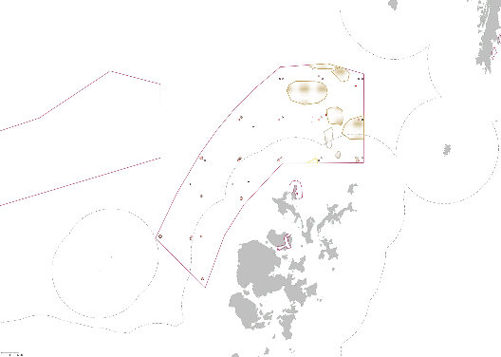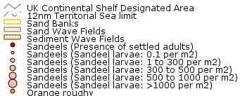
Central Fladen
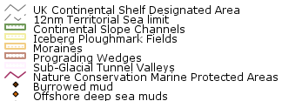

Norwegian Boundary Sediment Plain

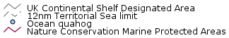
East of Gannet and Montrose Fields

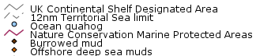
Pobie Bank Reef

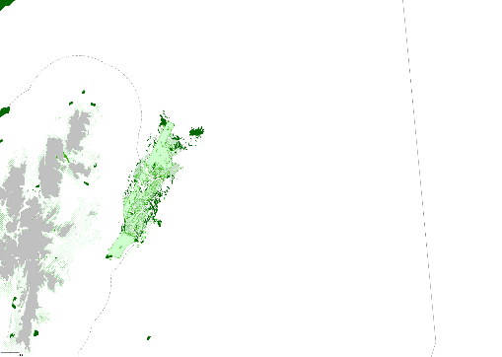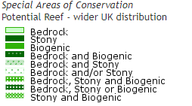

About us
The Centre for Environment, Fisheries and Aquaculture Science is the UK’s leading and most diverse centre for applied marine and freshwater science.

We advise UK government and private sector customers on the environmental impact of their policies, programmes and activities through our scientific evidence and impartial expert advice.

Our environmental monitoring and assessment programmes are fundamental to the sustainable development of marine and freshwater industries.

Through the application of our science and technology, we play a major role in growing the marine and freshwater economy, creating jobs, and safeguarding public health and the health of our seas and aquatic resources

Head office
Centre for Environment, Fisheries & Aquaculture Science
Pakefield Road
Lowestoft
Suffolk
NR33 0HT
Tel: +44 (0) 1502 56 2244
Fax: +44 (0) 1502 51 3865

Weymouth office
Barrack Road
The Nothe
Weymouth
DT4 8UB

Tel: +44 (0) 1305 206600
Fax: +44 (0) 1305 206601

Customer focus
We offer a range of multidisciplinary bespoke scientific programmes covering a range of sectors, both public and private. Our broad capability covers shelf sea dynamics, climate effects on the aquatic environment, ecosystems and food security. We are growing our business in overseas markets, with a particular emphasis on Kuwait and the Middle East.

Our customer base and partnerships are broad, spanning Government, public and private sectors, academia, non-governmental organisations (NGOs), at home and internationally.

We work with:

- a wide range of UK Government departments and agencies, including Department for the Environment Food and Rural Affairs (Defra) and Department for Energy and Climate and Change (DECC), Natural Resources Wales, Scotland, Northern Ireland and governments overseas.
- industries across a range of sectors including offshore renewable energy, oil and gas emergency response, marine surveying, fishing and aquaculture.
- other scientists from research councils, universities and EU research programmes.
- NGOs interested in marine and freshwater.
- local communities and voluntary groups, active in protecting the coastal, marine and freshwater environments.

www.cefas.co.uk

