WWF VIETNAM
VINATUNA

REPORT ON
THE USE AND EFFECTIVENESS OF CIRCLE HOOKS TESTED IN 16 HANDLINE VESSELS

NGUYEN HUU THANH
Independent Consultant
Marine Science & Fishing Technology Institute
NHA TRANG UNIVERSITY

Nha Trang, November 2019

INTRODUCTION
The protection of sea turtles is of great concern all over the world. In the Vietnamese waters, there are five species of sea turtles caught as bycatch of the fishery, and all populations are declining. In the Vietnam Yellowfin Fishery, including longlines and handlines, the bycatch include such sea turtles. Finding a way to solve the problem of catching both sea turtles and other protected species but ensuring economic efficiency for fishermen is very necessary in the current period.
Studies around the world, including Vietnam, have confirmed that the use of circle hooks (C-hooks) in tuna catching which are sharply curved back in a circular shape – can reduce the hooking rate of marine turtles by as much as 80% percent compared to traditional longline J hooks, leading to significant reductions in mortality rates. The positive benefits of C-hooks are unequivocal and largely unanimous.
Since 2016, the FIP Coordination Unit (included WWF and Vietnam Tuna Association - VINATUNA) has been working with industry partners and Government Agencies to further expand the using of C-hooks and documenting their results. To date, results have been largely positive (i.e. reduced sea turtle encounters while not negatively impacting target catch). However, less than 5% of the fleet estimated to be utilizing C-hooks and there are no handline vessels have been trialed. For tuna handline fishery, the ability to catch these sea turtles is considered to be lower than that of longlines fishery. However, in recent years, this fishing method has grown strongly due to fishermen transitioning from longlines to handlines. Therefore, the potential risk of this profession affecting marine turtles should be considered.
In 2019, with financial support from WWF-Hong Kong, WWF-Vietnam cooperated with partners to expand the usage of C-hooks (the C-hooks Project) in the Vietnam yellowfin tuna fishery to reduce marine turtle bycatch and mortality. The circle hooks were given to fishermen who are fishing with handlines in three provinces of Vietnam including Binh Dinh, Phu Yen and Khanh Hoa. In order to evaluate the usage as well as the effectiveness of C-hooks on handline fishery, a C-hook monitoring program was implemented. Thereby, the using and effectiveness of the C-hooks were annalyzed & evaluated. Accordingly, sixteen (16 trips) fishing trips with handliners and their results was monitored by tuna skippers.

2. METHODOLOGIES
2.1. Implementation period & venue
Monitoring results and records were carried out in handliners in three provinces in Vietnam including Binh Dinh, Phu Yen and Khanh Hoa. Fishing trips were conducted from 24th June to 8th September (respectively from 25/5 to 10/8 in lunar calendar), each handliner has a different fishing period. Each fishing trip has 10 to 15 fishing nights, the remaining time for moving to/from the fishing grounds or changing the fishing grounds.
2.2. Design experiments
- Choosing hook types
In recorded fishing trips, two types of hooks were used for monitored fishing trips. The first type is the traditional hooks (J-hook) which commonly used by local fishermen. The other type is circle hook which introduced by C-hook project. In order to compare the usage and effectiveness of the C-hook and traditional J-hook, fishermen were required to alternately use C-hooks & J-hooks on consecutive fishing nights. The only C-hooks were required to be used at first fishing night, and only J-hooks will be used on the next fishing night. Two types of hooks will be used alternatively until the last fishing night of the fishing trip.
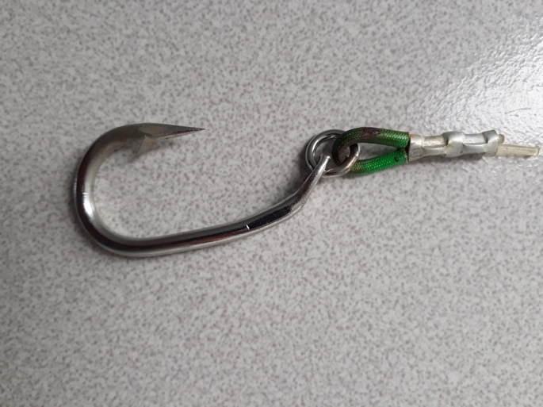
- J-hook | - C-hook
Figure 1. Circle hook size 14 with ring (right) and traditional J-hook (left)
- Choosing handline vessels for trials
In recent years, among the tuna fishing vessels, the general trend has been an increase in the number of handliners and a decrease in the number of longliners. This is the result of transferring from longliners to handliners. In order to evaluate the usage & effectiveness of C-hooks, 150 handline vessels in three provinces were selected to deliver C-hooks. Of which, 16 skippers were chosen to monitor the results on fishing trips including 6 skippers in Binh Dinh, 5 skippers from Phu Yen and other 5 skippers in Khanh Hoa province.

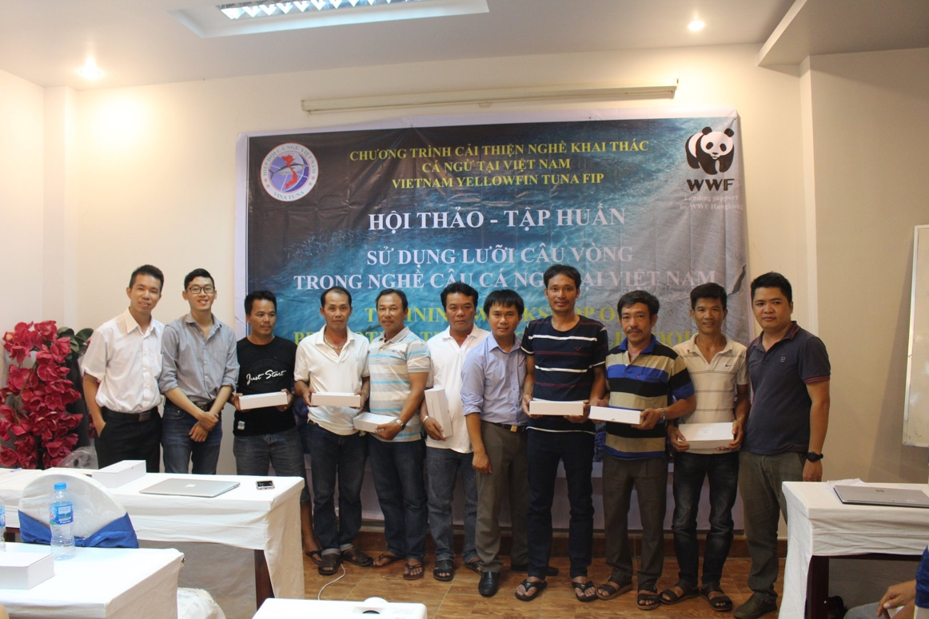
Figure 2. Delivery of C-hooks to tuna captains in Phu Yen province
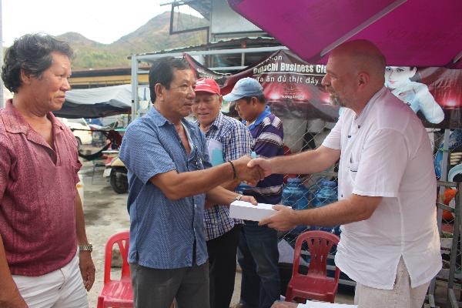
Figure 3. Delivery of C-hooks to skippers in Khanh Hoa province

2.3. Calculation and Analysis Method
To analyze and compare the efficiency of using C-hooks compared to J-hooks, a key aspect of the C-hook trials is to obtain a reliable estimation of Catch Per Unit Effort (CPUE), this is a parameter that clearly reflects the efficiency of the fishery and is used extensively in fisheries assessments. All handline vessels always use 4 hooks during the period of catching (replacing hooks will be conducted if losing hooks occur), and they all operate the same amount of time during the night. In the case, the CPUE indicator will be demonstrated by catch volume per fishing night for each vessel and calculated by following equation:
$CPUE=\frac{C}{N}$ (1)
Of which:
- C is the catch volume (illustrated by weight (kg) except turtle by individual)
- N is the number of fishing night.
CPUE indicators will be calculated for total catch (overall CPUE) and for target species by each type of hooks (J-hooks & C-hooks).
3. RESULTS & DISCUSSIONS
Generally, 16 monitored handliners operated 204 fishing nights, including 105 fishing nights using only C-hooks, and 99 fishing nights using only J-hooks. The total catch was 22,481 kg and the total CPUE was 110.20 kg/night.
3.1. Catch amount and CPUE
In the total catch of 22,481 kg, there were 10,975 kg of fish was caught by C-hooks accounted for 48,8% of total catch while J-hook caught 11,506 kg accounted for 51,2% total catch. These figures have shown that the total catch rate (for all species) of J-hook was higher than C-hook’s catch rate.
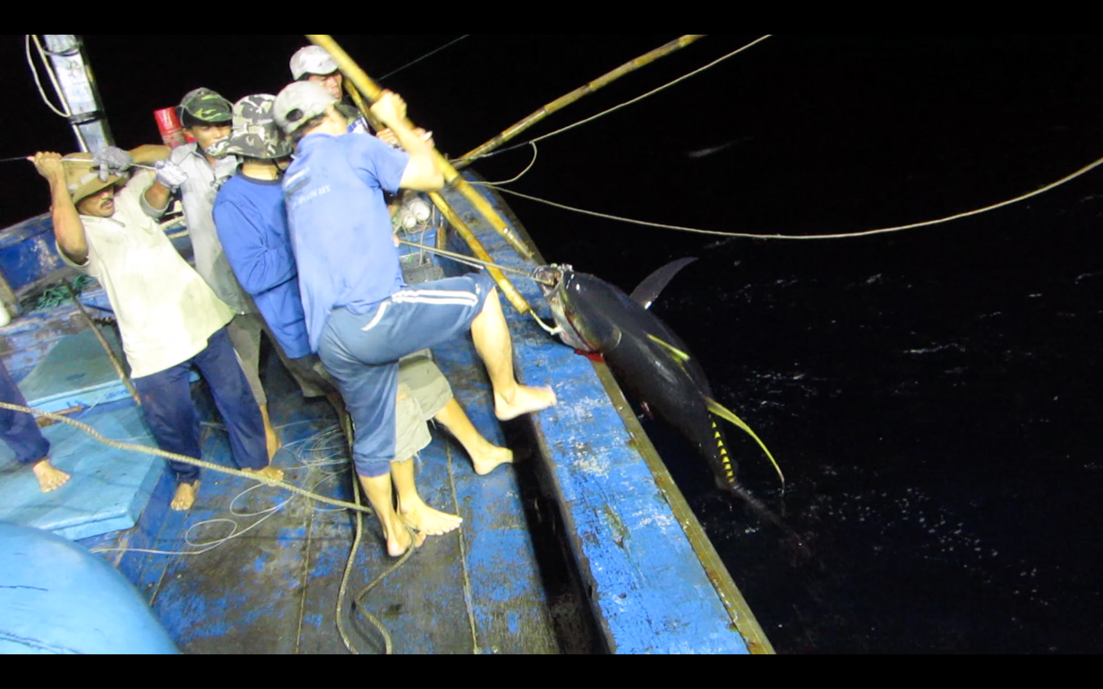
Figure 4. Catching tuna on-board
However, for target species catch (yellowfin tuna), the catch rate of C-hook got a bigger proportion. In total catch of yellowfin tuna was 15,850 kg. In which, C-hooks caught 8,560kg of yellowfin tuna reached 77,9% while J-hooks caught 7,290 kg accounted for 63.36%. The details of catch rates were shown in Table 1 below:
Table 1. Catch amount and CPUE for the total and target species
Hook type | Number of fishing night | Catch amount (kg) |  | CPUE (kg/fishing night)
 |  | Total | YFT | Total | YFT
C-hooks | 105 | 10,975 | 8,560 | 104.52 | 81.52
J-hooks | 99 | 11,506 | 7,290 | 116.22 | 73.64
Sum/average | 204 | 22,481 | 15,850 | 110.20 | 77.70
In term of effectiveness, the average CPUE indicator for all species was 110.2 kg per night. Of which, the C-hooks CPUE for all species was 104.52 kg/night, lower than CPUE of J-hook reached at 116.22 kg/night.
However, in the handline fishery, the main target species is yellowfin tuna which has higher value than others in the revenue of fishing trip. Thus, CPUE of yellowfin tuna plays more significant roles in the effectiveness of the fishing trip. The average CPUE of yellowfin tuna was 77.7 kg per night. In which, C-hook CPUE for yellowfin reached 81.52 kg/night which was higher than 73.64 kg/night of J-hook.
From analyzed information above has shown that, although the total CPUE of J-hook was higher than C-hook, but in the case of yellowfin tuna, C-hooks were more concentrated on target species which brings more economic value. On the other side, J-hook caught more secondary species. The CPUE indicators was illustrated in Figure 3 below:

Figure 5. The illustration of CPUE indicators by hook types
3.2. Species compositions
In sixteen (16) fishing trips with 204 fishing nights, fishers caught eight main species & some small quantity of the others. Of which, target species (yellowfin tuna) was 15,850kg reached 70,46% total catch. Other non-target retained species included Swordfish species (Xiphias gladius) with 1,805 kg, accounting for 8.03% total catch. The third species is Blue Marlin (Makaira nigricans) caught 1,635 kg, accounting for 7.27% total catch and the rest of other species. The details of species composition are illustrated in table 2 below:
Table 2. Species composition sorted by volume
TT | Vietnamese name | Scientific name | English name | Catch amount (kg) | Percentage (%)
1 | Cá ngừ vây vàng | Thunnus albacares | Yellowfin tuna | 15,850 | 70.46
2 | Cá Cờ Kiếm | Xiphias gladius | Swordfish | 1,805 | 8.03
3 | Cá Cờ Gòn | Makaira nigricans | Blue marlin | 1,635 | 7.27
4 | Cá Dũa/Nục heo | Coryphaena hippurus | Mahi mahi | 768 | 3.42
5 | Cá Thu Ngàng | Acanthocybium solandri | Wahoo | 763 | 3.39
6 | Cá Ngừ mắt to | Thunnus obesus | Bigeye tuna | 560 | 2.49
7 | Cá Mập Xanh | Prionace glauca | Blue shark | 405 | 1.80
8 | Cá khác |  | others | 705 | 3.14
 | Total |  |  | 22,481 | 100
The rates between target species and secondary species of 2 types of hook has inequality. While the percentage of primary species of the C-hook reached 77.9%, J-hooks caught only 63.4%. In consequences, the catch of secondary species of J-hook was higher than C-hook, when reached 36.6% compare to 22.1% of C-hook. The catch composition was shown in the figure 4 below:

Figure 6. The chart of species compositions by hook type
Recorded results also showed that there is no turtle were caught by both C-Hooks and J-Hooks. However, sharks are still found in the catches of two types of hook. C-Hooks catch 90 kg of Blue Shark, while J-Hooks catch more of this species, is 315 kg.
3.3. Hook-lost problems
Information from the recorded forms also indicates that there is a problem of hook-lost. In 204 fishing nights, 589 hooks were lost, including 229 C-hooks and 360 J-hooks. The average number of lost hook every night was 2.18 hooks for C-Hooks, this number is higher for J-Hooks, 3.64 hook per night.
Table 3. Summary of lost hook problem
Type of Hook | Number of fishing night | Number of lost hook  (hook) | Number of hook lost per night (hook/night)
C-Hooks | 105 | 229 | 2.18
J-Hooks | 99 | 360 | 3.64
Total | 204 | 589 | 2.89
4. Feedback Results
In order to get feedbacks on “Efficiency on using circle hooks on tuna catch and mitigating turtle bycatch in tuna fisheries”, a survey to 20 fishermen, who received C-hook from Project in 3 provinces, was carried out including Binh Dinh (5 respondents through Phone), Phu Yen (5 respondents in Dong Tac fishing port), Khanh Hoa (10 respondents in Hon Ro fishing port).
The questionnaires cover all main content of program such as: Efficiency of using circle hooks in tuna catch and bycatch, the efficiency of reducing sea turtle encounters, willingness to keep using and the willingness to pay (WTP) more for C-hooks and the awareness of ETP issues. The results are as follows:
  - Efficiency of catch
All respondents used C-hook which provided by Project in their fishing trips.
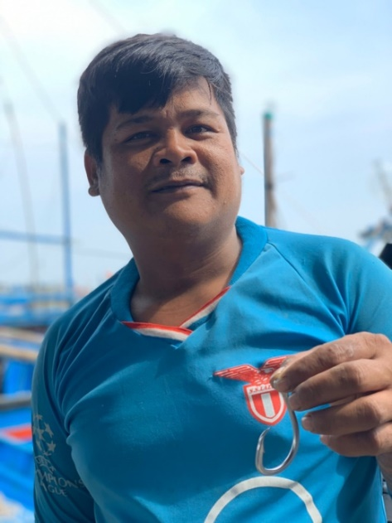
Figure 5. Using C-hook on Tuna handline vessel
Efficiency of Tuna catch: The catch of target species is one of the significant points in giving decisions on using or not of Circle hooks. In the scope of survey, 9 respondents (45%) responded that they think the C-hooks are more effective than J-Hooks, when they state that their catch volume and tuna catch rates per night increases. The 8 respondents (40%) supposed the C-hooks are equally effective. And the rest of fishermen suppose C-hooks are less effective (15%) than their traditional hooks.
Efficiency of secondary species: Secondary species in Handline fishery are Mahi Mahi, Swordfish, Marlin,… There is another source of income for Fishermen. In result that 60% of fishermen (12 respondents) assumed that the C-hooks is equally effective than J-Hooks, 25% of fishermen (5 respondents) assumed that the C-hooks is more effective than J-Hooks, and the rest of it is less effective.

Figure 7: Feedbacks on Efficiency of catch
  - Efficiency of reducing sea turtle encounters
100% of respondents (20 fishermen) answered that they did not encounter sea turtle on their fishing trip when using C-Hooks. Fishermen also mentioned that with big size and the offset of those circle hooks are very hard to hook accidentally or intentionally the sea turtle.
  - The certainty, durable of Circle Hooks and Hook-lost problem
The certainty and durable of Circle Hook: All respondents (100%) answered that the C-Hooks which is provided by the C-hooks Project have a good quality of material, the hook looks stronger and certain, the rings are seamless with hook which is very hard to break. The quality, hardness and certainty of Circle hook is better than J-Hooks.
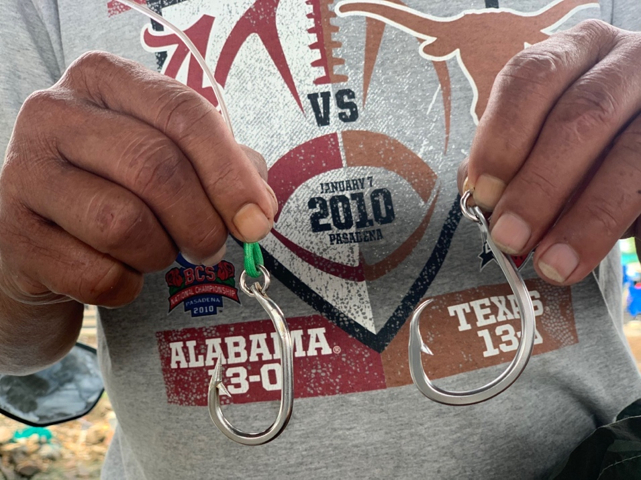
Figure 8: Comparison on the certainty of J-hook and C-hook
The hook-lost problem: all of fishermen (100%) pointed out 2 main reasons of the hook-loss problem:
+ Fish biting: Largehead hairtail and Shark are 2 species which usually bite lines when setting bait on the water. The average number of hook loss per night from 2-3 hooks per day which depends on season and fishing areas. At this point, J-hook and C-Hook is passive subject.
+ Hook problems: On the other hand, the quality of J-hook material and ring is not good as C-hook, so J-hook is easy breaking at the ring part, bent at the body and worn out the point of hooks. Fishermen must to change another one for next setting baits.
  - Willingness to keep using for C- hook

Figure 9: Willingness to keep using C-hook
As the chart above, 55% of fishermen (11 respondents) are willing to use C-Hooks in next fishing trips, when they realized some advantage aspects of C-Hook when compared to J-Hooks. 35% of fishermen (7 respondents) still need more trips to pilot then giving decision. And 10% of fishermen (2 respondents) do not want to use this C-Hooks cause of less of efficiency of catch.
  - Willingness to pay more C-Hooks for using:
The willingness to pay more C-hooks for using is shown in the chart as follows:

Figure 10: Willingness to pay C-hooks for using
The Chart shows 5 fishermen (25%) are willing to pay more without any conditions, 13 fishermen (65%) are willing to pay more if the price goes down and this products have to always available for paying when is necessary, 2 remained fishermen (10%) are not willing to pay more C-Hook for using.
  - Suggestion for expanding C-hook use
All of respondents (100%) suggested Government, VINATUNA and other related organizations should support on finance or more pilot programs. In order to make C-Hooks more common in the Vietnamese market and the price of it goes down.
11 fishermen (55%) suggested that VINATUNA and WWF should extend the pilot time or pilot hook programs to test and evaluate better.
  - Awareness of sustainable fishing and ETPs
Before the C-hook project, just only 3 out of 20 fishermen were participated in workshops on sustainability, and 17 remaining fishermen have no idea with ETPs, sustainable fishing.
In period of C-hook project, VINATUNA and WWF organized 2 workshops on sustainable fishing and ETPs in Binh Dinh and Phu Yen province. In total of 20 respondents, 10 fishermen participated (5 fishermen in Binh Dinh, 5 fishermen in Phu Yen), additionally 3 fishermen in Khanh Hoa who participated in other workshops in 2018, and 7 remaining fishermen in Khanh Hoa did not participated in any workshops.
Respondents were asked some questions regarding the importance of ETP and best practice in handling and releasing ETP. The percentage of respondents' understanding is shown in the below chart.

Figure 11: Understanding and awareness of ETPs
As the chart above, 12 fishermen (60%) have understanding on the importance of ETPs with marine ecosystem and fishing community. 3 fishermen have understanding but not fully. And also 5 fishermen have no idea with ETPs cause of did not have a chance to attend on workshop before.
8 fishermen (40%) have knowledge on best practice of handling and releasing ETPs and know clearly what should they do when encounter ETPs. 5 fishermen (25%) have understanding but not fully. And the rest of remaining fishermen (35%) have no idea with best practice on cause of did not have a chance to attend on workshop before.
5. CONCLUSIONS AND RECOMMENDATIONS
5.1. Conclusions
- The total catch of 16 fishing trips with 204 fishing nights was 22,481 kg. Of which, C-hooks caught 10,975 kg accounted for 48,8% and J-hooks caught 11,506 kg reached 51.2%. However, the yellowfin tuna catch of C-hook was 15,850 kg reached 77.9% of the C-hook’s total catch, which was higher than J-hooks caught only 7,290 kg accounted for 66.4%.
- In term of effectiveness, the average CPUE indicator of all species was 110.2 kg per night. Of which, the C-hooks CPUE of all species was 104.52 kg/night, lower than CPUE of J-hook for all species reached at 116.22 kg/night. However, the average CPUE of yellowfin tuna was 77.7 kg per night. In which, C-hook CPUE for yellowfin reached 81.52 kg/night which was higher than 73.64 kg/night of J-hook.
- For species compositions, in 204 fishing nights, fishermen caught eight (08) main species. Of which, C-hooks caught 77.9% and J-hooks caught only 63.4% of yellowfin tuna as considered as primary species.
- There were no sea turtles were found on monitored fishing trips. However, both types of hooks caught Blue Sharks, J-hooks caught 315kg compared to 90kg of Sharks caught by C-hooks.
- The problem of hook-lost occurred in both types of hooks where J-hooks were more serious for J-hooks.
- In the point of views from fishermen sides, all interviewed fishermen used C-hooks on their fishing trips. 55% interviewed fishermen are willing to keep using C-hooks when they recognized benefits when using C-Hooks and 65% are willing to pay for using if the price goes down and available in the local market.
5.2. Recommendations
After promoting using C-hooks in Vietnam tuna fishery and got feedbacks from fishermen, we would like to have following recommendations:
- Continue to expand the using of circle hooks to local fishermen in Binh Dinh, Phu Yen and Khanh Hoa provinces;
- In order to supply C-hooks to local fishermen commercially, the price of C-hooks need to be suitable with fishermen’s expectations and make them available on the local markets;
- Need more further studies on the species compositions of C-hooks, especially secondary species & bycatch in tuna fishing trips;
- Need more trainning workshops to educate and raise awareness for local fishermen on sustainable fishing and ETPs as well as well understood on C-hook effectiveness both in term of tuna catches & reducing ETPs as bycatch.

