COPPA UPDATE MARCH/JUNE 2022

16 Trips

Breakdown:

WCPFC Key Species Kg % of Total Catch

Yellowfin Tuna YFT | 8,681 | 80%
Bigeye Tuna BET | 0 | 0%
Albacore ALB | 0 | 0%
Swordfish SWO | 1,437 | 13%
Black Marlin BLM | 320 | 3%
Blue Marlin BUM | 40 | < 1%
Skipjack SKJ | 0 | 0
Sharks BE Thresher, Oceanic Whitetip and Blue (MANTA) | 115 | 1%
Marine Turtles Green and Olive Ridley | 20 | < 1%
All other bycatch (details available) | 144 | 1%

Details available as needed. The 2 turtles were released and the manta ray was retained. No sharks were reported caught but sharks hooked and released were also not reported.

UPDATED for June to December 2022 (16 Trips – Catch Data by Weight in KG.)
Note that all sharks and turtles were reported to be caught in bait net gear and not on handlines. All were released.

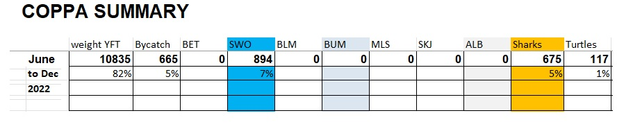

END SRF221228SD

