COPPA UPDATE FROM JANUARY. 2023 to JUNE 2023
Date of report: 2023/06/30
Author: Pham Mai Phuoc
Organization: Vietnam Tuna Association

1. Summary information
The brief report illustrates a summary of information on the COPPA program from Jan. 2023 to the end of June. 2023.
- Total observer: 10 captains
- Total trips conducted: 41
- Catch volume: 40904 Kg
- Total ETPs encountered: 26 Spc
- Main ports: Hon Ro – Nha Trang; Tam Quan Bac – Binh Dinh
2. Catch volume
WCPFC Key species | Kg | Percentage
Yellowfin Tuna YFT | 31928 | 78%
Bigeye Tuna BET | 1247 | 3%
Swordfish SWO | 2645 | 6%
Black Marlin BLM | 1337 | 3%
Blue Marlin BUM | 152 | < 1%
Skipjack SKJ | 3 | < 0.01%
Rays | 40 | 0%
Sharks | 40 | 0%
Marine Turtles | 275 | 1%
Other Bycatch | 3237.8 | 8%
Total | 40904.8

3. ETPs information
Total ETPs encountered events were recorded below:
Specie | Volume (Kg) | Count
Shark | 40 | 1
RAY | 276 | 9
Turtle | 40 | 16
Total | 356 | 26

 |  |  |  |  |  | Ray |  |  | Turtle |  |  | Shark
 |  |  |  |  |  | Species | Kg | Count | Species | Kg | Count | Species | Kg | Count
No. | Name | Reg # | Latitude | Longitude | Date and Time
1 | Huynh Cong Chanh | KH 95959 TS | 8.58 | 112.06 | 2023-05-15 09:37:35 |  |  |  | FBT | 28 | 1
2 | Huynh Cong Chanh | KH 95959 TS | 8.60 | 112.09 | 2023-05-19 19:42:32 |  |  |  | FBT | 3 | 1
3 | Huynh Cong Chanh | KH 95959 TS | 9.93 | 111.60 | 2023-05-21 20:27:52 | RAY | 2 | 1
4 | Huynh Cong Chanh | KH 95959 TS | 9.93 | 111.60 | 2023-05-22 05:17:55 |  |  |  | FBT | 24 | 1
5 | Huynh Cong Chanh | KH 95959 TS | 12.12 | 110.82 | 2023-05-25 21:36:15 | RAY | 7 | 1
6 | Huynh Cong Chanh | KH 95959 TS | 11.98 | 110.97 | 2023-06-26 14:04:11 |  |  |  | FBT | 28 | 1
7 | Kieu Ngoc Tuyen | KH 96779 TS | 12.01 | 110.22 | 2023-04-13 13:44:15 | RAY | 8 | 1
8 | Le Van Hoi | BD 97417 TS | 14.61 | 109.16 | 2023-02-03 12:44:44 | RAY | 3 | 1
9 | Le Van Hoi | BD 97417 TS | 14.30 | 110.49 | 2023-03-25 03:57:33 | RAY | 5 | 1
10 | Le Van Hoi | BD 97417 TS | 16.25 | 110.81 | 2023-04-15 22:20:51 | RAY | 3 | 1
11 | Le Van Hoi | BD 97417 TS | 16.95 | 113.41 | 2023-04-18 19:57:20 | RAY | 3 | 1
12 | Le Van Hoi | BD 97417 TS | 17.21 | 114.17 | 2023-04-23 04:41:32 | RAY | 4 | 1
13 | Nguyen Van Khoa | KH 91133 TS | 12.12 | 111.63 | 2023-05-14 07:56:11 |  |  |  | TTH | 5 | 1
14 | Pham Phu | KH 98246 TS | 11.91 | 110.86 | 2023-03-18 19:36:24 |  |  |  | FBT | 8 | 1
15 | Pham Phu | KH 98246 TS | 11.76 | 110.00 | 2023-03-26 05:05:14 |  |  |  | LKV | 40 | 1
16 | Pham Phu | KH 98246 TS | 11.75 | 110.13 | 2023-03-27 20:48:04 |  |  |  | FBT | 40 | 1
17 | Pham Phu | KH 98246 TS | 10.62 | 110.22 | 2023-04-25 04:28:53 |  |  |  | FBT | 20 | 1
18 | Tran Khac Thach | KH 99766 TS | 7.60 | 111.98 | 2023-02-13 09:31:21 |  |  |  | FBT | 10 | 1
19 | Tran Khac Thach | KH 99766 TS | 8.13 | 111.61 | 2023-03-21 03:33:22 | RAY | 5 | 1
20 | Tran Thai Thi | BD 97647 TS | 11.15 | 117.64 | 2023-02-25 23:17:03 |  |  |  | DKK | 9 | 1
21 | Tran Thai Thi | BD 97647 TS | 14.41 | 114.92 | 2023-04-27 05:09:51 |  |  |  | TUG | 7 | 1
22 | Tran Thai Thi | BD 97647 TS | 18.07 | 116.88 | 2023-05-19 01:51:17 |  |  |  | TUG | 9 | 1
23 | Tran Thoi Toi | BD 97894 TS | 14.89 | 116.46 | 2023-04-18 03:58:34 |  |  |  |  |  |  | CCG | 40 | 1
24 | Tran Thoi Toi | BD 97894 TS | 18.12 | 116.48 | 2023-05-20 13:29:29 |  |  |  | LKV | 15 | 1
25 | Tran Thoi Toi | BD 97894 TS | 18.31 | 116.50 | 2023-05-22 04:11:38 |  |  |  | LKV | 15 | 1
26 | Tran Thoi Toi | BD 97894 TS | 12.65 | 111.92 | 2023-06-14 22:21:16 |  |  |  | LKV | 15 | 1
ETPs encountered events images
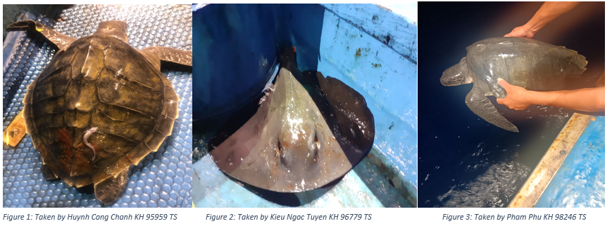
Observers reported that turtles were accidentally caught by baitnet, and all of them were released then. Rays were caught by hooks.

