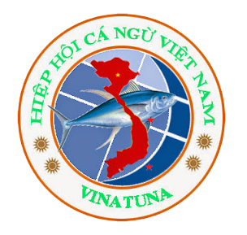
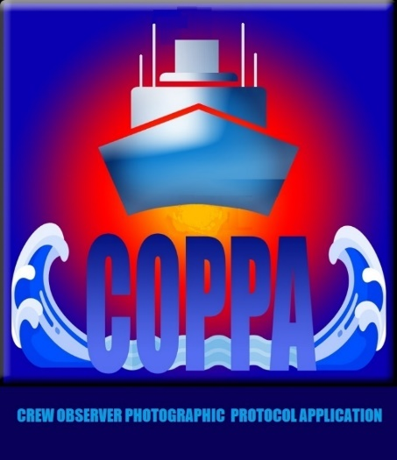
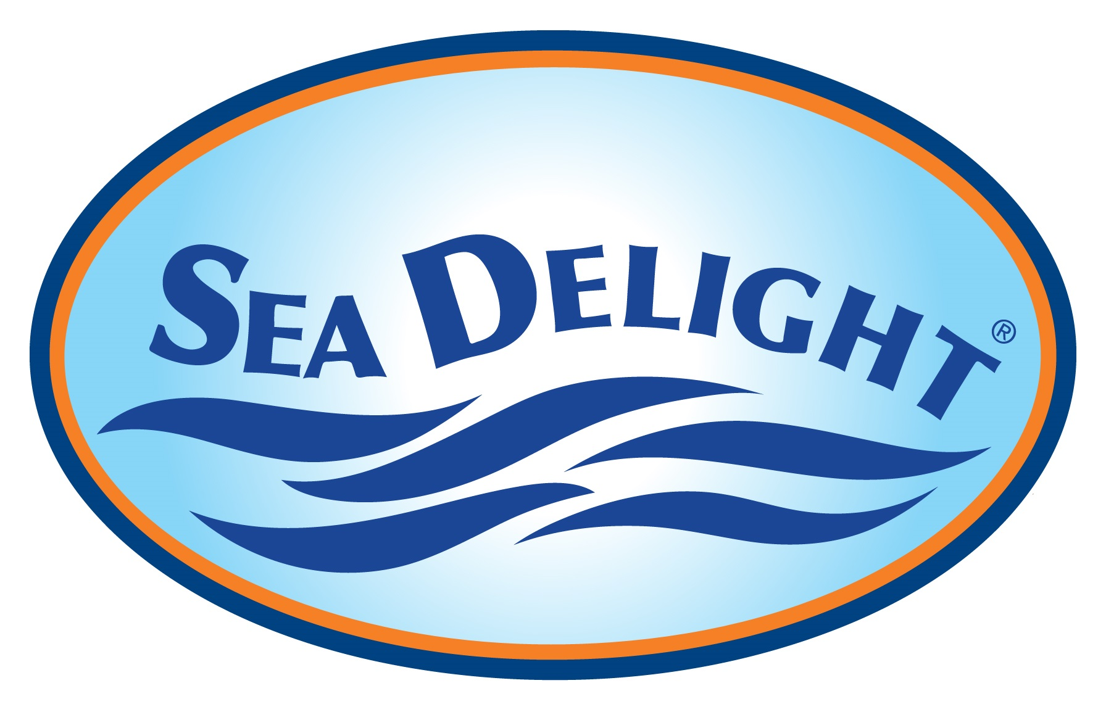

CREW OBSERVER PHOTOGRAPHIC PROTOCOL APPLICATION

COPPA 2.0 Annual Data Analysis Report (DRAFT)

Vietnam Handline Pelagic Species Fishery – Fishery Monitor Program

Lunar Year 2021 – All Trips Feb. 2021 to Feb. 2022

Prepared by: VINATUNA and Sea Delight

April 15, 2022

Introduction:

In early 2019 Sea Delight, VINATUNA and WWF Vietnam/USA began planning a concept for a new Android application. There was a need in the Vietnam Handline Fishery for more on-board observer data on bycatch, but official government observer trips were very expensive and only a few per year had been possible in the past.

The App concept was to allow fishing vessel crew or captains to easily collect catch data, including time, date and GPS location and document catch with photos. This would allow fishers to provide supplemental data as “Fishery Monitors”. This data could be used to support official observer data. The resulting Crew Observer Photographic Protocol Application is now in an improved version 2.0 and has been used to collect 2 years of catch data in the fishery

The first annual report on this project was released last year.

This new report for 2021/22 shows that some sharks are still being caught in the fishery, although this year fishers reported releasing all sharks due to instructions from local fishery authorities. Fishers in the northern section of the fishing grounds were not catching turtles on hook and line but in the small floating purse seine nets used for collecting bait at night. They report releasing all turtles alive. The fishers in Khanh Hoa reported no turtle encounters.

COVID raised some issues for this year. Covid lockdowns did keep some vessels in port for part of the year, but we were still able to collect data from 29 trips from a total of 4 vessels operating in Binh Dinh and Khanh Hoa provinces. Total catch reported last year was 42,646 kg. For this year’s report, primarily due to the COVID pandemic, 26,427 kilos of catch were reported.

1). Catch Data Snapshot

A total of 29 COPPA trips were completed with a total reported catch for all species of 26,427 kg. The reported estimated catch breakdown for Lunar 2021/22 is as follows:
WCPFC Key Species Kg % of Total Catch

Yellowfin Tuna YFT | 26,427 | 82%
Bigeye Tuna BET | 865 | 3%
Albacore ALB | 45 | < 1%
Swordfish SWO | 1,824 | 6%
Black Marlin BLM | 950 | 3%
Blue Marlin BUM | 765 | 2%
Skipjack SKJ | 2 | < 1%
Sharks BE Thresher, Oceanic Whitetip and Blue | 155 | < 1%
Marine Turtles Green and Olive Ridley | 121 | < 1%
All other bycatch (details available) | 896 | 3%

For Comparison, here is the breakdown of COPPA catch data from last year:

Species Kg % of Total Catch

Yellowfin Tuna YFT | 32,088 | 75%
Bigeye Tuna BET | 1,283 | 3%
Albacore ALB | 0 | 0
Swordfish SWO | 3,489 | 8%
Black Marlin BLM | 1,149 | 3%
Blue Marlin BUM | 2,021 | 5%
Skipjack SKJ | 26 | < 1%
Sharks Blue and BE Thresher | 275 | 1%
Marine Turtles (Green and Olive Ridley) | 150 | < 1%
All other bycatch (details available) | 2165 | 5%
Total: 42,646

For comparison: catch reported to WCPFC for 2016, 2017 and 2018:

Catch reported by Vietnam (in metric tons) to WCPFC for longline handline:
Year YFTkg % BET kg % SWO kg % All Marlin kg %
2016 | 16,423 | 92 | 1,115 | 6 | 340 | 2% | 58 | 0
2017 | 15,677 | 87 | 1,004 | 6 | 997 | 6 | 138 | 0.8%
2018 | 16,500 | 89 | 902 | 5 | 897 | 5 | 138 | 0.7%

For comparison, total catch from all gears in the last year Vietnam reported billfish catch, 2018:

Year YFTkg % BET kg % SWO kg % All Marlin kg %
2018 | 24,704 | 77 | 4,302 | 13 | 2,014 | 6 | 1,027 | 4

Vietnam’s 2020 billfish catch was not reported to WCPFC, but Vietnam has agreed to resume reporting with 2021 catch data in the 2022 report to WCPFC as part of its effort to cooperate fully with WCPFC as a Cooperating Non-Member.
Conclusions and Concerns on Shark Encounter Events; possible IUU activities and critical FIP Management Measures:

Sharks continue to be caught in the fishery and most are clearly banned for retention or possession by Annexes to Decree 26. Even though some fishers report releasing all sharks now, this is not verified and legally, some large pelagic sharks are still allowed to be retained and brought to market

As we complete the process of placing the WCPFC Key Species information posters with Port Authorities in the main tuna ports there is growing concern that shark finning of some species is allowed, while most species are banned. Fins alone of these species would be very difficult for Port Authorities to identify in the field.

This could lead to fishers accidentally (or intentionally) retaining fins from banned species and claiming them as from allowed species, thus engaging in the illegal retention of banned fins (IUU fishing). See the WCPFC Key Species Illustration at the end of this document to see banned and allowed shark species.

The participants and administration of the Vietnam Handline Tuna and Swordfish FIPs suggest a simple solution, adopt the WCPFC model and issue a decree requiring all legally retained sharks to only be retained with the fins naturally attached. This will make the work of shark identification for the Port Authorities easier and meet the requirements of MSC Certification.

4. Marine Turtle Concerns

The COPPA vessels from Khanh Hoa province did not report any turtle encounters this year. The vessels in Binh Dinh reported releasing 6 turtles this year, all caught in bait seine nets, not hook and line.

Although MARD and D Fish have done extensive turtle handling training with fishers as part of the Marine Turtle NPOA, it would be a good idea to initiate an investigation into how these turtles are interacting with the bait nets and possible mitigation measures. This should be planned soon as travel is now allowed. These measures could be integrated with ongoing DFISH and/or VINATUNA awareness and handling training in the fishing ports.

5. COPPA 2.0 completion and plans to expand to 6 or more vessels.

Currently we are working on plans on how to expand to a total of at least 6 vessels using COPPA to report catch data. It may be more practical to just get 2 or more additional fishers from any port as VINATUNA has recently recruited several who are interested in the program. We also have learned that the COPPA system needs to use dedicated new Android devices of good quality, rather than asking fishers to use their own phones. We also need to provide face-to-face training and device upkeep with fishers.

The progress made and data collected will be reported in the FIP Action Plans, on our websites and in this report next year. See WCPFC Key Species Illustration on the following page (go to “zoom to 200%” to view):

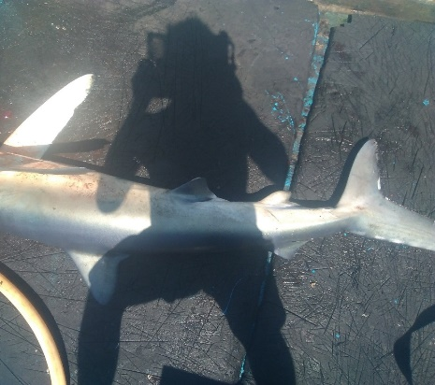

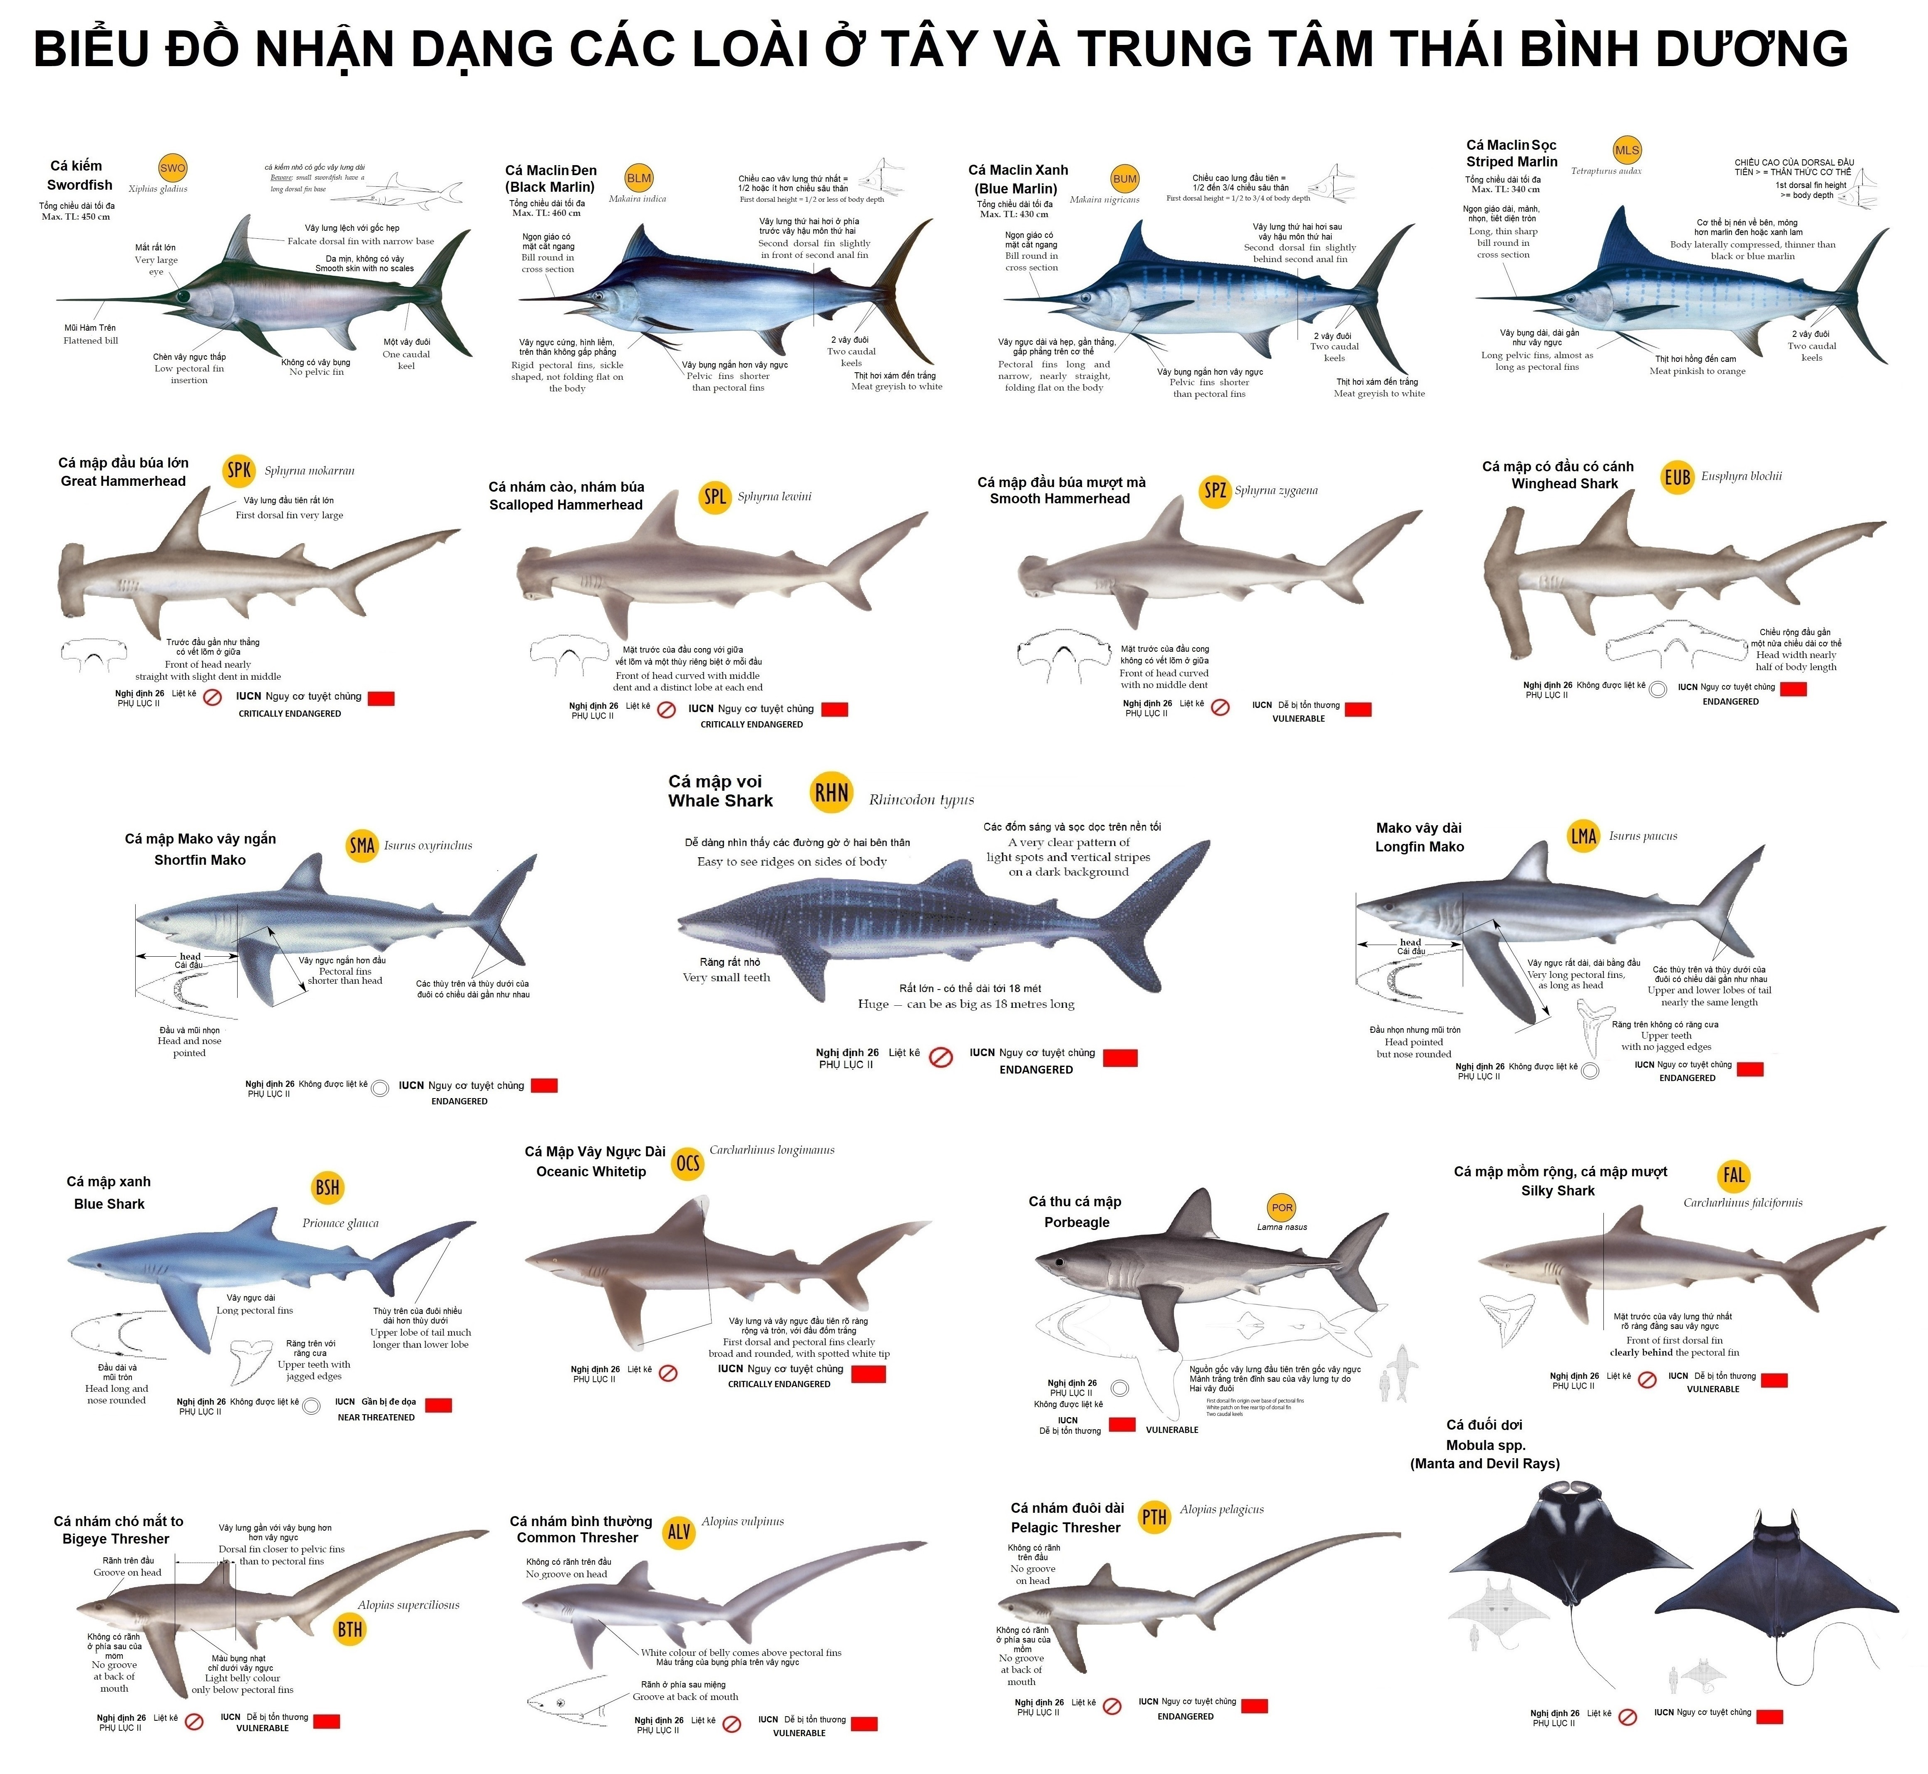

ENDSRF220412SD

