Table 1: Action Plan overview
Fishery name: UK Western Channel and Celtic Sea crustacean pot fishery:  Brown crab (Cancer pagurus) and lobster (Homarus gammarus) |  | AP Version: Version 5.4  Last updated (by): 30 April 2019 (TH)
Fishery location:  Western Channel (VIIe) (Crabs & lobster)  VIIf, and part of VIIg (Lobster only) | Fishing method:  Pots | Start date: March 2017  End date (anticipated): December 2021 (5 years) | Y1: Ends March 2018  Y2: Ends March 2019  Y3: Ends March 2020  Y4: Ends March 2021  Y5: Ends Dec 2021
Project leaders:  Project UK Fisheries Improvements (PUKFI) |  | Improvements recommended by:  Poseidon
Overview of the Action Plan:

Potting for edible crab and lobster is mainly, but not exclusively, an inshore fishing activity undertaken throughout the SW of England. The pre-assessment considers that, whilst there are a number of management measures already in place, including the availability of stock status reference points, these do not form a coherent, integrated harvest strategy. The main P1 actions therefore seek to address this, and further develop adaptive management mechanisms that makes management more responsive to the status of the stock.

Whilst no PIs failed under the P2 assessment, many would likely attract conditions. The Action Plan addresses this through a review of alternative management measures to minimise UoA-related mortality of all non-target primary and secondary species caught by this fishery, as well as bolstering current monitoring and research to ensure there is sufficient information on which to base management changes. Although it is unlikely that this fishery will have a significant impact on ETPs, it is suggested that appropriate management measures need to be considered where necessary. This needs to be embedded in an on-going, risk-based ETP impact monitoring system.

The governance and fisheries-specific management under P3 scored well in the pre-assessment. The only action proposed is the wider discussion and agreement of management needs and objectives with trans-boundary management authorities e.g. across IFCAs and (in the case of lobster), with the French and Irish MAs.

Colour code in tables below: | Principle 1 | Principle 2 | Principle 3

Summary Report (End Year 2)
Introduction
This report marks the finished of the second year in a five year Fisheries Improvement Project (FIP) for the UK Western Channel and Celtic Sea crustacean pot fishery for brown crab and lobster (see Table 1 above). The report provides a review of the progress made to date and what further actions need to be taken over the third year. This report has been prepared by Tim Huntington of Poseidon.
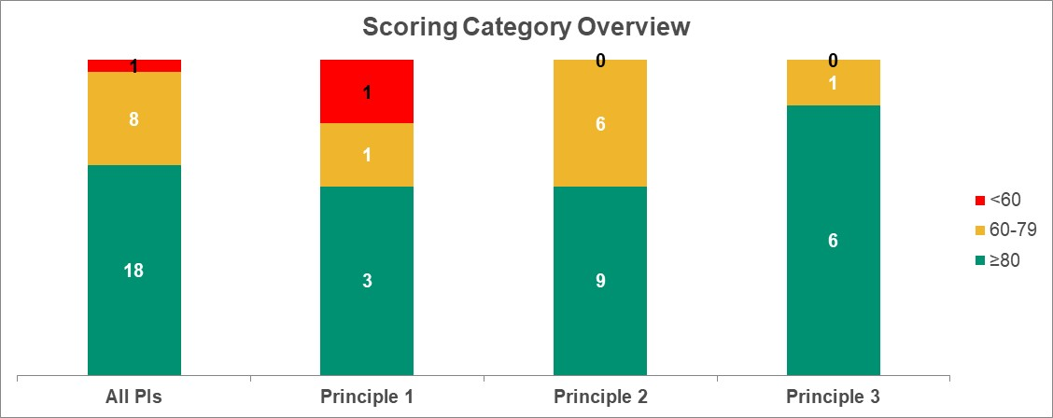
Main Findings
The fishery has made some progress over the year and is on target for all actions (although 2 milestones have been moved). The main progress has been in completing the P1 alternative measures analysis (Action 3), the secondary species risk analysis (Action 4) and the ETP risk analysis (Action 5). However the results of these have still not been formally considered for inclusion in fisheries management initiatives.
As can been seen from the scoring category overview to the right, eighteen Performance Indicators (PIs) score ≥80 (potentially a pass) and eight score 60 – 79 (potentially conditional pass) and one still remains >60 (a potential fail). Overall the fishery would fail at this point, mainly through weaknesses in P2).
The remaining tasks are mainly related developing a comprehensive Fisheries Management Plan (FMP) and using this as a tool for preparing the fishery for full assessment once the FIP has been completed.
Recommendations for actions and activities over Year 3
Key acronyms:
CPUE: Catch per unit effort
FIP: Fisheries Improvement Project
FMP: Fisheries Management Plan
HCR: Harvest Control Rules
PI: Performance Indicator
The current status of the FIP and the review results are shown in Table 3: Benchmark Tracking Tool (as at 01 May 2019) on page 7. Based on these, we have suggested a number of actions that need to be undertaken over the next year. These are summarised in below and are detailed in Table 2: Evaluation against Action Plan Milestones overleaf.
- Management WG to develop a draft Harvest Strategy by July 2019 for finalisation by the end of Y3 when it will be put out for further consultation
- Management WG to review alternative measures to reduced target species bycatch and embed them in the FMP by the end of Y3.
- Following the Voller report, formal review of primary and secondary bycatch management and information by the end of Y3.
- Review to assess whether any one bait species exceed 5% by volume of total catch.

Table 2: Evaluation against Action Plan Milestones
Standard requirement | Actions | Timescale / milestones | Progress / outcome | Revised milestone
1.2.1 Harvest strategy | Action #1: Develop formal harvest strategy that includes adaptive management measures where appropriate. | 6 months. Position paper produced, inc. identification of effort distribution by different fleets around the UoA, & identifying current harvest strategies, gaps and potential conflicts. | On target (Y2 60-79, actual 60-79)  Y1: Consultancy initially to be undertaken by CEFAS but possible conflict of interest issues requires this to be put out to independent consultation. The one independent bid was considered too expensive.  Y2: This element of the FIP is to be over-seen by a Management Working Group (WG) within the FIP (initially led by Sarah Clark, but to be chaired by Natural England (tbc) with both inshore and offshore representation. There is a need more PO involvement e.g. the CFPO. Task of Management WG to (i) agree hierarchical harvest strategy (FIP / regional levels), then to agree pre-emptory reference point areas for adaptive management. Defra happy to be involved as well as SD&CS, and IFCAs (Chloe Smith as link). Need to revisit WG ToR before possible first formal meeting in early June allocate responsibilities. Intention is to produce a preliminary strategy by the next SG meeting in July 2019.  Alex Holsgrove from Defra informed the SG (29-04-19) that legislation in place to roll over Western Waters Effort Regime (WWER) as is. This reform is not based on much scientific information and not so suitable for static gears. There has been a new round of stock assessment from CEFAS, showing that the stock status stable but being fished above MSY. CEFAS is looking at ways to improve stock assessment criteria, to take in local management measures. Any management changes have to be based on good scientific data and they are still looking at additional data needs, (no timelines as yet). 2 new data collection systems, (i) mounting of cameras in pots for real time animal movement to assist stock assessment and is currently being trialled (no results as yet) and a (ii) longer-term Bluetooth calliper system also introduced to send real-time data back to CEFAS (GPS linked). Aug 19 update from Defra (Jenny): WW Regime will be rolled over after Brexit. Harvest strategy still open. New timeline being developed in Sept 19. Will probably include FIP FMP as part of the strategy and management approach, with a focus on crabs, lobsters and scallops. Cefas working on stock assessment data & being ramped up. Also provided a map of IFCA bylaws.  Aug 19 meeting: D&S have adaptive management, but other IFCAs. Southern have a reform process, which will consider this. New Marine Pioneer project (S Clark) looking at pot effort limits in pilot areas. Fisher-driven, esp. due to reduced lobster CPUEs. But less applicable to other areas, e.g. Southern. Will look at different parameters for pot limitation e.g. pot numbers, vessel lengths, crew numbers, etc. MMO and >6 nm area also needs careful attention. Concern over latent capacity.
 |  | Yr 3 (M4-6): Proposals for a holistic harvest strategy. | (Y3 ≥80, actual tbc)  This action is not being addressed until Year 3 | None
 |  | Yr 3 (M6-12): Further consultation and formal acceptance of agreed strategy. | (Y3 ≥80, actual tbc)  This action is not being addressed until Year 3 | None
1.2.2 HCRs & tools | Action #2: Development of formal harvest control rules | Yr 3: Develop proposals for harvest control rules, based on the strategies identified in Action #1 above. | (Y3 60-79, actual tbc)  This action is not being addressed until Year 3 | None.
 |  | Yr 3: Proposals put out for consultation and finalised. | (Y3 60-79, actual tbc)  This action is not being addressed until Year 3 | None
 |  | Yr 4 Improved harvest control regime embedded in management processes. | (Y4 ≥80, actual tbc)  This action is not being addressed until Year 4 | None
 |  | Yr 5. Review and finalisation of harvest control rules. | (Y5 ≥80, actual tbc)  This action is not being addressed until Year 5 | None
2.1.2 Primary & 2.2.2 Secondary species management strategy | Action #3: Review alternative management measures to minimise mortality of all non-target 1° & 2° species | 6 months: Conduct review of alternative management measures for non-target species. | On target (Y1 60-79 actual 60-79)  Y1: Initial review of alternative management measures completed (Caslake, 2018).
 |  | Yr 2-3: Mainstreaming of alternative measures into management. | On target (Y2 60-79 actual 60-79) Milestone changed  Gus Caslake put together matrix of alternatives versus efficiency / trade-offs. Escape gaps have their downside (e.g. escape of valuable bycatch e.g. velvets, as well as escape of legal size lobsters. Hence medium cost element in matrix (also buying & fitting escape gap). But still the best option. Parlour pots have a longer possible soak time (inkwells lose legal size animals), so need to be hauled more regularly. Mesh size very expensive. It is noted that EMFF-funded pots have escape gaps and have given up the velvet fishery.  Gus’ / Matt Voller’s work demonstrates the need to consider different target fisheries in different areas (e.g. Southern catch smaller lobsters, so escape gaps are not liked). Southern IFCA do regular but occasional review of their management measures.  TH to send Gus FMP with directions on where to insert text. | Alternative measures need to be considered in the Management WG and embedded into the FMP. Will have to have a regional element, as will reflect different harvest strategy / objectives e.g. targeted / mixed fisheries.  By end Year 3 (≥80).
2.2.3 Information (secondary species) | Action #4: Information available on 2° species caught by the fisheries quantified & made available to managers. | Yr 1: Risk assessment carried out. | On target (Y1 60-79 actual 60-79)  A risk assessment was undertaken by Matt Voller, a Master’s student at Plymouth University, comparing Isle of Man, Inshore Potting Agreement (IPA) and Lyme Bay seasonal bycatch patterns. Sampling protocol reviewed by CEFAS. | Review Risk assessment upon completion (Sept 2018).
 |  | Yr 2: Based on the risk assessment, further data collection (1° or 2°) as required. | On target (Y2 60-79, actual 60-79)  Voller study completed in September 2018. There were some issues over some data e.g. Lyme bay catches of velvet crab which, according to industry sources, is very unlikely. There were also concerns about data presented in some graphs. Sam Davis did a lot of work on bycatch assessment in Cornwall.  Aug update: Jo P to send Gus Matt’s report. | Gus Caslake to review Voller report and suggest need for further data collection. He will also collect other bycatch data (e.g. from industry and other IFCAs (e.g. Cornwall)). Results to be presented as the SG Meeting in July 2019.
 |  | Yr 3. Formal report published. | (Y3 60-79, actual tbc)  This action is not being addressed until Year 3. Will need to include a formal review of bycatch status, management and information in the FMP. | None
2.3.1, 2.3.2, 2.3.3 ETP species outcome, management & information | Action #5: Gather additional information on nature & scale of ETP interactions and impacts. | Yr 1: GIS-based risk assessment. Listing of potential ETPs interacting with UoAs, and then mapping of ETP distribution overlap with UoA potting effort. | On target (Y1 60-79, actual 60-79)  An ETP risk assessment was conducted by CEFAS (Wynne, 2018). It has a useful analysis of the possible risks of pots with ETP species potentially likely to be encountered in the Channel, but the final report lacked any spatial mapping of ETP distribution overlap with UoA potting effort. | None
 |  | Yr 2. Based on the risk assessment, further data collection (1° or 2°) as required (possibly via FSP funding). | On target (Y2 60-79, actual 60-79)  Two ETP issues were identified by Wynne (2018): (i) whale entanglement (need spatial / observer data) and (ii) giant goby bycatch(can be returned alive.  Whales: Very low level interactions. Mostly limited to NW Scotland. No specific channels for whale migration / movement. ‘Floaty ropes’ are not permitted, so some management measures are already in place (2.3.2).  SD&CS (Beshlie Poole) to lead response, including the development of an industry whale reporting system. Maybe work with the Defra and Whale & Dolphin Conservation to demonstrate good intent. Aim to get pilot system in place by the end of the year. Aug update: New document available  It was noted that the Defra Cetacean Consultation group, inc. a bycatch group with a SW sub-group. SMRU observers on other fisheries e.g. sardines, produce annual reports and may have some data on whale sightings / interactions. The SG agreed that no new primary information needed but do need to examine published data on whale migration routes – embedded in the FMP.  Aug 19 update: See Shell fishermen’s reporting page.  Enough information now to populate the FMP.  Is an issue with recreational fishermen – this guidance could be used to advise recreational permit holders. But Southern no permitting … | Natural England will review this issue before the next SG Meeting in July 2019.
 |  | Yr 3: Based on the ETP risk assessment and additional data, identification of interactions with ETPs and consequences for ETP populations and the development of possible management approaches for reducing ETP interactions and impacts | (Y3 ≥80, actual tbc)  This action is not being addressed until Year 3.  To be embedded in the FMP. | none
 |  | Yr 4. Mainstreaming of ETP management approaches and introduce of the risk-monitoring system. | (Y4 ≥80, actual tbc)  This action is not being addressed until Year 4 | NONE
3.2.1 Fishery-specific objectives | Action #6: Discussion & agreement of management needs & objectives by transboundary management authorities | Each SG Meeting: Review and where necessary, promote improvements to UK and non-UK consultation and joint management processes. | On target (Y1 60-79, actual 60-79)  Discussions with Irish brown crab FIPs (Oct 2017) and French interests via MSC. There is still no formal international crab stock assessment in the Channel (there is an ICES biology group but this does not do stock assessment). In general there is a desire amongst fisheries research institutes to do ‘joined science’, but this will need greater political will to achieve.  NWWAC only the joint management forum for crustaceans but is focused on brown crab and does not include lobster.  Until Brexit is concluded, there will be considerable uncertainty over transboundary management arrangements for these fisheries.
 |  |  | On target (Y2 60-79, actual 60-79)  Spoke again with Irish FIP (Frank Fleming, 30-04-19). This is an open access fishery with too much effort They have three core areas of work:  - Working with Australian fisheries who have a fisher-owned electronic data hub which can be shared with the authorities. Developed a pilot programme to measure effort by individual vessels, inc. vessel tracks, hauling times / locations, etc. Can put sensors on buoys / dhans.  - Working on HCRs with Ollie Tully, esp. on data needs. Confident about stock assessment, but under pressure from high prices.  - Also working on pot bait e.g. semi-artificial substitutes. Now at 67% of traditional catch levels and aiming at 80%. Mackerel, gurnard, scad, ray backs, fish frames (farmed salmon frames). | TH to contact Ollie Tully about reference point discussion and feed back to Management WG.  Gus to do initial calculation of bait use by species to see if any are over the 5% ‘main’ secondary species threshold. If yes, will need to be considered for inclusion in FIP.
(Y3 ≥80, actual tbc)
Management WG to include transboundary management linkages and mechanisms in FMP.
Need to add in Welsh Government for northern Bristol Channel.
Bait: more information resulting from LO. Nathan 2014 bait report. Smaller boats use anything available and free. Larger boats used frozen bait e.g. herring and mackerel. 240 – 300 t per week.
 |  |  | (Y4 ≥80, actual tbc)
 |  |  | (Y5 ≥80, actual tbc)

Table 3: Benchmark Tracking Tool (as at 30 May 2019)
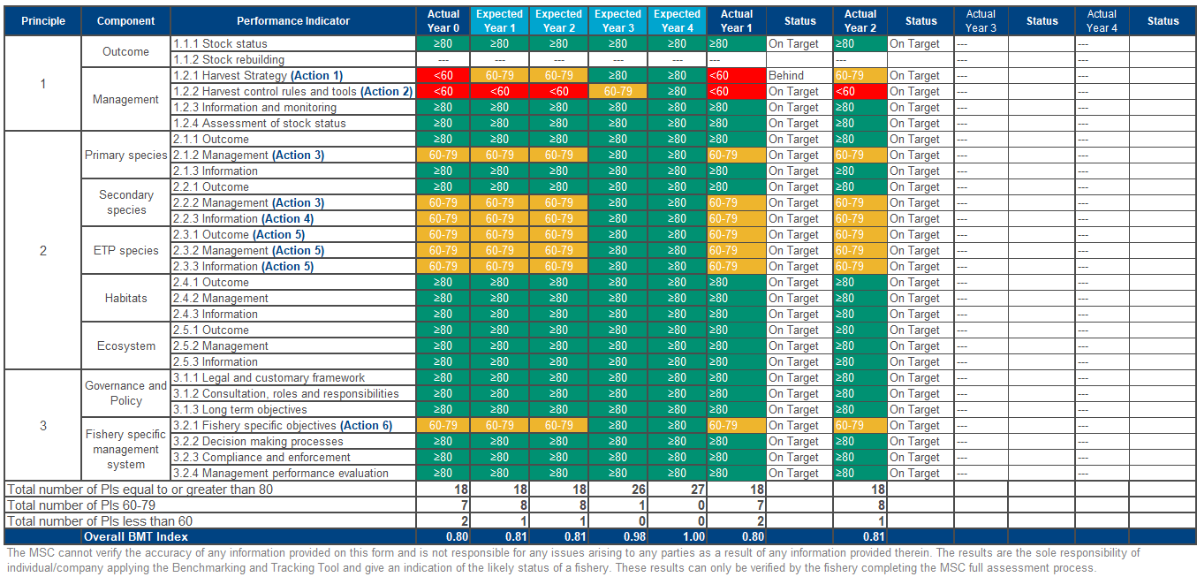

Appendix A: Pre-assessment scores
From: Acoura (2016). MSC Pre-Assessment for UK Western Channel and Celtic Sea edible crab fishery (pots). Project UK Fisheries Improvements. DRAFT REPORT. December 2016. Prepared for Project UK Fisheries Improvements by Crick Carleton, Nautilus Consultants.
Principle | Component | PI | Performance Indicator | Likely scoring level
1 | Outcome | 1.1.1 | Stock status | ≥80
 |  | 1.1.2 | Stock rebuilding
 | Management | 1.2.1 | Harvest Strategy | <60
 |  | 1.2.2 | Harvest control rules and tools | <60
 |  | 1.2.3 | Information and monitoring | ≥80
 |  | 1.2.4 | Assessment of stock status | ≥80
2 | Primary Species | 2.1.1 | Outcome | ≥80
 |  | 2.1.2 | Management | 60-79
 |  | 2.1.3 | Information | ≥80
 | Secondary species | 2.2.1 | Outcome | ≥80
 |  | 2.2.2 | Management | 60-79
 |  | 2.2.3 | Information | 60-79
 | ETP species | 2.3.1 | Outcome | 60-79
 |  | 2.3.2 | Management | 60-79
 |  | 2.3.3 | Information | 60-79
 | Habitats | 2.4.1 | Outcome | ≥80
 |  | 2.4.2 | Management | ≥80
 |  | 2.4.3 | Information | ≥80
 | Ecosystem | 2.5.1 | Outcome | ≥80
 |  | 2.5.2 | Management | ≥80
 |  | 2.5.3 | Information | ≥80
3 | Governance & policy | 3.1.1 | Legal and customary framework | ≥80
 |  | 3.1.2 | Consultation, roles and responsibilities | ≥80
 |  | 3.1.3 | Long term objectives | ≥80
 | Fishery specific management system | 3.2.1 | Fishery specific objectives | 60-79
 |  | 3.2.2 | Decision making processes | ≥80
 |  | 3.2.3 | Compliance and enforcement | ≥80
 |  | 3.2.4 | Management performance evaluation | ≥80

Wynne, S (2018). C7488: Project UK Fisheries Improvements: Task 3. Prepared by CEFAS. 9 pp + appendices
http://www.shellfishermen.org/report-a-sighting-or-entanglement-incident.html#

