

Code of Practice for Crab and Lobster Suppliers

Fishermen suppliers are requested to comply with this Code of Practice and will audited annually by trained Orkney Crab staff. This brings the activity on fishing boats into the Orkney Crab Quality System and gives customers increased assurances regarding both catch quality, food safety and the commitment of the Orkney inshore fisheries to sustainable practices and safe and fair working conditions.

Useful Contacts

Organisation | Main Contact Number | Additional Contact Number | Other/Contact Person
Orkney Crab | 01856 600 125 | 07852 432 178 | Kate Rydzkowski
Kirkwall Fisheries Office | 01856 875 834 |  | Andrew Livingston
Kirkwall Police Station | 101 | 999 (Emergency Only)
British Divers Marine Life Rescue | 01825 765 546 |  | In event of marine mammal entanglement
RSPB | 01856 850 176 |  | In event of sea bird entanglement

Crustacean selection
Brown crab
- All brown crab should be over 150mm carapace width, hard shelled, heavy and in good condition.
- Pre or post moult crabs should not be landed (white faced).
- Berried female crabs should not be landed.
- Crabs exhibiting “black spot” or other visibly diseased crab should not be landed
- Upper shell colour brownish red, underside yellow, typical of species
- No females with sunken or hollow ovaries during pre-roe stage (mid-summer)
- Odour typical of species, no ammonia or diesel smell
- Both claws present- missing claw(s) may result in reduced price of catchment
- Crab must be kept at cool (0-8Cº)

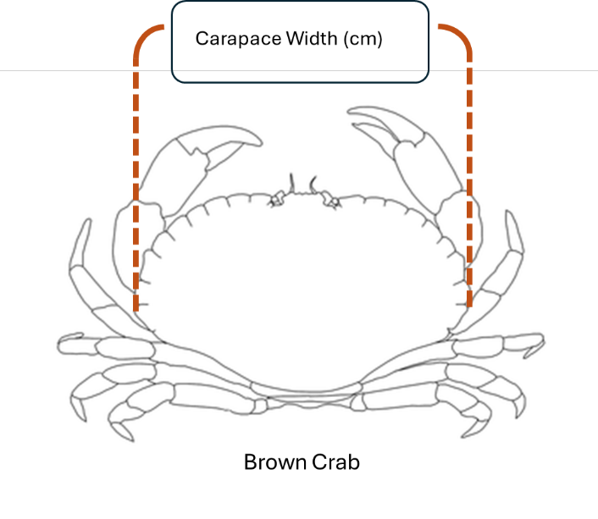

Velvet crab

- All velvet crab should be over 70mm carapace width, hard shelled, heavy and in good condition.
- Pre or post moult crabs should not be landed (white faced).
- Berried female crabs should not be landed.
- Crabs exhibiting “black spot” or other visibly diseased crab should not be landed
- Odour and colour typical of species, no ammonia or diesel smell
- Crab must be kept cool (0-8Cº)

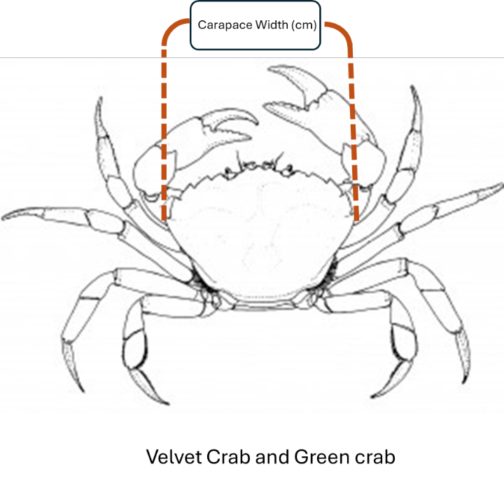

Lobster

- All lobsters should be over 90 mm in carapace length (male and females) but not over 155 mm in length (females), hard shelled, heavy and in good condition.
- Pre or post moult lobsters should not be landed.
- Berried female lobsters should not be landed.
- Female lobsters bearing a v notch or has been mutilated to obscure a v notch should not be landed

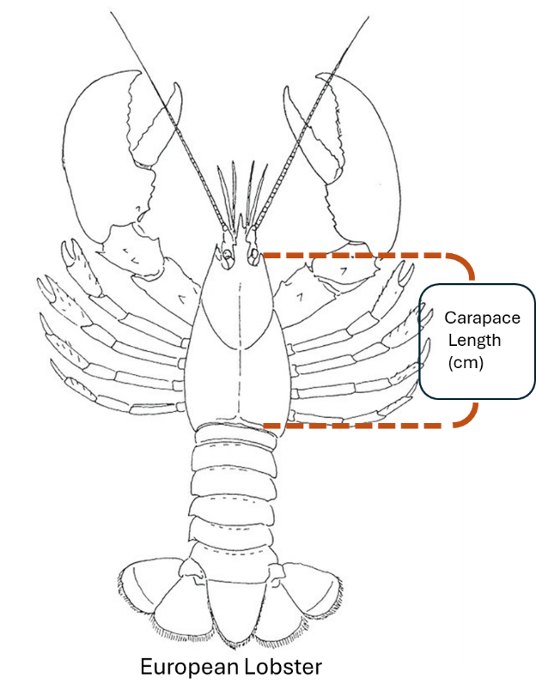

Animal Welfare
The Animal Welfare (Sentience) Act 2022 recognises in law that decapod crustaceans are sentient beings and that the ways in which we treat them may have an adverse effect on their welfare. Research has shown that large decapod crustaceans are sentient meaning they may be able to feel pain, suffering and distress.

The brown meat (hepatopancreas & liver) is a large digestive gland. It is a fragile organ that produces and contains powerful digestive enzymes called proteases. Trauma caused by rough handling can damage the organ leading to the release of these enzymes. Proteases are indiscriminate destroyers of protein and will readily digest the insides of a crustacean causing a loss of quality and a reduction in shelf life whether live or cooked.

Good handling and storage can prevent crabs being stressed and mean they are less likely to fight. Bad handling and storage on the other hand can increase stress levels leading to depletion of energy reserves, increased use of oxygen and increased excretion of waste products. Cases of severe stress have been known to lead to re-absorption of the ovaries and thereby tainting of the crab- meat when cooked. All of these can affect the eating quality of cooked crabmeat and a reduction in shelf-life.

To avoid crustacean suffering and ensure quality fishermen are encouraged to follow the below handling and storing practices:

- Reduce handling of crustaceans as far as possible by working as quickly and as gently as possible
- Hold crustaceans by the carapace – you should avoid holding crustaceans by the legs or claws
- Unwanted catch (e.g. undersized, berried, soft, out of condition) should be humanely handled and carefully returned to sea asap reducing the distance of fall as far as possible and where possible crustaceans should be returned to where they were caught or to a similar habitat
- When v-notching lobsters you should aim to minimise handling and use a clean, sharp tool specifically designed for the purpose to ensure the notch is of the right depth to minimise any risks to welfare
- Crustaceans should not be thrown or dropped and should be place carefully into containers
- Ensure that crustaceans are the right way up with their legs underneath them
- Species should be stored separately
- Skips, boxes and bongos must not be over-filled as this can lead to crushing on stacking.
- Avoid overfilling of containers that may lead to crustaceans at the bottom being crushed
- Crustaceans should be stored in a cool, moist dark environment e.g. covered with wet sack, blanket or carpet. In their natural environment they are not used to rapid changes in temperature or light and their gills can easily dry out if exposed to sunlight or wind.
- Claw clipping only performed on brown crab kept alive in viver tanks on boats for prolonged periods to prevent fighting and stress
- When nicking, it is good practice to use a block to ease the claw open and to sever the tendon in the hinge of the claw by applying a blade across the tendon, also known as a French nick, and to return crabs to salt water as quickly as possible
- You should avoid declawing live crab and lobsters
- For crustaceans kept in viver tanks these tanks should be kept clean with an adequate flow of clean water to maintain water quality
- You should avoid seawater intake close to freshwater outlets especially after periods of heavy rain.

For more information and guidance on animal welfare see Codes of Practice for the Welfare of Crabs, Lobsters, Crawfish and Nephrops 2024

All Orkney Crab suppliers must adopt our no nut, peanut and sesame seed policy, and products of thereof, which is not allowed to be stored or eaten on the boats. Also, fish is an allergen and is commonly used as bait to catch crab. Please ensure pieces of fish are removed from the catch so the risk of cross-contamination from fish to crab can be kept to the minimum.

Hygiene practices on vessels

- All boxes or bongos used to store crabs to be kept clean and in a good condition. All external labelling must be removed from barrels previously used to hold chemicals and it is the fisherman’s responsibility to ensure that all bongos are free from contamination and taint.
- Broken/cracked boxes to be replaced as these can harbour bacteria. Also, these can cause potential foreign body risk.
- Fishing vessels will not load fuel, use chemicals or detergent cleaners (bilge wash, deck scrubbers etc) when there is live shellfish on deck.

Bycatch

- Fishers are encouraged to use escape panels to prevent bycatch of non-target species where possible
Interactions with wildlife and habitats
- Care taken to avoid sensitive habitats such as maerl (cold water coral beds)
- Care taken not to disturb nesting sea-bird colonies
- Care taken not to endanger other marine life.
- It is recommended fishers use leaded rope where possible to prevent entanglement with marine mammals, seabirds, reptiles etc
- If entanglement occurs with marine mammals, seabirds, reptiles this should be reported to Orkney Crab and relevant authorities (marine mammals – SMASS, seabirds-RSPB)
Ghost fishing
Ghost fishing occurs when lost or discarded items of fishing gear continues to fish and catch animals, entangle and potentially kill marine life, smother habitat, and act as a hazard to navigation. There are several modifications to gear available which would reduce gear loss and/or ghost fishing such as escape panels in pots or biodegradable FADs.
- Lost fishing gear should be reported to the Fisheries Office
- Recovered or damaged gear should be disposed of on bins available on the pier
- Fishers advised to avoid fishing in bad weather to prevent gear becoming damaged and breaking away from lines causing ghost fishing

Waste disposal and environmental contamination

- Bilges not to be pumped in harbour or confined waterways
- All waste to be returned to shore and disposed of in responsible manner where practicable (plastics, oils, chemicals, bait boxes/bands, human food waste etc)
- Use only of approved anti-foulant paints

Social responsibilities

We require our supplied to meet our standards relating to social responsibilities. In the United Kingdom, the overarching legislation that governs fishing is The International Labour Organization’s Work in Fishing Convention (ILO 188) which is enforced by the MCA. ILO 188 applies to all fishermen working on fishing vessels of any size and entitles all fishermen to written terms and conditions of employment (a Fisherman’s Work Agreement), decent accommodation and food, medical care, regulated working time, repatriation, social protection and health and safety on board.

Owner responsibilities

Vessel owners must ensure that vessels are safe and seaworthy and in line with MCA regulations. Vessel owners must also ensure that skippers and crew are protected by contracts for work and are treated in a manner that does not breach any regulations.
Vessel owners should ensure that skippers and crew are trained and knowledgeable regarding their duties and the vessel on which they are working.

This document should be shared, read and understood by skippers and crew and a copy should be accessible whenever required.

Skipper responsibilities

Skipper responsibilities if not (Owner and skipper) are to ensure that crew is trained and competent to do their duties and where applicable report any issues with the vessel owner.

Fisher responsibilities

Labour rights

Child Labour
Child labour in the fishing industry is regulated by more than one regulatory instrument. The ILO Work in fishing convention 2007 minimum age and protection for young persons on fishing vessels sets out the following:

- The minimum age for working on a UK seagoing fishing vessel is 16, but provision can be made in certain circumstances for those aged 15 to do light work in the school holidays
- Additional safety measures are required to protect young persons (those under the age of 18), particularly for work which may jeopardise their health and safety
- Risk assessments with reference to young person must be carried out, there is guidance on this
- IF a young person is required to work at night, the vessels risk assessment must include steps to reduce the impact of night work on young people
- Night means a period of at least nine consecutive hours including the hours between midnight and 5a.m. (local time)
- An employer must provide health surveillance for those under the age of 18 years who work at night.
- There is guidance on the minimum hours of rest that are required for fishers under the age of 18

More information on this matter can be found here: ILO Work in Fishing Convention 2007

Grievance mechanism

ILO188 makes provisions for fishermen and interested parties to make complaints alleging a breach of the requirements: INTERNATIONAL LABOUR ORGANIZATION WORK IN FISHING CONVENTION (No. 188): COMPLAINTS. Complaints can be made to an MCA inspector either during an onboard audit, or via a phone call or by email which will be investigated by the MCA.

Fishing vessel owners are encouraged to develop non-mandatory on-board complaints procedures to try to resolve complaints at the lowest possible level. The ILO188 is high level, however, does provide a formal mechanism for seafarers in the UK to report a complaint either online, by phone, or in person to an MCA inspector. There are a number of independent organisations and charities who can offer assistance for seafarers to support them in raising grievances or welfare issues experienced in the workplace, including Fishermen’s Mission, Seafarers Charity and Stella Maris Charity.

Health and Safety of crew

Paul Knight
Managing Director Orkney Crab
>Date<

