Dafeng Crayfish Stock Assessment 2019
Author: Paul Medley Date: November 2019

Introduction
This is a summary of a stock assessment for crayfish Procambarus clarkia in Dafeng region of China updated from 2018. The stock assessment was carried out using Stan statistical software in R (package rstan). Full stock assessment details are available in separate RMarkdown scripts.
The crayfish fishery is strongly seasonal and only takes place from end of April to the beginning of August. The fishery is conducted using traps which rely on active crayfish entering the trap and crayfish are only active leaving their burrows during this period.
In 2018 and 2019 data were collected using observers who recorded catches and sampled to obtain size composition. A selection of fishers were asked to complete logbooks in which they recorded their catches. In addition, Jiangsu Baolong Group purchase data were entered on computer.

Method

Data and Priors
The stock assessment used data from two sources. The purchase data was used to calculate the total catch. Baolong Group are the main buyer of crayfish for export, so it was assumed catches from this area going to other markets was negligible. The second data were the catch-effort and size composition data from the observers. The logbook data resembled the purchase data and was not found useful for the assessment at this stage, although it is likely to be used for total catch estimation in future.
Growth parameter priors were based on published literature estimates, as was the natural mortality parameter. These are published values for European populations, which may have been occupying cooler water temperature than the Dafeng population. These priors may therefore need to be revised.
All other priors (fishing mortality, initial population size, catchability) were weak uninformative priors primarily used to stabilise the numerical estimation techniques. They should have negligible impact on estimates.

Model Structure
The population model is based on a single season depletion of a size structured population. The initial size structure is estimated using a spline function. This interpolates between fitted values, which allows the curve to be flexible without a function determining its shape. The spline curve was used because at this point there is no information on what the initial size composition might be like. More information might allow imposing some functional form.
The initial population size in each 1mm CL size bin was estimated using a spline curve which interpolates between fixed points. 8 points were defined 5mm apart across the size range. The abundance in each of these bins was estimated freely and abundance in the bins between them interpolated using the spline function.
Growth was modelled using a transition matrix. This calculates the proportion of each size bin either remaining in the bin or transferring to larger size bins on each time step. This is appropriate for short time series as it avoids the direct calculation of age, but is able to explain any change in size during the season.
Growth was assumed to be approximately linear during the season. Initially it was proposed to apply a von Bertalanffy growth curve, but sizes do not approach the maximum size suggested in the scientific literature (around 68mm), so the data are insufficient to estimate these parameters. Linear growth was a reasonable approximation over the short time period.
Selectivity can be included in the model, but again could not be estimated. It is not clear what if any fishing selectivity curve might apply. There is clear modal progression in the size composition. Given that the left-hand side of the frequency curve moves to the right, it is not likely that this is the result of minimum size selectivity function, but represents the abundance pattern in the population. Selectivity was therefore assumed to be flat over the available sizes 20-60mm CL.

Fitting
The model was fitted using Stan in R (package rstan). The “optimizing” function was used to explore model options and find the posterior mode to start the Markov Chain Monte Carlo (MCMC). The MCMC was run as four chains. MCMC convergence was confirmed through standard MCMC diagnostics. All R software was written in RMarkdown notebooks to aid review and sharing.

Stock Status Determination
The SSB estimate for the last four weeks of the season was used to determine stock status. By this point, catchability appeared to be decreasing in 2018, because, it was hypothesized, females would be increasingly retreating to burrows as they become berried. The model was used to estimate what the SSB would be without fishing. The SSB with fishing compared to the unexploited SSB over the last four weeks was compared to the MSY proxy of 40% to determine if the stock was overexploited.
Similarly, the estimated fishing mortality during the season could be compared to the constant fishing mortality which would produce 40% unexploited SSB (MSY target) or 20% unexploited SSB (PRI limit).
However, the update of the stock assessment in 2019 provided a very different picture of the population dynamics, with very little if any depletion apparent during the season. This was reported as being potentially an unusual year due to a typhoon hitting the coast towards the end of the season. To see whether there is a consistent pattern in the data year-to-year may not be determined except in the longer term. In the meantime, the first year provides the most precautionary management advice and therefore the status was not worse during 2019 compared to 2018.

Sensitivity Analyses
Sensitivity analyses applied were limited at this stage and only used to explore model structure. The limited data prevented wider model testing. All sensitivities were conducted in 2018. Data in 2019 showed a very different pattern and therefore a number more years data will be required to interpret this.
Separate q parameters were fitted for the first 10 weeks and the final seven weeks to see whether a better fit could be obtained assuming catchability changed through the season. No significant improvement was found in the fit with the additional parameter, so a single q parameter was retained for the base models. However, evidence for catchability change was used to exclude catch-effort data for the first 6 weeks and last 4 weeks from the series. This was not entirely satisfactory, but the only real option at this stage. Relating catchability to water temperature might provide a better solution, but it was found that data were insufficient to support this approach at this time.
A logistic selectivity function was applied, but parameters could not be reliably estimated. Because the selectivity function was confounded with the initial stock size, it was assumed flat for the sizes considered. This should be re-evaluated with more data.

Results
The spawning stock biomass was estimated to be between 500-1000t in 2018, with fishery inducing a decline during the season. However, in 2019 no decline was apparent, which led to an estimate of a much larger stock size by the model to compensate (Figure 1; Figure 2). This suggests that the two seasons were entirely different making full interpretation difficult.
The average fishing mortality across the seasons was greater than MSY level in the first, but less than MSY in the second. This is an artefact of average across seasons (Figure 3). The reality is the depletion levels were estimated substantial in the first season, but not detectable in the second.
Interpretation of these data at this stage is difficult as there is little evidence what a typical season looks like. Currently 2018 appears to be the worst-case, and therefore could be used for precautionary advice until more information becomes available.
The main result based on the 2019 data is two-fold:
- Improved data collection accounting for all catches, not just Baolong purchases, and ensure data covers the season throughout the period when catches occur, not just Baolong’s buying period. The CPUE time series was relatively short in 2019 which greatly increases the uncertainty in the assessment.
- Improved modelling accounting for additional effects. It is quite possible that there will be significant environmental changes year-to-year which will need to be accounted for separately in the model to generate a consistent pattern that can be used for management advice. For the current data both recruitment and catchability were estimated independently for each season. With more data, it should be possible to estimate the relationship between each season’s recruitment and catchability, which should lead to much more reliable results.

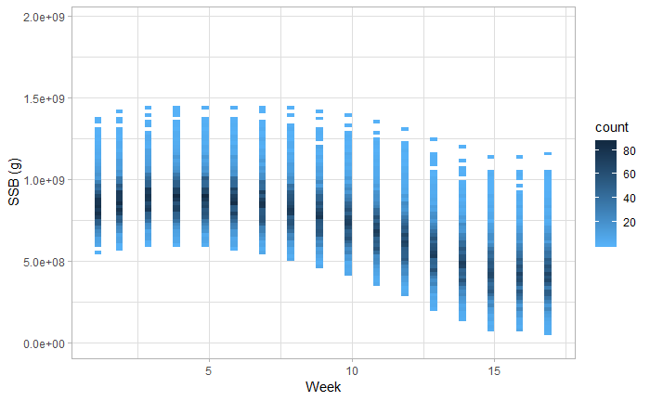

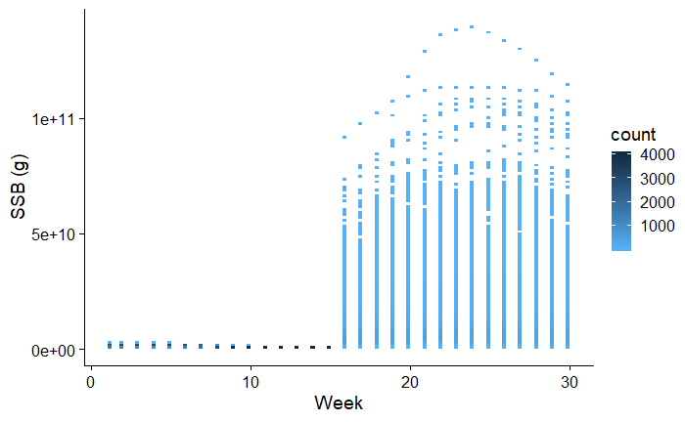
Figure 1 Spawning stock biomass (SSB) in grams estimated from the MCMC for each week during the 2018 season top and both seasons (bottom). “Count” represents the number of MCMC simulations.

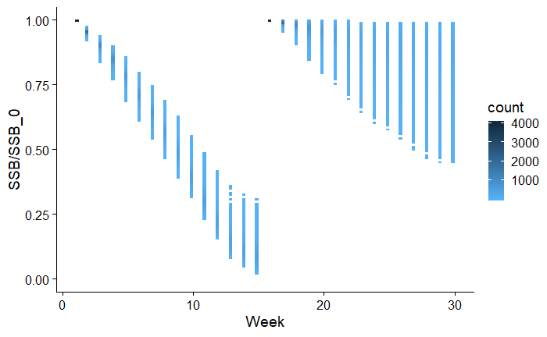
Figure 2 Spawning stock biomass relative to unexploited SSB through the season.

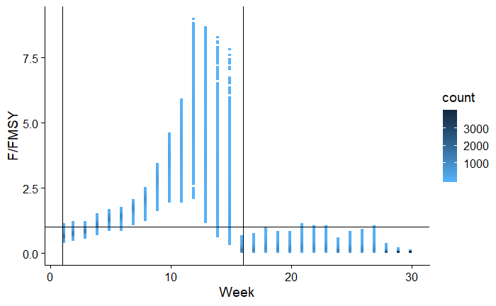
Figure 3 Fishing mortality during the season relative to F_{MSY}. The vertical lines represent the beginning of each season.

Harvest Control Rule
The harvest control rule should remain unchanged from 2018. The 2019 data presented a much more optimistic stock status than 2018, but this was estimated with much greater uncertainty. Therefore, it is recommended to continue using the precautionary HCR developed for the 2018 season until more information becomes available.
There was effectively one indicator available to monitor stock status, which was CPUE. The HCR requirements applied by MSC require intervention to maintain minimum biomass and protect recruitment. With effectively only one year of data, any idea of what minimum biomass would be is likely to require revision until sufficiently long time series has been obtained to be confident about the population dynamics of the stock. In the absence of a time series, the best option will be to assume the 2018 year is an "average" year and base the CPUE reference point on that.
A simulation model based on the stock assessment was used to evaluate possible HCR CPUE trigger reference points. The following assumptions were required:
- Fishing mortality will remain the same in future years. Fishing mortality reflects the numbers and distribution of traps, which are broadly static. Variation in fishing mortality estimates themselves are available from the MCMC.
- Recruitment may vary year to year. There is no estimate of this, but the HCR should be designed to be robust to any reasonable variation. Therefore, a lognormal with 0.6 standard deviation on the initial stock size is used. The size composition was assumed to remain unchanged.
- CPUE was simulated including the error estimate from the normal distribution. CPUE was only used from the valid period (weeks 7-13). If the CPUE does not fall below the trigger in this period, the fishery is not stopped.
- Other factors, such as growth and natural mortality, were assumed not to change in future years.
The simulations were run 1000 times using the MCMC parameter estimates for each of a range of CPUE trigger points based around the observed CPUEs. The performance of the HCR was evaluated by calculating the SSB/SSB_{F=0} , assuming the target MSY proxy of 40%. A precautionary trigger point should apply if there is a greater than 50% probability the stock will fall below this MSY level.
From the simulations, the median SSB at the SSB_{40%} occurs at around 8 crayfish/trap. This could be used as an interim trigger point. If the CPUE falls below 8 crayfish/trap within weeks 7-13 (last week of May – first week July), the fishery should be closed in the next week for the rest of the season.

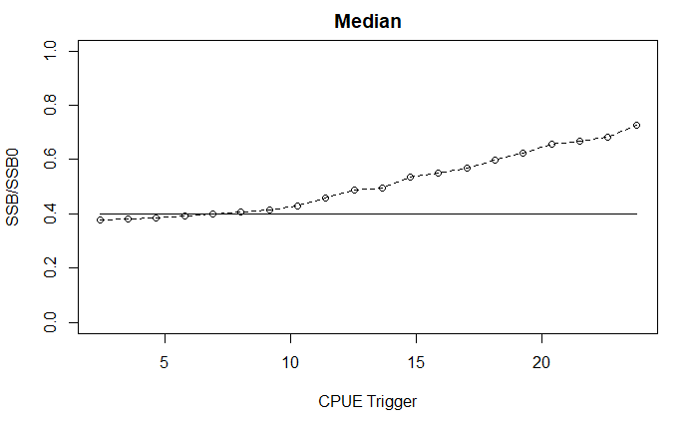
Figure 4 Median SSB resulting from different CPUE trigger points based on simulation using the stock assessment model and MCMC parameter set.

Conclusions and Recommendations
- There is no evidence that the stock is overfished, or that overfishing was occurring in 2018 or 2019. This is likely to remain the case unless the fishery changes significantly.
- The 2018 HCR should continue to be implemented that limits the number and distribution of traps to the current level, and stops the fishing season should the average weekly catch rate (weeks 7-13) fall below 8 crayfish per trap.
- A long-term monitoring programme needs to be developed. While this need not necessarily be as extensive as in 2018, it needs to be sufficient in the medium term to continue to test and develop the HCR, while in the longer term it needs to be able to support the HCR. Unlike 2019, data need to be collected through the season when catches are being taken irrespective of whether they are purchased by Baolong or not.
- The way data are collected, recorded and reported generally worked well. However, it is important when recording data on spreadsheets to use a consistent format and ensure data are entered as the right type, specifically dates are entered as dates, not strings.
- Total catch estimates will also be required for those periods when purchases are not being made. A simple method to estimate these will be required.
- The observer programme should continue to be carried out for another year, or until a replacement monitoring programme can be developed.
- Logbooks should continue to be used, but they need to record the catch from individual traps and all catches, not just catches sold to Baolong.
- The water temperature should continue to be recorded routinely.
- It should be noted that with small data sets, as in this case, stock assessments can be subject to significant revision as new data are added. This can lead to different conclusions and results in future years.

