**Action #1 Rebuild local Salmon stocks**

***Action Goal: Rebuild wild Kunashir Island Pink and Chum Salmon stocks within five years***

**PIs 1.1.1, 1.1.2**

This August, the problem of rebuilding Kunashir Island Pink and Chum Salmon local stocks was widely discussed during the FIP visit to Yuzhno-Sakhalinsk. This topic was discussed with scientists from SakhNIRO, SakhRybVod and managers of Kunashir fishing companies. The material collected shows that local communities and Kunashir fishing companies are making very significant efforts. Both scientists and stakeholders are aware of the problem and are trying to find solutions. Scientists from research institutes are conducting studies and developing scientific recommendations for salmon fishing under current conditions.

**Pink Salmon**

Data on Kunashir Pink Salmon biological characteristics have not been collected for several years due to the lack of sufficient number of spawners.

Taking into account the information received from specialists from Kunashir, the Head of the PCF Yuzhno-Kurilsky Ryibokombinat Co., Ltd (hereinafter – YKRK) suggested the Association of Fishermen of Sakhalin Region (AFS) to limit Pink Salmon fishing on Kunashir. This decision of Pink Salmon fishing ban until September 10 was made at the meeting of the Sakhalin Region Anadromous Fish Commission (Minutes of meeting No. 38 dated August 28, 2024). The document is available here:

[https://sakhalin.fish.gov.ru/upload/papka-faylov-dlya-novostey-upravleniya/Протокол%20от%2028.08.2024%20№%2038.pdf](https://sakhalin.fish.gov.ru/upload/papka-faylov-dlya-novostey-upravleniya/%D0%9F%D1%80%D0%BE%D1%82%D0%BE%D0%BA%D0%BE%D0%BB%20%D0%BE%D1%82%2028.08.2024%20%E2%84%96%2038.pdf).

Despite the measures to limit Pink Salmon fishing for the second year in a row, the escapement to spawning grounds remains extremely low. Some scientists believe that decline in Pink Salmon abundance is connected with the extreme environmental factors and changes in the hydrology of coastal waters affected the spawning. During the interviews all respondents noted that the Southern Kuril Islands are experiencing an abnormally hot summer in 2024. In mid-August, the air temperature in Yuzhno-Kurilsk and Kurilsk reached +28℃, while the coastal water temperature was 20 - 22℃. A similar pattern was observed in this fishing area in 2023.

For example, the article by Kanzeparova et al. (in the Bulletin on the study of Pacific salmon in the Far East No. 18/2024) states that the 2023 fishing season in the South Kuril Zone was unsuccessful. Realization of the projected catch volume (PC) amounted to only 17%. It is noted that during the Pink Salmon run an area of abnormally high temperatures was formed off the coast of the southern Kuril Islands (Fig. 6 - according to the text of the article), which prevented Pink Salmon from entering this fishing area. It is noted that catches of Pink Salmon on Hokkaido Island were also lower than expected.

This article, as well as other articles in Bulletin No. 18/2024, also notes the declining trend in Chum Salmon catches in almost all regions of the Russian Far East. In 2023, the Chum Salmon catch amounted to 79.1 thousand metric tons, which was 13% lower than forecast expectations.

Marchenko in his article “Results of Salmon fishery in the North Pacific and adjacent waters of the Arctic Ocean in 2023” published in Bulletin No. 18/2024 provides information on Pacific salmon catches, which shows a trend between the number of Pink and Chum Salmon and climatic changes in almost every region of the North Pacific Ocean.

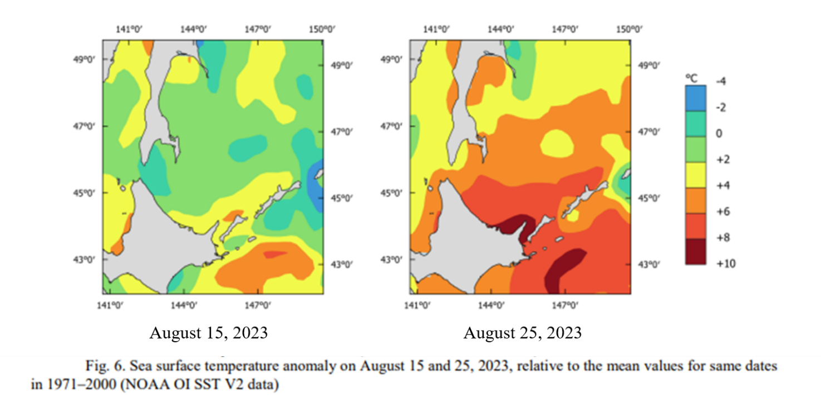

Impact of climate change on salmon populations has been widely studied and discussed by scientists from around the world. In early June, the North Pacific Anadromous Fish Commission (NPAFC) held its first workshop “Developing a Mechanistic Understanding of the Impact of a Changing Climate on the Salmon Abundance and Distribution Trends”. Scientists, managers, and other stakeholders discussed the current status and future of salmon and their habitats to conserve anadromous populations in a changing world.

The workshop organizers believe that “Improved understanding of the mechanisms that regulate the distribution and abundance of Pacific salmon will promote the conservation of anadromous populations in the North Pacific Ocean, allow for better projections, or at least include realistic uncertainty given climate change, of Pacific salmon production trends in the future, and enhance sustainable fisheries management, food security, and economic security in member nations.” The workshop proceedings and abstract brochure can be found on the NPAFC website: <https://workshop.npafc.org/workshop/html/home/index.html>.

**Kunashir Chum Salmon**

In 2014-2018, the average catch of Kunashir Chum Salmon was 1.65 thousand tons. After 2018, its average annual catch decreased to 0.54 thousand tons, and the projection was usually significantly higher than the actual catch. In 2023, exploitation of the projected catch volume was 37.8 % (Table 1), with one third of the catch Chum Salmon returned to the main rivers of the salmon hatcheries.

Table 1. Total and projected Chum Salmon catches on Kunashir Island in 2014-2023

| Parameter | Year | | | | | | | | | |
| --- | --- | --- | --- | --- | --- | --- | --- | --- | --- | --- |
| 2014 | 2015 | 2016 | 2017 | 2018 | 2019 | 2020 | 2021 | 2022 | 2023 |
| Projected catch volume (PC) ,  thousand tons | 1.90 | 1.77 | 1.77 | 1.50 | 1.30 | 2.10 | 1.50 | 0.60 | 0.90 | 0.90 |
| Total Catch,  thousand tons | 1.57 | 1.76 | 1.71 | 1.02 | 2.19 | 0.59 | 0.54 | 0.87 | 0.35 | 0.34 |
| % Realized | 82.6 | 99.4 | 96.6 | 68.0 | 168.5 | 28.1 | 36.0 | 145.0 | 38.9 | 37.8 |

In 2023, the migration dynamics of Kunashir Chum Salmon differed significantly from previous years. Thus, its spawning run began only in mid-September, and mass migration began in late September. The increase in catches from October 20-25 was due to the return of hatchery Chum Salmon and their runs to the base water bodies of the Lagunnoye Lake Salmon Hatchery and Ricorda River Salmon Hatchery.

**Commercial stock status (Chum Salmon)**

In the last three years, materials characterizing biological parameters of Chum Salmon spawners have been collected thanks to research funding, including YKRK. Statistical information on Chum Salmon catches and artificial reproduction of Kunashir salmon was collected.

According to scientific research data, in the last three years there is a decrease in the size, weight and change in the age structure of the stock compared to the data collected before 2013: the average weight of fish was 2.74 kg, length — 62.3 cm, fecundity — 2,286 fish eggs. The most abundant age group in 2023 returns was three-year-olds (53.7%). This age structure is not typical for Kunashir Chum Salmon. During 1993-2013, the average age structure of Chum Salmon in the Ilyushina River was: 2+ years — 5.3 %, 3+ years — 62.2 %, 4+years — 31.0 %, 5+ years — 1.5 %.

Escapement to spawning grounds in 2023 ranged from 0 to 12.5% depending on the watercourse. Total escapement to spawning grounds on the island did not exceed 10.55%, which is still a low value.

This year, YKRK continued to finance scientific work. Contracts with researchers from SakhNIRO and VNIRO were signed to monitor Kunashir rivers escapement by Pink and Chum Salmon and to collect data and study population characteristics. The contract on the collection and processing of adult Chum Salmon otoliths has also been signed. Also, the contract with SakhNIRO scientific support on Chum Salmon eggs otolith marking at the Lagunnoye Lake Salmon Hatchery is in the process of being signed.

Information on the dynamics of Pacific salmon runs, spawning grounds escapement and the condition of water bodies on Kunashir Island is detailed in the article by Tatiana Tochilina and co-authors (Tochilina et al., 2024).

As of September 15, the Chum Salmon fishing in the South Kuril Zone had only just begun, therefore data is not yet available. On October 01, a scientific team from VNIRO will arrive in Kunashir to collect biological and statistical data on Kunashir Chum Salmon in the 2024 season. The expeditions are planned to be completed in mid-November. The final report is planned to be compiled by the end of December 2024; it will include the dynamics of the Chum Salmon run and fishery, escapement to spawning grounds on Kunashir Island, biological characteristics of spawners, including age and fecundity.

Collection of scientific information on the 2024 season continues. Final data on reproduction of Kunashir Pink and Chum Salmon will be presented in reports from involved researchers in January 2025.

**List of literature and Internet resources**

Bulletin No. 18 on the study of Pacific salmon in the Far East. Electronic supplement to the scientific journal “Izvestiya TINRO”. Vladivostok, 2024

Kanzeparova A.N., Vaizova I.A., Nikiforov A.I., Belyaev V.A. Results of salmon fishery in the Far-Eastern fishery basin in 2023 (Itogi lososevoj putiny v Dal'nevostochnom rybohozyajstvennom bassejne v 2023 g.). Bulletin No. 18 on the study of Pacific salmon in the Far East. Electronic supplement to the scientific journal “Izvestiya TINRO”. Vladivostok, 2024

Marchenko S.L. Results of Salmon fishery in the North Pacific and adjacent waters of the Arctic Ocean in 2023 (Itogi lososevoj putiny v severnoj chasti Tihogo okeana i sopredel'nyh vodah Severnogo Ledovitogo okeana v 2023 godu). Bulletin No. 18 on the study of Pacific salmon in the Far East. Electronic supplement to the scientific journal “Izvestiya TINRO”. Vladivostok, 2024. P. 84.

Abstracts of The First NPAFC Workshop on Developing a Mechanistic Understanding of the Impact of a Changing Climate on the Salmon Abundance and Distribution Trends. June 4–5, 2024 Vancouver Airport Marriot Hotel, Richmond, BC, Canada

<https://workshop.npafc.org/workshop/html/home/index.html>

Tatyana G. Tochilina, Alexander V. Mikhailov, Vsevolod N. Leman. The state of spawning grounds, a study of the biology and population dynamics of Pacific salmon on Kunashir Island (Southern Kuril Islands) in 2023 (Sostoyanie nerestilishch, issledovanie biologii i dinamiki chislennosti tihookeanskih lososej o. Kunashir (Yuzhnye Kuril'skie ostrova) v 2023 g. TRUDY VNIRO. 2024. V. 196. P. 204-208

Minutes of meetings (Protocol) of the Sakhalin Region Anadromous Fish Commission No. 38 dated Aug 28, 2024:

[https://sakhalin.fish.gov.ru/upload/papka-faylov-dlya-novostey-upravleniya/Протокол%20от%2028.08.2024%20№%2038.pdf](https://sakhalin.fish.gov.ru/upload/papka-faylov-dlya-novostey-upravleniya/%D0%9F%D1%80%D0%BE%D1%82%D0%BE%D0%BA%D0%BE%D0%BB%20%D0%BE%D1%82%2028.08.2024%20%E2%84%96%2038.pdf)

Minutes of meetings with various stakeholders representatives during the FIP visit to Yuzhno-Sakhalinsk, August 2024.

Lyudmila Fedorova,

Fisheries Eco-Certification Consultant

September, 16 2024