Indonesian One-by-One Tuna Fishery Compliance and Policy Development Report
September 2020

Regional RFMOs
IPNLF conducted a gap analysis of Indonesia’s National Management Framework against management measures from the Regional Fishery Management Organization (RFMO). Tropical tunas are highly migratory species and are managed by RFMOs. Indonesia is a member of the Western & Central Pacific Fisheries Commission (WCPFC) and the Indian Ocean Tuna Commission (IOTC).

WCPFC
Indonesia is a cooperating member of the WCPFC and must comply with its management measures. Highlighted issues from the gap analysis included better data required on shark catches across Indonesian tuna catching gear types, better resolution of annual catch estimates data required across gear-types, ensure compatibility of Harvest Strategies and Control Rules for Indonesian Archipelagic Waters with WCPFCs, and relooking at mechanisms to address objectives under Other Commercial Fisheries.

IOTC

Fishery Compliance at the National and Provincial Levels
At the National and Unit of Assessment (UoA) level, most of the noncompliance issues found were unregistered vessels (those bellow 10GT), license expired and fishing out of destined fishing areas. For these issues, MMAF already sped up the process of vessel registration (SILAT), develop integrated vessels licensing system at provincial level (SIMKADA) and develop tuna fishing vessels database (DIVA-TUNA). By having those mechanism, it is expected that vessel owners and fishers can improve their compliance as registering a fishing vessel and issuing license are now getting easier.

Onboarding Events for Fishers and Vessels in FIPs (SOPs)
Onboarding activities to PL and HL fishing vessels under AP2HI membership are continuing this year in several target areas such as Southeast Sulawesi, West Nusa Tenggara, and West Papua. Fishers are engaged in a series of discussions from fishing related activities to current fishing regulation. However, the main objective is to gain a formal commitment in the form of a signed declaration to comply with several AP2HI member SOPs such as:

- The fisher agrees to operate fishing is sustainable ways
- The fisher should aware of ETPs species and is committed to handling it carefully when encountering them during the fishing operation
- The fisher agrees to provide necessary data, participate in data collection program, and be subjected to an inspection
- The fishers agree to implement good handling practices.
- The fishers agree to “no shark finning policy ” and comply with current fishing regulations.

In 2020, we have documented the signing of the SOP agreement of up to 100 pole-and-line and handline vessels across UoAs in the FIPs with total 433 vessels already signing the SOP.

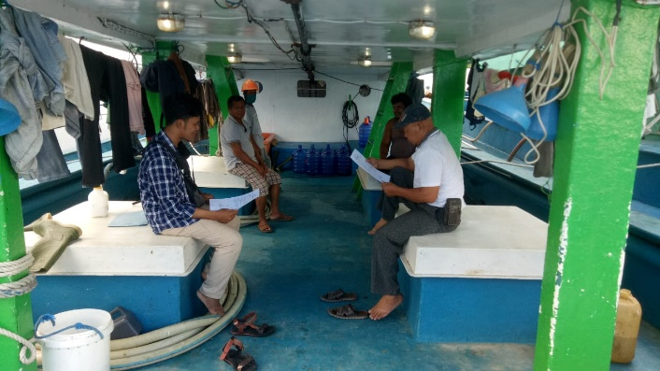
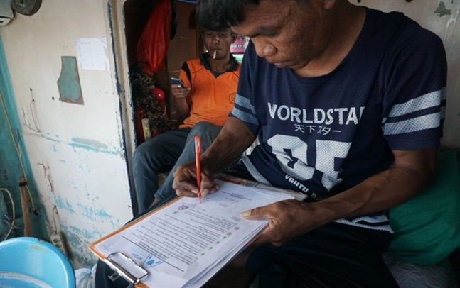
Photos: Onboarding vessels and crew onto the FIP

Transition to E-Logbooks
For monitoring, government implement e-logbook application that enable fishers to keep the log of fishing activities on their android mobile phone, with active GPS location. The data from elogbook then can inform the authority on the vessels compliance relate to fishing areas including whether it trespassing protected areas or not. Those that has serious non-compliance will not be able to get sail permit and might not be able re-extend their license on the upcoming year. AP2HI and IPNLF were also primary partners in the USAID-OCEANs program to drive electronic Catch Documentation and Traceability, to develop key data elements, pilot e-logbook applications and help scale these solutions in industry supply chains. Both IPNLF and AP2HI played an integral role in helping USAID-OCEANs to achieve the Digital Development Awards 2020.

SKPI training on Fish Handling, ETPs and Pollution
Comprehensive trainings across all pole-and-line and handline UoAs, from fishers, industry processors and Provincial Fisheries Agencies, to increase the national compliance to the regional regulation of tuna fishery and environmental awareness, as well as increase the best practice on harvest and post-harvest methods and safety during fishing operation. To raise the environmental awareness in tuna fishery, the participants learned to identify several target species and ETPs and how to release them safely during the fishing operation. In the fisheries management aspect, the participants learned the management and regulations on FADs and bait. In addition, the participants were also learned and assessed to get a certification on the standard in handling the catch on board of the fishing vessel and received a proper onboard and on port waste management.

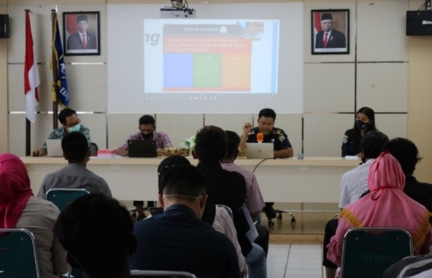
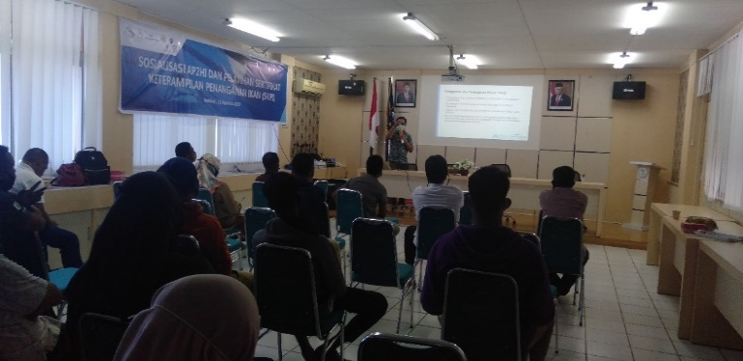
Photos: SKPI Trainings in Southeast Sulawesi

Vessel and Bagan Registration
Vessel and Bagan registration have been prioritized as potential compliance gaps for small-scale and supporting fisheries in our FIPs. Our activities assist fishers to obtain legal documents such as “Pas Kecil” and fishing vessel registration (BPKP) in Maluku. We have facilitated in registering 4 Bagan boats under 10 GT (Amen, Sumalina, Syalom, and Yelika) to support pole-and-line fisheries for fishers in Batu Gong Village in Ambon. These two documents are issued by the Ministry of Transportation and Ministry of Marine Affairs and Fisheries for BPKP and Pas Kecil, respectively. It is necessary to have these documents for small-scale boats so that landings are documented properly at the fishing port and their ownership of the boat is verified. In August 2020, we have facilitated and successfully obtained vessel registration (Pas Kecil and BPKP) for 33 small-scale tuna boats in Airpanas village, Ambon. These 1 GTs small boats registration proses have involved village and district level government to issue boat registration request and port authority official to officially measure the boat dimension the boats. We learned that by registering several boats in the same location simultaneously will significantly reduce the effort. In 2020, a total of 42 vessels in Ambon and 91 vessels in South East Sulawesi are under process on registering with the same method.

Photo: Vessel Registration for Small-Scale Vessel
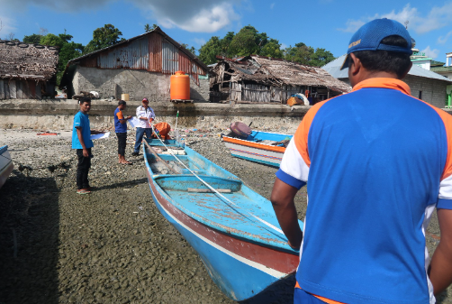

Establishing Fishery Co-Management Committees (FCMCs) in West Papua and SE Sulawesi
To strengthen the tuna fisheries management at the provincial level, we have initiated the development of the Fisheries Co-Management Committee (FCMC) in West Papua and Southeast Sulawesi provinces simultaneously. Initial scoping to identify related stakeholders in both provinces were completed before the official visit in two provinces in August. The official visit targeted the most relevant stakeholders from district/town and provincial government offices, port authority, private and state universities, fishers’ associations, and fishing companies. FCMCs enable provincial stakeholders to discuss fishery data and engage in fishery management.

Photo: Meeting with Provincial Government in SE Sulawesi and W Papua
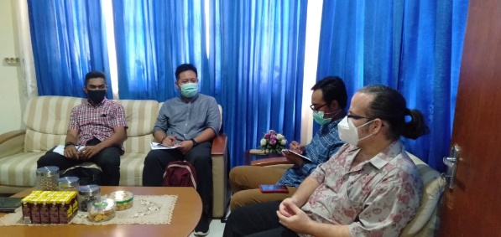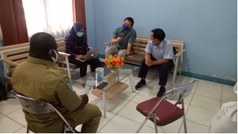

Vessel tracking device deployment
Monitoring using Vessel Tracking Device (VTD) aimed to see the vessel’s movement. Vessel’s movement in accordance with the permits that are owned becomes the basis for the vessel to comply with regulations. Installation of this device has other benefits depending on the device’s specification such as alert system while sailing. Vessel tracking program is implemented using sub-sampling method for vessels under 30 gross tonnages. Vessels are randomly selected and the devices are rotated on a regular basis to different vessels. So far in 2020, a total of 80 trips under AP2HI supply chain were covered by VTDs, and none of the trips indicated compliance issues.

Time lapse camera deployment
TLC installation on HL vessels, being one way to monitor the interaction of ETP (Endangered, Threaten, Protected) species with vessel (and everything inside the vessel) and to monitor fishermen activities while on board. TLC installation is proven quite effective to replace Observer On Board, as some vessels (especially for small boat) has no room to assign another person on board. Although, TLC also has weakness as it has limited angles/viewpoint to observe conditions all around. Thus, based on the TLC monitoring results, there is zero catch of ETP using this gear with 49 trip under AP2HI supply chain are covered by TLC.

