Herring surveys update from January 2021

Information provided by Tony Hooper (Connors Bros Marine Corp) and Jenna Munden (Herring Science Council).

Summary:
There were multiple reports from commercial fishers of large aggregations of juvenile herring remaining in Southwest New Brunswick (SWNB) during the fall and winter of 2020-2021. According to the Department of Fisheries and Oceans (DFO) management, juvenile herring in the SWNB region migrate to US waters to overwinter. To ground truth these reports, Connors Bros conducted hydroacoustic surveys from the vessel Canada 100, and shared their findings with stakeholders including the Department of Fisheries and Oceans (DFO). They found evidence of significant aggregations off Grand Manan, the Wolves and the Prong, and marked other areas where they sighted herring (Fig. 1). The significance of these survey results is that current understanding of annual migration patterns and stock structure of the 4VWX herring stock may need to be updated.

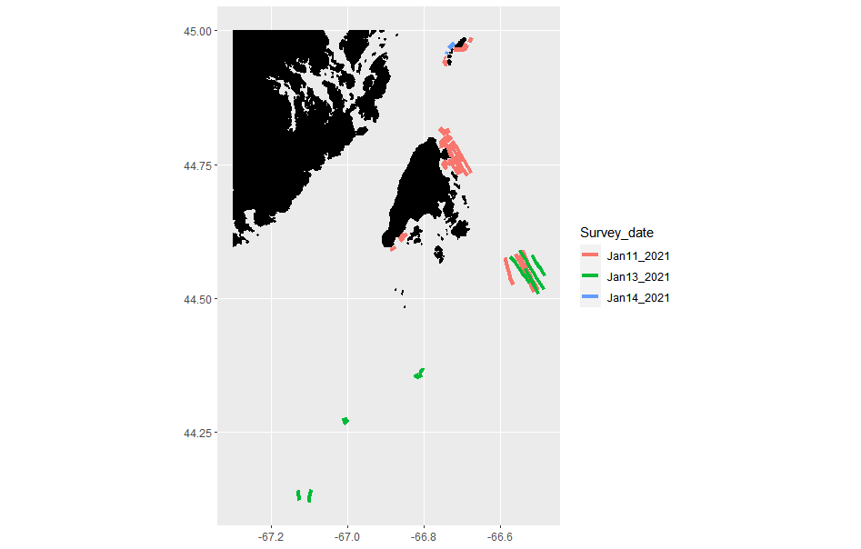
Figure 1. Map showing locations and dates of hydroacoustic surveys in SWNB. The large island in the center is Grand Manan.

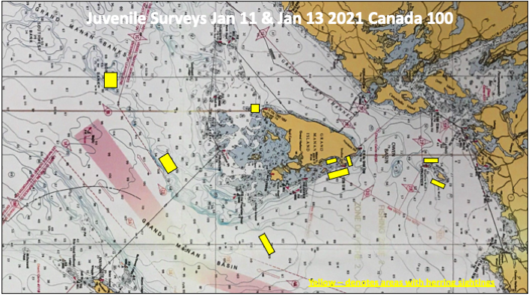
Figure 2. Map showing areas around Ground Manan Island where herring were sighted (yellow blocks) during surveys conducted in January 2021.

