We have identified a local partner Zehong, whose father was an experienced captain and famous among the local community. With Zehong and his father’s assistant, we have conducted in-depth interviews with a few fisher in Nan’ao Island, Shantou.
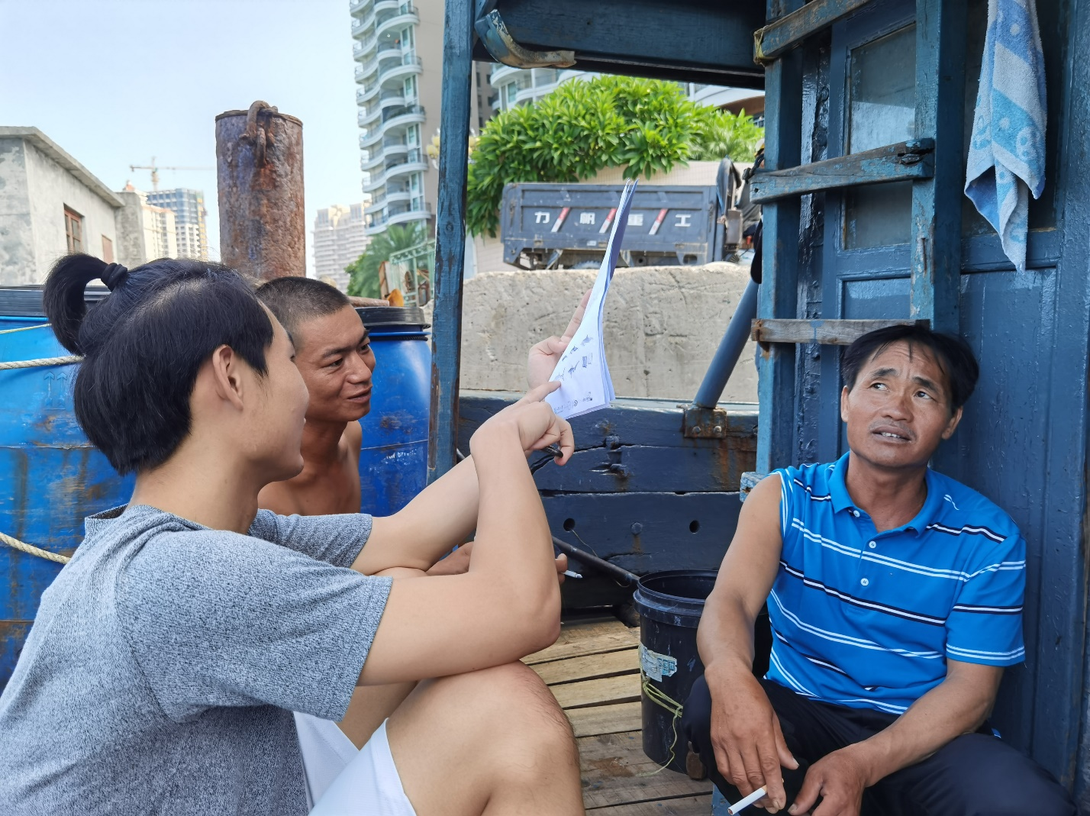
Local partner, a son of fisher (front, left), showing the map and figure to fisher. He is trying to get fisher’s knowledge about the ETP species, habitat and ecosystem impacts from squid and octopus fishing.
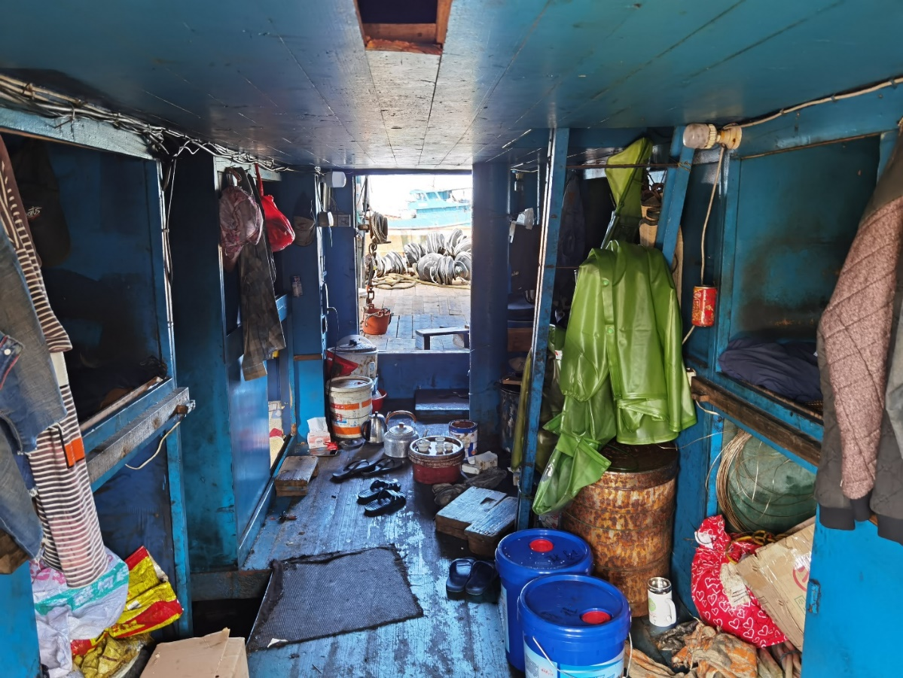
Inside a typical fishing vessel in Shantou
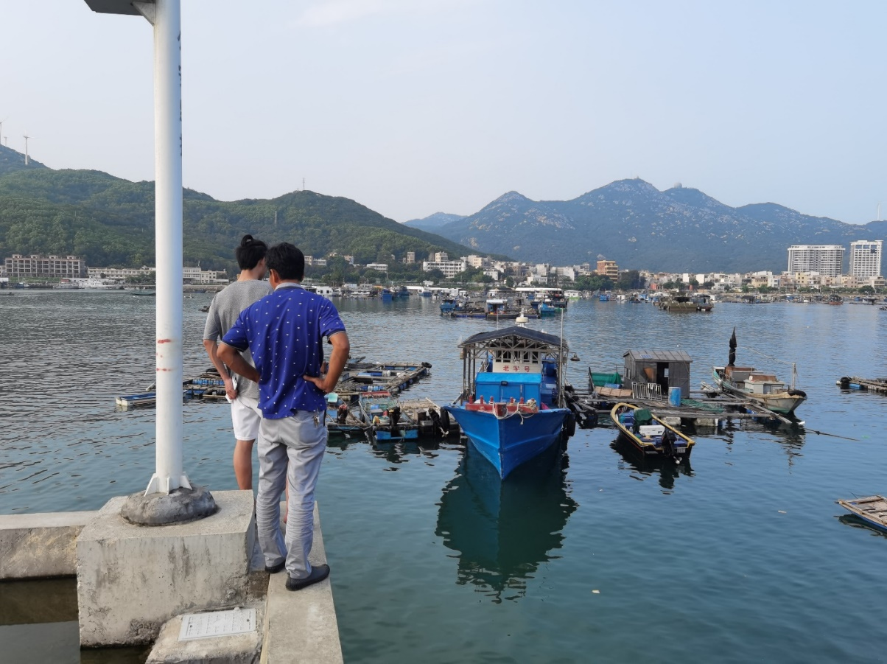
Some of fishing vessels and cage farming near the port

