Ireland’s Fishery Improvement Projects (FIP)
What are FIPs?
FIPs are a practical, industry-led approach to making continual improvements in the sustainability of specific fisheries in an ever more demanding marketplace. A key feature of FIPs is that the industry have a direct opportunity to influence the FIP workplans and therefore to take control of their own destiny.
They are based on co-operation between all sectors in the fishery chain, from catching to processing to retail. The credibility of FIPs comes from the fact that they are independently audited and validated on the progress towards sustainability that they are making.
Examples of progress towards sustainability could be using more selective gear, collection of scientific data by fishermen or the development of improved fishery management plans in a FIP.

What are the benefits of FIPs?
Through the FIP workplans a program of responsible fishing is developed. Problems are identified and measures to address these problems are implemented. Through collaboration with scientists the knowledge available for sustainable management is improved. Fishermen can retain access to markets which demand proof of sustainability and consumers can be assured that their seafood purchases are not contributing to environmental problems.

How many FIPs are there in Ireland?
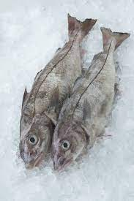
FIPs are a global initiative and 9 FIPs have now been established in Ireland. Species covered by FIPs are Brown Crab, Prawns, Hake, Haddock, Whiting, Coley, Monkfish, Megrim and Albacore Tuna.
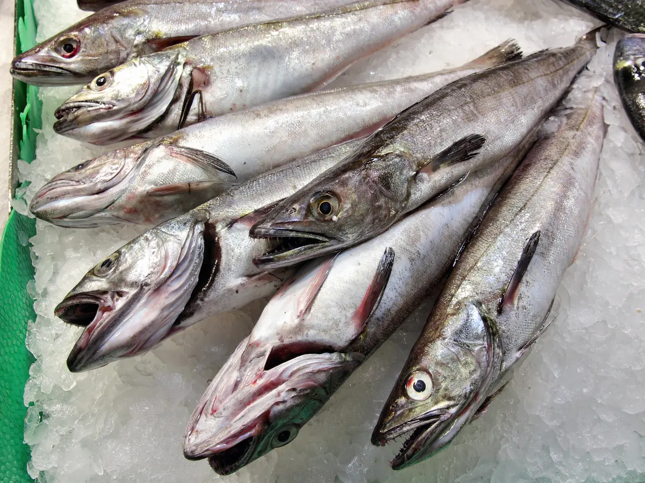
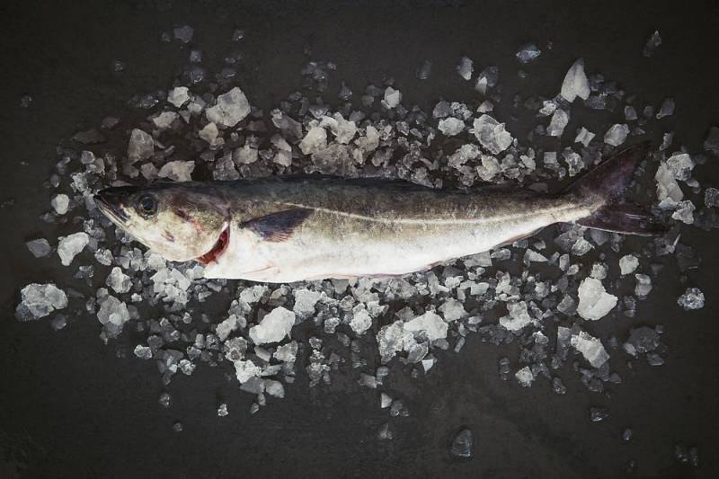

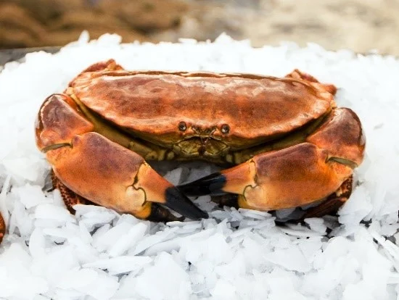
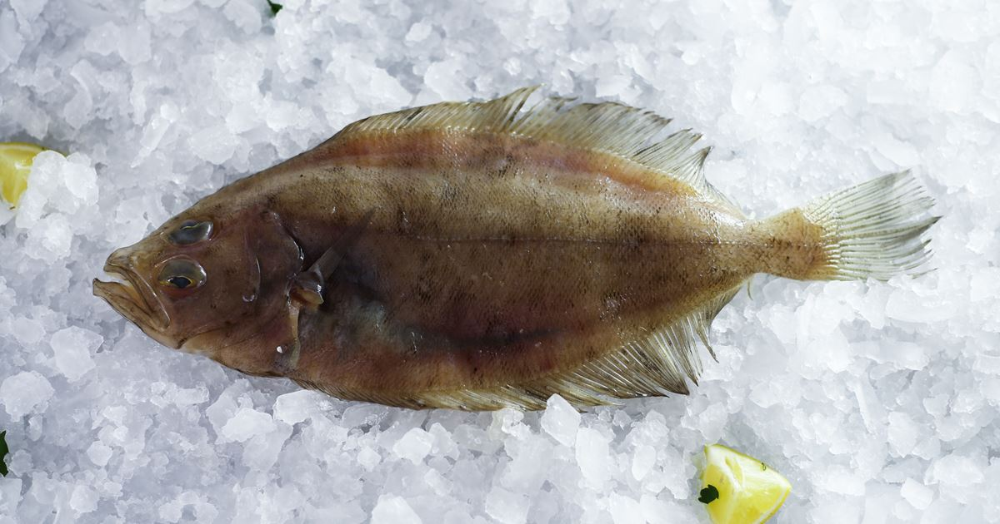
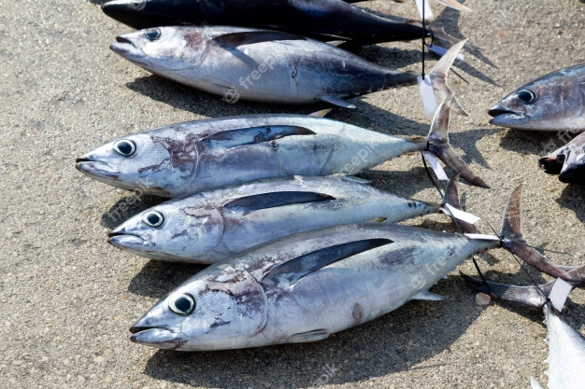
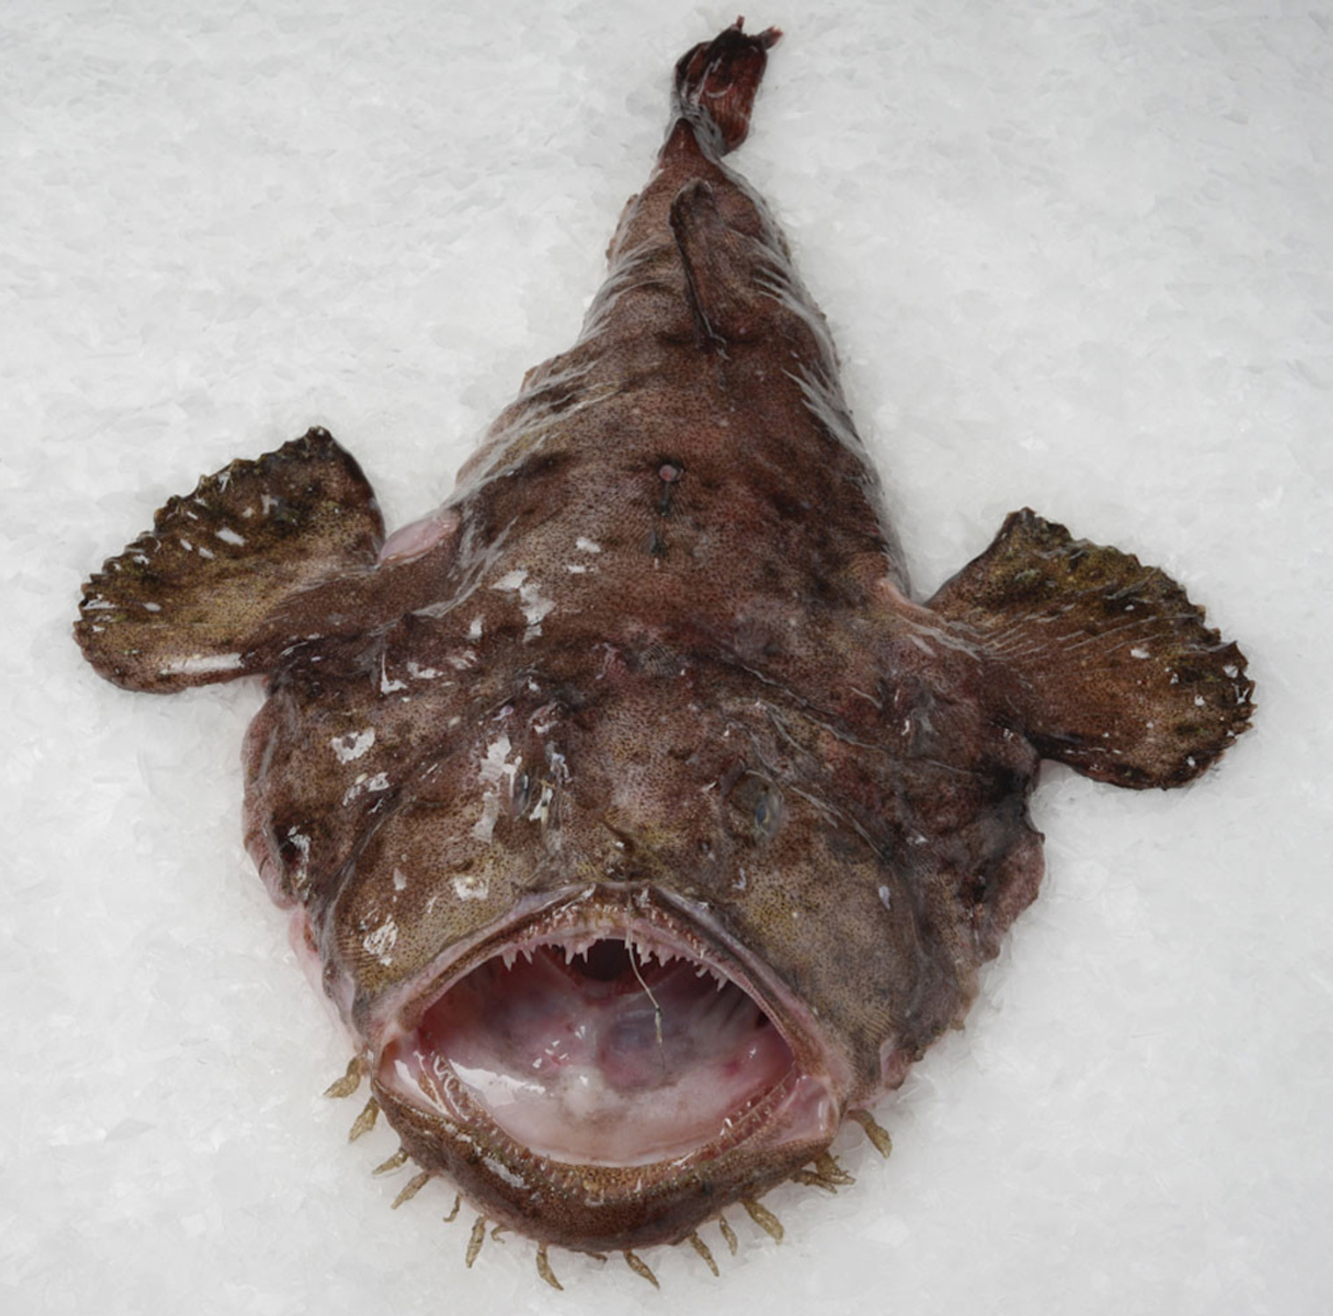
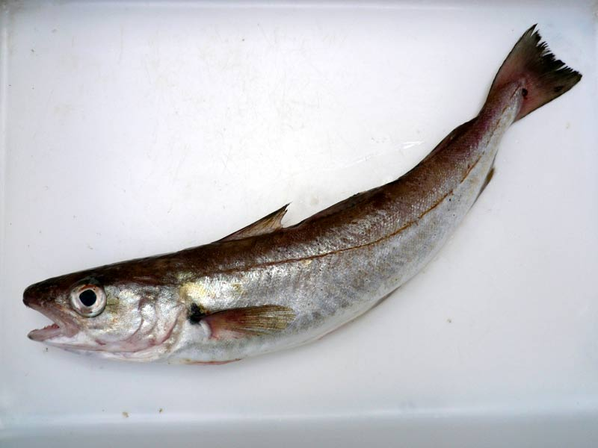
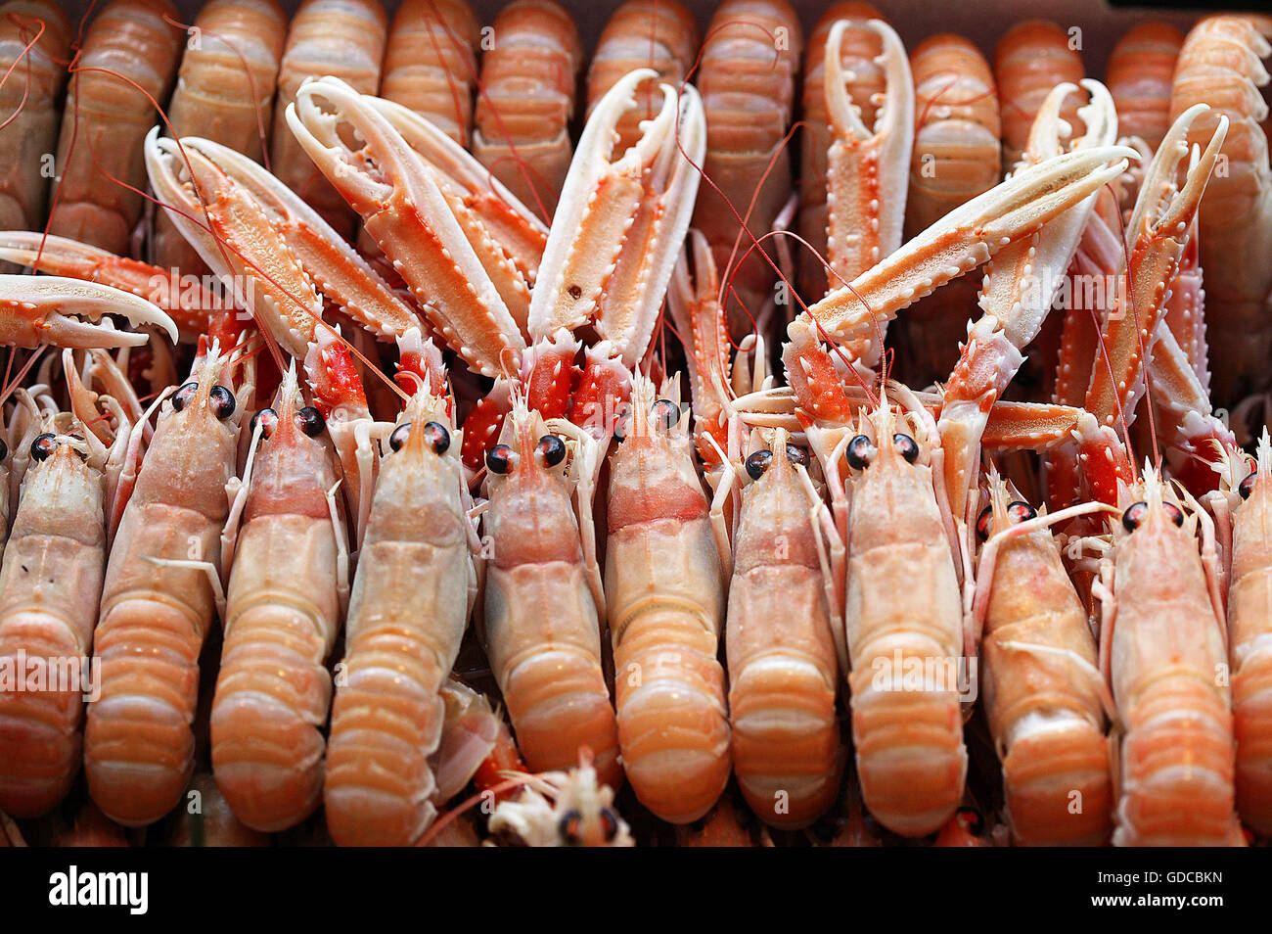

What issues do FIP workplans cover?
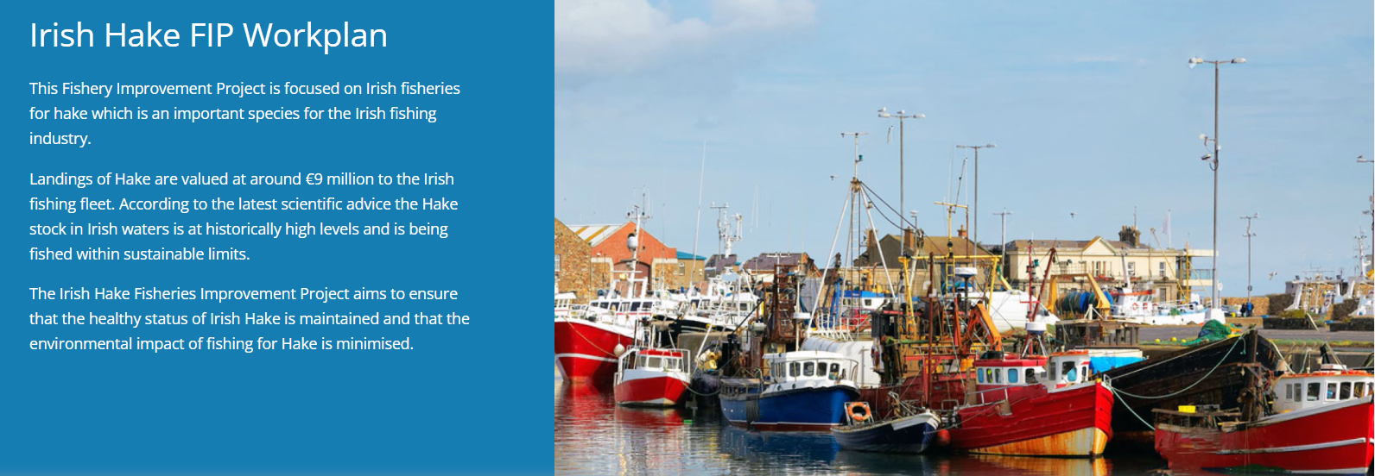
FIP workplans are developed in response to sustainability problems identified in an independent assessment. They cover the following core principles:
- Improving Stock Health
- Reducing Environmental Impact
- Good Governance
- Labour issues and human rights are being included as elements of FIP workplans from 2022 onwards.
One of the main actions in the Irish Whitefish and Prawn FIP workplans is to work with members of the BIM Conservation Team and one of the main focus areas we are working on collectively is the collection of information from FIP member vessels on selective fishing gears that they may be using.
The FIPs are also focussed on improving the provision of scientific data from fishing vessels through the taking out of scientific observers and participation in self-sampling schemes. This information has become even more important due to the lack of observer coverage over the past few years due to Covid and the negative impact this may have on both the scientific assessment and the ability to demonstrate the sustainability of fishing activities.
This initiative is supported by the co-ops and PO’s who recognise the importance of ensuring that the scientific assessment of these stocks is based on good information from fishing vessels. To participate please contact Macdara Ó Cuaig, the Marine Institute Fisheries Liaison, on 0872075988 who will provide additional information, data sheets for self-sampling and any further training required.

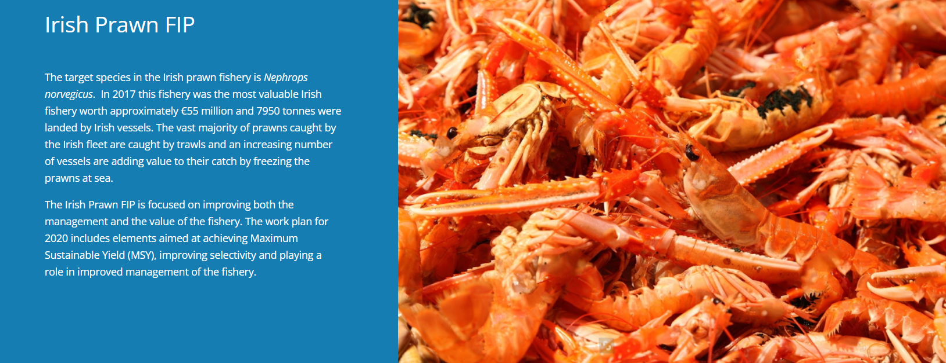

Contact
Please contact Mike Fitzpatrick at mike@vfact.com or on 0868584156 with any further queries regarding the FIPs in general.
FIP funding
All of the Irish FIPs are funded by BIM’s Sustainable Fisheries Scheme which is co-financed by the Department of Agriculture, Food and the Marine and the European Maritime and Fisheries Fund.

