August 23, 2019

Jacqueline Perry
Regional Director General
Department of Fisheries & Oceans
80 East White Hills
St. John’s NL A1C 5X1

Dear Jackie:

Re: Northern Cod LRP

Following the regional peer review process to evaluate the Limit Reference Point (LRP) for Northern Cod, DFO Science indicated that the LRP would be re-evaluated with further information on the productivity of the stock that corresponds to the gap in the stock-recruit relationship between roughly 400 and 800,000 t Spawning Stock Biomass. Further, DFO Science also indicated that further information on stock productivity in this range could be gathered through refinement of the Extended Northern Cod Model (1962-2018).

An LRP should represent the status below which serious harm is occurring to the stock. The LRP for Northern Cod is currently set as the average spawning stock biomass during the 1980s. Yet Northern Cod recovered from lower spawning stock biomass levels during the 1970 in the face of considerable fishery removals, fishery removal levels that would be unacceptable today. Thus, the 1970s period represents an empirical basis for establishing an LRP for Northern Cod.

While we recognize that the Extended Northern Cod model was considered provisional at the time of the January peer reviewed meeting, we would like to see a commitment from DFO to further refine the longer time-series model and to bring that information forward at the upcoming Northern Cod Assessment planned for March 2020, if not sooner. Such information could contribute to the establishment of a defensible Limit Reference Point for Northern Cod – needed for the development of the Northern Cod Rebuilding Plan.

Yours truly,
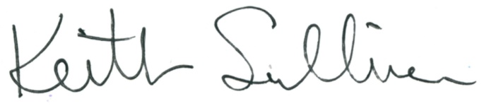

Keith Sullivan
President

