Environmental Risk Assessment of South West mixed fisheries:

Habitats

Summary of Consequence Spatial Analysis methodology & information collected by Samira Anand
September 2021

Contents
1 Introduction 3
1.1 Purpose of this document 3
1.2 Overview of the 2021 South West ERA 3
2 CSA Methodology 5
2.1 The semi-quantitative approach 5
2.2 What the CSA aims to achieve 6
2.3 Habitat definitions 6
2.4 Habitat productivity attributes 7
2.5 Encounterability Score 7
2.6 Gear types included in the CSA 8
Spatial overlap scores 8
3 Overview of information collected 9
3.1 Major habitat types within assessment area 9
3.2 Column headings 11
4 MSC scoring guidepost 13
5 Case Study: Beam trawl fishery 14
5.1 Fishing activity and habitats 14
5.2 Risk assessment 16
Spatial overlap between beam trawling and individual habitats 16
Habitats identified as high risk from beam trawling 16
Habitats identified as medium risk from beam trawling 17
Habitats identified as low risk from beam trawling 17
6 Summary of the impacts of each gear type 19
7 Scoring system 21
7.1 Habitat Productivity attributes 21
7.2 Gear-habitat interaction attributes 22
7.3 Seabed slope 23
7.4 Score Spatial Attributes: gear footprint 23
7.5 Score Other Spatial Attributes 23

Introduction

Purpose of this document
This document provides an overview of the methodologies used to conduct the Consequence Spatial Analysis (CSA) carried out during the south-west mixed fisheries Environmental Risk Assessment (ERA). This document also outlines what information has been collected, the format of data presentation in associated excel files, along with examples of the maps and figures produced for one of the gear types included in the CSA.
It is intended that this summary document should act as a guide to help readers more easily navigate the CSA documentation. It is therefore recommended that members of the expert panel read this document before viewing the entirety of the information provided as part of the CSA.
A similar guidance document has been produced summarising the methodologies and data structure of work carried out to assess the impact of fishing activity on commercial fish species and non-commercial species within the assessment area.

Overview of the 2021 South West ERA
Building on the 2013 Ecological Risk Assessment (ERA), the 2021 project provides a status update on the impact of fishing on key species, with a renewed focus on the impacts and ecosystem interaction of the activity of fishing.
The ERA focuses primarily on data limited species caught in the study area (ICES Divisions 7.e–h) (Fig. 1). These fisheries are typically mixed in nature and limited in scale; thus some are currently not subject to stock assessments by ICES or Cefas.
Three risk assessment methodologies have been applied to assess the risk fishing activities pose to commercial fish species, non-commercial species (seabirds, marine mammals, and turtles), and habitats. This document aims to summarise the information collected for the risks posed to habitats.
Figure 1. Area of coverage for the Ecological Risk Assessment of the south-west region, covering ICES Divisions 7.e (western English Channel), 7.f (Bristol Channel), 7.g (northern Celtic Sea) and 7.h (southern Celtic Sea). (Map sourced from the Cefas summary document 'Information on data limited stocks for the Seafish Ecological Risk Assessment of Southwest fisheries')

CSA Methodology
In accordance with the Risk-Based Framework (RBF) originally developed by the Marine Stewardship Council (MSC), the MSC Consequence Spatial Analysis (CSA) tool was applied to assess relative ecological risk to benthic habitats from fisheries in the assessment area.
Using information from workshops with fishery stakeholders and any other available data, the RBF allows data limited fisheries, which may in fact be well managed, to develop sustainable fisheries management plans.
In particular, a CSA aims to identify how habitats may be affected by fishing activity within the assessment area.

The semi-quantitative approach
A semi-quantitative, risk-based framework Consequence Spatial Analysis (CSA) has recently been developed and incorporated into the MSC assessment approach.
This study has applied the semi-quantitative approach, using data on the spatial overlap of defined CSA habitats (derived from EUSeaMap) and fishing activity data (from OSPAR, 2018) to score:
- Habitat productivity attributes - regeneration of biota & natural disturbance which are not influenced by gear type, and;
- Gear interaction attributes - how the gear interacts with the habitats
Essentially, these attributes assess the productivity and natural disturbance of the habitat and the capacity of the gear to remove that productivity. Spatial attributes are then scored to assess the extent of the overlap between the gear activity and the habitats.
A full description of the CSA methodology can be found in the Appendix of the CSA summary report1.

What the CSA aims to achieve
- Highlight the habitats within ICES divisions 7e-7h that are most at risk from fishing
- Determine how risk varies between towed fishing gears
Compare results to the preliminary Relative Benthic Status (RBS) assessment carried out by ICES to enable a critical discussion of the strengths and weaknesses of the two methods
The first step in this process was to define the habitats to be scored within the CSA methodology, followed by the attribution of scores against a set list of gears:

Habitat definitions
Habitats were defined using the European Nature Information System (EUNIS) level 3 habitat classification and then assigned to the pre-defined CSA habitats. ). Full details of translation can be found on L2. CSA (Habitats); Draft_Scoring_Info.xlsx; tab EUNIS to CSA.
Definition of habitat type begins by defining:
- Sub-biome (depth) and;
- Feature (if relevant)

Table 1. Sub-biome and Feature list
Sub-biome | Feature
Coastal margin (<25 m) | Seamounts
Shallow inner shelf (25-60m) | Canyons
Deep inner shelf (60-100m) | Abyss
Outer shelf (100-200 m) | Shelf Break (~150-300m)
Upper slope (200-700 m) | Sediment Plains
Mid-slope (700-1,500 m) | Escarpments
 | Plains of scattered reef
 | Large rocky banks

More detailed characteristics of the habitats are a combination of:
- Substratum – sediment type (e.g., hard substrate),
- Geomorphology – seafloor topography (e.g., flat rocky terrace) and
- Biota – characteristic floral and/or faunal group(s) (e.g., kelp-dominated seagrass bed and mixed epifauna, respectively).

Habitat productivity attributes
Habitat productivity attributes - regeneration of biota and natural disturbance – have been scored 1-3 for each habitat, accounting for sub-biome (depth):
- Coastal margin (<25 m)
- Shallow inner shelf (25-60m)
- Deep inner shelf (60-100m)
- Outer shelf (100-200 m)
- Upper slope (200-700 m)
- Mid-slope (700-1,500 m)
Scores relating to regeneration of biota also account for different biota:
- No epifauna
- Small erect/ encrusting
- Large erect (sponges)
- Large erect (ascidians and bryozoans)
- Seagrass communities/ mixed faunal communities/ hard corals
- Crinoids/ solitary/mixed communities/ hard and soft corals

(see Section 6 – ‘Scoring system’ for more details on how scoring was assigned)

Encounterability Score
Encounterability was assigned to CSA habitats as either:
- 3.0 = ‘flat’ or ‘low relief’ (assumed to be areas targeted by towed gears)
- 0.5 = ‘outcrop’ or ‘high relief’ (assumed to likely be avoided by towed gears)

Gear types included in the CSA
- Beam trawling
- Dredge fishing (predominantly for scallops)
- Otter trawl
- Demersal Seine netting

Spatial overlap scores
Spatial information on Swept Area Ratio (SAR) of the c-squares for each gear was overlayed on the CSA defined habitats and used to estimate the spatial overlap with fishing activities (all nations except Spain, which occurs mostly outside the study area (Edwards, pers com), derived from data obtained in 2017 by fishing activity data from the OSPAR request to ICES (ICES 2018).
Therefore, spatial overlap scores = % overlap of the habitat with the gear activity (SAR)

Overview of information collected

Major habitat types within assessment area
Just 3 habitat types accounted for the majority of the assessment area (Fig. 2; Table 1):
Fine flat small erect/encrusting – outer shelf (FFSm_OS) ~43%
Fine flat small erect/encrusting – deep inner shelf (FFSm_DIS) ~35%
Fine flat small erect/encrusting – shallow inner shelf (FFSm_SIS) ~6%

These three habitats share the same characteristics in terms of their substratum, geomorphology and biota (SGB). Each are composed of:
- Fine sediments (ranging from mud to coarse sediments)
- Flat & simple surface structure (mounds, undulations, current ripples) and;
- Small erect/encrusting/burrowing benthic invertebrate species (e.g., polychaete worms, amphipods, bivalves and echinoderms).
Figure 2. CSA habitats translated from EU SeaMap 2019 dataset (JNCC, 2019). Habitats highlighted in red boxes are the three habitats which dominate the study area (Table 1).

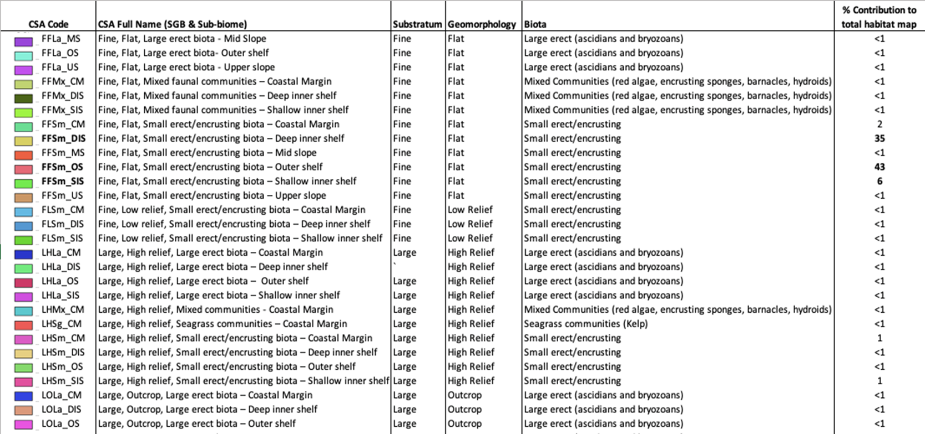
Table 2. CSA habitat codes, full names and percentage contribution to of each habitat to the total CSA habitat map. Definitions are based on substratum, geomorphology, biota and sub-biome. Habitat codes in bold are the three CSA habitats which dominate the study area.

Column headings
Table 3. Format (column headings) of information provided in the ‘CSA Sorted by Gear.xls Spreadsheet’. See section 7 for more detailed information on how scoring (1-3) was assigned. See also L2. CSA (Habitats); Draft_Scoring_Info.xlsx spreadsheet tab CSA_Scored
Grouping of columns |  | Column heading | Purpose / Definition
 |  | CSA Habitat Code | CSA codes (e.g. FFSm_OS) relate to substratum/geomorphology/biota (SGB) i.e. FFSm = Fine flat small erect/encrusting; and sub-biome i.e. OS = Outer Shelf
 | Habitat definition | Substratum | Fine, Medium, Large
 |  | Geomorphology | Flat, Low relief, Outcrop, High relief
 |  | Biota (Scoring Table) | Large/Small erect, No Fauna or Flora, Flora
 |  | Sub-biome (drop down) | e.g. Deep-inner shelf (60-100m)
 | Gear type | OSPAR Gear type | Beam, Dredge, Otter, Seine
Consequence Score (1-3) | Productivity | Regeneration of biota | Scored 1-3 (annual = 1, less than decadal = 2, more than decadal = 3)
 |  | Natural disturbance | As above (1-3 according to depth)
 | Gear-habitat interaction  (For Beam Trawling only) | Removability of biota | Scored 1-3 (1 = Low risk; 3 = High risk; Default for biota & depth)
 |  | Removability of substratum | Scored 1-3 (Default for gear type)
 |  | Substratum hardness | Scored 1-3 (Default for gear type)
 |  | Substratum ruggedness | Scored 1-3 (Default for gear type)
 |  | Seabed slope | Scored 1-3 (Inputted as ‘1’ - low degree of slope - for all CSA habitats as accurate information on geomorphology and associated slope was not available)
 |  | Consequence Score | Calculated as the average of habitat -gear interaction scores. The two habitat productivity scores are given twice the weight of the habitat-gear interaction scores
Spatial Score (0.5-3) |  | Gear footprint | All gear types scored as 3
 |  | Spatial Overlap (%) | % overlap of the habitat with the gear activity calculated from a GIS file
 |  | Spatial overlap score | Scored 1-3 based on % spatial overlap
 |  | Encounterability | Either 3 ‘flat’ or ‘low relief’ habitats or 0.5 for ‘outcrop’ or ‘high relief’ habitats
 |  | Spatial score | Geometrical average across spatial scoring variables; gear footprint, spatial overlap and encounter-ability
 |  | CSA Risk Score | Automatically calculated using a geometrical average across the Consequence and Spatial scores
 |  | MSC CSA-derived score | Probability (%) that there would be “reductions in habitat structure, biological diversity, abundance and function such that the habitat would be unable to recover to at least 80% of its unimpacted structure, biological diversity and function within 5-20 years, if fishing were to cease entirely (seebelow)”  Derived from CSA risk score using MSC calibration
 |  | Risk category | High, Med, Low
 |  | MSC scoring guidepost | <60% = High risk, 60-79% = Medium risk, >= 80% = Low risk (see below)

MSC scoring guidepost
In this assessment we have used the MSC approach to categorising habitats as high, medium and low risk. This is intended to measure risk of;

“Reductions in habitat structure, biological diversity, abundance and function such that the habitat would be unable to recover to at least 80% of its unimpacted structure, biological diversity and function within 5-20 years, if fishing were to cease entirely” (MSC, 2019)

The calibration of these risk levels is described in probability terms;

- High risk means that there would be no more than a 40% probability that the habitat is in the state described above, which would correspond to a score of less than 60 (automatic fail) in an MSC assessment.

- Medium risk means that there would be no more than a 30% probability that the habitat is in the state described above, which would correspond to a score of 60-79 (conditional pass) in an MSC assessment, where further action would be expected

- Low risk means that there would be no more than a 20% probability the habitat would be in the state described above and correspond to >80 in an MSC assessment.

Case Study: Beam trawl fishery
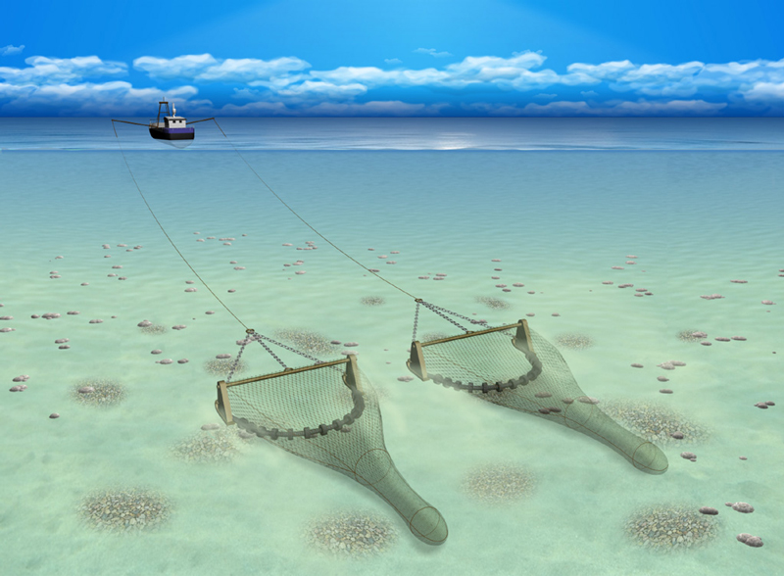
Figure 3. Beam trawl schematic (Image source: Seafish)

Fishing activity and habitats

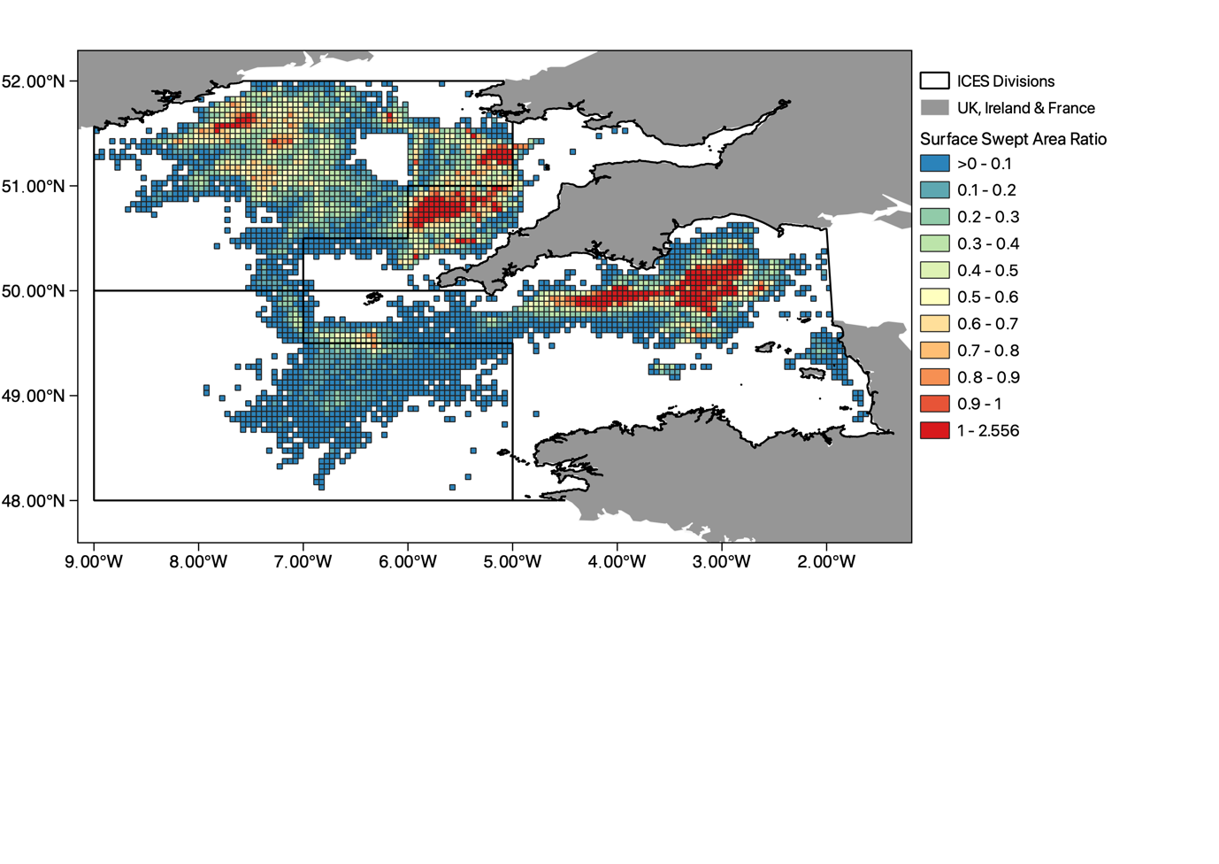
Figure 4. Beam trawl activity displayed using surface swept area ratio (SAR, yr⁻¹) in ICES division 7 e-h. SAR is displayed at 0.05°x 0.05° resolution (c-squares). White areas represent no beam trawl activity.

Beam trawl activity is concentrated off the (Fig. 4):
- South coast of Ireland
- South coast of Devon and Cornwall and;
- Between the north coast of Cornwall and south coast of Wales

Beam trawl activity intersects with 24 habitats, however, mostly occurs in (Fig.5):
- Fine flat small erect/encrusting biota – shallow inner shelf (FFSm_SIS),
- Fine flat small erect/encrusting biota – deep inner shelf (FFSm_DIS) and;
- Fine flat small erect/encrusting biota – outer shelf (FFSm_OS)
These habitats all share the same SGB attributes (fine sediment, relatively flat surface structure & small erect/encrusting/burrowing biota e.g. polychaetes, bivalves, amphipods) but occur at different depths.

Some beam trawling also occurs in (Fig. 5):
- Medium flat small erect/encrusting biota – coastal margin (MFSm_CM) and;
- Medium flat mixed faunal communities – shallow inner shelf (MFMx_SIS)

Figure 5. Spatial overlap intersection of beam trawl footprint with CSA habitats in ICES divisions 7e-h. White areas represent no intersection. Refer to Table 6 for CSA codes and full habitat descriptions.

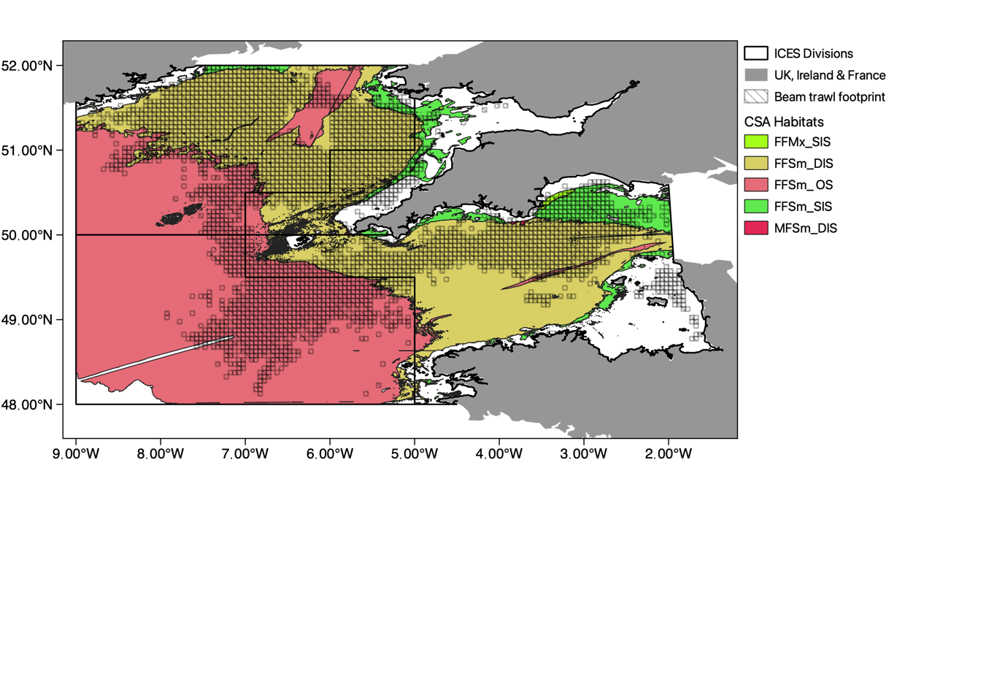
Figure 6. Habitats scored as high and medium risk to beam trawling activity following results from Consequence Spatial Analysis (CSA), with beam trawl footprint overlayed. Refer to Table 6 for CSA codes and full habitat descriptions.

Risk assessment

Spatial overlap between beam trawling and individual habitats

Ranged from <1% to 65%

Habitats identified as high risk from beam trawling
- Fine flat small erect/encrusting biota – deep inner shelf (FFSm_DIS)
- Fine flat mixed faunal communities – shallow inner shelf (FFMx_SIS)
(Due to their high intersection with beam trawling - see spatial overlap % and score)

It is important to highlight the comparison in relative risk between these habitats. They share similar spatial overlap % with beam trawl activity (FFSm_DIS; 68% overlap, and FFMx_SIS; 58% overlap).
Additionally, FFSm_DIS accounts for 35% of all habitats, whilst FFMx_SIS accounts for only <1% of habitats in ICES divisions 7e-h.

Habitats identified as medium risk from beam trawling
- Medium flat small erect/encrusting biota – deep inner shelf (MFSm_DIS)
- Fine flat small erect/encrusting biota – shallow inner shelf (FFSm_SIS)
- Fine flat small erect/encrusting biota – outer shelf (FFSm_OS)
These high/medium risk habitats are all relatively:
- Flat
- Fine or medium sized substratum
- Support small erect/encrusting/burrowing biota (e.g. polychaetes, bivalves, amphipods) or mixed faunal communities (e.g. seapens, burrowing anemones, Amphiura spp).

Habitats identified as low risk from beam trawling
- Medium/large substratum
- Low relief geomorphology
- Rocky outcrop geomorphology
- Large erect biota (i.e. ascidians, bryozoans or sponges)
- Kelp and seagrass communities and mixed communities (i.e. red algae, encrusting sponges, barnacles) are also at low risk (mostly inshore)
(It is expected that such habitats would be avoided by beam trawlers)
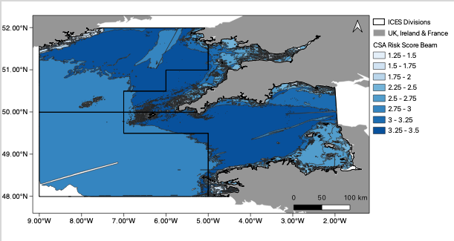
Figure 7. Map showing CSA Risk Score for beam trawl fisheries within the assessment area. Dark grey lines show the boundaries between pre-defined habitat types, see Fig. 6 for context.

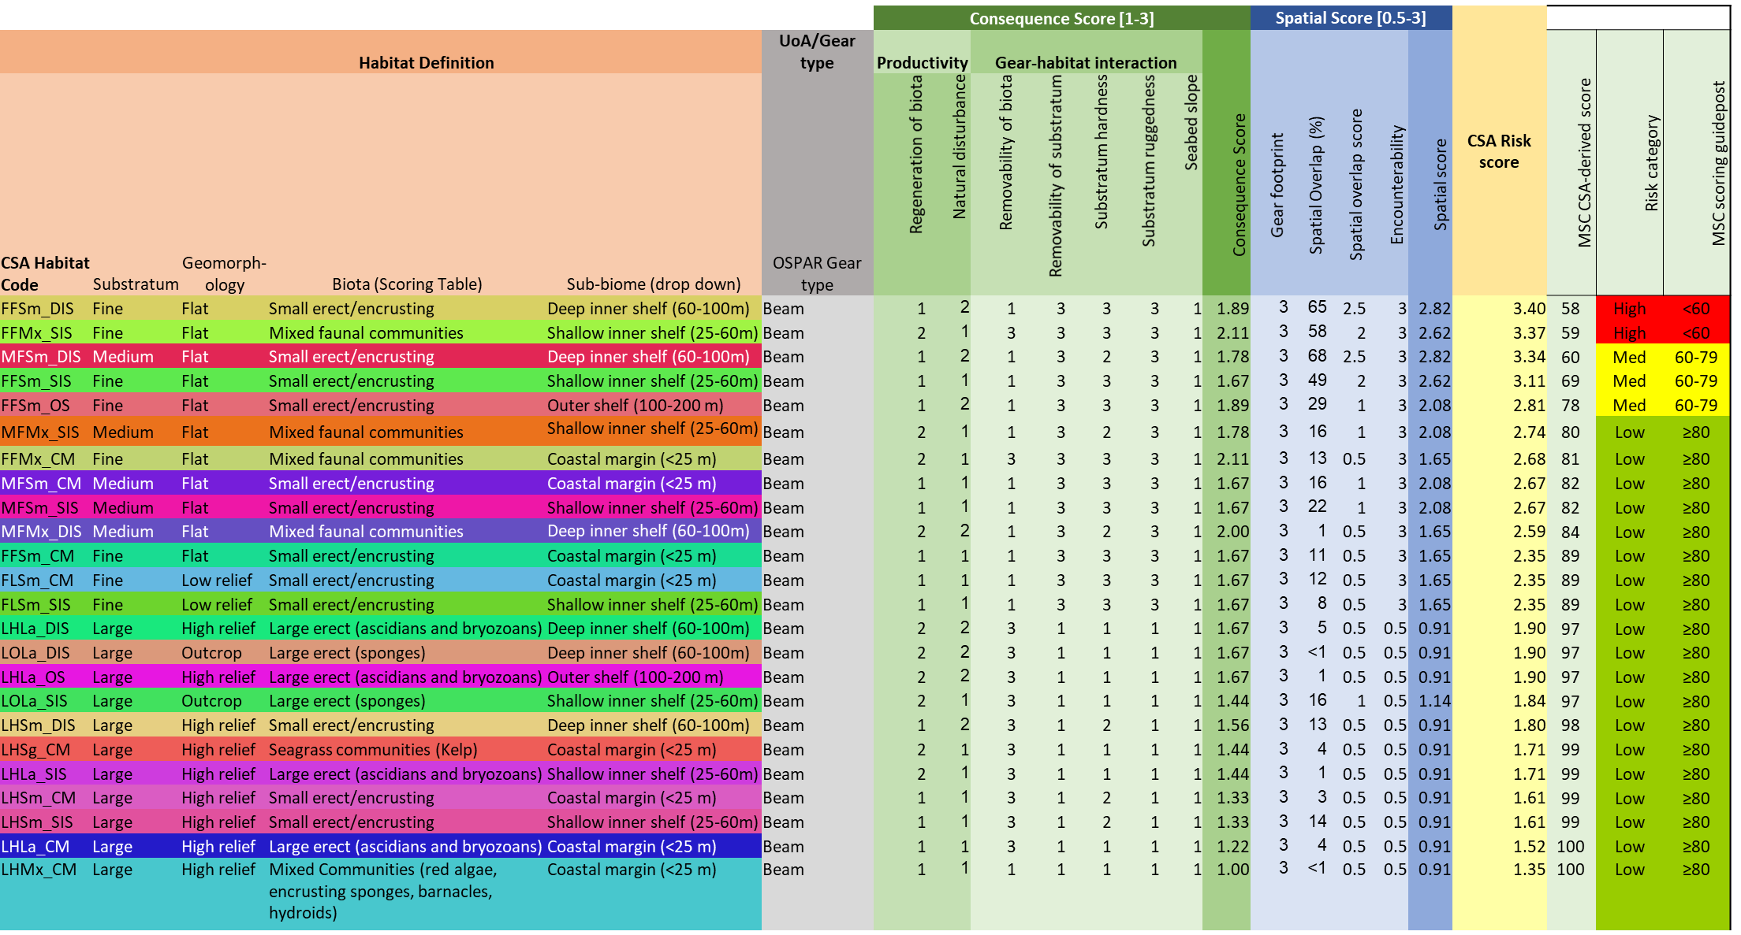
Table 4. Consequence Spatial Analysis worksheet based on MSC worksheet for risk-based framework (PI 2.4.1). Rank scoring, CSA risk score and MSC risk scoring displayed for CSA habitats which interact with beam trawl activity in ICES divisions 7 e-h (colour coding corresponds to CSA habitat code).

Summary of the impacts of each gear type

The CSA has identified the impact of the 4 gear types as follows:

- Otter trawling – 9 high risk and 7 medium risk habitats out of 32 habitats
  - Otter trawls have a larger footprint than the other gear types, they therefore posed a high or medium risk to the most habitat types as the overall CSA risk score is driven largely by the ‘Spatial overlap’ attribute

- Dredge activity - 2 high risk and 7 medium risk habitats out of 23 habitats
  - Dredges may present a greater localised impact due to their associated depletion rate (20%) which is higher than that of seines, otter, or beam trawls

- Beam trawl - 2 high risk and 3 medium risk habitats out of 24 habitats

- Seining - no habitats were ranked as high risk

(details of which habitats were ranked as high or medium risk are outlined in table 5).

Table 5. Summary of the habitat types deemed to be at high and medium risk from each gear type (seine not included as no all habitats were deemed to be at low risk from this gear type). See table 6 for a translation of CSA codes.
Gear type | Habitat CSA code | CSA Risk Score
Otter | FFMx_DIS | High
 | MFMx_OS
 | FFMx_SIS
 | FFSm_DIS
 | FLSm_DIS
 | MFSm_DIS
 | FFSm_OS
 | MFMx_DIS
 | FFMx_CM
 | FFSm_SIS | Medium
 | MFSm_OS
 | MFMx_SIS
 | FLSm_CM
 | MFSm_CM
 | MFSm_SIS
 | FFSm_CM
Dredge | FLSm_DIS | High
 | FFMx_SIS
 | MFSm_DIS | Medium
 | FFMx_CM
 | FFSm_SIS
 | FFSm_DIS
 | FLSm_CM
 | MFSm_SIS
 | MFMx_DIS
Beam | FFSm_DIS | High
 | FFMx_SIS
 | MFSm_DIS | Medium
 | FFSm_SIS
 | FFSm_OS

Scoring system

The information collected for each gear type will be used to assign a score reflecting their relative ecological risk from fishing activities in the assessment area.

Habitat Productivity attributes

Habitat Productivity Attributes | - Regeneration of biota (annual = 1, less than decadal = 2, more than decadal = 3)
 |  | No epifauna | Small erect/ encrusting | Large erect (sponges) | Large erect (ascidians and bryozoans) | Seagrass communities/ mixed faunal communities/ hard corals | Crinoids/ solitary/mixed communities/ hard and soft corals
 | Coastal margin (<25 m) | 1 | 1 | 1 | 1 | 2 | 1
 | Shallow inner shelf (25-60m) | 1 | 1 | 2 | 2 | 2 | 2
 | Deep inner shelf (60-100m) | 1 | 1 | 2 | 2 | 2 | 2
 | Outer shelf (100-200 m) | 1 | 1 | 3 | 2 | 3 | 3
 | Upper slope (200-700 m) | 1 | 1 | 3 | 3 | 3 | 3
 | Mid-slope (700-1,500 m) | 1 | 2 | 3 | 3 | 3 | 3
 | - Natural Disturbance
 | Coastal margin (<25 m) | 1 | Scores apply to all biota / gears
 | Shallow inner shelf (25-60m) | 1
 | Deep inner shelf (60-100m) | 2
 | Outer shelf (100-200 m) | 2
 | Upper slope (200-700 m) | 3
 | Mid-slope (700-1,500 m) | 3

Gear-habitat interaction attributes
Gear-habitat interaction attributes |  | Hand collection (i) | Demersal longline (iv) | Handline (ii) | Trap (iii) | Bottom gill net / entangling net (v) | Danish seine (vi) | Demersal trawl (pair, otter twin-rig, & otter multi-rig) (vii) | Dredge (viii)
 | - Removability of Biota
 | Low, robust, small (<5 cm), smooth, or flexible biota OR robust, deep-burrowing biota | 1 | 1 | 1 | 1 | 1 | 1 | 1 | 3
 | Erect, medium (<30 cm), moderately rugose, or inflexible biota OR moderately robust, shallow-burrowing biota | 1 | 1 | 1 | 2 | 2 | 2 | 3 | 3
 | Tall, delicate, large (>30 cm high), rugose, or inflexible biota OR delicate, shallow-burrowing biota | 1 | 2 | 2 | 2 | 3 | 3 | 3 | 3
 | - Removability of Substratum
 | Immovable (bedrock and boulders >3 m) | 1 | 1 | 1 | 1 | 1 | 1 | 1 | 1
 | <6 cm (transferable) | 1 | 1 | 1 | 1 | 1 | 2 | 3 | 3
 | 6 cm -3 m (removable) | 2 | 1 | 1 | 1 | 1 | 3 | 3 | 3
 | - Substratum hardness
 | Hard (igneous, sedimentary, or consolidated rock types) | 1 (all gears)
 | Soft (lightly consolidated, weathered, or biogenic) | 2 (all gears)
 | Sediments (unconsolidated) | 3 (all gears)
 | - Substratum ruggedness
 | High relief (>1 m), high outcrop, or rugged surface structure (cracks, crevices, overhangs, large boulders, rock walls) | 3 | 2 | 2 | 2 | 2 | 1 | 1 | 1
 | Low relief (<1.0 m), rough surface structure (rubble, small boulders, rock edges), subcrop, or low outcrop | 3 | 3 | 3 | 3 | 3 | 1 | 3 | 1
 | Flat, simple surface structure (mounds, undulations, ripples), current rippled, wave rippled, or irregular | 1 | 3 | 3 | 3 | 3 | 3 | 3 | 3

Seabed slope
Low degree (<1): plains in coastal margin, inner or outer shelf or mid-slope OR terraces in mid-slope OR rocky banks/ fringing reefs in coastal margin, inner or outer shelf, or upper or mid-slope | 1 (all gears)
Medium degree (1-10): terraces in outer shelf or upper slope | 2 (all gears)
High degree (>10): canyons in outer shelf, or upper or mid-slope OR seamounts/ bioherms in coastal margin, inner shelf, or upper or mid-slope | 3 (all gears)

Score Spatial Attributes: gear footprint
Hand collection | Demersal longline | Handline | Trap | Bottom gill net / entangling net | Danish seine | Demersal trawl (pair, otter twin-rig, and otter multi-rig) | Dredge
1 | 2 | 1 | 1 | 2 | 3 | 3 | 3

Score Other Spatial Attributes
Informed by a review of spatial patterns of gear use and habitat distribution (where possible).
Spatial Overlap | Gear overlap with habitat
 | ≤15% | >15 to ≤30% | >30 to ≤45% | >45 to ≤60% | >60 to ≤75% | >75%
 | 0.5 | 1 | 1.5 | 2 | 2.5 | 3
Encounterability | Likelihood of encounterability is
 | ≤15% | >15 to ≤30% | >30 to ≤45% | >45 to ≤60% | >60 to ≤75% | >75%
 | 0.5 | 1 | 1.5 | 2 | 2.5 | 3

Once the steps outlined above have been completed the overall risk score is automatically calculated.

Draft scoring will be submitted in advance of the Expert Group workshop, where CSA scores will be reviewed by all stakeholders.

Table 6. Summary of CSA habitat codes
CSA Code | Substratum | Geomorphology | Scoring Table Biota | Sub-Biome
LHSg_CM | Large | High Relief | Seagrass communities (Kelp) | Coastal Margin
LHSm_CM | Large | High Relief | Small erect/encrusting | Coastal Margin
LHMx_CM | Large | High Relief | Mixed Communities (red algae, encrusting sponges, barnacles, hydroids) | Coastal Margin
LHLa_CM | Large | High Relief | Large erect (ascidians and bryozoans) | Coastal Margin
MFSm_CM | Medium | Flat | Small erect/encrusting | Coastal Margin
FFSm_CM | Fine | Flat | Small erect/encrusting | Coastal Margin
LOLa_CM | Large | Outcrop | Large erect (ascidians and bryozoans) | Coastal Margin
FLSm_CM | Fine | Low Relief | Small erect/encrusting | Coastal Margin
FFMx_CM | Fine | Flat | Mixed Communities (red algae, encrusting sponges, barnacles, hydroids) | Coastal Margin
FFSm_SIS | Fine | Flat | Small erect/encrusting | Shallow Inner Shelf
FFMx_SIS | Fine | Flat | Mixed Communities (red algae, encrusting sponges, barnacles, hydroids) | Shallow Inner Shelf
LHSm_SIS | Large | High Relief | Small erect/encrusting | Shallow Inner Shelf
LHLa_SIS | Large | High Relief | Large erect (ascidians and bryozoans) | Shallow Inner Shelf
LOLa_SIS | Large | Outcrop | Large erect (ascidians and bryozoans) | Shallow Inner Shelf
MFSm_SIS | Medium | Flat | Small erect/encrusting | Shallow Inner Shelf
FLSm_SIS | Fine | Low Relief | Small erect/encrusting | Shallow Inner Shelf
MFMx_SIS | Medium | Flat | Mixed Communities (red algae, encrusting sponges, barnacles, hydroids) | Shallow Inner Shelf
FFSm_DIS | Fine | Flat | Small erect/encrusting | Deep Inner Shelf
FFMx_DIS | Fine | Flat | Mixed Communities (red algae, encrusting sponges, barnacles, hydroids) | Deep Inner Shelf
LHLa_DIS | Large | High Relief | Large erect (ascidians and bryozoans) | Deep Inner Shelf
LHSm_DIS | Large | High Relief | Small erect/encrusting | Deep Inner Shelf
LOLa_DIS | Large | Outcrop | Large erect (ascidians and bryozoans) | Deep Inner Shelf
MFSm_DIS | Medium | Flat | Small erect/encrusting | Deep Inner Shelf
MFMx_DIS | Medium | Flat | Mixed Communities (red algae, encrusting sponges, barnacles, hydroids) | Deep Inner Shelf
FLSm_DIS | Fine | Low Relief | Small erect/encrusting | Deep Inner Shelf
FFLa_OS | Fine | Flat | Large erect (ascidians and bryozoans) | Outer Shelf
FFSm_OS | Fine | Flat | Small erect/encrusting | Outer Shelf
LHSm_OS | Large | High Relief | Small erect/encrusting | Outer Shelf
LOLa_OS | Large | Outcrop | Large erect (ascidians and bryozoans) | Outer Shelf
MFMx_OS | Medium | Flat | Mixed Communities (red algae, encrusting sponges, barnacles, hydroids) | Outer Shelf
MFSm_OS | Medium | Flat | Small erect/encrusting | Outer Shelf
LHLa_OS | Large | High Relief | Large erect (ascidians and bryozoans) | Outer Shelf
FFLa_US | Fine | Flat | Large erect (ascidians and bryozoans) | Upper Slope
FFSm_US | Fine | Flat | Small erect/encrusting | Upper Slope
MFSm_US | Medium | Flat | Small erect/encrusting | Upper Slope
FFLa_MS | Fine | Flat | Large erect (ascidians and bryozoans) | Mid Slope
FFSm_MS | Fine | Flat | Small erect/encrusting | Mid Slope

 | For more information please contact:
 | Richard Caslake  Regional Manager - South West England  E: gus.caslake@seafish.co.uk | Seafish  18 Logie Mill,  Edinburgh  EH7 4HS  www.seafish.org

Data is summarised in the ‘L2. CSA (Habitats); Draft_Scoring_Info.xlsx’ spreadsheet and further information is provided in the summary document Consequence Spatial Analysis (CSA) for towed gear in the Celtic Sea (ICES 7e-h) summary report’ (both of which have been made available to the Expert panel)
The MSC Fisheries Standard | Marine Stewardship Council
Derived from: Williams et al. 2011. Evaluating impacts of fishing on benthic habitats: A risk assessment framework applied to Australian fisheries. Fisheries Research 112(3):154-167.
Details published by Vasquez et al. (2020). EUSeaMap 2019, A European broad-scale seabed habitat map, technical report. EASME/EMFF/2018/1.3.1.8/Lot2/SI2.810241– EMODnet Thematic Lot n° 2 – Seabed Habitats. https://doi.org/10.13155/74782
OSPAR data - ICES. 2019. Working Group on Spatial Fisheries Data (WGSFD). ICES Scientific Reports. 1:52. 144 pp. http://doi.org/10.17895/ices.pub.5648
WGFBIT - ICES. 2021. Working Group on Fisheries Benthic Impact and Trade-offs (WGFBIT; outputs from 2019 meeting). ICES Scientific Reports. 2:6. 101 pp. http://doi.org/10.17895/ices.pub.5955
Both the EUNIS Marine Classification 2019 spreadsheet and the EUNIS habitat search feature (https://eunis.eea.europa.eu/habitats.jsp) were used to obtain more detailed descriptions of habitats present within ICES divisions 7e-7h. Using this information, EUNIS habitats at level 3 classification were translated into CSA habitats based on substratum, geomorphology and depth.
For a full description of characteristics used in habitat definitions see summary document Consequence Spatial Analysis (CSA) for towed gear in the Celtic Sea (ICES 7e-h) summary report’
0.05° Latitude x 0.05° Longitude
ICES (2018) Spatial data layers of fishing intensity/ pressure per gear type for surface and subsurface abrasion, for the years 2009 to 2017 in the OSPAR regions II and III (ver. 2, 22 January, 2019): ICES data product release,https://doi.org/10.17895/ices.data.4686
CSA codes (e.g. FFSm_OS) listed in Table 1 relate to substratum/geomorphology/biota (SGB) i.e. FFSm = Fine flat small erect/encrusting; and sub-biome i.e. OS = Outer Shelf
The ‘CSA Scored Sorted by Gear’ spreadsheet provides information on the impact of each gear type (Beam, Dredge, Otter, Seine), with a separate tab for each.
See summary document Consequence Spatial Analysis (CSA) for towed gear in the Celtic Sea (ICES 7e-h) summary report for precise definitions of terms used in spreadsheet
Details and formulas used to calculate averages can be found in the L2. CSA (Habitats); Draft_Scoring _Info.xlsx spreadsheet
CSA framework instructs that dredge & demersal trawls should be scored as 3. The score for seine was adjusted to from 2 to 3 to reflect the relative impact of seining indicated by depletion rates calculated by Hiddink et al. (2017) Global analysis of depletion and recovery of seabed biota following bottom trawling disturbance. Proceedings of the Natural Academy of Science (both seine and otter trawls were assigned depletion rates of 0.06)
Note % Spatial overlap is in column AB outside the scoring table in the L2. CSA (Habitats); Draft_Scoring _Info.xlsx spreadsheet CSA scored tab, so that it did not affect the scoring calculations
Calibration of RBF scores into MSC default scoring has proved challenging, however by enabling us to understand and present relative risk, the risk scores produced enable the determination of which habitats should be management priorities. This CSA is not attempting to identify absolute impact.
Habitat with highest CSA risk score (3.40)
Also identified as high risk due to the fragility of some species present in this habitat (i.e. seapens Virgularia mirabilis and Pennatula phosphorea) in comparison to robust fauna such as polychaetes which are known to recover well to trawling events (Hiddink et al., 2017)
Hiddink et al. (2017). Global analysis of depletion and recovery of seabed biota following bottom trawling disturbance. Proceedings of the Natural Academy of Science: doi:10.1073/pnas.1618858114.

