Letter of support for Proposal IOTC-2021-SS4-PropD, as submitted by Kenya and Sri Lanka “On management of fish aggregating devices (FADs) in the IOTC Area of Competence”

Dear IOTC Secretariat

This letter serves to confirm support of its signatories for the titled CMM proposal, as recently submitted by Kenya and Sri Lanka for consideration during the upcoming Special Session of the Commission.

Signatories of this letter recognise the urgent need to improve FAD management in the Indian Ocean and consider this proposal to be both timely and suitable for this purpose. Successful implementation of this proposal will help facilitate rebuilding of the Indian Ocean yellowfin tuna stock, primarily by reducing catches of juvenile tropical tunas, but also by more broadly enabling sustainable management of modern purse seine fleets operations within the Indian Ocean. Implementation would also help mitigate other ecological impacts associated with drifting FADs, including those on turtles, sharks and marine mammals which are affected as direct bycatches, and through entanglement mortality with continued ghost fishing when FADs are lost, discarded or abandoned. The damage to coral reefs and other sensitive inshore habitats when FADs become stranded, as well as the contribution of FADs to marine debris and marine plastic pollution, could also be mitigated through implementation of this proposal.

Following various requests by NGOs and market stakeholders for CPCs to actively help resolve the overfished stock condition of yellowfin tuna in the Indian Ocean, we also take this opportunity to commend Kenya and Sri Lanka for their submission of this aligned proposal. We are encouraged to see coastal states taking a leadership position on these important matters and sincerely hope that more CPCs, and other stakeholders, will also show their support for this proposal as we collectively pursue sustainable management and thriving tuna fisheries throughout the IOTC area of competence.

Yours sincerely

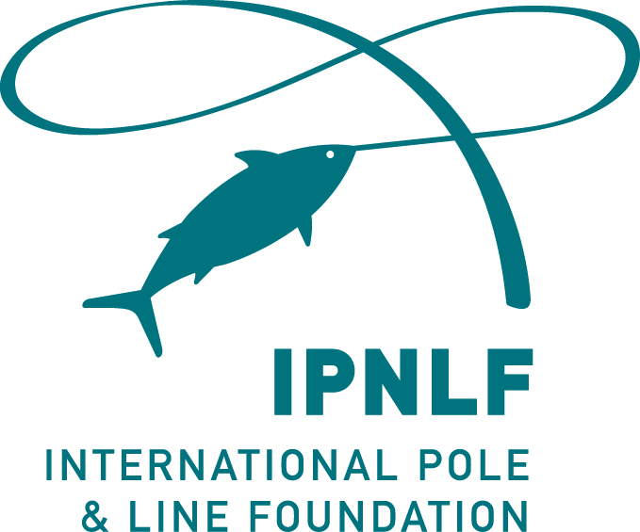 | 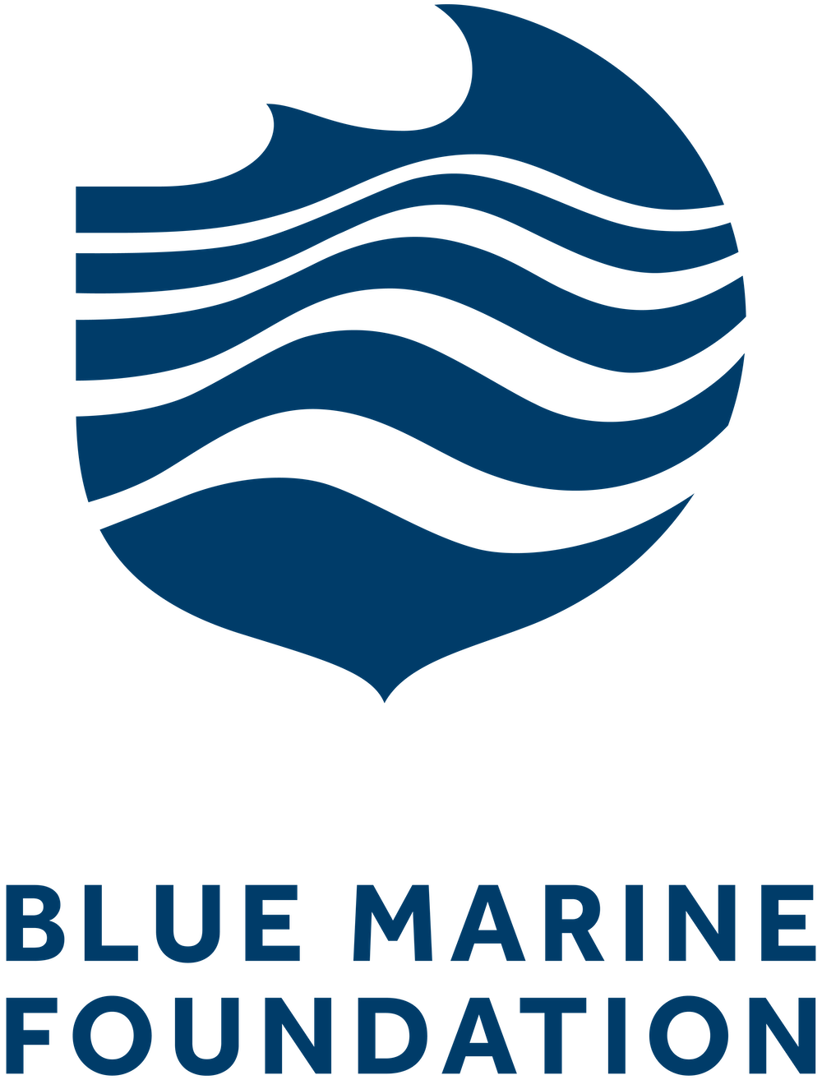
 | 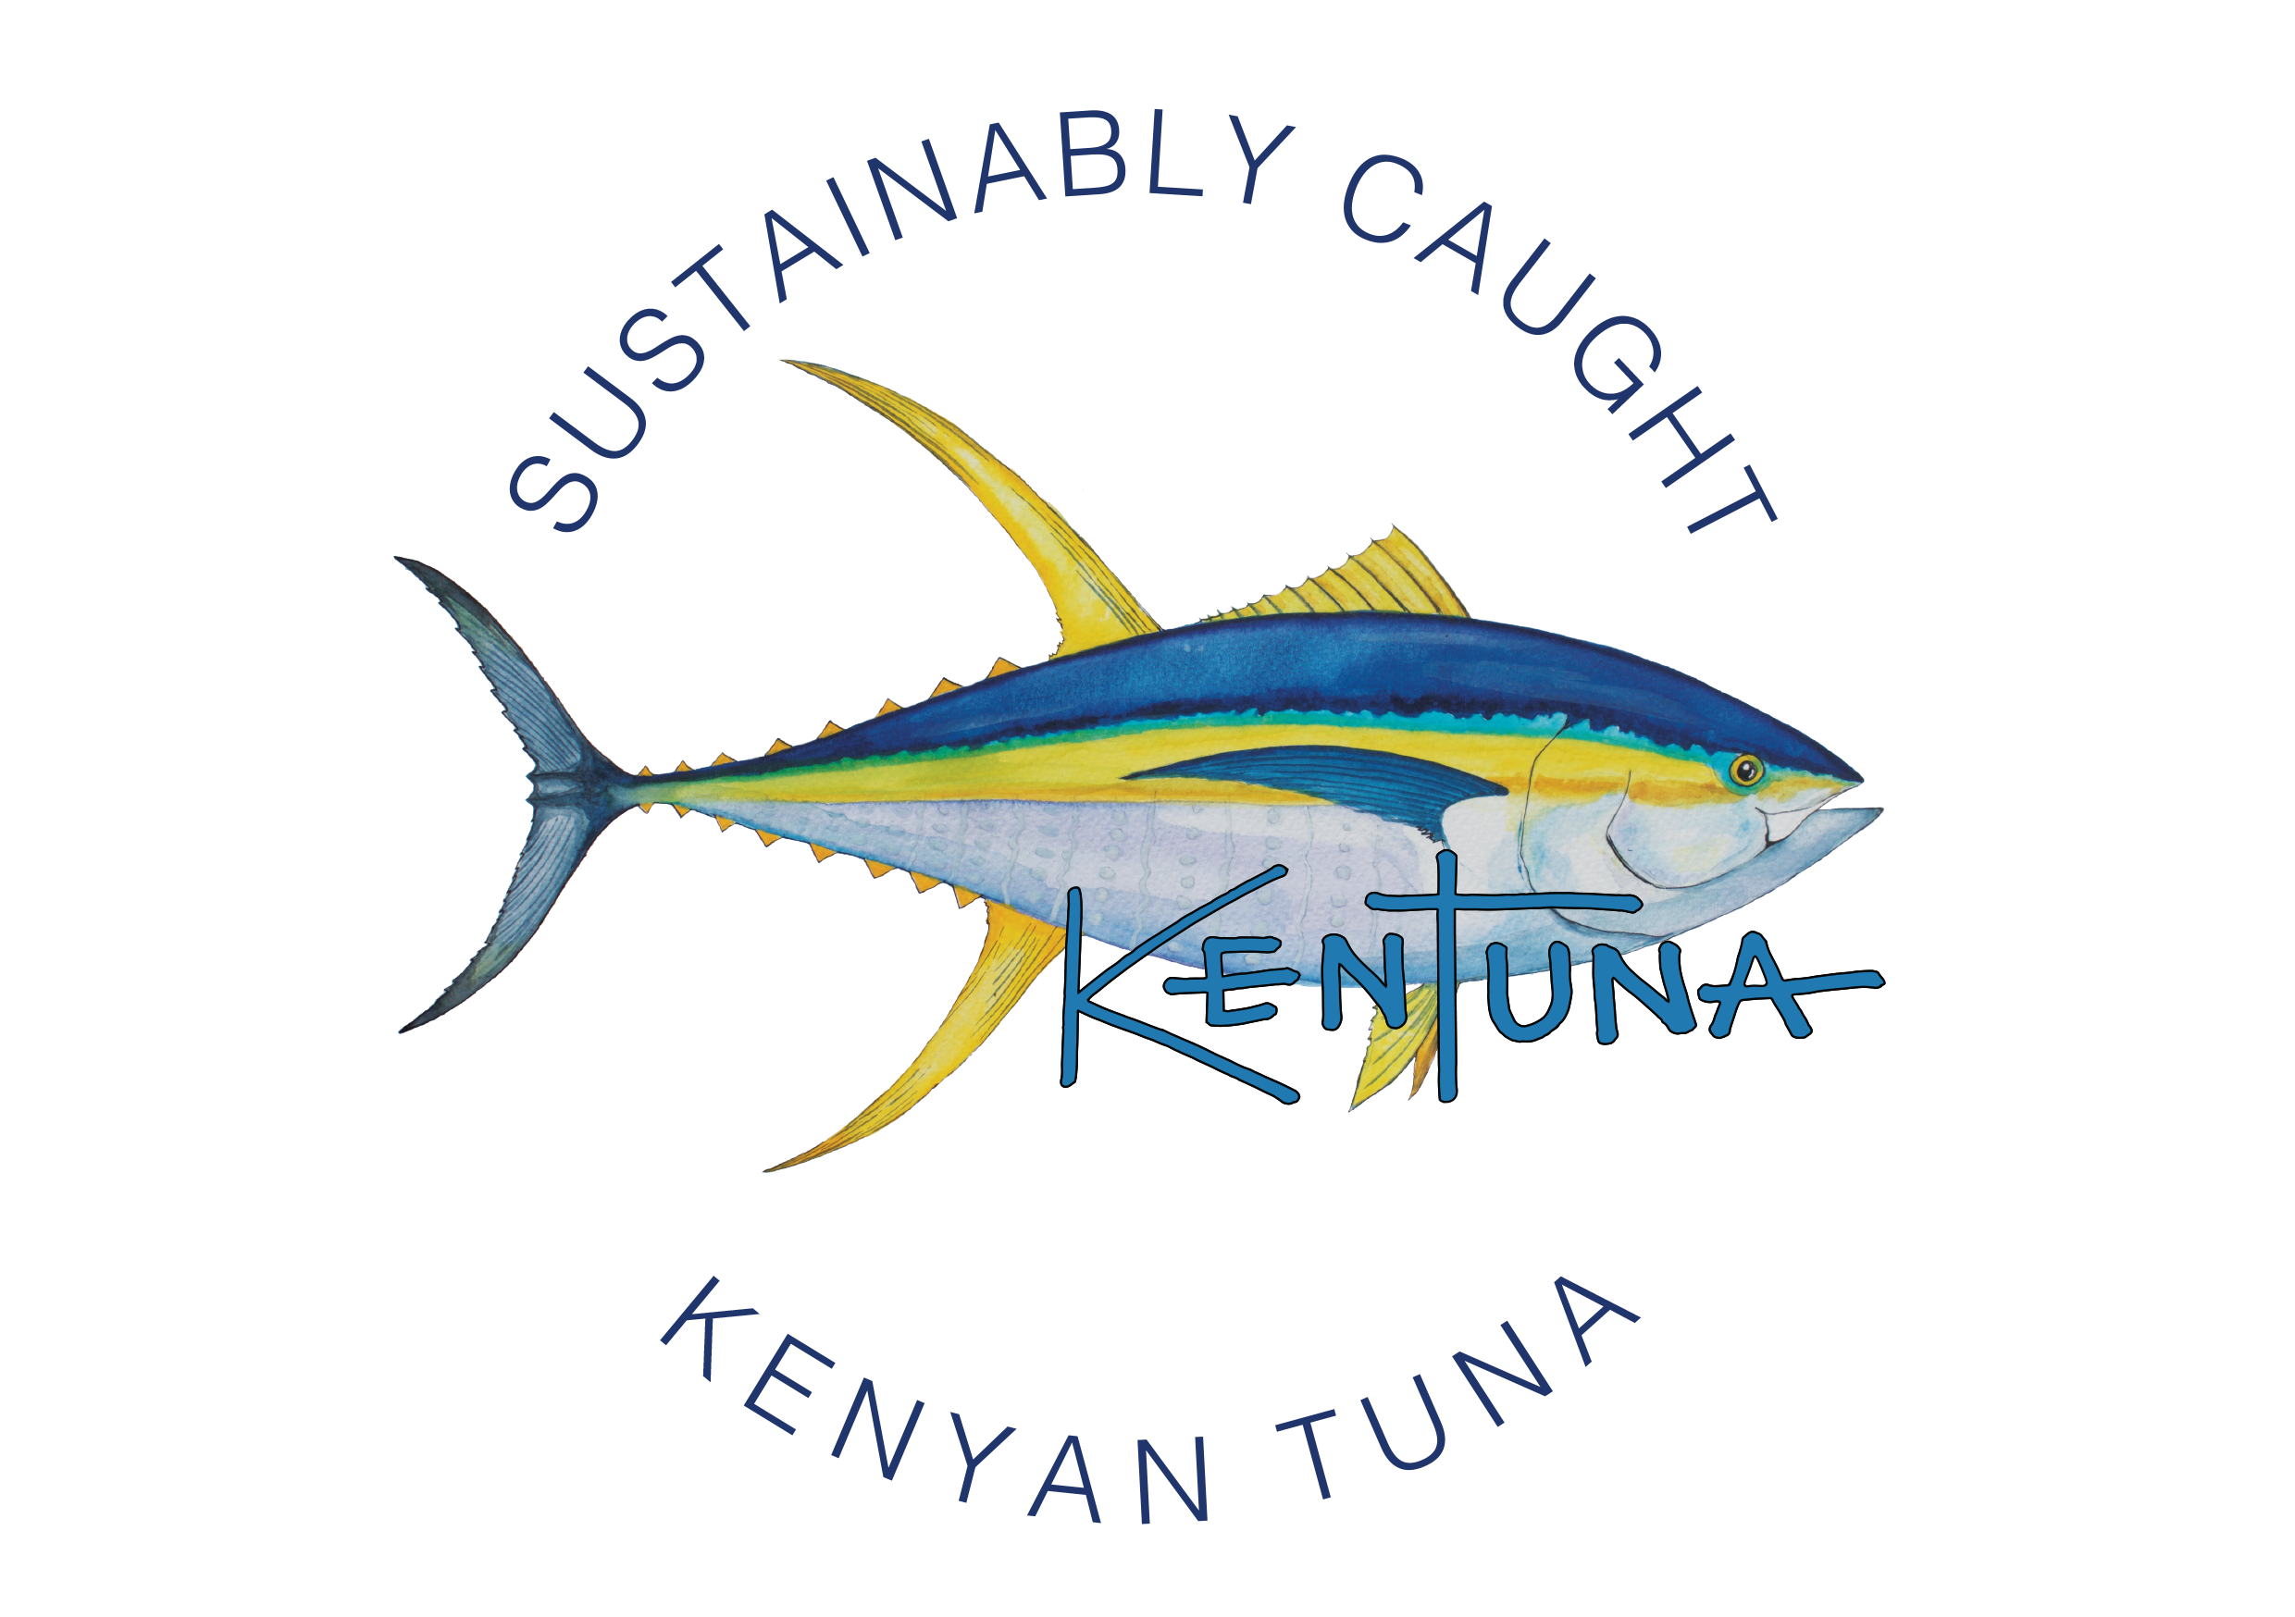 | 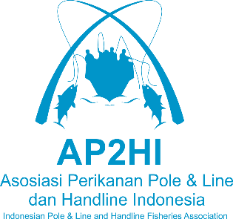
 | 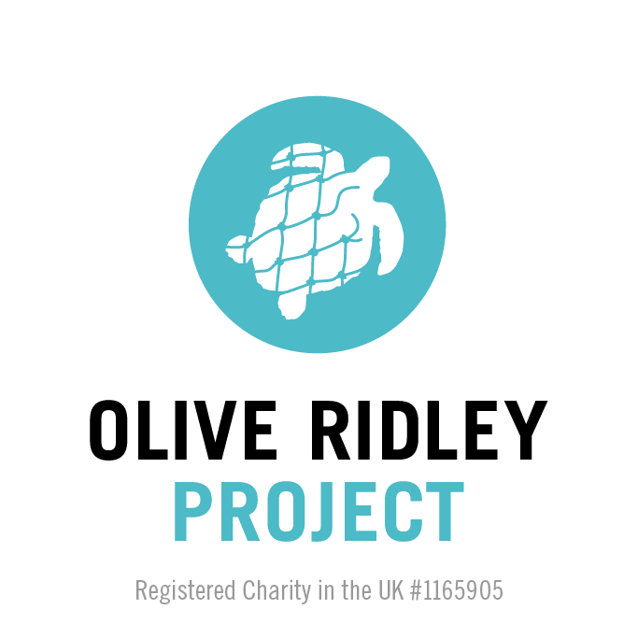
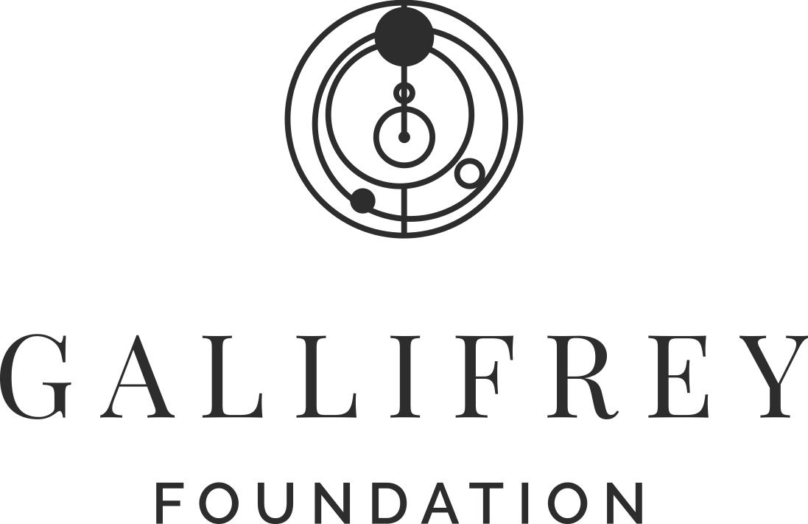 | 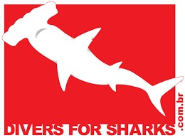
 | 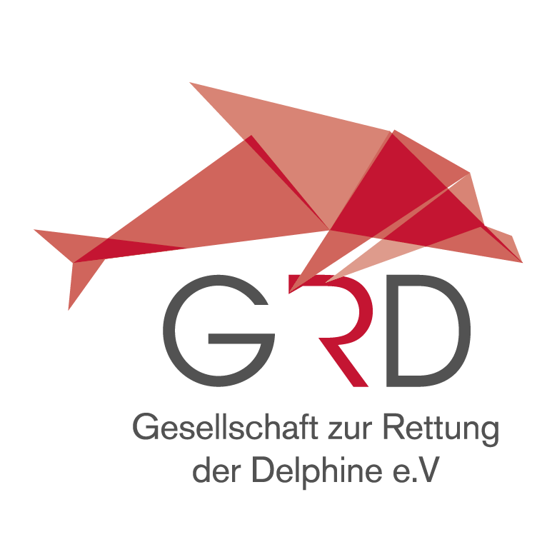 | 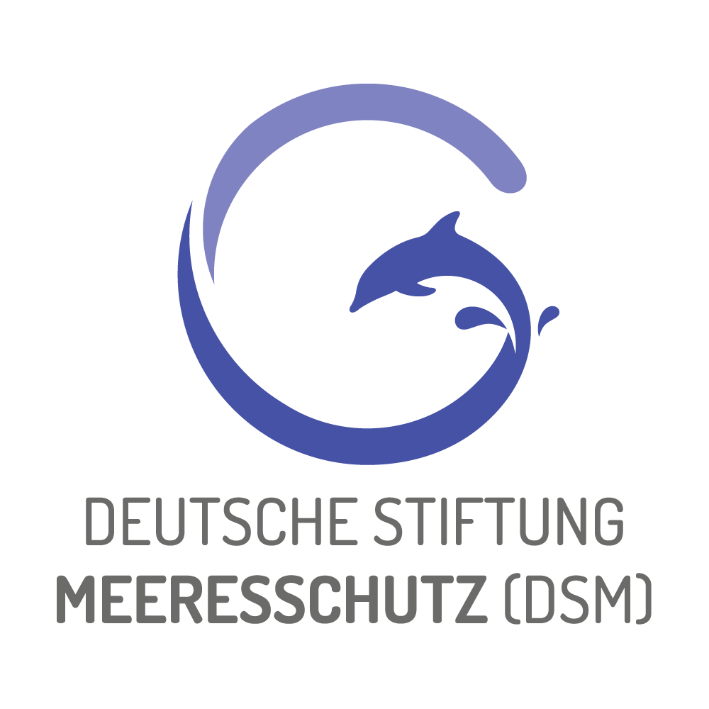
 |  | 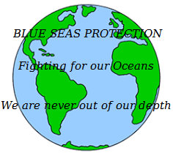
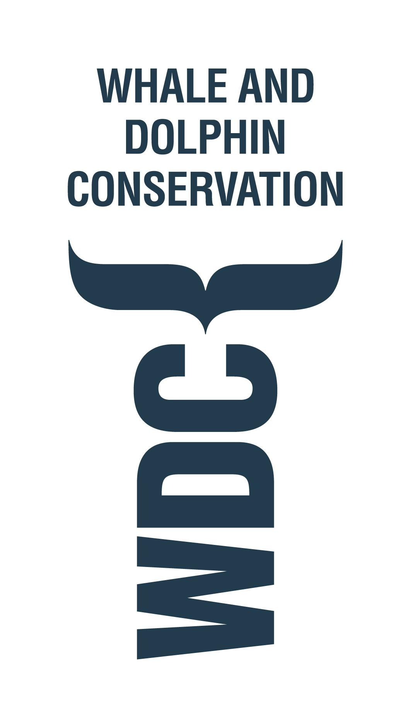 | 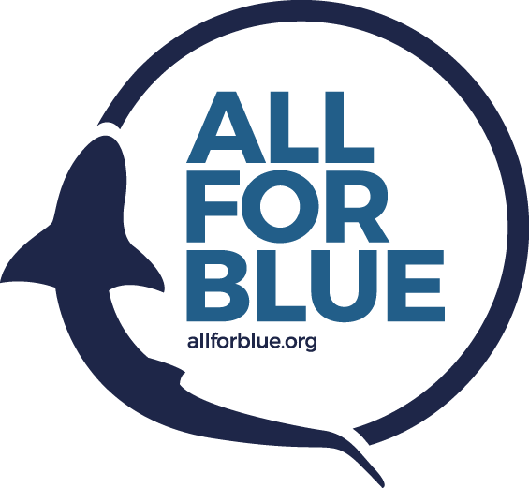 | 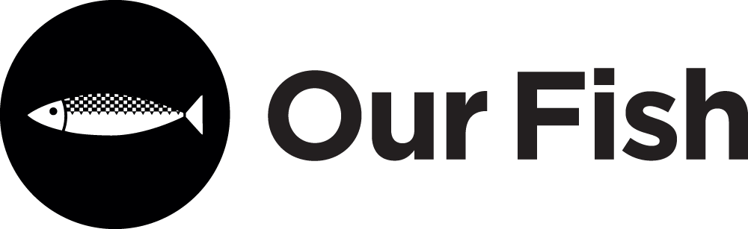
 |  | 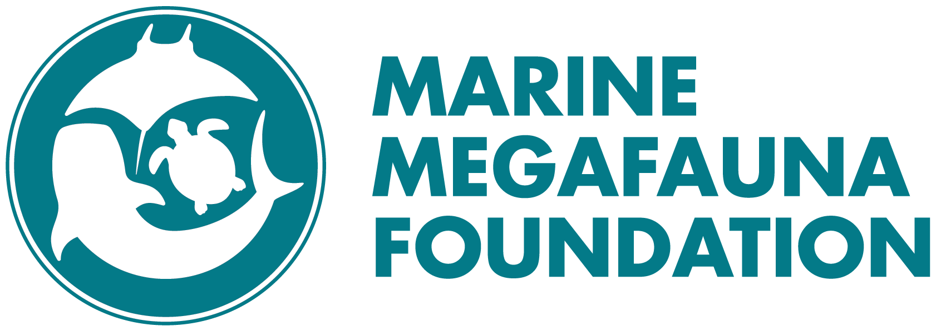
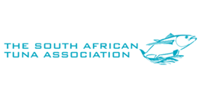 | KASA | 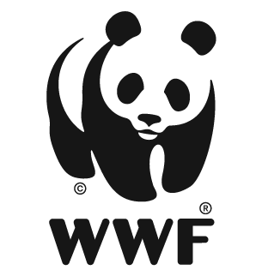
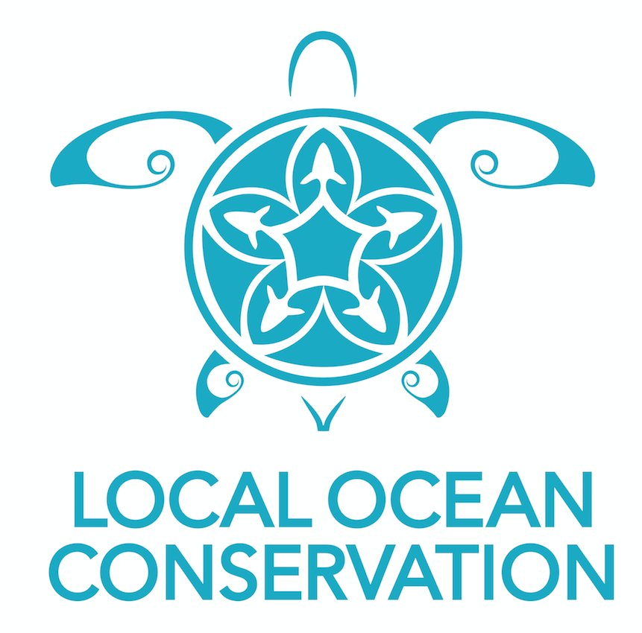 |  | IWC?
 | TNC | CORDIO East Africa?
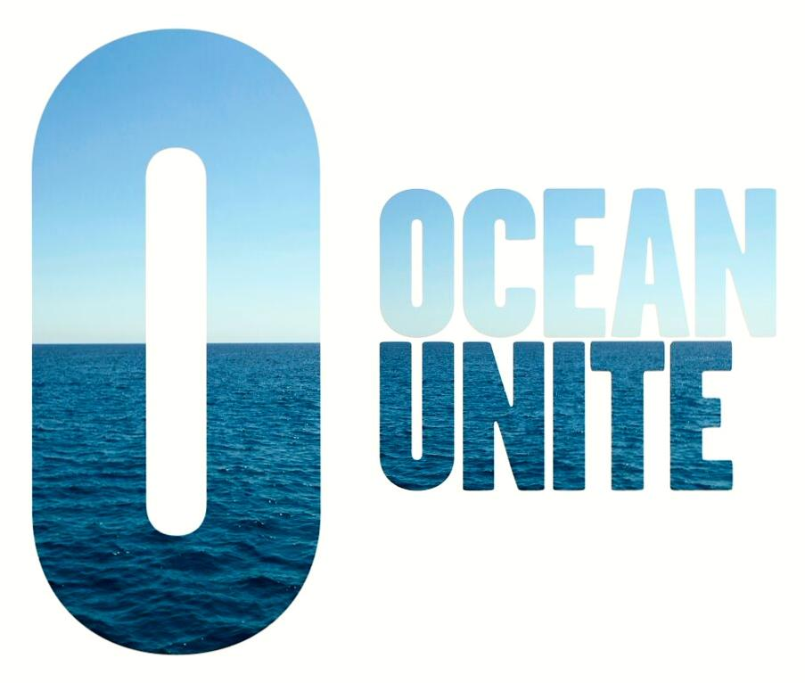 |  | 