Meeting note with Shantou Agriculture and Rural affair Bureau
(2022-07-30)

Participants: Hongbin Li (CEO, Haimao Ltd.), Fenjie Chen (FIP Facilitator), Xiangyu Lin (Director of Fisheries Affairs), Dongri Zheng (Director of Fisheries enforcement)

Summary of Meeting:

- The bureau confirmed the existence of legal dispute solutions for the current FIP fishery and all local fisheries generally. The fishermen are allowed to through the local fishing cooperative, local bureau, and court to complain about his/her issues, and if the dispute is under the managing scope, then the management body will help fishermen resolve the legal disputes. The municipal and country-level bureaus are all set up with complaint mailboxes for fishermen to contact the bureau for legal disputes and other questions they may have. While the effectiveness of legal dispute solution is not known from the interview;
- The consultation process is widely existing for many fisheries policies and regulations. Not only the municipal bureau will visit the country-level bureau and fishermen to collect their opinions about any new policies before they come into force, but also the provincial government will visit the municipal bureau to collect similar feedback for any new policies or management measures. But interviewee indicated the reduction of provincial level visits in recent years. If the new policies or regulations receive strong resistance from local fishermen, then the municipal bureau will provide such feedback back to the provincial government and indicate the difficulty of implementing new policy/regulation locally. This process is believed to be conducted regularly based on the interview, But we do not know the openness of the consultation process to all fisheries stakeholders and will need to confirm on next step interview;
- The specific management for the FIP fishery is currently missing. Part of the reason is there are many complicated backgrounds as obstacles to stopping any further management regulation implementation. For example, the overcapacity fishing efforts (vessels), the balance between keeping the fishermen's livelihood and conserving the fisheries' resources, and many others. The local bureau indicated there had been a natural decrease in fishing vessels in the last decades, from more than 3000 vessels to now more than 1000 vessels, but still, many issues/challenges hinder the specific management plan to implement. Suggest infeasible to conduct any specific management plan for the FIP fishery in the near future;
- Regarding the precautionary approach in the decision marking process, there are some precautionary approaches taken during the decision-making process but more focus on maintaining the livelihood of fishermen and keeping the social stability, but less focus on the resources conservations. Part of the reason may be the lack of awareness of conservation. There is a need to educate local and national government bodies on this aspect.
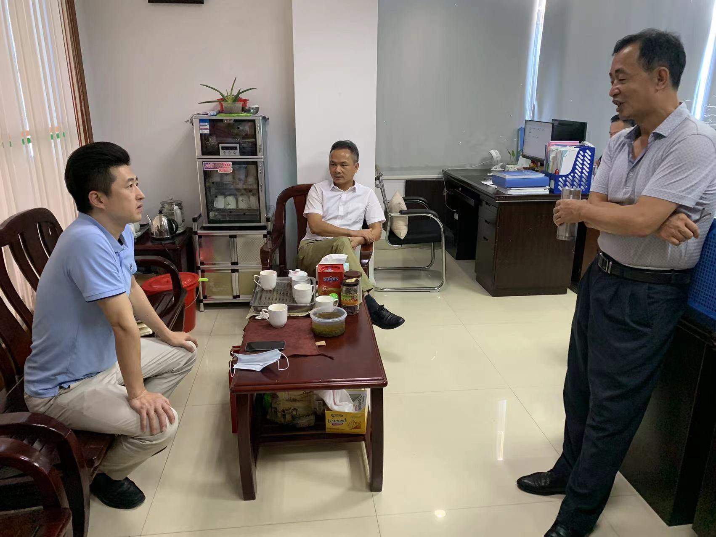
The snapshot of the interview/visit

