Minutes of meeting
FIP Updates to stakeholders
31th May 2022
UNDIP

Participants:
- PT. Cassanatama team
- UNDIP lecturer
*attendance list

The purposes of this meeting are:
- Share updates on the FIP activities and action plan
- Discuss join activities on student research and situation of WPP (Fisheries Management Area – FMA) 712
- Updates on existing research by UNDIP students in the KAMPUS MERDEKA program
- Further cooperation between the company and UNDIP in the FIP or beyond FIP

Result and Discussion:
- UNDIP team really interested to explore further on the research topics within shrimp fisheries, not only on stock status and ecosystem aspect, but also others including spatial, socio economic of the fishery
- There will be site visit by UNDIP lecturer to see the location to get a better understanding of the fishery landscape and fishers involved in the FIP
- Previous research still undergoing and the results will be shared to the company and FIP
- There are also opportunities to have intern not only in the FIP, but also in the factory and production line of the company
- UNDIP is part of the FMA 712 committee and will try to engage them in the shrimp fishery and start thinking about specific shrimp fishery management in the FMA

Pictures:
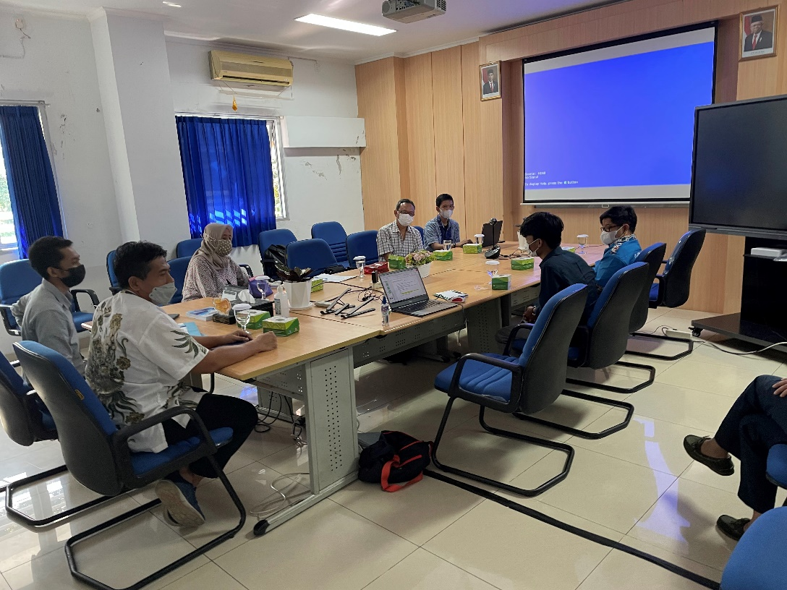

FIP Updates at UNDIP meeting room
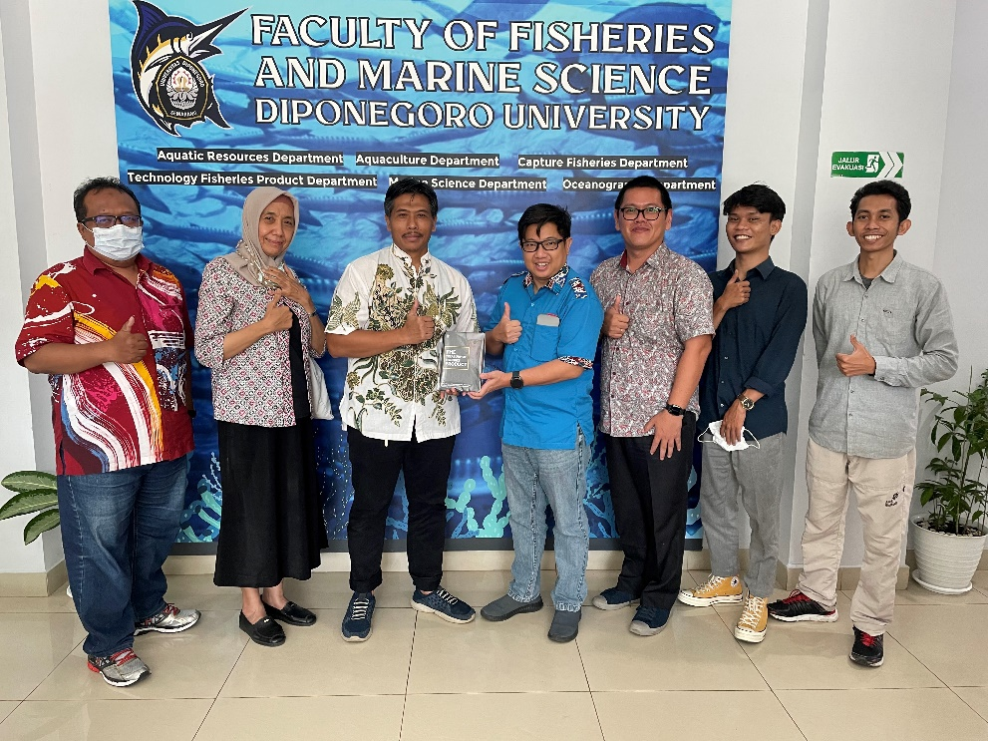

Group photo with UNDIP team

