FIP implementation- Stakeholder meeting to discuss progress of Y1Q2 action plan of MSC certification of Kerala shrimp & cephalopod trawl fishery
Minutes of meeting
Meeting title | Y1Q2 FIP action plan progress discussion workshop– MSC Certification – FIP implementation
Date | 24th June 2019
Time | 11.00 am – 12.00 noon
Place | MFD Seminar hall, CMFRI, Kochi
Chairperson | Dr Sunil Mohammed, CMFRI
Attended by | - Dr. T. V. Sathianandan, CMFRI  - Dr. G. Maheswarudu, CMFRI  - Dr. Josileen Jose, CMFRI  - Dr. S. Lakshmi Pillai, CMFRI  - Dr. Rekhadevi Chakraborty, CMFRI  - Dr. V. R. Madhu, CIFT  - Mr. Chinnadurai, CIFT  - Dr. Vinod Malayilethu, WWF-India  - Dr. Ranjit S, MSC-India  - Mr Ramakrishnan S, SEAI  - Mr. Joseph Xavier Kalappurackal, AKFBOA  - Dr. Vineetha A., FIP Coordinator
Agenda | - Discussion of progress of FIP action plan Y1Q2

Welcome address:
Mr Ramakrishnan S, SEAI

Opening of discussion:
Dr. Sunil Mohammed, CMFRI

Y1Q2 Actions:

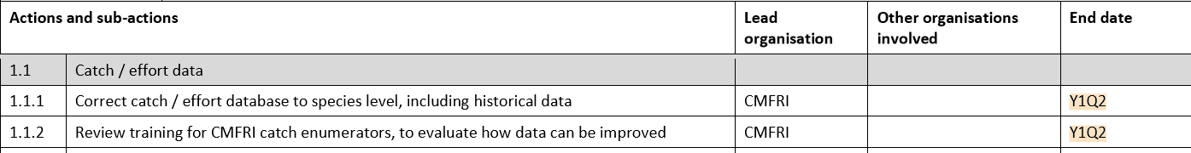

Discussion:
- To provide correct catch/effort data and to improve the data quality of FRAD database a meeting of CMFRI scientists was held at CMFRI on 19th June 2019. (Minutes of meeting attached, refer Agenda iii). The final date for collating the data till 2018 is extended to July 15th 2018.
- Regarding the workshop for enumerators to be held in the last week of June 2019, there are technical difficulties. Therefore, an email will be sent to the enumerators by FRAD, presently updating them the need to identify catch correctly. This will be followed by a video conferencing with the enumerators in July. The next training workshop for enumerators will be in 2020, during which direct training can be given.
- Regarding the stock assessment, the meeting of CMFRI scientists on 19th June formulated an assessment cycle for 137 species. (Details in Agenda I of MoM of 19th June meeting). This will be published in MFIS, July.
- Dr. Vinod will hand over the collected multi-species fisheries reviews to the FIP coordinator before 30th June, 2019.
- Implementation of square mesh on an experimental basis will be taken up by CIFT and AKBOA. Mr. Joseph Kalappurackkal of AKBOA will present this in July 10th meeting and will get back with the names of boat owners willing to try the square mesh cod ends by July 20th. Dr. Madhu of CIFT will coordinate the implementation and help with funding.
- Regarding the list of priority species by value of more than 5% in catch, FRAD will give the data to SEETTD during the last week of June, 2019.
- FIP coordinator will complete collection of data on sawfish and guitarfish before 30th June, 2019.

