FIP implementation- Stakeholder workshop for discussion of Y1Q2 action plan review and Y1Q3 action plan discussion of MSC certification of Kerala shrimp & cephalopod trawl fishery
Minutes of meeting
Meeting title | Y1Q2 FIP action plan review and Y1Q3 action plan discussion– MSC Certification – FIP implementation
Date | 22nd July 2019
Time | 10.00 am – 11.00 am
Place | MFD Seminar hall, CMFRI, Kochi
Chairperson | Dr Sunil Mohammed, CMFRI
Attended by | - Dr. T. V. Sathianandan, CMFRI  - Dr. G. Maheswarudu, CMFRI  - Dr. Rekhadevi Chakraborty, CMFRI  - Mr. Chinnadurai, CIFT  - Dr. Vinod Malayilethu, WWF-India  - Joseph Xavier Kalapurrackal, AKFBOA  - Mr Ramakrishnan S, SEAI  - Dr. Vineetha A., FIP Coordinator
Agenda | - Review discussion of action plan Y1Q2  - Extended deadline of implementation  - Discussion of action plan Y1Q3

Welcome address:
Mr Ramakrishnan S, SEAI
Introduction
Dr Sunil Mohammed, CMFRI

Y1Q2 Action plan:

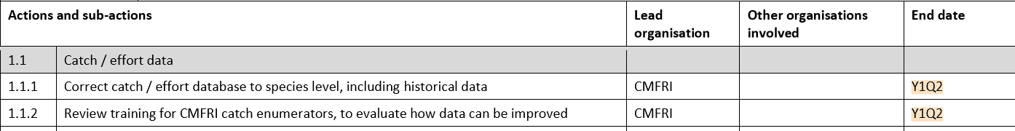
Y1Q3 action plan:
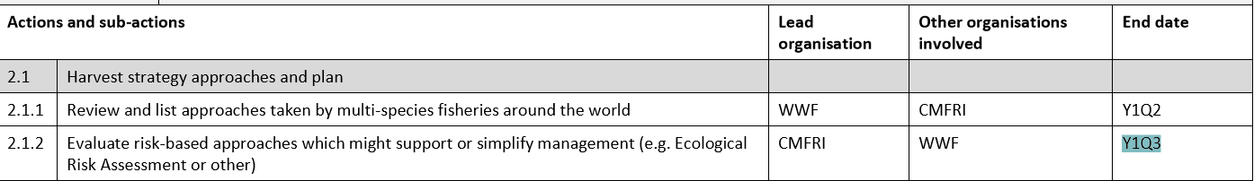

Action plan discussion and deadlines:

- The FRAD has received data to correct the spp records from all 4 divisions for 2018. This will be corrected and will be available by August 15, 2019. Once this is done historical data from 2007-2017 will be done likewise. [Action by Head FRAD, CMFRI].
- Experts to help the enumerators are identified, but due to software modification the system is not in action. This will be in operation within one month, i.e., by the end of 3rd quarter. [Action by Head FRAD, CMFRI].
- AKBOA and CIFT have identified 5 vessels from three ports, Beypore, Kollam and Kochi to implement square mesh cod end. CIFT will give a report on this by July 31st. [Action by CIFT].
- FRAD has grouped species according to life history and defined assessment cycle. The article has to be published to update in fisheryprogress.org
- WWF has compiled methodologies of harvest strategy approaches in multi-species fisheries around the world.
- Data on fishery interactions by sawfish and guitarfish is compiled by FIP coordinator. This wil be submitted to Dr. Sunil Mohammed for review.
- Y1Q3 action plan will be carried out by Dr. Rekhadevi and Dr. Sathianandan of CMFRI. Dr. Rekhadevi will read the articles compiled by WWF and will try to find ways to cover risks in the present fisheries under FIP.
Dr. Sathianandan (or a person identified by him) will vet it and a meeting of CMFRI scientists will be conducted by August end to review the progress.
[Action by Dr. Rekhadevi and Dr. Sathinandan, CMFRI].
- Next review meeting will be held on September 16, 2019.

