FIP implementation- Stakeholder workshop for discussion of Y1Q2 action plan review and Y1Q3 action plan discussion of MSC certification of Kerala shrimp & cephalopod trawl fishery
Minutes of meeting
Meeting title | Y1Q2 FIP action plan review and Y1Q3 action plan discussion– MSC Certification – FIP implementation
Date | 17th September 2019
Time | 11.00 am – 12.00 am
Place | MFD Seminar hall, CMFRI, Kochi
Chairperson | Dr Sunil Mohammed, CMFRI
Attended by | - Dr. T. V. Sathianandan, CMFRI  - Dr. Josileen Jose, CMFRI  - Dr. Rekhadevi Chakraborty, CMFRI  - Dr. Lakshmi Pillai, CMFRI  - Dr. Somy Kuriakose, CMFRI  - Mr. Vivekanand Bharti, CMFRI  - Dr. Madhu V R, CIFT  - Mr. Chinnadurai, CIFT  - Dr. Vinod Malayilethu, WWF-India  - Mr. T P George, Amalgam  - Mr Ramakrishnan S, SEAI  - Dr. Vineetha A., FIP Coordinator
Agenda | - Review discussion of action plan Y1Q2  - Extended deadline of implementation  - Discussion of action plan Y1Q3

Welcome address:
Mr Ramakrishnan S, SEAI
Introduction
Dr. Vineetha Aravind, FIP Coordinator

Y1Q2 Action plan:

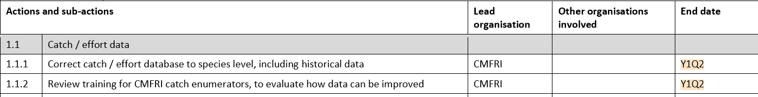
Y1Q3 action plan:
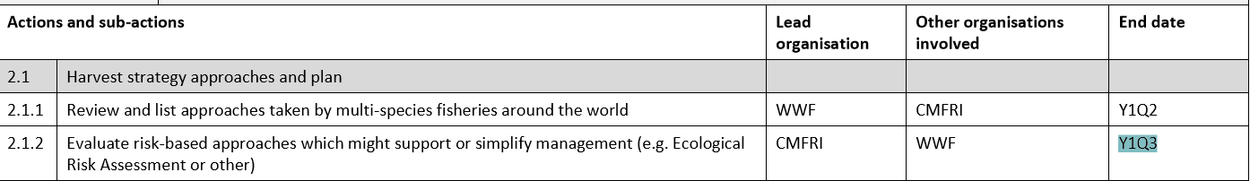
Y1 on going:

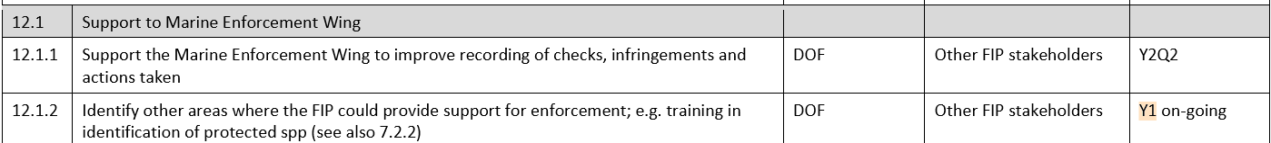

Action plan discussion and deadlines:

- The FRAD of CMFRI will provide data corrected to spp records for the year 2018 by September 21st 2019. Once this is done historical data from 2007-2017 will be done likewise. [Action by Dr. Sathianandan, CMFRI]. Action point 1.1.1
- FRAD has grouped species according to life history and defined assessment cycle. The analysis is under the process of publication, but an excel sheet will be given to FIP coordinator to upload in fisheryprogress.org. [Action by Dr. Somy, CMFRI]. Action point 1.2.1
- AKBOA and CIFT have identified 3 vessels from three ports, Beypore, Kollam and Kochi to implement square mesh cod end. CIFT will give list of boats and boat owners region wise by September 21st 2019. [Action by Dr Madhu, CIFT]. Action point 4.1.1
- Mr. Vivekanand of CMFRI will work on the list of priority species from existing knowledge, catch data and pre-assessment. FIP coordinator will send the list of P2 species to Mr. Vivekanand. Action point 5.1.1
- Dr. Rekhadevi CMFRI and Dr Madhu, CIFT will read the articles compiled by WWF and will try to find ways to cover risks in the present fisheries under FIP. Dr. Rekha will present it in the Journal club meeting of CMFRI. A meeting with Dr. Rekhadevi, Dr Madhu and FIP coordinator is scheduled on 27th September, 2019. Action point 2.1.2
- FIP Coordinator to contact the AD of fisheries and request to conduct a one-day workshop for the fisheries enforcement wing of state by resource persons of CMFRI and CIFT. WWF will fund the workshop.

