FIP - Field Trip Intern Report

To: Brazil
Period: November 25th – 30th.

November 25th – Flight Fort Lauderdale – Belem (PA)

Nov 26 and 27th – Braganca City

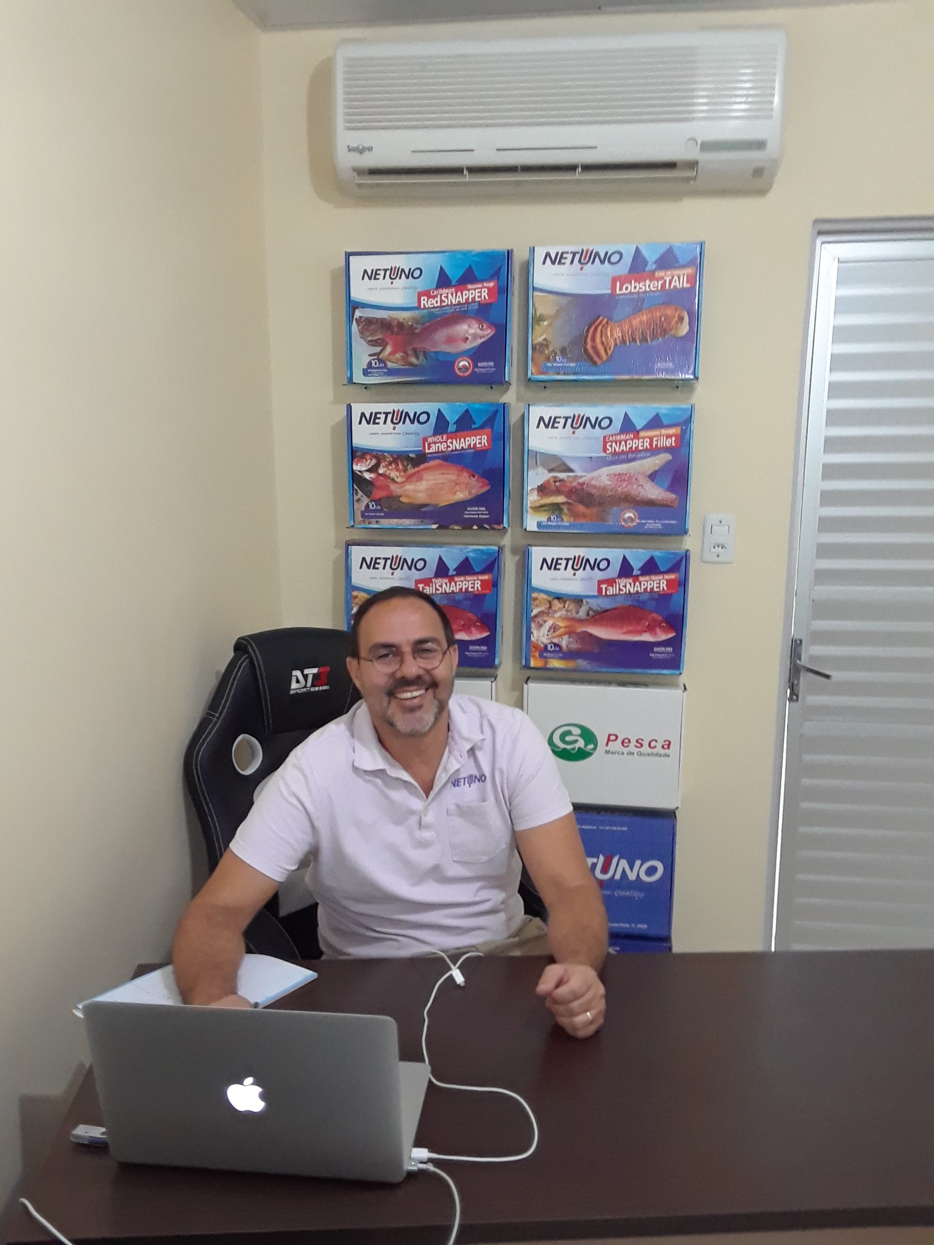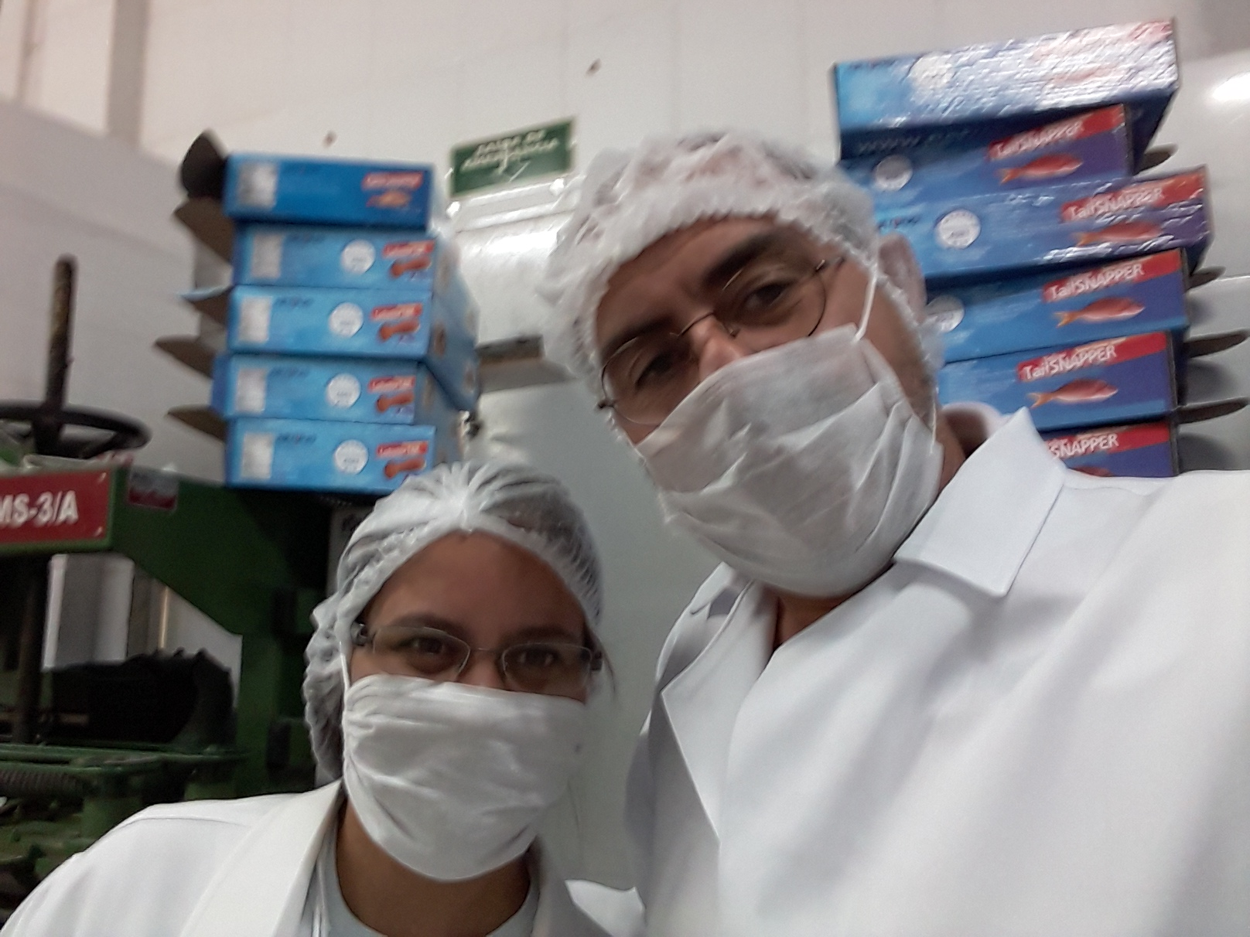

Meetings with Tanyse Gomes (1), President of the COOMPESCAR (Cooperativa Mista de Pesca e Aquicultura da Região do Salgado) and Danilo Gardunho (2), Secretario de Pesca da Prefeitura Municipal.

1 - Tanyse heard about and is trying to gather proves about a Venezuelan fleet that is fishing in Brazilian waters. She agrees that next step for the FIP is to avoid I.U.U. (both external and internal) with drastic action like sinking boats. We invited Coompescar Union to formally join the FIP and they accepted. Coompescar affiliates can increase near 20% of total landings to the FIP and with them we will reach almost 70% of total Caribbean Red Snapper production.

2 – Danilo is also aware and agree next step for the FIP is to avoid I.U.U. (both external and internal) with drastic action like sinking boats if needed. We resume the next FIP meeting plan for February / March’19.

Nov 28 and 29th – Brasilia

Belem – Brasilia flight

IABS 15 years celebration

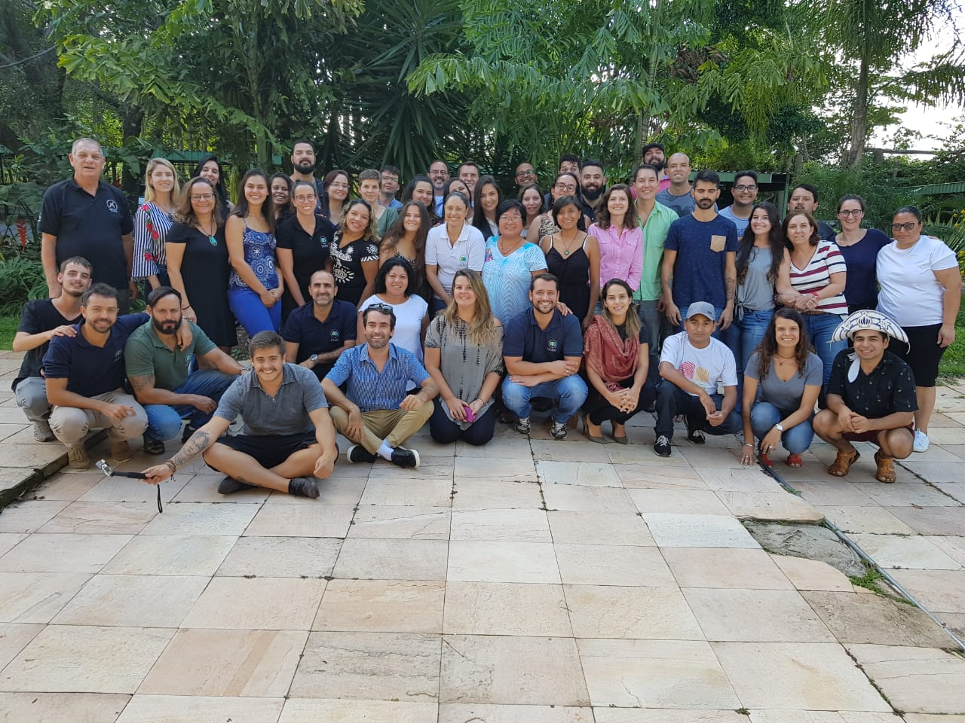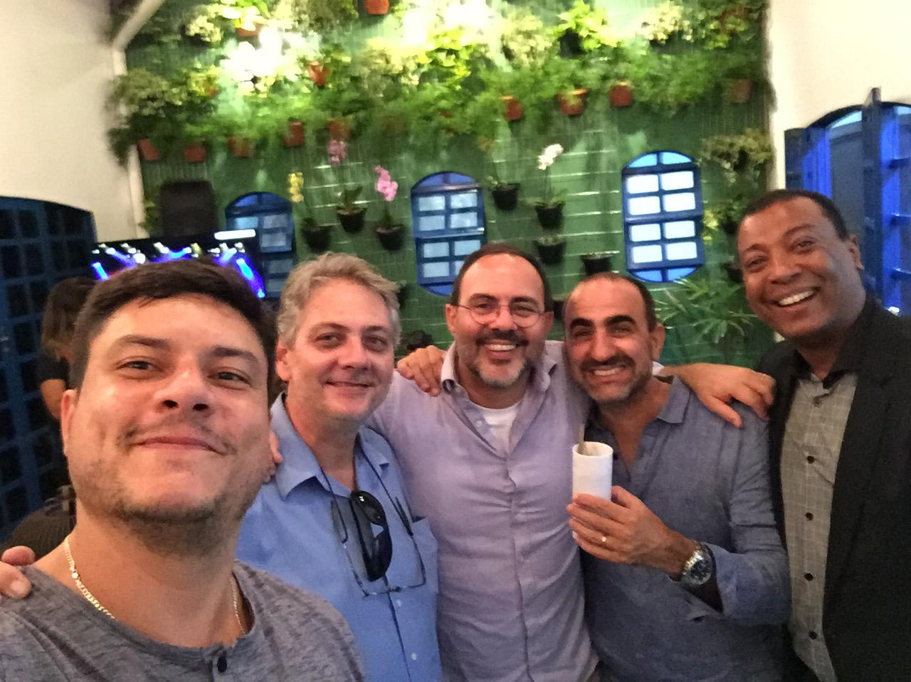

IABS staff (left) – Right - Rodrigo, Eric Routledge, Brugger, Assad and Claudio de Jesus.

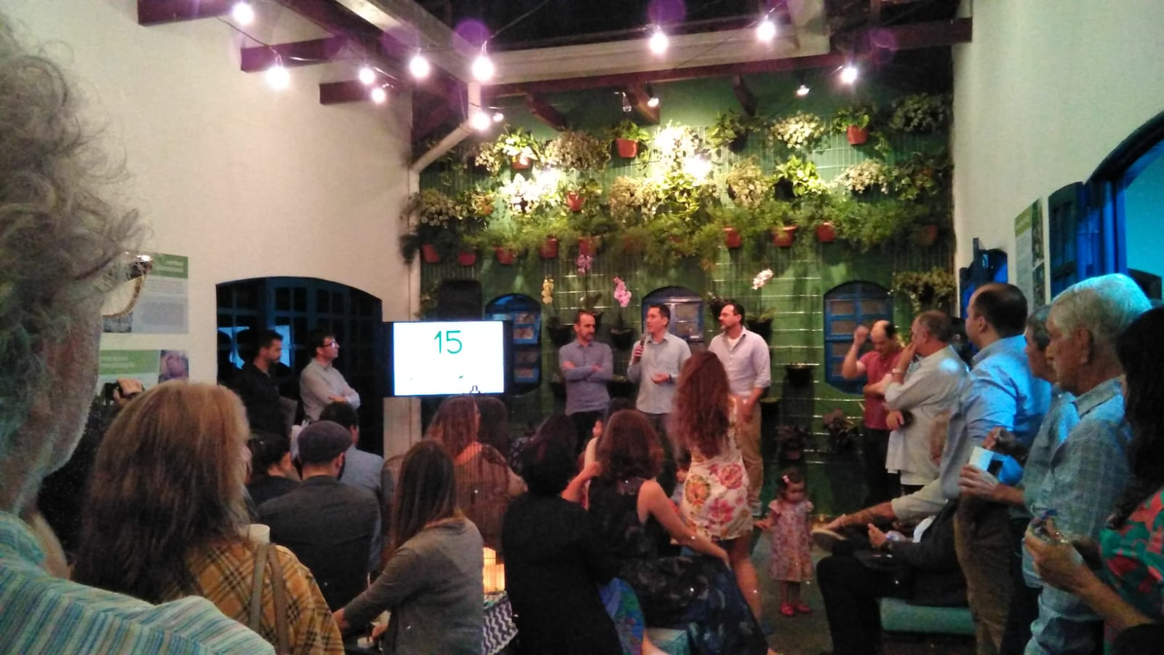

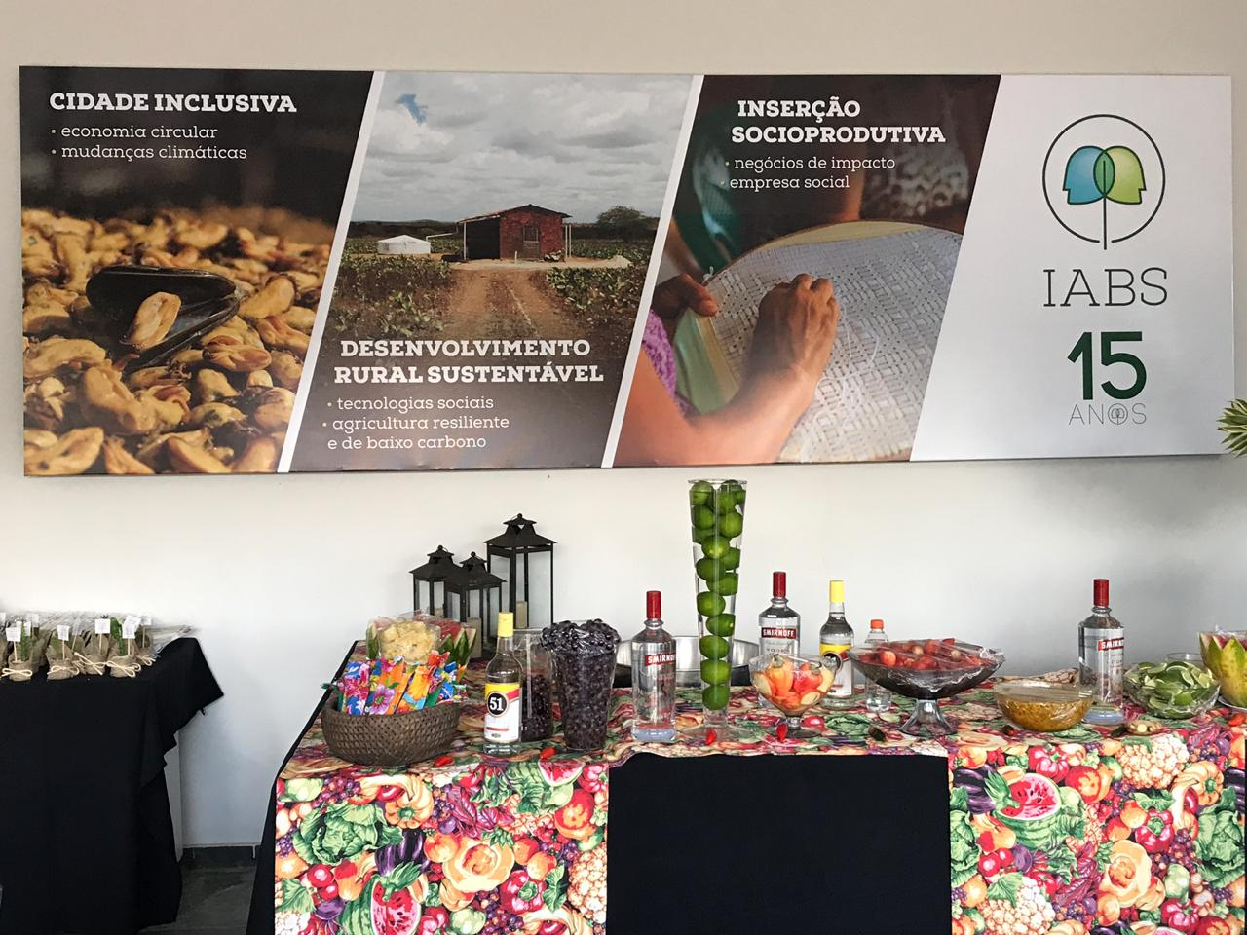

OCEANA meeting – with General Director Oc. Ademilson Zamboni, Oc. Martin Dias, Rodrigo Claudino, Miriam Bozzeto and Lara Iwanick.

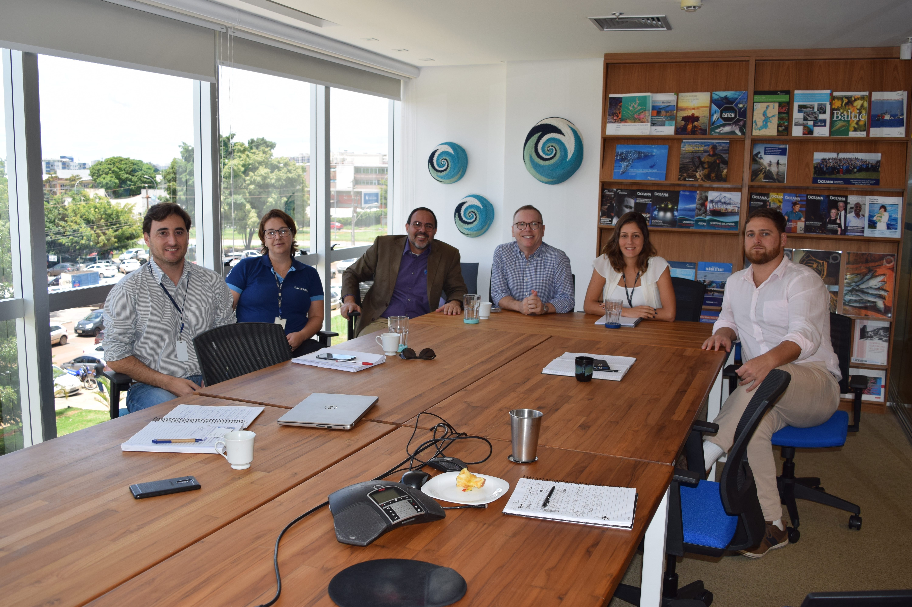

Subject addressed:

1 - FIP next steps;
2 – Cooperation opportunities in Sustainable Fisheries in Brazil.

Conclusions: Brazilian Oceana’s General Director and staff agreed that we could work together in activities that are strategic for both (FIP and Oceana) inside and outside the Caribbean Red Snapper fisheries and even supports a strike action to avoid the I.U.U. fleet from Venezuela and from Brazil. Independent of who is going to step in the Fisheries Secretary inside the Agriculture Ministry, Oceana will keep the effort to improve and monitor the Managements Plans for the fisheries that are under new path to step out the Portaria 445.

Nov 30th – Sao Paulo

WWF meeting - with Mariana Cora and Caio Faro.

Subject addressed:

1 - FIP next steps;
2 – Cooperation opportunities in ocean conservation in Brazil.

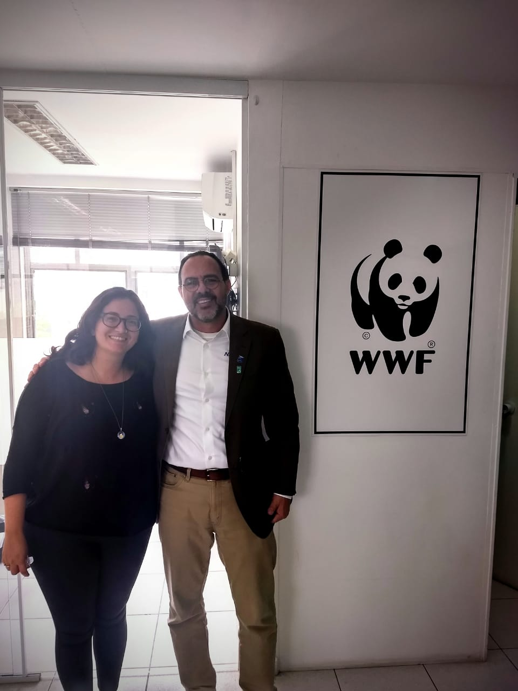

Conclusions: WWF can support us in Caribbean Red Snapper FIP and agree to the proposed strike to address the I.U.U problem. WWF also is very interested in our recent initiatives of carbon sink through seaweed farm and grouper release, once the activities takes part in Conservation Unities (APA litoral do Estado de Sao Paulo) where the NGO is an important player.

FIESP (Federação das Indústrias do Estado de São Paulo) Fisheries and Aquaculture Chamber meeting.

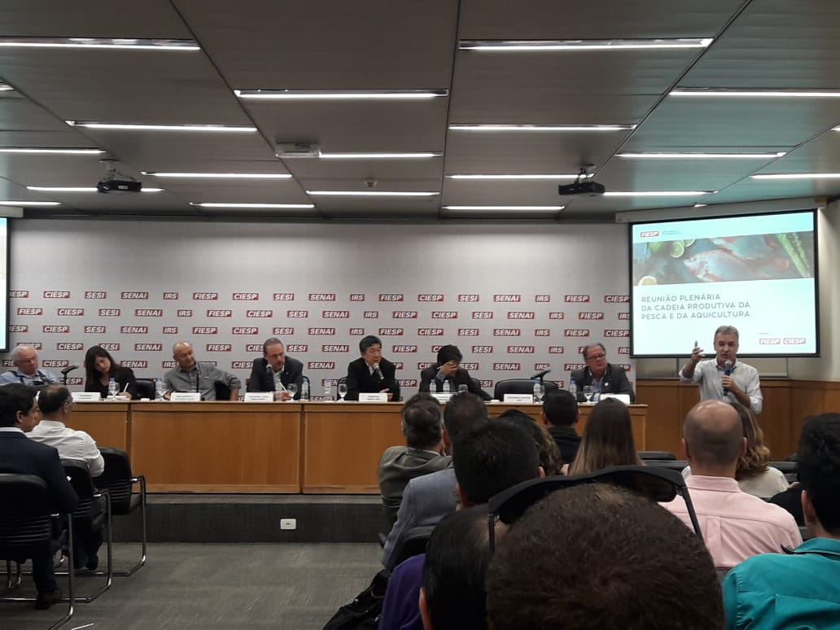

Nice occasion to meet important stakeholders in the Fisheries and Aquaculture sector in Brazil: Government (SEAP), Midia (Seafood Brasil), Associations (ABCC, PeixeBr, Abipesca, Sectorial Chambers in CNA and FIESP), Unions (Sindipi, Sindifrio), Companies (Paiche), Research Institutes (Embrapa, IPesca-SP) and to talk about the new elected government approach and proposition.

