Orkney Crab Market Sampling Guide

Introduction

Data collection is a key component in fish stock assessments, information from a wealth of sources is used to inform our understanding of fish stocks. This understanding is vital in developing appropriate management tools to supports sustainable fishing and the communities depending on them.

However, many fisheries are data deficient which makes it difficult for managers to provide sound advice and therefore rely on assumptions or extrapolations of data which is usually not regionally specific and altogether relevant to the fishery. For data poor fisheries, having a data collection program is a vital first step to improving the management for that fishery.

Sampling Programme Design

When developing a market sampling programme, it is impractical to measure all the parameters by census (sampling all the catch being landed). To this end parameters are estimated on a sub-sample of the catch being landed. For this to be effective a sampling programme must be set at an appropriate scale which balances the resource with data collection. Sampling frequency is therefore dependent on the resource available and on the size and variability of the fishing fleet. As these factors are fishery dependent, any sampling design should be tailored to suit the fishery, considering representativeness and sampling through space and time.

- Representativeness is a key factor in sampling programme design. This relates to both the boats and the gears they use. With in this fishery gear types are sampled separately as the fishery is predominantly made up of static gear (creels) with some dredges operated for King Scallops and jiggers used for a seasonal Mackerel fishery, there is also a hand dived fishery for King Scallops.
- Sampling through space and time is also important. Fishing areas are split for management purposes for this fishery, fishing areas are defined by ICES rectangles and Marine Scotland have their own division of the area. It is important that all areas which the fishery operate are sampled. There needs to be fair representation of all the fishing grounds that are used. However, if there are some fishing grounds that are used more frequently than others this will need to be sampled proportionally. Market sampling is done monthly for the fishery.

Sampling Area

The ICES rectangle that Orkney’s inshore fishery is within is Area Via (Iva?) and these are also divided into the areas that Marine Scotland use for their annual stock assessments which are (47E6, 47E7,46E6 and 46E7). In addition to this there is the offshore fishery which lands Brown Crab into Orkney this is mainly fished from grounds in ICES Area VIb which are the Marine Scotland areas known as 48E4, 47E5 and 47E4.
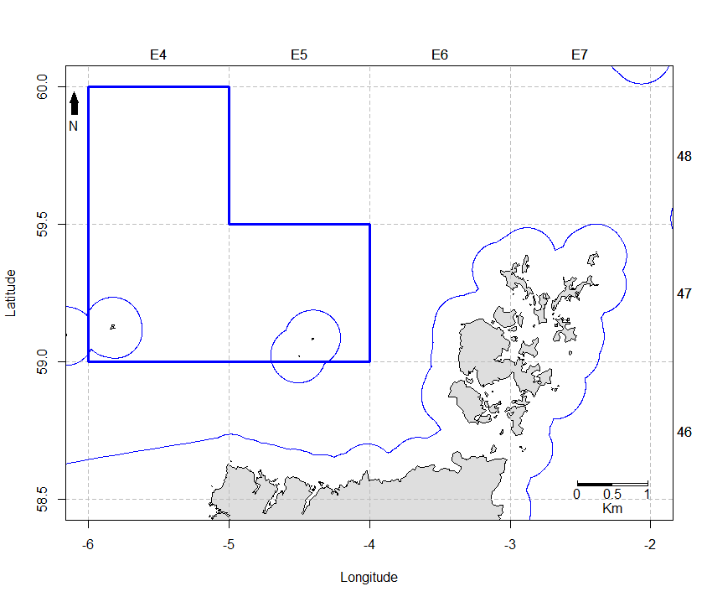

Methods

- Sub-sample of each vessel landing to ensure representation from all geographic locations and vessel size
- Frequency of sampling: based on monthly landings
- Equal representation from member boats and non-members boats (recording sheet)
- Monthly landings range from 30,000 – 70,000 kg total per month
- Approximate weight of samples taken one day of one month?

The ports of monthly sampling are:
- Orkney Crab Processing Factory
- Orkney Crab Ponds in Stromness if applicable

Data Collection Checklist

Data to be collected with each sample (all this data is entered into the sampling sheet)
- Vessel Name
- Fisherman Name
- Area Fished (If known) (StSq on recording sheet)
- Date Landed
- Total Weight landed
- Total weight of sub sample
- Carapace Width or Length of individuals
- Sex of individuals (M/F)

Sampling Equipment
- Gloves (Blue SWONA)
- Data sheets (printed on Waterproof paper)
- Clipboard
- Callipers (0-300mm)
- PPE clothing (Wellies, Waterproofs)
- Dictaphone (optional for recording CW instead of using data sheets)

Measuring Brown Crab (Cancer pagurus).

The measurement taken is Carapace Width (CW) and should be measured and recorded in millimetres (mm). Carapace with is taken from the widest part of the crab’s carapace and this measurement is the same for both male and female crabs.

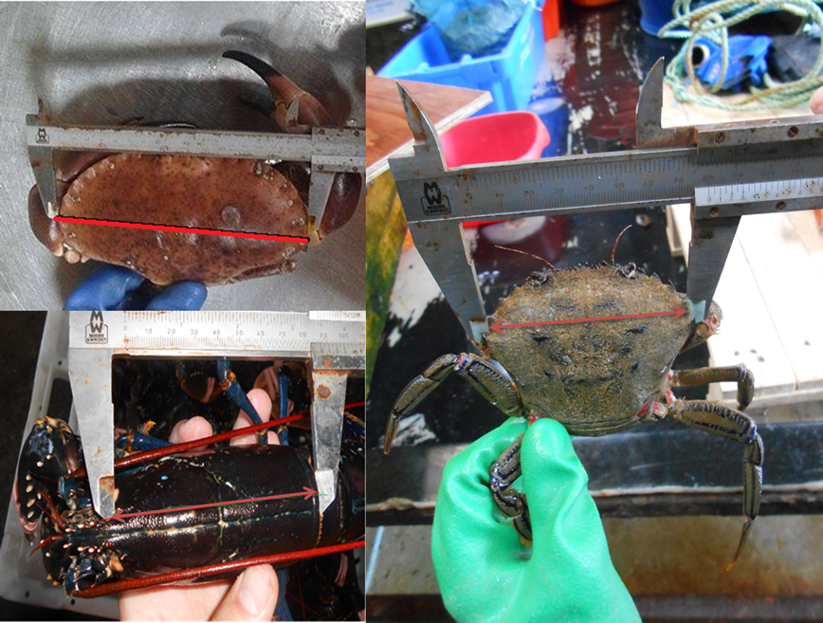

The data sheet above can be used during sampling if no Dictaphone is used but all data must be stored and recorded in electronic form for use in assessment and for analysis. Data should be recorded in a tally style format when being handwritten.
All files should be saved like Vesselname_Date as an excel file.
Data should be added to the master spreadsheet which will be used for analysis, all data files should be saved and ready to send to Marine Scotland by March each year for inclusion into their annual stock assessments.

