Kerala is the first state to distribute square mesh cod-end to trawl boat owners as a step towards sustainable fisheries
In another gesture towards sustainable and responsible fishing operations, Government of Kerala distributed square mesh cod-end nets to trawl boat owners under the subsidy scheme. The state was a pioneer in amending its Kerala Marine Fisheries Regulation Act, (Kerala Marine Fisheries Regulations Act (KMFRA) in 2017) recommends to use 25 mm square mesh cod-ends for shrimps and 35 mm square mesh cod-ends for fish and cephalopods. Many other Indian states followed suite and still others are planning to amend their respective state Marine Fisheries Regulation Acts to include the use of square mesh cod-end.
Now as part of stricter implementation of the law, the state is distributing square mesh cod-end to boat owners at a subsidized rate. As part of this a meeting was held at Thopumpady, Kochi on 13.12.2021. the meeting was organized by WWF India, using the ITM Fund of MSC to move towards sustainability. It was attended by Mr. Nausherkhan K, DD of Fisheries, GoK, Mr. Aneesh P, AD of Fisheries, GoK, Vypin, Dr. Madhu V R, Principal Scientist, CIFT, Mr. Vinod M, Associate Director, Marine Conservation Programme, WWF India, Dr. Vineetha Aravind, ITM Consultant, WWF India, Ms. Sangeetha N R, State coordinator, NETFISH MPEDA, boat owners of Thoppumpadi harbour and Suresh, boat owner under model boat project.
Ms. Sangeetha welcomed the guests. DD of Fisheries presided the function and after the presidential address, inaugurated the cod-end distribution. Dr Madhu talked about the experiments conducted by CIFT on square mesh cod end and the advantages of square mesh cod end. Mr Vinod talked about the work done by WWF towards sustainability in various Indian states.
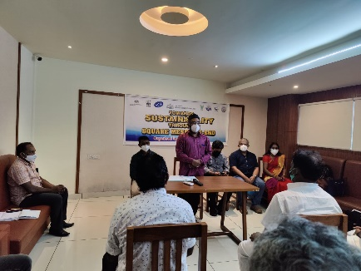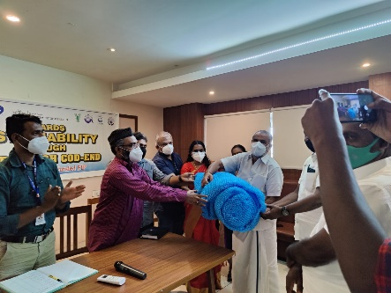

Mr. Suresh shared his experience in using the square mesh cod end. He talked about the doubt he and his crew had at first and how it was changed by using the cod-end.
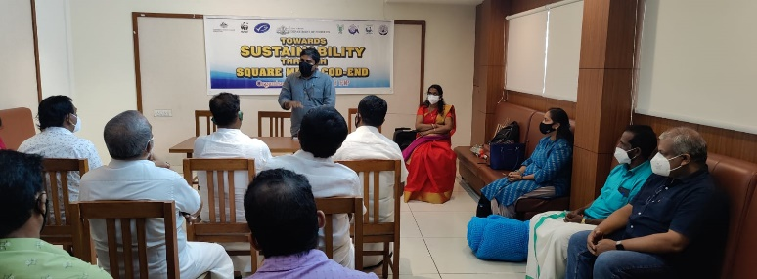

His boat is now using only square mesh cod-end. He also shared that the use of square mesh cod-end has helped them to have better fuel efficiency and enhanced quality of the catch.
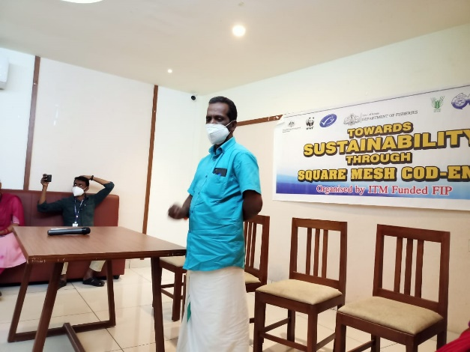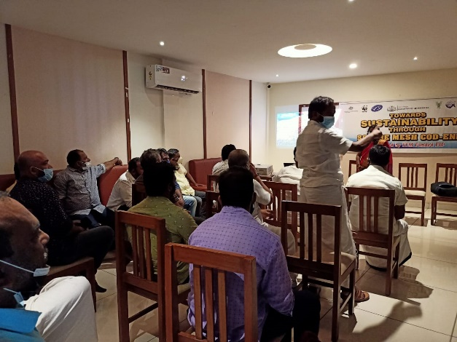

AD of Fisheries interacted with the boat owners and addressed their concerns. WWF India official talked about the experiments done by WWF in East coast of India on square mesh cod-end and the importance of sustainable fisheries. A video on the use of square mesh cod-end in the model boat was screened and NETFISH official elaborated on it. Dr Vineetha proposed the vote of thanks.
The meeting ended with lunch.

