Result 2.3. Fishery management
Task 2.3.1; 2.3.2
Internal Plan for the Management of Solid Urban Waste and Special Management (MSW) Special Management Waste (RME) derived from white shrimp fishing in the Ignlogar and Llano del Tigre cooperatives
Prepared by: Paulina Diaz for The Nature Conservancy Mx
Paulina.diaz@tnc.org
INTRODUCTION
Residues are parts of a product whose owner or holder discards and are commonly known as garbage, which can be classified and have an adequate post-handling, according to its characteristics. There is a classification according to the management that must be given to each one, in urban solid waste (MSW) and special handling waste (RME) (NOM-083-SEMARNAT, 2003).
The law establishes that RSU are those residues generated in dwelling houses, which result from the elimination of the materials they use in their domestic activities, the products they consume and their containers, packaging or packaging; the waste that comes from any other activity within establishments or on public roads that generates waste with household characteristics, and those resulting from the cleaning of roads and public places, provided that they are not considered by this Law as waste of another nature. Article 10 of the General Law for the Prevention and Integral Management of Waste (LGPGIR) establishes that the municipalities are in charge of the functions of integral management of urban solid waste, which consist of the collection, transfer, treatment, and final disposal. ( NOM-083-SEMARNAT-2003 ).
While RME are those generated in production processes, which do not meet the characteristics to be considered as dangerous or as solid urban waste, or that are produced by large generators of solid urban waste. Article 9 of the LGPGIR establishes that it is the power of the Federal Entities to authorize the comprehensive management of special management waste, and to identify those that within their territory may be subject to management plans (DOF, 2003).
STUDY AREA
This is the proposal for the management of residues from the white shrimp fishery in two cooperatives in the area of the Marismas Nacionales Biosphere Reserve, Nayarit. The first is the "SCPP Ignlogar SA de CV" which is located within the community known as Antonio R Laureles, in the municipality of Tecuala, Nay. Which has land access by the municipal highway of approximately 27 km from the municipal seat to the site. The second is the "SCPP Llano del Tigre SA de CV", this cooperative is located within a community known by the same name "Llano del Tigre" within the municipality of Rosamorada, Nay, which has land access by municipal road of 14.3 km to the municipal seat of Rosamorada. Both localities are continuous and share lagoon bodies ( Fig. 1)
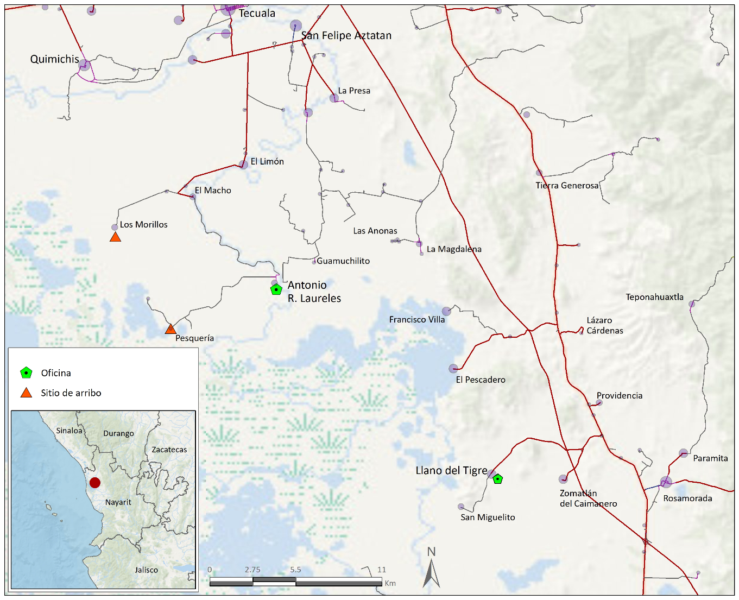
Figure 1. Location of the arrival sites of the fishing cooperatives SCPP Ignlogar SA de CV and SCPP Llano del Tigre SA de CV, in the state of Nayarit.
LOCAL SITUATION
Until 2011, Nayarit and Tlaxcala were the states with the lowest RSU and RME generation (0.8%), however, there is an upward trend due to the growing demands for goods and services for the Nayarit population brought about by the generation of waste solid as a consequence of the use of natural resources in urban and rural areas. (Municipal Development Plan of Rosamorada, Nayarit, 2021).
The state environmental policy on waste is based on the principles of reduction, recovery, and shared responsibility, as well as on the prevention and comprehensive management of waste. That includes in its development plan the integral management of MSW, composed of the activities of reduction at the source, separation, reuse, recycling, co-processing, biological, chemical, physical or thermal treatment, collection, storage, collection, transport, and final waste disposal.
For the management of MSW, the State of Nayarit has at least 22 final disposal sites (SDS), of which only 3 sites comply with NOM-083-SEMARNAT-2003, in terms of location and construction restrictions. and operation; These sites are located in the municipalities of Bahía de Banderas, Compostela, and Jala. In the localities of the municipalities of Rosamorada and Tecuala, the municipal services of MRSyME include collection and final disposal, which is carried out in the municipal capitals. Due to the remoteness of the rural communities to the north of Nayarit, the collection service is intermittent, so the community itself must take charge of its own management or final disposal, this includes, to a large extent, the collection of waste in open-air sites. open in voluntarily assigned areas or burning garbage in backyards.
RSU and RME GENERATION
In the northern region of the state of Nayarit, specifically in the area of the Marismas Nacionales biosphere reserve, in its rural locations, various economic activities are carried out, of which stand out; livestock, agriculture, and fishing. The most relevant fishing product is white shrimp, with a local production within the reserve of close to a thousand tons and in which more than a thousand fishermen participate.
This economic activity generates dividends for the community, but also derived from it, various RSU and RME are generated, among which those of an organic nature stand out, of which shrimp residues (heads) and accompanying Fauna (FAC) stand out, which are dumped directly into the marsh. Of inorganic nature, mainly; plastics such as containers for soaps and liquid disinfectants for general and personal hygiene, protection and hygiene items (bonnets and face masks), as well as waste from nets and finally those from Special Management (RME) such as oil-based paint waste, burned oil (oil change boats), sanitary waste
METHODOLOGY
The methodology is based on the characterization of the waste generated, by location, volume, and type. The classification thereof is according to their nature and post-handling potential and finally, the proposed final disposal considering the feasibility of on-site management, due to the intermittency of the collection services.
Phase 1.- Identification of RSU and RME. For the characterization of the RSU and RME, the producers themselves will be asked for information on the infrastructure, mainly the frequency of collection of this waste. At the same time, a visual survey will be carried out to identify the places voluntarily designated for the dumping of waste.
Phase 2. Calculation of the volume Generation of waste per capita/monthly The irregularity in the collection service, the lack of availability of appropriate sites, in the households it is customary to burn part of the waste generated, which is why it is not possible to perform the calculation of per capita waste production or daily production in accordance with the standard. However, considering the behavior of waste production, an estimation by volume can be implemented.
Location (not of users) | Guy | Amount
 | Organic
 | Inorganic
 | special handling
 | Organic
 | Inorganic
 | special handling
The generation per capita (kg/day/ inhab) is obtained based on the average production of solid waste per day among the total number of inhabitants (NMX-AA-61-1985).
Phase 3. Handling and final disposal. Waste management begins with classification, which was carried out in phase 2. The classification or separation of products is relevant for recycling. Recycling is the transformation of waste through different processes that allow its economic value to be restored (valorize), thus avoiding its final disposal, as long as this restitution favors energy and raw material savings without harm to health, ecosystems, or its elements.
The main advantages of recycling are the conservation of natural resources and the increase in the useful life of final disposal sites.
- The central objectives of recycling can be summarized as:
- Revaluation of waste.
- Reincorporation in the cycle of materials.
- Replacement of virgin raw materials.
- Reduce the amount of waste to be deposited.
- Limit the impact on the environment
The process of separating recyclable by-products has different stages. Separation at the source and separate collection are important conditions to obtain a material with a higher value in the market, in addition to quality, the recycling industry requires a sufficient volume to carry out its processes: these aspects, together with the high costs of transportation, are factors that influence the percentage of separation and subsequent recycling. Considering that most of the separation of by-products is carried out by the private and informal sectors, there is no data on by-products that are generated in the State to be reincorporated into production processes, coupled with the fact that there is a large dispersion of towns with little population, not generating large volumes of garbage and few recycling companies, which causes a large amount of unused recyclable waste in final disposal sites and also takes time away from its useful life. ( State Program for the Prevention and Integral Management of Waste for the State of Baja California Sur, 2020)
organic management
Option 1 Local composting. There are different composters that can be made locally or purchased, an example is the BCU COMMUNITY COMPOSTER which allows the composting of meat products. This is a simple, painless, and hygienic method. The composter must be placed at a minimum distance of 100 meters above the highest tide, it must be duly marked and it will have its own registration log. the procedure is the next
- Place the solid waste waste (shrimp heads), after each day.
- Record the corresponding data in the log (place, date, volume)
- Wait for the time recommended by the manufacturer.
- The products obtained are organic matter that can be dumped in gardens or community green spaces.
It is worth mentioning that the possibility of setting up a Final Disposal Site (SDF) is not a viable alternative, since according to the provisions of NOM-083-SEMARNAT-2003, where establishing the environmental protection specifications not only in the site selection stage, but also in the design, operation, and closure stages of an MSW and RME SDF, these should not be located in areas of marshes, mangroves, estuaries, swamps, wetlands, estuaries, alluvial and fluvial plains, aquifer recharge, archaeological; nor on caverns, fractures or geological faults. In turn, the management program of the Marismas Nacionales Biosphere Reserve, which includes the sites where the fishing sites of the cooperatives that intend to implement this proposal are located, has been established as an activity not allowed in the Subzone for Sustainable Use of the San Miguel-Zomatlán Ecosystems (where the community of Llano del Tigre is located) build confinements for solid waste, as well as hazardous materials and substances (Management Program Marismas Nacionales Biosphere Reserve, Nayarit. SEMARNAT. 2013)
Inorganic MSW management
Plastics: Plastics are products derived from hydrocarbons and are used for an endless number of applications, in addition to providing such potential, it has also brought an ecological cost. As is known, plastics have long life cycles and their potential disintegration takes long periods of time. It is common in one way or another for them to travel to continental waters where they accumulate, generating a great impact on marine ecosystems, in addition to small particles known as microplastics that can incorporate you into the food chain. Tinplate: Tinplate is a flat laminated product, consisting of steel, covered by a layer of tin. Food containers, preserves, juices, fruits, legumes, fish and meat, waxes, hygiene, and cleaning products are some of the uses of this recyclable material. Cardboard:
Collection considerations :
- Assign containers with lids and locks, properly labeled and assigned colors for identification (ie blue-plastic, grey-tin, orange-cardboard).
- Place containers outside the fishing product handling area or the areas intended for the consumption of food by producers.
- Preferably keep shelter indoors and attached to the ground in such a way that it cannot be easily knocked down under the impact of climatic events such as hurricanes and cyclones that usually affect the area periodically.
- Carry out a daily review to avoid the presence of harmful fauna (traps, repellents, and gel insecticides can be placed around each container).
- Carry out a periodic wash, after each waste collection event in order to reduce the possibility of the presence of bad odors and harmful fauna.
Collection considerations.
- Make a compliance agreement with the municipality of each locality to ensure a collection of RSU at least bimonthly.
- Identify MSW collection and recycling service providers for their integration into the circular economy through the revaluation of these
- Invite local schools to participate in collection and recycling.
Directory of collection and recycling service providers
- MORENO FLORES ANA VERONICA CLL GUTIERRE TIBON 41, SAN FELIPE AZTATAN, SAN FELIPE AZTATAN, NAY, CP63446 ( 389) 251 5475
- AUTONOMOUS UNIVERSITY OF NAYARIT permanent campaign. Old historical archive building (CEMIC-2), the City of Culture "Amado Nervo"
CP 63155, Tepic, Nayarit, Mexico. (311) 211-88-00 ext. 8918
RME inorganic handling
For the referent localities, the variety of RME is composed of derivatives of boat maintenance and arrival sites, these are paint residue and objects contaminated with it (plastic buckets, drill bits, shavings), and motor oil, batteries that contain lithium, nickel, mercury, cadmium, manganese, lead, zinc, or any other element that allows the generation of energy in them, at levels that are not considered as hazardous waste in the corresponding official Mexican standard.
For the local collection of RME, an area must be designated within the property that must consider the limitations indicated in the municipal or state urban development or ecological and environmental planning plans in force in the locality, as well as with the corresponding land uses. Like the waste subject to revaluation, it will be made available in a period of no more than 6 months through a collection service provider, which allows its adequate transport for final disposal.
Monitoring of the Internal Management Plan for RSU and RME
For the correct implementation of the proposal, it is important to designate a person responsible for monitoring, who can be designated from the cooperative to keep track of the log, as well as coordinate of the collection service providers. If there is availability, people who are interested in collaborating can join.
References
Official Mexican Standard NOM-083-SEMARNAT-2003. Environmental protection specifications for the selection of the site, design, construction, operation, monitoring, closure and complementary works of a final disposal site for urban solid waste and special handling. Official Journal of the Federation. Government of Mexico. 2003.
Municipal Development Plan of Rosamorada, Nayarit, 2021-2024. Official Newspaper. Organ of the Government of the State of Nayarit. 2021
Mexican Standard NMX-AA-61-1985. Protection of the environment-soil contamination-municipal solid waste-determination of generation. Official Journal of the Federation. Government of Mexico. 1992
State Program for the Prevention and Comprehensive Management of Waste for the State of Baja California Sur. Undersecretary of Sustainability Center for Urbanism and Architecture Studies, SA de CV Government of the State of Baja California Sur. 2011
Nayarit DR National Marshes Biosphere Reserve Management Program © Secretary of Environment and Natural Resources Blvd. Adolfo Ruíz Cortines 4209, Col. Jardines en la Montaña, Tlalpan CP 14210, Mexico, DF www.semarnat.gob.mx

