Project UK Fisheries Improvements Stage Two: Scallops
(Facilitated by the MSC)

Tuesday 18th June 2019 10.00 – 15:30
Jurys Inn, 43 Jeffrey Street,
Edinburgh, EH1 1DH

Attendees
AB Andrew Brown Macduff
BL Bill Lart Seafish
CD Calum Duncan ScotLINK (MCS)
CM Cameron Moffatt Young’s
DB Diane Buchanan Marine Scotland
DD David Donnan Scottish Natural Heritage
DW Dougie White West Coast Sea Products Ltd
FdB Femke de Boer SWFPA
FN Fiona Nimmo Poseidon
JPort Jim Portus SWFPA
LB Lynda Blackadder Scottish Government
MK Mike Kaiser Heriot Watt University

EP Erin Priddle MSC
JP Jo Pollett MSC
MB Matthew Bamping MSC
KA Karen Attwood MSC

Dial In
PD Peter Duncan IoM
RM Rob Mansfield Cefas

Apologies
Carrie McMinn
Ewen Bell
Joe Prosho
John Speers
Mike Park
Richard Luxmoore
Stuart McLanaghan

Welcome and Introductions (EP)
- Introduction to the group- this is the 4th meeting – action plan was signed off last time
- Tracking forward on actions and keeping up momentum

Minutes and Action Points (JP)
- The minutes have been circulated and the group agreed to sign them off
- Documentation to all go up on Fishery Progress
- Aligning S1 & S2 scallop FIPs – harmonization now occurred; anything being tackled UK wide are now the same
- The group were asked to consider a sub-group for environmental actions (P2) in order to track actions forward between meetings

- Fill in from Jo’s table – actions not associated with AP

Recap of FIP Structure, how it works, and timelines (JP)
- Reminder of FIP structure
- Copies of the Pre-Assessment and Action Plan are available online on FisheryProgress
- Snapshot in time – final Pre-Assessment signed off by the steering group in March in order to start addressing the actions in the action plan
- Action Plan to address any gaps found by pre-assessment
- Anything missing can be circulated and Dropbox folder can be created for circulation to Steering Group
- Everything available on FisheryProgress

- Meeting today assessing what needs to be done for Y1 actions, who needs to do what etc

- BMT explanation

- Sub group formation
  - For environmental actions
  - Steering group to think about which actions may need S-Gs and to be discussed at the end
  - Proposed that both S2 fisheries have a joint S-G for various actions
  - Focus groups are a good way of directing thinking

  - BL – economy of scale by combining Nephrops & Scallops, at least for 1st couple years of actions

Update on windfarm/cable funding (FdB)
- Wind farming cable plans in the next 2 – 5 yrs
- Community funds set up to benefit local communities including this fishery
- Many of these funds have asked to feed into PUKFI
- EDPR promise to undertake stock assessment but did not do it before work started
- Will look at other options

- 2 projects for £1500 both approved for £1250, for 2 scallop and 1 Nephrops project for Action 7

- Meeting with Peter Moore from EDPR – stock assessment in Moray Firth, suggested to look at discards instead. Seemed quite keen at time but have heard nothing back since

- MK - Disappointing that they are not doing pre-build stock assessment
  - Look at recovery rates of depleted scallop

  - Timing issues, but have pushed back timelines since last year

- DB - Commercial fisheries working group should be discussing this, not PUKFI
    - This is on hold as group not wanting to sign ToR

    - Should be considered as THE vehicle for application for funding
      - Not appropriate for community funding to be funneled through anything other than this fund

- MK - Interesting to know dynamics – would be good to know contact points for this fund
  - Contact at higher up at EDPR
  - Could offer to bring them back to the table if needs be

  - Meeting tentatively set up next month with FdB – no date yet
    - Report back in the autumn
Action: MK to talk to DB and FdB about whether approaching this contact is possible

Action 1 Stock Status (1.1.1) (MSS)
- 1a: VMS and biological data
  - Biological data on growth yet to be written up
  - Potential project to get up an running around gonad development with Aberdeen Uni and NEFC

- 1b: reference points
  - Still considered and on to do list
  - Lots of work to do with updated assessment
  - Drafting FDA document

- Cardigan Bay/IoM Follow up email with Peter Duncan

- How to determine Ref points
  - Outputs for TSA assessment can use ICES package to establish ref points
  - Various ref points that can be used

- CEFAS Presentation – Rob
  - 6 areas surveyed in 2017 (4) & 2018 (6)

  - 3 different data assessment streams & MMO landings/effort data
    - Dredge survey
      - Abundance
      - Age
    - UWTV survey
      - Abundance
    - Industry Sampling
      - Age

  - Timeline

  - Dredge Survey Design

  - Eastern Channel

  - Western Channel & Approaches to Bristol Channel
    - All beds with 2 years of data have seen an increase

  - North Sea

  - UWTV Survey
    - Fill in gaps between dredged areas
    - Put down non contact deployment with camera to count scallops and create estimated density which can be converted to biomass

  - Results of UWTV
    - No UWTV in North Sea
    - More surveys being undertaken this year but not entirely sure which ones

  - Industry Sampling data
    - Sig more scallops above MLS in 2018 than 2017

  - Cohort Modelling

  - Harvest Rate Estimates

  - Summary

- BL – how do you estimate total biomass in relation to dredge efficiency?
  - Correct estimates of biomass based on lit for gear efficiency

- MK – what’s the assumption for natural mortality?
  - Not sure but will pass on to EB

- MK - Camera V Dredge survey work – when scallops in high abundance there is good matching, but when low abundance this is a lot more difficult, has this been accounted for?
  - Some changes made this year
  - Has been addressed/commented on in assessment report

- AB – does MSY candidate include TV and dredge surveys?
  - Yes

- LB – industry suggested tow sites?
  - Was the case for the 1st tow but is now entirely randomized
  - Certain no. of industry allocated in 2017 but now fully randomized

- How does LB and Cefas update help fulfill this Action requirement?
  - This was reviewed by ICES working Group

  - Will LB be able to present something similar for Scottish data?
    - Would not be same format
    - Different type of modelling
    - Outputs of TSA would be descriptive and not come out with an MSY candidate
    - No ref points, harvest ratios etc
  - Would you consider these in future surveys?
    - This is the next step for the 5 stocks with data
Action: 2016 report online – to be sent to JP compiled online

- FN - Is timescale still valid?
  - Timescale runs to April 2020
  - Hope to have ref points by then

Action: RM – EB to send over email with more detail and this will be circulated

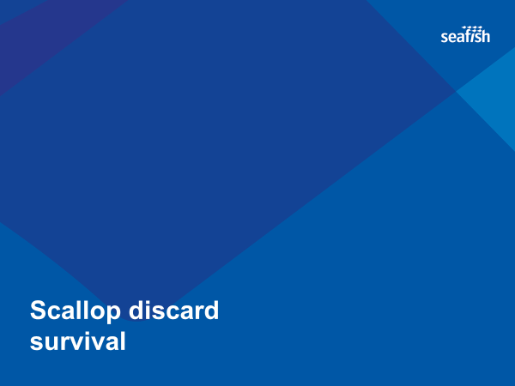
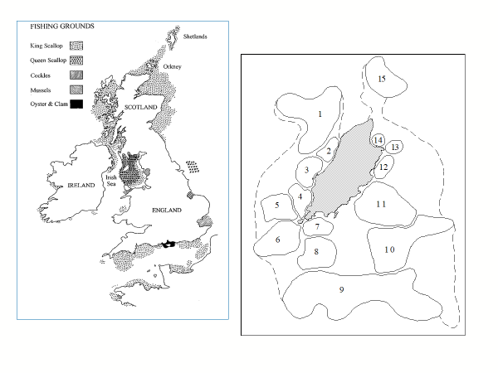
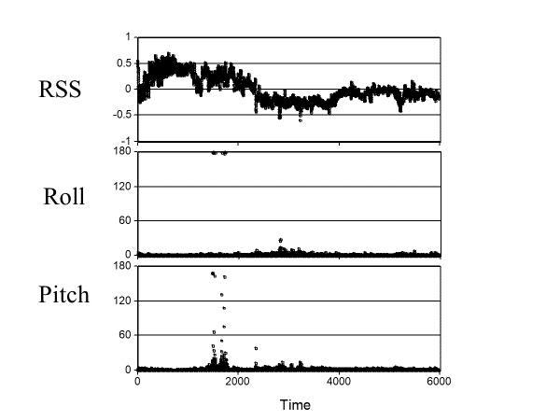
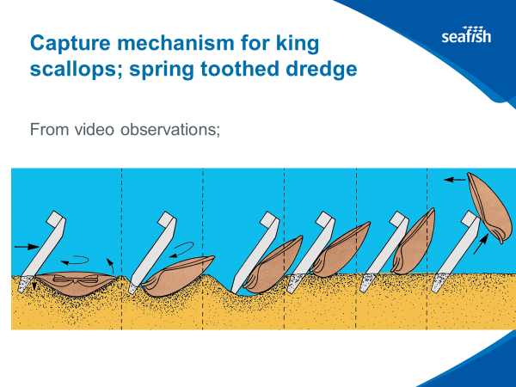
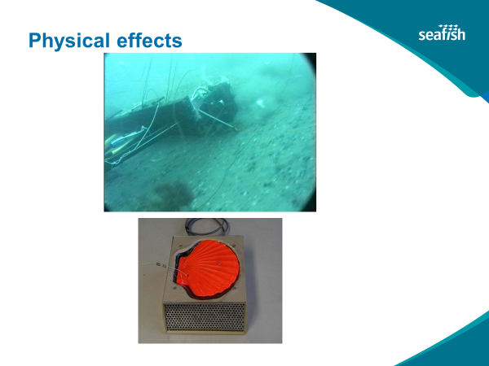
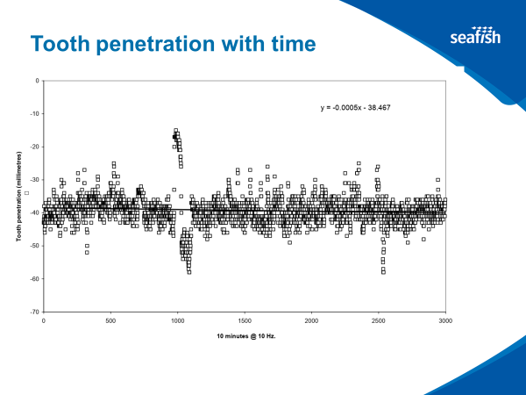
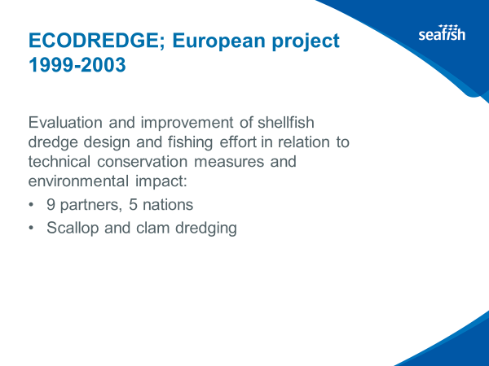
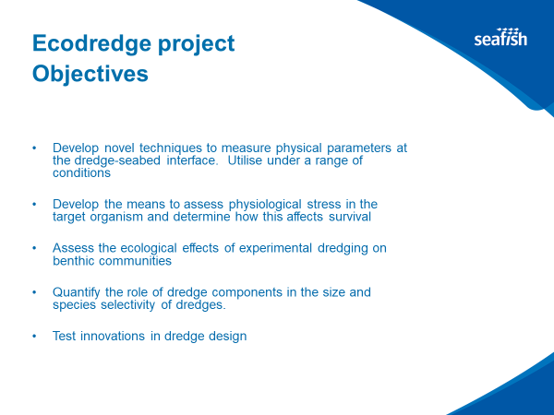
Action 2 Harvest Strategy (1.2.1) (Seafish/SICG)
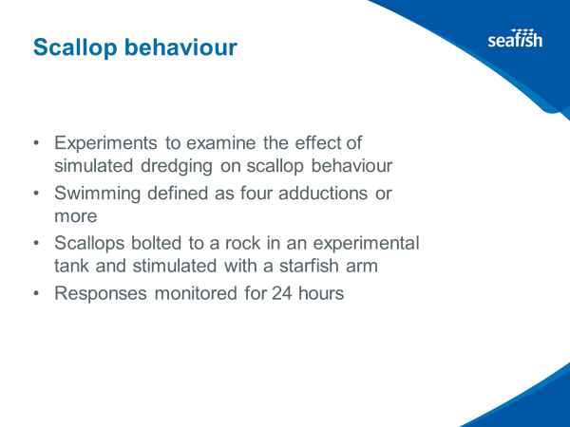
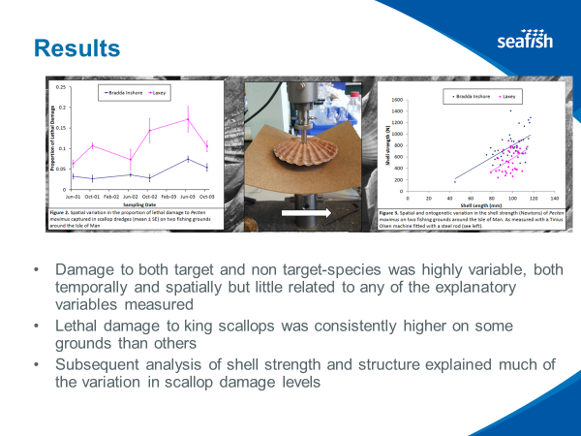
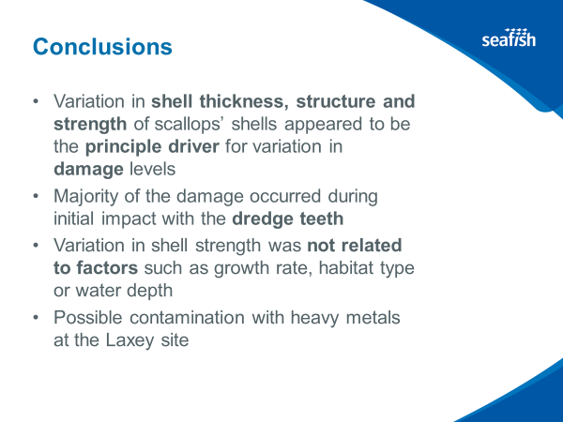
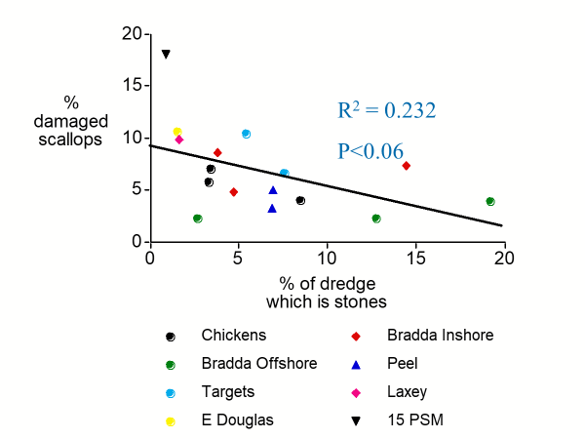
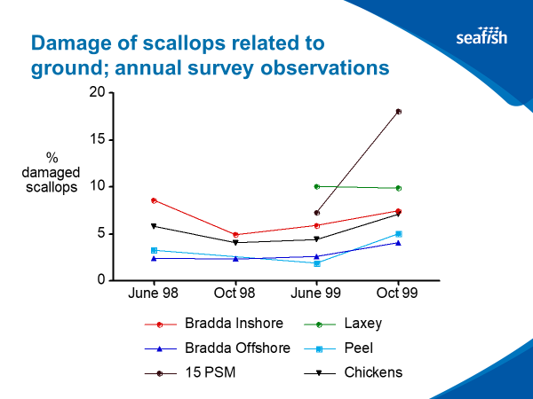
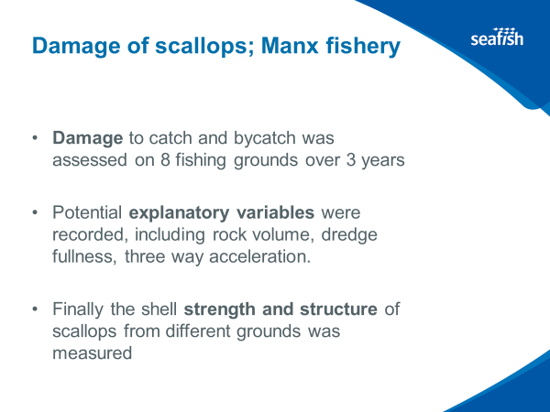
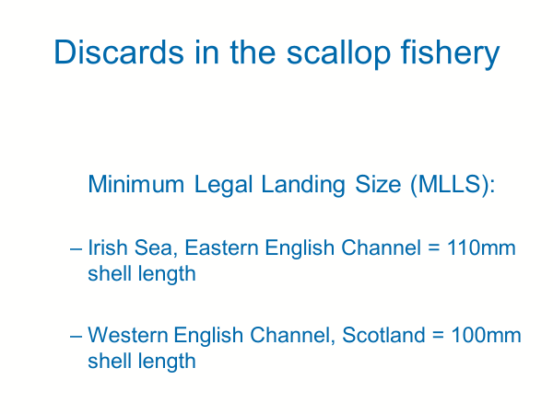
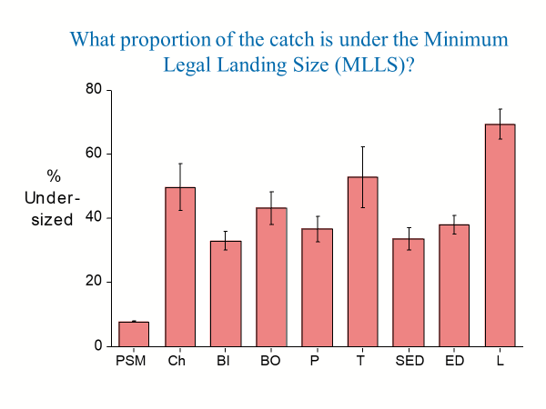
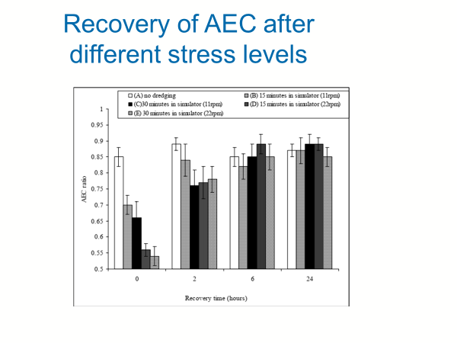
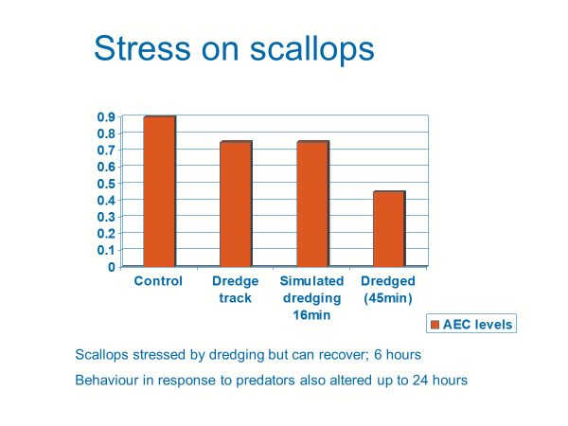
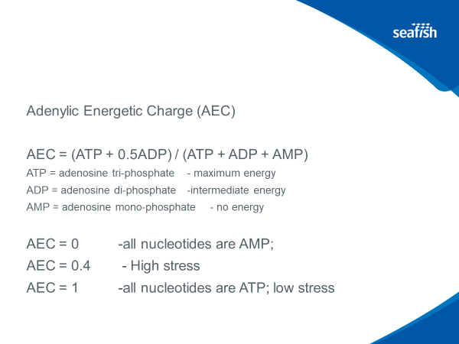
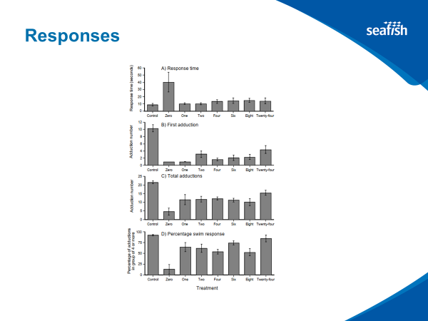
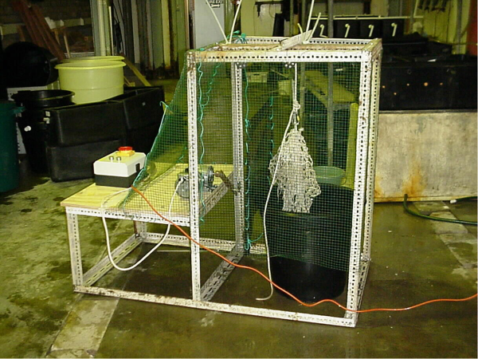
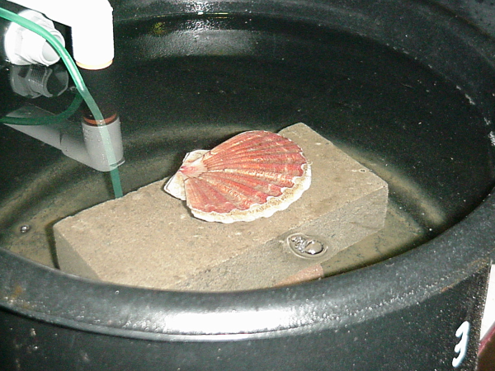
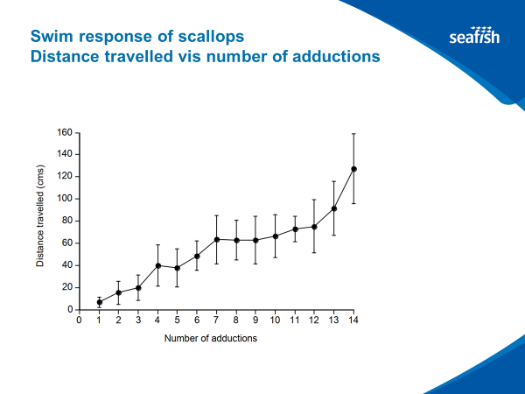
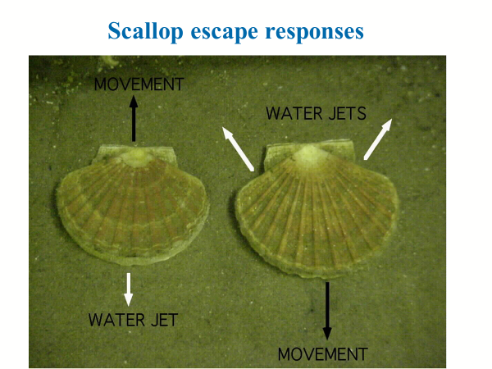
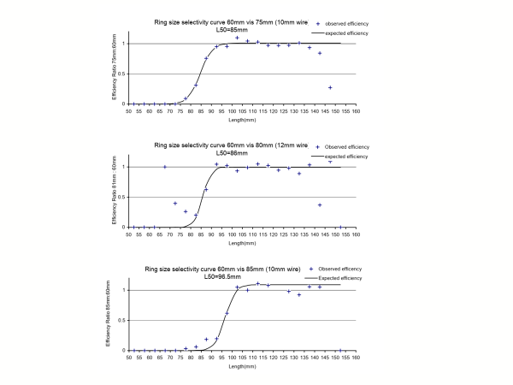
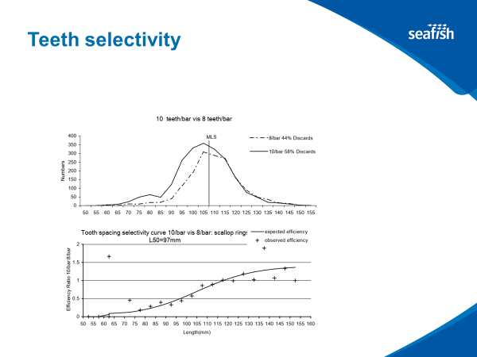
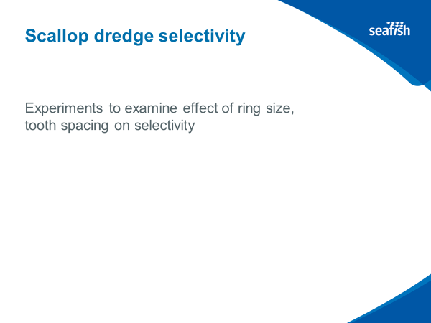
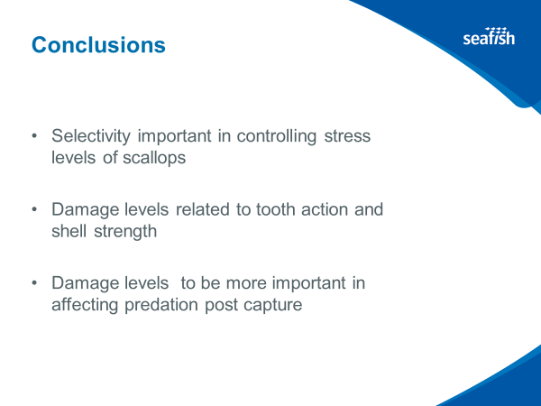
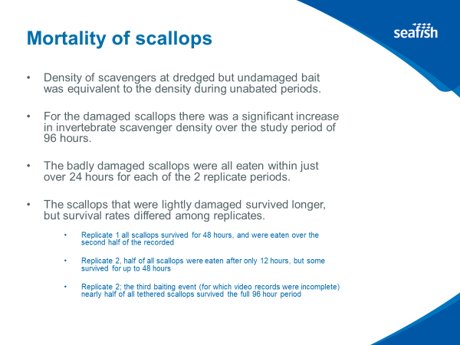
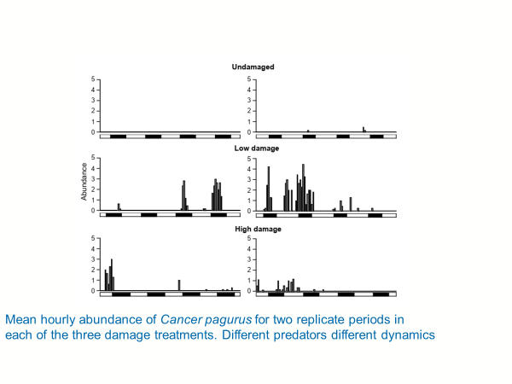
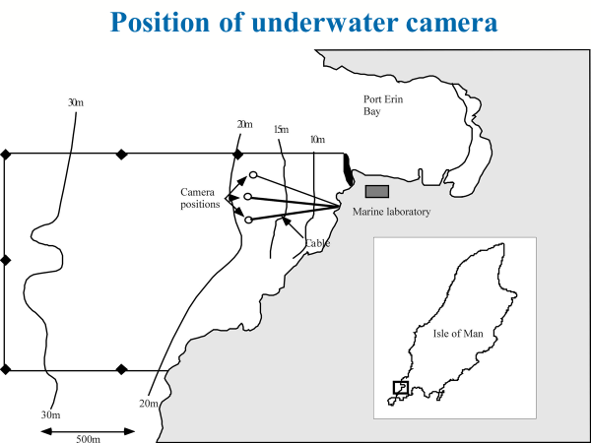
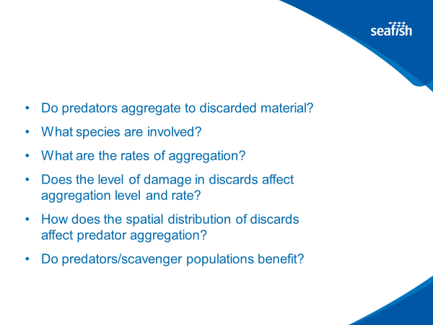
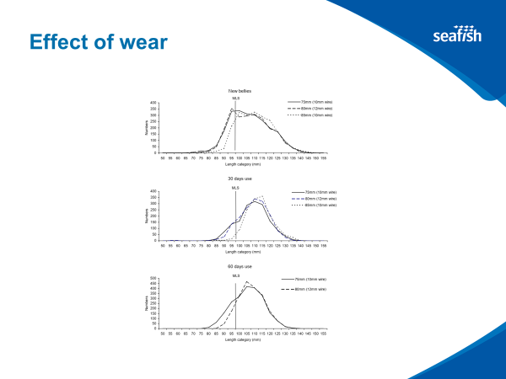
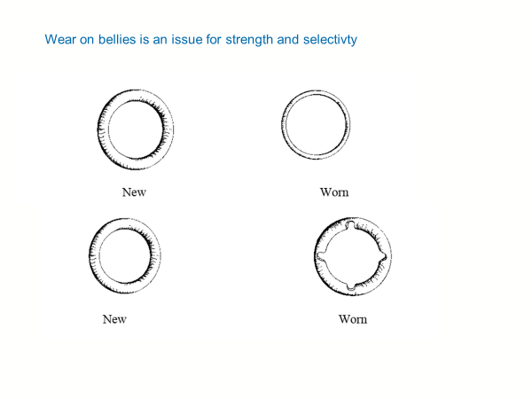
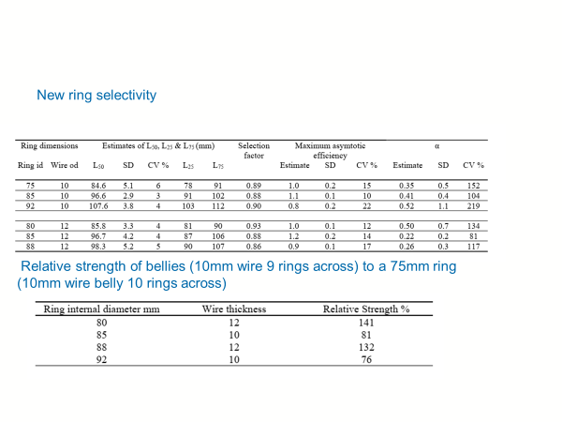

- Physical Effects - Dredge measured orientation, tooth penetration etc

- Scotland Minimum Landing Size 105mm (since 2017)

- ICES Bycatch Working Group being set up – ToR being signed currently

- Damage rate related to shell strength
  - Unsure why this shell strength was different for different areas
  - Possibly due to higher concentrations of metals in the region

- Dredge simulator collaborating using Robo-scallop
  - After simulated Dredge event, response time is longer and then number of abductions is significantly lower up to 24hours

- Stress on Scallops – dredging for a long period of time will reduce energy levels available to the scallop for up to 24 hours

- What happens when dredge scallops are left on the seabed?
  - Baited cameras to look at effects
  - Undamaged scallops don’t attract predators; damaged do attract predators
  - If undamaged but stressed, then predation rates were low
  - Badly damaged scallops were all eaten within 24 hours

- New Ring Selectivity
  - Larger ring dimensions lead to higher selectivity
  - All sizes of ring strong enough to begin with but after a while of usage rings can bend and change shape - become more selective and begin to break

- Scallops survive adequately if they are undamaged, even if they are stressed

- MK – what evidence can we usefully gather (with industry involvement) to inform unknown mortality
  - How chipped/unchipped a scallop is v dependent on habitat type, amount of time dredged etc – large number of variables
  - Experiments are limited in the number of scenarios they looked at

  - LB - Masters student looking at damage to scallop
    - Average 5% discard mortality – very low
    - This is being undertaken on the research vessel
    - Still in draft – would be good to have timings of this
    - Concur with MK observations

  - Evidence can be done simply with industry

  - May be possible to assess damage using the cameras on dredges

  - Macduff – when scallopers have dredged an area, crabbers go in after
    - Supports idea of predators
    - Another variable that these predators are removed
    - Not many skippers who would be willing to agree to cameras

    - JP – Steve Eusted (?) working on cameras for S1 Channel Scallops

  - Don’t have to physically be there to quantify damage, needs a days’ worth of filming in different locations and different boats

  - FN – to LB: Was increase in Minimum Landing Size linked to discard rates and survivability? Within MSC standard there must be a review of alternative measures
    - Alongside surveys for assessment processes
    - Came about due to work at ICES working group
    - Increase in MLS followed industry consultation – no changes to gear and not linked to mortality etc
    - Limited no of dredges per side – unless cameras fitted
    - Last stock assessment 2016 – lot of places increase of MLS would increase spawning stock

  - JPort - What avenue are we going to go down? Scallop dredge doesn’t go over ground once. There is a depletion rate of catches due to dredge efficiency. Might well be picking up damaged scallops on 2nd, 3rd and 4th passes which might change survival rate?
    - Acknowledge this and do probabilistic determination of picking up same scallop more than once

  - JPort - Deal with survivability mathematically as well? Different growth rates due to climatic factor or possibly damage?
    - 2 separate things –
      - different growth rates in different areas of the sea
      - BL results seem to indicate that severe damage over certain level scallop will not survive
    - Some assumptions must be made – natural mortality will far exceed natural mortality rate

  - Most scallops have very minimal damage

- Potential MSS study of discard rates to be done
- What are the next steps to track this action?
  - LB – industry suggests there is very little discarding
    - If bags are filling up too quickly then smaller scallops might not be able to be escape

  - Any discussions with industry action partners?
    - Different recruitment on different grounds may lead to different discard rates
    - Would be good to work out
    - Possible funding for observer program in Irish Sea – couple trips per year
    - There is data – not a data vacuum
    - Could use best available science to infer some discarding and survival rate. Issue comes down to whether industry is happy with these inferred rates

- Initial action was to understand what data was available – collation is natural next step and then let industry review
- MK – might be something to pose to ICES Working Group
  - Copy of Working Group Tor to be acquired and circulated – was updated in October 2018
  - 3-year timeframe for ToR – lot going on in 1st year, data collation and workshop on ageing
  - Bycatch and discard mortality on the back foot

  - Good to go through right forum – by next summer would have answers to this if Masters Student was put on it
    - Won’t have it all collated this year
    - Just figuring out who has what data
  - Next Scallop WG in October – proposal to be put to group and feed back to next SG
Action: MK and LB to liase around what evidence are needed and get timeline to report back with desk study and then get feedback from industry to determine whether this is reflective. BL to also be involved in conversation

- A clear understanding of what the cameras would record would be good so then this can be put to SICG – MK to write up brief for this
  - Avoids putting a scientist on board vessels
  - Easy to say but the practicalities and cost implications as well as storage and access to downloading these large datafiles
  - Automated system not yet in place

  - Just need to compile existing data and then if needs be do a couple days of data collection – 1 trip or so

- Wider debate to be had about future management with sentinel boats and wider application of cameras but this is a different discussion

- JP – can Channel project do similar thing?
  - This should be the same as this and would be good to harmonise between the 2 projects

- Helpful discussion and good actions to move forward
- Need to update AP timings to reflect ICES Working Group timeframes etc
Action: LB to circulate ToR and workplan; masters student thesis

Action 3 Harvest Control Rules (1.2.2) (SICG)
- Short discussion about need for SICG to engage with PUKFI process
- Agreed that SICG would attempt to coordinate so that there was no overlap
- SICG intends to manage all areas
- FIPs aiming for same objective and shouldn’t be any conflict

- FM – any progress since Scallop conference?
  - Reported back to SICG
  - Working groups set up – 1 looking at stock assessment for Channel; 1 for future man strategies; fleet structures and latent capacity – combined with man group; gear conflict resolution – MK on group, seabed mapping to show interaction between gear types across different habitats

- Harvest Control Rules being developed by industry in conjunction with relative authorities
  - Testing areas where fish authorities feel there is scope for man change
  - First check in to ensure feasibility and credibility
  - Early stages
  - Next meeting 28th June – update for next meeting

- Helen Hunter usual attends and gets all SG info

- EP – point of clarification, ref points for HCR and ref points for stock status?
  - Bio ref points for act 1 and fish man ref points for act 3

Action 4 Information and Monitoring (1.2.3) (MSS)
- Gap analysis for info gaps across stock assessment areas
  - ICES WG already done this
  - May be slightly outdated but already gathered and a useful starting point
  - To be shared with Group
  - Possible post for Ref Points and stock assessment
  - Collaboration with MK for PhD on West Coast
  - Aberdeen Gonad project
  - Orkney IFG Flag Funding for survey approved – looking to get survey up and running ASAP
  - JP to go straight to Elizabeth to keep updated

- Extending annual stock surveys
  - Cover 5 (& Orkney)
  - Clyde would be another – spoken to ships liaison officer about extending into this area
  - Will keep group updated

- Alternative options for stock ass
  - MSc student in place looking at data limited stocks
  - Will feed back – due to finish in Sept

- Data limited approach would be possible
  - Irish Sea on ToR for ICES WG
  - 3-year plan and in its infancy currently

- AB – future fisheries management doc, Scot Government ‘obliged’ to put funds in to these data limited fisheries
  - Consultation in autumn
  - Draft strategy in place by spring
  - Work streams in play late 2020/early 2021

- ICES WG on data limited approaches for Deep water fisheries
  - Continuing to be developed and plenty of tools available

Action: MSC to look at data limited approaches and feed back to group

- Intention for 4c milestone is to determine why there are different approaches from MS and others
  - Hope would be that all stocks could go through default, but RBF is available if necessary

Action 5 Assessment of Stock Status (1.2.4) (MSS)
- Feasibility of Orkney & Clyde stock surveys
  - Already covered

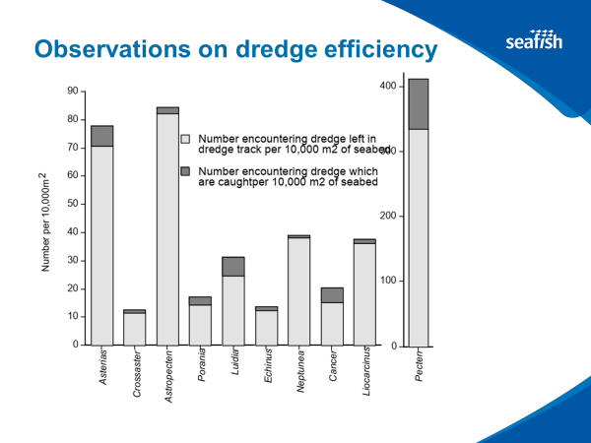
Action 6 Secondary Species (2.2.1, 2.2.2, 2.2.3) (Seafish)

- Great variability in dredge efficiency across UK

- Covering unobserved mortality is within AP
  - Would be good to fill in any data gaps
  - Very difficult to quantify

  - JPort – controversial topic, channel stock assessment doing underwater work to try and establish dredge efficiency status for various seabed types.
    - Other species are definitely caught
    - 2017 report used unpublished Dave Palmer work to work out catch rate depletion

- This action focuses on 2ndry species and this analysis is v old. Action is to
- LB - Bycatch data set fairly extensive, and paper in draft

- When working out what fraction of populations were affected by species for EcoDredge survey, it was suggested to be ~1%
- Brown crab was higher

- Larger things are more likely to be collected – whelks, large starfish etc

- Existing data needs to be collated and see what might be missing
- LD – bycatch paper published by end of year

- Ideas for data collation – all open access so could be done by an PUKFI partner such as Macduff or Poseidon
  - LB – industry suggest there is very little 2ndry species bycatch, but this does not seem to be the case
  - Data gap but for now should focus on existing published data

- Actions 2 and 6 may be aligned and coordinated with BL as lead

Action 7 ETP (2.3.1, 2.3.2, 2.3.3) (LINK/SNH)
- SNH to be moved to advisory role as they were unable to lead do to possible conflict of interest
  - Very willing to continue as participants

- Lots of work happening in the background relating to the need to collate information and make it available
- Sub-group idea is a good one for efficiencies of time etc
  - Geographically SNH only covers Scottish waters so would be good to contact sister orgs
  - SNH to be contact point – some discussion but not much feedback; will follow up
    - JP to follow up
    - LB also mentioned PUKFI to JNCC as a forum to align work

- Relevant consultations coming up:
  - Completing MPA network in Terr Waters – out now for 4 sites
  - 2nd phase of MPA man measures and consultation of PMFs outside MPAs – consultation to be out later this year

  - Should have relevant data and response that might inform action and can be made available as and when consultations come up

- Volunteers to be part of sub-group will be chased within 2 weeks

- MK – all about resource management. To pull together these resources takes person power. Might be good to have a body/person that can be tasked with getting this data
  - Industry partners could come together to fund a person who might be able to track forward on this data collection
  - Knowledge partnership fund; FIS Funding; Ocean Sustainability Fund; MSC Pathways Fund

- Capacity issue for MCS/LINK to be action lead for Sub-Group
  - If funding could be got to drive forward data collection etc then this might be more feasible

Action: MSC to look at funding possibilities and circulate draft proposal
- SG members send possible funding options to JP

- SNH/MSC now have internships available for up to a year

- AB – in terms of sub-groups it is difficult to commit until all sub-groups are confirmed
  - To be discussed and confirmed at end of meeting

Action 8 Habitats (2.4.1,2.4.2,2.4.3) (SNH/Heriot Watt)
- MK – pres
- Confirming funding for PhD (3.5 Yrs)
- Higher level generic work for all areas covered by PUKFI 2
  - Understand status of seabed habitat in relation to Scallop fishing effort
  - Recoverability/sensitivity map
  - Can inform management strategy
  - Feeds into ecosystem PIs as well due to dependence of scallop spat recruitment on seabed fauna
  - Can be done on existing publicly available data
- West Coast Data poor area – small scale fleet and therefore little to no VMS data
- overall project doesn’t fall over if this data is not available
- Defining UoA for fishery for cert process may have some holes in it – ‘swiss cheese’

- Timeline – contract to be signed off and advertised with person in place by Sept/Oct
  - Might be able to attend next meeting

- Leaning on SG for collaborations and industry liaison etc

- BL – potential for collaboration with Nephrops
  - Watching brief for now
  - Under-promise and potentially over-deliver
  - Should be able to use MSc projects around this wider PhD
  - Similar approaches can be played out on Nephrops drawing on same dataset

- Sub-Group will focus on action 7, 8 & 9

- FN - 8b would be covered by PhD or should come from SG?
  - Available online for Scotland
  - To take up with DEFRA/JNCC
  - Seafish may be compiling something similar
    - GIS tool that shows leg for conservation areas etc
  - PhD would feed into management plan development
  - SG to think about the different management approach scenarios and frame questions
  - This is to be done further down the timeline

Action 9 Ecosystems (2.5.1,2.5.2) (LINK/SNH/WWF)
- DD update
  - Not much different than discussed from actions 7 & 8
  - Strongly interlinked

- Expert Group to undertake SICA will probably be Management Sub-Group
  - What ecosystem effects should be focused on for SICA
  - Proposal put together and outside expert to undertake – possibly Poseidon

- JPort – distillation of what has been done in Channel to feed into this one?
  - SICA already undertaken by Cefas
  - JP to pull together this and present for next SGM

- MK – negative interaction between edible crab and scallop fisheries – buried female crab aggregations in Oct/Nov
  - Peak in bycatch scallop dredging
  - Temporary spatial closures possibly
  - Talk to other sectors about this
  - Not something to be worried about but should be looked at

- CM voiced his support for this Management Sub-Group approach
  - Need to think about other stakeholders
  - Focus group 1st but reach out to others at later points
  - Could join as S-G observers

Action 10 Legal Framework (3.1.1) (TBC sub group)
Action: JP spoke to Annika (Seafish NI) who can pull together relevant Irish Sea stakeholders

- Fishery Management Plan template is a useful template to store all work in one place as working doc
  - Don’t have to start from scratch on this
  - Created by PUKFI s1 consultant (Tim Huntington)
  - To be re-circulated by JP
  - Will be taken on by the client group but not to be thought about straight away

Action: MSC to have a look at alignment between S1 Channel Scallop

Action 11 Consultation Roles (3.1.2) (SICG)
- SICG list is effectively the stakeholders
- Industry consultation, but nothing much been done on this yet
- To update on this at next SGM

Action: JP to attend September SICG meeting to feed back on the progress of PUKFI S1 & 2

- MK – NGO consultation also important
  - Fishery Management plan good place to document formal and informal consultation and different regional consultation
  - Ireland leads on from Action 10a

Action: MSC to define where formal/informal consultation is necessary
- Documenting the flow chart of what consolation processes are occurring

- MK – typically during MSC assessment formal consultation occurs too late
  - 1 objection, which could be avoided if occurred earlier in the process, can take up a lot of time and money

- DD – there are several consultation processes that can be shared but to avoid these issues communications and outside engagement is key
  - This is a wider PUKFI approach
  - Not scripted in
  - Wider question about PUKFI engagement

- DD – communicating work done and engaging positively does need a plan

- No formal comms or engagement plan for PUKFI S1

- BL – touched on this with Nephrops yesterday.
  - Wider consultation with those not in the group
  - Not about those wanting to join the group

- AB – could take a leaf out of how consultation occurs around MPAs

- MK – interest of expediency, in 12 months’ time might be useful to cover off areas needing consultation with a mini ‘congress’ bringing people together and get input at this point. Invites further engagement at this point
  - Logistical cost but for those funding the project it would be a good showcase for the progress that the project is making

- JPort – Fishery Progress is an open forum which is public facing, and anyone can engage in
  - French PUKFI and Irish PUKFI development

- Bringing back to PIs
  - 1st is about who is in SG etc
  - 2nd is about info used
  - 3rd is consultation process

  - A lot can be learnt from PUKFI 1 and interaction with French
  - Fish Man Plan good place to document this
- Developing a PUKFI comms narrative – KA
Action 12 Fishery Specific Objectives (3.2.1) (SICG)
- Appropriate short/long term objectives

- SICG management group have some objectives emerging about controls around level of effort and manage unmanaged effort
- Looking at harmonization of measures and sharing pain across the sector
  - Bringing everyone up to highest standards, not bringing people down to lowest
  - Developing internally and then rolling out
  - No progress made unless legislation can be changed
  - Voluntary measures have been spoken about – e.g. self-regulation of Queen Scallops

- Translating and aligning objectives with P1 & 2
  - MSC can talk about standard but not tell fisheries how to meet it
  - Claire Pescod can now help with this

Action: SICG to update on short-term framework and timeline at next SGM

Action 13 Decision Making Process (3.2.2) (ALL)
- Until group has been formed it is difficult to decide what can be focused on
- Any movement in SICG Management Sub-Group on sub-dividing this geographically?
  - Lots of person power would be needed to have different group for each UoA
  - Internal conflict between UoA and UoC
  - Scallop man is more of an open book
  - Client group might also differ from geographical identity

- Something that could be pushed a year to figure out what these subdivisions could be?

- Action doesn’t state that a separate sub group is needed for each UoA

- Not a right or wrong answer, up to SG but as long as there is a process for decision making

- MK – politics needs to be considered. Only 1 governmental rep in the room. 1st priority to have governmental discussion as these people would frame rules of engagement
  - Sensible to incorporate politics into management

- Possible other sub-group?
  - May evolve from SICG work
  - May not be answers we want to hear but are answers nonetheless

Action: SICG to feedback what has come out of 26th June meeting at next SGM

Action 14 Compliance and Enforcement (3.2.3) (ALL)
- Appropriate monitoring system needs to be put in place

- AB – SWFPA pressing Scot Gov for VMS on all vessels
  - Decision taken a while ago
  - Going to tender soon
  - England and Wales may have already gone out – to check on this

- DD – timescales are reliant on other organizations to take actions forward
  - This action was specific in response to concerns about how you enforce closed areas and monitor if a vessel is fishing in a closed area
  - Working with industry to develop tech that might be available

  - Ways of doing this are controversial and things the industry might not want.

  - The point of this is to find what options may be more palatable to industry

- MK – opportunity to combine VMS with other innovations such as Bluetooth gear in/gear out would allow vessels to become scientific data vessels – industry would probably have to volunteer for this
  - Precision monitoring on the ground
  - Tech already being put in place and a platform to develop on
  - This could be beneficial for the industry as it would make stock assessments more specific

- AB – increasing pings could be part of the answer

- FIP could be at forefront of innovation
Action: AB to put together a draft proposal for SICG

- JPort – Devon & Severn IFCA developing innovations
  - Might be a useful idea to have a presentation on things occurring around the country in terms of tech updates

Action 15 Monitoring and management Performance Evaluation (3.2.4) (ALL)
- Significantly linked with Act 13 – already covered
Action: FN to edit Action Plan to reflect this link

Next Steps
- Sub group formation
  - Inform JP within 2 weeks – pressganged if necessary
  - Set them off from this point forward
  - Environmental Sub-Group is probably the most significant S-G

  - AB - SICG have Management S-G but is focused on Stage 1, should there be a different group for Stage 2?
    - JPort – not sure there is any point having 2, at least at this stage
    - Should other Scottish stakeholders be engaged other than SWFPA?
      - Something for SICG reps to think about

  - Possible innovation Sub-Group?
    - Probably useful people out there with long-time insight into fishery monitoring
    - SICG invite individuals to come to the group with their expertise on an ad hoc basis – this might be something for PUKFI to do too

- Communications/ Website
  - Press release of Stage 2 Funders – was it missing something?
    - ‘supported by’ rather than ‘funded by’
    - Already in fishing news
    - SICG possibly listed in text

    - Possible clarification? Extra press release in 6 months’ time to update this mistake

  - EP – wider value on others seeing the successes that have been made as a result of PUKFI
  - MSC to engage in a comms exercise for PUKFI – opportunity to do more in terms of branding
  - KA to lead – 6-month timeline
    - SG reps round table over summer with some comms experts with feedback in the autumn

  - JPort – already on FP, this was to be face of the FIP. No PRs have happened up until now
    - Have to think about future funding and buy in
    - PUKFI as its own brand in and of itself
    - Project has grown since its inception
    - More work could be done on promoting the good work being done

  - AB – FP is a dry website, would be good to have a website that processors could read and understand etc
  - Promotional material to justify why funders should continue to invest in PUKFI, as well as gain public support and fisheries policy

  - JPort – who owns the PUKFI engagement? Is there a spokesperson or is it a press release every now and then

- PUKFI governance (Open Seas engagement)
  - Being faced with tough choices, shouldn’t be all on MSC’s shoulders to make these higher-level decisions on behalf of the groups
  - OpenSeas have now made approach to join Steering Group
    - Believe they could sign up to ToR (in writing)
    - Mis-alignment with what they seem to say and what they do
    - Next step is to have a vote

  - Decisions are bigger than process currently developed
  - Process and due diligence to be done as this decision sets a precedent for the rest of PUKFI

  - Clearly a complex situation
  - Controversial group may detract from the progress that is being made

  - Any ideas/insights/opinions welcome
    - MK – conference style thing would be a good soft approach
      - OpenSeas may need a more immediate answer than this
      - OpenSeas linked in and will have close contact through the PhD

    - AB – request from OpenSeas has allowed SG to think about who is appropriate? Good to reflect on how groups might become members
      - Practicality means that the large area of the SG means that at some point the SG might become too unwieldy
      - This might be an opportunity to review SG members and reduce to number of people who are actively feeding into group

    - CD – OpenSeas would have some good things to feed into the Environment S-G and have been constructive with Good Fish Guide in past

AOB & date of next meeting
- MK – would be good to review format of meetings? Break up structure with more focused elements
  - Deeper focus on more interesting bits etc
  - Seek to update table before meeting so that some things can be focused on to be more time efficient
  - Sub-group might be good for this

  - Would have liked to have focused onto UoA v Management Unit discussion etc
    - 26th June meeting needs to occur before this can really been progressed properly

  - Would be good to circulate a document that can be filled in with progress beforehand
    - This may lead to some more targeted discussion and skipping over the dryer topics

- FN – nominate areas to focus on in the next SGM
  - Harvest Control Rules & Harvest Strategy

