C7488 Project UK Fisheries Improvement - Task 5. Monkfish ecosystem assessment
Information for Scale Intensity Consequence Analysis (SICA) of performance indicator (PI) 2.5.1

Author(s): Gwladys Lambert, Roi Martinez, Stephen Mangi
Issue Date: 18/01/19

Cefas Document Control
Submitted to: | Claire Pescod on behalf of Project UK Fisheries Improvements
Date submitted: | 18/01/2019
Project Manager: | Anna Sypniewska-Huk
Report compiled by: | Gwladys Lambert
Quality control by: | Stephen Mangi
Approved by and date: | Stephen Mangi 18/01/2019
Version: | 1.5

Version Control History
Version | Author | Date | Comment
1.0 | Gwladys Lambert, Roi Martinez | 23/05/18 | First draft
1.1 | Gwladys Lambert, Roi Martinez | 08/06/18 | Addressed QA comments by Tom Catchpole
1.2 | Gwladys Lambert | 11/06/18 | Accepted Mangi’s minor corrections
1.3 | Gwladys Lambert | 31/07/18 | Addressed customer’s comments
1.4 | Gwladys Lambert | 17/01/19 | Addressed customer’s comments post steering group workshop
1.5 | Gwladys Lambert | 18/01/19 | Addressed QA comments by Stephen Mangi

Executive Summary
We used the MSC SICA guidelines, under Performance Indicator (PI) 2.5.1, to provide information necessary to score the impact of beam trawling for monkfish in 27.7b-k and 8a-b, 8.d on the part of the ecosystem with which they interact. The aim was to provide information to allow the Project UK Fisheries Improvements (PUKFI) project Steering Group to identify and recommend further research and management actions that reduce ecosystem disruption to acceptable levels, if required.
Existing published literature has documented the effect of towed bottom gears on the seabed and its associated benthic and demersal communities and provided information on the effect of trawling on the ecosystem sub-components (species richness, functional diversity, community distribution, trophic/size structure). Here, Vessel Monitoring System (VMS) maps were compiled to enable scoring of the spatial scale, temporal scale and intensity of the activity. The maps and information collected from the literature were presented to industry representatives at workshops and their feedback gathered.
Monkfish beam trawling covers a very small part of the UoA (<15%). The authors consider that by including the activity which is not covered by VMS data (≤12m vessels), the percentage coverage would not exceed 15% (cut-off point on the MSC scoring scale).
The fishery is operated throughout the year, ranging from 345 to 352 days of activity per year during the 2012-2016 period. The intensity was difficult to score and subject to debate with the industry, due to their perceived lack of agreement between actual score (1-6) and associated wording in the MSC guidelines.
Beam trawling has been shown to have a significant impact on the local ecosystem and therefore defining which of the subcomponents is the most vulnerable is not straight forward as each subcomponent is linked to the others. For towed fishing gears such as trawling that has a significant impact on the seabed, effects on species composition is linked to the functional characteristics of the species. The beam trawl fishery will impact the species displaying the least resilient traits. The actual effect will depend on the spatio-temporal scale of the fishing intensity, the state of the original ecosystem and the level of natural disturbance it is already subjected to.
Beam trawls are also known to have poor selectivity, as several species are caught or indirectly impacted by the contact of the gear with the seabed. For instance, monkfish are caught alongside other commercially important species as part of a mixed fishery. The Cefas Observer Programme (COP) shows that megrim, cuttlefish, dogfish, plaice and a number of other species are caught alongside monkfish.
In terms of the food chain, monkfish are not thought to be key prey species, but there may be an indirect consequence of removing a top predator from the local ecosystem. However, stock assessment over the whole UoA does not show signs of decline of the species and therefore the impact might be limited at the larger scale.
Under a data limited approach, which could be questioned here in light of the data available for the fishery and published researched on beam trawl impacts, the score of PI 2.5.1 is likely to be low, despite the relatively small footprint of the fishery in its UoA.
Further investigation into the spatial footprint of non-VMS equipped vessels would help better characterise the footprint as well as further research into mapping the species habitat or considering the monkfish as two separate species. More details are given in the discussion with regards to gaps in information and suggested areas of future research.

Table of Contents
1 Introduction 4
1.1 Monkfish beam trawl fishery in area 27.7.b-k, 8.a-b and 8.d (southern Celtic Seas, Bay of Biscay) 4
1.2 Scale Intensity Consequence Analysis (SICA) 5
2 Methods 5
2.1 PI 2.5.1 SICA Spatial, temporal and intensity scale 5
2.2 PI 2.5.1 SICA Subcomponents 6
2.3 Maps 7
2.4 Catch composition 9
3 Results 9
3.1 Maps 9
3.2 Spatial scale of activity 11
3.3 Temporal scale of activity 12
3.4 Intensity of activity 12
3.5 Relevant subcomponents 13
3.5.1 Species composition 13
3.5.2 Functional group composition 13
3.5.3 Community distribution 13
3.5.4 Trophic/size structure 14
3.6 Further rationale to inform scoring 14
3.7 SICA scoring table for monkfish beam trawl fishery in area 27.7.b-k, 8.a-b and 8.d (southern Celtic Seas, Bay of Biscay) 16
4 Discussion 20
5 References 22

Figures and Tables
Figure 2-1 MSC SICA scoring tables 6
Figure 2-2 MSC SICA scoring table for the subcomponent 7
Table 2-1 Table of cut-off points for inclusion of tows in the fishing effort calculations 8
Figure 2-3 Maps of Unit of Assessment for Monkfish fishery 8
Figure 3-1 Map of sediment type of the UoA 9
Figure 3-2 Map of swept area ratio of monkfish beam trawling 2012 10
Figure 3-3 Map of swept area ratio of monkfish beam trawling 2013 10
Figure 3-4 Map of swept area ratio of monkfish beam trawling 2014 10
Figure 3-5 of swept area ratio of monkfish beam trawling 2015 11
Figure 3-6 Map of swept area ratio of monkfish beam trawling 2016 11
Table 3-1 Number of unique days of fishing for the monkfish beam trawl fishery in the UoA 12
Table 3-2 Table of proportion of the monkfish beam trawl activity by year and quarter 12
Figure 3-7 Catch composition of monkfish beam trawl fishery 13
Figure 3-8 Place of monkfish in the Celtic/Biscay ecosystem from 2012 Ecopath model, from Bentorcha et al. 2017 14

Appendix 1 Maps of monkfish fishery days/year by grid cell …………………………………..……………. 24

Introduction

Monkfish beam trawl fishery in area 27.7.b-k, 8.a-b and 8.d (southern Celtic Seas, Bay of Biscay)
There are two species included in the unit of assessment (UoA), the white monkfish Lophius piscatorius and the black monkfish Lophius budegassa. There is no clear evidence of the existence of separate stock units for each species in the UoA. Despite the biology and ecology of both species still being poorly understood, L. piscatorius is expected to grow faster than L. budagessa and live further north. Both are most abundant at depths of 200-800m but also occur in coastal waters. Size patterns observed in surveys suggest migrations with juveniles mostly found offshore, medium-sized fish inshore and larger adults offshore. Therefore, the species may exploit several ecological niches at various stages of their lifecycle. Monkfish are ambush predators who feed opportunistically, non-selectively on passing prey, which is lured by their specialised illicium. The diet of the small individuals is dominated by invertebrates while larger monkfish prey on fish, e.g. small gadoids, sandeels, flatfish, and, to a lesser extent, on cephalopods.
Monkfish is caught in mixed fisheries using a range of gear types such as otter trawls, gillnets and beam trawls. The units of assessment for this fishery include (i) bottom otter trawls, (ii) beam trawls and (iii) gillnets (trammel & entangling/gill nets) in the Western Seas and Channel (VII b-k, VIII a/b/d). The focus of the SICA analysis in this report is exclusively on the beam trawl component. The fishery (including all gears) is under EU quota management, with a joint quota for both species. The landings are all recorded as one species group as they are difficult to distinguish ashore. They are separated in sampling schemes designed at national level, which provide a splitting index that can be applied to the landings for assessment and management purposes. However, there remains a problem with the smaller, juvenile individuals as well as consistency between sampling schemes. Landings are in the range of 20-40 thousand tonnes per year, i.e. including all countries and metiers of the UoA. France takes most of the landings (60%), followed by Spain (20%), the UK (10%) and Ireland (10%). Minor landings have been recorded for Belgium, Germany and Portugal. About 95% of the UK landings consist of L. piscatorius. Across all countries, ca. 10% of L. piscatorius are caught in beam trawls, against 65% for otter trawls and 20% for gillnets. Discarding in this stock is relatively minor overall (in the order of 5-10%) although there will be large variations between gear types and possibly regions.
Beam trawls can be towed over a range of substrate types, from mud, sand to rocky or even cobbly grounds. Monkfish do not seem to strongly associate with one specific type of sediment. It is mostly found on sandy or muddy bottoms but is also present on shell, gravel and occasionally rocky areas. As with all other bottom towed fishing gears, beam trawls have direct impacts on the seabed that have been documented to be particularly detrimental on certain species and habitats. They are further known to have poor selectivity, which has been a focus of research in recent years. The UK Project 50%, for example, used gear modification techniques such as benthic panels, large mesh top panels and cod ends to reduce discard rates by about 50%. The pre-assessment report indicates that the primary species caught in the beam trawl monkfish fishery, except for monkfish, are megrim, plaice and sole and the secondary species are cuttlefish and gurnard. The 2018 ETP species analysis conducted in the UoA found that common skate was observed as bycatch in relatively significant amounts. Undulate ray was of concern prior to 2010 but seemed to have improved, i.e. decreased, while other elasmobranchs such as nurse hound, starry smooth hound and blond rays have increased. It reports the ETP species of the beam trawl fishery to be common skate, undulate ray, spurdog and northern gannet.

Scale Intensity Consequence Analysis (SICA)
The MSC SICA, under Performance Indicator (PI) 2.5.1, provides a framework to score the impact of an activity, defined as a Unit of Certification (UoC), over the ecosystem of the whole UoA in situations where data may be limited. The objective of this report is to provide some information towards the SICA scoring of the fishery described above (see details in methods overview below).
The MSC definition of an ecosystem under PI 2.5.1 refers to communities. It states that “there can be many interpretations of community—from very large-scale, ocean basin species assemblages to the small-scale, such as assemblages of a single taxon or small-scale habitat associations such as infaunal invertebrate communities. Community members include all mobile fauna, vertebrate or invertebrate, but do not include sessile organisms such as coral that are largely structural and therefore classified as habitat.” Impact on habitat and ETP falls under different PIs and are covered elsewhere in the MSC assessment process. Here we aim to provide information on the larger picture.

Methods

PI 2.5.1 SICA Spatial, temporal and intensity scale
We compiled Vessel Monitoring System (VMS) maps to help score the spatial, temporal and intensity scale of each activity under the PI 2.5.1 criteria. The spatial scale is defined as the percentage of the overall range of the stock covered by the greatest spatial extent of the activity of interest. The temporal scale is the number of single days in a year when the activity occurs. The intensity is based on a combination of spatial and temporal scales. See scoring tables below as extracted from the MSC documentation (Figure 2-1).
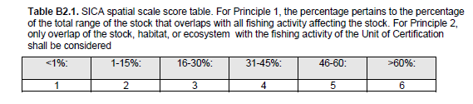
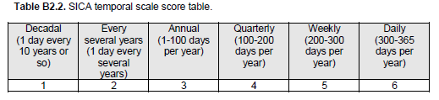
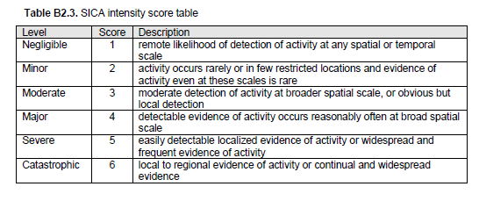
Figure 2-1 MSC SICA scoring tables
The maps, along with further information gathered from the literature and data on the catch composition of the monkfish beam trawl fishery, were presented at two workshops/meetings attended by representatives of the fishing industry in Ivybridge and Penzance, on the 16th and 17th April 2018 respectively. Here we report on the information presented, with some feedback on the discussions held at the meetings.

PI 2.5.1 SICA Subcomponents
The subcomponent aspect of the SICA analysis (scoring guidelines presented in Figure 2-2) includes species composition, functional group composition, distribution of the community and trophic/size structure. This information is used to discuss the rationale behind the scoring with respect to the fishery of interest, give indications of what might be seen as the most vulnerable subcomponent, and briefly report the discussions held with the industry representatives.
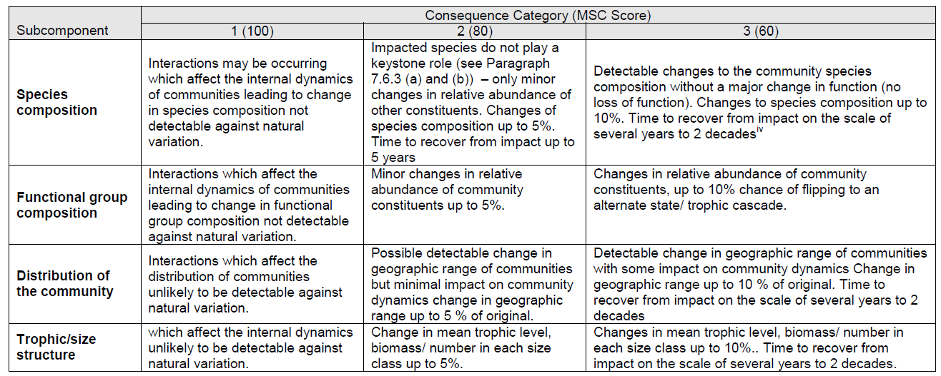
Figure 2-2 MSC SICA scoring table for the subcomponent
A wealth of published literature documenting the effect of towed bottom gears on the seabed and its associated benthic and demersal communities has been building up over the past 20+ years. A series of very recent studies (from 2016 onwards), resulting from projects such as BENTHIS and the ‘Trawling Best Practices Project’, have aimed to draw on the accumulated knowledge and evidence, using tools such as systematic reviews, metadata analyses and modelling approaches, to help better understand the interactions between fishing gears and ecosystems as well as the implications for sustainable management (see e.g. Kaiser and Spencer 1994; Groenewold and Fonds 2000; Kaiser et al. 2000; Jennings et al. 2001; Riemann and Hoffman 2001; Jennings et al. 2002; Heath 2005; Kaiser et al. 2006; Hiddink et al. 2008; Hiddink et al. 2011; van Denderen et al. 2013; Collie et al. 20016; Duplisea et al. 2016; Eigaard et al. 2016; Hiddink et al. 2016; Rijnsdorp et al. 2016; Bolam et al. 2017; Eigaard et al. 2017; Hiddink et al. 2017; Pitcher et al. 2017; Rijnsdorp et al. 2017; Sciberras et al. 2018). These cover aspects such as direct and indirect impact, recovery rates, interactions substrate type / communities / fishing gear, species and functional changes in composition, changes in size structure, in productivity, depth of disturbance in the sediment, link between fishing and top-down/bottom up control etc. We draw on the studies cited here and references therein to make some general comments on the likelihood of the fisheries of interest to have an impact on each subcomponent.

Maps
Maps were produced to support SICA analysis scoring and used as documents for SICA workshop discussion. Maps of fishing effort were created using VMS data (satellite position and speed of a fishing vessel larger than 12 meters reported every 2 hours) and logbook data (fishing trip dates, fishing gear characteristics and catches reported at ICES rectangle level). VMS data were selected only for fishing vessels belonging to South Western, Interfish and Cornish FPO’s. VMS points indicating fishing activity were selected to be those attached to a speed of 2 to 5 knots. Those VMS points were combined with the logbooks to filter out the beam trawlers trips where monkfish were the targeted species or anticipated in the catch. A minimum percentage composition was calculated for every year (Table 2-1) such that 95% of the monkfish landings would be represented for that year. Selected VMS data were then placed over a grid of 0.05 degrees square cells that covers the respective UoA areas. The SAR (swept area ratio) was calculated as the gear width multiplied by vessel speed and fishing time at each point. The point value was then aggregated per grid cell and divided by the area of the grid cell. The resulting SAR is therefore the number of time the grid cell has been fished over a year.
Table 2-1 Table of cut-off points for inclusion of tows in the fishing effort calculations
Year | Monkfish
2012 | 0.06
2013 | 0.07
2014 | 0.09
2015 | 0.07
2016 | 0.07

SICA spatial and temporal fishing impact indicators were supplied by fishery as swept area ratio and number of days fishing per year respectively. Swept area ratio is the proportion of each cell of the grid swept by the fishing gear (Gerritsen et al. 2013), the numbers of days fishing were represented by grid cell as well as total number of days in a year.
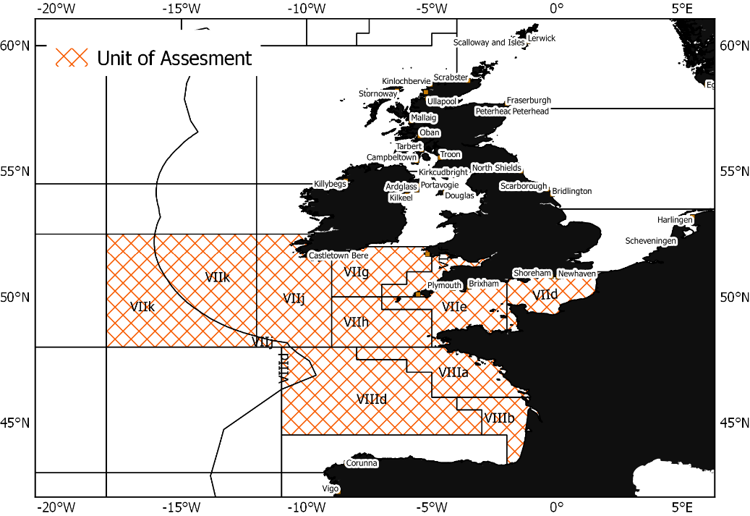
Figure 2-3 Maps of Unit of Assessment for Monkfish fishery

Catch composition
The information used here is presented elsewhere (see report for Task 6). In brief, a catch profile was developed using the data collected by Cefas Observer Programme (COP) between 2014 and 2017, in ICES areas VII b-k and VIIIa,b,d. The sampled trips used for the analyses were the ones considered to target monkfish (white and black-bellied monkfish). A trip was defined as targeting monkfish when this species constitutes 10% or more of the catch. For each trip, numbers-at-length were raised to the haul, based on an estimated proportion of the total catch volume sampled, then to the trip, based on the proportion of sampled hauls and fished hauls. The length-based data were converted to biomass, using length-weight relationships for each species collected during various scientific trawl surveys.

Results
Results of the SICA for monkfish beam trawl fishery in area 27.7.b-k, 8.a-b and 8.d (southern Celtic Seas, Bay of Biscay) are given below and summarised in SICA table format in section 3.7.

Maps
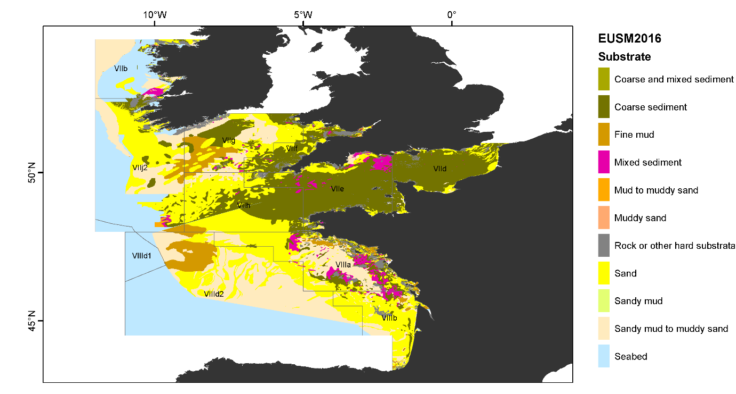
Figure 3-1 Map of sediment type of the UoA
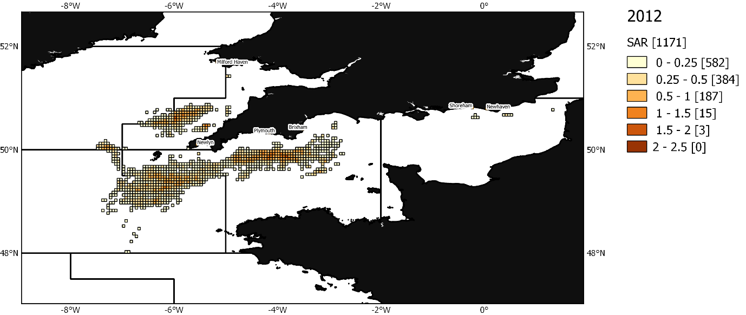
Figure 3-2 Map of swept area ratio of monkfish beam trawling 2012
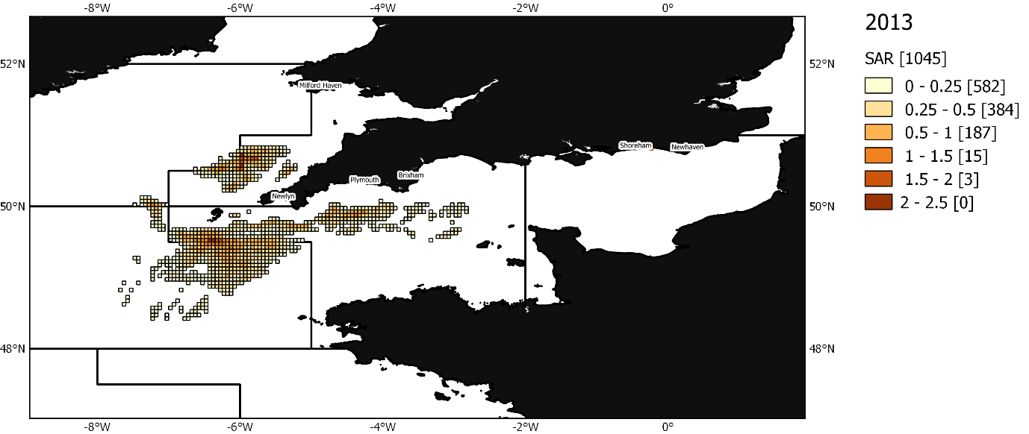
Figure 3-3 Map of swept area ratio of monkfish beam trawling 2013
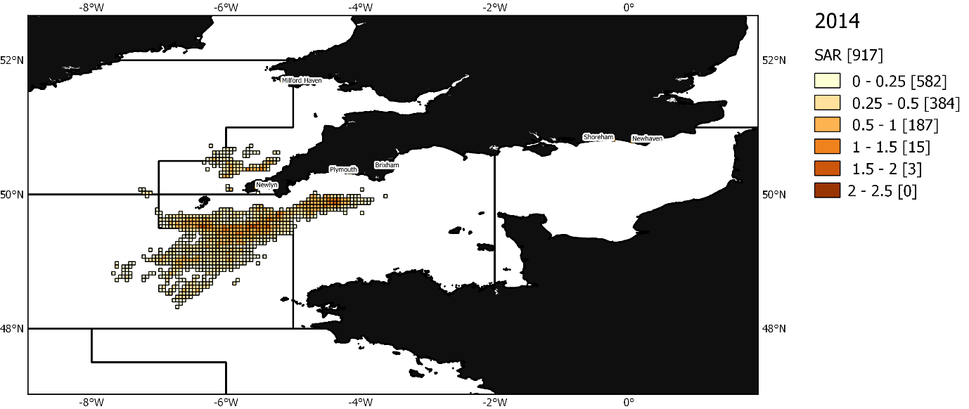
Figure 3-4 Map of swept area ratio of monkfish beam trawling 2014
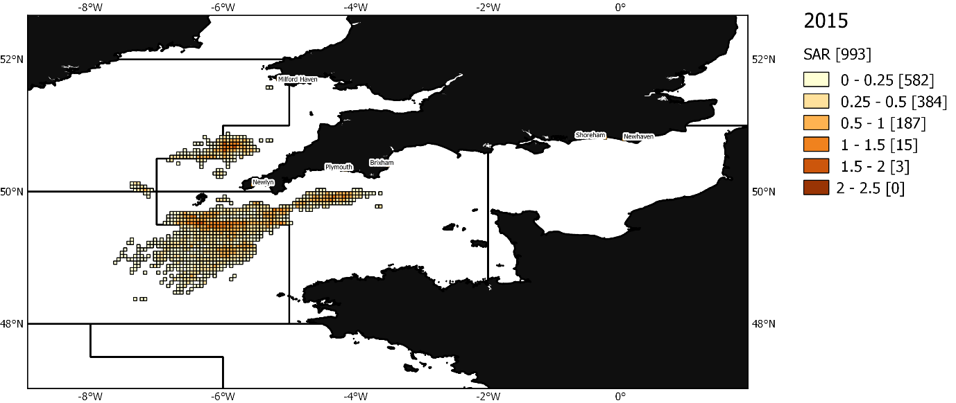
Figure 3-5 of swept area ratio of monkfish beam trawling 2015
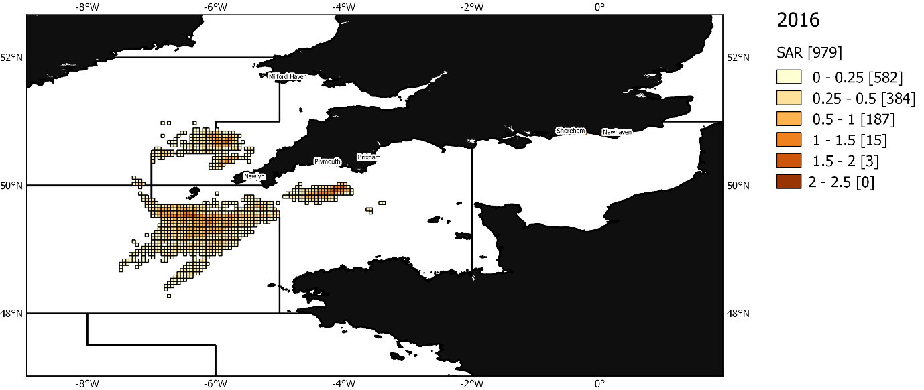
Figure 3-6 Map of swept area ratio of monkfish beam trawling 2016

Spatial scale of activity
The unit of assessment (UoA) covers ICES areas 7d,e,f,g,h,j,k and 8a,b,d, i.e. the English Channel + Celtic Sea + south Irish Sea + Bay of Biscay. Monkfish is widespread in the whole area, and, although some locations have got higher concentrations of the stock(s), there is no known habitat that monkfish will never be found in.
Considering this very large area, the fact that it is difficult to narrow down the habitat of monkfish, and that this assessment is for two species (L. budagessa and L. piscatorius), the spatial footprint of the UoC is very minimal (largely <15%, about 6% of the UoA). Beam trawls however can fish over a range of grounds, potentially very rough, as confirmed by fishers during the workshop and therefore are not tied to specific sections of the seabed. Workshop participants also confirmed that monkfish fishers tend to conduct exploratory tows, as opposed to sticking to very specific locations but the consistency of the extent of the VMS data over years suggest that the activity is contained within the boundaries of the areas shown on the maps. However, since the highest impact from a towed bottom fishing gear is when the gear is used in that area for the first time, exploratory tows will increase the risk of the fishery having a significant negative impact. Furthermore, the resolution of VMS data is low (i.e. one ping every 2 hours). Therefore, the question of the scale of sensitive habitats adds a limitation since one cannot confidently assess how sensitive habitats may be impacted by first time fishing at this resolution.
There is also a part of the fleet that is not covered by VMS data but the industry and IFCAs did not expect that this would affect the rating in view of the very low coverage of the activity compared to the UoA.

Temporal scale of activity
There are very few days in the year when no vessels of the UoC is active in the UoA.
Table 3-1 Number of unique days of fishing for the monkfish beam trawl fishery in the UoA
2012 | 2013 | 2014 | 2015 | 2016
352 | 350 | 345 | 348 | 351

Table 3-2 Table of proportion of the monkfish beam trawl activity by year and quarter
Quarter | 2012 | 2013 | 2014 | 2015 | 2016
1 | 0.3 | 0.23 | 0.19 | 0.24 | 0.22
2 | 0.23 | 0.24 | 0.27 | 0.29 | 0.26
3 | 0.24 | 0.28 | 0.29 | 0.25 | 0.25
4 | 0.23 | 0.25 | 0.25 | 0.22 | 0.27

Intensity of activity
There was a debate at the workshop on how the level of intensity should be scored due to the wording of the MSC score table. A score of 3, equating to “moderate”, is described as “moderate detection of activity at broader spatial scale, or obvious but local detection”. In light of the spatial and temporal scales of the activity described above, this was seen by the group as inappropriate. A score of 2, equating to “minor”, better reflected the relative impact of the fishery on the UoA. “Minor” corresponds to an “activity [that] occurs rarely or in few restricted locations and evidence of activity even at these scales is rare”. While the wording suggests very little impact, the industry agrees that the impact will be locally significant, but a score of 3 out of 6 seemed unrepresentative of the limited spatial extent of the UoC (relative to the UoA). Nevertheless, a score of 3 would have to be used here as it corresponds to the most conservative, lowest risk score.

Relevant subcomponents
The subcomponents include species composition, functional group composition, distribution of the community and trophic/size structure. A variety of research papers have discussed the impacts of beam trawling on habitats as discussed above (Section 2.2).

Species composition
As described earlier beam trawls have a poor selectivity, so a number of species will be caught or indirectly impacted by the contact of the gear with the seabed. The effect might be reflected in the resulting functional composition. Figure 3-7 shows the catch composition based on the Cefas observer programme, i.e. including discards, for the monkfish beam trawl fishery.
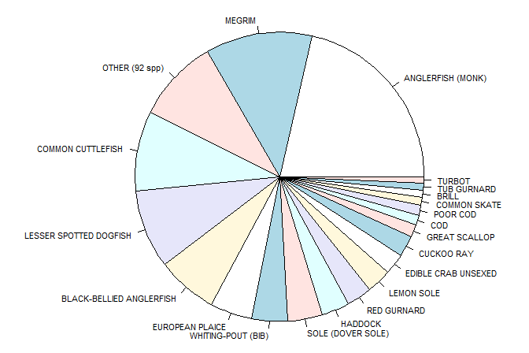
Figure 3-7 Catch composition of monkfish beam trawl fishery

Functional group composition
Most bottom fishing gears have an impact on specific functional groups. Beam trawling is known as one of the most impactful gear types, after scallop dredging, and therefore species that display certain characteristics such as being sessile, large, slow or hard shelled will suffer higher mortality rates than others and take longer to recover.

Community distribution
There is no suggestion that the fishing activity would directly interfere with the distribution of the community as such, although this might be an indirect consequence of removing a top predator from the ecosystem or affecting different species/functional groups disproportionately.

Trophic/size structure
Monkfish are opportunistic feeders and a top predator in this ecosystem (Figure 3-8). There are no reports of predators that specifically target monkfish in European waters although seals may prey directly on monkfish. Monkfish remains were found in one stranded sperm whale in the Netherlands. In Faroese waters juvenile monkfish remains have been found in the stomachs of large cod (Thangstad et al. 2006). Overall, monkfish are not thought to be a key prey species for any piscivorous fish, mammal or bird, although they may be taken opportunistically by a range of predators across their lifespan.

While the assessments are limited by the data availability and quality, the total biomass is still expected to be high relative to other species in the Western English Channel (Araujo et al. 2005), i.e. around where most of the monkfish beam trawl fishery occurs. Whether the ecosystem is dominated by bottom-up or top-down pressures will affect the level of impact of the direct removal of the species. Overall, stock assessments suggest that the stock is not showing a decline due to fishing pressure, but the assessment is over a large area making it difficult to draw conclusions at the local level. Furthermore, surveys used in the assessment do not cover the Western English Channel.

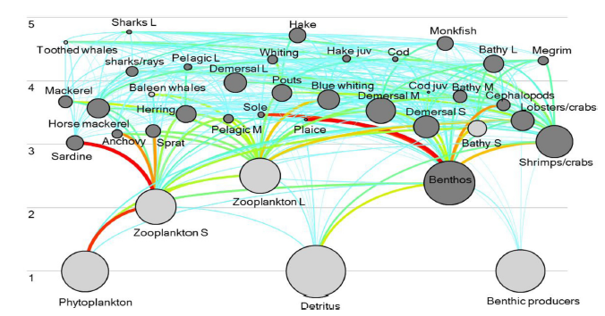
Figure 3-8 Place of monkfish in the Celtic/Biscay ecosystem from 2012 Ecopath model, from Bentorcha et al. 2017

Further rationale to inform scoring
The beam trawl fishery takes place in the western English Channel and eastern Celtic Sea (27.7.e and 27.7.h) which, from the habitat report Task 2, are dominated by sand and coarse sediment, followed by fine mud in 27.7.h and mixed and rocky substrates in 27.7.e. Combining all gear types that catch monkfish, the habitat report shows that 65% of the fishing effort area overlaps with coarse sediments, while there was a 6% overlap in 2016 with OSPAR threatened and protected habitats/species. 0% overlapped with vulnerable marine ecosystems (VMEs). The western part of the English Channel is deeper than the east, which is below 50m. The currents system is also mainly tidal, and waters are stratified, with deeper waters and weaker currents compared to the east. The seabed is coarser and there are richer benthic communities. As for the eastern Celtic Sea, species richness (number of species) is higher in the Celtic Sea than in the rest of the ecoregion (Celtic Seas) due to the number of warm-favouring Lusitanian species present. The Celtic Sea groundfish community consists of over a hundred species, but the 25 most abundant of these account for 99 percent of the total estimated biomass (of which monkfish is one).
A number of surveys are used or considered in the monkfish stock assessments that provide information on the stock distribution, abundance, biomass and the population dynamics characteristics. Some of the main ones are the
- French EVOHE-WIBTS-Q4 survey, covering the largest proportion of the stock distribution, the shelf area in the Celtic Sea and Bay of Biscay, and providing a recruitment index;
- Irish Groundfish Survey (IGFS-WIBTS-Q4), covering around Ireland and Northern Ireland;
- Spanish Porcupine Groundfish Survey (SPPGFS-WIBTS-Q4), covering the Porcupine Bank, west off Ireland;
- Irish Anglerfish and Megrim Survey (IAMS-Q1), covering from Northern Ireland, west of Ireland, and to the south of the Celtic Sea.

Other surveys such as the English Cefas Q1 Southwest Ecosystem Survey (Q1-SW-ECOS), the Q1 Irish Beam trawl Ecosystem survey (IBES) or the Q3 UK (E&W) beam trawl survey in divisions 7afg may be relevant to provide more information on the local ecosystem where monkfish is caught by the UoC, particularly Q1-SW-ECOS.

SICA scoring table for monkfish beam trawl fishery in area 27.7.b-k, 8.a-b and 8.d (southern Celtic Seas, Bay of Biscay)

Performance Indicator | Spatial scale of activity | Temporal scale of activity | Intensity of activities | Relevant subcomponents | Consequence score
Monkfish beam trawl southern Celtic Seas, Bay of Biscay | 2 | 6 | 3 | Species composition
 |  |  |  | Functional group composition | 60
 |  |  |  | Distribution of the community
 |  |  |  | Trophic size/structure
Rationale for Spatial scale of activity | The unit of assessment (UoA) covers ICES areas 7d,e,f,g,h,j,k and 8a,b,d, i.e. the English Channel + Celtic Sea + south Irish Sea + Bay of Biscay. Monkfish is widespread in the whole area, and, although some locations have got higher concentrations of the stock(s), there is no known habitat that monkfish will never be found in.  Considering this very large area, the fact that it is difficult to narrow down the habitat of monkfish, and that this assessment is for 2 species (L. budagessa and L. piscatorius), the spatial footprint of the UoC is very minimal (largely <15%, about 6% of the UoA). Beam trawls however can fish over a range of grounds, potentially very rough, as confirmed by fishers during the workshop and therefore are not tied to specific sections of the seabed. Workshop participants also confirmed that monkfish fishers do tend to conduct exploratory tows, as opposed to sticking to very specific locations but the consistency of the extent of the VMS data over years suggest that the activity is contained within the boundaries of the areas shown on the maps. However, since the highest impact from a towed bottom fishing gear is made the first time a new area is fished, exploratory tows will increase the risk of the fishery having a significant negative impact. Furthermore, the resolution of VMS data is low (i.e. one ping every 2 hours). Therefore, the question of the scale of sensitive habitats adds a limitation since one cannot confidently assess how sensitive habitats may be impacted by first time fishing at this resolution.  There is also a part of the fleet that is not covered by VMS data but the industry and IFCAs did not expect that this would affect the rating in view of the very low coverage of the activity compared to the UoA.
Rationale for Temporal scale of activity | There are very few days in the year when no vessels of the UoC is active in the UoA.
Rationale for Intensity of activity | There was a debate at the workshop on how the level of intensity should be scored due to the wording of the MSC score table. A score of 3, equating to “moderate”, is described as “moderate detection of activity at broader spatial scale, or obvious but local detection”. In light of the spatial and temporal scales of the activity described above, this was seen by the group as inappropriate. A score of 2, equating to “minor”, better reflected the relative impact of the fishery on the UoA. “Minor” corresponds to an “activity [that] occurs rarely or in few restricted locations and evidence of activity even at these scales is rare”. While the wording suggests very little impact, the industry agrees that the impact will be locally significant, but a score of 3 out of 6 seemed unrepresentative of the limited spatial extent of the UoC (relative to the UoA). Nevertheless, a score of 3 would have to be used here as it corresponds to the most conservative, lowest risk score.
Rationale for Consequence score | Beam trawls have a poor selectivity, so a number of species will be caught or indirectly impacted by the contact of the gear with the seabed and the effect might be reflected in the resulting functional composition. Catch composition based on the Cefas observer programme, i.e. including discards, shows the high diversity of species discarded. Most bottom fishing gears have an impact on specific functional groups. Beam trawling is known as one of the most impactful gear types, after scallop dredging, and therefore species that display certain characteristics such as being sessile, large, slow or hard shelled will suffer higher mortality rates than others and take longer to recover.  There is no suggestion that the fishing activity would directly interfere with the distribution of the community as such, although this might be an indirect consequence of removing a top predator from the ecosystem or affecting different species/functional groups disproportionately.  Monkfish are opportunistic feeders and a top predator in this ecosystem. There are no reports of predators that specifically target monkfish in European waters although seals may prey directly on monkfish. Monkfish remains were found in one stranded sperm whale in the Netherlands. In Faroese waters juvenile monkfish remains have been found in the stomachs of large cod (Thangstad et al. 2006). Overall, monkfish are not thought to be a key prey species for any piscivorous fish, mammal or bird, although they may be taken opportunistically by a range of predators across their lifespan.  While the assessments are limited by the data availability and quality, the total biomass is still expected to be high relative to other species in the Western English Channel (Araujo et al. 2005), i.e. around where most of the monkfish beam trawl fishery occurs. Whether the ecosystem is dominated by bottom-up or top-down pressures will affect the level of impact of the direct removal of the species. Overall, stock assessments suggest that the stock is not showing a decline due to fishing pressure but the assessment is over a large area making it difficult to draw conclusions at the local level. Furthermore, surveys used in the assessment do not cover the Western English Channel.  The beam trawl fishery takes place in the western English Channel and eastern Celtic Sea (27.7.e and 27.7.h) which, from the habitat report Task 2, are dominated by sand and coarse sediment, followed by fine mud in 27.7.h and mixed and rocky substrates in 27.7.e. Combining all gear types that catch monkfish, the habitat report shows that 65% of the fishing effort area overlaps with coarse sediments, while there was a 6% overlap in 2016 with OSPAR threatened and protected habitats/species. 0% overlapped with VMEs. The western part of the English Channel is deeper than the east, below 50m, the currents system is mainly tidal, and waters are stratified, with deeper waters and weaker currents compared to the east. The seabed is coarser and there are richer benthic communities. As for the eastern Celtic Sea, species richness (number of species) is higher in the Celtic Sea than in the rest of the ecoregion (Celtic Seas) due to the number of warm-favouring Lusitanian species present here. The Celtic Sea groundfish community consists of over a hundred species, but the 25 most abundant of these account for 99 percent of the total estimated biomass (of which monkfish is one).  A number of surveys are used or considered in the monkfish stock assessments that provide information on the stock distribution, abundance, biomass and the population dynamics characteristics. Some of the main ones are the French EVOHE-WIBTS-Q4 survey, covering the largest proportion of the stock distribution, the shelf area in the Celtic Sea and Bay of Biscay, and providing a recruitment index; the Irish Groundfish Survey (IGFS-WIBTS-Q4), covering around Ireland and Northern Ireland; the Spanish Porcupine Groundfish Survey (SPPGFS-WIBTS-Q4), covering the Porcupine Bank, west off Ireland; the Irish Anglerfish and Megrim Survey (IAMS-Q1), covering from northern Ireland, west of Ireland, and to the south of the Celtic Sea. Other surveys such as the English Cefas Q1 Southwest Ecosystem Survey (Q1-SW-ECOS), the Q1 Irish Beam trawl Ecosystem survey (IBES) or the Q3 UK (E&W) beam trawl survey in divisions 7afg may be relevant to provide more information on the local ecosystem where monkfish is caught by the UoC, particularly Q1-SW-ECOS.  Discussion - The fishery assessed here would likely get a score level of 60, despite the relatively small footprint over the UoA but because of the likely high local impact. The relatively small footprint is because the species is not tightly linked to a specific habitat and the UoC do not cover all gears and countries that target the stock(s). The assessment of the monkfish fishery combines two species, making their distribution range even larger in comparison to the UoC, while the UK seems to catch predominantly white monkfish L. piscatorius at 95%. Considering all this would likely increase the footprint of the UoC. Further effort should be allocated on finding solutions to split the two species if possible. Further investigation into the spatial and temporal activity of non-VMS equipped vessels would help better characterise the impact of smaller vessels. This information would confirm the anecdotal information shared at the workshop which suggested that the spatial footprint would not pass the threshold of <15% of the UoA for the monkfish-targeting beam trawls. It would be particularly important to better characterise the activity of the beam trawls on the ground as, if they conduct a significant amount of exploratory tows, the footprint and impact of the fishery will likely be greater than if they were going back to same grounds over and over again and it would cause a bigger threat to unmapped sensitive habitats. Also, there are no existing surveys that specifically cover this area of fishing ground(s) in the English Channel. Collecting good resolution data on habitats and associated species would help score the fishery ecosystem impact with more certainty (also distinguishing from natural variations and impact of other gears). Monkfish is a relatively abundant top predator so the impact of the fishery on the local foodweb could be significant. But, at the scale of the UoA, which corresponds to the assessment unit, there is no specific concern that monkfish is overfished, and the population has appeared relatively stable over years. Beam trawls could benefit from continuous research in gear technology improvement, e.g. improving selectivity. And with regard to gear selectivity, bycatch and discards, the UK observer program does not target specifically the “monkfish beam trawl fishery”, a better targeted sampling scheme would provide more reliable data that would serve a long-term monitoring programme if the fishery was to be certified.

Discussion
This report aims at providing some information necessary to score the impact of monkfish beam trawl fishing activities on the part of the ecosystem with which they interact, i.e. in areas 27.7b-k and 8a-b, 8.d. following the MSC SICA guidelines, under Performance Indicator (PI) 2.5.1. VMS maps were compiled to enable scoring of the spatial scale, temporal scale and intensity of the activity and existing published literature briefly reviewed to document the effect of towed bottom gears on the seabed and its associated benthic and demersal communities. It includes data, rationale and industry input to inform the MSC scoring process of the two fisheries of interest.
Under the current data limited approach for PI 2.5.1, the fishery assessed here would likely get a score level of 60, despite the relatively small footprint of the fishery in its UoA but because of the likely high local impact. The relatively small footprint is because none of the two monkfish species are tightly linked to a specific habitat and the UoC do not cover all gears and countries that target those given stocks. Furthermore, the assessment of the monkfish fishery combines two species, making their distribution range even larger in comparison to the UoC, while the UK seems to catch predominantly white monkfish L. piscatorius at 95%. Following from this, it is evident here that how the UoA is set will drive the outcome of the scoring on the scale of the impact. Considering all this would likely increase the footprint of the UoC. Further effort should be allocated on finding solutions to split the two species if possible.
Further investigation into the spatial and temporal activity of non-VMS equipped vessels would help better characterise the impact of smaller vessels. This information would confirm the anecdotal information shared at the workshop which suggested that the spatial footprint would not pass the threshold of <15% of the UoA for the monkfish-targeting beam trawls. A better understanding of the fishing speed would also make the VMS-derived fishing maps more accurate as with 2hr ping rates some of the activity will inevitably be missed. It would be particularly important to better characterise the activity of the beam trawls on the ground as, if they conduct a significant amount of exploratory tows, the footprint and impact of the fishery will likely be greater than if they were going back to same grounds over and over again and it would cause a bigger threat to unmapped sensitive habitats. Also, there are no existing surveys that specifically cover this area of fishing ground(s) in the English Channel. Collecting good resolution data on habitats and associated species would help score the fishery ecosystem impact with more certainty (also distinguishing from natural variations and impact of other gears).
Defining which of the subcomponents is the most vulnerable is not straight forward as each subcomponent is linked to the others. For towed bottom fishing gears, a large part of the literature on their impact focuses on functional differences observed in benthic communities and potential regime shifts, or at least they justify differences in species composition by their resilient/vulnerable traits. Monkfish is a relatively abundant top predator so the impact of the fishery on the local food web could be significant. But again, at the scale of the UoA, which corresponds to the assessment unit, there is no specific concern that monkfish is overfished, and the population has appeared relatively stable over years. Beam trawls could benefit from continuous research in gear technology improvement, e.g. making them more selective etc. With regards to gear selectivity, bycatch and discards, the Cefas Observer Programme does not target specifically the “monkfish beam trawl fishery”, a better targeted sampling scheme would provide more reliable data that would serve a long-term monitoring programme if the fishery was to be certified.
Considering that landings are reported, VMS data are available for a large part of the fleet, a stock assessment exists, multiple surveys are conducted over the UoA, and that there is a high volume of recently published research on fishing gear impacts on ecosystems and potential for recovery, one would need to justify why a data limited approach is considered appropriate in either case here. See for example the published standardised dataset for benthic macrofauna and sediments that covers faunal distribution all around the UK (publication: http://rdcu.be/wi6C , tool :https://www.benthosapps.net/ma_tool/). Complementing these large-scale data/information sources by collecting more detailed information on local ecosystems and fishers’ behaviour and working on developing less impactful gears would help working towards a sustainable management approach of these fisheries.
Overall, the report provides the information available to Cefas to map the fishing activity but misses out on the <12m vessels which, according to workshop participants, form an insignificant part of the UoCs. Further information could be gathered and used as suggested in this discussion to score the impact on the ecosystem components, although clearer guidelines on how changes should be assessed, against what and how would help with this task. A limitation here is the way the scoring is defined, i.e. the relative spatial footprint would mean that any negative impact, even if highly significant locally, would not affect the overall score of the fishery on their ecosystem impact performance indicator.

References
Araújo, J. N., Mackinson, S., Ellis, J. R., & Hart, P. J. B. (2005). An Ecopath model of the western English Channel ecosystem with an exploration of its dynamic properties. Science Series Technical Reports, 125.
Bentorcha, A., Gascuel, D., & Guénette, S. 2017. Using trophic models to assess the impact of fishing in the Bay of Biscay and the Celtic Sea. Aquatic Living Resources, 30, 7.
Bolam, S. G., Garcia, C., Eggleton, J., Kenny, A. J., Buhl-Mortensen, L., Gonzalez-Mirelis, G., van Kooten, T., et al. 2017. Differences in biological traits composition of benthic assemblages between unimpacted habitats. Marine Environmental Research, 126: 1-13.
Collie, J., Hiddink, J. G., Kooten, T. v., Rijnsdorp, A. D., Kaiser, M. J., Jennings, S., and Hilborn, R. 2016. Indirect effects of bottom fishing on the productivity of marine fish. Fish and Fisheries.
Duplisea DE, Jennings S, Warr KJ, Dinmore TA. 2002. A size-based model of the impacts of bottom trawling on benthic community structure. Can. J. Fish. Aquat Sci. 59, 1785–1795.
Eigaard, O. R., Bastardie, F., Breen, M., Dinesen, G. E., Hintzen, N. T., Laffargue, P., Mortensen, L. O., et al. 2016. Estimating seabed pressure from demersal trawls, seines, and dredges based on gear design and dimensions. ICES Journal of Marine Science, 73: i27-i43.
Eigaard, O. R., Bastardie, F., Hintzen, N. T., Buhl-Mortensen, L., Buhl-Mortensen, P., Catarino, R., Dinesen, G. E., et al. 2017. The footprint of bottom trawling in European waters: distribution, intensity, an seabed integrity. ICES Journal of Marine Science, 74: 847-865.
Gerritsen, H. D., Minto, C., & Lordan, C. 2013. How much of the seabed is impacted by mobile fishing gear? Absolute estimates from Vessel Monitoring System (VMS) point data. ICES Journal of Marine Science, 70(3), 523-531.
Groenewold S, Fonds M. 2000. Effects on benthic scavengers of discards and damaged benthos produced by the beam-trawl fishery in the southern North Sea. ICES J. Mar. Sci. 57, 1395–1406. (doi:10. 1006/jmsc.2000.0914)
Heath MR. 2005. Changes in the structure and function of the North Sea fish foodweb, 1973– 2000, and the impacts of fishing and climate. ICES Journal of Marine Science 62, 847–868.
Hiddink JG, Rijnsdorp AD, Piet G. 2008. Can bottom trawling disturbance increase food production for a commercial fish species? Can. J. Fish. Aquat. Sci. 65, 1393–1401.
Hiddink JG, Johnson AF, Kingham R, Hinz H. 2011. Could our fisheries be more productive? Indirect negative effects of bottom trawl fisheries on fish condition. J. Appl. Ecol. 48, 1441–1449.
Hiddink, J. G., Moranta, J., Balestrini, S., Sciberras, M., Cendrier, M., Bowyer, R., Kaiser, M. J., et al. 2016. Bottom trawling affects fish condition through changes in the ratio of prey availability to density of competitors. Journal of Applied Ecology, 53: 1500-1510.
Hiddink, J. G., Jennings, S., Sciberras, M., Szostek, C. L., Hughes, K. M., Ellis, N., ... & Collie, J. S. 2017. Global analysis of depletion and recovery of seabed biota after bottom trawling disturbance. Proceedings of the National Academy of Sciences, 114(31), 8301-8306.
Jennings S, Dinmore TA, Duplisea DE, Warr KJ,Lancaster JE. 2001. Trawling disturbance can modify benthic production processes. J. Anim. Ecol.70, 459–475.
Jennings S, Nicholson MD, Dinmore TA, Lancaster JE. 2002. Effects of chronic trawling disturbance on the production of infaunal communities. Mar. Ecol. Prog. Ser. 243, 251–260.
Kaiser MJ, Spencer BE. 1994. Fish scavenging behaviour in recently trawled areas. Mar. Ecol. Prog. Ser. 112, 41–49.
Kaiser MJ, Ramsay K, Richardson CA, Spence FE,Brand AR. 2000. Chronic fishing disturbance has changed shelf sea benthic community structure. J. Anim. Ecol. 69, 494–503.
Kaiser MJ, Clarke KR, Hinz H, Austen MCV,Somerfield PJ, Karakassis I. 2006. Global analysis of response and recovery of benthic biota to fishing. Mar. Ecol. Prog. Ser. 311, 1–14.
Pitcher, C. R., Ellis, N., Jennings, S., Hiddink, J. G., Mazor, T., Kaiser, M. J., Kangas, M. I., et al. 2017. Estimating the sustainability of towed fishing‐gear impacts on seabed habitats: a simple quantitative risk assessment method applicable to data‐limited fisheries. Methods in Ecology and Evolution, 8: 472-480.
Riemann B, Hoffmann E. 1991. Ecological consequences of dredging and bottom trawling in the Limfjord, Denmark. Mar. Ecol. Prog. Ser. 69, 171–178.
Rijnsdorp, A. D., Bastardie, F., Bolam, S. G., Buhl-Mortensen, L., Eigaard, O. R., Hamon, K. G., Hiddink, J. G., et al. 2016. Towards a framework for the quantitative assessment of trawling impact on the seabed and benthic ecosystem. ICES Journal of Marine Science , 73: i127-i138.
Rijnsdorp, A. D., Eigaard, O. R., Kenny, A., Hiddink, J. G., Hamon, K., Piet, G. J., ... Gregersen, Ó. 2017. Assessing and mitigating of bottom trawling. Final BENTHIS project Report (Benthic Ecosystem Fisheries Impact Study).
Sciberras, M., Hiddink, J. G., Jennings, S., Szostek, C. L., Hughes, K. M., Kneafsey, B., ... & Hilborn, R. 2018. Response of benthic fauna to experimental bottom fishing: A global meta‐analysis. Fish and Fisheries.
Thangstad, T. 2006. Anglerfish (Lophius spp) in Nordic waters. Nordic Council of Ministers.
van Denderen PD, van Kooten T, Rijnsdorp AD. 2013. When does fishing lead to more fish? Community consequences of bottom trawl fisheries in demersal food webs. Proc R Soc B 280: 20131883.

Appendix 1: Maps of monkfish fishery days/year by grid cell
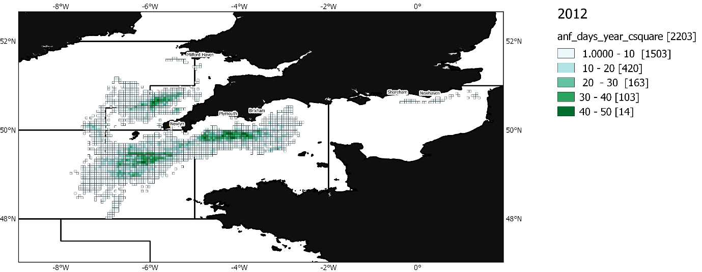
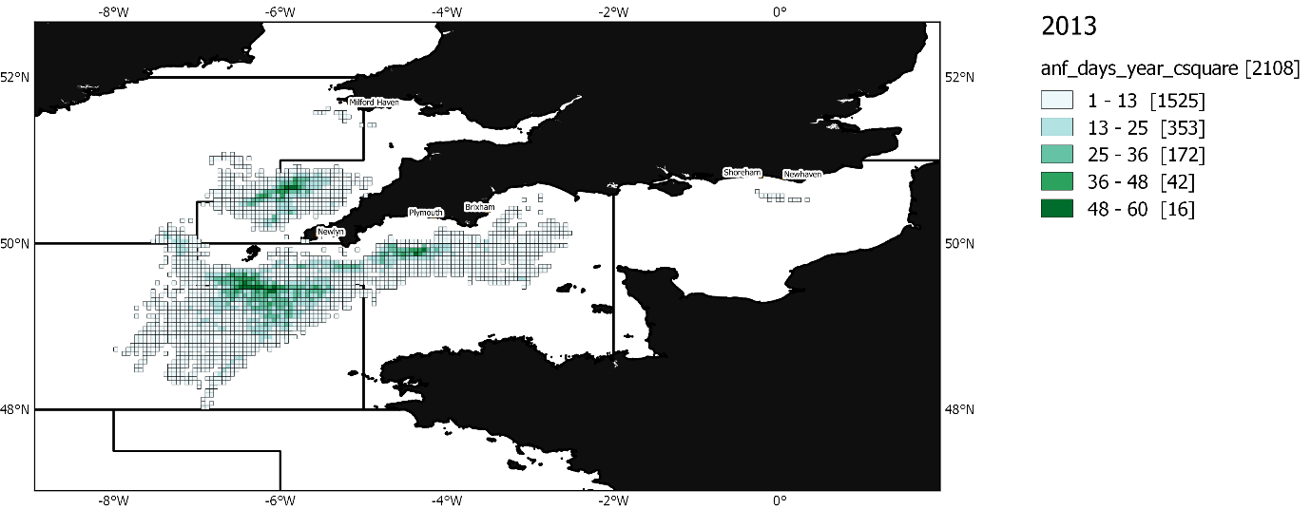
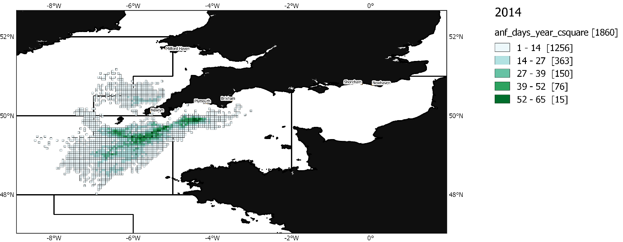
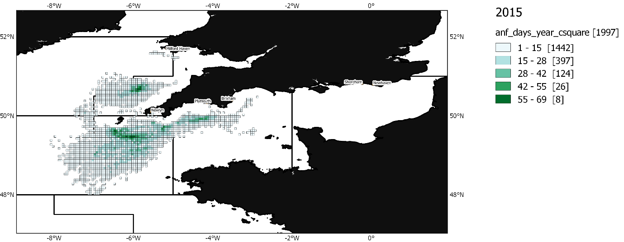
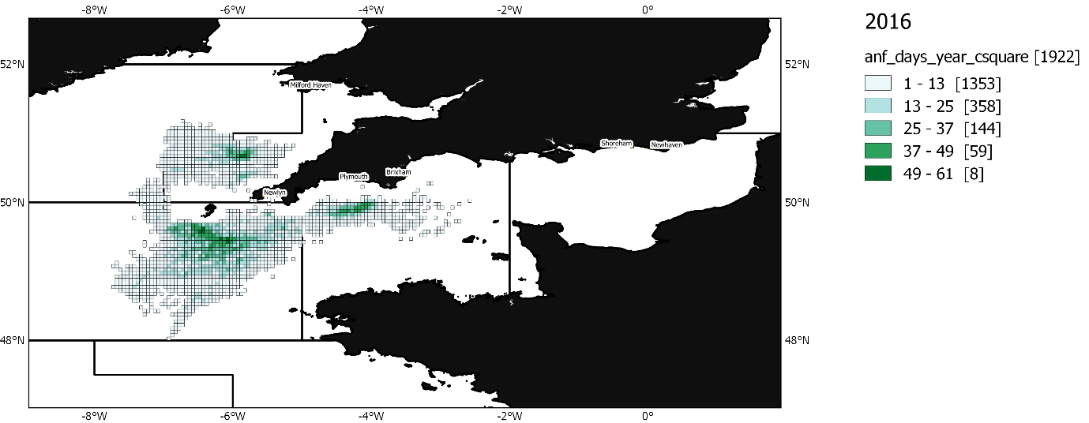

About us
The Centre for Environment, Fisheries and Aquaculture Science is the UK’s leading and most diverse centre for applied marine and freshwater science.

We advise UK government and private sector customers on the environmental impact of their policies, programmes and activities through our scientific evidence and impartial expert advice.

Our environmental monitoring and assessment programmes are fundamental to the sustainable development of marine and freshwater industries.

Through the application of our science and technology, we play a major role in growing the marine and freshwater economy, creating jobs, and safeguarding public health and the health of our seas and aquatic resources

Head office
Centre for Environment, Fisheries & Aquaculture Science
Pakefield Road
Lowestoft
Suffolk
NR33 0HT
Tel: +44 (0) 1502 56 2244
Fax: +44 (0) 1502 51 3865

Weymouth office
Barrack Road
The Nothe
Weymouth
DT4 8UB

Tel: +44 (0) 1305 206600
Fax: +44 (0) 1305 206601

Customer focus
We offer a range of multidisciplinary bespoke scientific programmes covering a range of sectors, both public and private. Our broad capability covers shelf sea dynamics, climate effects on the aquatic environment, ecosystems and food security. We are growing our business in overseas markets, with a particular emphasis on Kuwait and the Middle East.

Our customer base and partnerships are broad, spanning Government, public and private sectors, academia, non-governmental organisations (NGOs), at home and internationally.

We work with:

- a wide range of UK Government departments and agencies, including Department for the Environment Food and Rural Affairs (Defra) and Department for Energy and Climate and Change (DECC), Natural Resources Wales, Scotland, Northern Ireland and governments overseas.
- industries across a range of sectors including offshore renewable energy, oil and gas emergency response, marine surveying, fishing and aquaculture.
- other scientists from research councils, universities and EU research programmes.
- NGOs interested in marine and freshwater.
- local communities and voluntary groups, active in protecting the coastal, marine and freshwater environments.

www.cefas.co.uk

ICES. 2017. Report of the Benchmark Workshop on Widely Distributed Stocks (WKWIDE), 4-11 May 2017, Copenhagen, Denmark. ICES CM 2017/ACOM:36. 534 pp.
Project UK Fisheries Improvements - ETP report, Page 2018
Project UK Fisheries Improvements - Task 2, 2018
MSC Assessment ISF Iceland Anglerfish Fishery 2017 https://fisheries.msc.org/en/fisheries/isf-iceland-anglerfish/@@assessments
Stock annex to WKAngler, benchmark workshop for anglerfish stock assessment, February 2018, Copenhagen (unpublished), Hans Gerritsen
Project UK Fisheries Improvements – MSC Pre-assessment http://www.seafish.org/industry-support/fishing/project-uk/project-uk-fisheries-improvements/western-channel-monkfish-multiple-gear-fip
http://www.marlin.ac.uk/species/detail/2123
https://www.benthis.eu/en/benthis.htm
https://trawlingpractices.wordpress.com/
ICES. 2017. Report of the Benchmark Workshop on Widely Distributed Stocks (WKWIDE), 4-11 May 2017, Copenhagen, Denmark. ICES CM 2017/ACOM:36. 534 pp.

