HASIL TIME LAPSE CAMERA KUPANG 2018

Table 1. Ringkasan Trip Time Lapse Camera
Landing Site | VIC | Vessel Name | Name of TLC | Number of Video | Number of Trip
NTT - PPI. Oeba Kota Kupang | 530301/112 | USAHA BERSAMA 33 | KU_OB_530301.112_20180626 | 9 | 1
NTT - PPI. Oeba Kota Kupang | 530301/112 | USAHA BERSAMA 33 | KU_OB_530301.112_20180707 | 10 | 1
NTT - PPI. Oeba Kota Kupang | 530301/120 | USAHA BERSAMA 05 | KU_OB_530301.120_20180722 | 9 | 1
NTT - PPI. Oeba Kota Kupang | 530301/121 | USAHA BERSAMA 11 | KU_OB_530301.121_20180817 | 9 | 1
Jumlah Total TLC |  |  |  | 37 | 4
Total sampling I-fish |  |  |  |  | 214
Total berat sampling I-fish (kg) |  |  |  |  | 382922

Table 2. Hasil Tangkapan TLC, Port sampling dan Monthly Unloading
Hasil analisa TLC |  | Hasil Sampling integrated I-fish |  | Monthly Unloading for TLC
Spesies | Jumlah (ind) | Spesies | Berat (kg) | Spesies | Berat (kg)
BET | 1 | BET | - | BET | 0
SKJ | 2 | SKJ | - | SKJ | 2085
UN | 326 | UN | - | UN | -
YFT | 98 | YFT | - | YFT | 5246
Total | 427 | Total (Kg) |  | Total Tangkapan (Kg) | 7331
*UN : It is not ETP

Gambar 1. Catch composition based on TLC analyze

Table 3. Interaksi ETP
 | Interaction ETP | No Interaction ETP | Integrated | Total
All ETP TLC | 0 | 4 | No | 4
ETP all port sampling | 1 | 213 | No | 214

Issue based on TLC
- Nelayan melakukan penutupan pada lensa TLC selama sekitar 10 menit pada KU_OB_530301.120_20180722
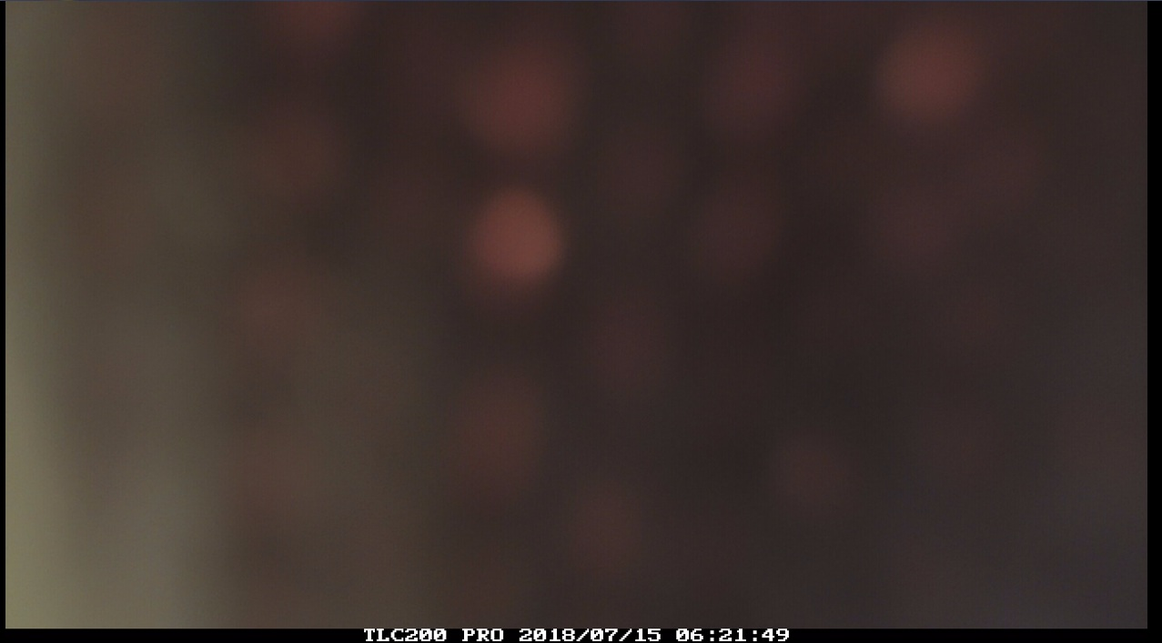

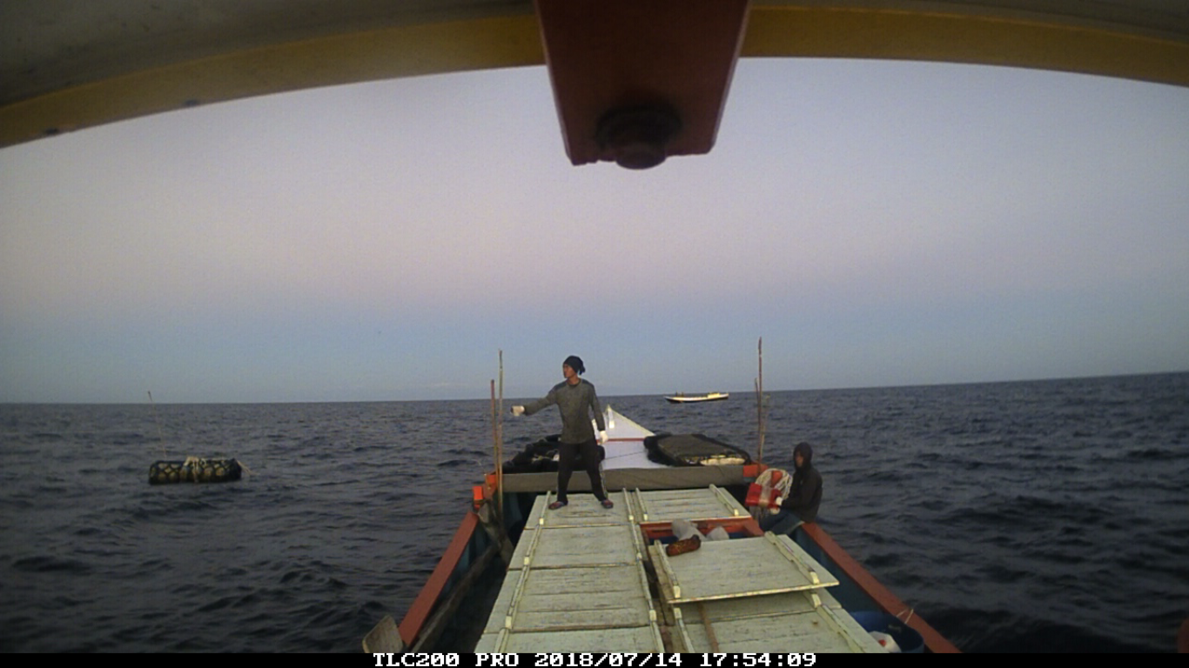
- Ada sekita 2-3 kapal dalam 1 FAD

- Terjadi sharing hasil tangkapan dari kapal PL ke kapal HL
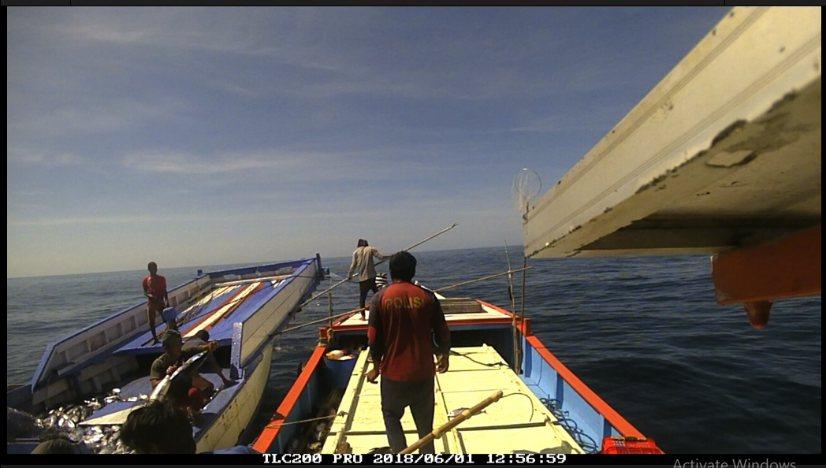

HASIL TIME LAPSE CAMERA Lombok 2018 dan Flywire 2019

Table 1. Ringkasan Trip Time Lapse Camera
Landing Site | VIC | Vessel Name | Name of TLC | Number of Video | Number of Trip
NTB - Labuhan Lombok Timur | 520301/042 | ULAN SARI 01 | LO_LL_520301.042_20180523 | 7 | 1
NTB - Labuhan Lombok Timur | 520301/042 | ULAN SARI 01 | LO_LL_520301.042_20180609 | 15 | 1
Jumlah Total TLC |  |  |  | 22 | 2
Total sampling I-fish |  |  |  |  | 204
Total berat sampling I-fish (kg) |  |  |  |  | 302716

Table 2. Hasil Tangkapan TLC, Port sampling dan Monthly Unloading
Hasil analisa TLC |  | Sampling integrated I-fish |  | Monthly Unloading for TLC
Spesies | Jumlah (ind) | Spesies | Berat (kg) | Spesies | Berat (kg)
BUM | Not analyzed yet | BUM | 63 | BUM | 63
BLM | Not analyzed yet | BLM | No | BLM | 61
SKJ | Not analyzed yet | SKJ | 118 | SKJ | 118
UN | Not analyzed yet | UN | - | UN | -
YFT | Not analyzed yet | YFT | 386 | YFT | 498
Total | Not analyzed yet | Total (Kg) | 567 | Total Tangkapan (Kg) | 740

Table 3. Interaksi ETP
 | Interaction ETP | No Interaction ETP | Integrated interaction | Total
All ETP TLC | Not analyzed yet | Not analyzed yet | Not analyzed yet | Not analyzed yet
ETP all port sampling | 4 | 200 | 0 | 204

