Report on the annual variation of whiteleg shrimp abundance

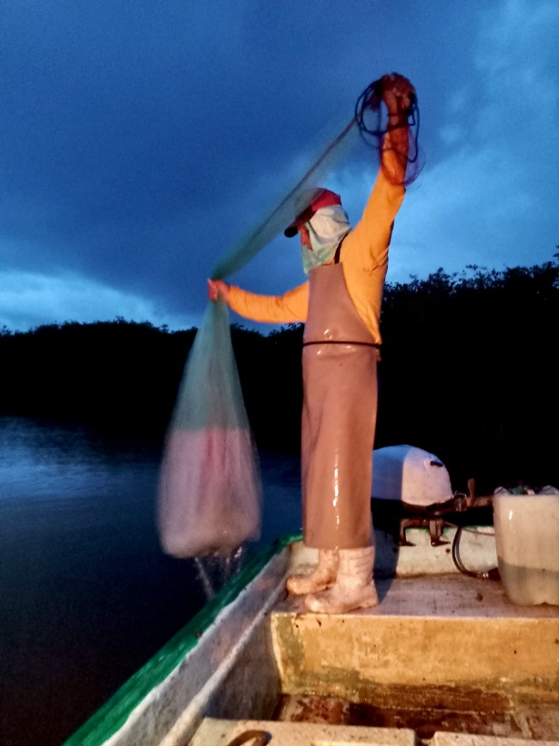
  - Mexico Marismas Nacionales artisanal whiteleg
  - Shrimp – trap / cast-nets

Yuliesky Garces | SmartFish AC | December 2023

Introduction
Shrimp fishing represents one of the most important fisheries in Mexico, with the Mexican Pacific being the region where the largest total shrimp catch is extracted (~ 92%) in Mexico (SAGARPA, 2021). This fishery occupies third place in terms of its volume of fishing production, however, due to its commercial value, it occupies first place in Mexico. Shrimp catches in the Mexican Pacific are mainly composed of three species, blue shrimp Litopenaeus stylirostris ( Stimpson 1871), white shrimp L. vannamei (Boone 1931) and brown shrimp Farfantepenaeus californiensis (Holmes (1900), as well as other species of penaeid shrimp.
Shrimp of the genus Litopenaeus spend most of their time in areas influenced by or in close relationship with river deltas, estuaries or coastal lagoons. Migratory movements obey the nature of their life cycle, which is dependent on estuaries or coastal lagoons, which are used as protection, feeding and growth areas. They have a preference for soft, muddy-sandy bottoms and feed on crustaceans, fish, mollusks, annelids, plants and organic detritus. Shrimp are species with a short life cycle (one to two years), rapid growth, early sexual maturity, high fecundity and high mortality rates (Hendrickx, 1996, Hernández-Covarrubias et al., 2012). Due to the currents and tides, the shrimp in its post-larva stage penetrates the estuaries and coastal lagoons (Macías-Regalado et al., 1982), where it virtually begins its growth (30 to 60 mm per month) with semi- benthic . Upon reaching the sub-adult state (approximately 140 mm in total length), they begin their migration towards marine waters to complete their reproductive cycle (Pearson, 1939, Cárdenas, 1951; Signoret, 1974). These organisms reach maximum size at approximately a year and a half, but are susceptible to capture from six months of age, therefore, season yields will depend on the strength of the year class, and this in turn will reflect success. or recruitment failure (García and Le Reste, 1981).
In Mexico, the use of the shrimp fishery is regulated by the Official Mexican Standard NOM-002-SAG/PESC-2013, which establishes the rights and obligations of users, as well as the conditions of access to the resource. As a shrimp management strategy, in addition to the regulation of fishing gear, temporary closures have been implemented with the purpose of limiting effort, protecting the reproductive period and maximizing performance, in order to ensure a sufficient number of individuals for subsequent cycles. of life. This ban, in recent years, has been established between April and September (with spatio-temporal variations), which ensures the recruitment of the species in the fishing area and therefore the conservation of shrimp species in the Mexican Pacific. .
In addition, there is a National Fisheries Charter, a document that constitutes a regulatory legal instrument that contains, among other aspects, the status of the populations and their fisheries, as well as the guidelines and management strategies. This document defines tools for sustainable use of the resource, through ecological and responsible management of the fishery. The main objective of these management tools is that ''the shrimp is used sustainably with two main long-term effects to which it aims to contribute, guaranteeing the food supply of the shrimp and improving the quality of life of the fishermen and their families''.
Reports of wild shrimp capture began in 1940 with a national production of 7,000 ton. From that year on, the shrimp fishery can be defined as developing, showing an increase in its production levels each season, its maximum reported historical catch. It was in 1987 with 84,000 t, after that year the fishery showed a stabilization in its catches. In recent seasons, 53,000 t per year on average were recorded, in which the participation of the Mexican Pacific Ocean to the country has varied between 43% and 77%. The average Pacific catch was 34,682 t (±10,423) and the maximum occurred in 2011/2009 with 52,094 t.
The white leg shrimp fishery that takes place within the Biosphere Reserve Marismas Nacionales in Nayarit (from now on BRMN) is one of the most important economic activities within the federal protected area. Fishing activities are the main source of food and livelihood for the local communities. According to Carvajal- Rascon et al. (2017), between 12 and 14 thousand fishers took part in fishing activities that generated up to $170 million pesos (~9 million USD). The average production of white leg shrimp ranged between 4 and 6 thousand tons which represented ~55% of the total annual fisheries production in the region (Carvajal- Rascon et al . 2017).
The management program states that around 15 different areas for shrimp extraction exist within the BRMN which are used by ~20 fishing cooperatives that hold authorization for the extraction of different species. The three most important species groups are white-leg shrimp (WLS), finfish (or Escama), and oysters (SEMARNAT-CONANP 2013). According to the head of the fishing technical office
The most important economic activity is the shrimp fishery, which is carried out by fishers who are divided into free fishers (those who can work with individual fishing permits or carry out the activity illegally) and members of one of the local cooperatives (Carvajal- Rascon et al., 2017). In addition to the authorized gear (cast nets, see figure below), local producers in the region use a traditional system of wooden piles (mostly mangrove) that are placed at the sea bottom across the estuary channels, known as tapos.

Materials and methods
Description of the study area
Marismas Nacionales (hereafter Marismas) is one of the largest mangrove forests on the Pacific coast of North America, located on the western Mexican coastal plain, in the southern region of Sinaloa and the northern border of Nayarit, bounding the eastern shore of the Gulf of California (Fig 1).
The BRMN is one of the most important and largest mangrove ecosystems in Mexico, with more than 133,000 Ha, this ecosystem hosts ~20% of the mangrove ecosystems in the country (SEMARNAT-CONANP 2013). However, several factors have impacted the status of the BRMN ecosystem. According to the management program, the main issues are related to physical changes in the drainage patterns due to the construction of protective walls, impacts of aquaculture and fisheries activities, reports of overfishing, coupled with the use of harmful extractive practices, and the absence of effective fishing management that have plunged the activity into a continuous crisis (SEMARNAT-CONANP 2013).
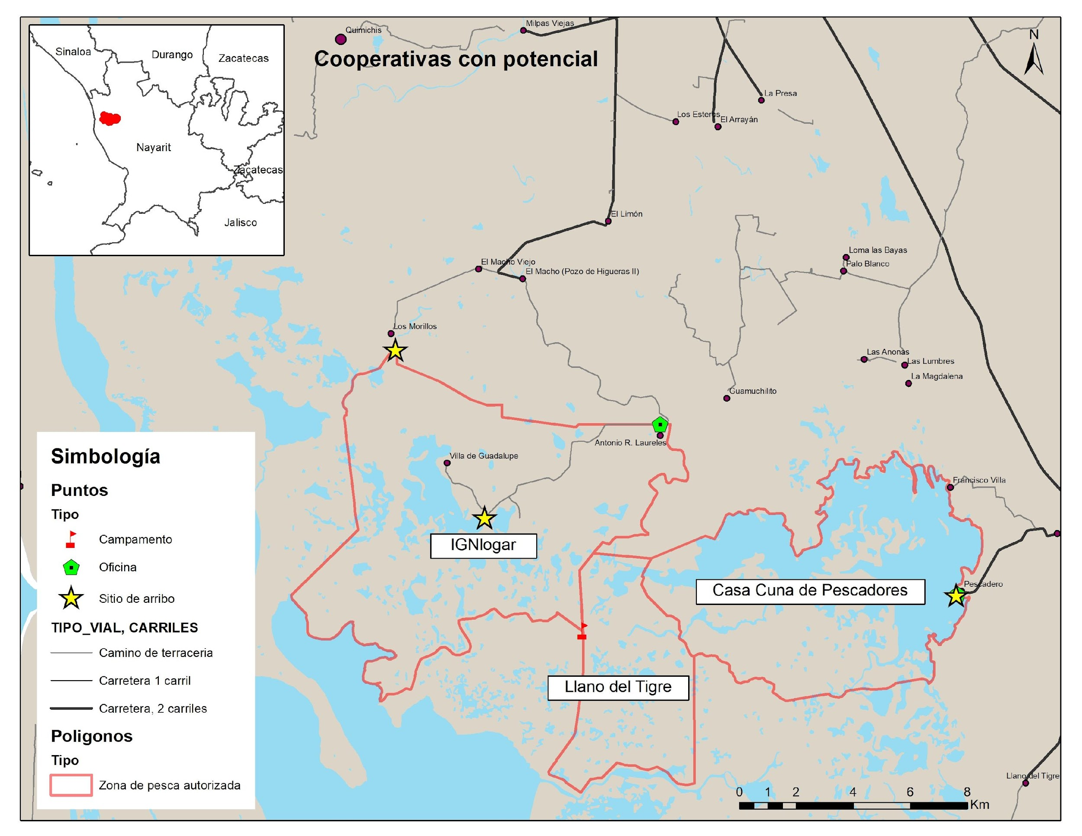
Figure 1. Location of National Marshes and the fishing areas of the fishing cooperatives participating in the FIP.
The shrimp catching season lasts between six and seven months, generally starting between August or September and ending between March and April. Only in the months of September, October, November approximately 80% of the total catch is obtained, the rest of the time it decreases to a third compared to the beginning of the season.
Data and applied methodology
The annual shrimp catch data, both national and for the state of Nayarit, were obtained from the statistical yearbook of Acuacultura and Pesca, 2022 (https://www.gob.mx/conapesca/documentos/anuario-estadistico-de-acuacultura- and-fishing). Subsequently, these data were processed and graphed with the objective of knowing the seasonal and annual variability of shrimp catches, mainly in the National Marismas region.
On the other hand, the monthly shrimp catch data of the cooperatives participating in the Fisheries Improvement Project (FIP) were obtained from the fishing logs of each cooperative. This information will allow studies of monthly and annual variation in shrimp catches to be carried out. in the fishing areas of each cooperative, as well as an evaluation of shrimp populations.
Furthermore, within the framework of the FIP, monthly biological monitoring is being carried out at different points (Fig. 2), to determine the distribution and abundance of the resource, as well as the accompanying fauna of the artisanal fishery.
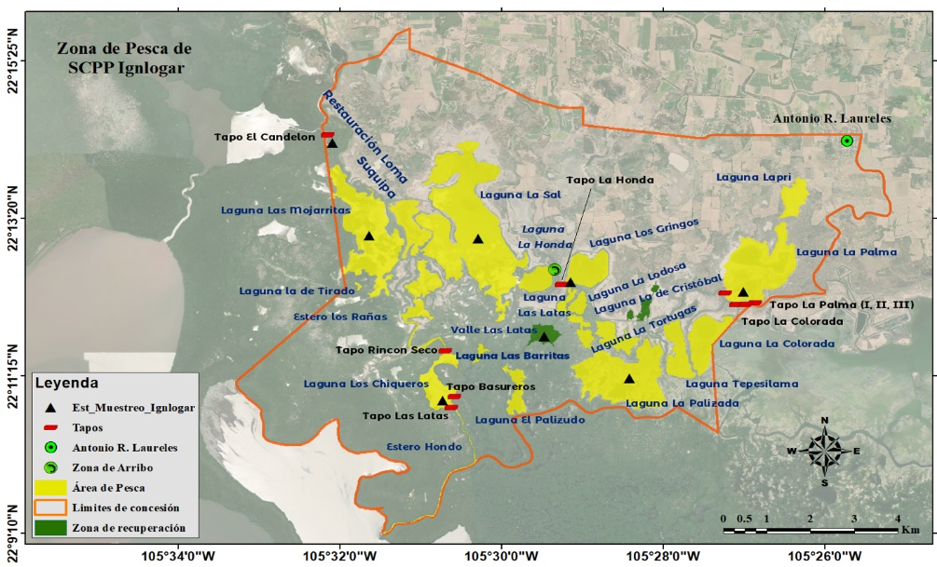
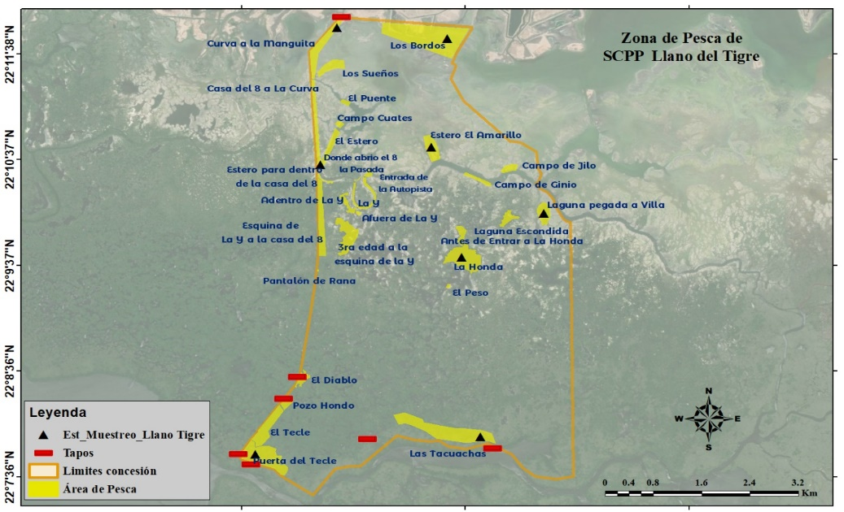
Figure 2. Sampling stations in situ for the monthly collection of biological data of the target species and associated with the fishery in the state of Nayarit, Mexico.

Result
Current status of the fishery
In Mexico, in the 1993 - 2022 order, an average of ~ 60 thousand tons of wild shrimp was recorded, registering the historical maximum in the 2015 season with approximately 84 thousand tons of shrimp. In general, it is observed that in the 1990s the shrimp catch ranged between 46 thousand tons per year. While, since the 2000s, shrimp capture has had an upward trend, exceeding 50 thousand tons per year, possibly as a result of the expansion of the fleet and fishing areas. However, since its historical maximum reached in 2015 (Fig. 3), it has been observed that the total shrimp catch in Mexico is oscillating around the historical average (60 thousand tons).
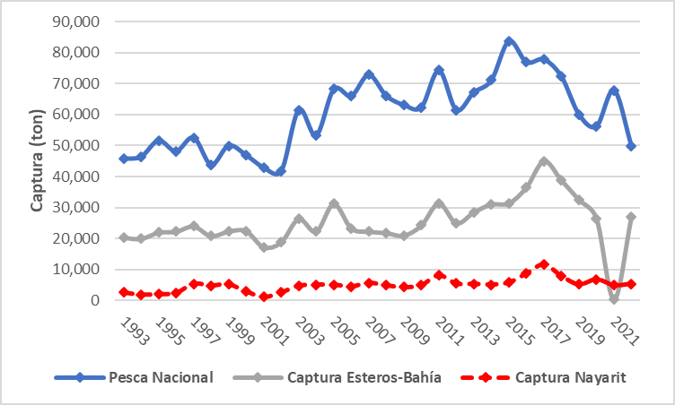
Figure 3. Shrimp catch in tons of live weight: National, Esteros and Bahía and Nayarit by season.

As expected in a multi-species fishery, the stability observed in total shrimp catches presents diverse patterns when the catch is studied by fishing areas and shrimp species. The capture in estuaries and bay is mainly given by the Litopenaeus species (white and blue shrimp). The period studied records an annual average of ~25 thousand tons of shrimp catch, with historical maximums of approximately 45 thousand tons in 2017 (Fig. 4). Note that the shrimp catch in estuaries and bays has always remained above 20 thousand tons, except in 2021, where catches decreased below 1,000 tons.
In general, it has been observed that, since 2003, shrimp catches in the estuary and bay have remained or oscillated around the historical average (Fig. 4), despite presenting catch seasons below 25 thousand tons. (2008, 2009 and 2021). For its part, starting in 2013, an upward trend has been observed, registering its historical maximum in 2018 and subsequently showing a decrease in its catches, but maintaining catches above the historical average. In 2021, the lowest historical catch (~400 tons) was recorded in estuaries and bays (Fig. 4), possibly related to the impact of three hurricanes (Rick, Pamela and Nora) and a Tropical Storm (Dolores) in the main fishing areas and in the months of capture.
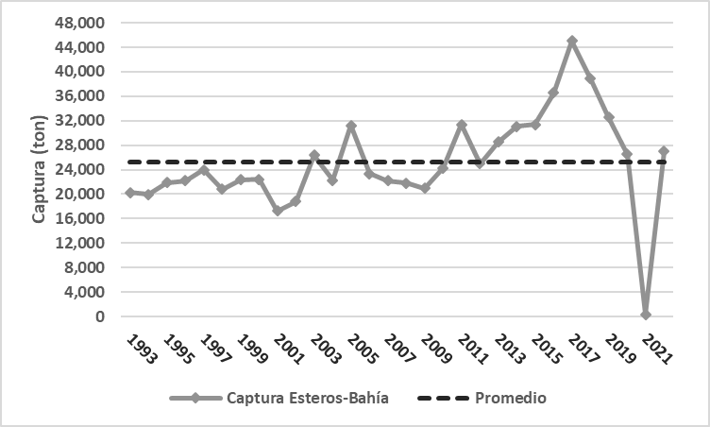
Figure 4. Annual catches and historical average of the shrimp fishery in Esteros and Bahías during the period from 1993 to 2022

In relation to the annual catches of shrimp fishing in the state of Nayarit, these presented a historical average of approximately five thousand tons. In general, two main periods have been observed, one in the 1990s, with catches lower than the historical average, and another after 2003, where catches have exceeded the annual average (Fig. 5). The first period, (1993-203), recorded the lowest annual catches observed (1994 and 2001), with values less than two thousand tons. The second period, (2004-2022), in addition to always oscillating above the historical annual average (five thousand tons), presented the highest annual catches, with values greater than 11 thousand tons of shrimp in 2017 (Fig. 5). In general, annual catches show an increasing pattern since 2001, with a fluctuation close to or greater than five thousand tons of shrimp per year for the state of Nayarit, Mexico. This stability in catches could be given by the different strategy measures (temporary closures, fishing permits, etc.) that have been implemented over the years in said fishery (NOM-002-SAG/PESC-1993).

Figure 5. Catch and annual average of shrimp in tons for the state of Nayarit. The black line corresponds to the historical average of annual shrimp catches.

Shrimp capture in fishing cooperatives
The annual catch of shrimp is carried out during the fishing period that runs from September to March, with the greatest abundance between the months of September and November. The studied stage of the shrimp fishery in National Marshes is located in the last decade, since the cooperatives did not record their catch data prior to 2013 (Fig. 6).
The average annual shrimp catch of the cooperatives participating in the FIP is approximately 500 tons. The maximum values of recorded abundances were observed in 2017 (~ 800 tons), while the minimum annual catch was observed in 2021 with ~ 200 tons of shrimp (Fig. 6).
For its part, the seasonality of catches in fishing years shows monthly variability (Fig. 7). The monthly average catch is approximately 75 tons and in general, the months of September and October record catches greater than 100 tons. From 2013 – 2017 the monthly catch follows a similar pattern from September to December, with the maximum catches in September and October, gradually decreasing catches towards the end of the year. This period records a monthly average of approximately 100 tons, with catches exceeding 300 tons in the months of September and October.

Figure 6. Annual shrimp catch recorded by the cooperatives participating in the Fisheries Improvement Project (FIP).

During the period 2018 – 2023, a decrease in monthly shrimp catches is generally observed, with a monthly average of approximately 50 tons. Although September and October continue to record the largest catches, it was observed that these do not exceed 250 tons. In addition, a decrease in catches was observed in the remaining months of the fishing season, for example, in the 2021 fishing season, the monthly catch in the months of September and October corresponded to approximately 92% of the overall catch of the fishing season. Although it is necessary to mention that this year, the region was affected by two hurricanes, which caused a decrease in fishing days and possibly an effect on the migration of shrimp to the surrounding maritime area.
During the 2023 fishing period for the cooperatives participating in the FIP, a recovery has been observed in the average annual catches (Fig. 6). This increase has been related to higher monthly catches, exceeding 100 tons per month per cooperative and, in addition, to greater abundance of shrimp in the months of November and December (Fig. 7).

Figure 7. Monthly catch of shrimp in the fishing areas of the fishing cooperatives that participate in the FIP, during the fishing months between the period 2013-2023.

Conclusions
It is necessary to continue recording fishermen's catches and monthly biological monitoring to continue improving information related to the shrimp fishery in National Marshes.

References
Arriaga, L., JM Espinosa, C. Aguilar, E. Martínez, L. Gómez and E. LOA (Coord.), 2000. Priority land regions of Mexico. National Commission for the Use and Knowledge of Biodiversity in Mexico. Mexico.
Berlanga-Robles, CA, & Ruiz-Luna, A. 2002. Land use mapping and change detection in the coastal zone of Northwest Mexico using remote sensing techniques. Journal of Coastal Research, 18, 514–522.
Berlanga-Robles, CA, & Ruiz-Luna, A. 2006. Assessment of landscape changes and their effects on the San Blas estuarine system, Nayarit (Mexico), through Landsat imagery analysis. Marine Sciences , 32, 523–538.
Blais , Y. (Ed.). (2003). Factual record: Aquanova submission (SEM-98-006). Montreal, Quebec: Commission for Environmental Cooperation.
Branch, TA, Jensen, OP, Ricard, D., Ye, Y., and Hilborn , R. 2011. Contrasting global trends in marine status obtained from catches and from stock assessment. Conservation Biology 25(4):777-786.
Carvajal- Rascom , MA, Torres-Origel, JF, Farrell-Campos, SG, Bolado- Martinez , E., and Martinez -Escalante G. 2017. Fishing in National Marshes 2001-2015. Networks -SuMar . November 2017. p. 36
CONAPESCA 2020. Statistical Information by Species and Entity https://www.conapesca.gob.mx/wb/cona/informacion_estadistica_por_especie_y_entidad
Official Gazette of the Federation 2015. Mexican Official Standard NOM-064-SAG/PESC/SEMARNAT-2013, On capture systems, methods and techniques prohibited in fishing in waters under federal jurisdiction of the United Mexican States.
Ezcurra, E., Barrios, E., Ezcurra, P., Ezcurra, A., Vanderplank, S, Vidal, O., Villanueva-Almanza, L and Aburto-Oropeza, O. 2019. A natural experiment reveals the impact of hydroelectric dams on the estuaries of tropical rivers. Science Advances https://ezcurralab.ucr.edu/sites/g/files/rcwecm3506/files/2020-05/137.pdf
Flores Verdugo, FJ, González Farías, YF, Zamorano, DS, Ramírez García P., 1992. Mangrove ecosystems of the pacific coast of México: distribution, structure, litterfall and detritus dynamics, in U. Seliger (eds) Towards the rational use of high salinity tolerant plants. Kluwer Academic Publishers, Netherlands.
Flores-Verdugo, F., Amezcua, F., Kovacks , JM, Serrano, D., and Blanco-Correa, M. 2014. Changes in the Hydrological Regime 6 of Coastal Lagoons Affect Mangroves and Small Scale Fisheries: The Case
Flores-Verdugo, F., González-Farías, F., Blanco-Correa, M., & Nuñez -Pasten, A 1997. The Teacapán -Agua Brava Marismas Nacionales mangrove ecosystem on the Pacific coast of Mexico. In: B. Kjer - fve , L. Drude , & EH Diop (Eds.). Mangrove ecosystem studies in Latin America and Africa (pp. 35–46). France: UNESCO .
Garcia, SM 1989. The management of coastal penaeid shrimp fisheries. In 'Marine Invertebrate Fisheries: their Assessment and Management'. (Ed. JF Caddy.) pp. 281-306. (J. Wiley: New York, Chichester, Brisbane, Toronto, Singapore.)
García, SM 1996. Stock recruitment relationships and the precautionary approach to management of tropical shrimp fisheries. Mar Freshwater Res 47:43-58.
Garcia -Carmona, J., Lopez-Florez, PL, Fonseca-Morales, MA 2014. Sustainable Rural Tourism and Riverside Shrimp Fishing with Tapos, Cultural Heritage of the State of Nayarit. EDUCATECONCIENCIA Magazine. Volume 4, No. 4. ISSN: 2007-6347 July-December 2014. Tepic, Nayarit. Mexico Pp.79-92
Guillet , R. 2008. Global study of shrimp fisheries. FAO Fisheries Technical Paper 475.
Hendrickx ME, 1996. The benthic Penaeoidae shrimp (Crustacea: Decapoda: Dendobranquiata) of the Mexican Pacific. National Commission for the Knowledge and Use of Biodiversity. Mexico . 147 p.
Hernandez-Guzman , R., Ruiz-Luna, A., & Berlanga-Robles, CA 2008. Assessment of runoff response to landscape changes in the San Pedro subbasin (Nayarit, Mexico) using remote sensing data and GIS. Journal of Environmental Science and Health. Part A, Toxic/Hazardous Substances & Environmental Engineering, 43, 1471–1482.
INAPESCA. 2016. Evaluation and Management of the Mexican Pacific shrimp fishery (capture, reference points, biomass, age, environment, accompanying fauna.
INAPESCA. 2017. Opinion on the start of the closed season. Analysis of the behavior of the shrimp fishery on the Mexican Pacific coast in the 2016-2017 season, for the implementation of the beginning of the closed season in 2017.

