Mexico Marismas Nacionales artisanal whiteleg shrimp - trap /cast-nets

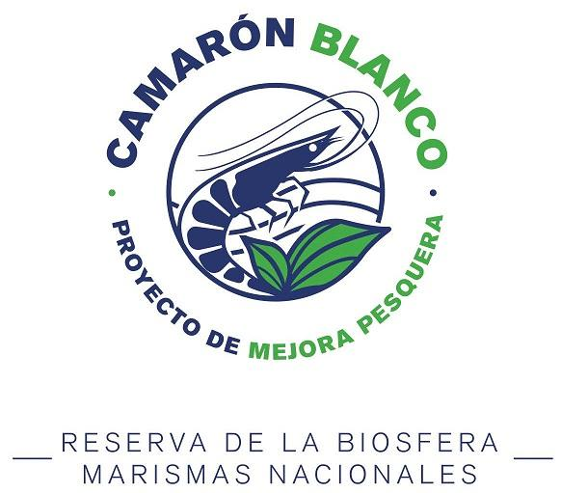

Biological and Physical Data Sampling Program

SmartFish Valor Rescue AC
The Nature Conservancy
June 2023

Prepared by:
Yuliesky Garces Rodriguez

SmartFish AC
Márquez de León No. 2395, Col. Centro
La Paz, Baja California Sur, Mexico.
PC 23000

I. Introduction
The Marismas Nacionales Biosphere Reserve (RBMN) is an extensive wetland system located in the northwest of the state of Nayarit, and is part of the coastal plains of the Mexican Pacific ( Fig. 1 ) . The natural region of RBMN has an approximate area of 175,000 ha and is characterized by presenting diverse habitats, such as coastal lagoon systems, mangrove swamps, swamps, deltas, and marshes, which are constantly changing due to geomorphological processes and anthropogenic pressure. . The system is fed by 12 rivers, among which the Santiago, San Pedro-Mezquital, Acaponeta, Cañas and Rosamorada rivers stand out for their flow (Blanco et al., 2011). On the other hand, it presents several artificial channels, the most important being that of Cuautla, (opened in 1973), which connects the lagoon system of Marismas Nacionales (Laguna Agua Brava) with the Pacific Ocean. The RBMN, according to the hydrological and sedimentary flow, is divided into 10 continental hydrological sub-regions, fourteen tidal basins and forty-seven tidal sub-basins.
The region's climate is semi-warm, sub-humid, with annual rainfall of more than 1,500 mm (Blanco et al., 2011) and the influence of humid monsoon-type winds from the sea. In addition, the RBMN presents a marked seasonality determined by the rainy season, which begins in May, although the maximum precipitation values are concentrated from June to October (average 964 mm) (CONAGUA, 2004). On the other hand, the region presents a type of predominantly semidiurnal mixed tide and although there is little information for the coastal and inland lagoons of the system, due to the internal location of most of the wetlands, the changes in the tidal level become of approximately ±3 cm in various areas where the current tidal amplitude may have an interval of 50 and 100 meters, such as the Las Garzas lagoons, Chahuín -Chihua (Ortega- Solis , 2011, Arce et al., 2015).
The RBMN ecosystem is of great biological importance as it is a habitat that allows the growth, feeding and protection of various coastal species, white shrimp and oysters being the most important for fishing activities. These areas also serve as a refuge for migratory waterfowl (ducks and shorebirds) and wildlife species such as the river crocodile ( Crocodylus acutus ) and the jaguar ( Panthera onca ).
Among the most relevant economic activities in RBMN is fishing, being the economic livelihood of more than 14 thousand people. The fishing zone within the RBMN is divided into 15 capture areas, which are used by 20 fishing cooperative societies, with authorization for the extraction and capture of different species. The main species captured by the fishing cooperatives organized in the RBMN are divided into three large groups: shrimp, oyster and scale, with a fishing utilization of 41.5%, 36% and 18.7% respectively.
Although the RBMN is an ecosystem with favorable characteristics for fishing production, the overexploitation of fishing resources, the inappropriate use of exploitation practices, the mismanagement of cooperatives, the absence of fishing authorities and the alterations in the ecosystem, have led to a continuing economic crisis in the region. In order to identify and improve this situation, a Fisheries Improvement Project (FIP) was implemented in the white shrimp ( Litopenaeus vannamei ) fishery in conjunction with the government of the region and the Sociedad de Cooperativas of Fisheries Production (SCPP) Ignlogar and Llano del Tigre. These cooperatives are located in the tidal basin of Agua Brava and in the hydrological subregions of Rio Acaponeta, Rio San Francisco, Rio Bejuco and Rosamorada.
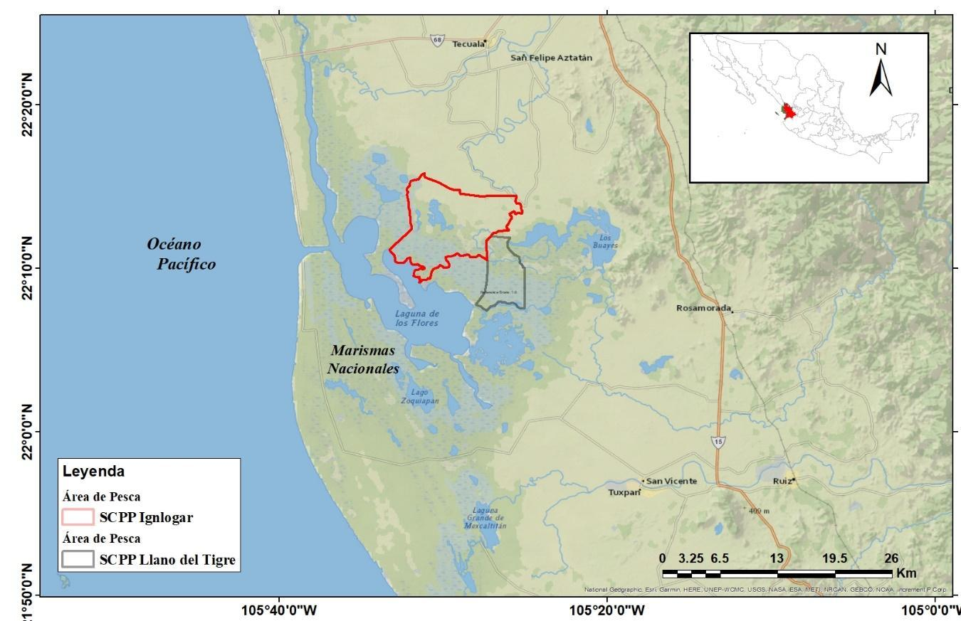
Figure 1. Location of the fishing areas corresponding to the SCPP Ignlogar and SCPP Llano del Tigre cooperatives.

L. vannamei occupies different habitats throughout its life cycle, which gives the fishery a sequential nature, so its exploitation in the different phases -growth, and reproduction- should not affect recruitment, reproductive potential, and the fishing production of the species. In the RBMN, the most important commercial species is white shrimp, with an average annual production of approximately 3,538 tons, during the fishing season that runs from September to March (Chávez-Herrera et al., 2020). In general, this fishery is based on the capture of juveniles and is of enormous importance for coastal fishermen in the months of September and November.
The data collected on the white shrimp fishery during the Monitoring Program in Marismas Nacionales will support the development of a fisheries management plan for Marismas Nacionales, including the impact of fishing on the ecosystem. In addition, a list of the species associated with the white shrimp fishery will be obtained, and the impact on the habitat of the different cast nets used in the sampling will be evaluated.
The hydrological information collected also allows different studies to be carried out, such as determining the monthly thermohaline behavior of the lagoons, as well as the annual cycle of nutrients in the fishing area of the cooperatives. In addition, the joint analysis of both data (physical and biological) will also allow for correlation studies between the abundance of white shrimp and the hydrological variability of the fishing area.

II. General objective
Evaluate the abundance and population parameters of the white shrimp ( Litopenaeus vannamei ) in Marismas Nacionales.
Specific objectives
1.- Determine the spatiotemporal distribution of the abundance and biomass of the white shrimp population observed in the fishing areas of each cooperative.
2.- Evaluate the environmental impact of the white shrimp fishery in Marismas Nacionales.
3.- Determine the composition of the bycatch.
4.- Determine the impact of the white shrimp riparian fishery on the accompanying fauna in Marismas Nacionales.
5. Determine the hydrological variability in the RBMN.

III. Materials and methods
Fieldwork
Professors and students from the National School of Fisheries Engineering, Autonomous University of Nayarit (ENIP-UAN) will participate in the in situ sampling, with the collaboration of SmartFish AC, TNC, and the cooperatives.
The monitoring will be carried out in the fishing zones corresponding to the cooperatives of SCPP Ignlogar and SCPP Llano del Tigre ( Fig. 1 ). The sampling in RBMN will have a monthly frequency, but bimonthly in each of the participating cooperatives ( Table 1 ) and will be carried out during the five years planned for the project.
To obtain physical and biological data, a network of in situ stations (8 stations) was established for the fishing areas of the two cooperatives participating in the project ( Fig. 2 and 3 ). Physical data (temperature, salinity, nutrients, sediments, etc.) and biological data (total length, weight, etc.) will be recorded at each station, both of the white shrimp catches and of the species associated with the fisher.
For biological sampling, at each of the sampling stations, two casts will be made with cast nets of different mesh sizes (1.5; 1.0 inches), with the aim of identifying and comparing the abundances of catches and their impact. in it habitat. The total catch of white shrimp will be weighed for each set made and a random sample of 3 pounds (from each set) will be selected to perform biometric measurements (total length) individually. In addition, samples will be taken to the ENIP-UAN laboratories to determine the age and growth of the fishing resource.

Table 1. Programming of the sampling in the stations defined for the fishing zones of each cooperative. The sampling will be repeated every year during the duration of the project.
Zone  Of sampling | Sampling Period
 | Jan | Feb | Sea | Apr | May | Jun | Jul | Aug | Sep | Oct | Nov | Dec
SCPP Ignore |  | x |  | x |  | x |  | x |  | x |  | x
SCPP Plain of the Tiger | x |  | x |  | x |  | x |  | x |  | x

In relation to the associated fauna, the total catch obtained by each set will be weighed and a random sample will be taken to identify and measure each individual individually. The catches recorded by each net used (different mesh sizes) will allow the evaluation of the impact of the fishing gear on the fauna associated with the white shrimp fishery.
In each fishing area, the habitat in which the white shrimp inhabit will be characterized and the bottoms with their most conspicuous flora and fauna will be described. The measurements of abiotic variables in water will be carried out monthly for 12 months in each fishing area and the variables salinity, temperature, and dissolved oxygen will be measured. The physical data will be taken at each sampling station in situ every month and will be determined by means of a multiparameter probe (HANNA HI98194). The values obtained in each abiotic variable will have their average values calculated with their standard errors for each area and month sampled. A two-way analysis of variance will be carried out, with a confidence level of 95%, to compare the values of the variables measured by zones and by sampling months. In addition, for both fishing zones, sediment samples will be taken at each sampling station every four months (1 for each climatic season) and will be analyzed in the ENIP-UAN laboratories.

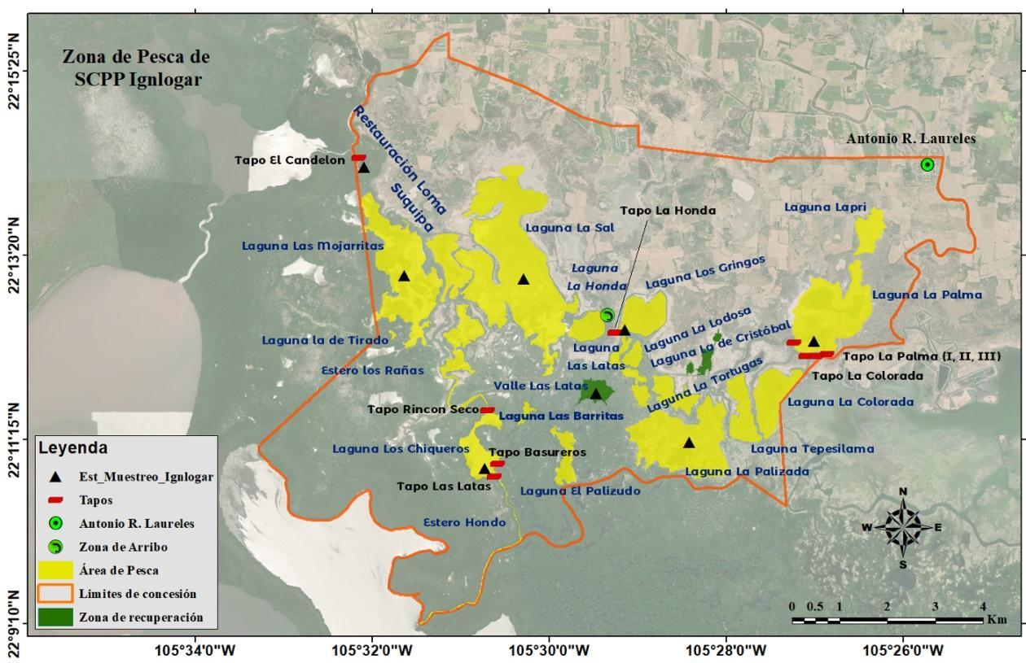
Figure 2. Sampling Stations to obtain physical data and biological information on the white shrimp fishery and associated fauna in the Ignlogar SCPP fishing area. The black triangles correspond to the sampling stations.
Biological sampling in the arrival area
This sampling will be carried out throughout the fishing season and will be carried out at the points where the fishermen deliver their catch to their corresponding SCPP (arrival zones). The sampling will be carried out with a weekly frequency (two samplings per week) for each cooperative. On each sampling day, the catch of at least 5 fishermen will be selected, with the aim of collecting information from the different fishing areas corresponding to the SCPP sampled. The total weight of each fisherman's catch will be recorded, and 5 pounds of white shrimp will be selected at random, where the total length of each individual will be measured. On the other hand, the weight of the catch of the associated fauna will also be recorded and a list of the main species caught will be drawn up, as well as a folder of photographs.
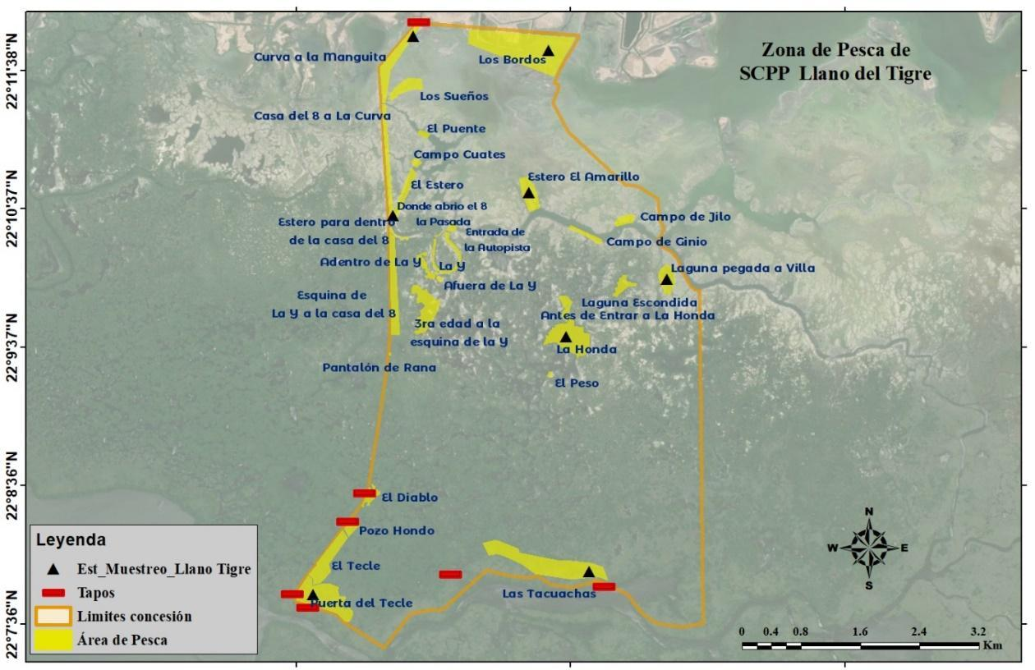
Figure 3. Sampling stations to obtain physical data and biological information on the white shrimp fishery and associated fauna in the fishing area of the Llano del Tigre SCPP. The black triangles are the sampling stations.
IV Results
A great challenge for obtaining data was access to various sampling points in different months, due to the variation in water flow during the dry season, so there are points with parameters that could not be recorded during the sampling. .
The physical data sampling identified the variables of pH, dissolved oxygen (and the corresponding particles per million), temperature, salinity, pressure, and conductivity. At the moment, there is data for the months of September, November, and April in the Llano del Tigre area and October in Antonio R. Laureles.
The data obtained and its variation (if applicable) through the months are shown in the following graphs:
Plain of the Tiger
Sampling points:
- The Tecuachas
- Gate of the Tecle
- the sling
- Lagoon attached to Villa
- The Yellow Estuary
- Estero inside the house of 8
- Curve to Sleeve
- The Bordos
A) pH
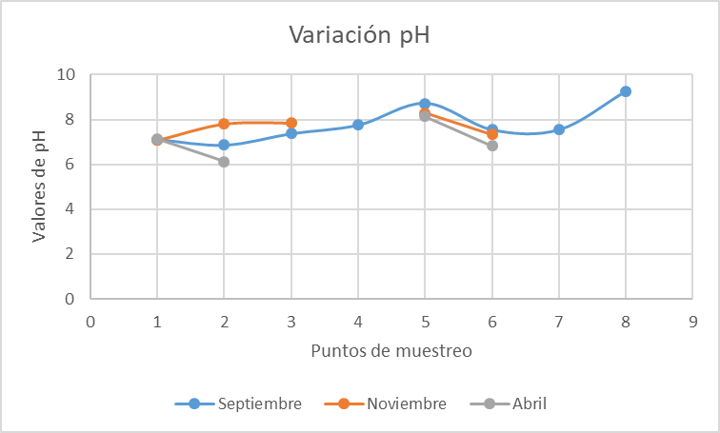
B) Dissolved oxygen
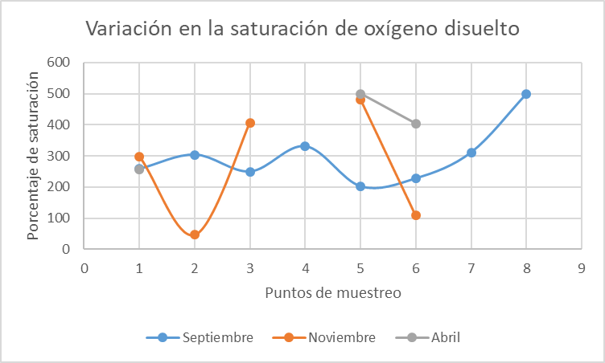

C) Salinity
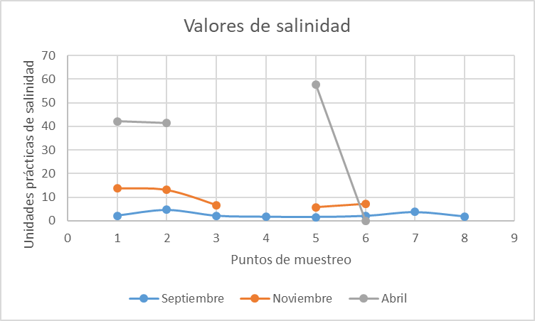

D) Pressure
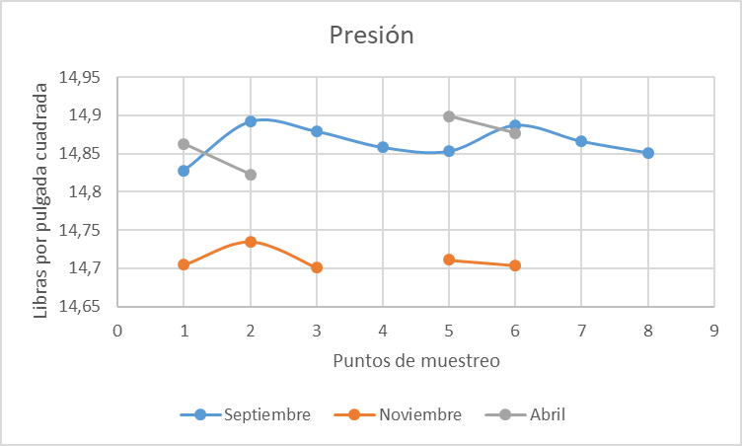

E) Conductivity
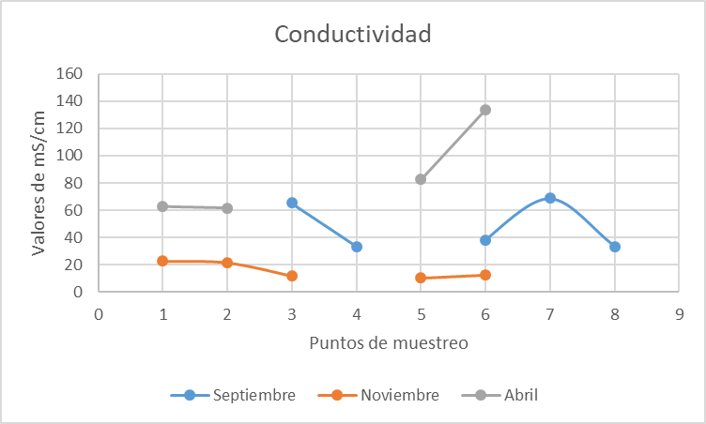
Antonio R. Laureles
Sampling points:
- cover the cans
- Valley Las Latas
- La Palizada Lagoon
- tapo la palma
- Cover the Honda
- Las Mojarritas Lagoon
- Tapo El Candelón (no data due to low water flow at the point)
- Salt Lagoon

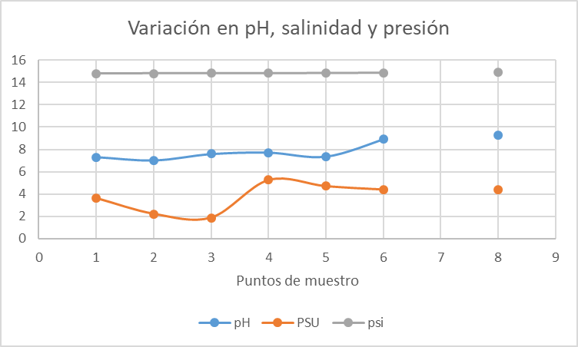

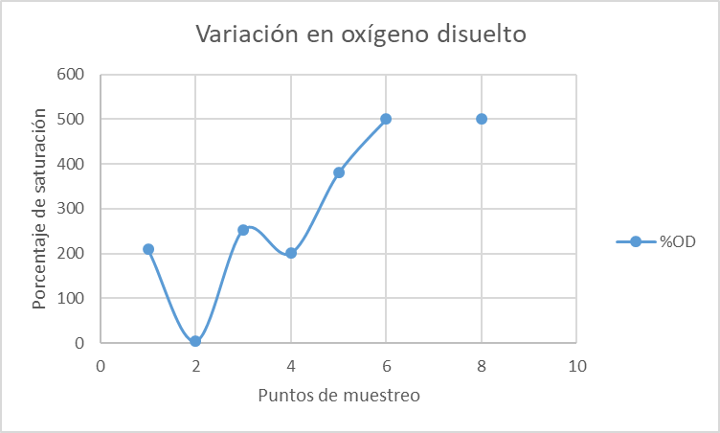

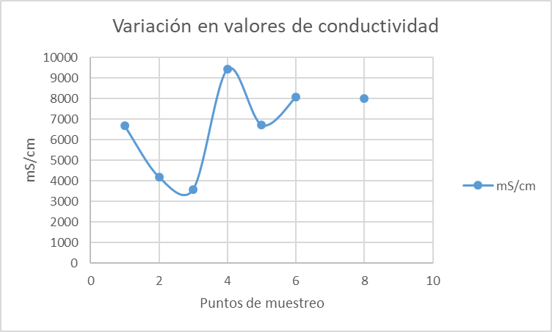
V References
Arriaga, L., JM Espinosa, C. Aguilar, E. Martínez, L. Gómez and E. LOA (Coord.), 2000. Priority terrestrial regions of Mexico. National Commission for the Use and Knowledge of Biodiversity in Mexico. Mexico.
Blais, Y. (2003). Factual record: Aquanova submission (SEM-98-006): prepared in accordance with Article 15 of the North American Agreement on Environmental Cooperation. Montreal, Quebec: Commission for Environmental Cooperation, Y 3. EN 8:17 12
Branch, TA, Jensen, OP, Ricard, D., Ye, Y., and Hilborn , R. 2011. Contrasting global trends in marine status obtained from catches and from stock assessment. Conservation Biology 25(4):777-786.
Carvajal- Rascom, MA, Torres-Origel, JF, Farrell-Campos, SG, Bolado- Martinez, E., and Martinez-Escalante G. 2017. Fishing in National Marshlands 2001-2015. Redes- SuMar. November 2017. p. 36
CONAPESCA 2020. Statistical Information by Species and Entity https://www.conapesca.gob.mx/wb/cona/informacion_estadistica_por_especie_y_entidad
Official Gazette of the Federation 2015. Official Mexican Standard NOM-064-SAG/PESC/SEMARNAT-2013, On systems, methods, and capture techniques prohibited in fishing in waters of federal jurisdiction of the United States of Mexico.
Ezcurra, E., Barrios, E., Ezcurra, P., Ezcurra, A., Vanderplank, S, Vidal, O., Villanueva-Almanza, L and Aburto-Oropeza, O. 2019. A natural experiment reveals the impact of hydroelectric dams on the estuaries of tropical rivers. Science Advances https://ezcurralab.ucr.edu/sites/g/files/rcwecm3506/files/2020-05/137.pdf
Flores Verdugo, FJ, González Farías, YF, Zamorano, DS, Ramírez García P., 1992. Mangrove ecosystems of the Pacific coast of México: distribution, structure, litterfall and detritus dynamics, in U. Seliger (eds) Towards the rational use of high salinity tolerant plants. Kluwer Academic Publishers, Netherlands.
Flores-Verdugo, F., González- Farias , F., Blanco-Correa, M., & Nuñez-Pasten , A 1997. The Teacapán -Agua Brava Marismas Nacionales mangrove ecosystem on the Pacific coast of Mexico. In: B. Kjer - fve , L. Drude , & EH Diop (Eds.). Mangrove ecosystem studies in Latin America and Africa (pp. 35–46). France: Unesco.
Flores-Verdugo, F., Amezcua, F., Kovacks, JM, Serrano, D., and Blanco-Correa, M. 2014. Changes in the Hydrological Regime 6 of Coastal Lagoons Affect Mangroves and Small-Scale Fisheries: The Case
of the Mangrove-Estuarine Complex of Marismas Nacionales (Pacific Coast of Mexico). in. Amezcua , F. and Bellgraph , B (eds), Fisheries Management of Mexican and Central American Estuaries, 81 Estuaries of the World, DOI 10�1007 / 978-94-017-8917-2_6 ,
Guillet , R. 2008. A global study of shrimp fisheries. FAO Fisheries Technical Paper 475.
Hendrickx ME, 1996. The benthic Penaeoidae shrimp (Crustacea: Decapoda: Dendobranquiata) of the Mexican Pacific. National Commission for the Knowledge and Use of Biodiversity. Mexico 147 p.
INAPESCA. 2016. Evaluation and Management of the Mexican Pacific shrimp fishery (catch, reference points, biomass, age, environment, accompanying fauna.
INAPESCA. 2017. Opinion on the start of the closure. Analysis of the behavior of the shrimp fishery on the Mexican Pacific coast in the 2016-2017 season, for the implementation of the closure beginning in 2017.
Hernandez-Guzman, R., Ruiz-Luna, A., & Berlanga-Robles, CA 2008. Assessment of runoff response to landscape changes in the San Pedro subbasin (Nayarit, Mexico ) using remote sensing data and GIS. Journal of Environmental Science and Health. Part A, Toxic/Hazardous Substances & Environmental Engineering, 43, 1471–1482.
Garcia -Carmona, J., Lopez-Florez, PL, Fonseca-Morales, MA 2014. Sustainable Rural Tourism and Shrimp and Tapos River Fishing, Cultural Heritage of the State of Nayarit. EDUCATECONSCIENCE Magazine. Volume 4, No. 4. ISSN: 2007-6347 July-December 2014. Tepic, Nayarit. Mexico Pp.79-92
Garcia, SM 1989. The management of coastal penaeid shrimp fisheries. In 'Marine Invertebrate Fisheries: their Assessment and Management'. (Ed. JF Caddy.) pp. 281-306. (J. Wiley: New York, Chichester, Brisbane, Toronto, Singapore.)
Garcia, SM 1996. Stock recruitment relationships and the precautionary approach to the management of tropical shrimp fisheries. Mar. Freshwater Res. 47:43-58.
Berlanga-Robles, CA, & Ruiz-Luna, A. 2002. Land use mapping and change detection in the coastal zone of Northwest Mexico using remote sensing techniques. Journal of Coastal Research, 18, 514–522.
Berlanga-Robles, CA, & Ruiz-Luna, A. 2006. Assessment of landscape changes and their effects on the San Blas estuarine system, Nayarit (Mexico), through Landsat imagery analysis. Marine Sciences, 32, 523–538.

XII Annexes
Table 2. Coordinates of the points where the in situ sampling (physical and biological) will be carried out in the fishing area of the SCPP Ignlogar.
Season | Name | Latitude | Length
1 | Tapo El Candelon | 22° 14' 18.17''N | 105° 32' 5.49''W
2 | Las Mojarritas Lagoons | 22° 13' 4.60''N | 105° 31' 38.43''W
3 | Salt Lagoon | 22° 13' 2.91''N | 105° 30' 18.94''W
4 | Cover the Honda | 22° 12' 27.39''N | 105° 29' 9.59''W
5 | Valley the Cans | 22° 11' 45.11''N | 105° 29' 29.04''W
6 | tapo la palma | 22° 12' 20.63''N | 105° 27' 0.21''W
7 | La Palizada Lagoon | 22° 11' 11.29''N | 105° 28' 25.62''W
8 | Los Chiqueros Lagoon | 22° 10' 56.91''N | 105° 30' 46.00''W

Table 3. Coordinates of the points where the in situ sampling (physical and biological) will be carried out in the fishing area of the SCPP Llano del Tigre.
Season | Name | Latitude | Length
1 | The Tacuachas | 22° 07' 55.52''N | 105° 25' 52.38''W
2 | Gate of the Tecle | 22° 07' 47.17''N | 105° 27' 51.99''W
3 | the sling | 22° 09' 40.10''N | 105° 26' 2.40''W
4 | Lagoon attached to Villa | 22° 10' 5.14''N | 105° 25' 18.45''W
5 | The Yellow Estuary | 22° 10' 42.96''N | 105° 26' 17.97''W
6 | Estero inside the house of 8 | 22° 10' 34.62''N | 105° 27' 18.06''W
7 | Curve to Sleeve | 22° 11' 53.06''N | 105° 27' 9.15''W
8 | The Bordos | 22° 11' 45.83''N | 105° 26' 10.19''W

