

**Skipjack fishery sampling 2024**

**Monthly report**

**August**

September 2, 2024, Puerto Angel, Oaxaca.

# “Bridge Fishing Sampling” Report for the month of August 2024.

Corresponding dates: August 1, August 8, August 15, August 22, and August 29, 2024.

# Fisheries sampling from August 1, 2024

On August 1st of this year, at 7:30 am, the sampling activities of skipjack fish began on the main beach of Puerto Ángel. These activities were led by Michelle Salinas Cabrera, who was in charge of measuring the specimens. Efraín Castillo was in charge of weighing the specimens and Claudia recorded this data in the sampling tables designed for this purpose.

The weather was warm and several boats went out to fish. The results of the search for skipjack were not very favourable for the fishermen, with catches varying between 0 and 25 specimens maximum per boat.

The following catches were recorded: the Kelly vessel captured 25 specimens, of which 9 black skipjack specimens were weighed and measured; the Diosmarcito vessel captured 7 specimens of which 2 were measured and weighed, the Emannuel captured 18 specimens and 6 specimens were measured and weighed, the Fernandita captured 14 specimens, measuring and weighing 4.

Other vessels such as the Rebeca caught 8 specimens, Irene caught 15, Albatros II 0, and the Abuelo 20, however, data on weights and measurements were not obtained due to the demand for fish by buyers.

Most of the boats reported having caught fish off Roca Blanca and Cometa. The price on the beach for black skipjack was $50 pesos.

Participants:

* Women: 2
* Men: 10

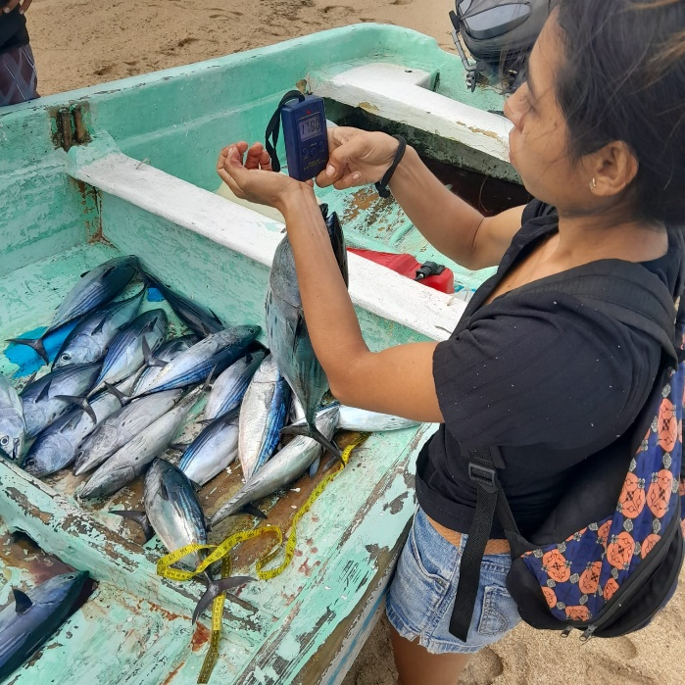

Illustration . Photographic evidence of black skipjack capture from the Kelly vessel.

*ii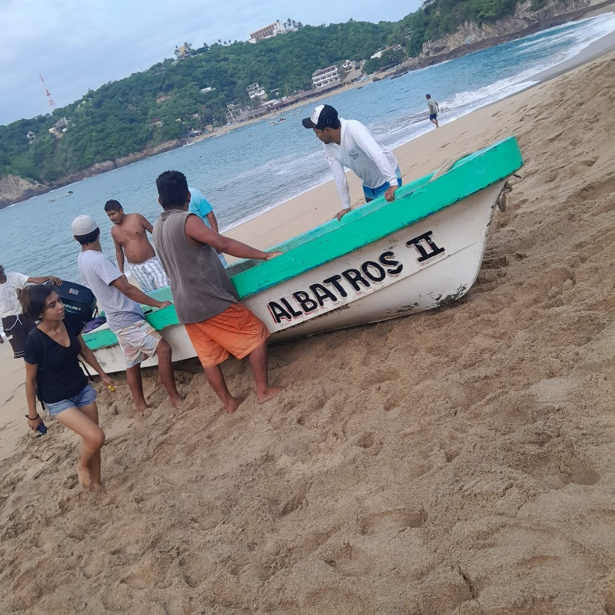*

*Illustration 2. Photographic evidence of the Albatros II vessel.*

# Fisheries sampling of August 8, 2024

At 7:30 am, the sampling activities for skipjack began on the beach, led by Michelle Salinas Cabrera, who was in charge of measuring the specimens. Efraín Castillo was in charge of weighing the specimens and Claudia recorded this data on the sampling tables designed for this purpose. The skipjack catch on this day was favorable, since the fishermen reported very good catches.

Data were collected from the Keiko III vessel, which captured 40 black skipjack, of which 14 were measured and weighed; the Kelly captured 170 individuals, of which 21 were measured and weighed; the Rebeca vessel captured 22 individuals, of which 4 individuals were weighed and measured; the Emannuel vessel captured 100 individuals, of which 7 were weighed and measured; Albatros captured 24 individuals, of which weighing and measurement data were obtained for 7; the Odisea captured 80, of which 13 were measured and weighed; the Irene captured 52 individuals, of which 9 individuals were measured and weighed.

Most of the vessels reported having fished in front of Puerto Ángel, Salchi, Zapotengo, Tijera, Ventanilla and Roca Blanca.

The price of the copy was $25 and $30 pesos at the beach.

Participants:

* Women: 2
* Men: 11

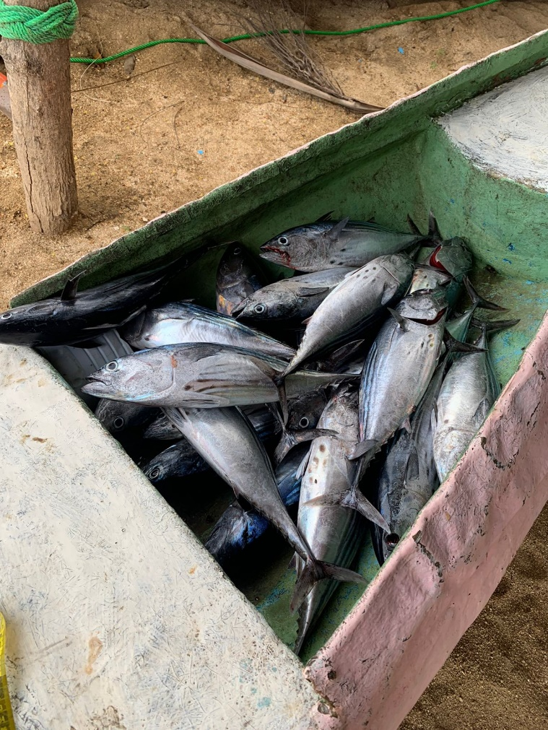

*Illustration 3. Photographic evidence of black skipjack capture from the vessel Irene.*

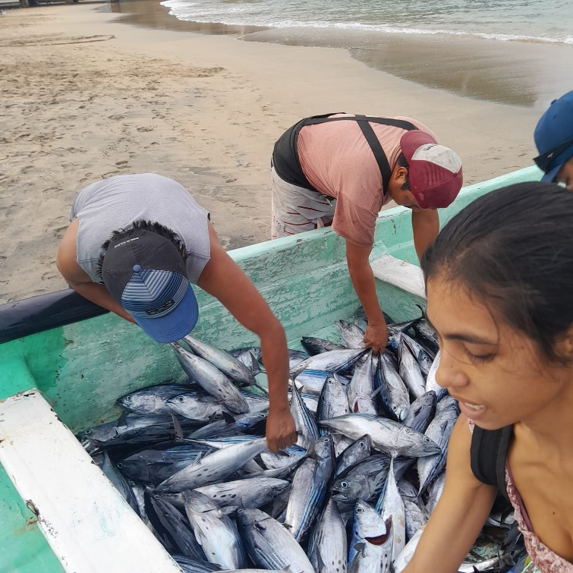

*Illustration 4. Photographic evidence of black skipjack capture from the Kelly vessel.*

# Fisheries sampling from August 15, 2024

At 7:30 am, the sampling activities of skipjack fish began on the beach, led by Michelle Salinas Cabrera, who was in charge of measuring the specimens. Efraín Castillo was in charge of weighing them and Claudia recorded the data in the sampling tables.

The weather was warm and several boats went out to fish. The results of the search for skipjack were favourable for the fishermen, with catches ranging from 1 to 140 specimens maximum per boat.

The following catches were recorded: the vessel Rebeca captured 50 specimens, of which the weight and length of 8 specimens of black skipjack were taken; the vessel Irene captured 49 specimens of which 6 were measured and weighed, the vessel Esclavo captured 80 specimens and 13 specimens were measured and weighed; Albatros captured 60 specimens of black skipjack and 5 specimens were measured and weighed; the vessel Santa Fe captured 70 specimens of black skipjack and 10 specimens were measured and weighed, the vessel Jennifer captured 50 specimens of black skipjack and 11 specimens were measured and weighed; the vessel Kelly captured 140 specimens, measuring and weighing 10 black skipjack and 2 tooth skipjack; The Odisea vessel captured 90 black skipjack, 9 of which were measured and weighed; America captured 46 of which were measured and weighed; Juquila captured 20 of which 4 of which were measured and weighed; it also caught an incidental catch from a mountain range which was measured and weighed. The Arcangel vessel captured a total of 90 black skipjack, 13 of which were measured and weighed.

Most of the boats reported having fished in front of tijera, zapotengo, toba and white rock, the fishermen commented that the black skipjack was eating red shrimp. The price at the beach for the black skipjack was $25 pesos.

Participants:

* Women: 2
* Men: 15

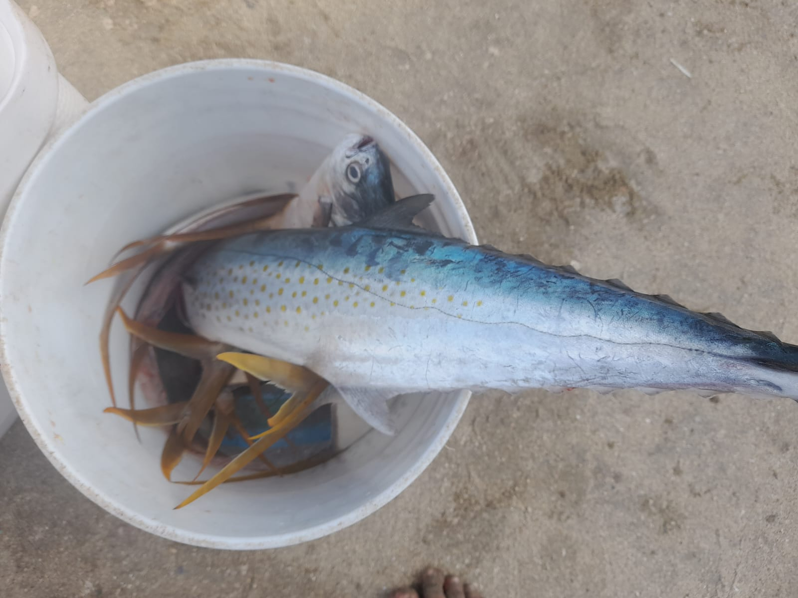

*Illustration 5. Photographic evidence of the capture of a saw from the Juquila vessel*

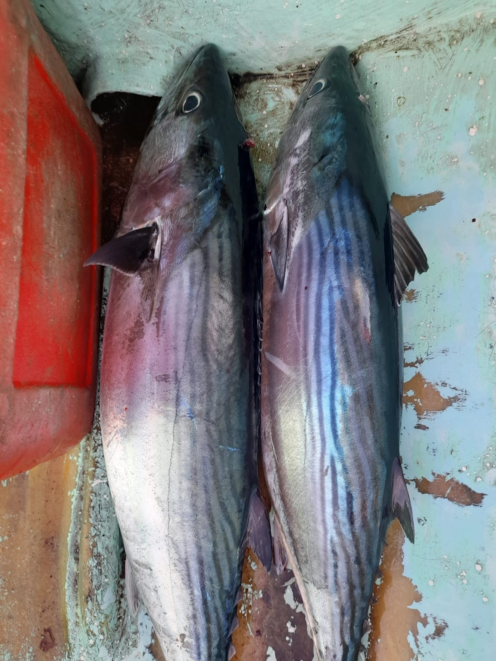

*Illustration 6. Photographic evidence of the Kelly barge's toothed skiff.*

# Fisheries sampling of August 22, 2024

At 7:30 am, the sampling activities of skipjack fish began on the beach, led by Michelle Salinas Cabrera, who was in charge of measuring the specimens. Efraín Castillo was in charge of weighing them, Claudia Cruz recorded the data in the sampling tables, and Aidee Jimenez took photographic records.

Records were obtained from the vessels Irene, which captured 34 specimens, of which 8 specimens were weighed and measured; Juquila captured 30 specimens, of which the weight and length of 5 specimens of black skipjack were taken; the vessel Jassive II captured 17 specimens of black skipjack, of which 3 were measured and weighed; the vessel Santa Fe II captured 22 black skipjack and 5 specimens were measured and weighed; the vessel Diosmarcito captured 50 black skipjack and 5 specimens were measured and weighed; Arcangel captured 22 specimens and 4 specimens were measured and weighed; the Odisea captured 42 black skipjack and 7 specimens were measured and weighed; the vessel Rebeca captured 22 black skipjack and 5 specimens were measured and weighed; Emannuel boat captured 12 specimens and 2 specimens were measured and weighed

Most of the boats reported having caught fish off Toba, Tijera, Zapotengo and Roca Blanca. The price on the beach for black skipjack was between $30 pesos.

Participants:

* Women: 3
* Men: 13

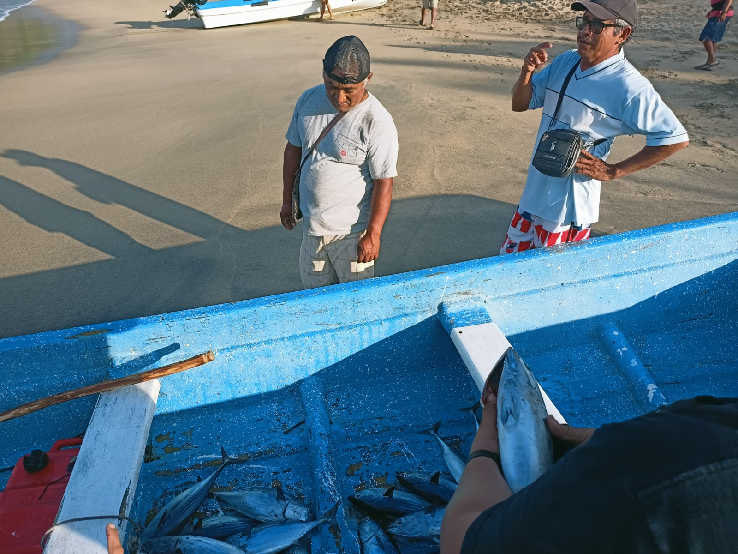

*Illustration 7. Photographic evidence of the capture of the Santa Fe II vessel.*

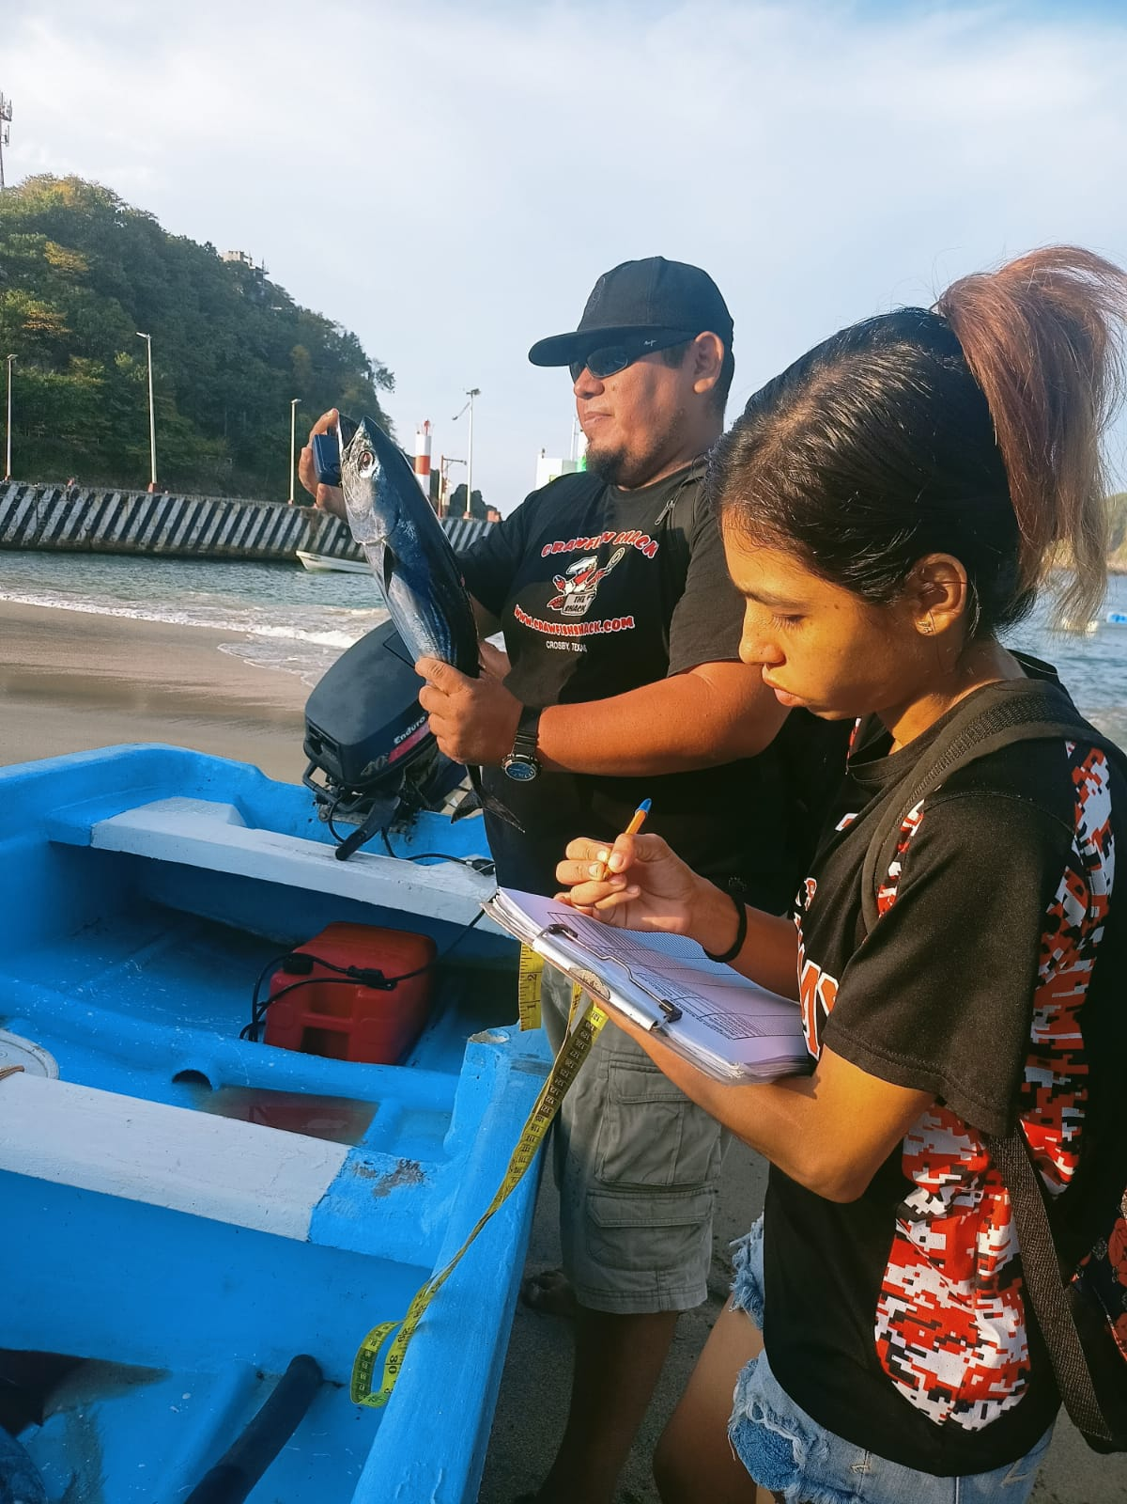

*Illustration 8. Photographic evidence of the capture of black skipjack from the vessel La Rebeca.*

*.*

# Fisheries sampling of August 29, 2024

At 7:30 am, the sampling activities for skipjack tuna began on the beach, led by Michelle Salinas Cabrera, who was in charge of measuring the specimens. Efraín Castillo was in charge of weighing them, Claudia Cruz recorded the data in the sampling tables, and Aidee Jimenez took photographic records.

Data was collected from the vessel Irene, which captured 10 black skipjack, of which 7 individuals were measured and weighed; the Keiko II captured 12 black skipjack, of which 5 individuals were measured and weighed; Jassive II captured 32 individuals, of which 9 individuals were weighed and measured; the vessel Kelly captured 35 individuals, of which 8 individuals were weighed and measured; Arcangel captured 29 individuals, weighing and measurement data were obtained for 7; the vessel Diosmarcito captured 43, of which 4 were measured and weighed; the Albatros captured 28 black skipjack , of which 8 individuals were measured and weighed; Odisea captured 40 black skipjack, weighing and measurement data were obtained for 11; the Santa Fe II captured 28, of which 8 were measured and weighed; The Rebeca boat captured 52 black scorpion fish, of which 7 individuals were measured and weighed.

Most vessels reported fishing off Toba,

zipolite, Zapotengo and San Agustin.

The price of the copy was $25 and $30 pesos at the beach.

Participants:

* Women: 3
* Men: 15

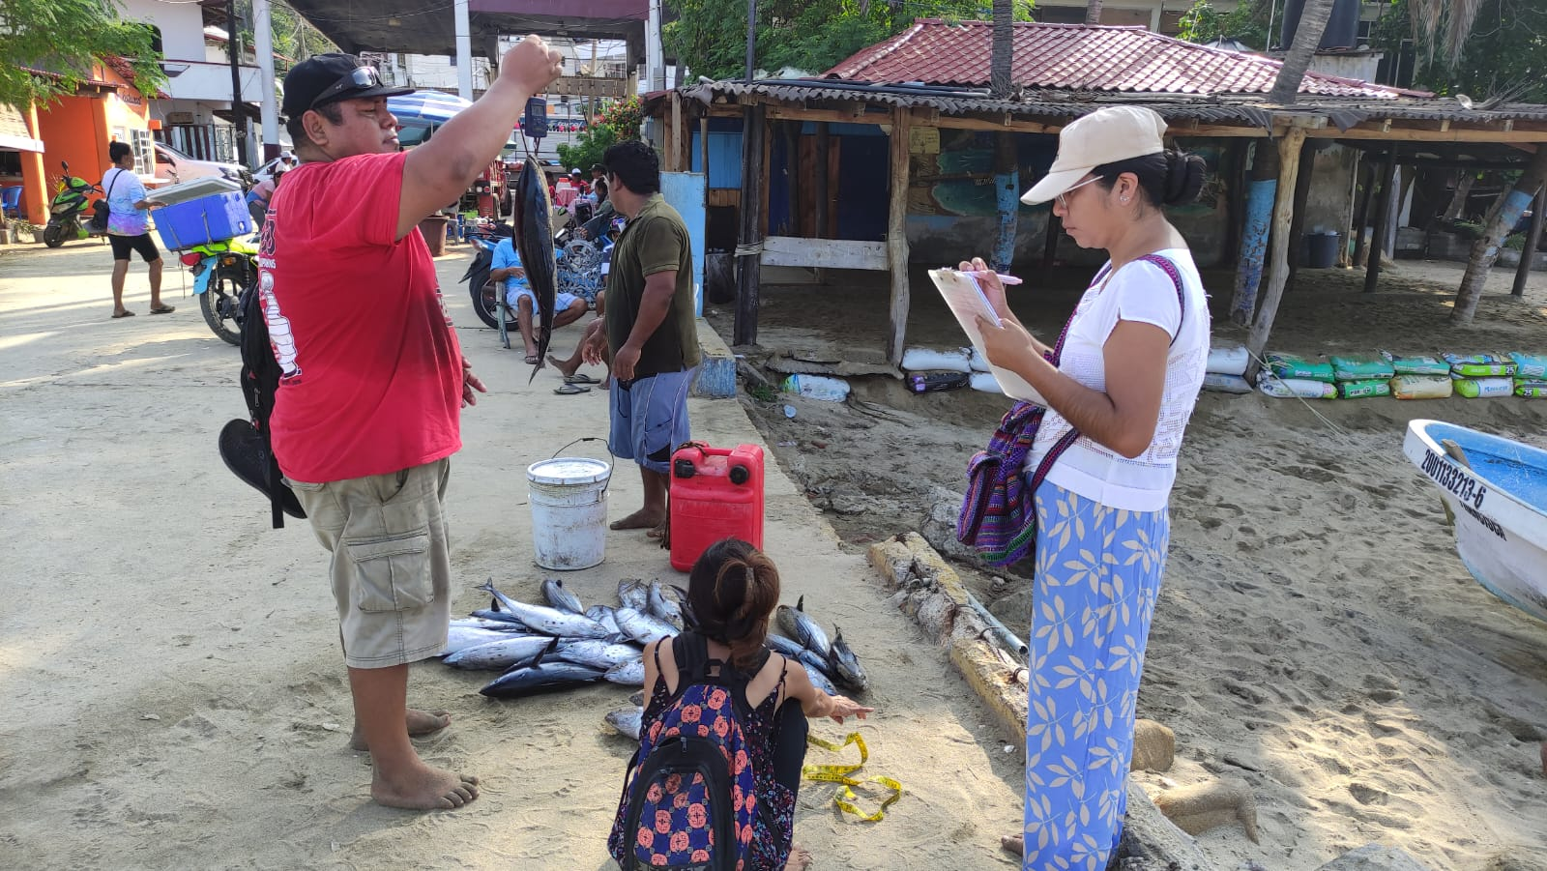

*Illustration 9. Photographic evidence of the capture of black skipjack from the Odisea vessel.*

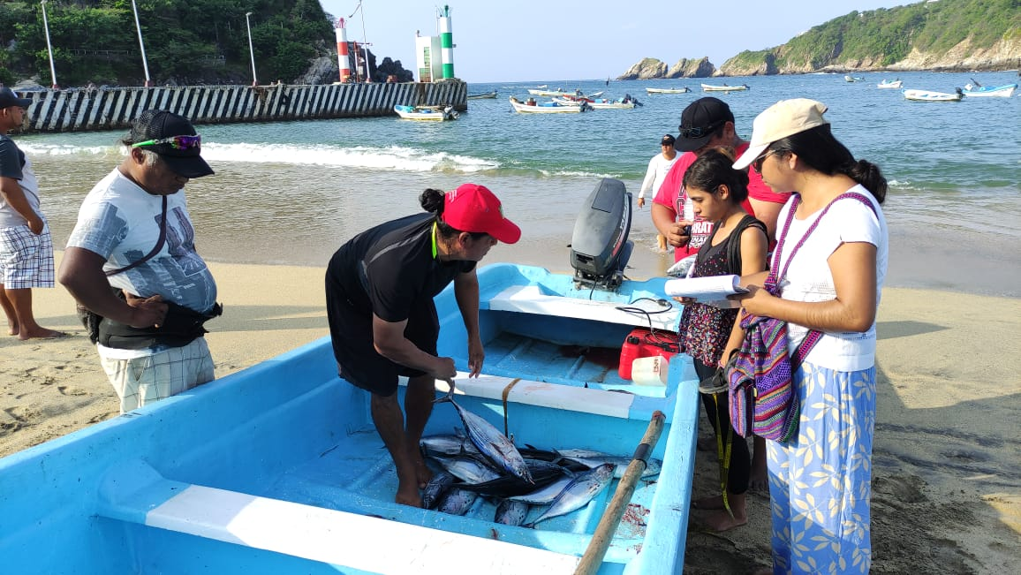

*Illustration 10. Photographic evidence of black skipjack capture from the Rebeca vessel.*

Annex 1. Barrilete sampling tables for August 1, 2024.

|  |  |  |  |  |  |
| --- | --- | --- | --- | --- | --- |
| KEG SAMPLING – PUERTO ÁNGEL, OAXACA 01/08/2024 | | | | | |
| **Reference Site** | Kite | **Boat** | Emannuel | **Fishing art** | Trolling |
|
| **Capture (# individuals)** | 18 | **Total Cap. (kg)** |  | **Fishing time/start-end** | 1 hour |
|
| **Price on the beach** | $50 | **Another species captured #** |  | **Gasoline (liters and $)** | 15 L |
|
| **Captain/ responsible** | Emannuel | **Number of crew** | 1 | **Groceries $** | $10 |
|
| **Individual** | **Species** | | **Length (cm)** | **Weight (kg)** | **Comments** |
| 1 | Black barrel | | 47 | 1.47 |  |
| 2 | Black barrel | | 50 | 1.3 |  |
| 3 | Black barrel | | 46.5 | 1.52 |  |
| 4 | Black barrel | | 45 | 1.5 |  |
| 5 | Black barrel | | 49.5 | 1.55 |  |
| 6 | Black barrel | | 49 | 1.84 |  |
|  |  | |  |  |  |
|  |  | |  |  |  |

|  |  |  |  |  |  |
| --- | --- | --- | --- | --- | --- |
| **Reference Site** | Kite | **Boat** | Kelly | **Fishing art** | Trolling |
|
| **Capture (# individuals)** | 25 | **Total Cap. (kg)** |  | **Fishing time/start-end** | 2 hours |
|
| **Price on the beach** | $40 | **Another species captured #** |  | **Gasoline (liters and $)** | 10 L |
|
| **Captain/ responsible** | Gustavo | **Number of crew** | 2 | **Groceries $** | $20 |
|
| **Individual** | **Species** | | **Length (cm)** | **Weight (kg)** | **Comments** |
| 1 | Black barrel | | 49 | 2.13 |  |
| 2 | Black barrel | | 48.5 | 1.73 |  |
| 3 | Black barrel | | 446 | 1.45 |  |
| 4 | Black barrel | | 50 | 2.09 |  |
| 5 | Black barrel | | 47 | 1.5 |  |
| 6 | Black barrel | | 46 | 1.54 |  |
| 7 | Black barrel | | 49.5 | 1.48 |  |
| 8 | Black barrel | | 46.5 | 1.8 |  |
| 9 | Black barrel | | 47 | 1.49 |  |
|  |  | |  |  |  |
|  |  |  |  |  |  |
|  |  |  |  |  |  |
|  |  | |  |  |  |

|  |  |  |  |  |  |
| --- | --- | --- | --- | --- | --- |
| KEG SAMPLING – PUERTO ÁNGEL, OAXACA 01/08/2024 | | | | | |
| **Reference Site** | White rock | **Boat** | Fernandita | **Fishing art** | Trolling |
|
| **Capture (# individuals)** | 14 | **Total Cap. (kg)** |  | **Fishing time/start-end** | 1 hour and a half |
|
| **Price on the beach** | $40 | **Another species captured #** |  | **Gasoline (liters and $)** | 8 L |
|
| **Captain/ responsible** | Fernando | **Number of crew** | 1 | **Groceries $** | $15 |
|
| **Individual** | **Species** | | **Length (cm)** | **Weight (kg)** | **Comments** |
| 1 | Black barrel | | 47 | 1.61 |  |
| 2 | Black barrel | | 44 | 1.46 |  |
| 3 | Black barrel | | 44 | 1.16 |  |
| 4 | Black barrel | | 48 | 1.73 |  |
|  |  | |  |  |  |
|  |  | |  |  |  |

|  |  |  |  |  |  |
| --- | --- | --- | --- | --- | --- |
| KEG SAMPLING – PUERTO ÁNGEL, OAXACA 01/08/2024 | | | | | |
| **Reference Site** | Comet and White Rock | **Boat** | Godmarcito | **Fishing art** | Trolling |
|
| **Capture (# individuals)** | 7 | **Total Cap. (kg)** |  | **Fishing time/start-end** | 1 hour |
|
| **Price on the beach** | $40 | **Another species captured #** |  | **Gasoline (liters and $)** | 10 L |
|
| **Captain/ responsible** | Hector | **Number of crew** | 1 | **Groceries $** | $10 |
|
| **Individual** | **Species** | | **Length (cm)** | **Weight (kg)** | **Comments** |
| 1 | Black barrel | | 46 | 1.44 |  |
| 2 | Black barrel | | 47 | 1.66 |  |
|  |  | |  |  |  |
|  |  | |  |  |  |
|  |  | |  |  |  |
|  |  | |  |  |  |
|  |  | |  |  |  |
|  |  | |  |  |  |
|  |  |  |  |  |  |
|  |  | |  |  |  |

Annex 2. Barrilete sampling tables for August 8, 2024.

|  |  |  |  |  |  |
| --- | --- | --- | --- | --- | --- |
| KEG SAMPLING – PUERTO ÁNGEL, OAXACA 08/08/2024 | | | | | |
| **Reference Site** | Scissors | **Boat** | Keiko III | **Fishing art** | Trolling |
|
| **Capture (# individuals)** | 40 | **Total Cap. (kg)** |  | **Fishing time/start-end** | 2 hours |
|
| **Price on the beach** | $30 | **Another species captured #** |  | **Gasoline (liters and $)** | 10 L |
|
| **Captain/ responsible** | Jerome | **Number of crew** | 1 | **Groceries $** | $15 |
|
| **Individual** | **Species** | | **Length (cm)** | **Weight (kg)** | **Comments** |
| 1 | Black barrel | | 43.5 | 1.66 |  |
| 2 | Black barrel | | 49 | 1.72 |  |
| 3 | Black barrel | | 49 | 1.46 |  |
| 4 | Black barrel | | 49 | 1.46 |  |
| 5 | Black barrel | | 48.5 | 1.65 |  |
| 6 | Black barrel | | 46 | 1.5 |  |
| 7 | Black barrel | | 47.5 | 1.69 |  |
| 8 | Black barrel | | 45 | 1.42 |  |
| 9 | Black barrel | | 46.5 | 1.73 |  |
| 10 | Black barrel | | 47.5 | 1.64 |  |
| 11 | Black barrel | | 50 | 1.68 |  |
| 12 | Black barrel | | 43.5 | 1.44 |  |
| 13 | Black barrel | | 47 | 1.63 |  |
| 14 | Black barrel | | 47 | 1.6 |  |

|  |  |  |  |  |  |
| --- | --- | --- | --- | --- | --- |
| KEG SAMPLING – PUERTO ÁNGEL, OAXACA 08/08/2024 | | | | | |
| **Reference Site** | Estacahuite Point | **Boat** | Cardigan | **Fishing art** | Trolling |
|
| **Capture (# individuals)** | 22 | **Total Cap. (kg)** |  | **Fishing time/start-end** | 2 hours |
|
| **Price on the beach** | $30 | **Another species captured #** |  | **Gasoline (liters and $)** | 15 L |
|
| **Captain/ responsible** | Martial | **Number of crew** | 1 | **Groceries $** | $10 |
|
| **Individual** | **Species** | | **Length (cm)** | **Weight (kg)** | **Comments** |
| 1 | Black barrel | | 48 | 1.41 |  |
| 2 | Black barrel | | 50 | 1.9 |  |
| 3 | Black barrel | | 49.5 | 1.72 |  |
| 4 | Black barrel | | 47 | 1.61 |  |
|  |  | |  |  |  |

|  |  |  |  |  |  |
| --- | --- | --- | --- | --- | --- |
| KEG SAMPLING – PUERTO ÁNGEL, OAXACA 08/08/2024 | | | | | |
| **Reference Site** | Zapotengo | **Boat** | Odyssey | **Fishing art** | Trolling |
|
| **Capture (# individuals)** | 80 | **Total Cap. (kg)** |  | **Fishing time/start-end** | 2 hours |
|
| **Price on the beach** | $30 | **Another species captured #** |  | **Gasoline (liters and $)** | 15 L |
|
| **Captain/ responsible** | Jose VV | **Number of crew** | 1 | **Groceries $** | $20 |
|
| **Individual** | **Species** | | **Length (cm)** | **Weight (kg)** | **Comments** |
| 1 | Black barrel | | 48 | 1.86 |  |
| 2 | Black barrel | | 46.5 | 1.65 |  |
| 3 | Black barrel | | 51 | 2.13 |  |
| 4 | Black barrel | | 52 | 2.34 |  |
| 5 | Black barrel | | 46.5 | 1.5 |  |
| 6 | Black barrel | | 50 | 1.92 |  |
| 7 | Black barrel | | 47.5 | 1.66 |  |
| 8 | Black barrel | | 44 | 1.51 |  |
| 9 | Black barrel | | 48 | 1.67 |  |
| 10 | Black barrel | | 46 | 1.63 |  |
| 11 | Black barrel | | 45 | 1.49 |  |
| 12 | Black barrel | | 46 | 1.86 |  |
| 13 | Black barrel | | 48 | 1.56 |  |

|  |  |  |  |  |  |
| --- | --- | --- | --- | --- | --- |
| KEG SAMPLING – PUERTO ÁNGEL, OAXACA 08/08/2024 | | | | | |
| **Reference Site** | White Rock | **Boat** | Kelly | **Fishing art** | Trolling |
|
| **Capture (# individuals)** | 170 | **Total Cap. (kg)** |  | **Fishing time/start-end** | 2 hours |
|
| **Price on the beach** | $30 | **Another species captured #** |  | **Gasoline (liters and $)** | 20 L |
|
| **Captain/ responsible** | Gustavo | **Number of crew** | 2 | **Groceries $** | $20 |
|
| **Individual** | **Species** | | **Length (cm)** | **Weight (kg)** | **Comments** |
| 1 | Black barrel | | 50 | 1.94 |  |
| 2 | Black barrel | | 45 | 1.67 |  |
| 3 | Black barrel | | 47.5 | 1.65 |  |
| 4 | Black barrel | | 48 | 1.66 |  |
| 5 | Black barrel | | 47 | 1.5 |  |
| 6 | Black barrel | | 49.5 | 1.64 |  |
| 7 | Black barrel | | 45 | 1.5 |  |
| 8 | Black barrel | | 46 | 1.56 |  |
| 9 | Black barrel | | 49.5 | 1.97 |  |
| 10 | Black barrel | | 45.5 | 1.54 |  |
| 11 | Black barrel | | 46.5 | 1.62 |  |
| 12 | Black barrel | | 44 | 1.74 |  |
| 13 | Black barrel | | 47 | 1.5 |  |
| 14 | Black barrel | | 47.5 | 1.8 |  |
| 15 | Black barrel | | 47 | 1.59 |  |
| 16 | Black barrel | | 47 | 1.6 |  |
| 17 | Black barrel | | 47 | 1.58 |  |
| 18 | Black barrel | | 48.5 | 1.49 |  |
| 19 | Black barrel | | 46.5 | 1.59 |  |
| 20 | Black barrel | | 47 | 1.36 |  |
| 21 | Black barrel | | 43.5 | 1.58 |  |

|  |  |  |  |  |  |
| --- | --- | --- | --- | --- | --- |
| KEG SAMPLING – PUERTO ÁNGEL, OAXACA 08/08/2024 | | | | | |
| **Reference Site** | Window | **Boat** | Emanuel | **Fishing art** | Trolling |
|
| **Capture (# individuals)** | 100 | **Total Cap. (kg)** |  | **Fishing time/start-end** | 2 hours |
|
| **Price on the beach** | $30-$25 | **Another species captured #** | 7 red mullets | **Gasoline (liters and $)** | 15 L |
|
| **Captain/ responsible** | Emanuel | **Number of crew** | 1 | **Groceries $** | $10 |
|
| **Individual** | **Species** | | **Length (cm)** | **Weight (kg)** | **Comments** |
| 1 | Black barrel | | 46.5 | 1.56 |  |
| 2 | Black barrel | | 47 | 1.44 |  |
| 3 | Black barrel | | 47 | 1.67 |  |
| 4 | Black barrel | | 45 | 1.52 |  |
| 5 | Black barrel | | 44 | 1.41 |  |
| 6 | Black barrel | | 49 | 1.74 |  |
| 7 | Black barrel | | 48 | 1.9 |  |
|  |  | |  |  |  |

|  |  |  |  |  |  |  |  |  |  |  |
| --- | --- | --- | --- | --- | --- | --- | --- | --- | --- | --- |
| KEG SAMPLING – PUERTO ÁNGEL, OAXACA 08/08/2024 | | | | | | | | | | |
| **Reference Site** | | In front of Puerto Angel | | **Boat** | | Irene | | **Fishing art** | | Trolling |
|
| **Capture (# individuals)** | | 52 | | **Total Cap. (kg)** | |  | | **Fishing time/start-end** | | 2 hours |
|
| **Price on the beach** | | $30 | | **Another species captured #** | |  | | **Gasoline (liters and $)** | | 15 L |
|
| **Captain/ responsible** | | Alberto | | **Number of crew** | | 1 | | **Groceries $** | | $15 |
|
| **Individual** | | **Species** | | | | **Length (cm)** | | **Weight (kg)** | | **Comments** |
| 1 | | Black barrel | | | | 46 | | 1.44 | |  |
| 2 | | Black barrel | | | | 48 | | 1.78 | |  |
| 3 | | Black barrel | | | | 45 | | 1.42 | |  |
| 4 | | Black barrel | | | | 47 | | 1.77 | |  |
| 5 | | Black barrel | | | | 45 | | 1.64 | |  |
| 6 | | Black barrel | | | | 47 | | 1.6 | |  |
| 7 | | Black barrel | | | | 47.5 | | 1.75 | |  |
| 8 | | Black barrel | | | | 48 | | 1.75 | |  |
| 9 | | Black barrel | | | | 46 | | 1.58 | |  |
|  | |  | |  | |  | |  | |  |
|  | |  | |  | |  | |  | |  |
|  | |  | |  | |  | |  | |  |
|  | |  | | | |  | |  | |  |
| KEG SAMPLING – PUERTO ÁNGEL, OAXACA 08/08/2024 | | | | | | | | | | |
| **Reference Site** | Sausage | | **Boat** | | Albatross | | **Fishing art** | | Trolling | |
|
| **Capture (# individuals)** | 24 | | **Total Cap. (kg)** | |  | | **Fishing time/start-end** | | 2 hours | |
|
| **Price on the beach** | $30 | | **Another species captured #** | |  | | **Gasoline (liters and $)** | | 20 L | |
|
| **Captain/ responsible** | Alberto | | **Number of crew** | | 1 | | **Groceries $** | | $20 | |
|
| **Individual** | **Species** | | | | **Length (cm)** | | **Weight (kg)** | | **Comments** | |
| 1 | Black barrel | | | | 46.5 | | 1.76 | |  | |
| 2 | Black barrel | | | | 36 | | 1.68 | |  | |
| 3 | Black barrel | | | | 45 | | 1.53 | |  | |
| 4 | Black barrel | | | | 46.5 | | 1.53 | |  | |
| 5 | Black barrel | | | | 48 | | 166 | |  | |
| 6 | Black barrel | | | | 59 | | 1.8 | |  | |
| 7 | Black barrel | | | | 48.5 | | 1.67 | |  | |
|  |  | | | |  | |  | |  | |

Annex 3. Skipjack sampling tables for August 15, 2024.

|  |  |  |  |  |  |
| --- | --- | --- | --- | --- | --- |
| KEG SAMPLING – PUERTO ÁNGEL, OAXACA 08/15/2024 | | | | | |
| **Reference Site** | Scissors | **Boat** | Irene | **Fishing art** | Trolling |
|
| **Capture (# individuals)** | 49 | **Total Cap. (kg)** |  | **Fishing time/start-end** | 2 hours |
|
| **Price on the beach** | $25 | **Another species captured #** |  | **Gasoline (liters and $)** | 15 L |
|
| **Captain/ responsible** | Alberto Cordero Carmona | **Number of crew** | 1 | **Groceries $** | $10 |
|
| **Individual** | **Species** | | **Length (cm)** | **Weight (kg)** | **Comments** |
| 1 | Black barrel | | 44 | 1.6 |  |
| 2 | Black barrel | | 42 | 1.3 |  |
| 3 | Black barrel | | 45.5 | 1.58 |  |
| 4 | Black barrel | | 46 | 1.4 |  |
| 5 | Black barrel | | 45 | 1.72 |  |
| 6 | Black barrel | | 43 | 1.33 |  |
|  |  | |  |  |  |

|  |  |  |  |  |  |
| --- | --- | --- | --- | --- | --- |
| KEG SAMPLING – PUERTO ÁNGEL, OAXACA 08/15/2024 | | | | | |
| **Reference Site** | White rock | **Boat** | Cardigan | **Fishing art** | Trolling |
|
| **Capture (# individuals)** | 50 | **Total Cap. (kg)** |  | **Fishing time/start-end** | 2 hours |
|
| **Price on the beach** | $25 | **Another species captured #** |  | **Gasoline (liters and $)** | 15 L |
|
| **Captain/ responsible** | Martial | **Number of crew** | 1 | **Groceries $** | $15 |
|
| **Individual** | **Species** | | **Length (cm)** | **Weight (kg)** | **Comments** |
| 1 | Black barrel | | 46 | 1.75 |  |
| 2 | Black barrel | | 46 | 1.64 |  |
| 3 | Black barrel | | 47 | 1.72 |  |
| 4 | Black barrel | | 50 | 1.91 |  |
| 5 | Black barrel | | 48 | 1.78 |  |
| 6 | Black barrel | | 51 | 1,992 |  |
| 7 | Black barrel | | 48 | 1.51 |  |
| 8 | Black barrel | | 47 | 1.5 |  |
|  |  | |  |  |  |
|  |  | |  |  |  |

|  |  |  |  |  |  |
| --- | --- | --- | --- | --- | --- |
| KEG SAMPLING – PUERTO ÁNGEL, OAXACA 08/15/2024 | | | | | |
| **Reference Site** | Zapotengo | **Boat** | Odyssey | **Fishing art** | Trolling |
|
| **Capture (# individuals)** | 90 | **Total Cap. (kg)** |  | **Fishing time/start-end** | 2 hours |
|
| **Price on the beach** | $25 | **Another species captured #** |  | **Gasoline (liters and $)** | 10 L |
|
| **Captain/ responsible** | Jose VV | **Number of crew** | 1 | **Groceries $** | $20 |
|
| **Individual** | **Species** | | **Length (cm)** | **Weight (kg)** | **Comments** |
| 1 | Black barrel | | 50 | 2.1 |  |
| 2 | Black barrel | | 46.5 | 1.47 |  |
| 3 | Black barrel | | 46 | 1.66 |  |
| 4 | Black barrel | | 46 | 1.5 |  |
| 5 | Black barrel | | 48 | 1.62 |  |
| 6 | Black barrel | | 43 | 1.56 |  |
| 7 | Black barrel | | 48.5 | 1.75 |  |
| 8 | Black barrel | | 48.5 | 1.71 |  |
| 9 | Black barrel | | 44.5 | 1.42 |  |
|  |  | |  |  |  |

|  |  |  |  |  |  |
| --- | --- | --- | --- | --- | --- |
| KEG SAMPLING – PUERTO ÁNGEL, OAXACA 08/15/2024 | | | | | |
| **Reference Site** | Zapotengo | **Boat** | Archangel | **Fishing art** | Trolling |
|
| **Capture (# individuals)** | 90 | **Total Cap. (kg)** |  | **Fishing time/start-end** | 2 hours 1/2 |
|
| **Price on the beach** | $25 | **Another species captured #** |  | **Gasoline (liters and $)** | 10 L |
|
| **Captain/ responsible** | Angel VV | **Number of crew** |  | **Groceries $** | $15 |
|
| **Individual** | **Species** | | **Length (cm)** | **Weight (kg)** | **Comments** |
| 1 | Black barrel | | 48.5 | 1.81 |  |
| 2 | Black barrel | | 51 | 2.1 |  |
| 3 | Black barrel | | 45 | 1.63 |  |
| 4 | Black barrel | | 48 | 1.82 |  |
| 5 | Black barrel | | 47 | 1.62 |  |
| 6 | Black barrel | | 46 | 1.68 |  |
| 7 | Black barrel | | 48.5 | 1.8 |  |
| 8 | Black barrel | | 48 | 1.7 |  |
| 9 | Black barrel | | 45.5 | 1.48 |  |
| 10 | Black barrel | | 47.5 | 1.69 |  |
| 11 | Black barrel | | 45.5 | 1.59 |  |
| 12 | Black barrel | | 46.5 | 1.83 |  |
| 13 | Black barrel | | 43 | 1.42 |  |

|  |  |  |  |  |  |
| --- | --- | --- | --- | --- | --- |
| KEG SAMPLING – PUERTO ÁNGEL, OAXACA 08/15/2024 | | | | | |
| **Reference Site** | Scissors | **Boat** | Juquila | **Fishing art** | Trolling |
|
| **Capture (# individuals)** | 20 | **Total Cap. (kg)** |  | **Fishing time/start-end** | 2 hours 1/2 |
|
| **Price on the beach** | $25 | **Another species captured #** | Saw | **Gasoline (liters and $)** | 20 L |
|
| **Captain/ responsible** |  | **Number of crew** | 1 | **Groceries $** | $15 |
|
| **Individual** | **Species** | | **Length (cm)** | **Weight (kg)** | **Comments** |
| 1 | Saw | | 63 | 1.95 |  |
| 2 | Black barrel | | 44 | 1.5 |  |
| 3 | Black barrel | | 43 | 1.49 |  |
| 4 | Black barrel | | 59 | 1.81 |  |
| 5 | Black barrel | | 48 | 1.59 |  |
|  |  | |  |  |  |
|  |  | |  |  |  |

|  |  |  |  |  |  |
| --- | --- | --- | --- | --- | --- |
| KEG SAMPLING – PUERTO ÁNGEL, OAXACA 08/15/2024 | | | | | |
| **Reference Site** | White Rock | **Boat** | Kelly | **Fishing art** | Trolling |
|
| **Capture (# individuals)** | 140 | **Total Cap. (kg)** |  | **Fishing time/start-end** | 2 hours 1/2 |
|
| **Price on the beach** | $25 | **Another species captured #** | Tooth barrel | **Gasoline (liters and $)** | 20 L |
|
| **Captain/ responsible** | Gustavo | **Number of crew** | 2 | **Groceries $** | $15 |
|
| **Individual** | **Species** | | **Length (cm)** | **Weight (kg)** | **Comments** |
| 1 | Black barrel | | 49 | 1.97 |  |
| 2 | Black barrel | | 48.5 | 1.87 |  |
| 3 | Black barrel | | 48 | 1.7 |  |
| 4 | Black barrel | | 49 | 1.95 |  |
| 5 | Black barrel | | 47 | 1.66 |  |
| 6 | Black barrel | | 48 | 2 |  |
| 7 | Black barrel | | 47 | 1.63 |  |
| 8 | Black barrel | | 49.5 | 1.97 |  |
| 9 | Black barrel | | 47 | 1.77 |  |
| 10 | Black barrel | | 48.5 | 1.87 |  |
| 11 | Tooth barrel | | 57.5 | 2.5 |  |
| 12 | Tooth barrel | | 62 | 3.24 |  |
|  |  | |  |  |  |

|  |  |  |  |  |  |
| --- | --- | --- | --- | --- | --- |
| KEG SAMPLING – PUERTO ÁNGEL, OAXACA 08/15/2024 | | | | | |
| **Reference Site** | Tuff | **Boat** | Santa Fe | **Fishing art** | Trolling |
|
| **Capture (# individuals)** | 70 | **Total Cap. (kg)** |  | **Fishing time/start-end** | 2 hours |
|
| **Price on the beach** | $25 | **Another species captured #** |  | **Gasoline (liters and $)** | 20 L, $530 |
|
| **Captain/ responsible** | Jose Luis | **Number of crew** | 1 | **Groceries $** | $30 |
|
| **Individual** | **Species** | | **Length (cm)** | **Weight (kg)** | **Comments** |
| 1 | Black barrel | | 47 | 1.7 |  |
| 2 | Black barrel | | 45 | 1.41 |  |
| 3 | Black barrel | | 45.5 | 1.64 |  |
| 4 | Black barrel | | 47 | 1.53 |  |
| 5 | Black barrel | | 45.5 | 1.61 |  |
| 6 | Black barrel | | 43.5 | 1.33 |  |
| 7 | Black barrel | | 50 | 1.71 |  |
| 8 | Black barrel | | 43 | 1.34 |  |
| 9 | Black barrel | | 48 | 1.64 |  |
| 10 | Black barrel | | 47 | 1.77 |  |
|  |  |  |  |  |  |
|  |  |  |  |  |  |
|  |  | |  |  |  |

|  |  |  |  |  |  |
| --- | --- | --- | --- | --- | --- |
| KEG SAMPLING – PUERTO ÁNGEL, OAXACA 08/15/2024 | | | | | |
| **Reference Site** | Scissors | **Boat** | Slave | **Fishing art** | Trolling |
|
| **Capture (# individuals)** | 80 | **Total Cap. (kg)** |  | **Fishing time/start-end** | 3 hours |
|
| **Price on the beach** | $25 | **Another species captured #** |  | **Gasoline (liters and $)** | 15 L |
|
| **Captain/ responsible** | Jose Luis | **Number of crew** | 2 | **Groceries $** | $10 |
|
| **Individual** | **Species** | | **Length (cm)** | **Weight (kg)** | **Comments** |
| 1 | Black barrel | | 43.5 | 1.74 | There are porpoises but there is no interaction |
| 2 | Black barrel | | 46 | 1.57 |
| 3 | Black barrel | | 47.5 | 1.84 |  |
| 4 | Black barrel | | 44 | 1.48 |  |
| 5 | Black barrel | | 46.5 | 1.62 |  |
| 6 | Black barrel | | 46 | 1.5 |  |
| 7 | Black barrel | | 47 | 1.72 |  |
| 8 | Black barrel | | 43.5 | 1.45 |  |
| 9 | Black barrel | | 46 | 1.65 |  |
| 10 | Black barrel | | 45.5 | 1.5 |  |
| 11 | Black barrel | | 47 | 1.59 |  |
| 12 | Black barrel | | 46.5 | 1.76 |  |
| 13 | Black barrel | | 45 | 1.46 |  |

|  |  |  |  |  |  |
| --- | --- | --- | --- | --- | --- |
| KEG SAMPLING – PUERTO ÁNGEL, OAXACA 08/15/2024 | | | | | |
| **Reference Site** | Zapotengo and scissors | **Boat** | Jennifer | **Fishing art** | Trolling |
|
| **Capture (# individuals)** | 50 | **Total Cap. (kg)** |  | **Fishing time/start-end** | 2 hours |
|
| **Price on the beach** | $25 | **Another species captured #** |  | **Gasoline (liters and $)** | 10 L |
|
| **Captain/ responsible** | Ignacio Cabrera | **Number of crew** | 2 | **Groceries $** | $15 |
|
| **Individual** | **Species** | | **Length (cm)** | **Weight (kg)** | **Comments** |
| 1 | Black barrel | | 47 | 1.66 |  |
| 2 | Black barrel | | 46 | 1.6 |  |
| 3 | Black barrel | | 48 | 1.75 |  |
| 4 | Black barrel | | 45 | 1.68 |  |
| 5 | Black barrel | | 46 | 1.6 |  |
| 6 | Black barrel | | 48 | 1.81 |  |
| 7 | Black barrel | | 45 | 1.62 |  |
| 8 | Black barrel | | 46 | 1.54 |  |
| 9 | Black barrel | | 47 | 1.65 |  |
| 10 | Black barrel | | 48 | 1.72 |  |
| 11 | Black barrel | | 46.5 | 1.52 |  |

|  |  |  |  |  |  |
| --- | --- | --- | --- | --- | --- |
| KEG SAMPLING – PUERTO ÁNGEL, OAXACA 08/15/2024 | | | | | |
| **Reference Site** | Facing white rock | **Boat** | Albatross | **Fishing art** | Trolling |
|
| **Capture (# individuals)** | 60 | **Total Cap. (kg)** |  | **Fishing time/start-end** | 2 hours |
|
| **Price on the beach** | $25 | **Another species captured #** |  | **Gasoline (liters and $)** | 10 L-12 L |
|
| **Captain/ responsible** | Alberto | **Number of crew** | 1 | **Groceries $** | $15 |
|
| **Individual** | **Species** | | **Length (cm)** | **Weight (kg)** | **Comments** |
| 1 | Black barrel | | 48 | 1.82 |  |
| 2 | Black barrel | | 50 | 1.62 |  |
| 3 | Black barrel | | 46.5 | 1.58 |  |
| 4 | Black barrel | | 45.5 | 1.6 |  |
| 5 | Black barrel | | 47 | 1.66 |  |
|  |  | |  |  |  |
|  |  |  |  |  |  |
|  |  | |  |  |  |

|  |  |  |  |  |  |
| --- | --- | --- | --- | --- | --- |
| KEG SAMPLING – PUERTO ÁNGEL, OAXACA 08/15/2024 | | | | | |
| **Reference Site** | Scissors | **Boat** | America | **Fishing art** | Trolling |
|
| **Capture (# individuals)** | 46 | **Total Cap. (kg)** |  | **Fishing time/start-end** | 2 hours 1/2 |
|
| **Price on the beach** | $25 | **Another species captured #** |  | **Gasoline (liters and $)** | 10 L |
|
| **Captain/ responsible** | Juanon | **Number of crew** | 1 | **Groceries $** | $15 |
|
| **Individual** | **Species** | | **Length (cm)** | **Weight (kg)** | **Comments** |
| 1 | Black barrel | | 49.5 | 1.81 |  |
| 2 | Black barrel | | 47 | 1.56 | Everyone is eating red shrimp |
| 3 | Black barrel | | 48 | 1.8 |
|  |  | |  |  |  |

Annex 4. Skipjack sampling tables for August 22, 2024.

|  |  |  |  |  |  |
| --- | --- | --- | --- | --- | --- |
| KEG SAMPLING – PUERTO ÁNGEL, OAXACA 08/22/2024 | | | | | |
| **Reference Site** | Zpotengo | **Boat** | Odyssey | **Fishing art** | Trolling |
|
| **Capture (# individuals)** | 42 | **Total Cap. (kg)** |  | **Fishing time/start-end** | 2 hours |
|
| **Price on the beach** | $30 | **Another species captured #** |  | **Gasoline (liters and $)** | 10 L |
|
| **Captain/ responsible** | Jose VV | **Number of crew** | 1 | **Groceries $** | $20 |
|
| **Individual** | **Species** | | **Length (cm)** | **Weight (kg)** | **Comments** |
| 1 | Black barrel | | 48 |  |  |
| 2 | Black barrel | | 47 |  |  |
| 3 | Black barrel | | 47.5 |  |  |
| 4 | Black barrel | | 49 |  |  |
| 5 | Black barrel | | 47 |  |  |
| 6 | Black barrel | | 47 |  |  |
| 7 | Black barrel | | 46.5 |  |  |
|  |  | |  |  |  |
|  |  | |  |  |  |
|  |  | |  |  |  |
|  |  |  |  |  |  |
|  |  |  |  |  |  |
|  |  | |  |  |  |

|  |  |  |  |  |  |
| --- | --- | --- | --- | --- | --- |
|  | | | | | |
| KEG SAMPLING – PUERTO ÁNGEL, OAXACA 08/22/2024 | | | | | |
| **Reference Site** | In front of fear | **Boat** | Juquila | **Fishing art** | Trolling |
|
| **Capture (# individuals)** | 30 | **Total Cap. (kg)** |  | **Fishing time/start-end** | 2 hours |
|
| **Price on the beach** | $30 | **Another species captured #** |  | **Gasoline (liters and $)** | 15L |
|
| **Captain/ responsible** | Yuka | **Number of crew** | 2 | **Groceries $** | $20 |
|
| **Individual** | **Species** | | **Length (cm)** | **Weight (kg)** | **Comments** |
| 1 | Black barrel | | 47 | 1.78 |  |
| 2 | Black barrel | | 49 | 1.5 |  |
| 3 | Black barrel | | 49 | 1.86 |  |
| 4 | Black barrel | | 46.5 | 1.9 |  |
| 5 | Black barrel | | 46 | 1.58 |  |
|  |  | |  |  |  |
|  |  | |  |  |  |
|  |  | |  |  |  |
|  |  | |  |  |  |

|  |  |  |  |  |  |
| --- | --- | --- | --- | --- | --- |
| KEG SAMPLING – PUERTO ÁNGEL, OAXACA 08/22/2024 | | | | | |
| **Reference Site** | Scissors | **Boat** | Santa Fe II | **Fishing art** | Trolling |
|
| **Capture (# individuals)** | 22 | **Total Cap. (kg)** |  | **Fishing time/start-end** | 2 hours |
|
| **Price on the beach** | $30 | **Another species captured #** |  | **Gasoline (liters and $)** | 10 L |
|
| **Captain/ responsible** | Jose Luis | **Number of crew** | 1 | **Groceries $** | $10 |
|
| **Individual** | **Species** | | **Length (cm)** | **Weight (kg)** | **Comments** |
| 1 | Black barrel | | 46.5 | 1.79 |  |
| 2 | Black barrel | | 47.5 | 2 |  |
| 3 | Black barrel | | 44 | 1.68 |  |
| 4 | Black barrel | | 48 | 1.73 |  |
| 5 | Black barrel | | 45 | 1.44 |  |
|  |  | |  |  |  |
|  |  | |  |  |  |
|  |  | |  |  |  |

|  |  |  |  |  |  |
| --- | --- | --- | --- | --- | --- |
| KEG SAMPLING – PUERTO ÁNGEL, OAXACA 08/22/2024 | | | | | |
| **Reference Site** | Scissors | **Boat** | Godmarcito | **Fishing art** | Trolling |
|
| **Capture (# individuals)** | 50 | **Total Cap. (kg)** |  | **Fishing time/start-end** | 2 hours |
|
| **Price on the beach** | $30 | **Another species captured #** |  | **Gasoline (liters and $)** | 15 L |
|
| **Captain/ responsible** | Hector | **Number of crew** | 1 | **Groceries $** | $10 |
|
| **Individual** | **Species** | | **Length (cm)** | **Weight (kg)** | **Comments** |
| 1 | Black barrel | | 49 | 1.94 |  |
| 2 | Black barrel | | 46 | 1.72 |  |
| 3 | Black barrel | | 40.5 | 1.41 |  |
| 4 | Black barrel | | 45.5 | 1.59 |  |
| 5 | Black barrel | | 46.5 | 1.89 |  |
|  |  | |  |  |  |
|  |  | |  |  |  |
|  |  | |  |  |  |

|  |  |  |  |  |  |
| --- | --- | --- | --- | --- | --- |
| KEG SAMPLING – PUERTO ÁNGEL, OAXACA 08/22/2024 | | | | | |
| **Reference Site** | Saint Augustine | **Boat** | Jassive II | **Fishing art** | Trolling |
|
| **Capture (# individuals)** | 17 | **Total Cap. (kg)** |  | **Fishing time/start-end** | 2 hours |
|
| **Price on the beach** | $30 | **Another species captured #** |  | **Gasoline (liters and $)** | 10 L |
|
| **Captain/ responsible** | Felipe | **Number of crew** | 1 | **Groceries $** | $10 |
|
| **Individual** | **Species** | | **Length (cm)** | **Weight (kg)** | **Comments** |
| 1 | Black barrel | | 46 | 1.61 |  |
| 2 | Black barrel | | 45 | 166 |  |
| 3 | Black barrel | | 48 | 1.66 |  |
|  |  | |  |  |  |
|  |  | |  |  |  |

|  |  |  |  |  |  |
| --- | --- | --- | --- | --- | --- |
| KEG SAMPLING – PUERTO ÁNGEL, OAXACA 08/22/2024 | | | | | |
| **Reference Site** | Scissors and sausage | **Boat** | Irene | **Fishing art** | Trolling |
|
| **Capture (# individuals)** | 34 | **Total Cap. (kg)** |  | **Fishing time/start-end** | 2 hours |
|
| **Price on the beach** | $30 | **Another species captured #** |  | **Gasoline (liters and $)** | 10 L |
|
| **Captain/ responsible** | Alberto | **Number of crew** | 1 | **Groceries $** | $10 |
|
| **Individual** | **Species** | | **Length (cm)** | **Weight (kg)** | **Comments** |
| 1 | Black barrel | | 48 | 1.77 |  |
| 2 | Black barrel | | 48 | 1.59 |  |
| 3 | Black barrel | | 46 | 1.72 |  |
| 4 | Black barrel | | 46 | 1.68 |  |
| 5 | Black barrel | | 45 | 1.44 |  |
| 6 | Black barrel | | 43 | 1.41 |  |
| 7 | Black barrel | | 45 | 1.52 |  |
| 8 | Black barrel | | 46.5 | 1.67 |  |
|  |  | |  |  |  |
|  |  | |  |  |  |
|  |  |  |  |  |  |
|  |  |  |  |  |  |
|  |  | |  |  |  |

|  |  |  |  |  |  |
| --- | --- | --- | --- | --- | --- |
| KEG SAMPLING – PUERTO ÁNGEL, OAXACA 08/22/2024 | | | | | |
| **Reference Site** | Zapotengo | **Boat** | Archangel | **Fishing art** | Trolling |
|
| **Capture (# individuals)** | 22 | **Total Cap. (kg)** |  | **Fishing time/start-end** | 2 hours |
|
| **Price on the beach** | $30 | **Another species captured #** |  | **Gasoline (liters and $)** | 10 L |
|
| **Captain/ responsible** | Angel VV | **Number of crew** | 1 | **Groceries $** | $10 |
|
| **Individual** | **Species** | | **Length (cm)** | **Weight (kg)** | **Comments** |
| 1 | Black barrel | | 47.5 | 1.86 |  |
| 2 | Black barrel | | 48 | 1.85 |  |
| 3 | Black barrel | | 47 | 1.67 |  |
| 4 | Black barrel | | 46 | 1.59 |  |
|  |  | |  |  |  |
|  |  | |  |  |  |

|  |  |  |  |  |  |
| --- | --- | --- | --- | --- | --- |
| KEG SAMPLING – PUERTO ÁNGEL, OAXACA 08/22/2024 | | | | | |
| **Reference Site** | White rock | **Boat** | Cardigan | **Fishing art** | Trolling |
|
| **Capture (# individuals)** | 22 | **Total Cap. (kg)** |  | **Fishing time/start-end** | 2 hours |
|
| **Price on the beach** | $30 | **Another species captured #** |  | **Gasoline (liters and $)** | 15 L |
|
| **Captain/ responsible** | Martial | **Number of crew** | 1 | **Groceries $** | $20 |
|
| **Individual** | **Species** | | **Length (cm)** | **Weight (kg)** | **Comments** |
| 1 | Black barrel | | 48.5 | 2 |  |
| 2 | Black barrel | | 48.5 | 1.93 |  |
| 3 | Black barrel | | 48 | 1.83 |  |
|  | Black barrel | | 49 | 1.62 |  |
|  | Black barrel | | 48 | 1.84 |  |
|  |  | |  |  |  |
|  |  |  |  |  |  |
|  |  | |  |  |  |

|  |  |  |  |  |  |
| --- | --- | --- | --- | --- | --- |
| KEG SAMPLING – PUERTO ÁNGEL, OAXACA 08/22/2024 | | | | | |
| **Reference Site** | Tuff | **Boat** | Emannuel | **Fishing art** | Trolling |
|
| **Capture (# individuals)** | 12 | **Total Cap. (kg)** |  | **Fishing time/start-end** | 2 hours |
|
| **Price on the beach** | $30 | **Another species captured #** |  | **Gasoline (liters and $)** | 10 L |
|
| **Captain/ responsible** | Emannuel | **Number of crew** | 1 | **Groceries $** | $10 |
|
| **Individual** | **Species** | | **Length (cm)** | **Weight (kg)** | **Comments** |
| 1 | Black barrel | | 36 | 1.05 |  |
| 2 | Black barrel | | 36 | 1 |  |
|  |  | |  |  |  |
|  |  | |  |  |  |
|  |  | |  |  |  |
|  |  |  |  |  |  |
|  |  | |  |  |  |

Annex 5. Skipjack sampling tables for August 29, 2024.

|  |  |  |  |  |  |
| --- | --- | --- | --- | --- | --- |
| KEG SAMPLING – PUERTO ÁNGEL, OAXACA 08/29/2024 | | | | | |
| **Reference Site** | In front of Puerto Angel | **Boat** | Irene | **Fishing art** | Trolling |
|
| **Capture (# individuals)** | 10 | **Total Cap. (kg)** |  | **Fishing time/start-end** | 2 hours |
|
| **Price on the beach** | $25 | **Another species captured #** |  | **Gasoline (liters and $)** | 15 L |
|
| **Captain/ responsible** | Alberto | **Number of crew** | 1 | **Groceries $** | $10 |
|
| **Individual** | **Species** | | **Length (cm)** | **Weight (kg)** | **Comments** |
| 1 | Black barrel | | 50 | 1.33 | 4 barrels devised |
| 2 | Black barrel | | 47 | 1.65 |  |
| 3 | Black barrel | | 45 | 1.17 |  |
| 4 | Black barrel | | 49 | 1.68 |  |
| 5 | Black barrel | | 45 | 1.34 |  |
| 6 | Black barrel | | 44 | 1.14 |  |
| 7 | Black barrel | | 43 | 1.14 |  |
|  |  | |  |  |  |

|  |  |  |  |  |  |
| --- | --- | --- | --- | --- | --- |
| KEG SAMPLING – PUERTO ÁNGEL, OAXACA 08/29/2024 | | | | | |
| **Reference Site** | Zapotengo | **Boat** | Keiko II | **Fishing art** | Trolling |
|
| **Capture (# individuals)** | 12 | **Total Cap. (kg)** |  | **Fishing time/start-end** | 2 hours |
|
| **Price on the beach** | $25 | **Another species captured #** |  | **Gasoline (liters and $)** | 10 L |
|
| **Captain/ responsible** | Geronimo | **Number of crew** | 1 | **Groceries $** | $20 |
|
| **Individual** | **Species** | | **Length (cm)** | **Weight (kg)** | **Comments** |
| 1 | Black barrel | | 47.5 | 1.13 |  |
| 2 | Black barrel | | 43.5 | 1.14 |  |
| 3 | Black barrel | | 43 | 1.33 |  |
|  |  | | 45.5 | 1.12 |  |
|  |  | | 45.5 | 1.25 |  |
|  |  | |  |  |  |
|  |  |  |  |  |  |
|  |  | |  |  |  |

|  |  |  |  |  |  |  |  |  |  |  |  |  |  |  |  |  |  |  |  |  |  |  |  |  |  |  |  |  |  |  |  |  |  |  |
| --- | --- | --- | --- | --- | --- | --- | --- | --- | --- | --- | --- | --- | --- | --- | --- | --- | --- | --- | --- | --- | --- | --- | --- | --- | --- | --- | --- | --- | --- | --- | --- | --- | --- | --- |
| KEG SAMPLING – PUERTO ÁNGEL, OAXACA 08/29/2024 | | | | | | | | | | | | | | | | | | | | | | | | | | | | | | | | | | |
| **Reference Site** | | | | | | Zipolite | | | | | | **Boat** | | | | | | Jassive II | | | | | | **Fishing art** | | | | | | Trolling | | | | |
|
| **Capture (# individuals)** | | | | | | 32 | | | | | | **Total Cap. (kg)** | | | | | |  | | | | | | **Fishing time/start-end** | | | | | | 2 hours | | | | |
|
| **Price on the beach** | | | | | | $25 | | | | | | **Another species captured #** | | | | | |  | | | | | | **Gasoline (liters and $)** | | | | | | 10 L | | | | |
|
| **Captain/ responsible** | | | | | | Felipe | | | | | | **Number of crew** | | | | | | 1 | | | | | | **Groceries $** | | | | | | $20 | | | | |
|
| **Individual** | | | | | | **Species** | | | | | | | | | | | | **Length (cm)** | | | | | | **Weight (kg)** | | | | | | **Comments** | | | | |
| 1 | | | | | | Black barrel | | | | | | | | | | | | 45 | | | | | | 1.23 | | | | | |  | | | | |
| 2 | | | | | | Black barrel | | | | | | | | | | | | 46.5 | | | | | | 1.1 | | | | | |  | | | | |
| 3 | | | | | | Black barrel | | | | | | | | | | | | 44.5 | | | | | | 1.16 | | | | | |  | | | | |
| 4 | | | | | | Black barrel | | | | | | | | | | | | 46 | | | | | | 1.18 | | | | | |  | | | | |
| 5 | | | | | | Black barrel | | | | | | | | | | | | 47 | | | | | | 1.41 | | | | | |  | | | | |
| 6 | | | | | | Black barrel | | | | | | | | | | | | 45 | | | | | | 1.26 | | | | | |  | | | | |
| 7 | | | | | | Black barrel | | | | | | | | | | | | 46.5 | | | | | | 1.12 | | | | | |  | | | | |
| 8 | | | | | | Black barrel | | | | | | | | | | | | 46 | | | | | | 1.15 | | | | | |  | | | | |
| 9 | | | | | | Black barrel | | | | | | | | | | | | 48.5 | | | | | | 1.27 | | | | | |  | | | | |
|  | | | | | |  | | | | | | | | | | | |  | | | | | |  | | | | | |  | | | | |
|  | | | | | |  | | | | | |  | | | | | |  | | | | | |  | | | | | |  | | | | |
|  | | | | | |  | | | | | |  | | | | | |  | | | | | |  | | | | | |  | | | | |
|  | | | | | |  | | | | | | | | | | | |  | | | | | |  | | | | | |  | | | | |
| KEG SAMPLING – PUERTO ÁNGEL, OAXACA 08/29/2024 | | | | | | | | | | | | | | | | | | | | | | | | | | | | | | | | | | |
| **Reference Site** | | | | | Zapotengo | | | | | | **Boat** | | | | | | Kelly | | | | | | **Fishing art** | | | | | | Trolling | | | | | |
|
| **Capture (# individuals)** | | | | | 35 | | | | | | **Total Cap. (kg)** | | | | | |  | | | | | | **Fishing time/start-end** | | | | | | 2 hours | | | | | |
|
| **Price on the beach** | | | | | $25 | | | | | | **Another species captured #** | | | | | |  | | | | | | **Gasoline (liters and $)** | | | | | | 15 L | | | | | |
|
| **Captain/ responsible** | | | | | Gustavo | | | | | | **Number of crew** | | | | | | 2 | | | | | | **Groceries $** | | | | | | $20 | | | | | |
|
| **Individual** | | | | | **Species** | | | | | | | | | | | | **Length (cm)** | | | | | | **Weight (kg)** | | | | | | **Comments** | | | | | |
| 1 | | | | | Black barrel | | | | | | | | | | | | 46 | | | | | | 1.26 | | | | | |  | | | | | |
| 2 | | | | | Black barrel | | | | | | | | | | | | 42.5 | | | | | | 1.38 | | | | | |  | | | | | |
| 3 | | | | | Black barrel | | | | | | | | | | | | 43 | | | | | | 1.75 | | | | | |  | | | | | |
| 4 | | | | | Black barrel | | | | | | | | | | | | 44 | | | | | | 1.05 | | | | | |  | | | | | |
| 5 | | | | | Black barrel | | | | | | | | | | | | 47.5 | | | | | | 1,2 | | | | | |  | | | | | |
| 6 | | | | | Black barrel | | | | | | | | | | | | 47 | | | | | | 1.28 | | | | | |  | | | | | |
| 7 | | | | | Black barrel | | | | | | | | | | | | 47 | | | | | | 1.17 | | | | | |  | | | | | |
| 8 | | | | | Black barrel | | | | | | | | | | | | 31 | | | | | | 0.375 | | | | | |  | | | | | |
|  | | | | |  | | | | | | | | | | | |  | | | | | |  | | | | | |  | | | | | |
|  | | | | |  | | | | | | | | | | | |  | | | | | |  | | | | | |  | | | | | |
| KEG SAMPLING – PUERTO ÁNGEL, OAXACA 08/29/2024 | | | | | | | | | | | | | | | | | | | | | | | | | | | | | | | | | |
| **Reference Site** | | | | ipolite | | | | | | **Boat** | | | | | | Godmarcito | | | | | | **Fishing art** | | | | | | Trolling | | | | | |
|
| **Capture (# individuals)** | | | | 43 | | | | | | **Total Cap. (kg)** | | | | | |  | | | | | | **Fishing time/start-end** | | | | | | 2 hours | | | | | |
|
| **Price on the beach** | | | | $25 | | | | | | **Another species captured #** | | | | | |  | | | | | | **Gasoline (liters and $)** | | | | | | 20 L | | | | | |
|
| **Captain/ responsible** | | | | Hector | | | | | | **Number of crew** | | | | | | 1 | | | | | | **Groceries $** | | | | | | $20 | | | | | |
|
| **Individual** | | | | **Species** | | | | | | | | | | | | **Length (cm)** | | | | | | **Weight (kg)** | | | | | | **Comments** | | | | | |
| 1 | | | | Black barrel | | | | | | | | | | | | 41 | | | | | | 1 | | | | | |  | | | | | |
| 2 | | | | Black barrel | | | | | | | | | | | | 43.5 | | | | | | 1.07 | | | | | |  | | | | | |
| 3 | | | | Black barrel | | | | | | | | | | | | 46 | | | | | | 1.22 | | | | | |  | | | | | |
|  | | | |  | | | | | | | | | | | | 44,,5 | | | | | | 1.18 | | | | | |  | | | | | |
|  | | | |  | | | | | | | | | | | |  | | | | | |  | | | | | |  | | | | | |
| KEG SAMPLING – PUERTO ÁNGEL, OAXACA 08/29/2024 | | | | | | | | | | | | | | | | | | | | | | | | | | | | | | | | |
| **Reference Site** | | | In front of San Agustin | | | | | | **Boat** | | | | | | Albatross | | | | | | **Fishing art** | | | | | | Trolling | | | | | |
|
| **Capture (# individuals)** | | | 28 | | | | | | **Total Cap. (kg)** | | | | | |  | | | | | | **Fishing time/start-end** | | | | | | 2 hours | | | | | |
|
| **Price on the beach** | | | $25 | | | | | | **Another species captured #** | | | | | |  | | | | | | **Gasoline (liters and $)** | | | | | | 10 L | | | | | |
|
| **Captain/ responsible** | | | Alberto Cordero | | | | | | **Number of crew** | | | | | | 1 | | | | | | **Groceries $** | | | | | | $10 | | | | | |
|
| **Individual** | | | **Species** | | | | | | | | | | | | **Length (cm)** | | | | | | **Weight (kg)** | | | | | | **Comments** | | | | | |
| 1 | | | Black barrel | | | | | | | | | | | | 47 | | | | | |  | | | | | |  | | | | | |
| 2 | | | Black barrel | | | | | | | | | | | | 43 | | | | | |  | | | | | |  | | | | | |
| 3 | | | Black barrel | | | | | | | | | | | | 44.5 | | | | | |  | | | | | |  | | | | | |
| 4 | | | Black barrel | | | | | | | | | | | | 44.5 | | | | | |  | | | | | |  | | | | | |
| 5 | | | Black barrel | | | | | | | | | | | | 45 | | | | | |  | | | | | |  | | | | | |
| 6 | | | Black barrel | | | | | | | | | | | | 46 | | | | | |  | | | | | |  | | | | | |
| 7 | | | Black barrel | | | | | | | | | | | | 45 | | | | | |  | | | | | |  | | | | | |
| 8 | | | Black barrel | | | | | | | | | | | | 45 | | | | | |  | | | | | |  | | | | | |
|  | | |  | | | | | | | | | | | |  | | | | | |  | | | | | |  | | | | | |
| KEG SAMPLING – PUERTO ÁNGEL, OAXACA 08/29/2024 | | | | | | | | | | | | | | | | | | | | | | | | | | | | | | | |
| **Reference Site** | | Tuff | | | | | | **Boat** | | | | | | Santa Fe II | | | | | | **Fishing art** | | | | | | Trolling | | | | | |
|
| **Capture (# individuals)** | | 28 | | | | | | **Total Cap. (kg)** | | | | | |  | | | | | | **Fishing time/start-end** | | | | | | 2 hours | | | | | |
|
| **Price on the beach** | | $25 | | | | | | **Another species captured #** | | | | | |  | | | | | | **Gasoline (liters and $)** | | | | | | 10 L | | | | | |
|
| **Captain/ responsible** | | Jose Luis | | | | | | **Number of crew** | | | | | | 1 | | | | | | **Groceries $** | | | | | | $10 | | | | | |
|
| **Individual** | | **Species** | | | | | | | | | | | | **Length (cm)** | | | | | | **Weight (kg)** | | | | | | **Comments** | | | | | |
| 1 | | Black barrel | | | | | | | | | | | | 44 | | | | | | 1.25 | | | | | |  | | | | | |
| 2 | | Black barrel | | | | | | | | | | | | 46 | | | | | | 1.17 | | | | | |  | | | | | |
| 3 | | Black barrel | | | | | | | | | | | | 45.5 | | | | | | 1.4 | | | | | |  | | | | | |
| 4 | | Black barrel | | | | | | | | | | | | 43 | | | | | | 1.05 | | | | | |  | | | | | |
| 5 | | Black barrel | | | | | | | | | | | | 47.5 | | | | | | 1.36 | | | | | |  | | | | | |
| 6 | | Black barrel | | | | | | | | | | | | 43 | | | | | | 1.04 | | | | | |  | | | | | |
| 7 | | Black barrel | | | | | | | | | | | | 44 | | | | | | 1.22 | | | | | |  | | | | | |
| 8 | | Black barrel | | | | | | | | | | | | 46.5 | | | | | | 1.23 | | | | | |  | | | | | |
|  | |  | | | | | | | | | | | |  | | | | | |  | | | | | |  | | | | | |
| KEG SAMPLING – PUERTO ÁNGEL, OAXACA 08/29/2024 | | | | | | | | | | | | | | | | | | | | | | | | | | | | | | |
| **Reference Site** | Tuff | | | | | | **Boat** | | | | | | Cardigan | | | | | | **Fishing art** | | | | | | Trolling | | | | | |
|
| **Capture (# individuals)** | 52 | | | | | | **Total Cap. (kg)** | | | | | |  | | | | | | **Fishing time/start-end** | | | | | | 2 hours | | | | | |
|
| **Price on the beach** | $25 | | | | | | **Another species captured #** | | | | | |  | | | | | | **Gasoline (liters and $)** | | | | | | 10 L | | | | | |
|
| **Captain/ responsible** | Eliezer | | | | | | **Number of crew** | | | | | | 2 | | | | | | **Groceries $** | | | | | | $20 | | | | | |
|
| **Individual** | **Species** | | | | | | | | | | | | **Length (cm)** | | | | | | **Weight (kg)** | | | | | | **Comments** | | | | | |
| 1 | Black barrel | | | | | | | | | | | | 49 | | | | | | 1.73 | | | | | |  | | | | | |
| 2 | Black barrel | | | | | | | | | | | | 46.5 | | | | | | 1.36 | | | | | |  | | | | | |
| 3 | Black barrel | | | | | | | | | | | | 46 | | | | | | 1.28 | | | | | |  | | | | | |
| 4 | Black barrel | | | | | | | | | | | | 43.5 | | | | | | 1.13 | | | | | |  | | | | | |
| 5 | Black barrel | | | | | | | | | | | | 45 | | | | | | 1.15 | | | | | |  | | | | | |
| 6 | Black barrel | | | | | | | | | | | | 44.5 | | | | | | 1.26 | | | | | |  | | | | | |
| 7 | Black barrel | | | | | | | | | | | | 47 | | | | | | 1.45 | | | | | |  | | | | | |
|  |  | | | | | | | | | | | |  | | | | | |  | | | | | |  | | | | | |
|  |  | | | | | | | | | | | |  | | | | | |  | | | | | |  | | | | | |
|  |  | | | | | | | | | | | |  | | | | | |  | | | | | |  | | | | | |
|  |  | | | | | |  | | | | | |  | | | | | |  | | | | | |  | | | | | |
|  |  | | | | | |  | | | | | |  | | | | | |  | | | | | |  | | | | | |
|  |  | | | | | | | | | | | |  | | | | | |  | | | | | |  | | | | | |