Impacts and interactions on habitat and protected species associated with the skipjack fishery in Puerto Ángel, Oaxaca.

Authors: Efraín Castillo Lorenzano; Alicia Muñoz Ray; Lourdes Aide Jimenez Aparicio

Results of the Oaxacan Fund for Nature Conservation consultancy
March 2025

INTRODUCTION
Within the Mexican Pacific, Oaxaca has a coastal strip of 597.5 km, 8,623 km ² of continental shelf, 10,733 km ² of patrimonial sea and 184,000 km ² of exclusive economic maritime zone; where 170,000 ha of estuarine ecosystems are found, of which 145,000 ha are coastal lagoons, in 61 lagoon systems (Martínez, 1999). On the coast of Oaxaca, in the community of Puerto Ángel, San Pedro Pochutla, the main coastal fishery for black skipjack Euthynnus lineatus (Kishinouye, 1920) of the Mexican Pacific coast is located (INAPESCA, 2012). This community depends on fishing, agricultural and tourism activities (50%, 40% and 10% respectively). Often combining fishing and tourism, with fishing being the main activity (Vera, 2005).
The Oaxaca coastline belongs to the continental collision coast due to the contact between the American and Cocos plates (Carranza et al., 1975). The fishing community of Puerto Ángel is located in the maritime region of the South Pacific, characterized by the presence of the Middle American Trench, a subduction zone that extends along the central and southern Pacific coast of Mexico, encompassing the coast of Oaxaca (Pardo & Suárez, 1995; Vázquez-Caamal, 2021). This geological environment includes cliffs, beaches, bays, and rock formations of igneous and metamorphic origin (Ferrari et al., 2012). From November to April, the Norte or Tehuano winds predominate in Puerto Ángel. These winds originate from Alaska and Canada and are a product of anticyclonic atmospheric gyres (Romero-Centeno & Zavala Hidalgo 2003). They cause marine upwellings that favor the emergence of cooler, nutrient-rich waters. Water temperatures typically range between 26°C and 29°C (Fiedler & Lavín, 2015). The dominant currents in this area include the Northwest Equatorial and the Costa Rica Coastal currents (Zamudio and Hogan, 2011).
The black skipjack, Euthynus lineatus has a wide distribution in tropical and subtropical waters, starting from the Eastern Pacific off Simeon, California, USA southwards to the Galapagos Islands and northern Peru, inhabiting mainly the pelagic-oceanic zone, at a depth of 0 to 40 m (Collete & Nauen, 1983).
This species of black skipjack is considered highly active (Collette & Nauen, 1983). Euthynnus lineatus , performs large-scale migrations, but does not belong to the group of tunas classified as “highly migratory”, since its migrations are not transoceanic, but rather its movements are more associated with continental shelves, around islands and archipelagos (FAO, 1994; DOF, 2012), which explains why it is one of the most abundant tuna species in some coastal locations (Ramos-Cruz et al., 2009).
Skipjack in the northern states of Mexico are caught mainly for black skipjack and bonito, from both offshore and coastal fleets. In other states, black skipjack, chula, and toothfish are primarily caught in artisanal fishing. In Oaxaca, the black skipjack fishery is essential to the local economy and is primarily carried out by artisanal means. It is especially concentrated in the coastal area between Puerto Escondido and Puerto Ángel, extending to areas near the Bays of Huatulco, Oaxaca (INAPESCA, 2012). Puerto Ángel stands out as the main producer of black skipjack nationwide (Ramos-Carrillo et al. , 2011; INAPESCA, 2012).
Artisanal skipjack fishing is carried out using small vessels with outboard motors, operating in areas from the coastline to fishing areas located between the 60 and 100 m isobaths. Targeted fishing for these species uses handlines with hooks and trolling (INAPESCA, 2012). Particularly in Puerto Ángel, this fishing is carried out using an artisanal fishing technique called curricán.
The beaches of Puerto Ángel, in addition to being the main producer of black skipjack in the country (Ramos-Carrillo et al., 2011; INAPESCA, 2012), are an area of great tourist attraction due to its scenic beauty, its beaches, and the ecotourism activities offered, as it is home to diverse ecosystems thanks to the area's favorable geographical position. In 2017, Bastida-Zavala and colleagues documented 949 species of invertebrates and 762 species of vertebrates, although future research is expected to reveal greater diversity in the region.
GENERAL OBJECTIVE
The following document seeks to identify the interactions and impacts of the skipjack fishery in Puerto Ángel, Oaxaca, within the habitat and with the protected species of the region.

SPECIFIC OBJECTIVES
- Describe the fishing methods used to catch skipjack in Puerto Ángel.
- Identify positive and negative interactions of the skipjack fishery with the habitat (biodiversity, engine mechanics/oils, organic and inorganic debris, ghost nets).
- Document non-target species caught incidentally (direct impact).
- Identify the indirect impacts of the skipjack fishery on protected species.

METHODOLOGY
To identify the impacts and interactions of the skipjack fishery on habitat and protected species in the Puerto Ángel region of Oaxaca, a combination of qualitative and quantitative methods is used. The methodology is structured in three main phases: a literature search, semi-structured interviews with researchers and fishermen, and direct observation in fishing areas.
1. Bibliographic search
A comprehensive review of the scientific literature, technical reports, and documents related to the skipjack fishery in the region was conducted. The search focused on identifying previous studies on fishing techniques, habitat interactions, and records of protected species affected by fishing activity. Databases such as Google Scholar, the Digital Library of the National Fisheries Institute (INAPESCA), and the International Union for Conservation of Nature (IUCN) were consulted, as well as local studies and technical documents prepared by the University of the Sea (UMAR) and other academic institutions in the region.
2. Semi-structured interviews with key stakeholders
To obtain firsthand information on fishing practices and local perceptions regarding impacts on habitat and protected species, a total of eleven semi-structured interviews were conducted: nine interviews to identify environmental impacts (five with experienced fishers, four with researchers or professionals who work or have worked with fisheries in Puerto Ángel, Oaxaca), and two interviews with experienced fishers to identify commonly used skipjack fishing methods in the fishing community of Puerto Ángel, Oaxaca.
The interviews were designed to explore a variety of topics, including fishing techniques used to capture skipjack, observed habitat changes over time, and experiences with bycatch of protected species. Two interview formats were developed: one for fishers, with questions focused on their daily practices and empirical knowledge of the environment ( Annex 1.a ), and another for researchers, aimed at delving deeper into technical and scientific aspects related to the fishery ( Annex 1.b ).
3. Direct observation in fishing areas
The observation phase was carried out through beach monitoring in the main bay and ongoing visits to the area over the months. This activity allowed for real-time documentation of the fishing techniques used, the type of gear employed (such as artisanal trolling), and the interaction of fishing activity with the habitat and the species present. In addition, photographs and videos illustrating fishing practices and marine habitat characteristics were reviewed. These images supported the visual description of the techniques and documented incidental captures of non-target species.

4. Biological monitoring database
One of the coastal activities related to the Fisheries Improvement Project (FIP) is the biological monitoring of skipjack tuna in Puerto Ángel's main bay. This monitoring has been conducted since 2023, and therefore a comprehensive database exists that also records the species observed by fishermen during their operations and their interactions with non-target species. Through analysis of this database, relevant information was obtained that allows us to understand and compare the interviews and documented literature. Subsequently, non-target species captured incidentally during fishing operations were recorded. The Fishbase website ( https://fishbase.se/search.php ) was used to verify the identity of the captured species.
RESULTS
Fishing techniques used to capture skipjack tuna in Puerto Ángel, Oaxaca: gillnets and traditional trolling
To accomplish the first objective, a description was provided of the fishing methods used to capture skipjack in Puerto Ángel, Oaxaca. Through direct observations and interviews with local fishermen, the capture methods used were documented. In addition, navigation and school location strategies were recorded, as described below.
1. Gillnet fishing method

The most common species caught in gillnets in Puerto Ángel are the so-called sea squid, which also includes horse mackerel ( Caranx hippos ), as illustrated in Figure 1, and black skipjack ( Euthynnus lineatus ). According to interviews with local fishermen, three ways of using gillnets to catch skipjack were identified in Puerto Ángel:
- With grappling nets: Floating devices are used to keep the net in a semi-stationary position, facilitating capture as the schools move.
- Drifting with the current: The nets are left to float freely following the movement of ocean currents, intercepting schools of fish in their path.
- Encierro: This method consists of going out at night with the net on board the boat to locate shoals of fish, especially skipjack, and surround them with the net, ensuring their capture.
Of these three methods, the most commonly used method for capturing black skipjack ( Euthynnus lineatus ) according to fishermen interviews is the so-called " Encierro " (run-in fishing). This method of fishing is carried out at night and lasts approximately 1 to 2 hours. It all begins by leaving Puerto Ángel's main bay in a smaller boat measuring approximately 20 to 25 feet. A fisherman stands at the bow (where the net's lead is placed), searching out to sea for a school of skipjack using the bioluminescent trails created by the fish as they swim. This fisherman gives the order to start pulling the tip of the net (3 ⅕ to 5 inches) with the floating bollard and the other end with the lead, around the school ( Fig. 1 ).

Once the school of fish is enclosed, the net is slowly hauled in, preventing the phosphorus from reacting or glowing, and the net circle is made smaller by pulling the net manually. Once the fish is enclosed, a lamp is shone in the center of the net, and the fish stick to the net (entangled alone); the skipjack is hauled in by balls, compacting it. Once the net with the school of skipjack is on the boat, the catch is checked, and if there is a large quantity, it is returned to the pier (or other casts are made), as shown in Figure 1. Finally, at the pier, the product is transferred to containers with ice, the nets are arranged, and they wait until dawn the next day to wait for the wholesale buyers or the retail intermediaries, who are mostly women, and who buy on the beach.
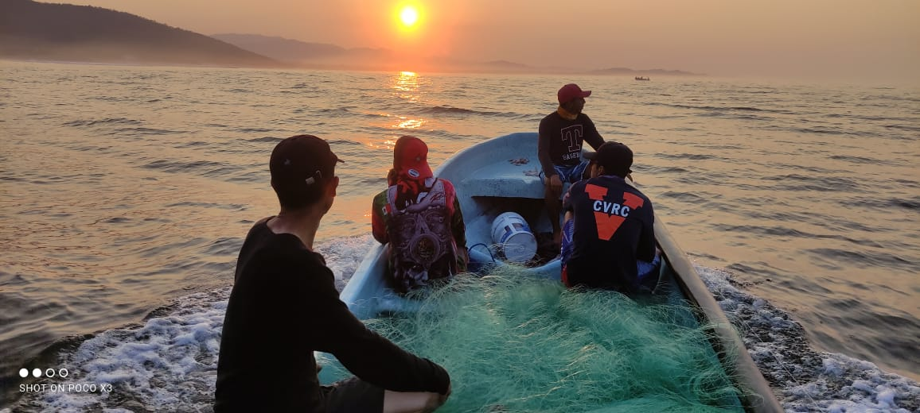
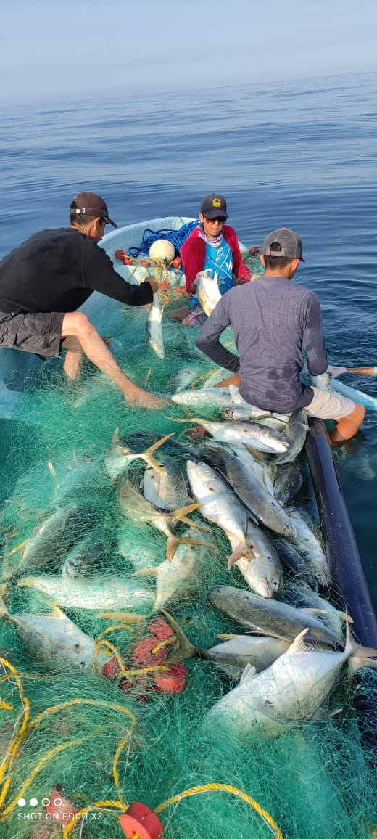
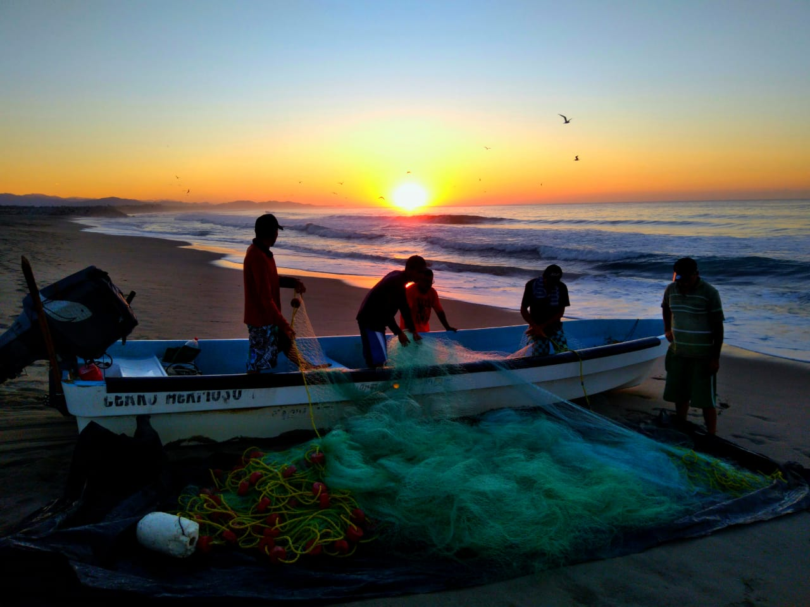

Figure 1. Illustrative photographs of the beginning of fishing with gillnets at night and return to the pier after a day of fishing (not fishing with nets in Puerto Ángel, Oax.).
2. Artisanal trolling fishing method
This method of trolling for skipjack in Puerto Ángel is unique in that it is traditional and uses fishing gear handcrafted by the fishermen.
During sea observations and fisherman interviews, it was recorded that skipjack fishermen use boats 20 to 22 feet long, with outboard motors of 40 to 75 horsepower. Fishermen tie one or two wooden poles approximately 2.5 meters long to the centerline of the boat (Fig. 2b). Attached to the ends of these poles are 140 mm monofilament (nylon) fishing lines (Fig. 2c), the length of which varies according to the angler's preference (15 strokes or more). These lines are rigged with plastic lures, lead, and two size 6 or 7 hooks joined with steel line. This lure is known locally in Puerto Ángel as "curricán" (Figs. 2a and 2c). The boats move quickly across the water's surface, following the movement of schools of skipjack parallel to the coastline (at a speed slightly faster than trolling sailfish). When a skipjack is caught, fishermen reel in the line and haul the catch onto the boat (Fig. 2d). Previously, they killed skipjack or left them to die on the boat; now, they use the ikejime technique (a Japanese method of painless fish slaughter that involves using a sharp instrument to destroy the brain and then draining the blood), and then ice the fish (this technique is used when the fish is sold at the Punta Sacrificio Cooperative's processing plant).
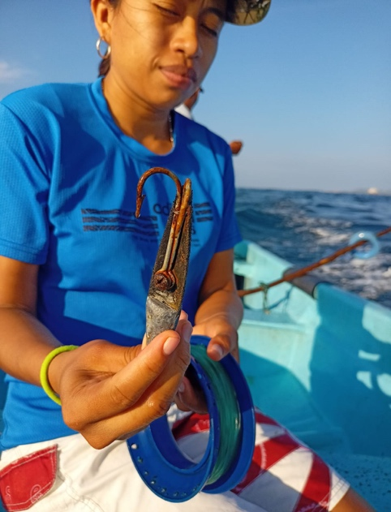
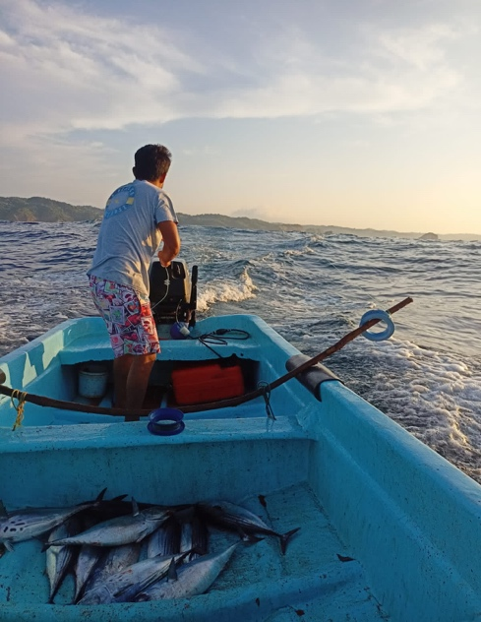
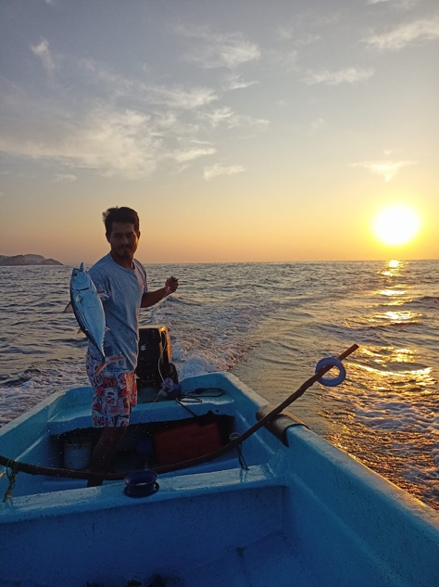
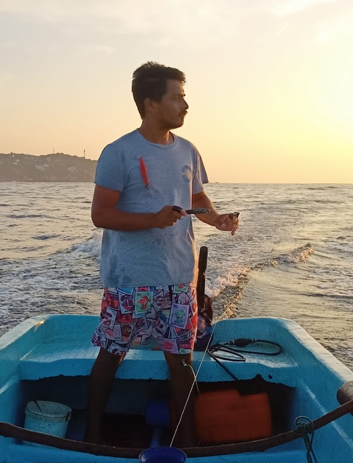

a
b

c
d

Figure 2. Illustrative photographs of the beginning of artisanal trolling in Puerto Ángel, Oaxaca. a) Artisanal trolling for skipjack fishing; b) Wooden poles for attaching the fishing line and trolling rod.
Positive and Negative Interactions of the Skipjack Fishery in the Habitat
The accounts collected from interviews with fishermen indicate that they have observed changes in water quality, the presence of certain species, and the state of marine ecosystems in the Puerto Ángel area. The main impacts they acknowledge are presented below:
1. Impact on protected species and accidental capture:
- Frequency of contact: The most common encounters during skipjack fishing are with dolphins and sea turtles, especially the olive ridley turtle ( Lepidochelys olivacea) and the tropical spotted dolphin ( Stenella attenuata ), who steal skipjacks when they have been caught by fishermen.
- Bycatch: Protected species are released when caught accidentally; very few are injured. Small skipjack and non-target species are released; when fish species suitable for human consumption are offered for sale. There are no formal management procedures for protected species.
- Knowledge and training: There are informal agreements on best practices, but few fishers have received formal training in protecting vulnerable species. They are familiar with marine mammal regulations, avoid disturbing whales, and generally do not interfere with their fishing activities.
- Measures to reduce bycatch: They suggest the use of fishing gear such as artisanal trolling, used by several generations, which has improved and focused on skipjack fishing in the area, as well as the gradual elimination of gillnets used for skipjack fishing.
2. Impact on the Habitat
- Reefs and water quality: Skipjack fishing does not affect reefs because it is fished on the surface, not within reefs. Reduced fish availability and coral bleaching have been observed, especially after events such as red tides and changes in water temperature (warming).
- Waste and Pollution: Although most fishermen implement waste collection practices (during and after fishing) and store oil in special containers, there are still practices of dumping it on the beach. Awareness raising is suggested for the entire fishing community in Puerto Ángel.
- Conservation practices: There are individual and authority initiatives to carry out beach cleanups, but a broader, coordinated effort focused on the entire Puerto Ángel community is lacking.
Testimonies gathered from interviews with researchers who have worked in Puerto Ángel fisheries indicate that they have observed changes in some aspects, such as changes in water quality, the presence of certain species, and the state of marine ecosystems, which are mentioned below:
1. Impacts of the Skipjack Fishery
- Skipjack fishing in Puerto Ángel is considered low-impact due to the predominant use of artisanal trolling, a technique that is selective for skipjack. However, the use of gillnets and purse seine fishing reduces selectivity and may affect other non-target species.
- Pollution problems have been reported in the bay due to sewage and fecal contamination. Climate change and phenomena such as El Niño impact the availability of skipjack and other migratory species. Specific information on the relationship between skipjack fishing and local biodiversity is lacking.
2. State of the Marine and Coastal Habitat
- State of reefs and marine habitats: Reef deterioration is reported due to coral bleaching caused by climate change. At Estacahuite Beach, some corals have shown signs of recovery. Tourism activity represents a significant impact on reef ecosystems, not associated with skipjack fishing. Damage from coastal fishing is considered minimal.
- Relationship between fishing and water quality : The Universidad del Mar (UMAR) has documented high levels of fecal contamination in Puerto Ángel Bay. Although studies on marine pollution exist, the effects of fishing activity on water quality have not been thoroughly investigated.
- Impacts on beaches and boarding areas : The lack of environmental awareness among fishermen and tourists has resulted in waste pollution and oil spills on beaches. In recent years, hazardous waste containers have been implemented, but challenges persist regarding their proper use.
3. Conservation and Sustainable Management
- Effectiveness of responsible fishing : The introduction of hooks instead of nets has reduced the bycatch of protected species.
- Best management practices: Improved capture and storage technologies are recommended to reduce losses and improve product quality. Adding value to skipjack could encourage more sustainable harvesting.
- Successful conservation actions : Some fishermen have begun limiting their catch based on market demand. One example is the ban on ojotón fishing in Puerto Ángel Bay, which was driven by the fishermen themselves.
- The role of fishing communities in conservation: Collaboration with fishers is key to implementing conservation measures. However, challenges remain in integrating local knowledge with scientific research.
Non-target species caught incidentally (direct impact)
Interviews with fishermen and researchers revealed the presence of some bycatch during fishing operations. This was evidenced in the monthly records obtained from the 2024-2025 beachside monitoring of the skipjack FIP in Puerto Ángel. Fishermen indicated that, although they try to avoid these interactions, some species are occasionally caught accidentally, especially during certain seasons. Researchers also confirmed the existence of such bycatch and its sale to the public. Through verification using the Fishbase website ( https://fishbase.se/search.php ), the identity of some species was corroborated, as shown in Table 1.
Table 1. Non-target species of the skipjack fishery in Puerto Ángel, Oaxaca, according to interviews and the FIP-skipjack beach monitoring database.
Common name of the non-target species | Scientific name of the species
Goat | Cephalopholis panamensis (Steindachner, 1876)
Saw | Scomberomorus saw Jordan & Starks, 1895
Golden | Coryphaena hippurus Linnaeus, 1758
Amberjack | Seriola rivoliana Valenciennes, 1833
Chef | Caranx caballus Günther, 1868
Mackerel | Caranx caninus Günther, 1867
Red mullet | Auxis brachydorax Collette & Aadland, 1996
Indirect impacts of the skipjack fishery on protected species
Through a literature review, several species with some protection status were identified that could interact with the skipjack fishery in Puerto Ángel, Oaxaca. These include the leatherback turtle ( Dermochelys coriacea ), the hawksbill turtle ( Eretmochelys imbricata ), and the olive ridley turtle ( Lepidochelys olivacea ). Marine mammals such as humpback whales ( Megaptera novaeangliae ) and others, as shown in Table 2, are also present, due to their presence in the region where fishing trips take place and the migratory activity of some of them.

Table 2. Presence of groups and species according to bibliographic review, which could interact with the skipjack fishery in areas near Puerto Ángel, Oaxaca.
Cluster | Species | Conservation Status (IUCN, 2024) | NOM-059-SEMARNAT-2010 | Ecological Importance / Notes | References
Sea Turtles | Leatherback turtle ( Dermochelys coriacea ) | Vulnerable (VU) | In danger of extinction | Migration to the beaches of Oaxaca. | IUCN (2024), Márquez (1990), Eckert et al. (1999), Abreu-Grobois & Plotkin (2008)
 | Green turtle ( Chelonia mydas ) | Endangered (EN) | In danger of extinction | Migration to the beaches of Oaxaca. | IUCN (2024), Márquez (1990), Eckert et al. (1999), Abreu-Grobois & Plotkin (2008)
 | Hawksbill turtle ( Eretmochelys imbricata ) | Critically Endangered (CR) | In danger of extinction | Migration to the beaches of Oaxaca. | IUCN (2024), Márquez (1990), Eckert et al. (1999), Abreu-Grobois & Plotkin (2008)
 | Olive ridley sea turtle ( Lepidochelys olivácea ) | Not evaluated by IUCN | In danger of extinction | Nesting on the beaches of Oaxaca; Escobilla. | SEMARNAT (2010), Márquez (1990)
Marine Mammals | Humpback whale ( Megaptera novaeangliae ) | Least Concern (LC) | Special protection | Ecological importance and tourist attraction | IUCN (2024), Perry et al. (1999), Reeves et al. (2002)
 | Bottlenose dolphin ( Tursiops truncatus ) | Least Concern (LC) | Special protection | Interactions with fishing activities | IUCN (2024), Perry et al. (1999), Reeves et al. (2002)
 | Spotted dolphin ( Stenella attenuata ) | Least Concern (LC) | Special protection | Importance in marine trophic balance | IUCN (2024), Perry et al. (1999), Reeves et al. (2002)
 | California sea lion ( Zalophus californianus ) | Not specified in IUCN | Special protection | Monitored since 1991; trophic balance and sustainable tourism | Meraz & Sánchez-Díaz (2008)
Seabirds | Golden Eagle ( Buteo albonotatus ) | Not specified in IUCN | Special Protection (Pr) | Presence in areas near Puerto Ángel | SEMARNAT (2010)
 | Black-backed Hawk ( Buteogallus anthracinus ) | Not specified in IUCN | Special Protection (Pr) | Limited interaction with the fishery | SEMARNAT (2010)
 | Elegant tern ( Thalasseus elegans ) | Not specified in IUCN | Special Protection (Pr) | Coastal habits, limited interaction. | SEMARNAT (2010)
Marine Reptiles | Pelagic sea snake ( Hydrophis platurus ) | Not specified in IUCN | Not protected | Low interaction with the fishery | Meraz (2008)
Ecosystems | Coral reefs | Not applicable | Not applicable | Essential habitat for fish, sharks and other marine organisms | Reyes-Bonilla (2003), Wilkinson (2004)
Fish and Sharks | Parrotfish ( Scarus spp. ) | Not specified in IUCN | Unprotected | Important in the control of macroalgae on coral. | Reyes-Bonilla (2003)
 | Whitetip shark ( Carcharhinus albimarginatus ) | Not specified in IUCN | Unprotected | Crucial role in reef health; pressure from overfishing | Alcérreca-Huerta et al. (2018)

Now, through interviews with fishermen, the following species were found to exhibit some type of interaction during their fishing trips:

Table 3. Protected species that, according to interviews with fishermen, interact with the skipjack fishery in areas near Puerto Ángel, Oaxaca.
Protected Species | Action Taken by Fishermen
Olive Ridley Turtle (Lepidochelys olivacea) | Avoid injuring them with the boat. If they get trapped, they free themselves.
Leatherback Turtle (Dermochelys coriacea) | Rarely seen (1-3 times per year). Contact is avoided.
Spotted dolphin (Stenella attenuata) | It hangs from the kite on the hooks. It indicates the location of the fish .
Rough-toothed dolphin (Steno bredanensis) | They steal kites from hooks and nets. Fishermen try to chase them away.
Bottlenose dolphin (Tursiops truncatus) | It approaches boats and can steal fish.
Spinner dolphin (Delphinus delphis) | Occasionally observed. No direct interaction.
White-bellied dolphin (Stenella longirostris) | Indicates the presence of schools of fish.
Humpback whale (Megaptera novaeangliae) | Observed seasonally (November-February). Contact is avoided.
Hydrophis platurus (Linnaeus,  1766) | Occasionally caught on the hook, it is released.
Common gull, scallops, frigate birds | Used as indicators of fish schools.

Discussion

Gillnets are used to capture fishery resources from inland waters and in coastal fisheries in Mexico (Oginni et al. 2006). In Puerto Ángel, Oaxaca, black skipjack ( Euthynnus lineatus ) fishing is based on the use of gillnets and artisanal trolling, techniques that have been adapted to the local ecological and social context. The gillnet is a passive fishing technique in which fish are trapped by the operculum as they try to pass through the mesh (Oginni et al., 2006).
However, in Puerto Ángel, fishermen have developed specific strategies to optimize their use, such as the "enclosure" method, in which schools detected by bioluminescence are surrounded at night, allowing for more targeted and efficient capture. This technique minimizes bycatch compared to nets, although it does not completely eliminate the risk of ghost nets, which are gillnets that are lost or abandoned (usually after becoming entangled on the bottom) and continue to capture and kill fish for long periods of time, a recurring problem associated with the loss of nets on the seabed (Cochrane, 2005).
Environmental and socioeconomic changes have transformed Puerto Ángel, as Rubio (2017) points out, with the decline in coffee imports and the rise of tourism. Fishermen and researchers agree that sewage and waste pollution has degraded beaches, inlet and bar systems, and marine habitats. Studies by the Universidad del Mar confirm high levels of coliforms in the bay and water wells. Furthermore, the deterioration of coral reefs, documented since 1998 (Reyes-Bonilla and Leyte-Morales), continues to worsen, affecting fisheries and highlighting the urgent need for sustainable management strategies.
Interviewed researchers express concern about the increase in anthropogenic pollution in Puerto Ángel, particularly due to the lack of drainage systems. This problem, combined with the effects of climate change, has resulted in a greater frequency and irregularity of so-called red tides, as noted by Torres (2015).
The interviews conducted showed that artisanal skipjack trolling allows for more selective catches of adult skipjack. Unlike gillnets, this method requires knowledge of skipjack fishing areas and the manual development of appropriate lures, which is passed down from generation to generation. The effectiveness of this method depends on the fisherman's ability to identify behavioral patterns of schools and quickly maneuver the boat to follow their movement with the troll. Although trolling reduces bycatch compared to gillnets, it captures fewer skipjack in terms of catch volume. Both methods present challenges and opportunities, but the improvement and use of artisanal trolling for over 40 years demonstrates the adaptation of fishers to their environment and the importance of integrating management and fishing strategies based on local knowledge to ensure long-term viability.

CONCLUSIONS AND RECOMMENDATIONS

Small-scale fishing communities share interests, values, and a distinct cultural identity due to their ongoing interactions (Villanueva & Flores, 2016). However, during the present study, we noticed a rejection by some fishermen of their peers who use gillnets. This is because black skipjack are caught in large schools with low size and species selectivity. Furthermore, gillnets damage the skipjacks during fishing, causing them to collide with each other, generating fish with spoiled flesh considered to be of poor quality. This lowers sales prices and impacts daily sales for other fishermen who only use trolling methods.
Skipjack fishing in Puerto Ángel, Oaxaca, is carried out primarily using gillnets and artisanal trolling. The "encirclement" gillnet technique is the most commonly used technique for capturing black skipjack ( Euthynnus lineatus ). Its use can generate bycatch of other species, including some protected species. Artisanal trolling is notable for its selectivity and lower impact on non-target species.
Although skipjack fishing has a low impact on the reef habitat, interactions with protected species such as sea turtles and dolphins have been recorded, especially the olive ridley turtle ( Lepidochelys olivacea ) and the tropical spotted dolphin ( Stenella attenuata ), which are the species most frequently encountered in fishing operations.

After analyzing the interviews and the available data, the present work states the following:
- Fishermen propose reducing the use of gillnets.
- Habitat impact: Skipjack fishing does not directly affect reefs, as it takes place on the water's surface and not on the bottom .
      - Changes in marine biodiversity have been observed due to fishermen, including fish decline and coral deterioration due to climate events, but very few studies exist.
      - In conclusion, both fishermen and researchers agree that pollution from sewage and waste affects beaches and mouth-bar systems, especially during the rainy season due to the input of fresh water Martínez-Lievana, et. al 2013; Mendoza Amézquita et. al 2017. Especially in
- Conservation and sustainable management: Artisanal trolling has proven to be more sustainable by reducing the bycatch of protected species.
- Incidental capture of non-target species: Seven species were identified as incidentally captured, including the cabrilla ( Cephalopholis panamensis ), the sierra ( Scomberomorus sierra ), the dorado ( Coryphaena hippurus ), the amberjack ( Seriola rivoliana ), the cocinero ( Caranx caballus ), the horse mackerel ( Caranx caninus ) and the red mullet ( Auxis brachydorax ), which are marketed.
- Indirect impact on protected species : The fishermen interviewed mention that they interact with the following protected species: the olive ridley sea turtle (Lepidochelys olivacea); the tropical spotted dolphin (Stenella attenuata); the rough-toothed dolphin (Steno bredanensis); the bottlenose dolphin (Tursiops truncatus); the spinner dolphin (Delphinus delphis); the white-bellied dolphin (Stenella longirostris); the humpback whale (Megaptera novaeangliae); and the snake (Hydrophis platurus) (Linnaeus, 1766). The olive ridley sea turtle (Lepidochelys olivacea) and the tropical spotted dolphin (Stenella attenuata) are the species with which they have the greatest interaction. However, due to the type of fishing and artisanal lure used, interactions are very rare, and when they occur, harming them is avoided. Greater monitoring and mitigation strategies are required to minimize the negative effects on marine fauna.
- Fishing Policies and Regulations: A study on skipjack growth and reproduction is required to establish appropriate closures.

General recommendations for skipjack fishing:
- Implement formal training for fishermen on good practices and management of protected species.
- Promote the use of artisanal trolling as a sustainable alternative to gillnets.
- Develop community strategies to reduce pollution and improve marine habitat conservation.
- Strengthen fisheries monitoring to continuously assess the environmental impact of the activity.

Participating institutions and organizations:
Oaxacan Fund for Nature Conservation (FOCN), Oaxacan Committee for Aquaculture Health and Safety (COSIA), SmartFish AC, the Pochutla Technological Institute, the Punta Sacrificio SC de RL Fishing Production Cooperative, and Curricaneros de Puerto Ángel.

REFERENCES

Abreu-Grobois, FA, & Plotkin, P. 2008. Lepidochelys olivacea . The IUCN Red List of Threatened Species.
Alcérreca-Huerta, J.E., Ramos, R., & Reyes-Bonilla, H. (2018). Coral reef ecosystems of Oaxaca. Marine Ecology, 29(3), 287–297.
Bastida-Zavala, JR, et al. (2017). Marine biodiversity in the southern Mexican Pacific: an updated inventory of species. Mexican Journal of Biodiversity, 88(4), 928-946.
Bastida-Zavala, R., Meraz-Hernando, J., García-Madrigal, M., Montoya-Márquez, A., Rosas-Alquicira, F., Lopéz-Pérez, R., & Barrientos-Luján, N. (2013). Marine and coastal biodiversity of Oaxaca, Mexico [with erratum]. Check List, 9(2), 329-390.
Carranza, E.A., E.M. Gutiérrez & T.R. Rodríguez. 1975. Continental Morpho-Tectonic Units of the Mexican Coasts. Annals of the Institute of Marine Sciences and Limnology, UNAM, Mexico 2 (1): 81-88.
Cochrane, K.L. (Ed.). (2005). A Fisheries Manager's Guide: Management Measures and Their Implementation (Vol. 424). Food & Agriculture Org.
Collette, BB, & Nauen, CE 1983. Scombrids of the world: an annotated and illustrated catalog of prickly pears, mackerels, bonitos, and related species known to date. v. 2.
Official Gazette of the Federation (DOF) 2012. Agreement announcing the update to the national fishing charter. Secretariat of Agriculture, Livestock, Rural Development, Fisheries and Food. https://dof.gob.mx/nota_detalle.php?codigo=5265388&fecha=24/08/2012#gsc.tab=0
Eckert, KL, Bjorndal, KA, Abreu-Grobois, FA, & Donnelly, M. 1999. Research and management techniques for the conservation of sea turtles. IUCN/SSC Marine Turtle Specialist Group.
FAO 1994: Review of the world status of highly migratory and straddling stocks. FAO Fisheries Technical Paper No. 337, 75 pp.
Ferrari, L., Orozco-Esquivel, T., Manea, V.C., & Manea, M. (2012). The dynamic history of the Trans-Mexican Volcanic Belt and the Mexico subduction zone. Tectonophysics, 522-523, 122-149.
Fiedler, PC, & Lavín, MF 2015. Oceanographic conditions of the Eastern Tropical Pacific. In WF Perrin, B. Würsig, & JGM Thewissen (Eds.), Encyclopedia of Marine Mammals (3rd ed., pp. 668-672). Academic Press.
National Fisheries Institute (INAPESCA). 2012. National Fisheries Charter. Agreement announcing the updated National Fisheries Charter. Official Gazette of the Federation. Mexico. 236 pp.
IUCN 2024. The IUCN Red List of Threatened Species. Version 2024-1. https://www.iucnredlist.org
Márquez, MR 1990. FAO Species Catalogue: Sea Turtles of the World. FAO.
Martínez Ramírez, E. 1999. Taxonomy and zoogeography of the freshwater ichthyofauna of the state of Oaxaca Mexico (Doctoral dissertation, University of Barcelona).
Martínez-Lievana, C., Huante-González, Y., Santiago-Morales, I., Sandoval-Orozco, G., Estrada-Vázquez, C., & Madrid-González, J. 2013. Water quality assessment of wells in Puerto Ángel, San Pedro Pochutla, Oaxaca. Cienc. Mar, 18, 11-18.
Meraz, J. (2008). Pelamis platurus (Reptilia: Elapidae) on the coast of Oaxaca. Science and the Sea, 11, 39-43.
Mendoza Amézquita E., Isabel Ramírez Aguilar, Jens Andreas Seim, Rafael Blanco Betancourt, and Víctor Manuel Martínez Rodríguez. 2017. Water quality and numerical simulation in Puerto Ángel Bay, Oaxaca, Mexico. 8(19): 16-32 2017
Meraz, J., & Sánchez-Díaz, V.M. (2008). Marine mammals on the central coast of Oaxaca. Mexican Journal of Biodiversity, 79(1), 143–151.
Oginni O, EA Fasakin, AM Balogun. 2006. Gillnets selectivity of Cichlidae Sarotherodon galilaeus (Linneaus 1758) in Iwo Reservoir, South West Nigeria. Middle-East Journal of Scientific Research 1(1): 10-15.
Pardo, M., & Suárez, G. 1995. Shape of the subducted Rivera and Cocos plates in southern Mexico: Seismic and tectonic implications. Journal of Geophysical Research: Solid Earth, 100(B7), 12357-12373.
Perry, SL, DeMaster, DP, & Silber, GK (1999). The Great Whales: History and status of six species listed as endangered under the US Endangered Species Act of 1973. Marine Fisheries Review, 61(1), 1-74.
Ramos-Carrillo, S., V. Anislado-Tolentino, G. González-Medina, G. Cerdenares-Ladrón de Guevara, P.A.M. Gama, and Y. De La Rosa-Domínguez. 2011. Research project report: Analysis of biodiversity and fishing impacts to determine the feasibility of establishing a tuna refuge zone off the coast of Oaxaca. Universidad del Mar, Puerto Ángel, Oaxaca. 122 pp.
Ramos-Cruz, S. 2009. Length-weight relationship and condition factor in the black skipjack Euthynnus lineatus (Kishnouye, 1920)(Perciformes: Scombridae), caught off the coast of Oaxaca, Mexico.
Reyes-Bonilla, H. 2003. Coral reefs of the Mexican Pacific coast. Coral Reefs, 22(4), 477-479.
Reyes-Bonilla, Héctor, & Leyte-Morales, Gerardo E. (1998). Corals and coral reefs of the Puerto Ángel region, west coast of Mexico. Journal of Tropical Biology , 46 (3), 679-681. Retrieved September 25, 2024, from http://www.scielo.sa.cr/scielo.php?script=sci_arttext&pid=S0034-77441998000300022&lng=en&tlng=en .
Romero-Centeno, R. & J. Zavala-Hidalgo. 2003. Isthmus of Tehuantepec Wind Climatology and ENSO Signal. Journal of Climate. 16(15): 2628-2639.
Rubio, I. 2017. An uncertain destiny. Tourism expansion, damage, and environmental risks on the Oaxaca coast. Acta sociológica, 73, 83–122. https://doi.org/10.1016/j.acso.2017.08.003 .
Ministry of Agriculture, Livestock, Rural Development, Fisheries and Food. 2013. Mexican Official Standard NOM-001-SAG/PESC-2013, Responsible tuna fishing. Specifications for purse seine fishing operations. Official Gazette of the Federation. Retrieved from https://www.dof.gob.mx/nota_detalle.php?codigo=5329799&fecha=16/01/2014#gsc.tab=0
Ministry of Agriculture, Livestock, Rural Development, Fisheries and Food. (2010). Mexican Official Standard NOM-059-SAG/PESC-2010, To reduce bycatch in tuna fisheries . Official Gazette of the Federation. Retrieved from https://www.dof.gob.mx
Ministry of Environment and Natural Resources. 2010. Mexican Official Standard NOM-059-SEMARNAT-2010, Environmental Protection – Native Mexican Species of Wild Flora and Fauna – Risk Categories and Specifications for Their Inclusion, Exclusion, or Change – List of Species at Risk. Official Gazette of the Federation. Available at: https://www.profepa.gob.mx/innovaportal/file/435/1/NOM_059_SEMARNAT_2010.pdf
Torres, G. (2015). Assessment of red tides during 1968–2009 in Ecuador. http://hdl.handle.net/1834/10342
Vázquez-Caamal, A. 2021. Tectonic dynamics and their influence on the coastal geology of southern Mexico. Bulletin of the Mexican Geological Society, 73(2), 131-150.
Vera, G. 2005. Social vulnerability and expressions of disaster in the district of Pochutla, Oaxaca. In: The Social Construction of Risks and Hurricane Paulina, Coordinated by Virginia García. Center for Research and Advanced Studies in Social Anthropology, Mexico City, 151 pp.
Villanueva, J., & Flores, A. (2016). Contribution of artisanal fishing to food security, rural employment, and household income in South American countries. Food and Agriculture Organization of the United Nations (FAO), Santiago.
Wilkinson, C. (2004). Status of Coral Reefs of the World: 2004. Global Coral Reef Monitoring Network.
Zamudio, L., & Hogan, PJ 2011. Summer generation of the Southern Gulf of Mexico eddies. Journal of Geophysical Research: Oceans, 116(C12), C12024.

