VIETNAM TUNA ASSOCIATION
THE VIETNAM YELLOWFIN TUNA FISHERY IMPROVEMENT PROJECT

MID-TERM REPORT ON
The Vietnam Yellowfin Tuna Fishery Improvement Project Activity Coordination in 2019 – 2020
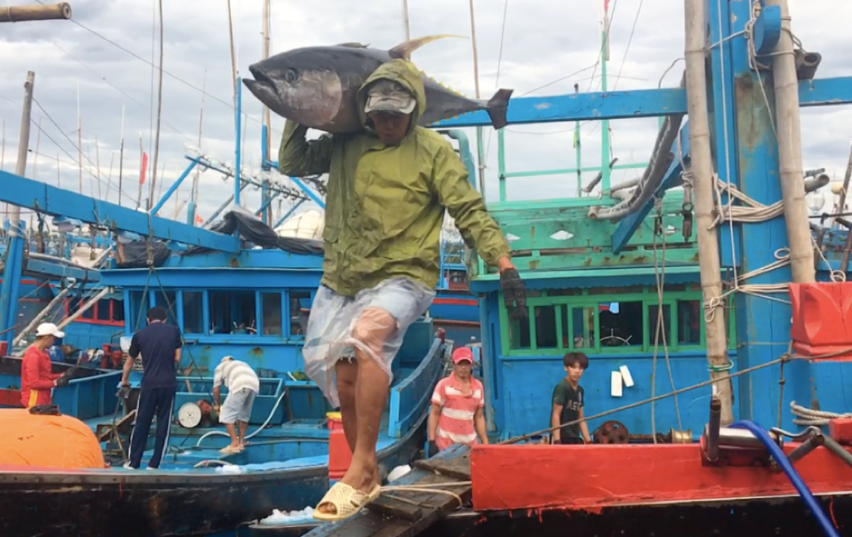

Reported to: WWF US
Reported by: Vietnam Tuna Association
By technical staff: Tran Van Hao

NHA TRANG, AUGUST 2020
I. PROJECT OVERVIEW
- Title: Vietnam Yellowfin Tuna Fisheries Improvement Project Coordination
- Recipient: Tran Van Hao
- Project Period: Nov 2019 – Dec 2020 (extension to December 2020)
II. PROJECT DESCRIPTION
  - Project Objectives:
Promote & Coordinate Vietnam Yellowfin Tuna Fishery Improvement Project Activities in 2019 & 2020 with details activities as below:
  - Project Activities:
- ISSF-PVR implementation
  - Register for FIP fleets on ISSF-PVR
- FIP Code Traceability & eLogbook
  - Apply FIP traceability Code to tuna processors
  - 3rd party data verification on FIP products
  - Design & develop electronic fishing logbook (eLogbook) & identify potential pilot opportunities
  - Pilot QR code with FIP tractability code
- General FIP Supports
  - Attend roundtable meeting in Hanoi
  - Translation FIP communications & updates to participants
  - Website upgrades

III. PROJECT RESULTS

3.1. Design & develop eLogbook Application
VINATUNA has designed & develop Vietnamese version electronic logbook. The eLogbook has main functions including Registration, Recording at sea, Administration and a web server for data analysis. The Application has designed & revised to exactly follow logbook form on Circular 21/2019/TT-BNN of Vietnam Government.
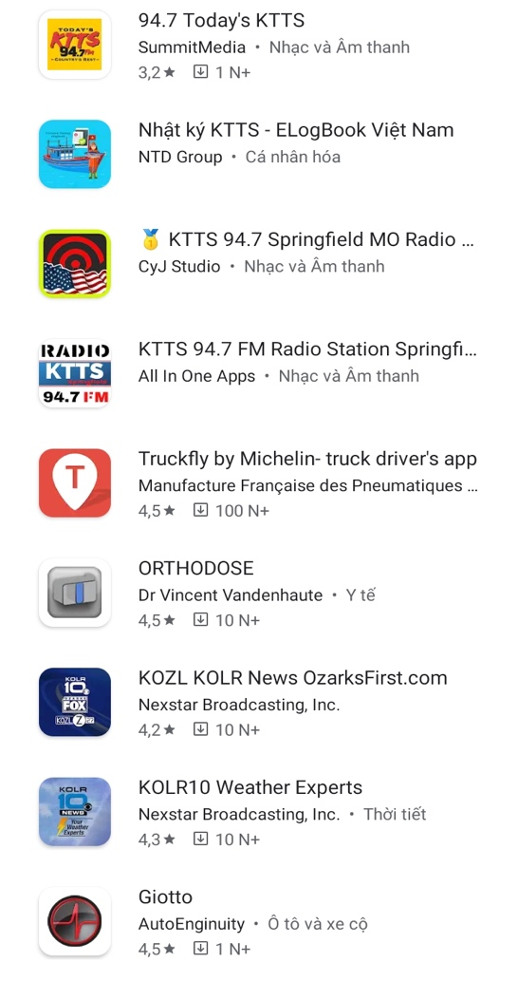 | 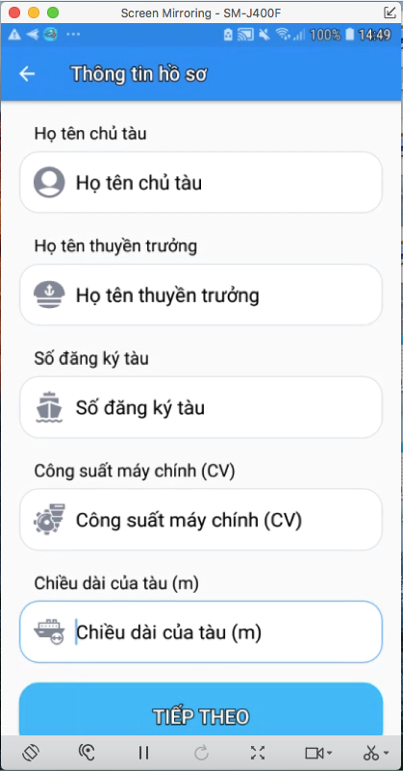
(a) | (b)
Figure 1. The eLogbook Application on Google Store / CH Play on Android (a) and Registration form on eLogbook (b)
The eLogbook has designed mainly focus to tuna handlines fishery, however application also have stand-by functions for other fishing methods such as purse seine fishery, gill-net fishery or trawl fishery.

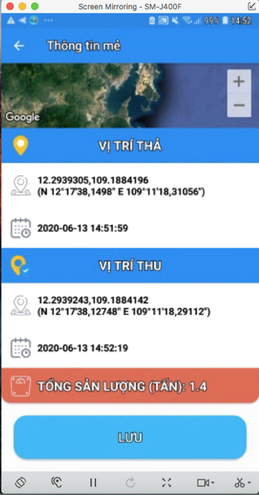
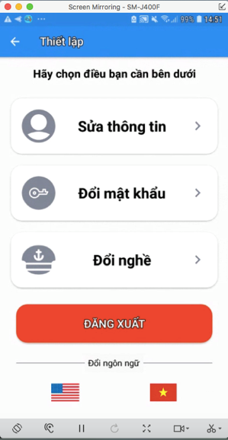
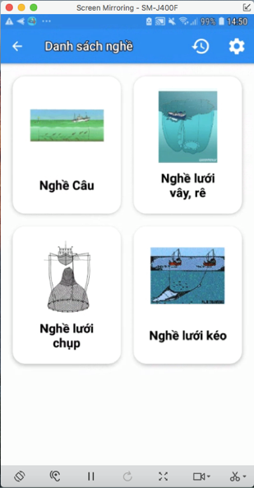
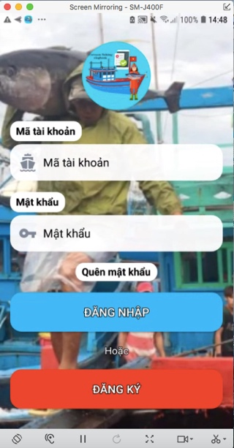

Figure 2. Main windows on eLogbook Application: Log in, Track locations, Main fishing methods and Administrations windows
In order to identify the potential pilot opportunities, VINATUNA has work closely with SeaDelight to test & pilot eLogbook Application in the fishing grounds.
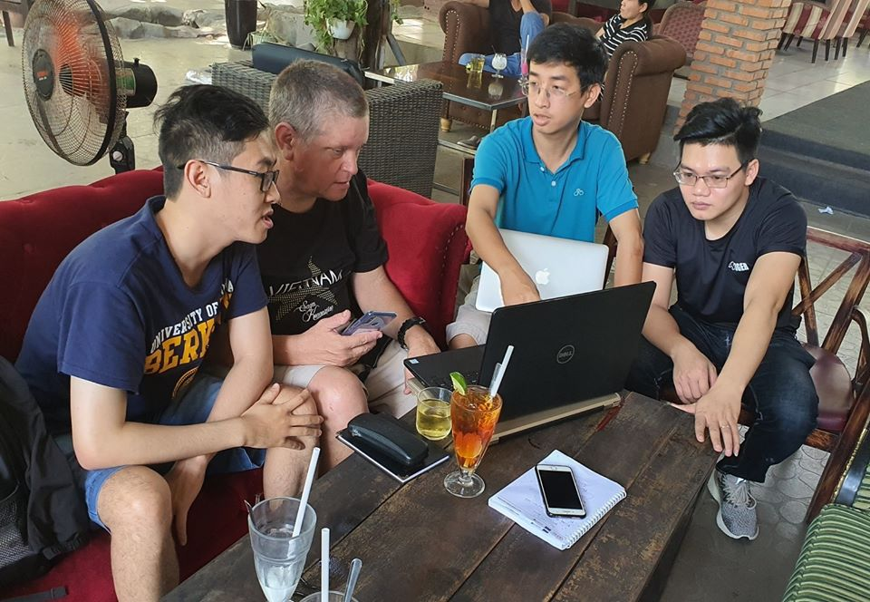

Figure 3. VINATUNA team working with SeaDelight Sustainability Director to identify potential pilot opportunities for eLogbook
3.2. Verification of FIP production from 3rd party data
VINATUNA has signed contract with VASEP to provide monthly tuna export data by markets & by products. From that, starting from Jan 2020, VASEP will provide monthly tuna export value for VINATUNA for 4 main products (frozen fillet tuna - HS0304, other frozen tuna HS03 except HS0304, cannery tuna products – HS16 and other HS16) for all export markets but mainly focus to US market.

Table 1. The monthly tuna export data of Vietnam by markets
Markets | Jan | Feb | Mar | Apr | May
US | 26,148,258 | 23,044,459 | 12,822,139 | 19,948,244 | 19,971,653
EU | 11,350,435 | 9,972,674 | 4,853,149 | 13,579,438 | 8,517,438
China & HK | 567,159 | 129,201 | 14,800 | 167,615 | 373,553
Japan | 3,413,869 | 2,600,297 | 1,577,168 | 2,459,760 | 2,928,177
ASEAN | 3,616,828 | 4,350,914 | 1,654,364 | 3,479,033 | 2,373,060
Korea | 85,682 | 157,641 | 43,200 | 208,759 | 109,812
Others | 18,000,467 | 14,452,738 | 7,615,450 | 9,936,069 | 10,456,476
Total | 63,182,698 | 54,707,924 | 28,580,270 | 49,778,918 | 44,730,169

Table 2. The monthly tuna export data by products of Vietnam
Products | Jan | Feb | Mar | Apr | May
HS0304 | 34,139,883 | 28,426,878 | 12,435,871 | 17,694,755 | 15,283,680
Others HS03 | 3,036,640 | 2,171,925 | 1,792,897 | 5,698,362 | 3,791,915
HS16 | 15,299,624 | 14,973,005 | 9,380,033 | 17,695,364 | 18,890,862
Other HS16 | 10,706,551 | 9,136,116 | 4,971,469 | 8,690,437 | 6,763,712
Total | 63,182,698 | 54,707,924 | 28,580,270 | 49,778,918 | 44,730,169

Table 3. The monthly export data to US market by products
Products | Jan | Feb | Mar | Apr | May
HS03 | 235,274 | 87,692 | 40,087 | 35,312 | 445,208
HS0304 | 16,046,282 | 14,464,070 | 6,026,341 | 8,054,203 | 7,233,597
HS16 | 5,739,695 | 5,823,522 | 4,011,581 | 7,861,785 | 8,842,673
Other HS16 | 4,127,007 | 2,669,175 | 2,744,130 | 3,996,944 | 3,450,175
Total | 26,148,258 | 23,044,459 | 12,822,139 | 19,948,244 | 19,971,653

The Table 3 has shown the export value of tuna products that “Processed in Vietnam” where HS0304 (red line) has shown the value of frozen filleted tuna products which mainly from FIP products. The constrains here is that the statistical data has not separated from FIP products or re-export products.

3.3. ISSF-PVR Registration
In order to register FIP vessels fleets on ISSF-PVR system, VINATUNA has worked closely with ISSF to prepare all related documents & fill-in all form as guides from ISSF-PVR. However, in the first periods, all Vietnam fishing vessels do not have IMO number which is one of obligatory KDEs need to be full-filled. After discussed as case of small-scale of Vietnam fishery (most of tuna fishing vessels are less than 24m length) and do not have IMO numbers. Thus now, VINATUNA is working again with ISSF to put all of these fleets into PVR system.
Figure 4. ISSF-PVR Registration forms for Vietnam FIP Fleets

3.4. Promote FIP Code traceability & Pilot QR code
At the end of 2019, there were 14 local tuna processors had participated in FIP Code audit process. Of which, 3 processors have passed for the 2nd audit (Hai Long, Hong Ngoc & BIDIFISCO). VINATUNA has planed for 2020 audits in July/Aug 2020 for 2nd audits for the remaining processors. Most of local FIP processors are in the supply chain to FIP Partners such as SeaDelight, ANOVA or HILO Fish…etc

3.5. Upgrade FIP websites
VINATUNA has signed contract with IT team to upgrade FIP website. This FIP website will work independently with VINATUNA websites. VINATUNA has registered the domain at www.vietnam-yft-fip.vn . The websites will open soon in next few weeks once the domain is open & all contents of websites are approved.

- PROBLEMS AND CONSTRAINTS
  - FIP production verification
As mentioned above, the 3rd data verification from VASEP only provide exported data in value rather than in volume. Moreover, the verified export data also are only separated by markets & by products which have not separated into companies (FIP Partners). While our FIP code have not cover for all Vietnam tuna products (estimated just around 85 – 90% of the total). Thus, the production volume by processors and/or by international buyers / importer are not verified yet.
  - ISSF-PVR
As mentioned above, IMO number is a challenge in the first period and mostly resolved after discussions with ISSF. However, registration for Vietnam fishing vessel fleets into international system also need to be consulted with Vietnam Government (Directory of Fisheries – DFISH). This issue is ongoing process between VINATUNA & DFISH to get the approval officially from DFISH. Besides that, VINATUNA also would like to have a carefully consultation process with fishing vessels owners to help them well understand on their responsibilities & best practices onboard when they register for PVR.
- ONGOING ACTIVITIES
  - Monthly export data update by markets & by products (HS code)
  - Consult with DFISH & fishing vessel owners on PVR registrations
  - FIP Code traceability audit in 2020
  - Coordinate with SeaDelight to pilot QR code
  - Develop & Upgrade FIP Websites contents
  - Test/trials eLogbook & finding resources to pilot eLogbook on the fields

VI. APPENDICES (IF APPLICABLE)
- Press Articles
https://seadelightglobal.squarespace.com/news/2020/6/1/vietnam-e-logbook-app-ready-for-first-trials?fbclid=IwAR2zXy4JWK9yEongIQunqf4nL40Qb5yoEv5VnM1Lrocxtndf1gWKpfLi_Is

