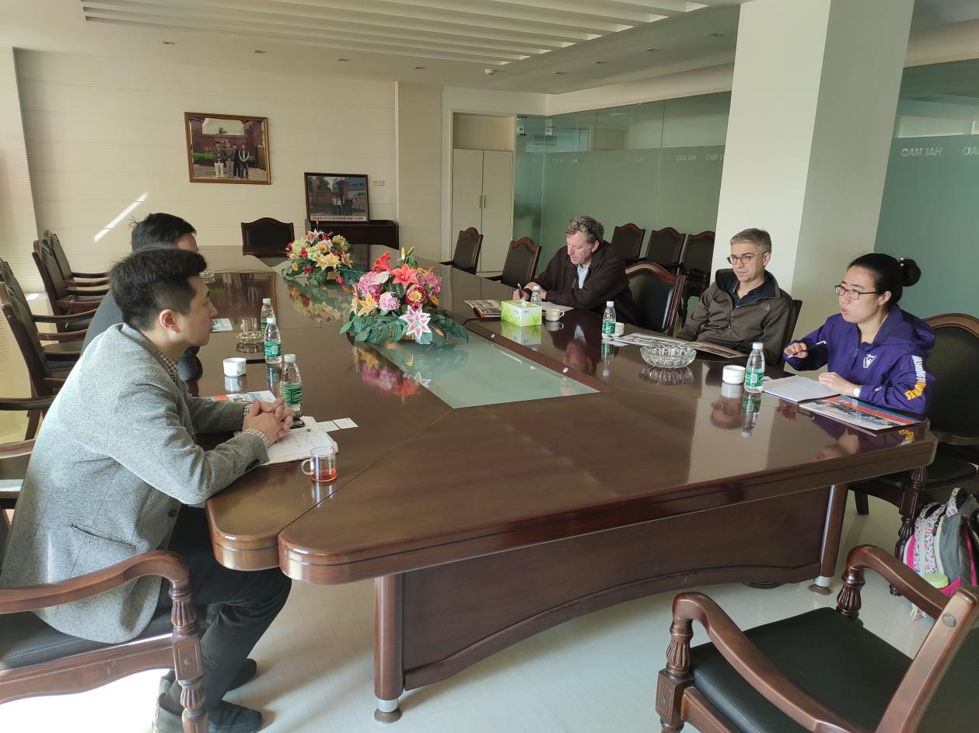
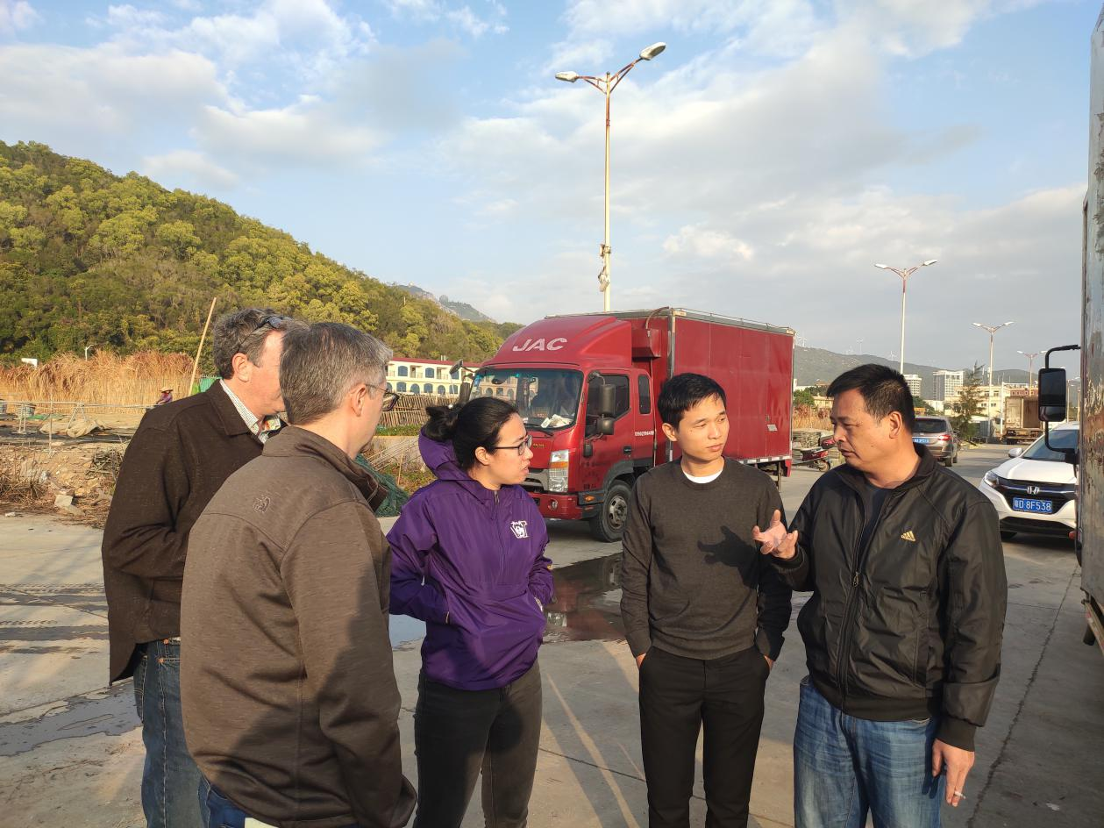
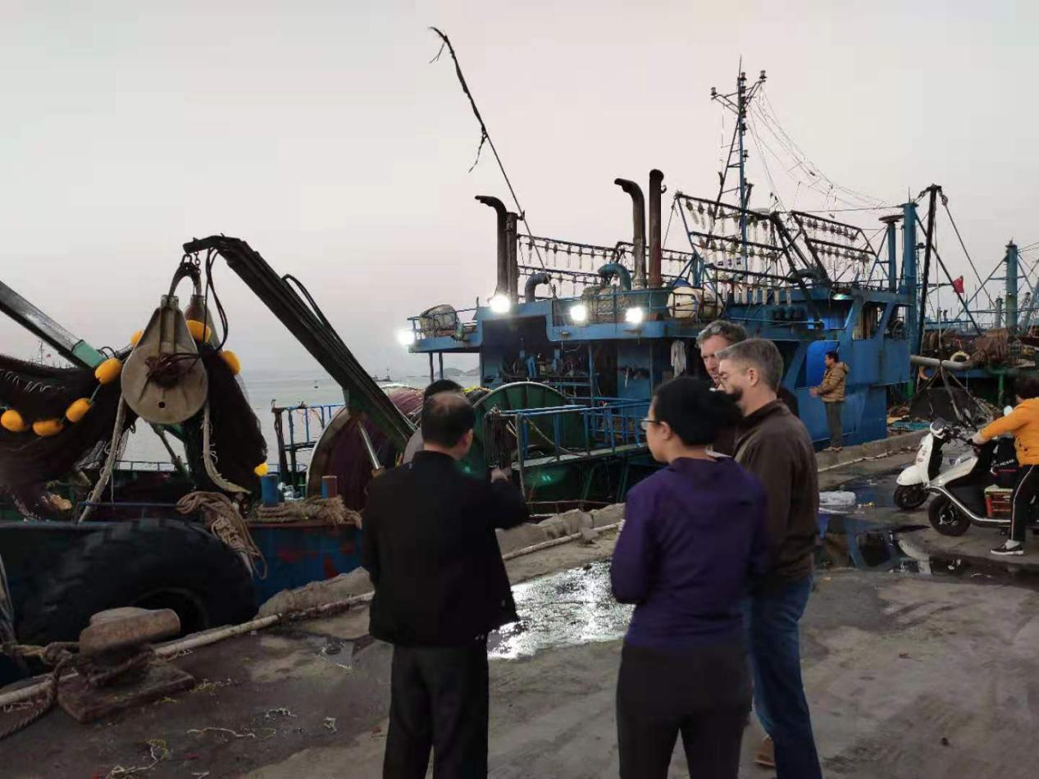

In December 2019, China Blue and two fishery economics experts from the University of Washington, visited the local fishing villages and fishing ports, identify the local fisheries dilemmas. Analyze the current status of local fishing efficiency, from an ecological, economic, and community perspective.

