Irish Nephrops FIP report on approaches to protecting Prawn Fishing Grounds/Functional Units

Introduction
The Irish Nephrops FIP was registered as a Basic FIP on Fishery Progress in September 2020 and currently has a B rating. An MSC pre-assessment was conducted for the Nephrops fishery in August 2018. The main findings of this pre-assessment showed variations in levels of fishing effort relative to Maximum Sustainable Yield (MSY) across the fishery, and a mismatch between management and scientific assessment units. A workplan based on the pre-assessment report findings was developed and the FIP is scheduled to run until 2025.

The workplan based on the pre-assessment covers seven Functional Units (FU) in the ICES subarea VII region. The workplan is aimed at tackling any outstanding issues raised as part of the pre-assessment and is due to be reviewed in 2023.
Strengths and weaknesses of Irish Nephrops Fishery: From Pre-assessment
Strengths | Weaknesses
Functional Unit (FUs) 15 is fluctuating around a level consistent with MSY. | Assessing UoA/UoCs comprising FUs 15, 20-21 and 22 is problematic as they are only partially within Irish waters.
A harvest strategy exists for the FUs as a whole which has been set in line with scientific advice since 2012 | In FUs 17, 19 and 22 fishing mortality hasn’t been fluctuating around a level consistent with FMSY for long enough to score ≥80 at PI 1.1.1.
Relevant information is collected to support the harvest strategy. | FUs 16, 18/Areas outside FUs and 20-21 do not have sufficient reference points to be able to assess stock status. However, preliminary RBF assessment suggest these stocks would score ≥80 at PI 1.1.1
The fishery is likely to present a low risk to ETP species and so meet national and international requirements for protection of ETP species | The availability of information is not consistent across the FUs. The time series is short for FUs 16, 19 and 20-21 and absent for FU18/Areas outside FUs.
The footprint of most UoAs does not overlap with VMEs. | In relation to the harvest strategy and control rules, the TAC is set at the level of the subarea rather than the individual stocks (FUs) which risks unsustainable fishing of particular stocks
There is robust governance and policy, consultation and decision-making processes. | One of the main primary species in the Irish Sea Nephrops fishery, whiting, is below its PRI and discards remain high despite measures to reduce bycatch. One of the main primary species in the Celtic Sea area, cod is below its PRI and fishing mortality is above FMSY
Clear, long-term objectives are explicit within the management system | It is not possible to determine whether the main secondary species, Rajidae, are above biologically based limits. RBF is likely to be required to enable assessment of stock status. Preliminary RBF assessment suggests Rajidae would pass.
Evidence exists that fishers comply with the management system including providing information on the fisheries performance | It is not possible to determine that the UoAs do not cause serious or irreversible harm to commonly encountered habitats.
There is a system for evaluating the performance of the fishery. | In FU16 there have been issues reported of misreporting occurring over a number of years and high-grading

Main findings of pre-assessment report:

Breakdown per MSC principle.
Under Principle 1, only one of the seven Functional Units (FU 15) assessed would likely score ≥80 for PI 1.1.1, Stock Status, while the remaining six would likely score 60-79, pass with conditions. For FUs 17,19 and 22 stocks status not in line with Bmsy was the rationale for the 60-79 score while for FUs 16, 18/ Areas outside FUs, and 22 the scoring rationale was due to lack of Bmsy reference points for the stock. It was noted that if the fishery went for full assessment the Risk Based Framework would need to be used to score FUs 16, 18/ Areas outside FUs, and 22.
While a harvest strategy exists for the fishery, the TAC is set at the subarea level not per FU. To support the harvest strategy, data on stock abundance and harvest rates are collected which is used to identify FU-specific reference points but the availability of this information is not consistent across FUs. Short time series of data for FUs16, 19 and 20-21 or absent for FU18/Areas outside FUs was also a rationale for the score of 60-79. A key issue affecting the scoring of Management Strategy and Harvest Control Rule (HCR) PIs for all FUs, is that the TAC, is not set at the appropriate spatial resolution. The pre-assessment recommendation was that management strategy, including HCR and TACs, should be implemented at FU level to ensure sustainable exploitation of the stocks. This recommendation is also put forward annually by ICES advice on fishing opportunities for Irish Nephrops.
Under Principle 2, primary and secondary species were identified for each FU. For FU 15 and 19, the poor status of whiting in the Irish Sea which is mostly caught as bycatch in the Nephrops fishery is a major issue. Whiting is below the PRI and the stock size is extremely low. Discards remain high despite technical measures introduced to reduce fin fish catch. As a result, for FU 15 and 19 the primary species outcome and management PIs score less than 60. In the Celtic Sea region, for FUs 16, 17, 18/Areas outside FUs, 19, 20-21 and 22 cod by-batch is a major issue. Cod is below the PRI in this area and fishing mortality, although decreasing, is above Fmsy. It was noted that a stock recovery plan is in place to rebuild the stock. However, mortality is difficult to control due to mixed fisheries interactions. Due to these issues the FUs around the Celtic Sea region are likely to score 60-79, pass with conditions, for the primary species outcome and management PIs.
The main secondary species of concern effecting all FUs is Rajidae species. As the status of Rajidae is unknown and there are no reference points defined for this species a preliminary RBF assessment was conducted which determined the species was at low risk under so the UoA/UoCs are likely to score 80 in this PI.
For ETP species PI scoring, it was noted that demersal trawling presents low risk to ETP species, although some bycatch is recorded. However due to the shortcomings in current monitoring and reporting the UoA/UoCs are likely to score 60-79, pass with condition, for the ETP information PI. It was noted that bycatch data used for the scoring of the ETP information PI was only available at the ICES region level and not per FU which may have impacted the scoring.
Due to the evidence of long-term adverse effects from Nephrops trawling on benthos in mud habitats and the condition in relation to the serious or irreversible harm threshold used in the Habitats Outcome PI. It was determined that all UoA/UoCs are unlikely to score 60 or above in the Habitats outcome and management PIs. As all UoA/UoCs obtained a likely score of less than 60 in at least two PIs (Habitats outcome and management) they fail to pass Principle 2.
Principle 3 highlighted the disconnect between scientific advice and current approaches to management of the fishery. As seen in Principle 1, scientific advice is available at the FU level while management is applied at the subarea rather than the FU level. This risks unsustainable levels of fishing in certain FUs. The existence of a management policy was noted and is stated to have clear long-term objectives under CFP but the short- and long-term objectives of the UoA/UoCs are not in line with achieving outcomes under MSC Principles 1 and 2. Other scoring issues under Principle 1 come from insufficient data on stock status and fishing levels inconsistent with Fmsy within the FUs. Under principle 2 concerns surrounding stock status and bycatch levels of both Whiting and Cod as a primary species of the UoA/UoCs under this pre-assessment resulted in scoring of 60-79, pass with conditions. The difficulty in controlling fishing mortality in the mixed stock fishery also contributed to the scoring rationale. The pre-assessment highlighted that there is a strategy in place within the fishery to recover and rebuild stocks of primary species but at current stock levels it is too early to determine the effectiveness of the recovery strategy. One of the main issues under principle 2 PIs is under habitats and known effects of Nephrops trawling on mud habitats, the pre-assessment noted concern with how this may affect VME habitats. It was suggested that if undertaking a full assessment that the fishery would fail under Principle 2.
While the pre-assessment described evidence of decision-making processes to achieve fishery specific objectives there was not enough evidence that these result in definitive management strategies. However, there was sufficient mechanisms to evaluate the fishery management system. Monitoring control and surveillance systems are evident throughout the UoA/UoCs but there are concerns over misreporting within FU 16 over a number of years. It was determined that the overall fishery would score 60-79 under principle 3, pass with conditions.
The final recommendation of the pre-assessment was that there were a few issues which need to be addressed within the Nephrops trawl fishery and that at the current stage of the fishery these obstacles need to be addressed prior to considering moving forward with full MSC assessment.

The workplan based on the pre-assessment has the following principles:
Principle 1- Stock management
P1 objectives:
- To improve the scientific data available on all Irish prawn stocks through improved observer coverage and industry data collection.
- To use that information to inform a management approach which protects stocks within individual functional units.

Principle 2: Minimising Environmental Impact
P2 objectives:
- To improve knowledge and develop a strategy to reduce bycatches of Irish Sea Whiting and Celtic Sea Cod in the prawn fishery.
- Work with the UK Nephrops FIP on the Irish Sea fishery which is common to both FIPs.
- A further objective is to minimize the presence of plastic and other litter in the marine environment.

Principle 3: Management System
P3 objective:
- The objective of the FIP regarding Principle 3 is to investigate and encourage the implementation of the best potential management systems which could protect functional units within an area VII-based approach.

Why focus on Functional Units?
The rationale behind a functional unit-based approach for Irish Nephrops comes from high level recommendations including ICES advice and the North Western Waters Multi Annual Plan (EU Regulation 2019/472). ICES advice for Nephrops fishing opportunities states to ensure that the stock in Functional Unit X is exploited sustainably, management should be implemented at the Functional Unit level. ICES recognises the North Western Waters Multi Annual Plan (NWWMAP) for subarea 7 and considers this management plan to be precautionary when implemented at the Functional Unit level.
In the NWWMAP under Article 8: Safeguards, the plan details when science indicates abundance is below MSY Btrigger that remedial measures shall be adopted to address abundance issues. These remedial measures may include suspending the target fishery for the FU and other FU based measures to ensure the rapid return of the FU stocks to levels above those capable of producing MSY.
From a FIP perspective the Nephrop pre-assessment noted that an area-based management approach risks displacement of unused catch from one FU to other FUs resulting in unsustainable landing levels in particular areas. It was recommended that under harvest strategy, the Nephrops fishery would not achieve the required SG80 score under the MSC standard due to the fact that management within the fishery is not at the appropriate spatial resolution.
In an effort to address this, the FIP workplan set the following objective: “In collaboration with industry, scientists, and managers, the FIP will conduct an assessment of potential approaches to protecting functional units within an area VII-based approach”. This report is intended to form the first step on the road to developing a FIP approach to the protection of Nephrops stocks within functional units without changing the overarching Area 7 based management approach.

Map of Irish FUs
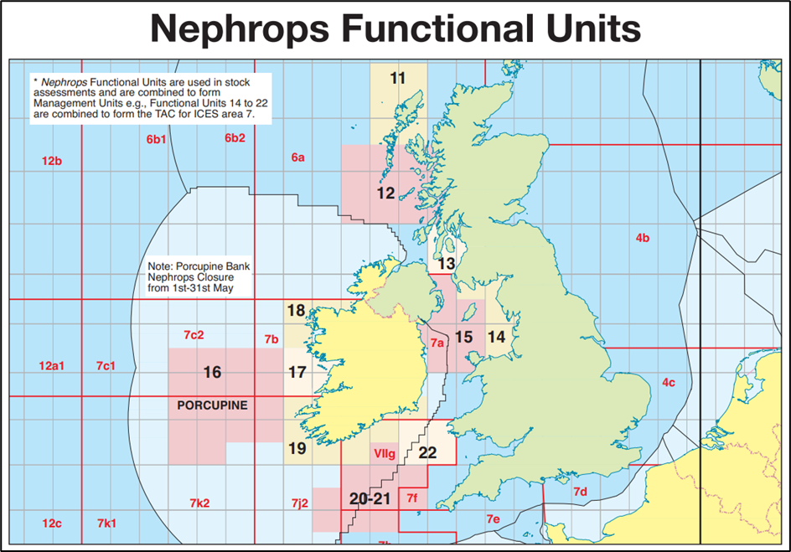Map from BIM Fisheries Management Chart 2022.
https://bim.ie/wp-content/uploads/2021/02/BIM-Fish-Man-2022_08032022.pdf

Table of Irish FUs as per UK report
Functional Unit | ICES Division | Stock Status |  | Are reference points defined |  |  | Survey |  | MSC Pre-assessment PI score |  |  | Irish Landings per FU 2021 (tonnes)
 |  | F2021 < FMSY | SSB2022 > Btrigger | Blim | MSY Btrigger | F MSY | UWTV | Last survey | 1.1.1 | Reason | ICES Advice
15- Irish Sea West | 7a | Yes | Yes | ❌ | ✅ | ✅ | Annual | 2022 | SG 80 | Stock abundance above MSY Btrigger. High degree of certainty that stock is above PRI. | 2017 | 1512
16- Porcupine | 7b, 7c, 7j ,7k | Yes | Not defined | ❌ | ❌ | ✅ | Annual | 2022 | SG 60-79 | Not enough stock data to determine PRI | 2017 | 1611
17-Aran, Galway Bay, and Slyne Head | 7b | Yes | No | ❌ | ✅ | ✅ | Annual | 2021 | SG 60-79 | Stock close to MSY Btrigger and not consistent with Fmsy | 2017 | 490
19- Ireland SW and SE Coast | 7a, 7g, 7j | Yes | No | ❌ | ✅ | ✅ | Annual | 2022 | SG 60-79 | Time series data too short to determine if stock is consistent with MSY | 2017 | 413
20-21- Labadie, Jones, and Cockburn | 7g, 7h | Yes | Yes | ❌ | ✅ | ✅ | Annual | 2022 | SG 60-79 | Stock data time series too short to determine PRI | 2017 | 610
22- Celtic Sea- the Smalls | 7g, 7f | Yes | No | ❌ | ✅ | ✅ | Annual | 2022 | SG 60-79 | While stock is above MSY Btrigger, stock not consistent with Fmsy | 2017 | 1537

Consultation

Interviews were conducted with a range of fishers including skippers of large-scale freezer trawlers and smaller inshore Nephrops trawlers, fishermen’s co-op managers and representatives of fishermen’s organistions. Interviews were open ended with respondents being asked open questions designed to elicit their own views in order to avoid the problem of priming respondents to give particular answers due to questions being overly specific or prescriptive.
The topic of functional units itself can be a divisive one within management of Irish Nephrops fisheries and in order to avoid defensive responses the term prawn fishing ground was mainly used instead. The questions asked generally followed those listed below although other topics also came up in some interviews.

Sustainability Issues Identified
There were a number of sustainability issues identified by the survey respondents. While most of these issues cover the fishery as a whole, some are related to specific fishing grounds. Several respondents spoke of wanting to implement sustainability measures but saw lack of uptake across the fleet as an issue. There was also the issue of sustainability versus economic gain with some responders expressing the wish to be more sustainable but when others in the fleet adopt a measure which increases bulk prawn catches it can be difficult not to follow suit. Some of the issues centred around a lack of uniform regulation across different countries or the need for enhanced scientific advice.
An overall issue raised across this survey was the need to improve real time science. Those surveyed saw the need to resolve issues between the catching sector and scientists and the ability to manage stocks in real time to protect female and juvenile Nephrops from excessive fishing pressure. Connected to this issue were questions around the extent of UWTV surveys. Many of those surveyed queried whether UWTV surveys cover the full extent of the fishing grounds and the accuracy of these surveys in picking up all burrows when females are inactive.
Concerns about mesh sizes and quad rigs putting pressure on small prawns were brought up by some respondents. The view that quad rigs resulted in more closed meshes resulting in higher catches of small prawns was expressed. These respondents also felt that 80mm mesh size was too small resulting in too much fishing pressure in some fishing grounds on smaller prawns.
Area specific issues were raised with major emphasis placed on the need to protect FU 16, the Porcupine Bank, due to its economic importance and the perception that prawns there grow more slowly.
From an inshore perspective issues with variations of stock levels on inshore fishing grounds was highlighted, the drivers of this are thought to be irregularities in weather and water temperature.
A lack of opportunities in whitefish fisheries resulting in increased participation in prawn fishing was raised as an additional relevant factor in sustainability of Irish prawn fisheries.

Solutions Proposed
Under the area of proposed solutions to the issues raised, none of the respondents supported FU specific management or quotas but there was generally support for the implementation of some focused measures, such as technical conservation measures (TCMs), that would protect stocks in specific fishing grounds, particularly FU 16.
Some technical conservation measures mentioned were a change in mesh size across fishing grounds, including inshore. Some surveyed supported a change to 90mm mesh size while a move to 100mm mesh size was also proposed with the suggestion that those who fish at this mesh size be subsidised in areas with small prawns until catch size increases.
Temporal and spatial closures in order to protect female prawns were proposed particularly in relation to the Porcupine with the additional possibility of rotational closures across other fishing grounds where necessary to protect females. Most recommendations on closures were aimed at FU 16, Porcupine Bank. Those surveyed agreed it was best to work with scientists from May onward to assess proportions of females in catches for FU 16. Once female numbers reach a threshold figure in catches it was proposed that the FU should be closed to all vessels until scientists assessed that female proportions in the catch were low again.
To further reduce pressure on functional units an introduction of a booking system was proposed for FU 16 whereby vessels would receive a quota for FU 16 and not any of the other FUs which would potentially leave the other prawn fishing grounds free for smaller vessels.
Overall, those surveyed saw protecting female and/or juvenile nephrops as the most effective solutions to FU sustainability issues.

Discussion
In general, those surveyed agreed that sustainability measures are needed to ensure the future of the Nephrops fishery. There are already some area specific measures in place to protect stocks, such as in FU 16 with the “of which” quota and under Regulation (EU) 2020/2015 where mesh size must be 100mm in areas south of 51 degrees.
A positive outcome from this survey come from the emphasis placed on fishing for economic value rather than bulk catches. Regardless of the different measures proposed, the industry seems to be in general agreement on the need for quality, sustainably caught prawns rather than landing high numbers of small prawns. Values based on indicative data from one fisher below show the extreme variation in the value of individual prawns as they increase in size:
Grade | Value individual prawn €
5-10/kg | €3.70
10-15/kg | €1.70
15-20/kg | €0.97
20-30/kg | €0.5
30-40/kg | €0.21
40-50/kg | €0.11

Conclusion
Overall impressions from this consultation show that there is support for proactive technical measures to protect specific prawn stocks but that improved co-operation both within the industry and between industry and science is required.
Once specific measures are developed, an improved working relationship with scientists to assess the proposed measures will be required. The Irish prawn FIP has been working closely with the Marine Institute and provides a useful forum for enhancement of this relationship. Using scientific information to determine how effective these measures would be in ensuring stocks are above MSY B trigger is vital from a regulatory perspective as required under the NWWMAP. Further research is required to determine if the proposed solutions, such as the protection of Nephrops females will actually result improvements in stock levels.
Communicating with industry players to assess the economic impacts of proposed measures is important to ensure greater cooperation. It is crucial to ensure measures introduced are viable for the industry in the long term in order to establish a positive outlook on implementation. Inherent in this is the consideration of the specific nature of different fishing grounds and needs of different fleet sectors. What is viable or applicable to large freezer vessels may cause issues for smaller inshore vessels and tailoring the approach to account for these different contexts is necessary.
There is a pressing need for further discussion on measures to protect prawn fishing grounds/ Functional Units. These discussions can take place through the FIP at regular meetings but for wider community outreach, using other forums such as the IFSRP would allow for greater industry communication. The next step in this process is to discuss proposals with industry and scientists at an upcoming IFSRP workshop on 24th January 2023.

